Task 1 : Data source selection and Supporting Factors
UCI Adult Income Dataset
- From UCI ML repository which is reliable and well cited.
- Dataset contains 48,842 records (>15000), divided into 32561 training and 16281 testing records.
- Has both numerical and categorical features, with 14 predictor variables.
Numerical
- Age
- Final Weight (Individuals with similar demographic characteristics receive similar weights)
- Education Num (Total number of years of education)
- Capital Gain
- Capital Loss
- Hours per week
Categorical
- Work class
- Education
- Marital status
- Occupation
- Relationship
- Race
- Sex
- Native Country
- Support supervised learning, income exceed 50K or not
- Has anomalies (missing values, class imbalance)

Target variable and prediction objective
Target variable is the Income

This is a binary categorical variable and represents individual annul income level.
- Less than or equal to 50,000: 76%
- Greater than 50,000: 24%

Due to 3:1 class distribution as depicted in figure 1, which is a skewed dataset need to address class imbalance before feeding it to ML model.
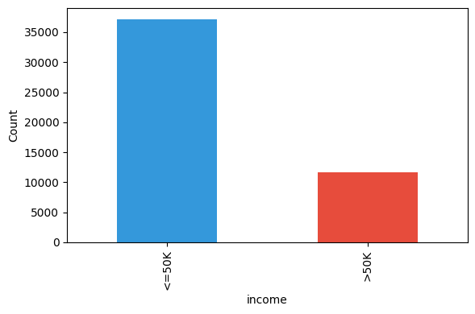
Figure 1: Income distribution

Creating supervised binary classification is the prediction objective

This uses demographic, Occupational, Personal and Financial features listed above.

Literature Review
- Scaling Up the Accuracy of Naive-Bayes Classifiers: A Decision-Tree Hybrid
Source: Proceedings of the Second International Conference on Knowledge Discovery and Data Mining
Summary
Addresses the limitations of Naive Bayes and Decision Trees models. This proposes a framework NBTree to improve prediction accuracy on large, mixed features data.

- Comparative Study of Machine Learning Algorithms on Census Income Data Set
Source: International Journal of Engineering Research and Applications
Summary
- Compares supervised classifiers on the UCI Adult income data.
- Testing with nonlinear models using accuracy and F1scores
- Shows gradient boosting has the highest predictive power for this dataset with F1-Score of 0.65
- Shows population weight has no linear correlation with individual income status.

- Machine Learning on UCI Adult Dataset Using Various Classifier Algorithms And Scaling Up The Accuracy Using Extreme Gradient Boosting
Source: Advanced Optimization Studies Compendium
Summary
- Presents multi model optimization strategy with greater accuracy on the Adult dataset.
- Incorporates classifications like kNN, Logistic Regression before building the multi model strategy
- Evaluation of Fairness in Machine Learning Models using the UCI Adult Dataset
Source: Brazilian Symposium on Databases Data share Track
Summary
- Address trade offs between classification accuracy and algorithmic fairness
- Evaluate Regression algorithms and Ensemble algorithms with incoperating socio economic attributes like Sex and race
- Feature Selection for Financial Data Classification Using Random Forest, Boruta, and Recursive Feature Elimination
Source: ResearchGate Financial Analytics Publication Index
Summary
- Targets dimension reduction, feature selection and model interpretability on financial records using Adult income dataset
- Recursively eliminate features and bring down 14 features to optimized 5 features which minimizes the overfitting in classification and regression models

- Predicting Adult Income Utilizing Various Artificial Intelligence Models
Source: The Eurasia Proceedings of Science, Technology, Engineering and Mathematics
Summary
- Testing accuracy of multi model systems using balanced and unbalanced datasets.
- Random forest has good accuracy on the dataset

Research Gaps and Proposed Approach
- Lack of Model Family Comparison
Existing studies in the above-mentioned research papers focuses on single model or compare only two or three algorithms (such as Random Forest vs kNN). We would implement and compare multiple machine learning algorithms in different categories, such as Linear Model (Logistic Regression), Distance-Based Model (KNN), Tree-Based Model (Random Forest), Ensemble Boosting Model (XGBoost), and Deep Learning (ANN).

- Generic Imbalance Handling
Research papers apply class imbalance methods without consideration of the specific model type. We would try targeted imbalance strategy for specific models. Fore example Scale Positive Weight for XGBost, Class Weighting for linear and tree-based.

- MLOps
Here we would implement containerized deployment with model versioning with monitorig strategies targeting end to end MLOps pipeline.

Task 2: Data Analysis and Feature Engineering

Exploratory Data Analysis (EDA)
Correlation Analysis
As depicted in figure 2 correlation matrix shows weak linear correlations between all numerical features. All correlation coefficients are less than 0.15. So, we keep all variables because they could bring more information. And linear model alone could not work well because of weak correlation between numerical variables. So, we need to bring tree-based models like random forest or XGBoost because they can capture non-linear relationships.
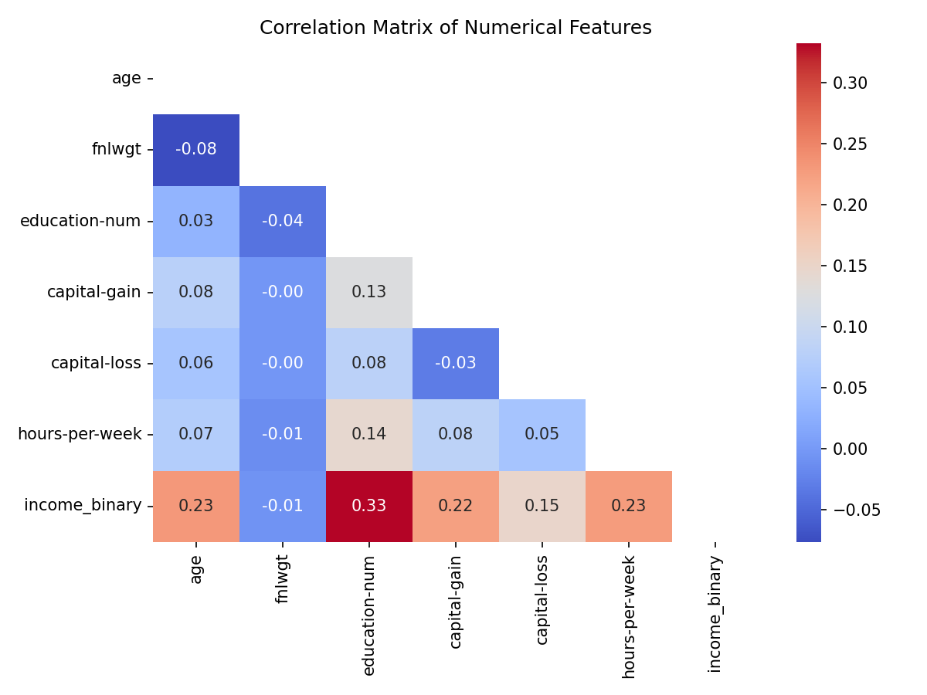
Figure 2: Correlation Matrix of Numerical Features
Numerical Feature Distribution
Figure 3 depicts histogram of numerical features.
- Hours-Per-Week: Hours per week centered around 40 hrs because that is standard week hours.
- Education-Num: Education represents years of education peaking at 9(Highschool Graduate).
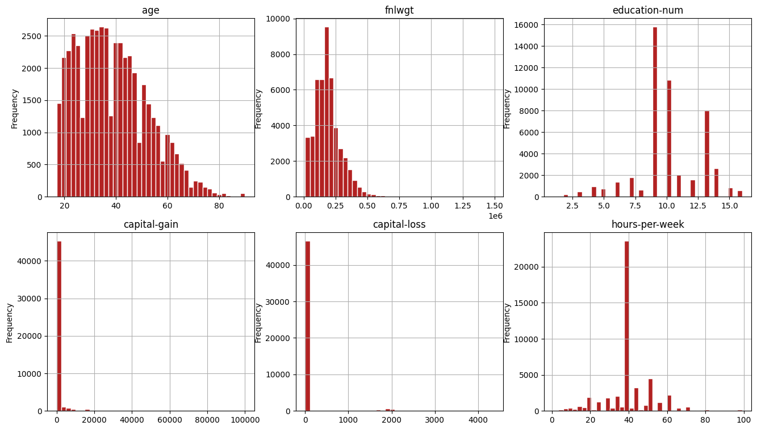
Figure 3: Numerical Features Distribution
Categorical Features vs Income
Figure 4 depicts categorical features vs Income percentage.
- Marital-Status: Individuals with Married-civ-spouse status have highest proportion of high income
- Occupation: Executive and Managerial (Exec-managerial) class and Professional Specialty (Prof-specialty) class has the highest high income
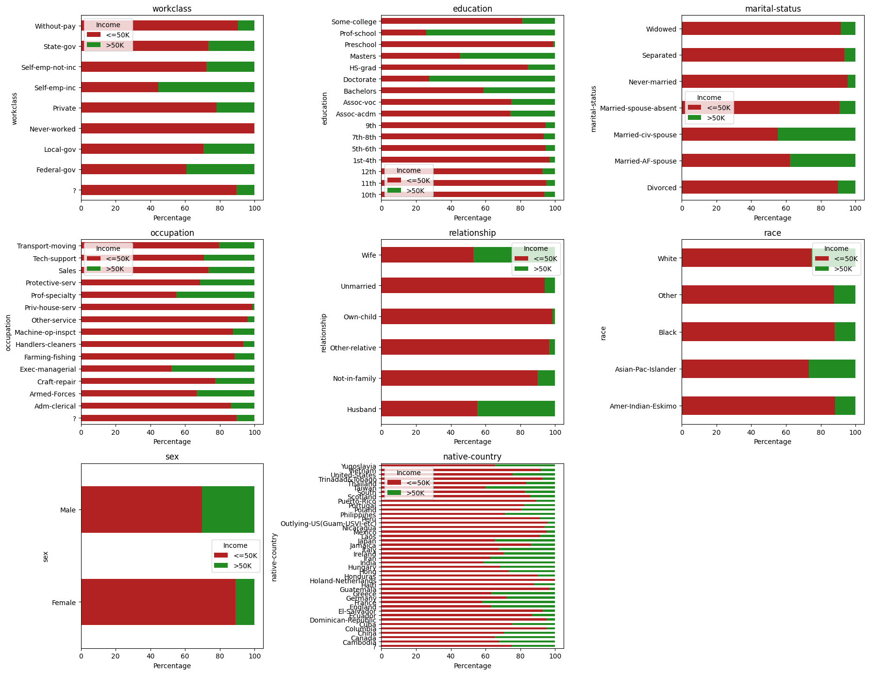
Figure 4: Categorical Income distribution percentage

Data Cleaning
Handling Missing Values
Missing values represented as ‘?’ in the original dataset and we replaced with ‘NaN’ and the rows were dropped. Resulting dropping 3620 rows (~7%). This is acceptable because it still has 45175 records.
Removing Duplicates
Dropped 47 duplicate records.
Feature Elimination
Remove fnlwgt column

- Table 1 contains the correlation coefficient of numerical variables to the target ‘Income’ variable. And fnlwgt has coefficient of -0.0072 showing virtually no linear association.
Feature | Correlation Coefficient
fnlwgt | -0.007227
age | 0.236839
education-num | 0.332981
hours-per-week | 0.227146
income_binary | 1.000000
Table 1: Numerical to Income Correlation

- Above 2nd paper in literature review “Comparative Study of Machine Learning Algorithms on Census Income Data Set”, they also removed fnlwgt from calcaultion.
- This is not an attribute of individual instead statistical calculation based on demographic characteristics.

Feature Engineering
We introduced five new features based on existing understanding of the features.
1. ‘capital_net’ (capital-gain - capital-loss): Captures the net return of capital.
2. ‘has_capital’ Binary feature (1 or 0) based on capital gain or capital loss respectively.
3. ‘age_group’ Binned Life stages: Young (0-25), Early-Career (25-35), Mid-Career (35-45), Senior (45-55), Pre-Retire (55-65), Retired (65-100).
4. ‘hours_category’ Binned hours-per-week: Part-Time (0-34), Full-Time (34-40), Overtime (40-100).
5. ‘edu_group’ Simplified education: Grouped into Low, High-School, Some-College, Bachelors, Advanced.

Feature Importance with Random Forest Classifier
We use random forest classifier here because unlike standard correlation which look at straight linear relationships random forest captures the nonlinear boundaries. Figure 5 depicts the python code.
Eg: Age does not have straight line relationship with income (income may increase at middle age but drops when they retire). Correlation would miss this but Random Forest catches this by threshold split (age > 25 and age < 25)
Below are the top 10 features sorted by importance
- age: 17.15%
- relationship: 11.32%
- hours-per-week: 8.80%
- occupation: 8.76%
- capital_net: 7.93%
- marital-status: 6.97%
- capital-gain: 6.55%
- education-num: 5.68%
- edu_group: 5.36%
- workclass: 5.06%

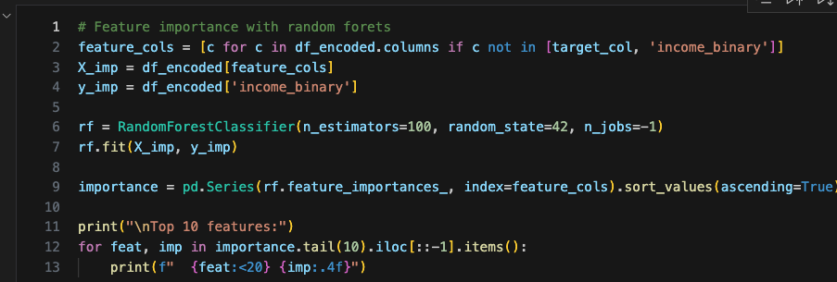

Figure 5: Feature importance with Random Forest Classifier

Task 3: Model Development and Optimization

Algorithm Selection
Here we implemented five machine learning models representing disticty algorithm families.
1. Logistic Regression (Linear Model): This is fast to train, predicts True or False, and S shape logistic function for prediction.
2. K-Nearest Neighbors (KNN) (Distance-based): Classifies based on similarity in multi-dimensional feature space.
3. Random Forest (Tree-based Ensemble): Multiple decision trees. Natively handles non-linear boundaries and categorical features.
4. XGBoost (Ensemble Boosting): A gradient boosting machine. Builds Tress sequentially to correct mistakes. Can handle missing values natively.
5. Artificial Neural Network / MLPClassifier (Deep Learning): Stacks hidden layers with activation functions to learn complex, non-linear feature representations.

Preparing the Dataset for ML
We need to prepare the dataset with preprocessing and scaling to avoid crashing and improve accuracy. Here we would use ‘ColumnTransform’ to handle Numertical and Categorical features.
- StandardScalar(Z-Score) for Numerical
- OneHotEncoder for Categorical: Turns category labels to numbers where ML can understand
This also prevents data leakage where fit() the model it calculates only from training data and not touches test data which could fails the model in production.
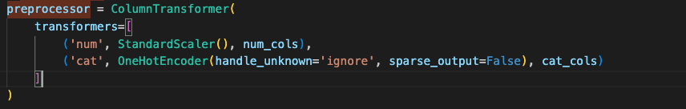
Figure 6: Preprocessing and Scaling

Handling Class Imbalance
Out of 5 main class imbalance techniques we would use three here for balance skewed data set before feeding to ML model.
- Logistic Regression & Random Forest: Using class weighting. We do not worry about balancing and tell model creation algorithm to balance it (class_weight='balanced').
- XGBoost: Scale Positive Weight, Here we give weight to the algorithm. Initially we identified imbalance ratio is 3.18. scale_pos_weight = 3.18
- ANN: Here we use RandomOverSampler. This would balance by duplicating existing in minority. Here the high income class(> 50K) is the minority. 3 out of every 4 rows network look will be low income(=<50K). Network would get 76% accuracy score by shifting weights to predict “low income” every time. Gradients for high income class become smaller. By Random Oversampling we can ensure that every training batch network finds equal high and low income data. This forces network to actively adjust its weight to learn the features.

Hyperparameter Optimization and Cross-Validation
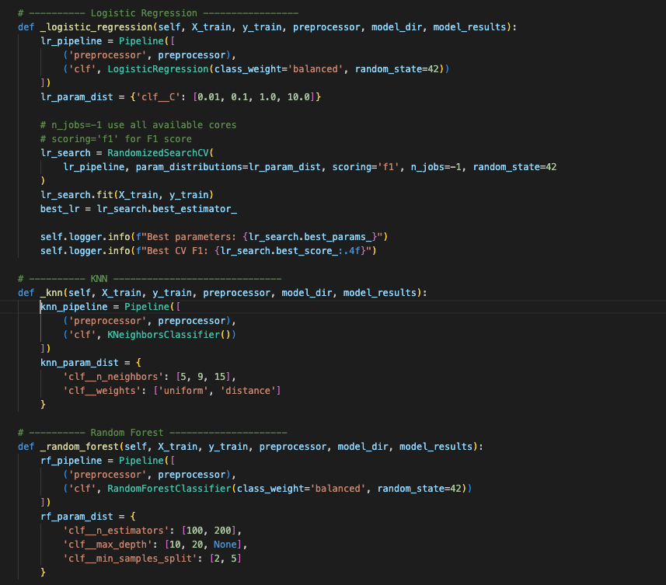
Figure 7: Minimum python code for Train and Best Hyper param, F1 calculation
Figure 7 depcits the minimized python code for model tuning and findinf best hyper param values and F1 scores. This code can find in use case under file name train_and_tune_usecase.py
We use Randomized Search Cross-Validation for finding best settings for hyperparameters. This would find the best settings with good enough accuracy without wasting computing time.
Considerations
True Positive = TP
True Negative = TN
False Positive = FP
False Negative = FN
Accuracy = Ratio of correct predictions to the total predictions

$$Accuracy=\frac{TP+TN}{TP+TN+FP+FN}$$

Precision = Out of predicted positive how many actual positive.

$$Precision=\frac{TP}{TP+FP}$$

Recall(Sensitivity) = Out of actual positive how many successfully predicted positive.
$$Recall=\frac{TP}{TP+FN}$$

F1-Score = Balance between Precision and Recall
The fundamental goal is decreasing FP and FN values which eventually increase Precision and Recall values.

$$F1-Score=2 x \frac{Precision x Recall}{Precision+Recall}$$

F1-Score is the harmonic mean, according to above equation increasing both precision and recall would increase the F1-Score but we need to make sure make the model smarter with approaches like below rather than manually adjusting the threshold values.
- More Features
- Better Algorithms
- Collect More data

Model Evaluation Results
Model | Hyperparameters Optimum | F1-Score
Logistic Regression | {'C': 1.0} | 0.6957
KNN | {'weights': 'uniform', 'n_neighbors': 15 } | 0. 6716
Random Forest | {'n_estimators': 20, 'min_samples_split': 5, 'max_depth': 20} | 0. 7094
XGBoost | {'n_estimators': 100, 'max_depth': 7, 'learning_rate': 0.2} | 0.7205
ANN | {'hidden_layer_sizes': (50,), 'alpha': 0.01, 'activation': tanh} | 0.6936
Table 2: Model Cross Validation F1-Score and Optimum Hyprparameters

XGBoost achieved the highest cross validation F1-Score of 0. 7205

Task 4: Performance Evaluation and Model Comparison
Evaluated 5 optimized models on the test set using Accuracy, Precision, Recall, F1 Score, ROC-AUC, and PR-AUC.

Model Performance Comparison

Model | Accuracy | Precision | Recall | F1-Score | ROC-AUC | PR-AUC
Log-Regression | 81.43% | 58.75% | 84.20% | 0.6921 | 0.9086 | 0.7811
KNN | 83.75% | 69.51% | 61.38% | 0.6520 | 0.8894 | 0.7478
Random Forest | 83.21% | 62.33% | 81.86% | 0.7067 | 0.9136 | 0.7956
XGBoost | 83.56% | 62.3% | 85.36% | 0.7203 | 0.9265 | 0.8271
ANN | 82.01% | 60.15% | 81.38% | 0.6917 | 0.9083 | 0.7789

Table 3: Model validation Summary
Considerations
ROC-AUC : Receiver Operating Characteristic – Area Under the Curve
This tells how good model separating High Income and Low-Income classes.

PR-AUC: Precision-Recall Area Under the Curve
Evaluates model performance across all possible decision thresholds. Here it can cope better with imbalance dataset as we have here over ROC-AUC because it ignores True Negative.

According to Table 3 we can highlight following

- XGBoost is the top performer with highest F1-Score(0.7023) which leads to most balance between precision and recall. ROC-AUC and PR-AUC also highest here so XGBoost can separate the High and Low income better.
- Both XGBoost and Logistic Regression is good in identifying high earners. They have the highest Recall values 85% and 84% respectively, so it has the minimum False Negative which minimizes predicted high earner but actually low.
- Random Forest offers best overall performance with good F1-Score of 0.7067 and ROC-AUC of 0.9136.

Visualization

ROC Curve

Figure 8 depicts ROC-Curves of the models and it shows XGBost has the highest AUC which achieves highest diagnostic capability. KNN has the lowest.
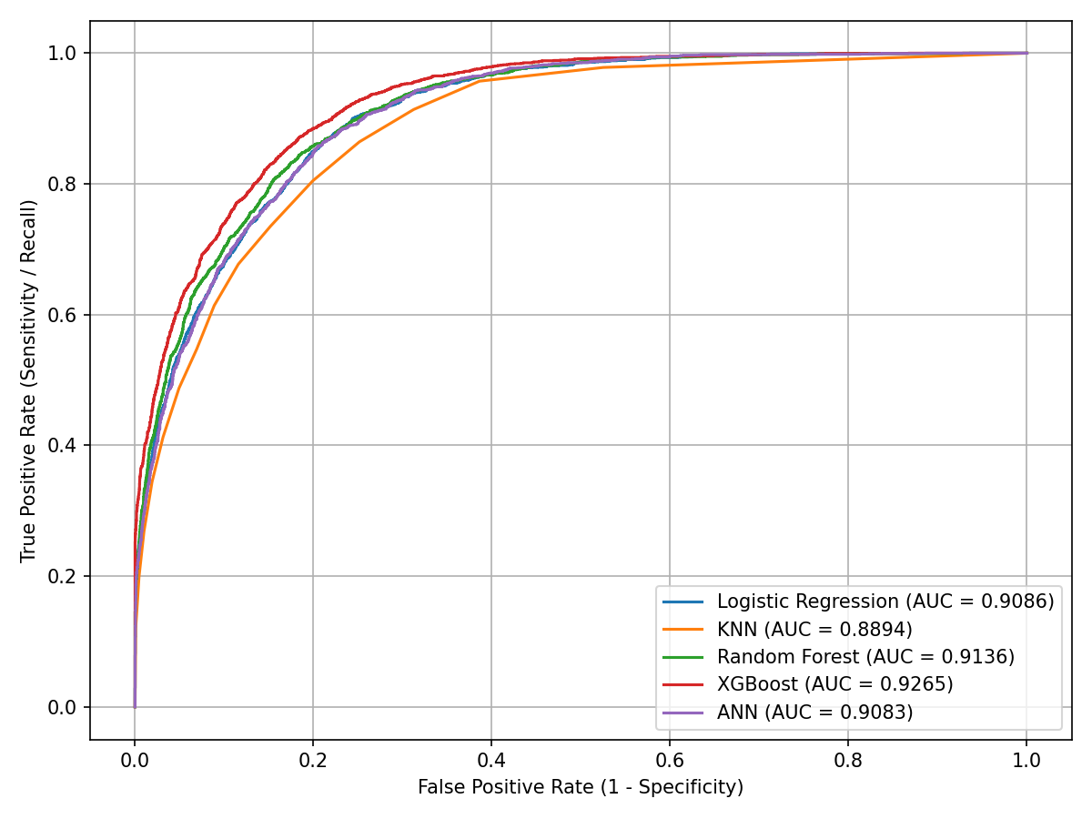
Figure 8: ROC Curves

Precision- Recall Curve

Figure 9 depicts PR Curves of the models and it shows XGBost has the highest average precision which is very good in finding high income earners.

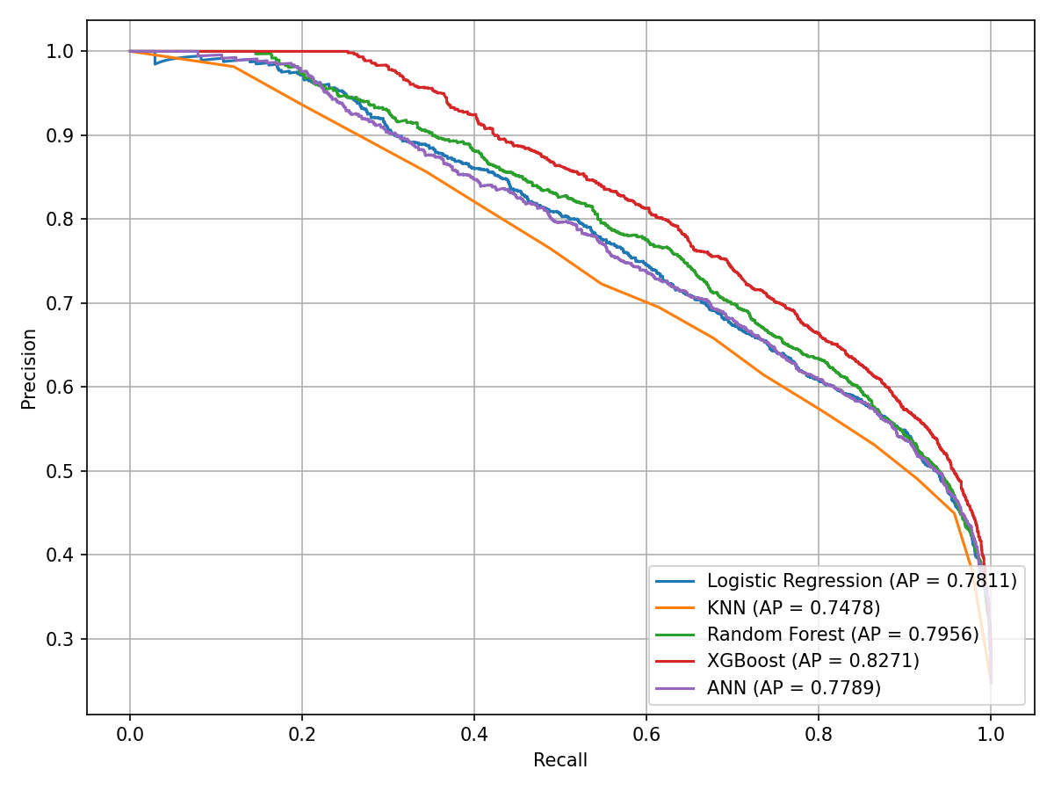
Figure 8: PR Curves

XGBoost Error Analysis
We analyzed the errors (False Positive and False Negative) of the best performing model which is XGBoost across Sex and Educational Group which had the top two highest correlation coefficient above.
False Positive (FP) : Predict > 50K(High Income) but in real its < 50K( Low Income)
False Negative (FN): Predict <50K(Low Income) but in real its >50K(High Income)

Sex | Total | Errors | Error Rate | FP | FN
Male | 6093 | 1249 | 20.50 | 1006 | 243
Female | 2942 | 236 | 8.02 | 151 | 85
Table 4: Error Profile By Sex
Table 4 depicts Gender based analysis and we can that model is more prone to False positive on Males, predicting them high earners more often than they really are.
Education Group | Total | Errors | Error Rate | FP | FN
Advanced | 768 | 155 | 20.18 | 135 | 20
Bachelors | 1512 | 302 | 19.97 | 238 | 64
College | 2711 | 484 | 17.85 | 400 | 84
High-School | 2915 | 474 | 16.26 | 364 | 110
Low | 1129 | 70 | 6.20 | 20 | 50
Table 5: Error Profile By Education Group
According to Table 5 above its noticeable that Advanced and Bachelors degree has high eror rate (~20%). Predicting high income due to has degree but actual income is lower.
Low education group ha very low error rate (6.20%).

