MSc Data Science

Machine Learning Coursework

Chamika Deshan
COMScDS251P-015

Setup

For this project we used python for programming, and incoperated clean architecure and dependency injection for seperation in concern. The source code can be downloaded from git repositoy below.

https://github.com/deshancha/machinelearning_cw

Adjsuting the paramter below in .env file can Disable/Enable Logs, Default is enabled.

LOG_ENABLED=1

Q1: Applied Supervised Machine Learning

Task 1 : Data source selection and Supporting Factors
UCI Adult Income Dataset
- From UCI ML repository which is reliable and well cited.
- Dataset contains 48,842 records (>15000), divided into 32561 training and 16281 testing records.
- Has both numerical and categorical features, with 14 predictor variables.
Numerical
- Age
- Final Weight (Individuals with similar demographic characteristics receive similar weights)
- Education Num (Total number of years of education)
- Capital Gain
- Capital Loss
- Hours per week
Categorical
- Work class
- Education
- Marital status
- Occupation
- Relationship
- Race
- Sex
- Native Country
- Support supervised learning, income exceed 50K or not
- Has anomalies (missing values, class imbalance)

Target variable and prediction objective
Target variable is the Income

This is a binary categorical variable and represents individual annul income level.
- Less than or equal to 50,000: 76%
- Greater than 50,000: 24%

Due to 3:1 class distribution as depicted in figure 1, which is a skewed dataset need to address class imbalance before feeding it to ML model.
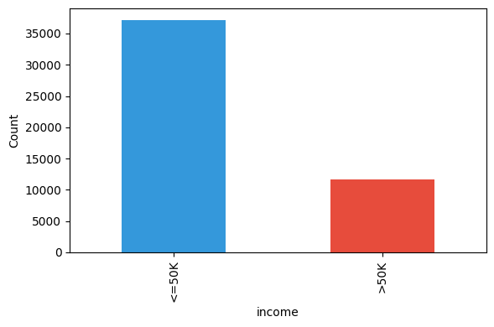
Figure 1: Income distribution

Creating supervised binary classification is the prediction objective

This uses demographic, Occupational, Personal and Financial features listed above.

Literature Review
- Scaling Up the Accuracy of Naive-Bayes Classifiers: A Decision-Tree Hybrid [1]
Source: Proceedings of the Second International Conference on Knowledge Discovery and Data Mining
Summary
Addresses the limitations of Naive Bayes and Decision Trees models. This proposes a framework NBTree to improve prediction accuracy on large, mixed features data.

- Comparative Study of Machine Learning Algorithms on Census Income Data Set [2]
Source: International Journal of Engineering Research and Applications
Summary
- Compares supervised classifiers on the UCI Adult income data.
- Testing with nonlinear models using accuracy and F1scores
- Shows gradient boosting has the highest predictive power for this dataset with F1-Score of 0.65
- Shows population weight has no linear correlation with individual income status.

- Machine Learning on UCI Adult Dataset Using Various Classifier Algorithms And Scaling Up The Accuracy Using Extreme Gradient Boosting [3]
Source: Wordpress Technical Report
Summary
- Presents multi model optimization strategy with greater accuracy on the Adult dataset.
- Incorporates classifications like kNN, Logistic Regression before building the multi model strategy
- Evaluation of Fairness in Machine Learning Models using the UCI Adult Dataset [4]
Source: Brazilian Symposium on Databases Data share Track
Summary
- Address trade offs between classification accuracy and algorithmic fairness
- Evaluate Regression algorithms and Ensemble algorithms with incoperating socio economic attributes like Sex and race
- Feature Selection for Financial Data Classification Using Random Forest, Boruta, and Recursive Feature Elimination [5]
Source: International Information and Engineering Technology Association
Summary
- Targets dimension reduction, feature selection and model interpretability on financial records using Adult income dataset
- Recursively eliminate features and bring down 14 features to optimized 5 features which minimizes the overfitting in classification and regression models

- Predicting Adult Income Utilizing Various Artificial Intelligence Models
Source: The Eurasia Proceedings of Science, Technology, Engineering and Mathematics
Summary
- Testing accuracy of multi model systems using balanced and unbalanced datasets.
- Random forest has good accuracy on the dataset

Research Gaps and Proposed Approach
- Lack of Model Family Comparison
Existing studies in the above-mentioned research papers focuses on single model or compare only two or three algorithms (such as Random Forest vs kNN). We would implement and compare multiple machine learning algorithms in different categories, such as Linear Model (Logistic Regression), Distance-Based Model (KNN), Tree-Based Model (Random Forest), Ensemble Boosting Model (XGBoost), and Deep Learning (ANN).

- Generic Imbalance Handling
Research papers apply class imbalance methods without consideration of the specific model type. We would try targeted imbalance strategy for specific models. Fore example Scale Positive Weight for XGBost, Class Weighting for linear and tree-based.

- MLOps
Here we would implement containerized deployment with model versioning with monitorig strategies targeting end to end MLOps pipeline.

Task 2: Data Analysis and Feature Engineering

Exploratory Data Analysis (EDA)
Correlation Analysis
As depicted in figure 2 correlation matrix shows weak linear correlations between all numerical features. All correlation coefficients are less than 0.15. So, we keep all variables because they could bring more information. And linear model alone could not work well because of weak correlation between numerical variables. So, we need to bring tree-based models like random forest or XGBoost because they can capture non-linear relationships.
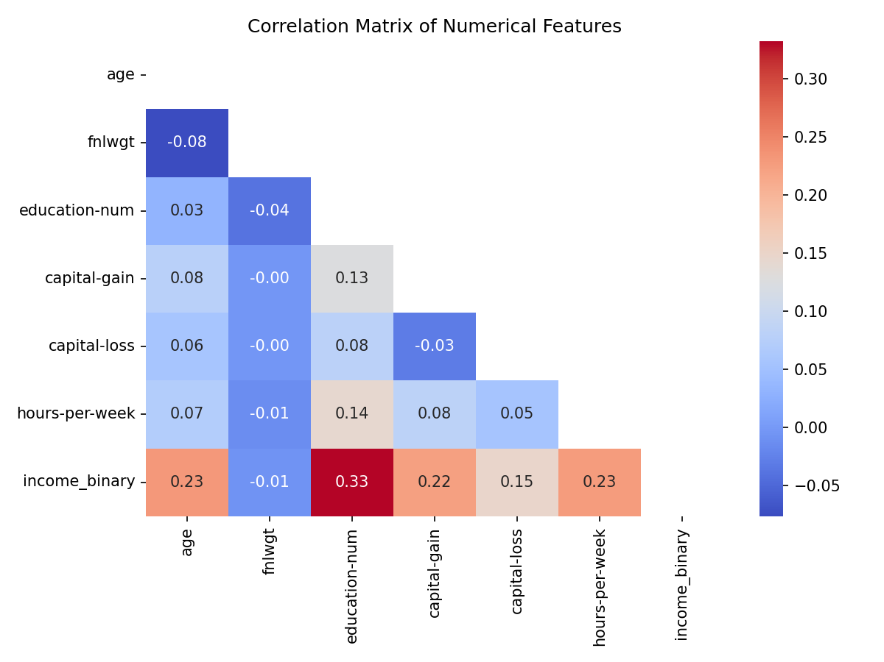
Figure 2: Correlation Matrix of Numerical Features
Numerical Feature Distribution
Figure 3 depicts histogram of numerical features.
- Hours-Per-Week: Hours per week centered around 40 hrs because that is standard week hours.
- Education-Num: Education represents years of education peaking at 9(Highschool Graduate).
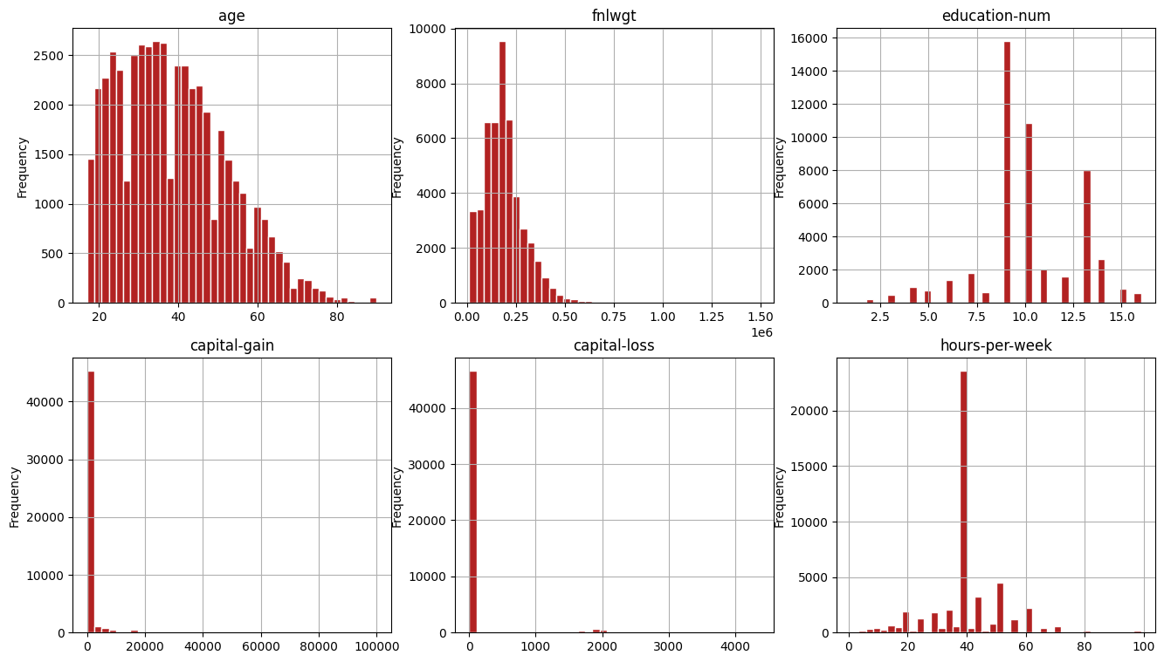
Figure 3: Numerical Features Distribution
Categorical Features vs Income
Figure 4 depicts categorical features vs Income percentage.
- Marital-Status: Individuals with Married-civ-spouse status have highest proportion of high income
- Occupation: Executive and Managerial (Exec-managerial) class and Professional Specialty (Prof-specialty) class has the highest high income
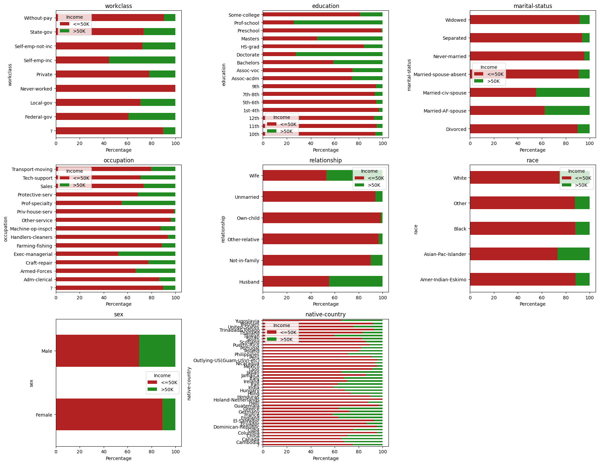
Figure 4: Categorical Income distribution percentage

Data Cleaning
Handling Missing Values
Missing values represented as ‘?’ in the original dataset and we replaced with ‘NaN’ and the rows were dropped. Resulting dropping 3620 rows (~7%). This is acceptable because it still has 45175 records.
Removing Duplicates
Dropped 47 duplicate records.
Feature Elimination
Remove fnlwgt column

- Table 1 contains the correlation coefficient of numerical variables to the target ‘Income’ variable. And fnlwgt has coefficient of -0.0072 showing virtually no linear association.
Feature | Correlation Coefficient
fnlwgt | -0.007227
age | 0.236839
education-num | 0.332981
hours-per-week | 0.227146
income_binary | 1.000000
Table 1: Numerical to Income Correlation

- Above 2nd paper in literature review “Comparative Study of Machine Learning Algorithms on Census Income Data Set”, they also removed fnlwgt from calcaultion.
- This is not an attribute of individual instead statistical calculation based on demographic characteristics.

Feature Engineering
We introduced five new features based on existing understanding of the features.
1. ‘capital_net’ (capital-gain - capital-loss): Captures the net return of capital.
2. ‘has_capital’ Binary feature (1 or 0) based on capital gain or capital loss respectively.
3. ‘age_group’ Binned Life stages: Young (0-25), Early-Career (25-35), Mid-Career (35-45), Senior (45-55), Pre-Retire (55-65), Retired (65-100).
4. ‘hours_category’ Binned hours-per-week: Part-Time (0-34), Full-Time (34-40), Overtime (40-100).
5. ‘edu_group’ Simplified education: Grouped into Low, High-School, Some-College, Bachelors, Advanced.

Feature Importance with Random Forest Classifier
We use random forest classifier here because unlike standard correlation which look at straight linear relationships random forest captures the nonlinear boundaries. Figure 5 depicts the python code.
Eg: Age does not have straight line relationship with income (income may increase at middle age but drops when they retire). Correlation would miss this but Random Forest catches this by threshold split (age > 25 and age < 25)
Below are the top 10 features sorted by importance
- age: 17.15%
- relationship: 11.32%
- hours-per-week: 8.80%
- occupation: 8.76%
- capital_net: 7.93%
- marital-status: 6.97%
- capital-gain: 6.55%
- education-num: 5.68%
- edu_group: 5.36%
- workclass: 5.06%

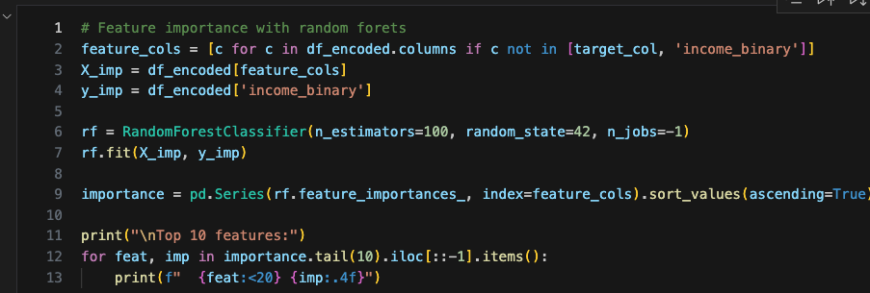

Figure 5: Feature importance with Random Forest Classifier

Task 3: Model Development and Optimization

Algorithm Selection
Here we implemented five machine learning models representing disticty algorithm families.
1. Logistic Regression (Linear Model): This is fast to train, predicts True or False, and S shape logistic function for prediction.
2. K-Nearest Neighbors (KNN) (Distance-based): Classifies based on similarity in multi-dimensional feature space.
3. Random Forest (Tree-based Ensemble): Multiple decision trees. Natively handles non-linear boundaries and categorical features.
4. XGBoost (Ensemble Boosting): A gradient boosting machine. Builds Tress sequentially to correct mistakes. Can handle missing values natively.
5. Artificial Neural Network / MLPClassifier (Deep Learning): Stacks hidden layers with activation functions to learn complex, non-linear feature representations.

Preparing the Dataset for ML
We need to prepare the dataset with preprocessing and scaling to avoid crashing and improve accuracy. Here we would use ‘ColumnTransform’ to handle Numertical and Categorical features.
- StandardScalar(Z-Score) for Numerical
- OneHotEncoder for Categorical: Turns category labels to numbers where ML can understand
This also prevents data leakage where fit() the model it calculates only from training data and not touches test data which could fails the model in production.
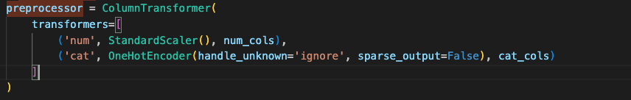
Figure 6: Preprocessing and Scaling

Handling Class Imbalance
Out of 5 main class imbalance techniques we would use three here for balance skewed data set before feeding to ML model.
- Logistic Regression & Random Forest: Using class weighting. We do not worry about balancing and tell model creation algorithm to balance it (class_weight='balanced').
- XGBoost: Scale Positive Weight, Here we give weight to the algorithm. Initially we identified imbalance ratio is 3.18. scale_pos_weight = 3.18
- ANN: Here we use RandomOverSampler. This would balance by duplicating existing in minority. Here the high income class(> 50K) is the minority. 3 out of every 4 rows network look will be low income(=<50K). Network would get 76% accuracy score by shifting weights to predict “low income” every time. Gradients for high income class become smaller. By Random Oversampling we can ensure that every training batch network finds equal high and low income data. This forces network to actively adjust its weight to learn the features.

Hyperparameter Optimization and Cross-Validation
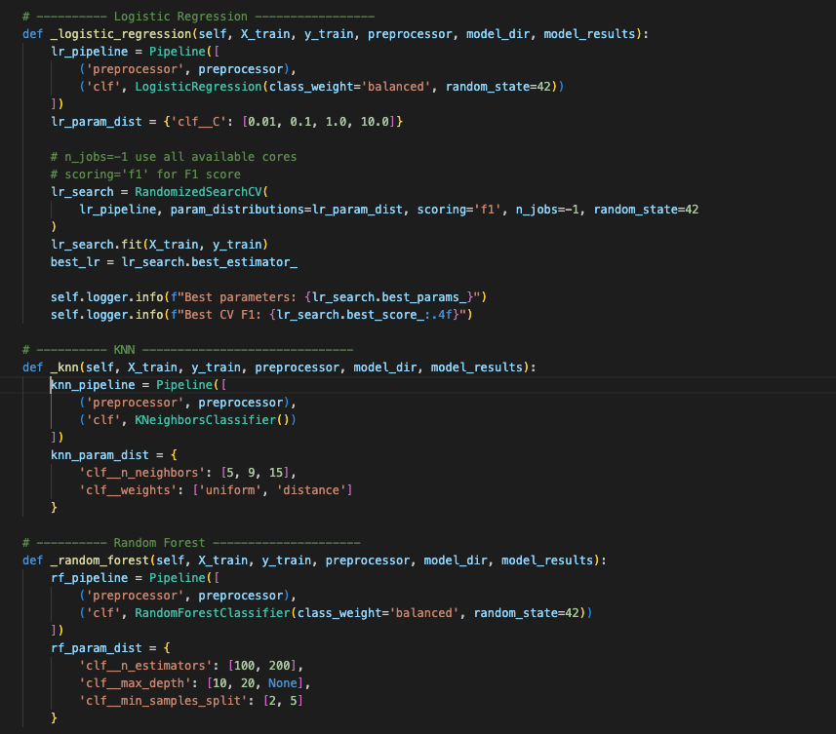
Figure 7: Minimum python code for Train and Best Hyper param, F1 calculation
Figure 7 depcits the minimized python code for model tuning and findinf best hyper param values and F1 scores. This code can find in use case under file name train_and_tune_usecase.py
We use Randomized Search Cross-Validation for finding best settings for hyperparameters. This would find the best settings with good enough accuracy without wasting computing time.
Considerations
True Positive = TP
True Negative = TN
False Positive = FP
False Negative = FN
Accuracy = Ratio of correct predictions to the total predictions

$$Accuracy=\frac{TP+TN}{TP+TN+FP+FN}$$

Precision = Out of predicted positive how many actual positive.

$$Precision=\frac{TP}{TP+FP}$$

Recall(Sensitivity) = Out of actual positive how many successfully predicted positive.
$$Recall=\frac{TP}{TP+FN}$$

F1-Score = Balance between Precision and Recall
The fundamental goal is decreasing FP and FN values which eventually increase Precision and Recall values.

$$F1-Score=2 x \frac{Precision x Recall}{Precision+Recall}$$

F1-Score is the harmonic mean, according to above equation increasing both precision and recall would increase the F1-Score but we need to make sure make the model smarter with approaches like below rather than manually adjusting the threshold values.
- More Features
- Better Algorithms
- Collect More data

Model Evaluation Results
Model | Hyperparameters Optimum | F1-Score
Logistic Regression | {'C': 1.0} | 0.6957
KNN | {'weights': 'uniform', 'n_neighbors': 15 } | 0. 6716
Random Forest | {'n_estimators': 20, 'min_samples_split': 5, 'max_depth': 20} | 0. 7094
XGBoost | {'n_estimators': 100, 'max_depth': 7, 'learning_rate': 0.2} | 0.7205
ANN | {'hidden_layer_sizes': (50,), 'alpha': 0.01, 'activation': tanh} | 0.6936
Table 2: Model Cross Validation F1-Score and Optimum Hyprparameters

XGBoost achieved the highest cross validation F1-Score of 0. 7205

Task 4: Performance Evaluation and Model Comparison
Evaluated 5 optimized models on the test set using Accuracy, Precision, Recall, F1 Score, ROC-AUC, and PR-AUC.

Model Performance Comparison

Model | Accuracy | Precision | Recall | F1-Score | ROC-AUC | PR-AUC
Log-Regression | 81.43% | 58.75% | 84.20% | 0.6921 | 0.9086 | 0.7811
KNN | 83.75% | 69.51% | 61.38% | 0.6520 | 0.8894 | 0.7478
Random Forest | 83.21% | 62.33% | 81.86% | 0.7067 | 0.9136 | 0.7956
XGBoost | 83.56% | 62.3% | 85.36% | 0.7203 | 0.9265 | 0.8271
ANN | 82.01% | 60.15% | 81.38% | 0.6917 | 0.9083 | 0.7789

Table 3: Model validation Summary
Considerations
ROC-AUC : Receiver Operating Characteristic – Area Under the Curve
This tells how good model separating High Income and Low-Income classes.

PR-AUC: Precision-Recall Area Under the Curve
Evaluates model performance across all possible decision thresholds. Here it can cope better with imbalance dataset as we have here over ROC-AUC because it ignores True Negative.

According to Table 3 we can highlight following

- XGBoost is the top performer with highest F1-Score(0.7023) which leads to most balance between precision and recall. ROC-AUC and PR-AUC also highest here so XGBoost can separate the High and Low income better.
- Both XGBoost and Logistic Regression is good in identifying high earners. They have the highest Recall values 85% and 84% respectively, so it has the minimum False Negative which minimizes predicted high earner but actually low.
- Random Forest offers best overall performance with good F1-Score of 0.7067 and ROC-AUC of 0.9136.

Visualization

ROC Curve

Figure 8 depicts ROC-Curves of the models and it shows XGBost has the highest AUC which achieves highest diagnostic capability. KNN has the lowest.
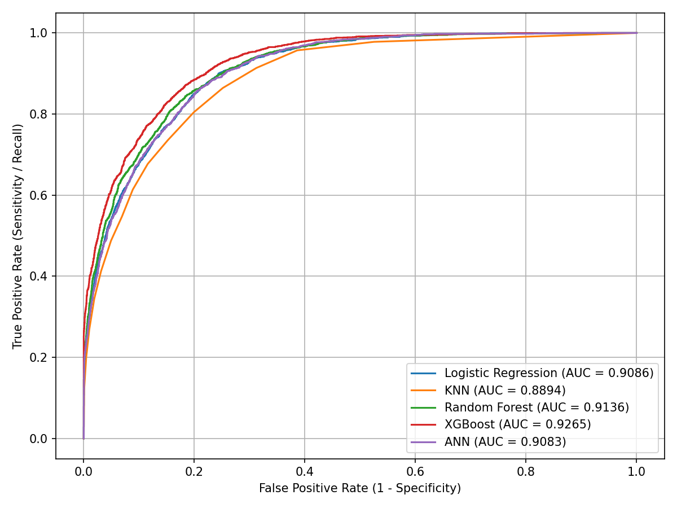
Figure 8: ROC Curves

Precision- Recall Curve

Figure 9 depicts PR Curves of the models and it shows XGBost has the highest average precision which is very good in finding high income earners.

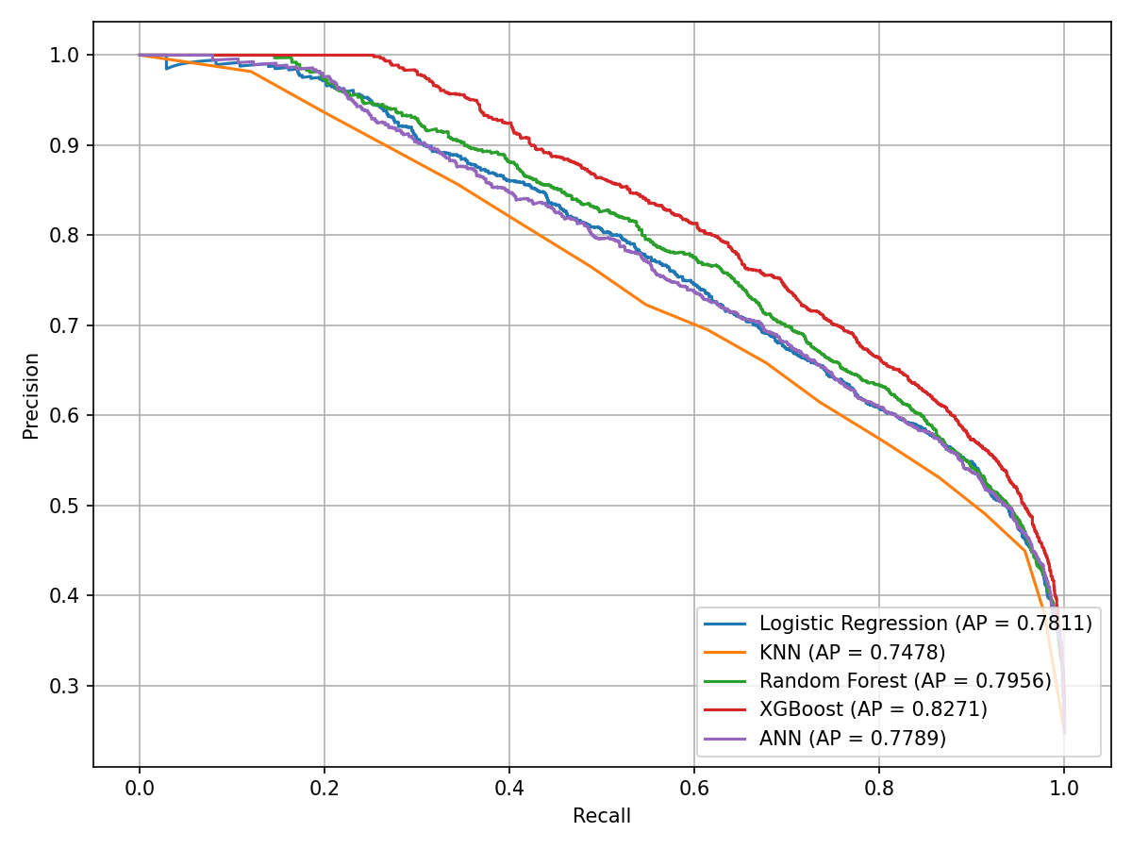
Figure 8: PR Curves

XGBoost Error Analysis
We analyzed the errors (False Positive and False Negative) of the best performing model which is XGBoost across Sex and Educational Group which had the top two highest correlation coefficient above.
False Positive (FP) : Predict > 50K(High Income) but in real its < 50K( Low Income)
False Negative (FN): Predict <50K(Low Income) but in real its >50K(High Income)

Sex | Total | Errors | Error Rate | FP | FN
Male | 6093 | 1249 | 20.50 | 1006 | 243
Female | 2942 | 236 | 8.02 | 151 | 85
Table 4: Error Profile By Sex
Table 4 depicts Gender based analysis and we can that model is more prone to False positive on Males, predicting them high earners more often than they really are.
Education Group | Total | Errors | Error Rate | FP | FN
Advanced | 768 | 155 | 20.18 | 135 | 20
Bachelors | 1512 | 302 | 19.97 | 238 | 64
College | 2711 | 484 | 17.85 | 400 | 84
High-School | 2915 | 474 | 16.26 | 364 | 110
Low | 1129 | 70 | 6.20 | 20 | 50
Table 5: Error Profile By Education Group
According to Table 5 above its noticeable that Advanced and Bachelors degree has high eror rate (~20%). Predicting high income due to has degree but actual income is lower.
Low education group ha very low error rate (6.20%).

Task 6: Cloud Deployment and MLOps Strategy

Model Packaging and Containerization
To ensure runtime reproducibility, portability(local, AWS ECS), scalability and resolving easy deployment without worrying about dependency versions the machine learning model pipeline is packaged into an standalone environment using docker. Figure 9 shows docker file content.

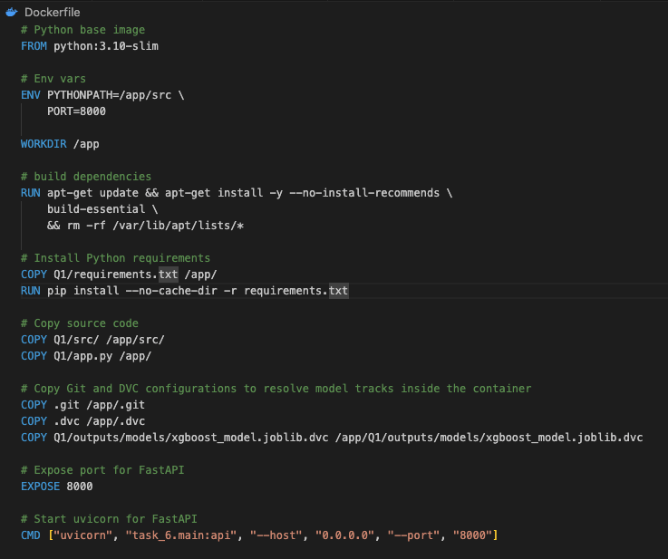
Figure 9: Dockerfile

API Development
FastAPI were used to implement Restful API because it inherantly support asynchronous request handling and automatic swagger documentation. The request validation were done with Pydantic. Here api handles the feature engineering dynamically at server side. Figure 10, 11 amd 12 depicts the python codes for this part.
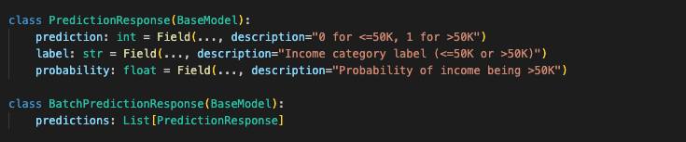
Figure 10: Request Validation
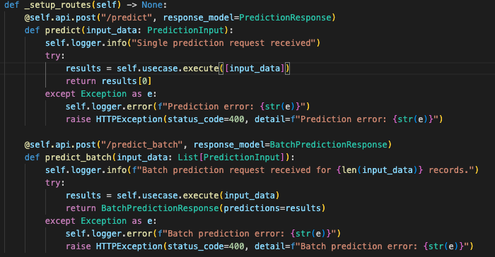
Figure 11: API Endpoints for realk time and batch prediction
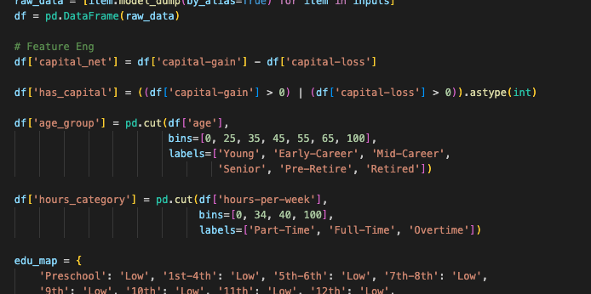
Figure 12: Feature engineering for the input payload

Prediction Types
- Real Time: This is ideal for the places where they needs smooth user experience like web forms and loan application portals.
- Batch: For usecases where it does not need realtime for example scoring a database of large number of users overnight for target mailings.API Tests
We have implemented a test suites for api validations whech is meant to local and CI level execution.
Currently It has Following Verification cases and figure 13 depicts the test cases.
- Single Prediction (Low Income): Young person with with no capital gains
- Single Prediction (High Income): Professional with good capital gain and Master level education
- Batch Prediction: Send profiels as batch array for verification

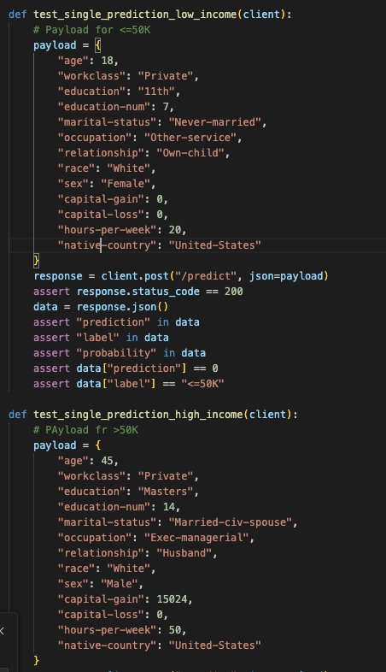
Figure 13: Test Suite

Clean Architecture & Dependency Injection Implementation
To ensure modularity, separation of concerns, and ease of testing, the API layer is structured according to Clean Architecture patterns, and Dependency Injection (DI) framework were used for handling dependencies which support scalable test case writing without worrying about server connections.
- Layer Separation:
  - Domain Model: Validation and data transfer objects (PredictionInput, PredictionResponse, and BatchPredictionResponse) at domain/model/models.py
  - Domain Interface: Declares the interface for model serving (IApiServer)
  - Domain Use Case: Houses the Core Business logic: IncomePredictionUseCase depicted in figure 14 below.
    - Pydantic validation entities
    - Create the Pandas inputs
    - Feature engineering logic
    - Invokes the XGBoost
  - Data Layer: Implements the concrete API routing and controller logic by satisfying the IApiServer interface (ApiServerImp) Figure 15 below depcits ApiServer implmentation.

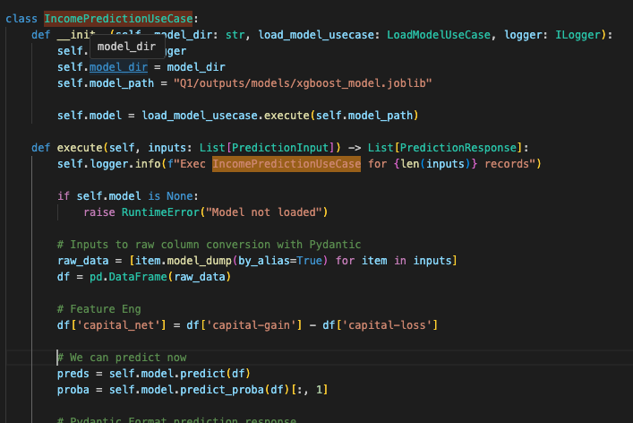
Figure 14: IncomePredictionUseCase
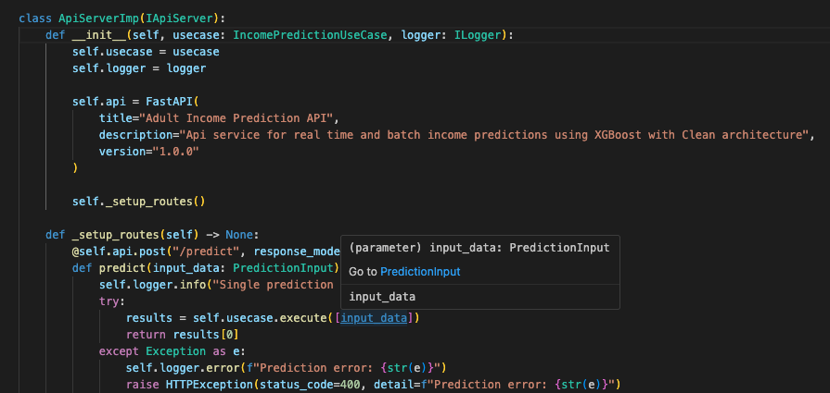
Figure 15: Api Server Implementation

- Dependency Injection:
  - Configurations and register dependencies as depicted in figure 16
  - They can by dynamically resolved and injected
  - Scope were defined as they requires like singleton or factory
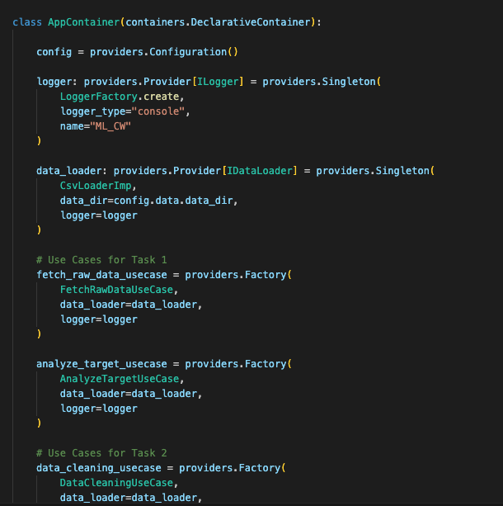
Figure 16: Dependency Injection Container

MLOps Pipeline and Automation

Data and Model Versioning, Publishing and Fetching
- DVC (Data Version Control): Git can handle codes fine but it breaks for large files. Here ML model binaries (xgboost_model.joblib) should not tracked by Git. Here we use DVC to track these binaries.
- GitOps Tracking Protocol:
  - Model files are git ignored
  - DVC tracks the binary and generates a pointer file which is a unique hash representing that speciffic version of model file as depicted in figure 17
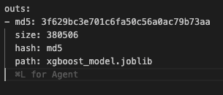
Figure 17: Pointer file(xgboost_model.joblib.dvc) created for XGBost classifier model
  - The .dvc file added to git where it can find from the dvc repositary later
- DVC Storage: This is the model storage allowing pushing and fetching of the model using the registred pointer file above. Here we use a local directory as dvc storage but when it goes to Cloud environment we can use a cloud sorage like Amazon S3.
- Programmatic Model Publishing Use Case: Clean architecture use case (PublishModelUseCase) under task_4 for model tracking. It adds the model to DVCand pushes the binary artifact to the remote storage. Figure 18 depctis the logic written in python.
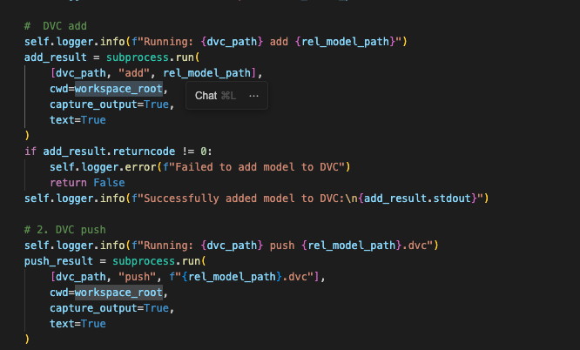
Figure 18: Publishing model to defined storage
- Fetching with DVC Apo
We load DVC pointed model using DVC python api. Here we have a LoadModelFromDvcUseCase which loads the mode from DVC storage as depicted in figure 18 below. This gives following advantages
    - Keep the docker image smaller. Pullying model dynamicall at app start than putting into docker image.
    - Model version control, when we open the model we can specify git tag which serve as the model version in dvc repo as depcited in Figure 19 and bbelow.
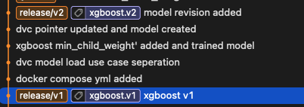
Figure 19a : Git Tag for model versioning
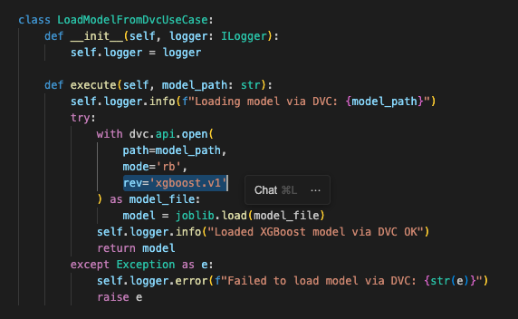
Figure 19b : Load model from DVC storage specifying git tag as the version

Continuous Integration and Continuous Deployment (CI/CD)
We use Buildkite for CI/CD workflows. Figure 20 depicts buildkite steps configuration yaml.
- Continuous Integration: For every Pull Request to git, buildkite triggers the static and unit tests step
- Continuous Deployment: Once the testing step passes buildkite executes the build step. Maintain release branch filterting to execute these stsps.
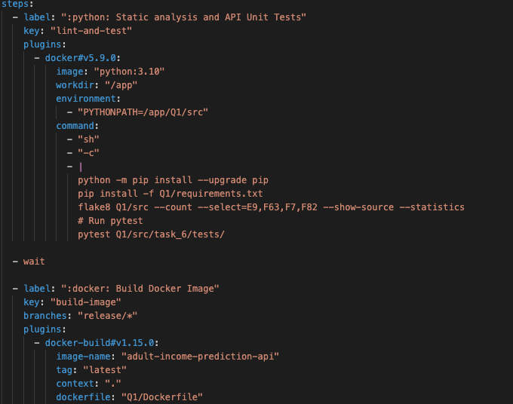
Figure 20 : Buildkite Steps

Docker Compose – Containerization
We define a local docker environment using docker compose yml as depcited in figure 21. Here we mount he locally hosted remote storage for data version control. Because DVC api can access model cached files for get them inside docker.
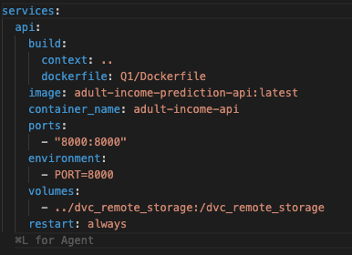
Figure 21: docker-compose yml

Q2 : Advanced Time Series Forecasting

Dataset Understanding and Literature Review
BTC-USD Cryptocurrency Dataset
- Data Source is Yahoo Finance (yfinance API)
- Daily Frequency
- 2372 Rows of daily closing price, high, low, open and trading volume

Literature Review
- Machine learning model for Bitcoin exchange rate prediction using economic and technology determinants [6]
Source: International Journal of Forecasting
Summary
Explored Bitcoin forecasting using ARIMA and deep recurrent neural networks (RNN/LSTM). They demonstrated ARIMAis efficient for linear changes but struggeles with extreme vlatality.
- Evaluation of Tree-Based Ensemble Machine Learning Models in Predicting Stock Price Direction of Movement [7]
Source: Journal of information science and technology, data, knowledge, and communication
Summary
Evaluated tree-based ensemble methods (XGBoost) for financial assets. XGBoost is flexible and robust to outliers. Its limited in extrapolating beyond the range of prices observed during training.
- A hybrid volatility forecasting framework integrating GARCH, artificial neural network, technical analysis, and principal components analysis [8]
Source: Expert Systems with Applications Journal
Summary
Proposed a hybrid GARCH+LSTM model. They were used this to prove hybrid statistical and neural models outperforms standalone models.

Model Selection Driven Factors
Cryptocurrency markets are characterized by
    - Non-stationarity : Statistical properties like mean price and variance are constantly shifting, what worked yesterday many not work today.
    - Extreme Volatalitry: Price changes in massive and unpredictable drifts over very short periods
    - Regime Shifts: Market can instatly move from steady upward trend to high-panic spike. Recently oil price hike with Iran war is an example.
Therefore we implement models from different families and evaluate those approaches.
- ARIMA : This is a Statistical model which captures linear autoregressive and moving averages in series
- XGBoost : This is a Machine Learning model leverages a gradient boosting tree structure.
- GARCH : A statistical and econometric model to measure and track market risk to capture volatility.

Time Series Exploration and Preprocessing

Preprocessing and Feature Engineering
Thansform raw market data values to structures and model friendly inputs. Figure 2.1 and 2.2 depicts the cleaning and cleaned data set respectively.
- Remove unnesssary columns like Source
- Standardizing key column mappings
- Enforce Numeric and DateTime types
- Eliminate missing
- Negate anomalies like like negative values
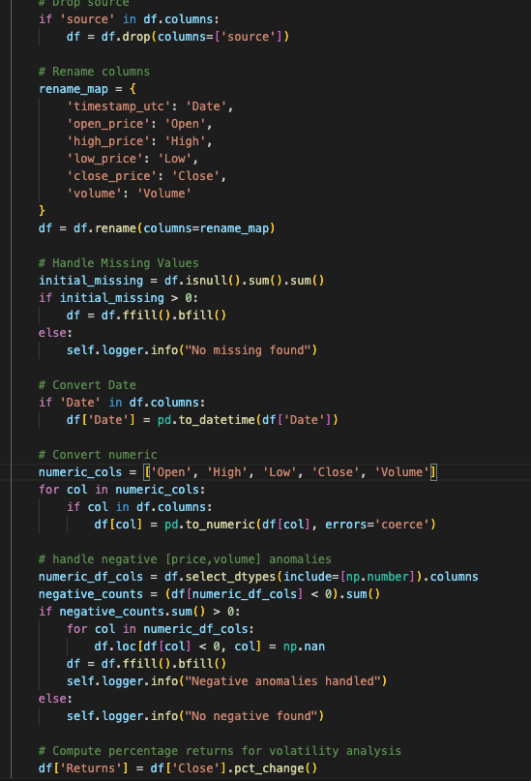
Figure 2.1: Cleaning

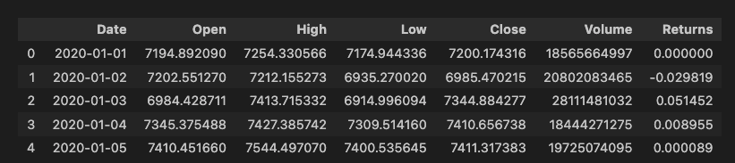
Figure 2.2: Cleaned dataset
Feature Engineering
  - Calendar Features
With the possibility of handing seasonal behaviour but (unlikely associate with crypto trading except weekend trends due to clousure of finacial institutes) we added calendar features.
  - Lag Features
This gives the model a memory. 1: Previos day, 2: 2 days ago. And also it helps to identify cyclic patterns. 7: Weekly patterns, 30: Mothly patterns

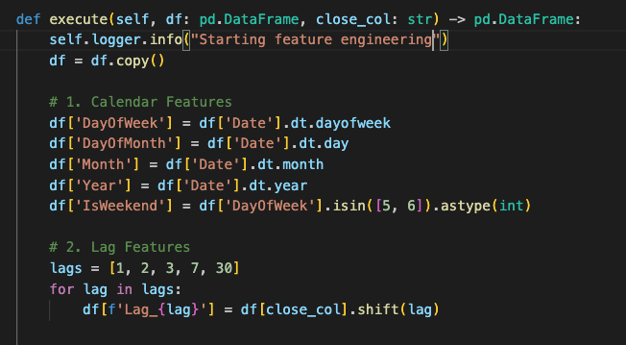
Figure 2.2: Feature Engineering

Visualizations
Historical Price Plot
Figure 2.3 depicts BTC historial closing price chart. Bitcoin's supply schedule is hardcoded to cut the mining suppy in half nearly every four years. Historical values depicts exactly same as depicted in figure 2.3 which has occurred in early 2024. This can be identified as macro cycles which is predictable.
Trading Volume Plot
As depicted in figure 2.4 trading volume plots volume spikes align with large price changes which showcasing the capital exchange in bull and bear market.
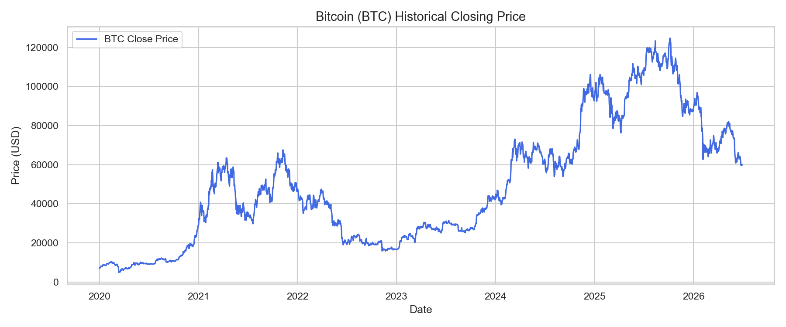
Figure 2.3: BTC historical closing price
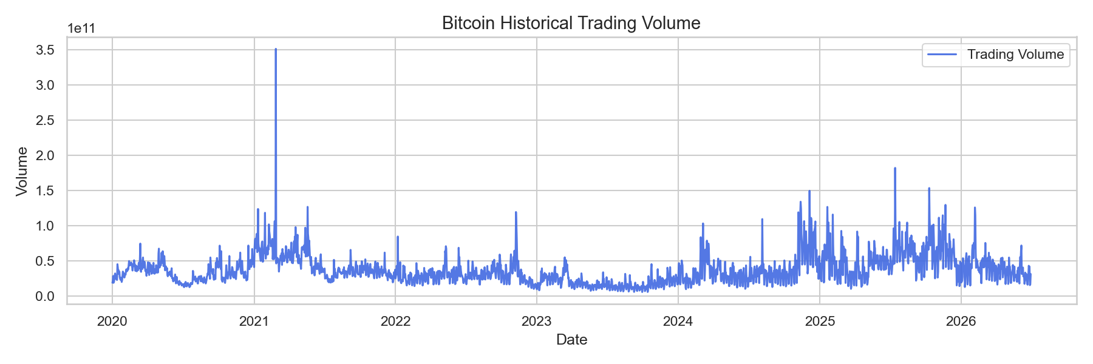
Figure 2.4: Historical Trading Volume
Returns Plot
As depicted in figure 2.5 daily percentage change returns changes around meamn zero. Even BTC changes over time and massive upward trends the percentage changes gives a different picture. On any given date the BTC might go up by 5% and down by 5%. Over a long period all these ups and downds average out ot 0%. Which makes this stationary series goes up and down around a flat baseline.
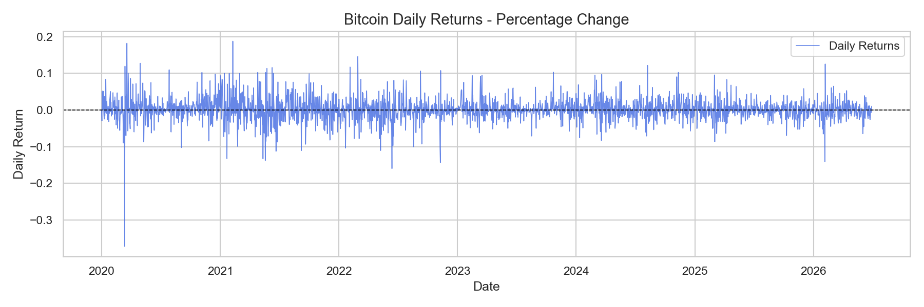
Figure 2.5: Daily Return Plot

Stationarity Tests – ADF(Augmented Dickey Fuller)
ADF evaluates whether time series has a unit root (non stationary and trending) or its stationary.
H0(Null Hypotheis): Series has a unit root, means its non-stationary. (Statistical properties like mean, variance will change over time). This is a one sided test means it simply test greater or less than baseline.
H1(Alternative): It does not have unit root
Here we test close price and daily returns (percentage change) for testing stationary and figure 2.6 depicts ADF test python code and Table 211 illutrates the result.
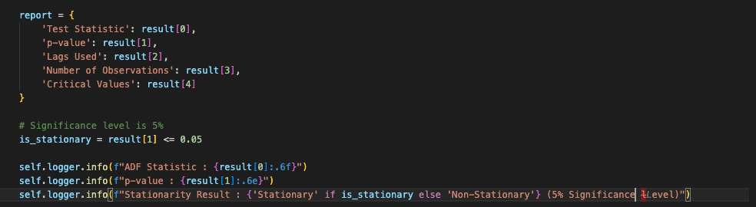
Figure 2.6: ADF testing python code

Series | P-val | Result (5% Sig Level)
Close Price | 0.5252 | Non-Stationary
Returns (Pct Change) | $$8.96×{10}^{-29}$$ | Stationary
Table 2.1: ADF Test Result
Close Price : P-Val(0.5252) > 0. 05 means it fails to reject null hypothesis
Percentage Change: P-Val($8.96×{10}^{-29}$) < 0.05 means it rejects the null hypothesis, confirms it’s stationary. So this is viable for timeseries and economical modeliing.

Model Development and Optimization

Data Splitting (Train, Validation and Test)
We use chronological splitting to avoid data leakages becauses which is a inherant issue of random splitting. For example model may train data from Wednesday and test on Tueday data and train agin from Thursday. Wenesday and Thursday already contain information on what happened on Tuesday. So the model is cheating, predicting the past using knowledge of future.
Here we use chronological split which past can only predict future not other way.
- Train Set (70%): 1,639 observations (Jan 31, 2020 to Jul 26, 2024)
- Validation Set (15%): 351 observations (Jul 27, 2024 to Jul 12, 2025)
- Test Set (15%): 352 observations (Jul 13, 2025 to Jun 29, 2026)

Model Implementation

ARIMA
Model Params (p, d, q)
- P(Autoregressive) : How many past days price history model should look
- D(Integration) : How many times the data needs to be differenced to make it stationary
- Q(Moving Average): Past forecast error count model should use to smoothening
Grid Search
Instead guessing which valeus for p,d,q are the best, define a grid of possibilities. And it builds the grid of every possible combination.
P = [0, 1, 2]
d = [1]
q = [0, 1, 2]
Here we omit seasonal orders param because bitcoin trades 24 x7 and not much deals with fixed calendar based seasonal cycles. With setting d = 1, the model operates as stationary ARMA (2, 2) on the first differenced absolute price changes of bitcoin.
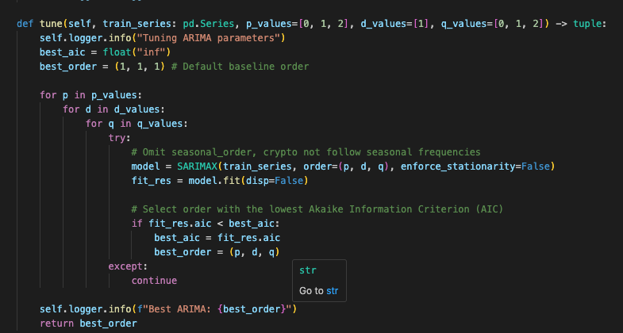
Figure 2.7: ARIMA model implementation

XGBoost
Here the hyperparameters optimized with grid search to minimize RMSE(Root Mean Squared Error). And it gave optimized params as n_estimators: 200, max_depth: 3, and learning_rate: 0.03. Data leakages were prevented by enforcing exclusion of raw price variables(Open, High, Low, Adj Close) and target returns. This ensures model trains on structural indicators and calendar features.
Concerns
Open, High, Low, and Close are highly correlated, if we included them to XGBoost it could bypass engineered feature completely. It may simply look at High or Open value to predict Close calue.
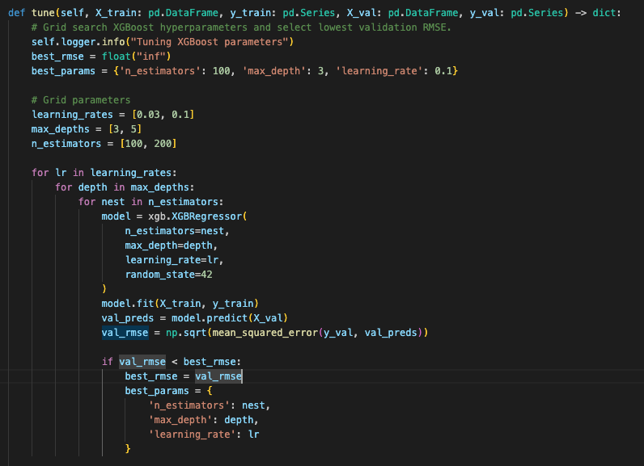
Figure 2.8: XGBoost model implementation

Model Forecasting Comparison
Following matrix were used for evaluation and results are depicted in Table 2.2
- Mean Absolute Error (MAE)
- Root Mean Sqaured Error (RMSE)
- Mean Absolute Percentage Error (MAPE)
Model | MAE | RMSE | MAPE
ARIMA | 1580.63 | 3370.51 | 1.77%
XGBoost | 23060.47 | 29707.12 | 22.23%
Table 2.2: Evalaution Results of Models
Here ARIMA significantly outperform XGBoost with MAPE with just 1.77% compared to XGBoost 22.23%
XGBoost has high MAE of ~23000 and RMSE of ~30000. This indicate that it has major directional or scaling shift on the test set.
During training raw prices were entirely removed and XGBoost totally predicts the values from calendar features. Without histroical price fed into XGBoost may lacks the absolute baseline.
Model prediction on test set which depicts in figure 2.9 clearly indicate above behaviour noticed in matrix that ARIMA clearly outperforms XGBoost in test set.
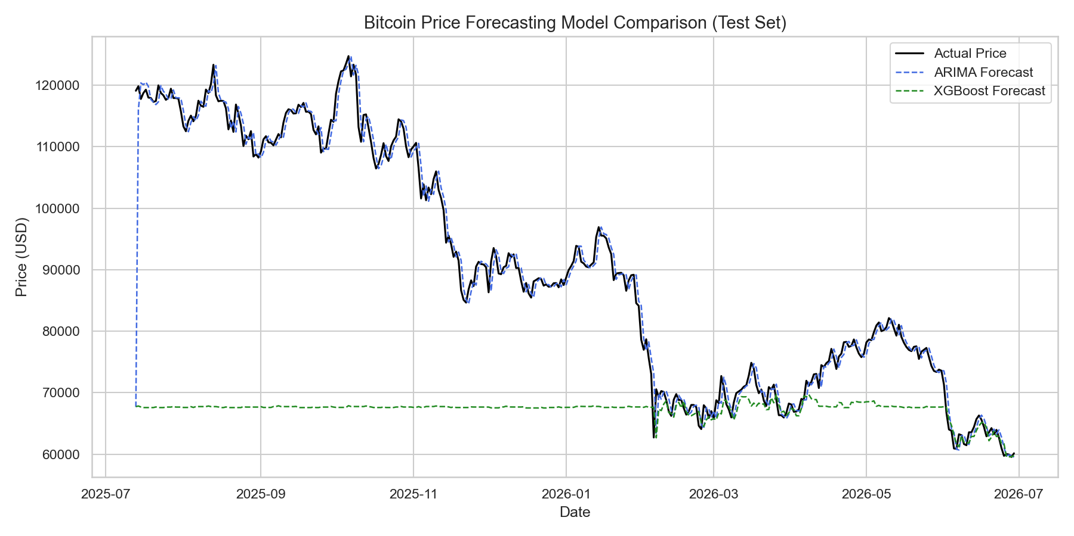
Figure 2.9: Test set model forecasting plots

Volatility Modeling using GARCH (Generalized Autoregressive Conditional Heteroskedasticity)

Garch models are exclusively to model and forecase volatality. Below are few concerns with GARCH.
Conditional
Volatality today depends on past information
Heteroskedasticity (Changing variance)
Standard statistical models assumes the market risk profile is same. But changing variance here implies that it is not. The spread of the data(vairance) is constantly changing.
ARCH Effect
This addresses volatality clustering. Current variance is directly related on immediate past events. The visible market outcome is volatality clustering.
- High variance Condition
Recently expereince market shock leads to a cluster of large price mevement
- Low Variance Condition
Recently it was calm resulting a cluster of small price movement
Due to the above factors in production grade GARCH is not used to predict price direction. Intead it paired with directional models to assess the risk factors.
For an example if ARIMA predict price increase, we can use GARCH to forecast volatality. This would help traders to reduce trade size and protect the capital.

Analyze the Time Series for changing variance
As depicted on figure 2.10 we run ARCH-LM test on returns mean to find the p-value assuming the significance level is 0.05.
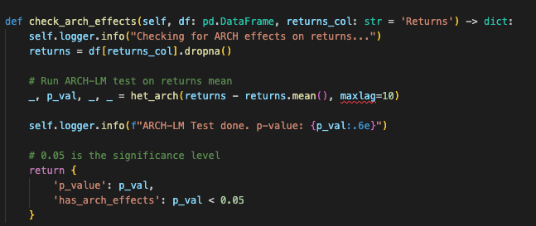
Figure 2.10: ARCH effect testing

Here we got significantly low p-value 1.981030 x 10⁻¹⁸ which is below out significance level(0.05). So we can reject null hypothesis of constant variance.

This proves ARCH effect and volatality clutering present in the BTC dataset.

Implement the GARCH Model
Here we use GARCH(1,1), p = 1, q = 1
p = Measures impact of recent market shocks on current volatality
q = Persistance of historical volatality over time
p = 1, q = 1, looking 1 step back for both market shock and historical volatality
Figure 2.11 depicts GARCH model (1,1) implementation.
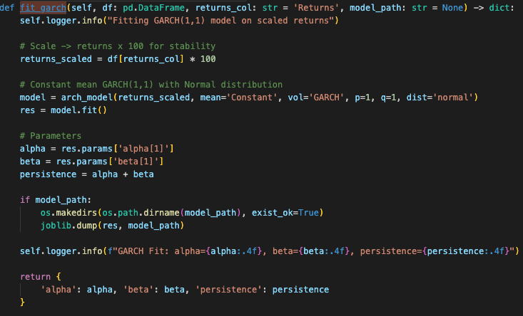
Figure 2.11: GARCH Implementation
Alpha | 0.0957
Beta | 0.8787
Persistance (Alpha + Beta) | 0.9744
Table 2.3: GARCH Parameters
ARCH Coeeficient(Alpha)
Measures the immediate impact of yesterday market shock. The value 0.096 satisfies non negative condition. Model is sensitive to short term price shocks.
GARCH Coefficent (Beta)
This measures the impact of historical volatality. Beta is 0.8787 wich is significantly larger than Alpha variance much depends on long term swings rather than short term.
Volatality Persistance
This is 0.9744 which is closer to 1, this means if volatality shock enters it stays longer and decays at very slow rate.

Model Comparison, Insights, and Critical Reflection
We already compared ARIMA and XGBoost comparison in above table 2.2.

Critical Reflections
XGBoost failt to comply on Test data set and predicted flat values.
We splits the dataset and assigned 70% for training. But if we refer to the figure 2.3 above which reflects the bitcoin historical data, starting later 2024 bitcoin reached record high which are mostly fits in the test dataset (30%). Trees cannot extrapolate predictions outside the range of target labels observed in training dataset. That is the reason for flat values capped near training maximum which is exactly what addresses in the Ernest et al[7].

Question 3: Optimization using Genetic Algorithms

Problem Definition and Literature Review
Project Portfolio Selection (Resource Allocation) was selected as our optimization problem. Here need to select optimal subset of projects from pool of avialable projects to maximize the profit with considering capital budget constraints, constraints with avialable developer hours and other logical constraints.

Resource Constraints : Budget Limit and Developer Hours

Logical Constraints :
    - Mutual Exclusion : Certain projects cannot picked together
    - Dependency : Some projects depends on completion of another

Mathematical Formulation
Here we need to Pick N number of projects that maximises the profit.
Objective Function
$$Max \sum_{i=1}^{N}{{Pr}_{i }} . {BD}_{i}$$

$$\sum_{i=1}^{N}{C_{i }} . {BD}_{i }≤ TB$$

$$\sum_{i=1}^{N}{H_{i }} . {BD}_{i }≤ TDH$$

${Pr}_{i }$: Profit of project i
${BD}_{i }$ : Binary Decision Variable $∈(0, 1)$ of selecting the project/not
$C_{i}$ : Cost of project i
$H_{i}$ : Hours of project I required
$TB$ : Total Budget Avaialable
$TH$ : Total Developer Hours Avaialable

Literature Review
- Revisiting the Evolution of Genetic Algorithms in Scheduling [9]
Source: Applied Soft Computing, Elsevier
Summary
Conducted a review of nearly 1500 publications on Genetic Algorithms in scheduling. The study showed that GA remains one of the most widely used optimization techniques due to its flexibility and effectiveness.
- Matheuristics: Survey and Synthesis [10]
Source: International Transactions in Operational Research
Summary
Heuristic search and metaheuristics are optimization approaches and here they conducted a study of using Mixed Integer Programming (MIP) with hose techniques. They found that mathematical optimization with heuristic search increase computational efficiency of the solution.
- A Didactic Review on Genetic Algorithms for Industrial Planning and Scheduling Problems [11]
Source: IFAC-PapersOnLine, Elsevier
Summary
Study of using GA for solving industrial and shedulting problems. They found that GA provides high quality near optimal solutions for hard optimization problems while maintaining reasonable computational time.

Slecting GA and MIP

Mixed Integer Programming (MIP)
This is mathematically optimal programming solution to slicing the search space using branch and cut method to make the best possible decision. The “Mixed” part here meant to be handle two distinct types of variables.
- Integer/Binary varaibles : This is for problems that cannot be devided into fractions. For example the projet selection above is select or not. We cannot execute the project partially
- Continous variables : Numbers may have fraction values. For example the problems like 1.5 devleoper hours if applciable.

The above objective function we have only one decision variable and they multiply by known constant, its linear programming problem we are tryingto address. So it’s specialized in linear models we can call it Mixed Integer Linear Programming.

Genetic Algorithm (GA)
For simple use cases MIP normally superior because, they execute fast and guarantees we found best possible combination. But when the problem shifts from simple use cases to more extreme complex use cases GA becomes the preferred choice. Following are some cases where GA becomes the superior choice.
  - Massive problem Size: Eg: 100,000 projects, number of combinations may not be possible for MIP to handle
  - Non-Linear variables: Eg: Profile = Project 1^ 2, MIP may fail here, GA do not care linearity
  - Complex Time-sequence dependencies: Eg: due to a holiday season in 2 months developer hours availability significantly reduce.

Data Preparation and Problem Analysis
We have generated dataset of size 30 (N = 30) projects as sample shown in figure 3.1 below.

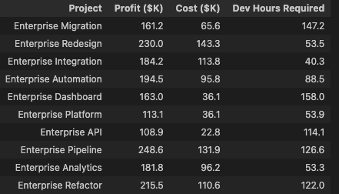
Figure 3.1: Projects
Total Cost for 30 projects: $2226K
Total Developer Hours Required: 2566

We set 50% as the capacity threshold
Total Budget: $1113K
Total Developer Hours Limit: 1283

Mutual Exclusion: From below pairs only 1 project can be selected

- P3 (Enterprise Automation), P7 (Enterprise Pipeline)
- P12 (Enterprise Testing), P18 (Enterprise Optimizer)
- P22 (Cloud Integration), P27 (Cloud Pipeline)

Dependency Projects: Below shows interdependent projects.

- P8 (Enterprise Analytics) requires P2 (Enterprise Integration)
- P15 (Enterprise Portal requires P10 (Enterprise Rewrite)
- P25 (Cloud Platform) requires P20 (Cloud Migration)

Figure 3.2 illustrates the data preparation step implementation in python code from use case “DataPreparationUseCase”

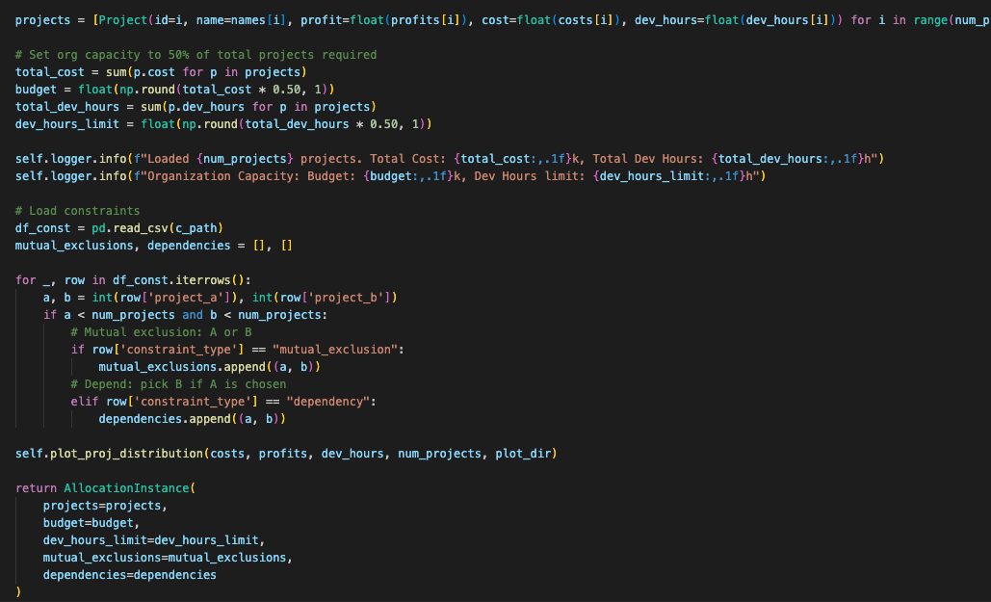

Figure 3.2 Data Preparation implementation

Figure 3.3 illustrates project distribution plots which visualize the cost vs profit tradeoff. The size of the points represents the required developer dev hours.

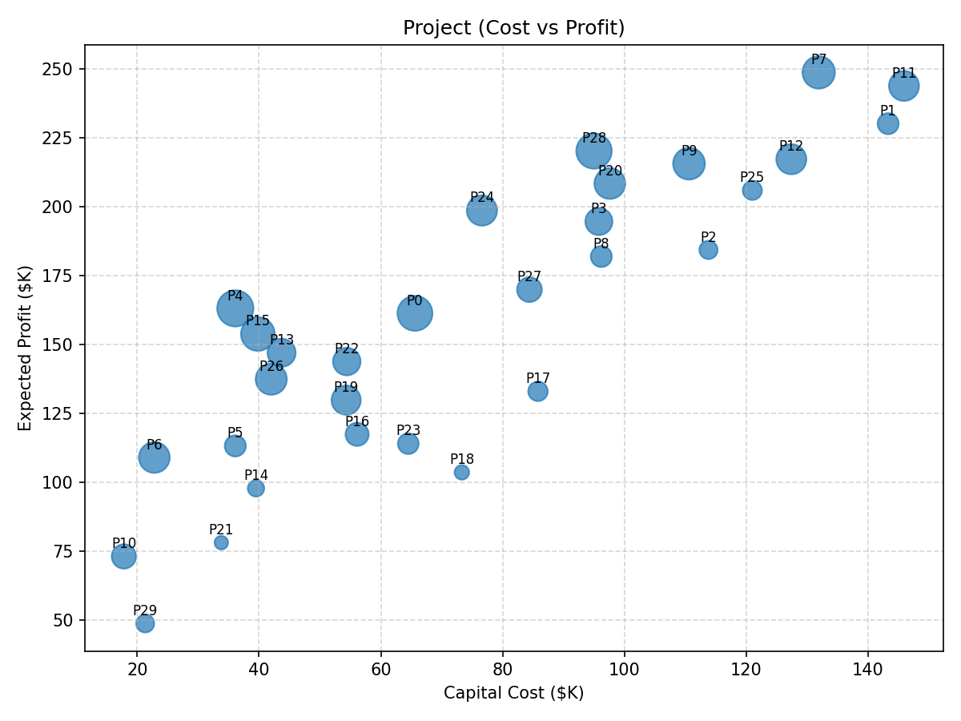
Figure 3.3: Project Distribution Plot

From the figure 3.3 plot, we can say best projects sit in the top-left region where high profit and low cost and we need to consider about smaller point size which is low developer hours required.

Best Candidates

  - P4, P15, P13 and P26: High profit for low cost
  - P6: Decent profit for very low cost

High Profit but Cost or Labor requirement is intensive

  - P7, P11, P1: Highest Profitable projects but requires heavy capital cost to incur
  - P28: Very good profit but large point which means high developer hours consumption

Projects to Avoid

  - P18, P17: Locates in the bottom-right region, lower profit and high capital cost
  - P29: Very low profit

Complexity Analysis
The size of the search space for 30 projects is 2³⁰ which is nearly 1.07 x 10⁹ possible combinations. Brute force evaluation of over 1 billion combinations is computationally very expensive which requires better solutions like GA and MIP.

Genetic Algorithm Design and Implementation

Chromosome representation and Popualtion Initalization Strategy
Becase we have 30 projects we need to created a binary array of size 30 as the representaion of a chromasome. This is same as the feature select/not usecase we use binary represenation to keep feature or drop as the chromasome. As the same in the projet selectrion usecase of ours we need to decide keep the project or not.

$$Chromasome= [1=keep the project, 0=not, …]$$

The population size and generation count are dynamically configurable to support hyperparameter tuning as depicted in figure 3.4
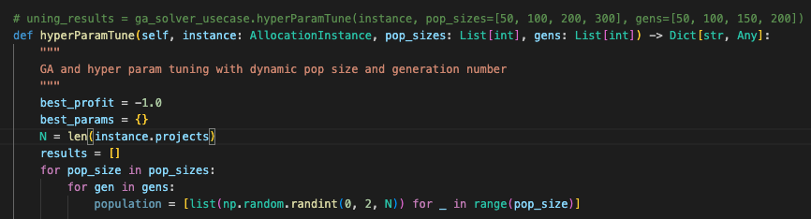
Figure 3.4 : Population creation

Fitness Function
We have fitness function implemented with score based on total expected profit. For the fitness scores we assign low and high penalties for vialations.
Low Penalties : Vialations of Budget and Labour constraints assign low penalties.
High Penalties : Logical constraint vialation like mutual exclusion and dependency we assign high penalty which brings negative scores. Here we have picked 500 which exceed maximum profit from the 30 pool projects.
Finally fitness value calculated as below function and logics depicted in figure 3.5 below.
$$Fitness Value=Total Profit-Penalty$$

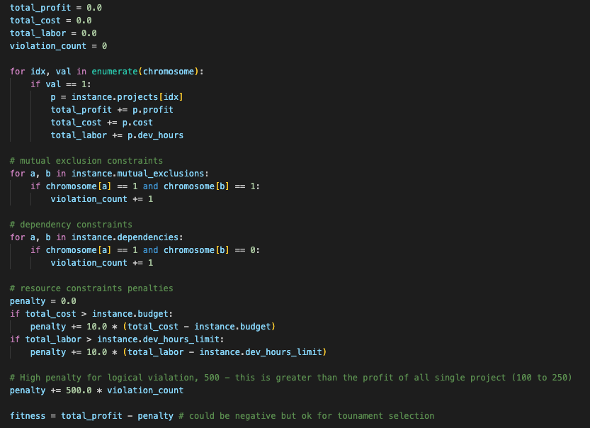
Figure 3.5: Fitness function for GA

Selection Method (Tournament selection)
This is used to select the fittest candidate as a parent from the current population to crossover to produce childrens for next generation as depciuted in figure 3.6 below.
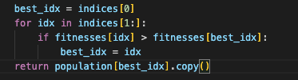
Figure 3.6: Tounament selection implementation

Crossover Operators
This is combining two parent chromasomes to create a child. The idea behind is child inherits the best traits. Here we apply uniform cross over mechanism. Its like coin is tossed and determines whether the parent 1 and parent 2 properties are swapped and create and update child 1 and child 2 properties which is the cross over. The logic is depicted in figure 3.7 below.
Additionally we do not cross over 100% instead we keep a cross over rate to 80% which make sure there is a 20% chance that parent pass traits starigh to the next generation without being traits swapped. This make sure good solutions from tournament selection survives intact into the next generation witohut breakdown in every generation. If 100% crossover we cannot make sure this would preserve.
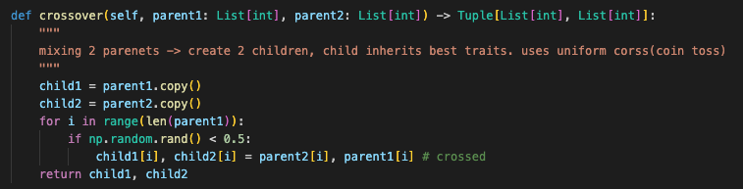

Figure 3.7 : Unform Crossover

Mutation Operation
Random Small changes introduced to prevent algorithm stuck in a local trap. Logic is depicted in figure 3.8 below.
$$Before=\left[0, 1, 0…\right]$$
$$After=[0, 0, 1… ]$$
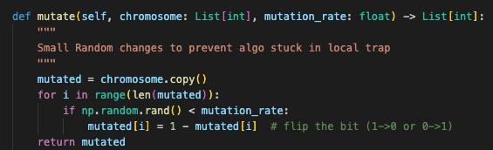

Figure 3.8: Random mutation with bit flipping

Elitism

This is a process of automatically copying the best chromosomes directly into the next generation without crossover or mutation. Without Elitism we would notice a oscilation as depicted in figure 3.9. With addressing elitism of selecting the best score for next generation its continously improved and stabalize as depicted in figure 3.10 below. Figure 3.11 below depicts elitism implementation.
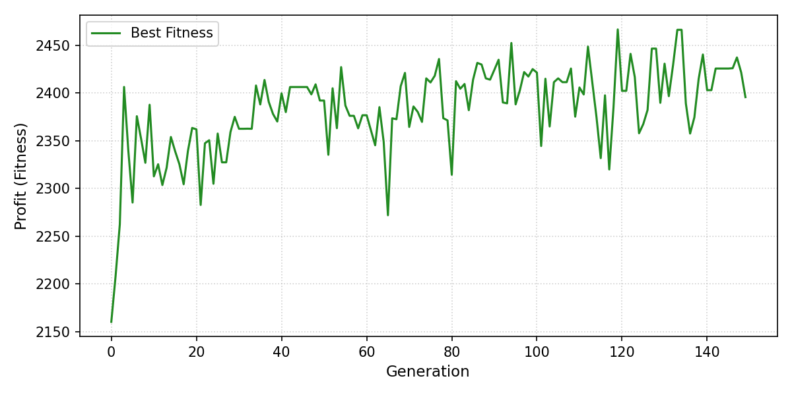
Figure 3.9: GA Best Score Curve without Elitism (Up and Down)

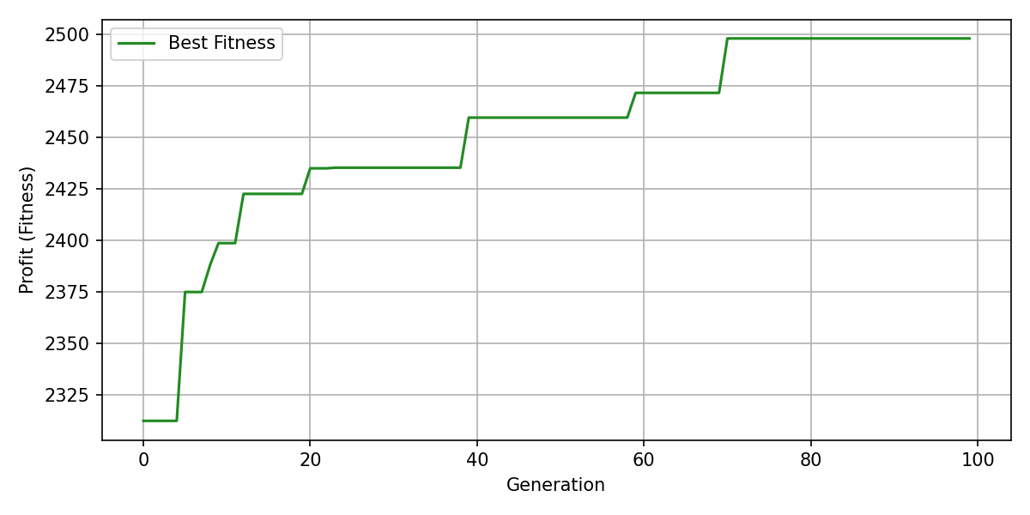
Figure 3.10: GA Best Score Curve with Elitism
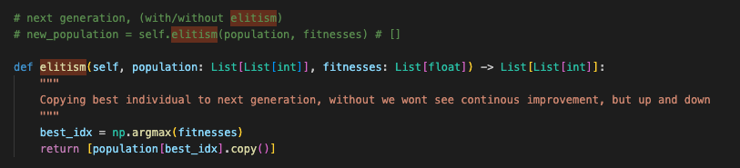
Figure 3.11 : Elitism implementation

Hyperparameter tuning
The main parameters we use for GA here are population size and generations size. To identify the best parameters for 30 project portfolios, we used the param value combination as

Population Size $∈\{50, 100, 200, 300\}$

Generations $∈\{50, 100, 150, 200\}$
After searching over the grid space depicted in table 3.1 below, the best parameters found that maximized the profit is
Population Size: 50
Generations: 100
Profit: $2497K
 | Generation 50 | Generation 100 | Generation 150 | Generation 200
Population 50 | (50, 50) | (50, 100) | (50, 150) | (50, 200)
Population 100 | (100, 50) | (100, 100) | (100, 150) | (100, 200)
Population 150 | (150, 50) | (150, 100) | (150, 150) | (150, 200)
Population 200 | (200, 50) | (200, 100) | (200, 150) | (200, 200)
Table 3.1: Grid Space for population and Generation
Results
From the 30 projects portfolio we were able to pick the optimum portfolio as illustrated in figure 3.12. The result is 16 projects have been selected and 14 got rejected with maximum profit gain with maximum resource allocation as depicted in table 3.2 below.
Maximum Profit | $2497.2
Cost | Spent $1108 from Budget $1113.2K
Dev Hours | Used 1275h from 1283.3h available
Table 3.2: BILP execution result for project 30

Figure 3.12 below depicts the optimum solution picked by GA. For 30 projects portfolio it has picked 15 projects.
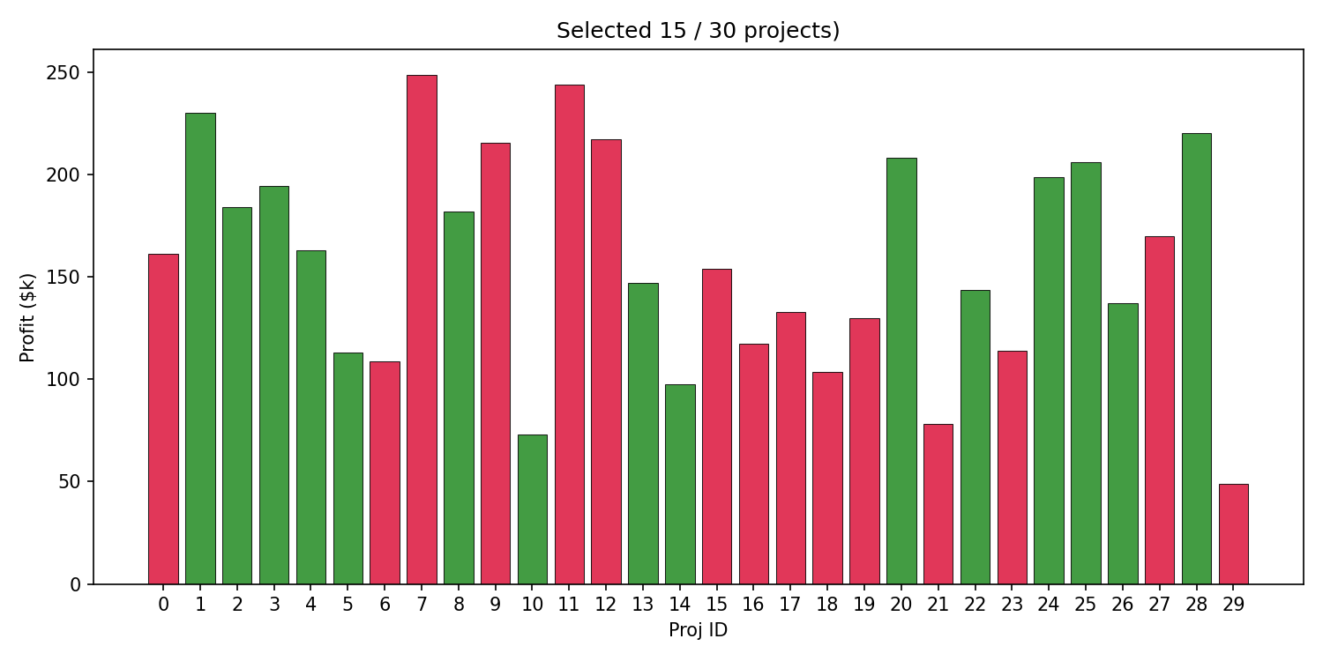
Figure 3.12: GA results of portfolio selection (Green – selected, Red, Rejected)

Mixed Integer Programming
As we addressed in the section 1 above, we are trying to address Binary Integer Linear Programming Model here where decision variable is zero or one.
Binary Decision Variable (BD)
$$BD= \left\{\begin{aligned}1 \\ 0 \end{aligned}\right.$$
1: Project I selected
0: Project I did not select

Objective Function (F)
$$Maximize \sum_{i=1}^{N}{{Pr}_{i} . {BD}_{i}}$$

${Pr}_{i}$ : Profit from project i
BD: Binary decision of project (i) (1 or 0)
Constraints
As above we have resource constraints and logical constraints.
Resource Constraints
  - Total required hours for all selected projects should be less than or equal to Total Developer Hours available
  - Total required cost for all selected projects should be less than or equal to Total Budget willing to spent
Logical Constraints
  - Mutual Exclusion, where if 2 projects conflicting only one of them could pick
  - Dependency, where selecting of a project may require another project already selected
Implement the MIP model
Figure 3.13 below illustrates our implementation of BILP using PuLP python lib. Unlike GA this guarantees to finding the single optimum project portfolio.
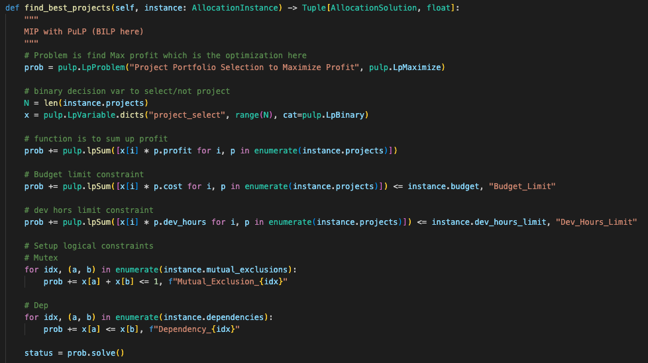
Figure 3.13: BILP implementation
Results
From the 30 projects portfolio we were able to pick the optimum portfolio as illustrated in figure 3.14 below. The result is 16 projects have been selected and 14 got rejected with maximum profit gain with maximum resource allocation as depicted in table 3.3 below.
Maximum Profit | $2511.7K
Cost | Spent $1109.2K from Budget $1113.2K
Dev Hours | Used 1281.4h from 1283.3h available
Execution Time | 0.21 seconds
Table 3.3: BILP execution result for project 30
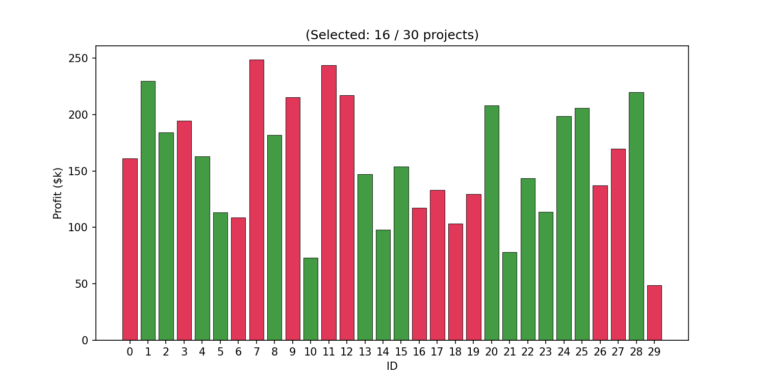
Figure 3.14 BILP(MIP) results of portfolio selection (Green – selected, Red, Rejected)

Comparative Analysis and Critical Reflection
We used project size range as [10, 20, 50, 100, 150, 300, 500, 600, 700, 800, 900, 1000]] for comparing GA and MIP. We have 30 projects data in our original data set and for additional project we create the data with random values and use the same resource and logical constraints above.

Finally, we plot the execution time against the project size as the figure 3.15 below.

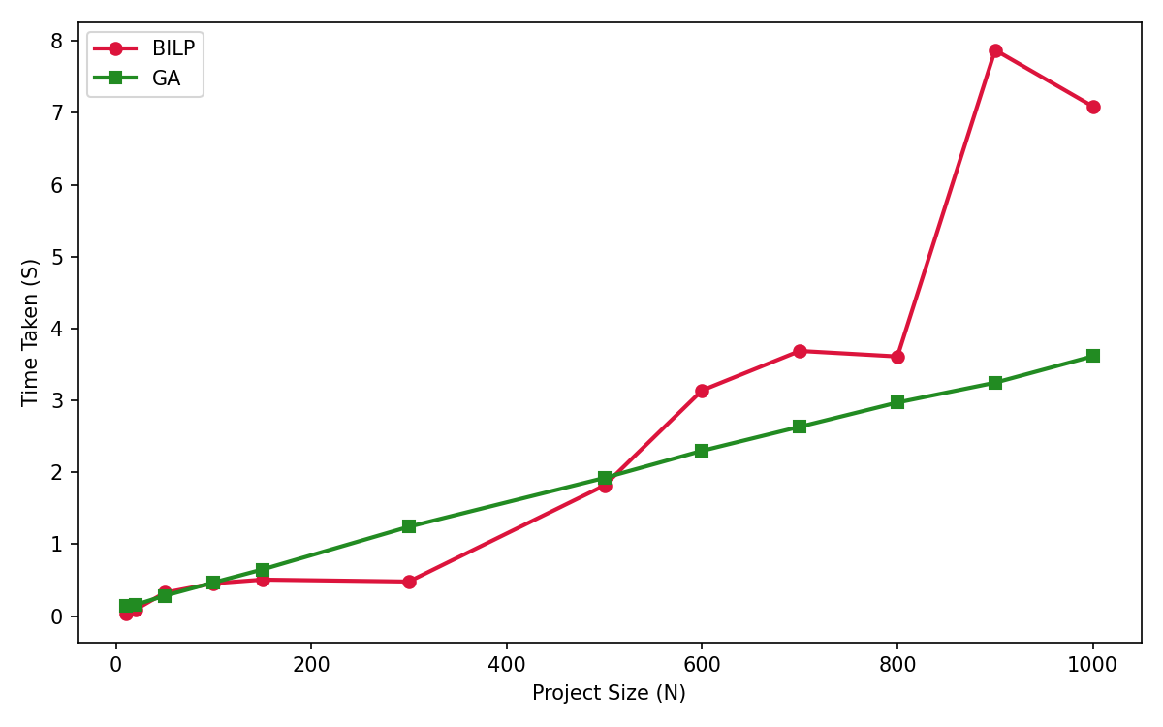
Figure 3.15: GA vs BILP/MIP (Execution time against Project size)

Comparison

Optimul Solution

 | Profit ($K) | Cost ($K) | Dev Hours | Project Count
GA | 2497 | 1108 | 1275 | 15
BILP (MIP) | 2511 | 1109 | 1281 | 16

Table 3.4: BA vs BILP optimul solution

MIP algorithm gurantees the absolute optimum but GA finds a near optimual solution. GA profit is 99.4% of BILP which is almost identical.

Computation Time
As depicted in figure 3.15 above for small project sizes (<500) BILP/MIP is faster. For larger problems MIP becomes slower due to greater level of branch nodes and GA time scales linearly. MIP time is highly volatile but GA time is prdictable due to linear scaling.

References

  - R. Kohavi, "Scaling up the accuracy of Naive-Bayes classifiers: A decision-tree hybrid," in Proceedings of the Second International Conference on Knowledge Discovery and Data Mining (KDD), Portland, OR, USA, 1996, pp. 202–207.
  - A. Chockalingam et al., "Comparative study of machine learning algorithms on census income data set," International Journal of Engineering Research and Applications (IJERA), vol. 9, no. 8, pp. 78–81, Aug. 2019.
  - M. Topiwalla, "Machine learning on UCI Adult dataset using various classifier algorithms and scaling up the accuracy using extreme gradient boosting," Technical Report, Feb. 2017. [Online]. Available: WordPress.com.
  - L. B. Sena and J. C. Machado, "Evaluation of fairness in machine learning models using the UCI Adult Dataset," in Proceedings of the Brazilian Symposium on Databases (SBBD), 2024, pp. 1–6.
  - C. Dewi, R. A. Andika, E. Haryani, D. Riantama, A. Sajid, M. M. Alam, and M. M. Su'ud, "Feature selection for financial data classification using Random Forest, Boruta, and Recursive Feature Elimination," Ingénierie des Systèmes d'Information, vol. 30, no. 8, pp. 2165–2173, Aug. 2025. doi: 10.18280/isi.300822.
  - W. Chen, H. Xu, L. Jia, and Y. Gao, "Machine learning model for Bitcoin exchange rate prediction using economic and technology determinants," International Journal of Forecasting, vol. 37, no. 1, pp. 28–43, Jan.–Mar. 2021, doi: 10.1016/j.ijforecast.2020.02.008.
  - S. Dey, Y. Roy, and S. Das, "Evaluation of tree-based ensemble machine learning models in predicting stock price direction of movement," Information, vol. 11, no. 6, p. 332, Jun. 2020. doi: 10.3390/info11060332.
  - W. Kristjanpoller and M. C. Minutolo, "A hybrid volatility forecasting framework integrating GARCH, artificial neural network, technical analysis, and principal components analysis," Expert Systems with Applications, vol. 109, pp. 1–11, Nov. 2018. doi: 10.1016/j.eswa.2018.05.011.
  - K.-C. Ying, P. Pourhejazy, and K.-Y. Chen, "Revisiting the evolution of genetic algorithms in scheduling," Applied Soft Computing, vol. 201, Art. no. 115602, Jun. 2026, doi: 10.1016/j.asoc.2026.115602.
  - M. A. Boschetti, A. N. Letchford, and V. Maniezzo, "Matheuristics: Survey and synthesis," International Transactions in Operational Research, vol. 30, no. 6, pp. 2840–2866, Nov. 2023, doi: 10.1111/itor.13301.
  - A. Neumann, A. Hajji, M. Rekik, and R. Pellerin, "A didactic review on genetic algorithms for industrial planning and scheduling problems," IFAC-PapersOnLine, vol. 55, no. 10, pp. 2593–2598, 2022, doi: 10.1016/j.ifacol.2022.10.100.

