Principles of Data Science Portfolio CW2

OPTION 1: Agentic AI Workflow for Automated Trading (Finance Domain)

Project Repository
https://github.com/deshancha/principlesofDscPortfolioWork

Project Setup
Project used Python for programming, and a virtual environment to manage dependencies.
1: Create Virtual Environment
python3 -m venv .venv
2: Activate Virtual Environment
source .venv/bin/activate
3: Install Dependencies
pip install -r requirements.txt
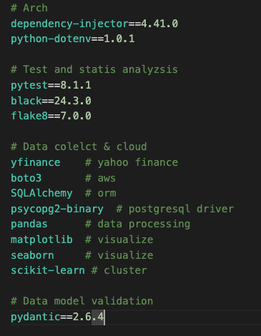
4: Environment Variables
Create a .env file at the root directory to setting up the configurations.
YAHOO_FINANCE_TICKERS="BTC-USD,ETH-USD,SOL-USD,BNB-USD,DOGE-USD"
START_DATE="2020-01-01"
END_DATE="2026-03-31"
AWS_REGION_NAME="us-east-1"
AWS_S3_BUCKET_NAME[aws-s3-bucket-name]"
AWS_RDS_TABLE_NAME="[aws-aurora-rds-table-name]"
DB_CONNECTION_STRING="mysql+pymysql://[username]:[password]@[host]:[port]/[database-name]"

Project Architecture
This project was built focusing on scalability and separation.

Clean Architecture
The code adheres to clean architecture principles and separated between domain and data layers.
domain: models, abstract managers, usecases
data: manager implementation
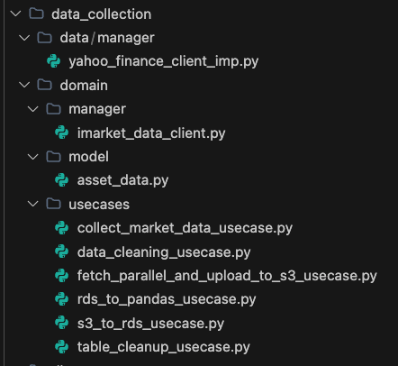

Dependency Injection
By using a dependency injector all services instantiated inside AppContainer. This ensures dependency flow decouples via interfaces. This would make the atchitecture more future proof and allow mock injection for testing.
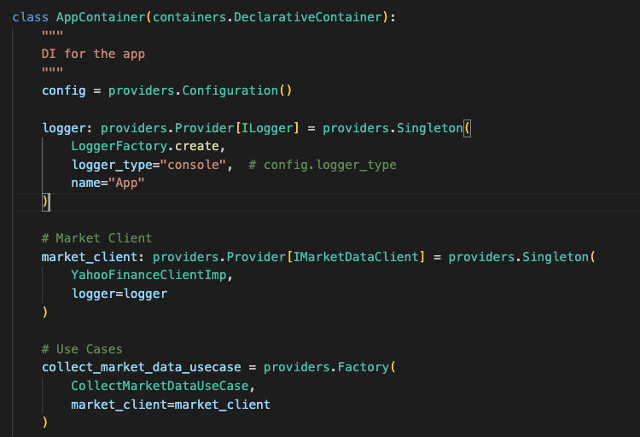

Modularized

Source is modularized for separate distinct modules.
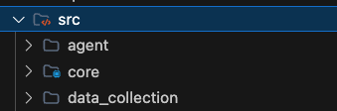
Module Root | Description
src/core | Core components like (AWS S3/RDS Managers), utilities like logger, core module formatted log strings
src/data_collection | Infrastructure layer implementing data fetching, uploading and loading with operations like below defined as usecases  - Collect yahoo finance market data  - Upload to AWS S3  - Download from AWS S3  - AWS S3 to AWS RDS  - AWS RDS to Pandas  - AWS RDS Cleanup
src/agent | Contains the agent workflow divided in to function modules as components  - CoinAnalysisModule  - MockNewsItemModule  - DecisionModule  - DecisionEvaluateModule

Threading
Pulling large different types of data sets from Yahoo Finance API and transmitting them to AWS S3 introduces delays. By using asynchronous methods increase the transmission time significantly.
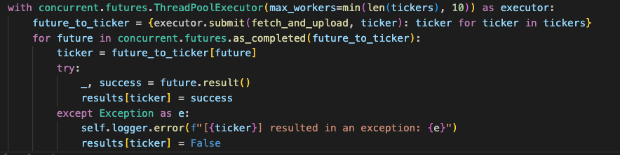

Logger
Shared Logger component for logging in the application.
This can be disabled with .env configuration
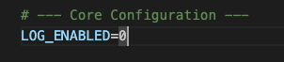

Data Collection
Related Configuration in .env
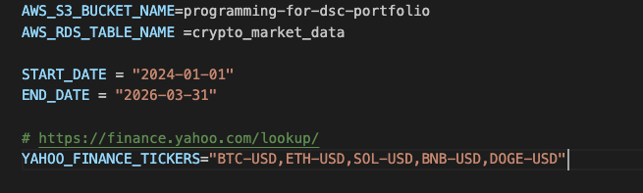

Collected following five crypto currency coins USD rates details from Yahoo finance Data
  - BitCoin - BTC
  - Ethereum - ETH
  - Solana - SOL
  - Build and Build - BNB
  - Dogecoin - DOGE
Following components has been implemented
- Download yfinance tickers configured in “YAHOO_FINANCE_TICKERS” env var between “START_DATE” and “END_DATE” and upload to AWS S3 as json
- Save all the configured tickers them inside AWS RDS table
- Load pandas dataframes from AWS RDS configured in “YAHOO_FINANCE_TICKERS”

Execution with CMD Args
python app.py [arg]
Argument | Description | Action
-1 | Drop/Cleanup Data | - Execute DataCleaningUseCase.  - Drops market data tables in RDS.
1 | YFinace Put to S3 | - Execute FetchParallelAndUploadToS3UseCase  - Fetch Yahoo Finance data from specified .env tickers asynchronously and put the raw JSON into AWS S3.
2 | S3 to RDS | - Execute S3ToRDSUseCase  - Pulls the JSON from AWS S3.  - Structures them into relational data format  - Save to AWS RDS relational database table
3 | Extract to Pandas | - Execute RDSToPandasUseCase  - Extracts market data from AWS RDS  - Load them to Pandas DataFrame

EDA - Data Cleaning
This is demonstrated in two Jupyter note book file
- eda_data_cleaning_single.ipynb
Data Clean up Step by Step for targeted Yahoo Finance Ticker
- eda_data_cleaning_all.ipynb
Execute Clean up for All configured tickers using the “data_cleaning_usecase” usecase

Steps 1: Meaningful Rename and Drop the Columns Not need
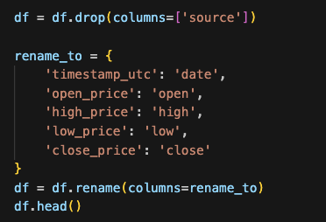

Step 2: Handle Missing Values with forward filling
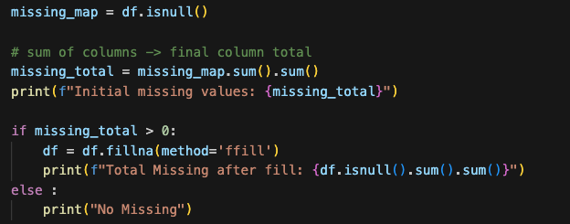
Notes : No missing values found for any coin
Step 2: Convert Data Types
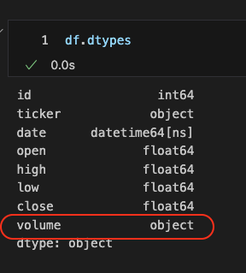
Volume column were identified as object and converted to number.
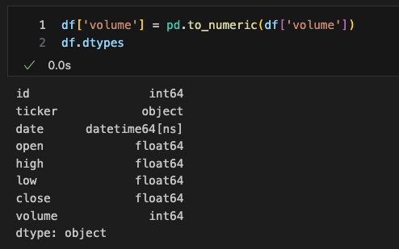
Step 4: Line Chart
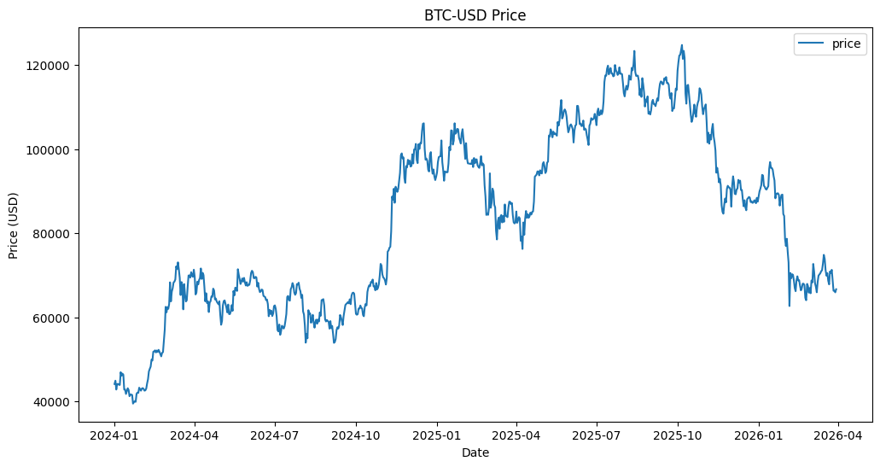

EDA – Feature Engineering and Clustering
We use trade price Percentage change day over day for clustering algorithm because of following reasons
- Crypto currency trade in different scales.
Eg: Bitcoin trads in thousands of dollars but Doge trades in smaller dollar values
- If closing price were fed to K-Means the model would be heavily biased
Eg: expensive vs cheap coins
- Daily percentage change would normalize the dataset and allows equal weight for comparison
Standard Deviation of daily close value used for acting as the risk factor.
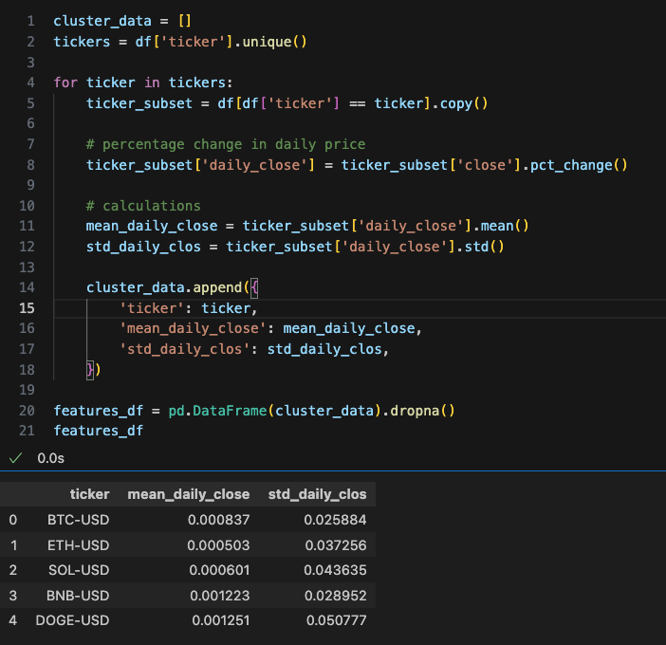

We pick K as 3 to fit into 3 clusters which possibly interpret as following types
- High Rist
- Medium Risk
- Low Risk

Result
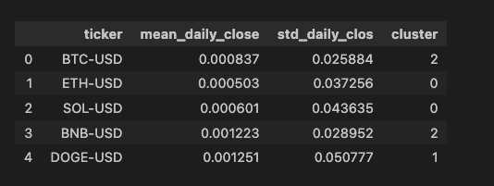

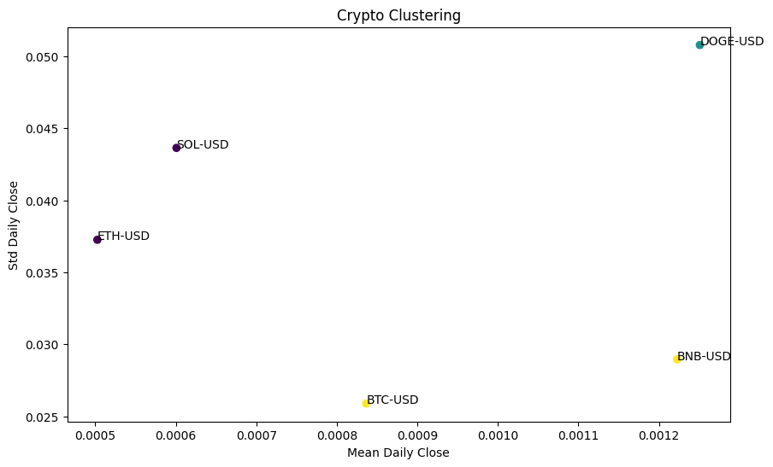

Crypto Coins Volatility
BTC – 0.025 Lowest STD Daily Close (Lowest Volatility)
BNB – 0.028 Very Low Volatility
ETH – 0.037 Moderate Volatility
SOL – 0.043 High Volatility
DOGE – 0.05 Highest Volatility

Crypto Coins Clusters
- Low Risk – BTC and BNB
- Medium Risk – ETH and SOL
- High Risk – DOGE

Trading Agent
Following components has been implemented to show case agentic AI workflow
- Coin Analysis (src/agent/domain/components/coin_analysis.py)
Based on Clustering/volatility insights above the coins were assigned to risk categories and agent returns the details
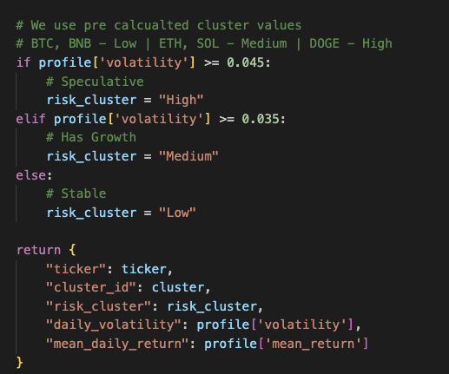

- Information Retrieval (src/agent/domain/components/information_retrieval.py)
Simulates an RAG (Retrieval Augmented Generation) pipeline. Simply mock the market sentiment (Bullish vs. Bearish) for the coins.
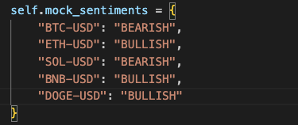

- Decision Module (src/agent/domain/components/decision_module.py)
Simulates LLM Agentic Decisions by getting the sentiment and returns BUY or SELL decision.

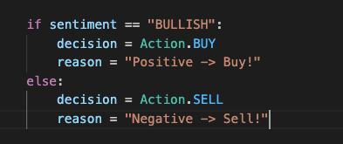

- Decision Evaluate (src/agent/domain/components/dicision_evaluate.py)
Simulate the risk manager. Based on the decision module output this determines the portion of capital to be spent for a coin based on its cluster.
(ex: allocating capital for low-risk coins, but limiting spending on high-risk coins)

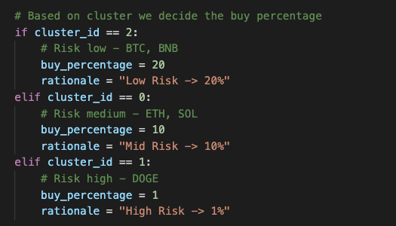

Execution of Trading Agent

python app.py 4
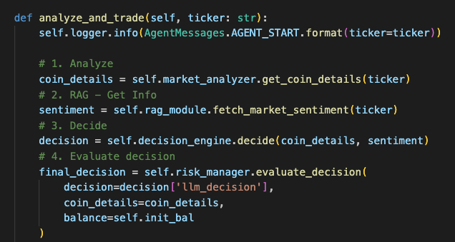

Result

