IT5437 Assignment 1

Intensity Transformations and Neighborhood

Filtering
Index No: 249309R
Name: I.D Jayawardana

Question 01
Code:
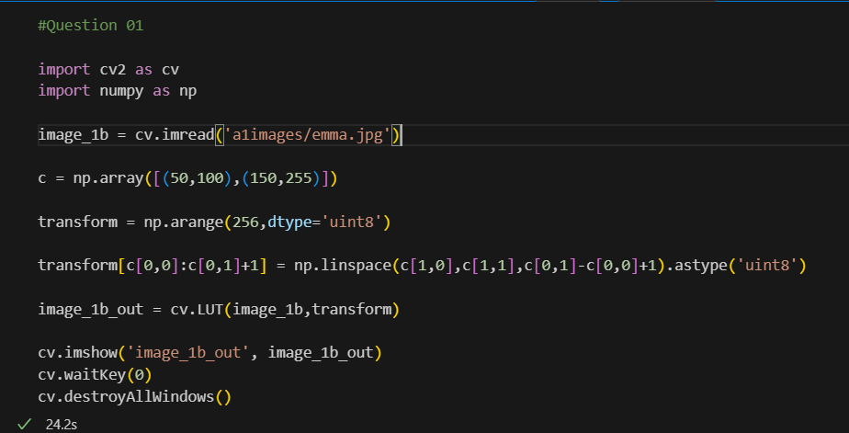
Result:
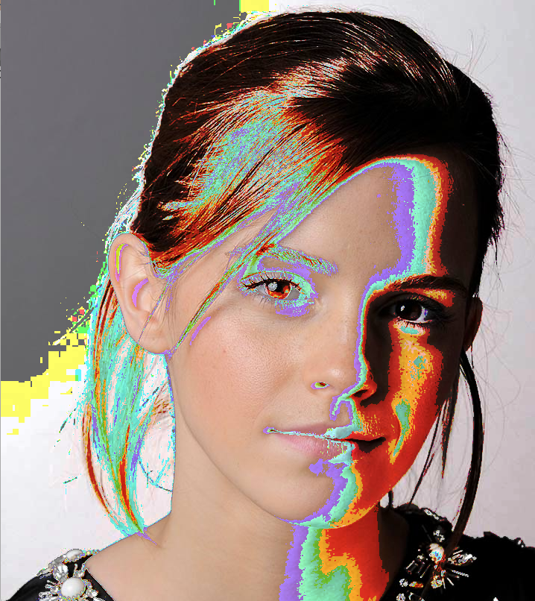
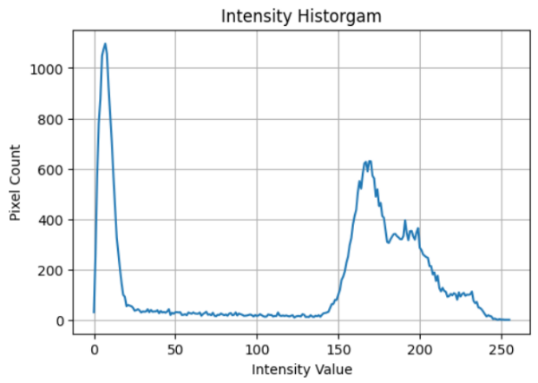
Question 02:
First, I implemented an Intensity Histogram with pixel counts, to identify the intensity bands for Grey Matter and White Matter using the peaks.
Based on that,
- Gray Matter: 150-190
- White Matter: 190-255
Applied relevant Transformations:
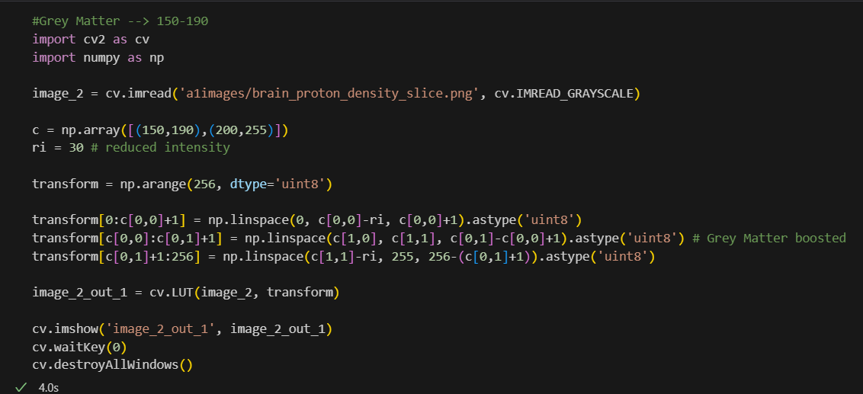
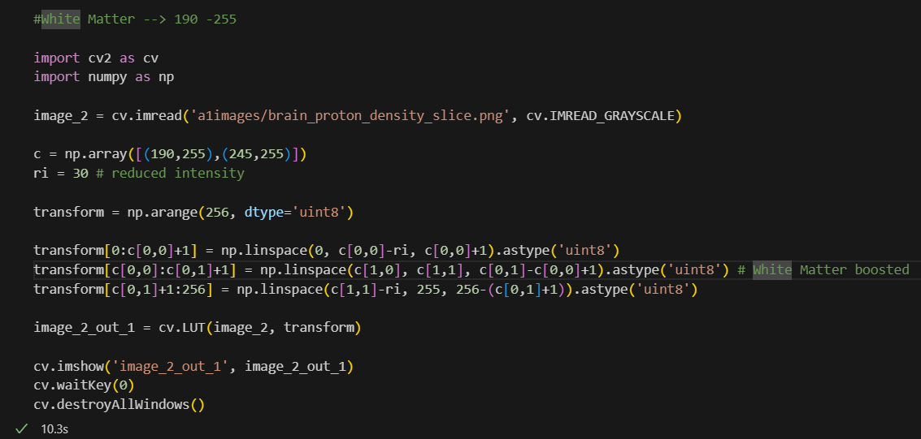
Results:
