1. Install IntelliJ IDEA using .exe. (DON’T download the Ultimate option because it’s not free after 30 days)

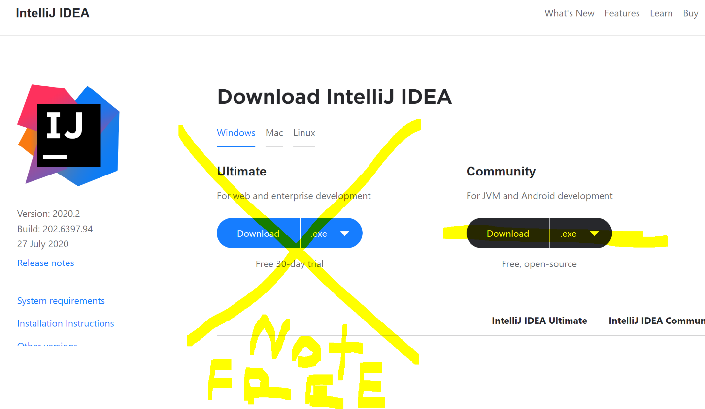

1. Click Open or Import in IDEA.

1. Then, open build.gradle (you should have it)

1. Open build.gradle as a project.

1. You’ll need to wait for the program to begin (this might take up to 20 min for first-time users)

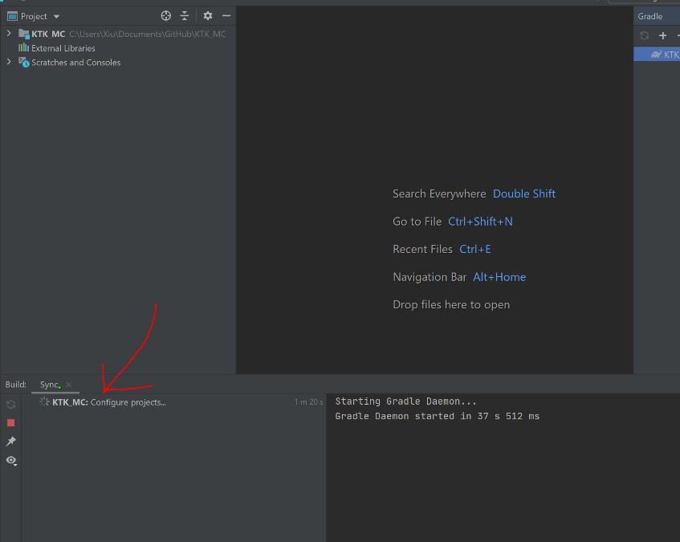

1. Then, click the Gradle option at the far right of the screen (red arrow)

1. Open Tasks, then open fg_runs, then double-click on getIntellijRuns.

1. After clicking, click on the dropdown on the top and select runClient.

1. After selecting the dropdown, click Run.

1. After a few mins, Minecraft will open. Click Singleplayer.

1. After clicking, you will find a screen like this. Change the world name and click the game mode for Creative. Then click Create New World.

1. You should spawn in a world. Type ‘/’, and type give [playername] [modname]: [blockname].

1. Then, place a few of your blocks.

