**TA Screener 2**

**Heikin Ashi Candle Stick**

**Pattern on Changing Colours**

**LOW LEVEL DESIGN**

**Data Flow Diagram:**

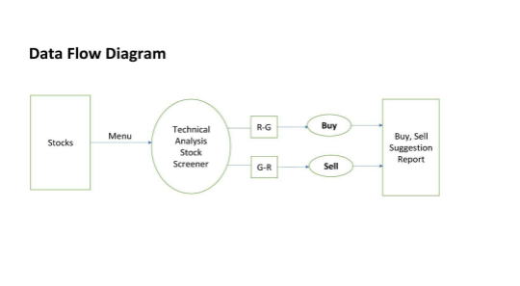Data Flow Diagram Overview:

The Purpose of this project is to implement a stock

analysis application using Heikin-Ashi formula that

will help user to select stocks.

The technical analysis method involves examining data generated through market activities, such as volume and prices.

Technical Analysis helps identify trading opportunities using actions of Market Participants through charts and it helps traders to pick good stocks to trade.

In the technical analysis we use a Green and Red colours of stock charts to analyze market data, with the help of colours user can easily buy or sell their stocks.

**Data Flow Diagram Level 1**

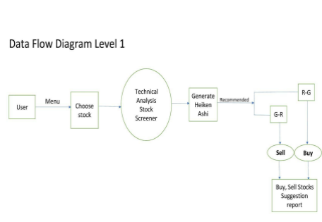Data Flow Diagram Level 1 Overview:

● First user enter into the application then Menu will be displayed to the user.

● In the technical analysis display stock file based on their past and present data records.

● User choose stock file based on his interest, Then it generate heikin ashi graph report and recommend to the user.

● If colour changes Red to Green then user can buy that stock and if colour changes Green to Red then user can sell that stock.

● And the finally stock suggestion report will generate to the user.

**Flow Chart:**

**Flow Chart Overview**:

**User:**

User have to enter into the application.

**Menu:**

It display the stocks files. It helps user to select stock file based on their interest.

**Choose Stock:**

It hepls user to choose stock file.

**Recommendation:**

It Recommend user to select stock file based on their past and present data.

**Red-Green (R-G) And Green-Red (G-R):**

If colour changes from Red to Green then user can Buy that stock. If colour changes from Green to Red then user can sell that stock.

**Suggestion Report:**

It generate suggestion report for user to pick good stock.

**Heikin Ashi Graph :**

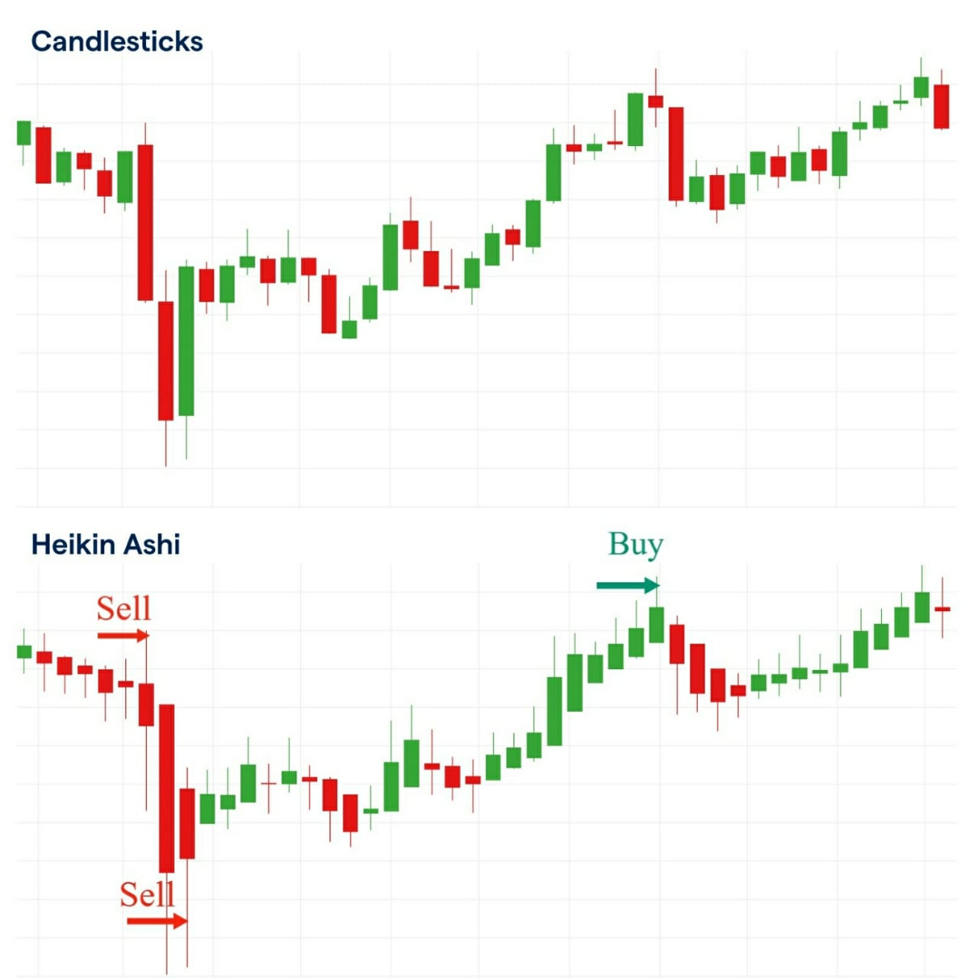● Like regular candlesticks, Heikin Ashi candles will display four

different price levels lowest point, highest point, and open and

close prices, but it will use data from the current and previous

session to derive their values.

● The candles on traditional candlesticks usually change from green to red (up or down), making it difficult for some traders to interpret.

● It display more consecutive colored candles, making it easy for traders to identify past price movements and current trends. ● Heikin Ashi graph usually stay green in upward and red in a downward.

● The candles begin from the middle of the candlestick.

**Technique of Heikin-Ashi :**

The Heikin-Ashi technique averages price data to create a Japanese candlestick chart that filters out market noise.

**Calculation**

As for candlesticks, values for Open, High, Low and Close are required.

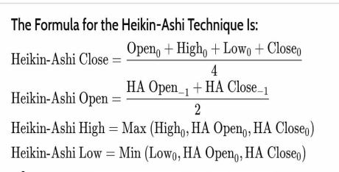

● The Heikin Ashi — also spelled Heiken Ashi — is both a technical analysis indicator and a chart type, depending on how it is used.

● Traders that familiarise themselves with Heikin Ashi can use it to their advantage to help determine trends and trend reversals in a wide range of financial markets.

● This can be applied to different trading strategies also, such as day trading and swing trading.