**GET :** [**http://localhost:8085/welcome**](http://localhost:8085/welcome)

**POST :** [**http://localhost:8085/uploadFile**](http://localhost:8085/uploadFile)

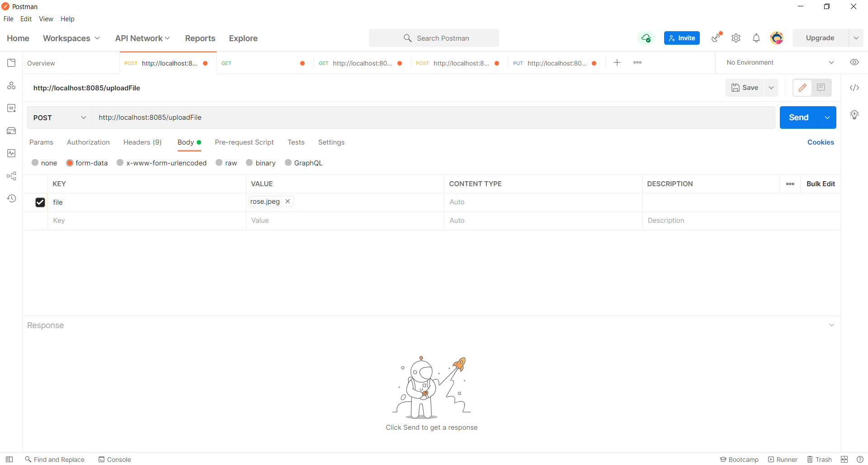

**GET :** [**http://localhost:8085/downloadFile/51A82FC4AA806DC033F0AECD5985258D.jpeg**](http://localhost:8085/downloadFile/51A82FC4AA806DC033F0AECD5985258D.jpeg)

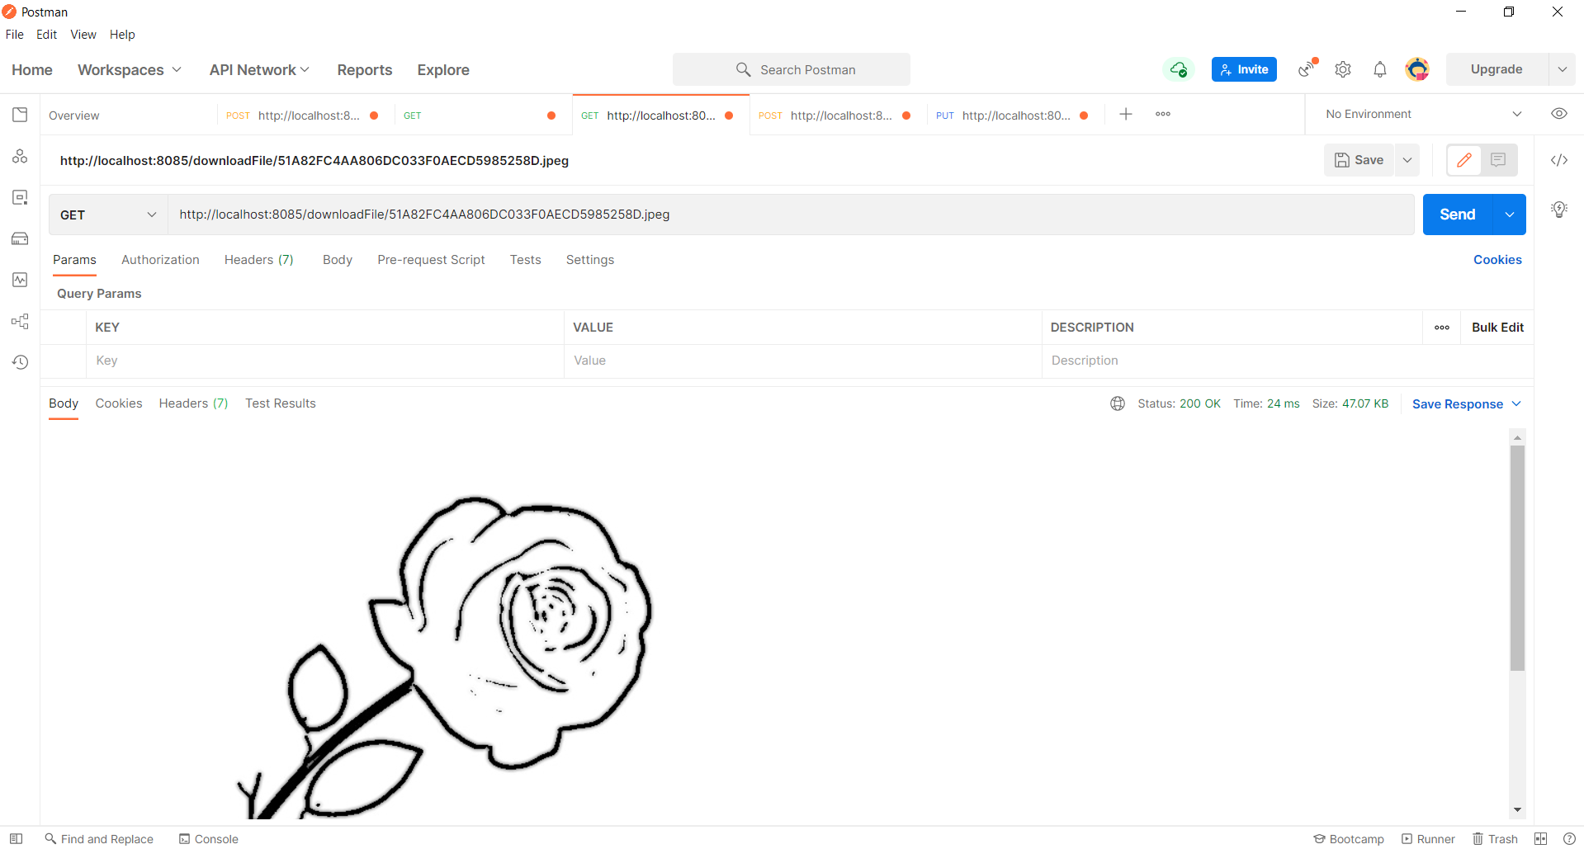

**POST :** [**http://localhost:8085/signup**](http://localhost:8085/signup)

{

"username": "steve",

"password": "clark",

"email_id": "Sincere@april.biz",

"created_datetime": "2021-10-10 11:36:00"

}

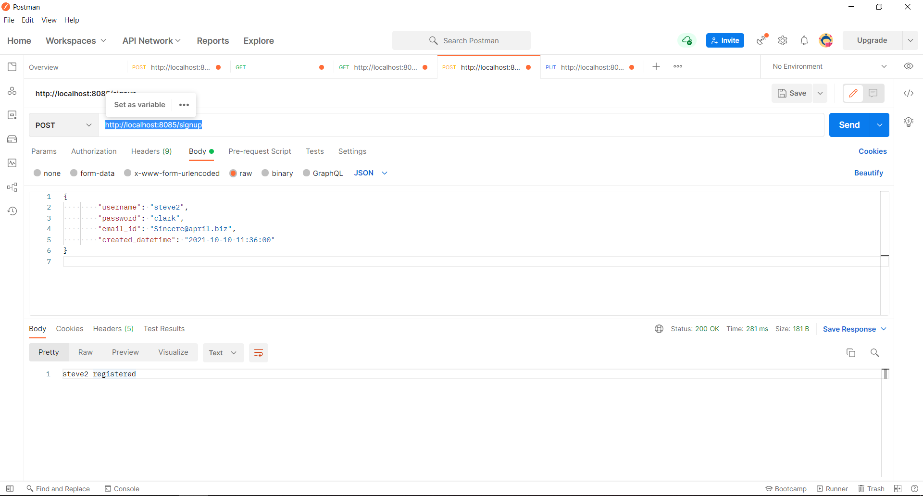

**PUT :** [**http://localhost:8085/resetpassword**](http://localhost:8085/resetpassword)

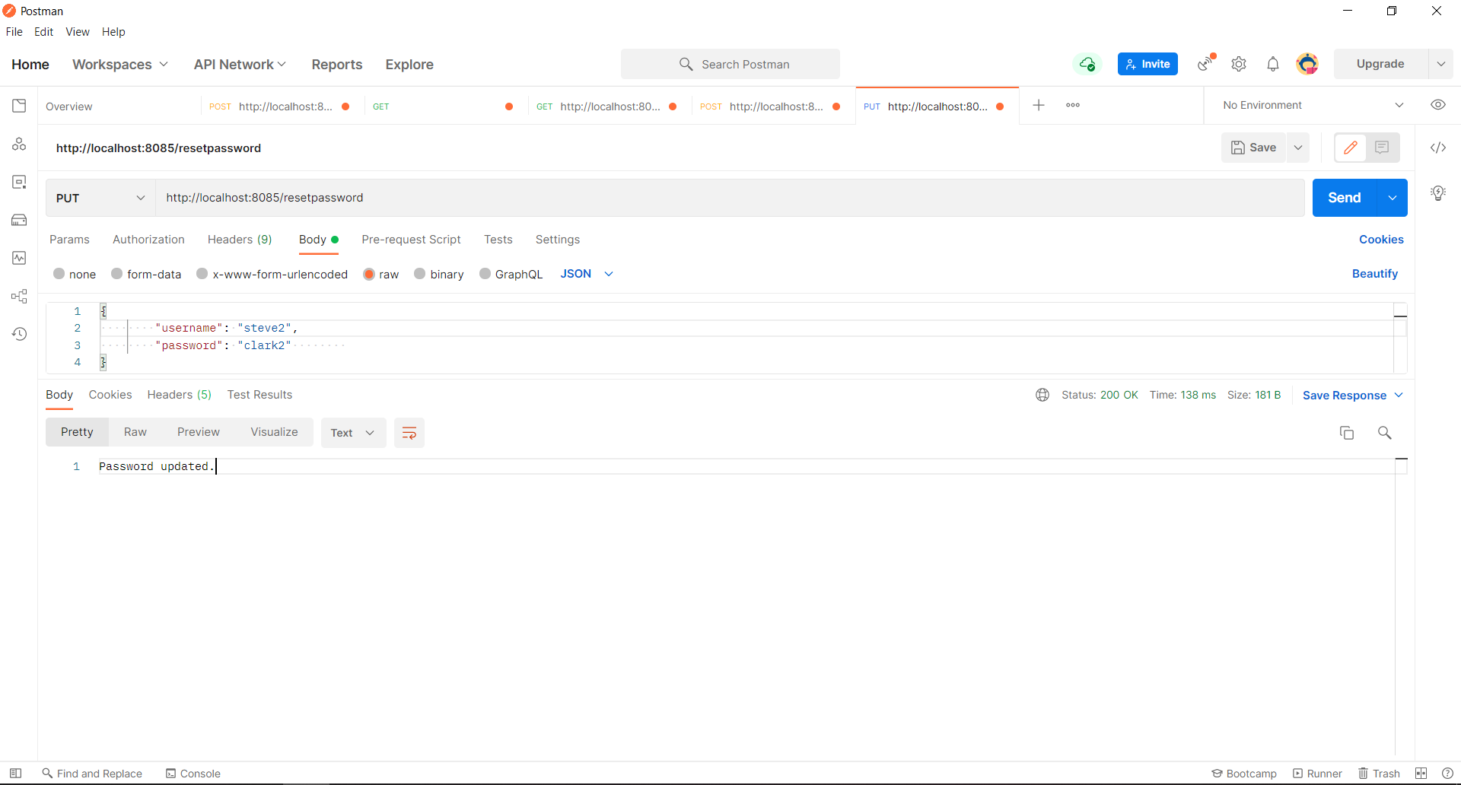

CREATE DATABASE CARTOONIZEME;

USE CARTOONIZEME;

CREATE TABLE `app_user_details` (

`user_id` bigint NOT NULL,

`created_datetime` varchar(20) DEFAULT NULL,

`email_id` varchar(50) DEFAULT NULL,

`full_name` varchar(50) DEFAULT NULL,

`password` varchar(20) DEFAULT NULL,

`username` varchar(20) DEFAULT NULL,

PRIMARY KEY (`user_id`),

UNIQUE KEY `UK_r88y2c6qwn47sv7tb3vds74y3` (`username`)

) ENGINE=InnoDB DEFAULT CHARSET=utf8mb4 COLLATE=utf8mb4_0900_ai_ci;

insert into app_user_details (username, password, full_name, email_id, created_datetime)

values ('test', 'test', 'test', 'test@gmail.com', current_timestamp());