Enhancing the Data Transmission Security in Cloud Using Machine Learning
Cloud servers provides heavy computation resources and storage at cheaper cost which is migrating all small and big network based applications for cloud deployment. Due to network connectivity cloud often fall prey of cyber attackers which can perform different number of attacks during communication between cloud server and user. Attackers can generate many forms of attack like DDOS, MITM and many more.
To combat against such attacks many cryptography based algorithms were introduced but its required heavy computation and can leak data if encrypted keys are exposed to attackers.
To overcome from above issues we are employing machine learning based algorithms such as KNN and ANN which are one of the powerful ML algorithms to detect any type of Anomaly activities. To further enhance ANN performance we are tuning ANN with ABC (artificial bee colony) optimization algorithm.
ABC inspired from the foraging behaviour of honeybees to solve optimization problems. ABC will get initialized with number of iterations and populations and then keep optimizing ANN model performance by choosing random population with max given number of iterations. In each iteration ABC will compute fitness values and this process continues till no more fitness can be enhanced.
To train and test above algorithms performance we have used NSL KDD dataset which has total 41 features and after optimization ABC selected 32 features with best learning rate as 0.001, number of epochs as 10 and number of tuning neurons are 32 and 64 for two different ANN layers.
We have compared ANN with ABC performance with KNN and ANN algorithms and each algorithm performance was evaluated in terms of accuracy, precision, recall and FSCORE.
SCREENSHOTS
For dataset analysis, training and testing we have used JUPYTER notebook and for prediction we have used flask based web framework. In below screens showing code and output with blue colour comments
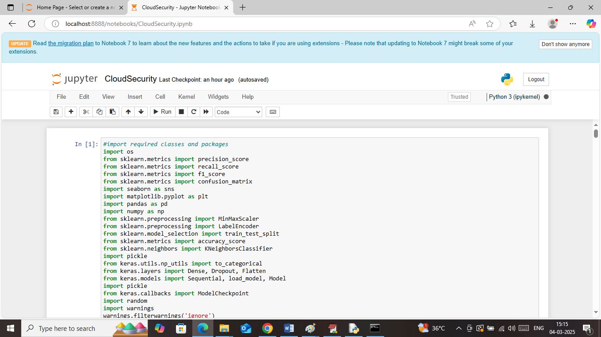
In above screen importing required python classes and packages
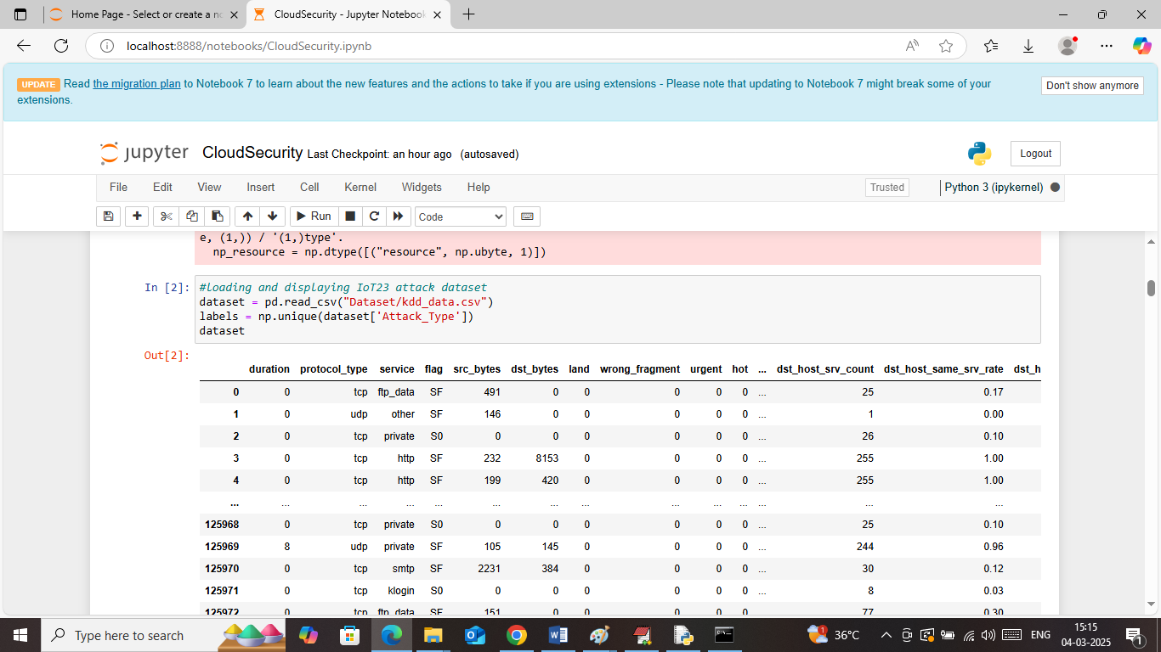
In above screen loading and displaying KDD dataset values and can see dataset contains both non-numeric and numeric values and by using processing technique we need to convert non-numeric to numeric values
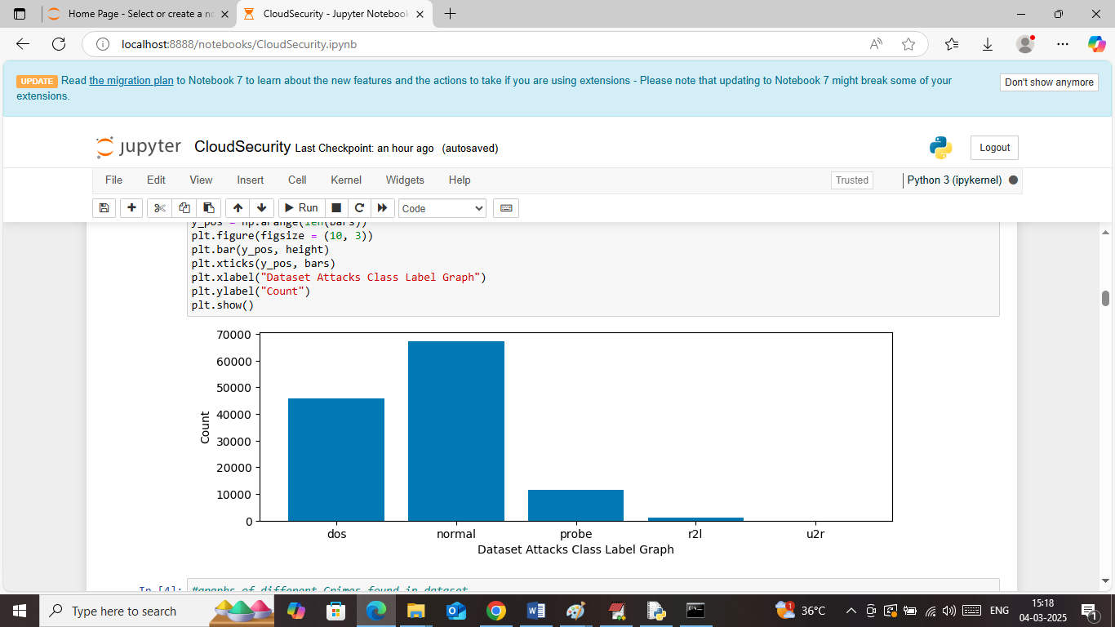
In above screen visualizing graph of different attacks found in dataset where x-axis represent attack names and y-axis represents number of instances
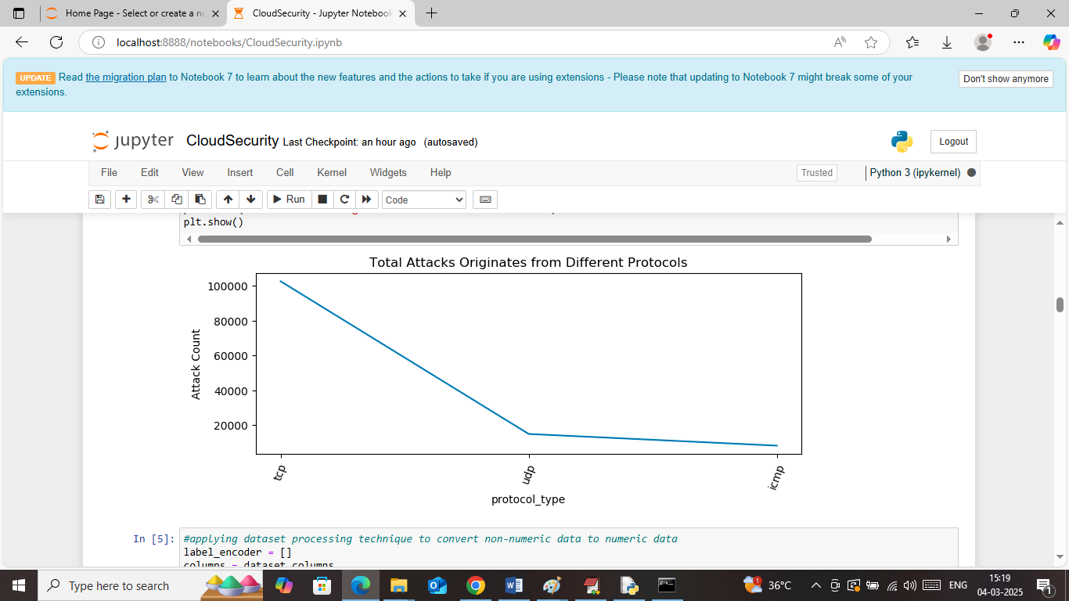
In above screen visualizing graph of number of attacks happened from different protocols where x-axis represents Protocol and y-axis represents count
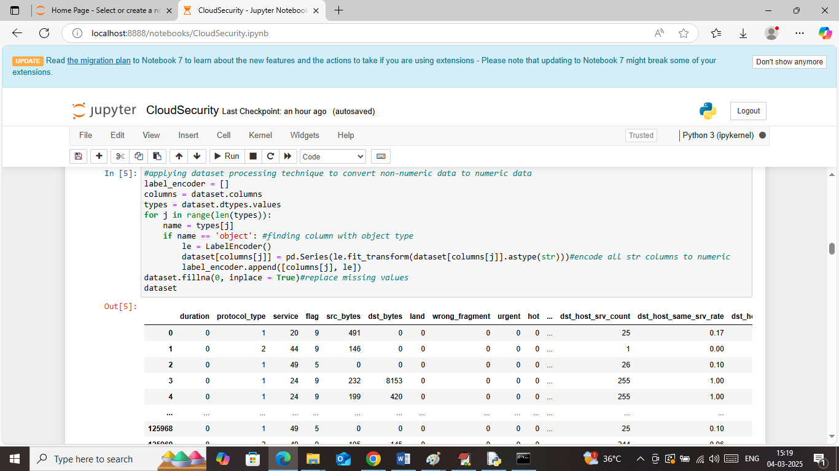
In above screen applying label encoding technique to convert non-numeric data to numeric data and then handling missing values and then can see all values are converted to numeric format
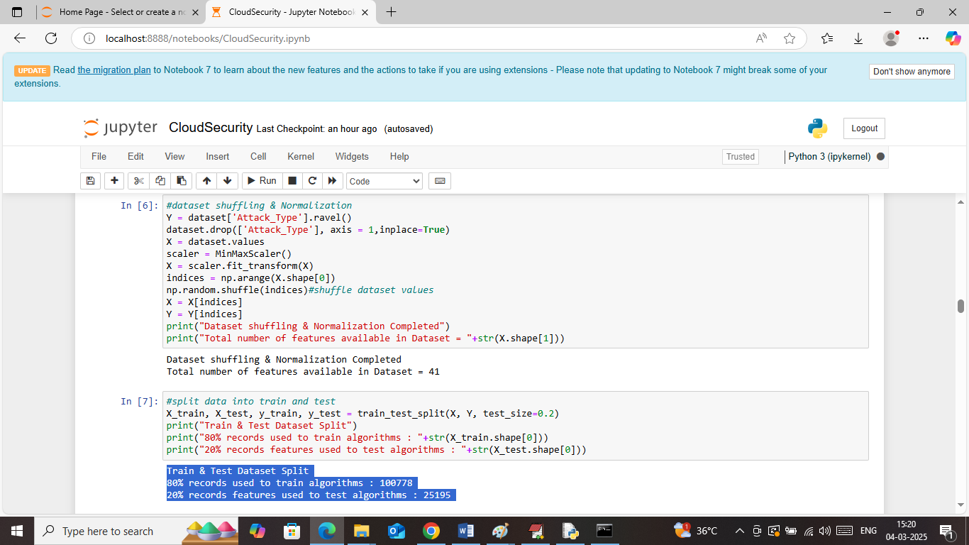
In above screen in first block shuffling and normalizing dataset values and can see dataset contains total 41 features and then in next block splitting data into train and test where application using 80% data for training and 20% for testing
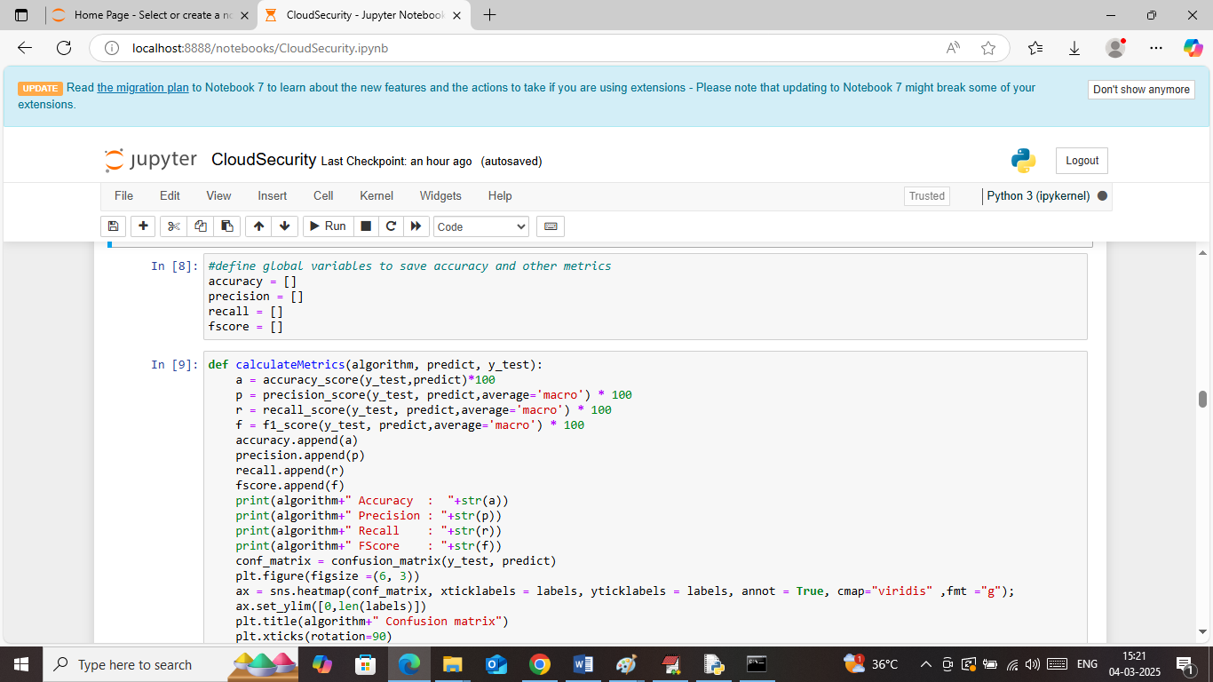
In above screen defining function to calculate accuracy and other metrics
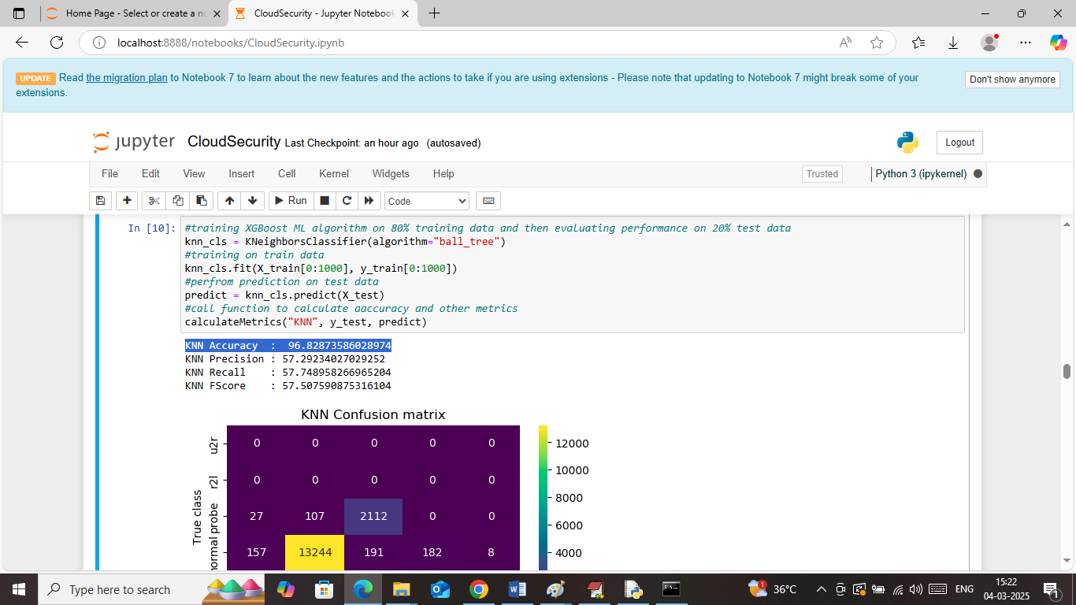
In above screen KNN got 96% accuracy and can see other metrics like precision, recall and FSCORE. Below is the confusion matrix graph
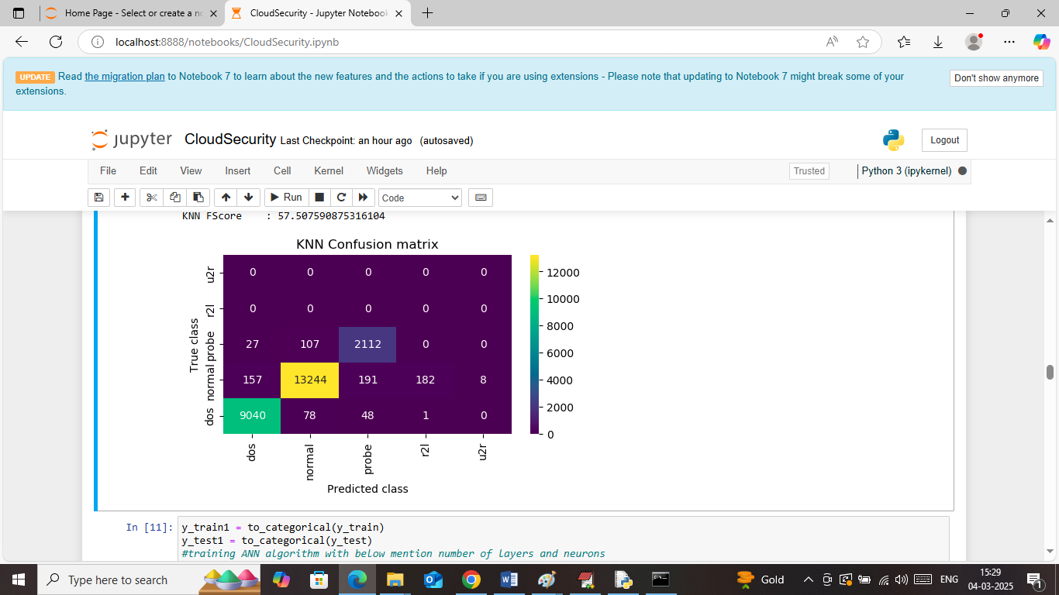
In above KNN confusion matrix classification graph x-axis represents ‘predicted labels’ and y-axis represents true labels and then all different colour boxes in diagonal represents correct prediction count and remaining blue boxes represents incorrect prediction count which are very few
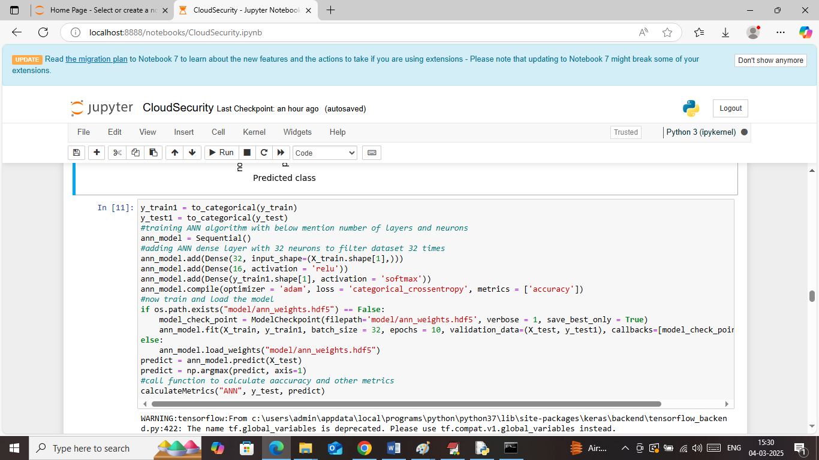
In above screen training and loading ANN algorithm and after execution will get below output
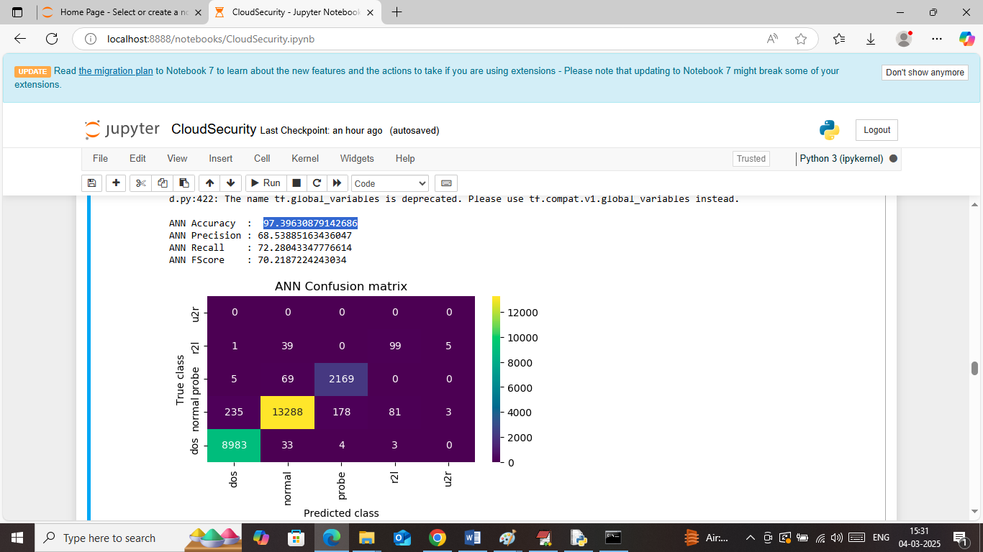
In above screen ANN got 97% accuracy and can see other metrics also
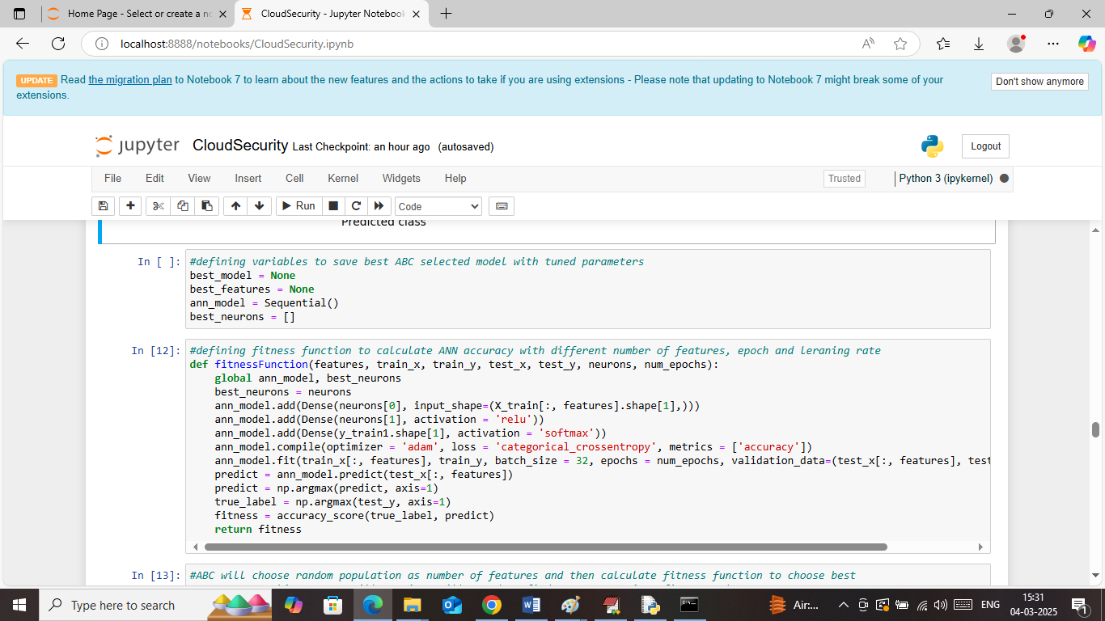
In above screen defining fitness function for ABC algorithm
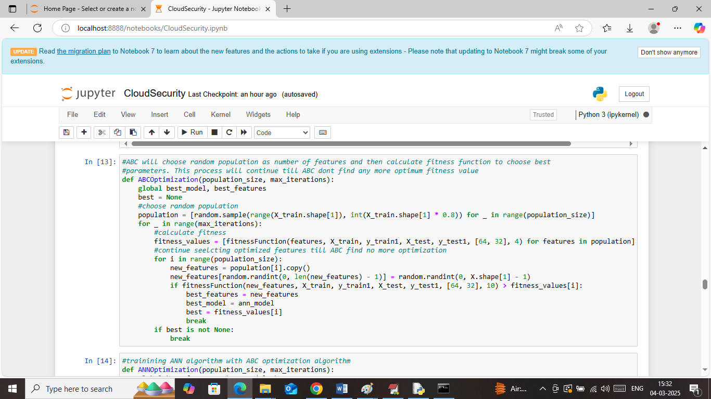
In above screen defining ABC optimization function which chooses random samples and then calculating fitness values to choose best model with best parameters
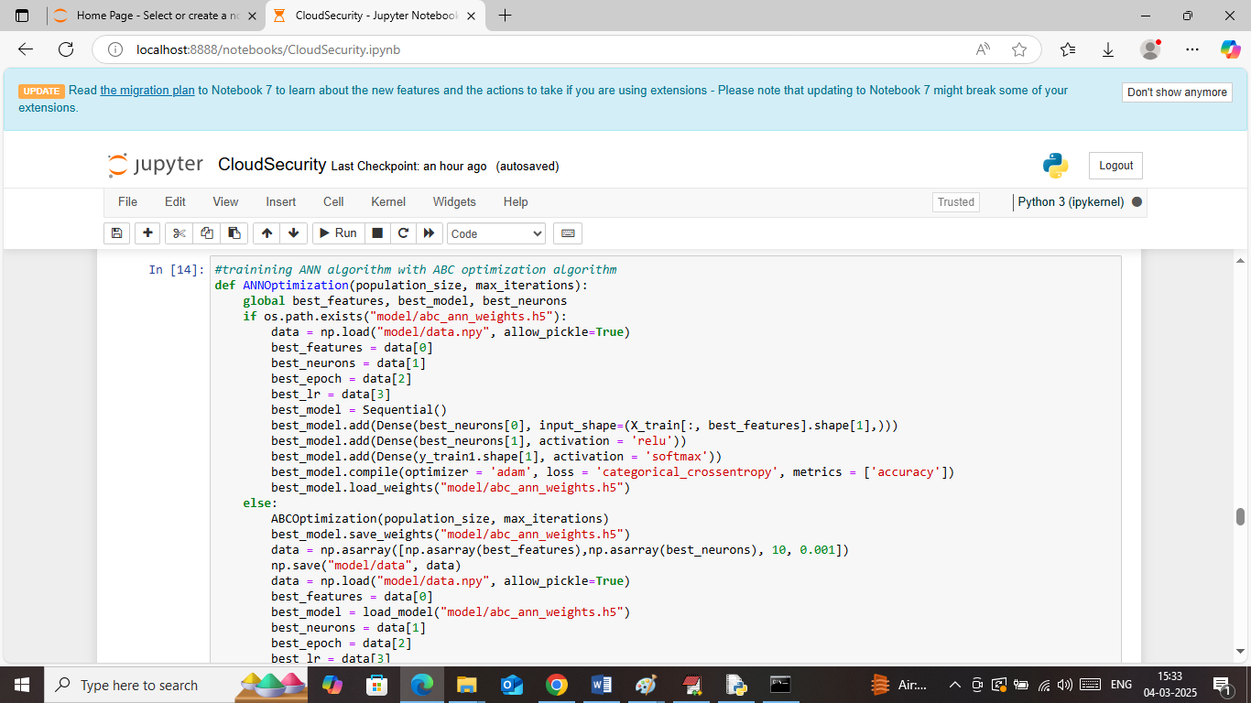
In above screen training ANN with ABC optimization and after executing above block will get below output
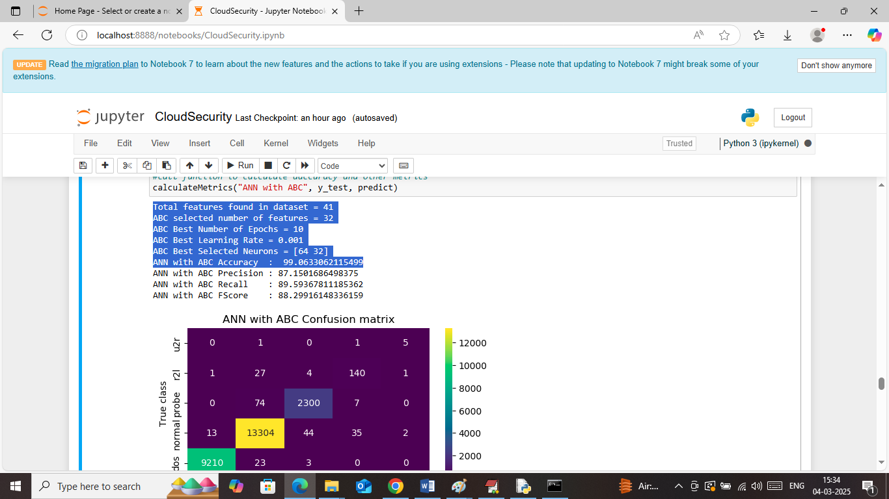
In above screen displaying best selected features, neurons and other tuned parameters and then ANN with ABC got 99% accuracy and can see other metrics also
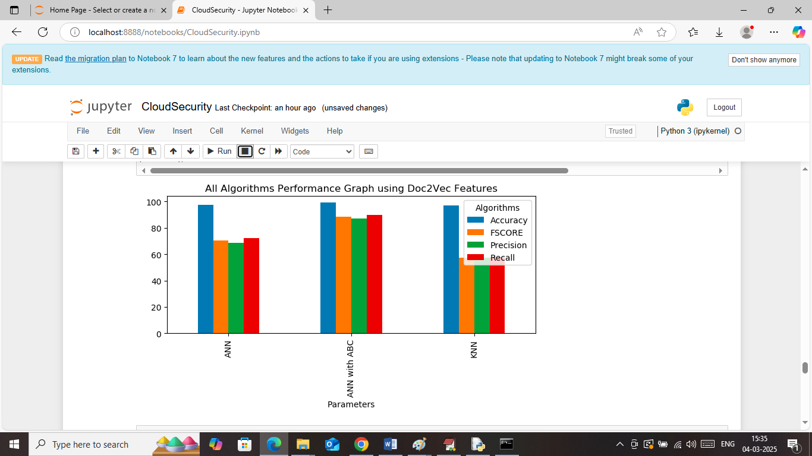
In above screen displaying comparison graph between all algorithms where x-axis represents algorithm names and y-axis represents accuracy and other metrics in different colour bars
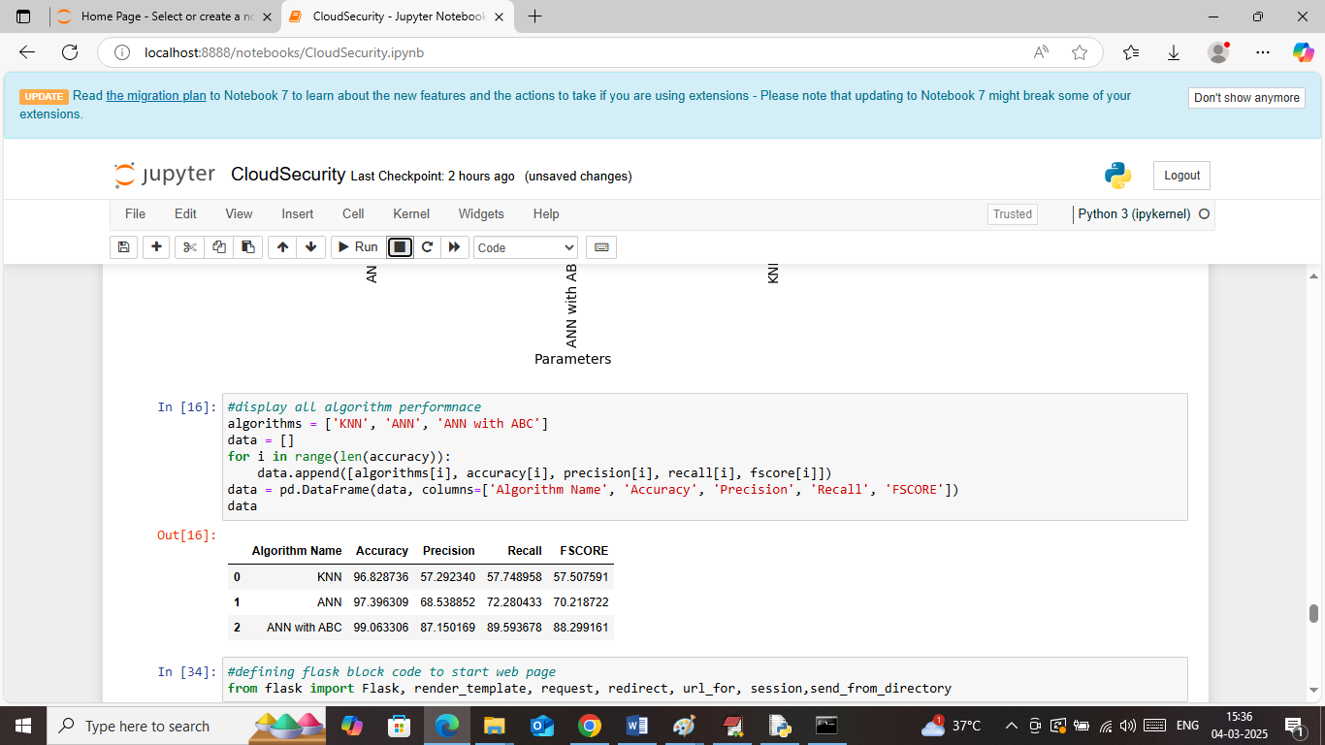
In above screen displaying all algorithms performance in tabular format and in all algorithms ANN with ABC got high accuracy
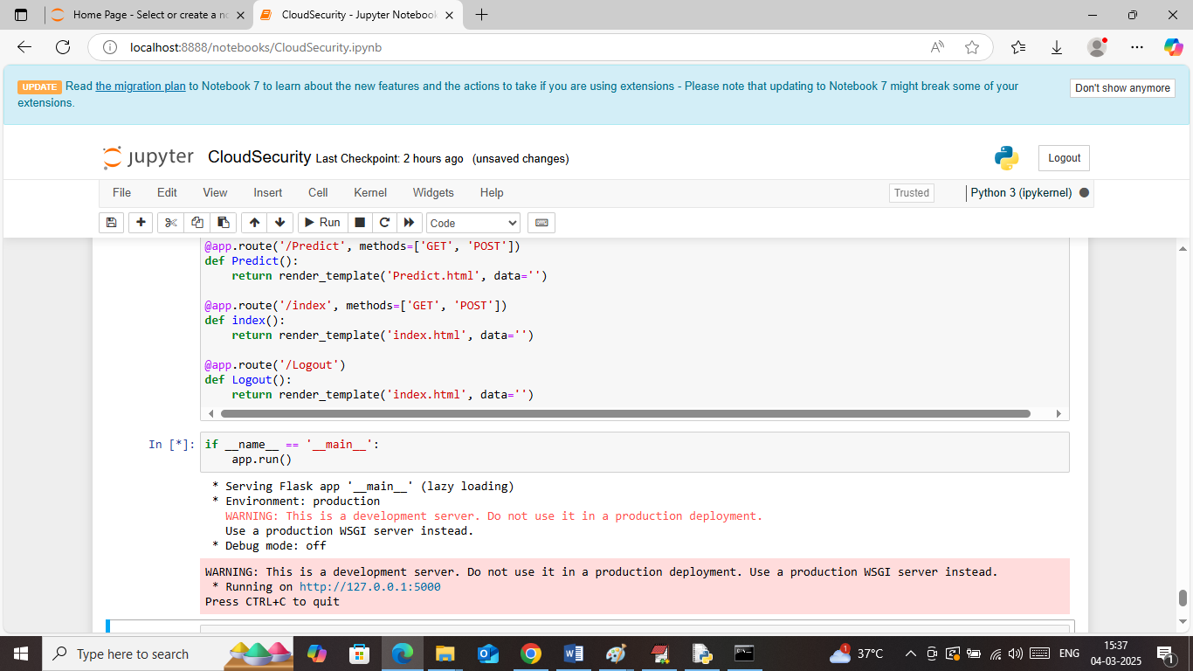
In above screen run all flask blocks to start flask server like above page and then open browser and enter URL as http://127.0.0.1:5000/index and then press enter key to get below page

In above screen click on ‘Predict Data Security’ link to get below page
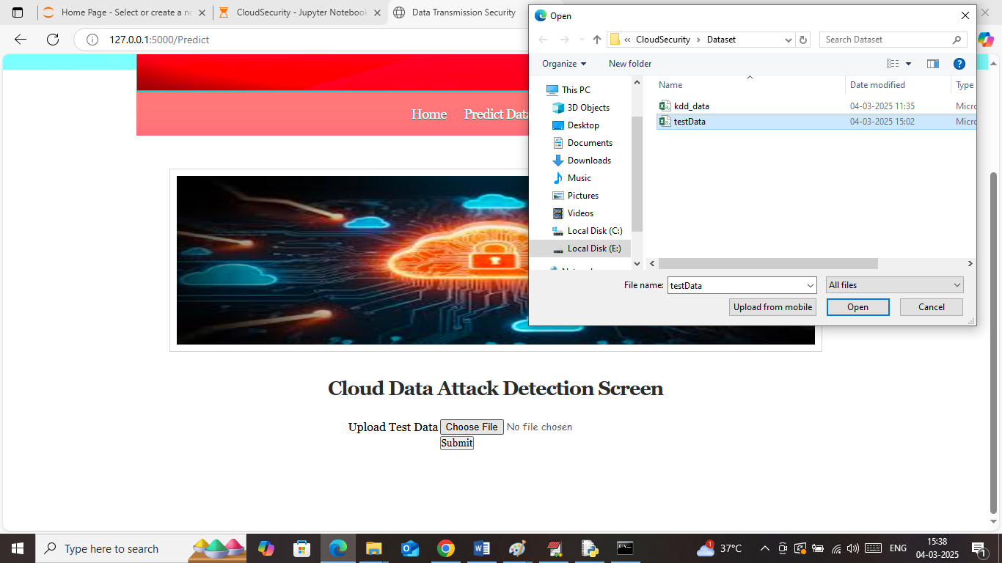
In above screen selecting and uploading ‘test data.csv’ file and then click on buttons to get below page
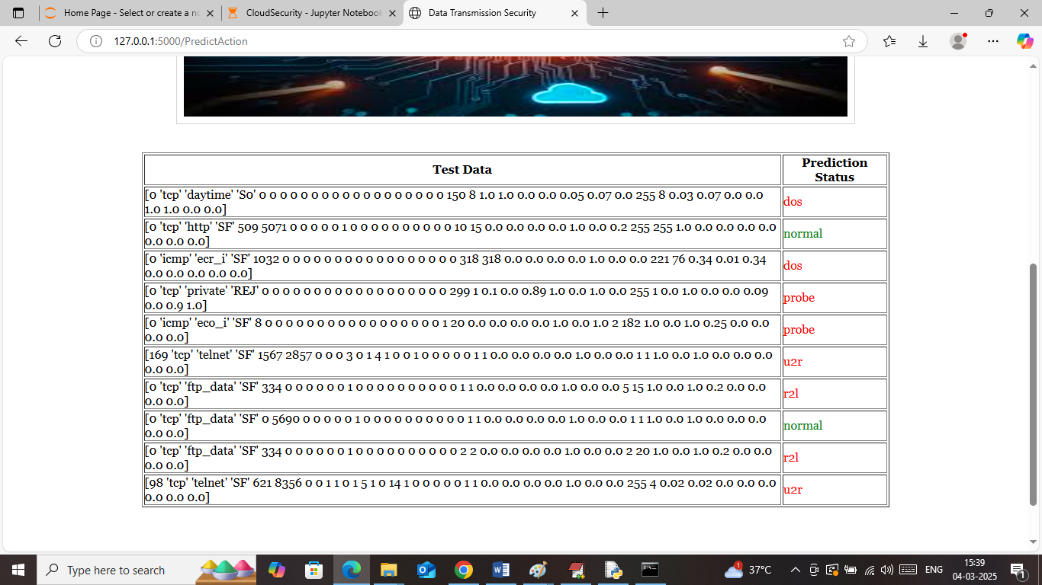
In above screen in first column can see TEST data values and in second column can see predicted attack types.
So in above screen using JUPYTER we did training and with web framework we performed prediction

