**Green Shadow (Pvt) Ltd.**

**Front-end (React)**

The Screenshots Of The Front-End That I Created Using React Are Included In This Document.

1. Login Page

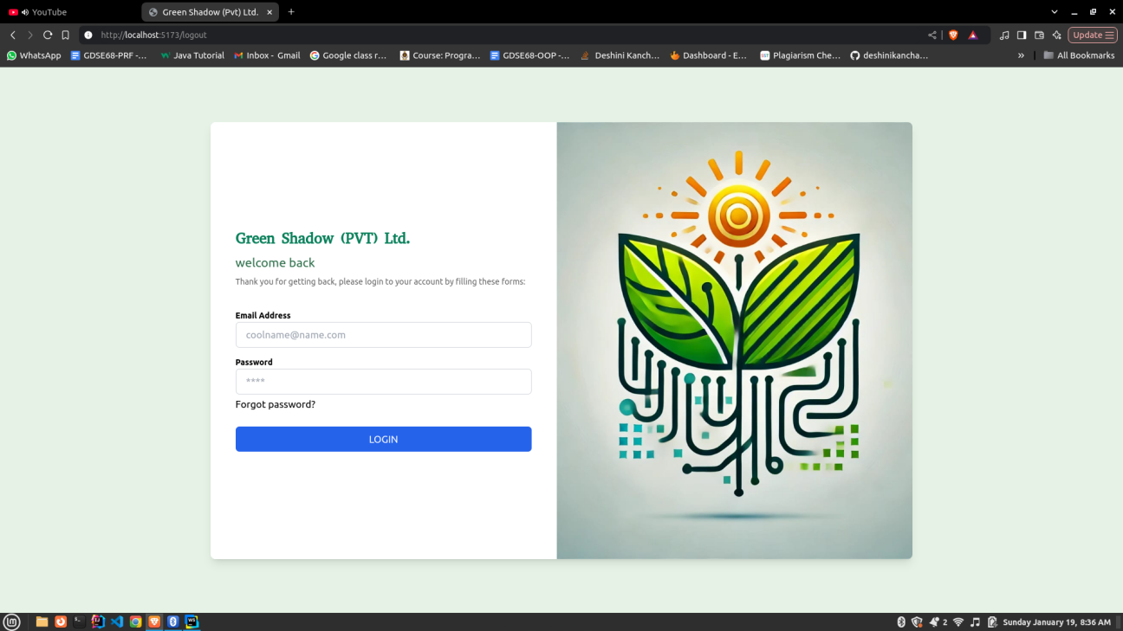

2. Dashboard Page

Only Hardcoded Data Is Included Here.  
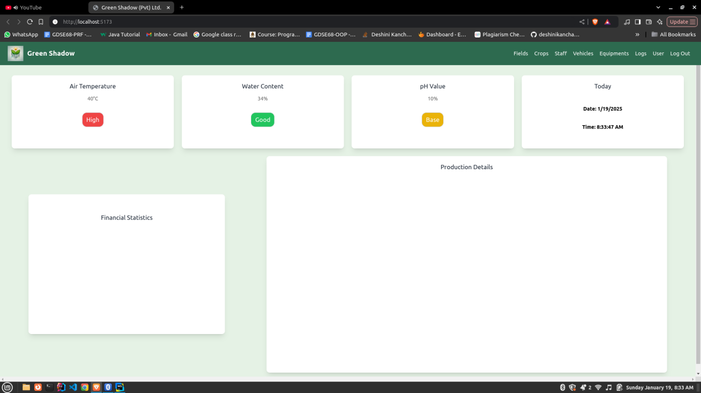

3. Field Page.

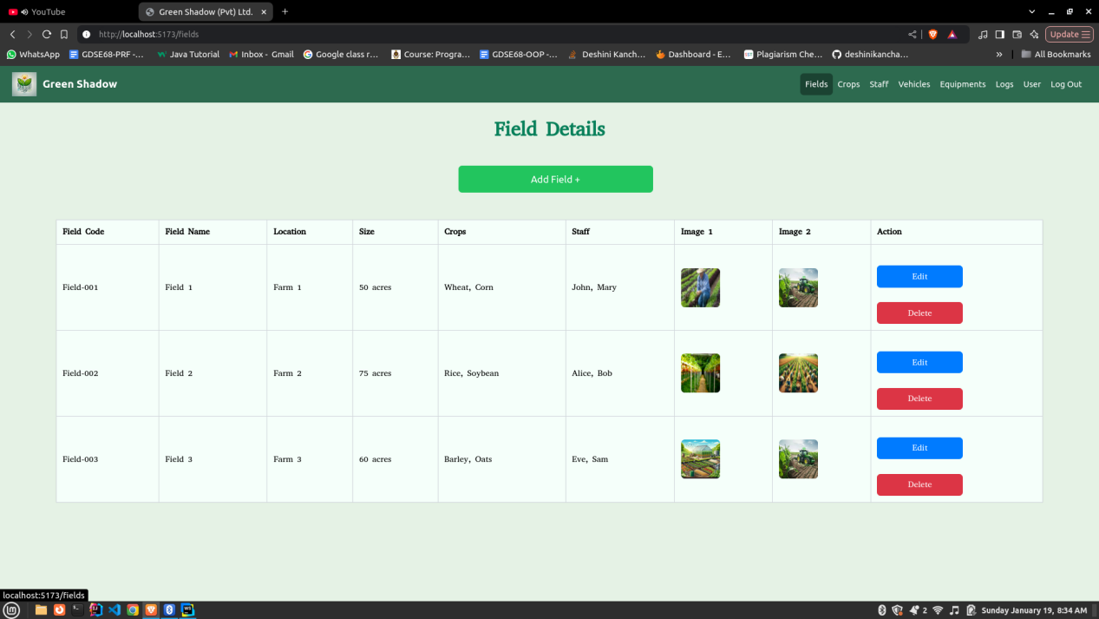

4. Crops Page

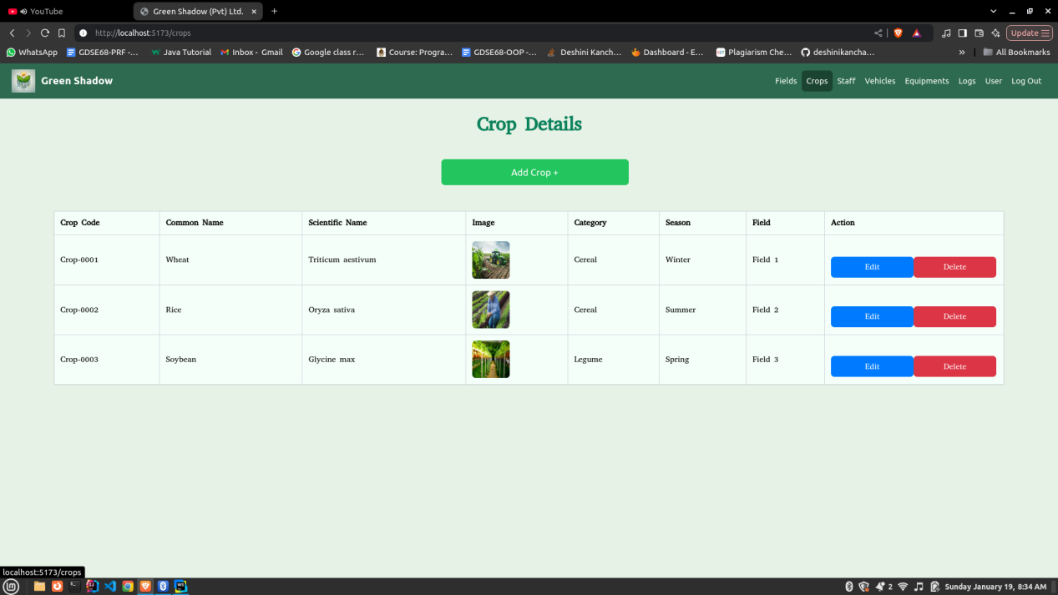

5. Staff Page

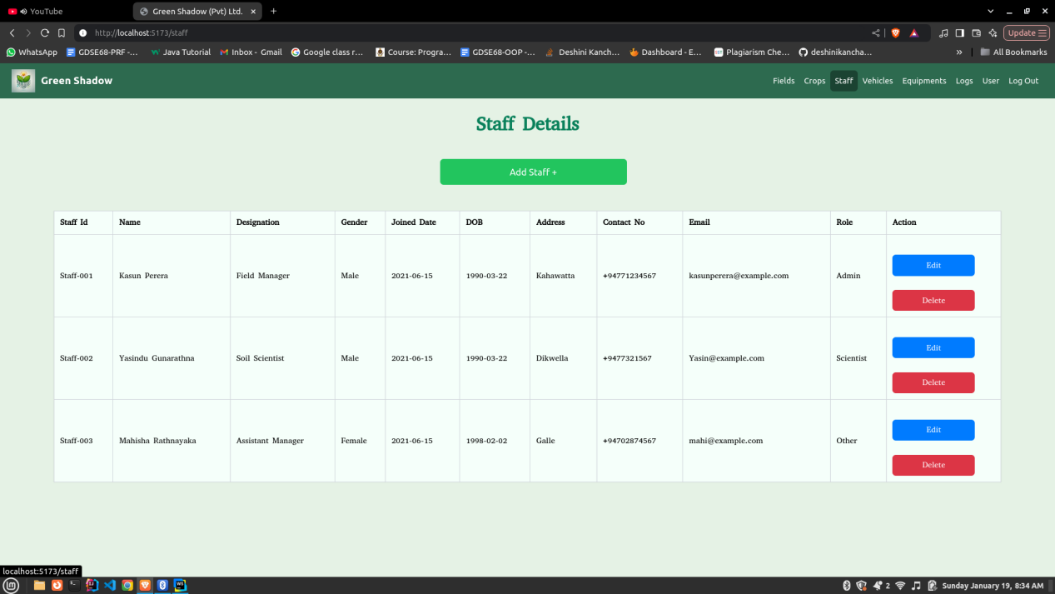

6. Vehicles Page

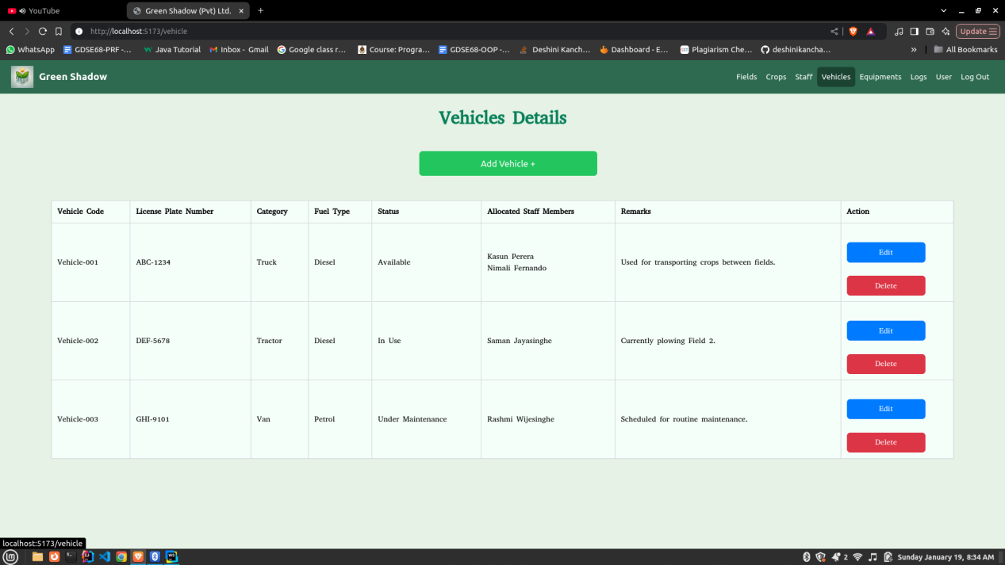

7. Equipments Page

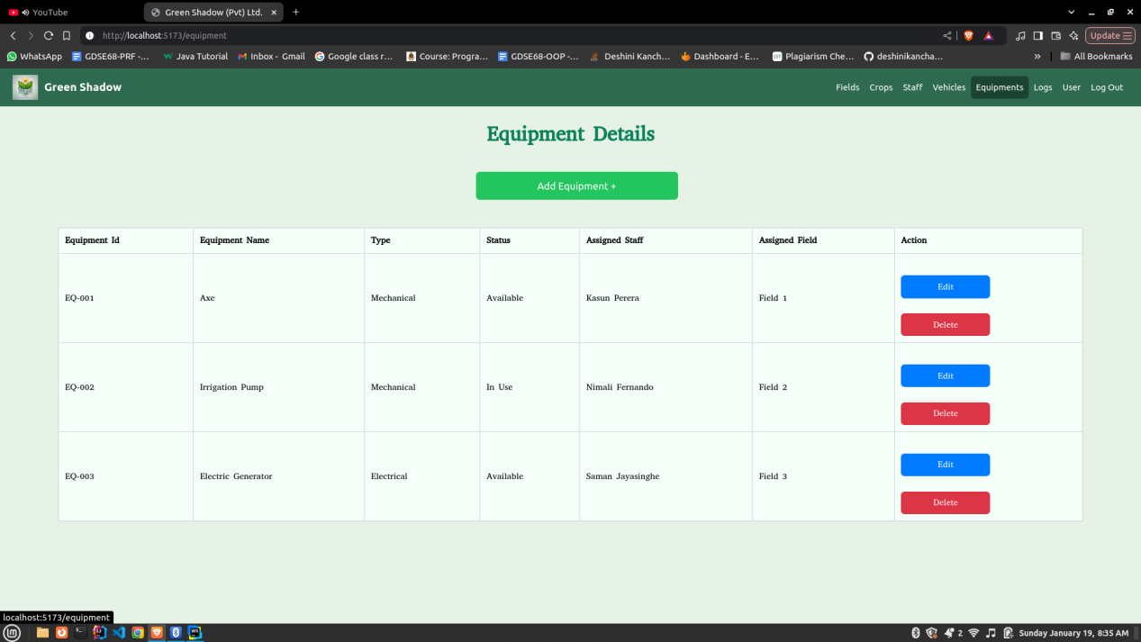

8. Monitoring Log Page

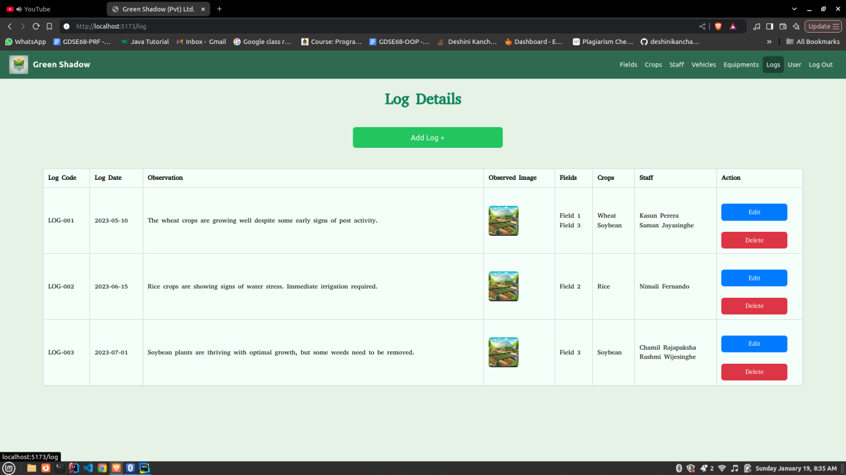

9. User Page

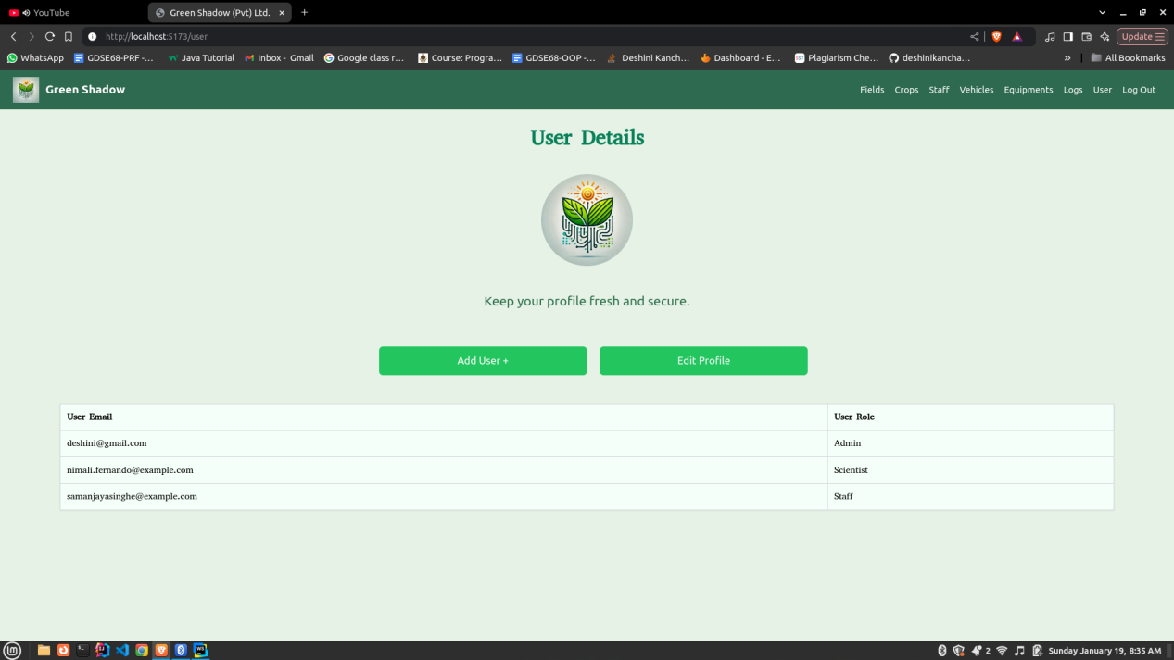

The Data Populated In The Tables On Each Page Is Dummy Data. Additionally, It Is Possible To Enter Data Through Input Fields And Save It To The Table. You Can Also Edit And Delete The Data. Each Page Has a Form To Capture The Relevant Input, As Shown In The Image Below.

10. Pop Up Form

