1. **EVEN ODD CHECK:-**

num=9875

if num%2 == 0:

print('The number is even')

else:

print('The number is odd')

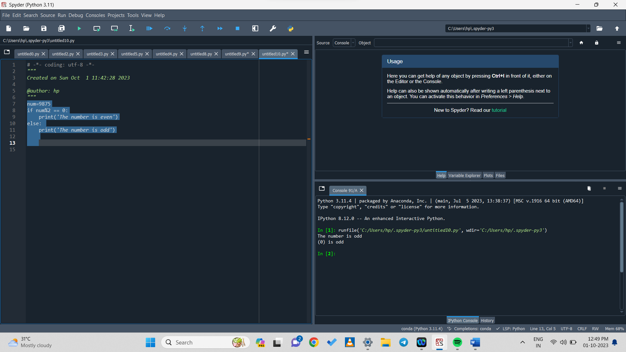

1. **ODD OR EVEN CHECK BY TAKING USER INPUT:-**

num=int(input('Enter a number:'))

if(num%2) == 0 :

print((num), 'is Even')

else:

print((num), 'is Odd')



1. **DECIMAL CHECK:-**

d=float(input('Enter a number'))

if d%1==0:

print('False')

else:

print('True')

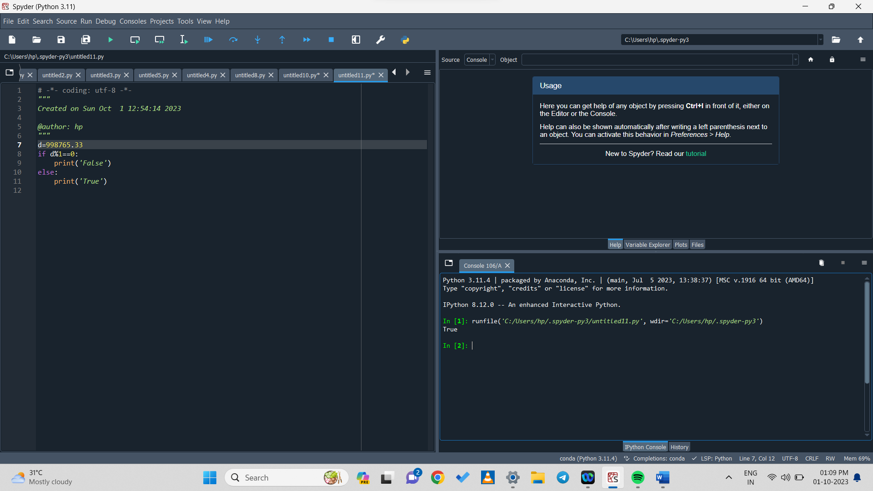

1. **DECIMAL CHECK BY USING USER INPUT:-**

d=float(input('Enter a number'))

if d%1==0:

print('False')

else:

print('True'**)**

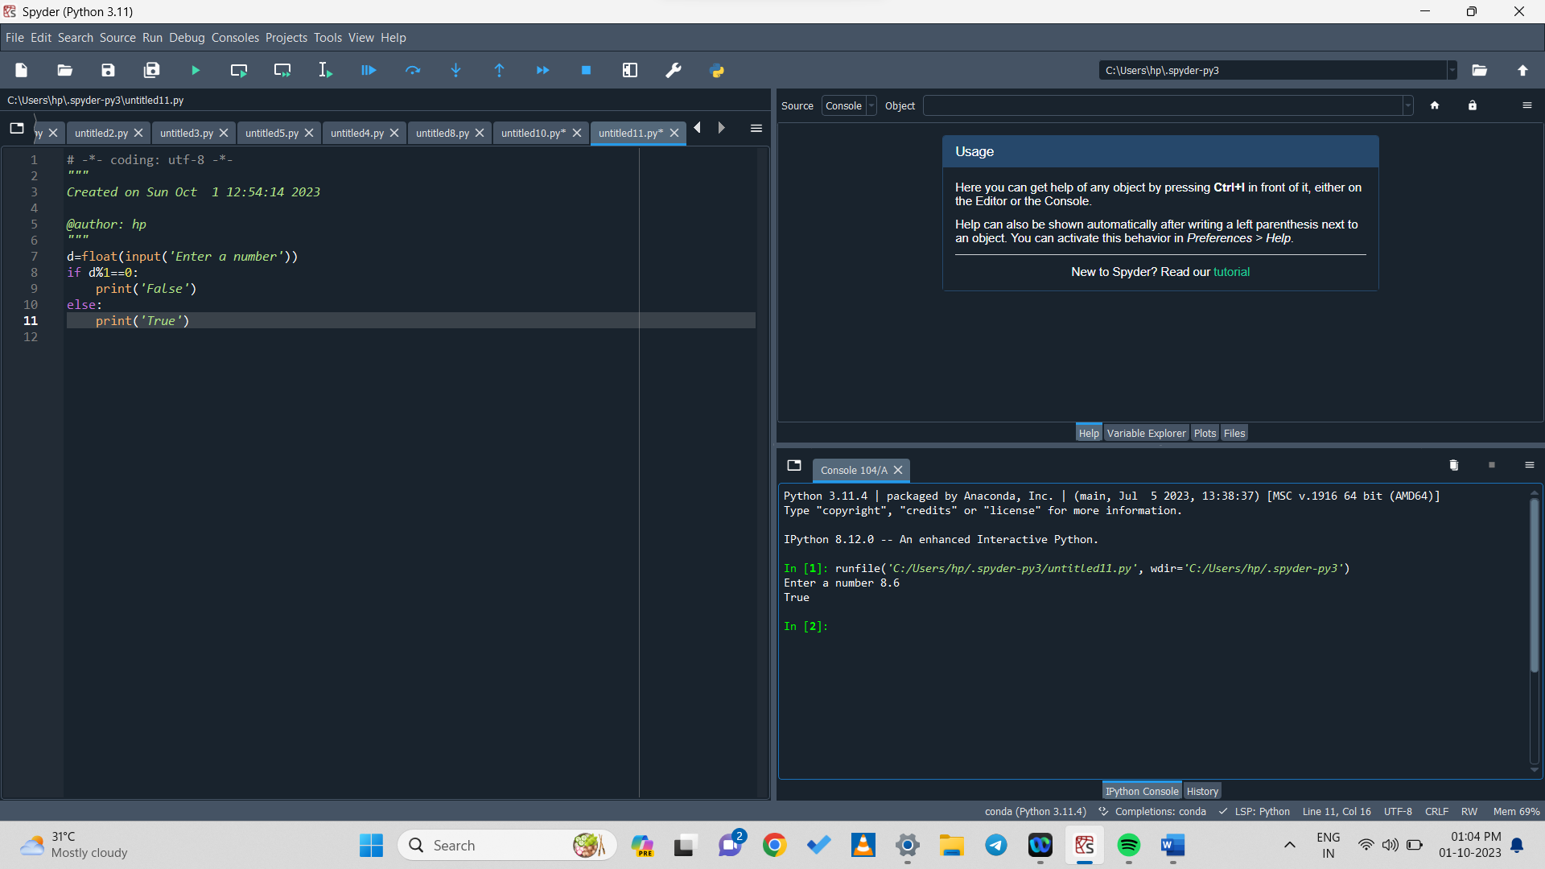

1. **Comparison:**

a= float(input('Enter a number:'))

b= float(input('Enter a number:'))

if (a>b):

print('True')

else:

print('False')

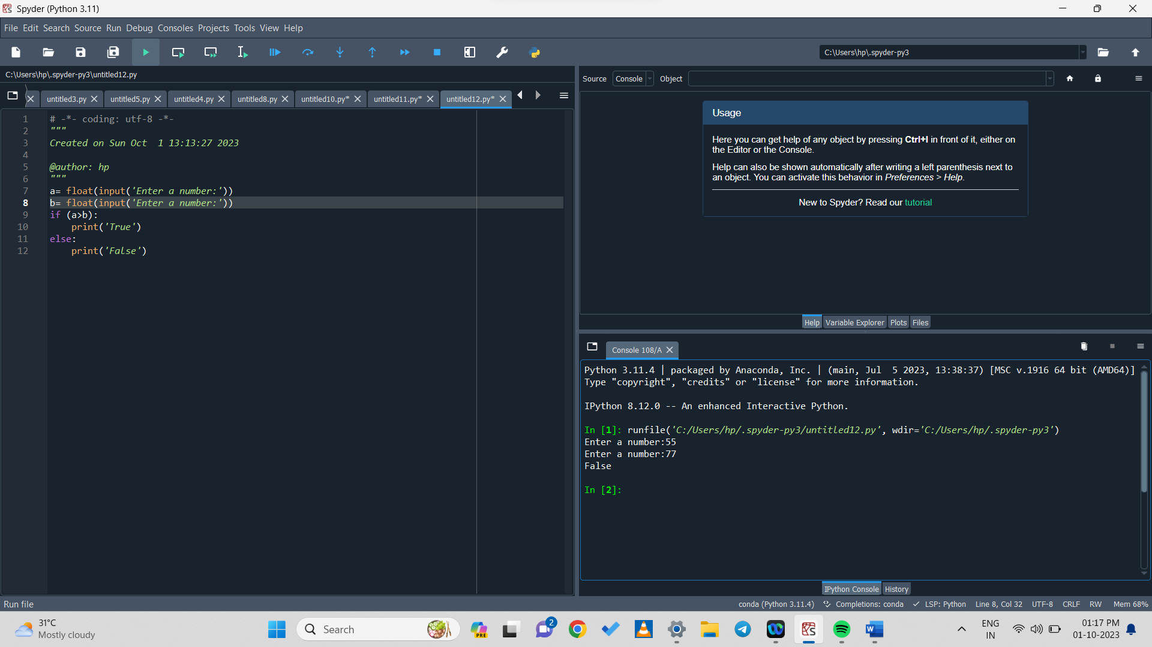

a= float(input('Enter a number:'))

b= float(input('Enter a number:'))

if (a>b):

print('True')

else:

print('False')

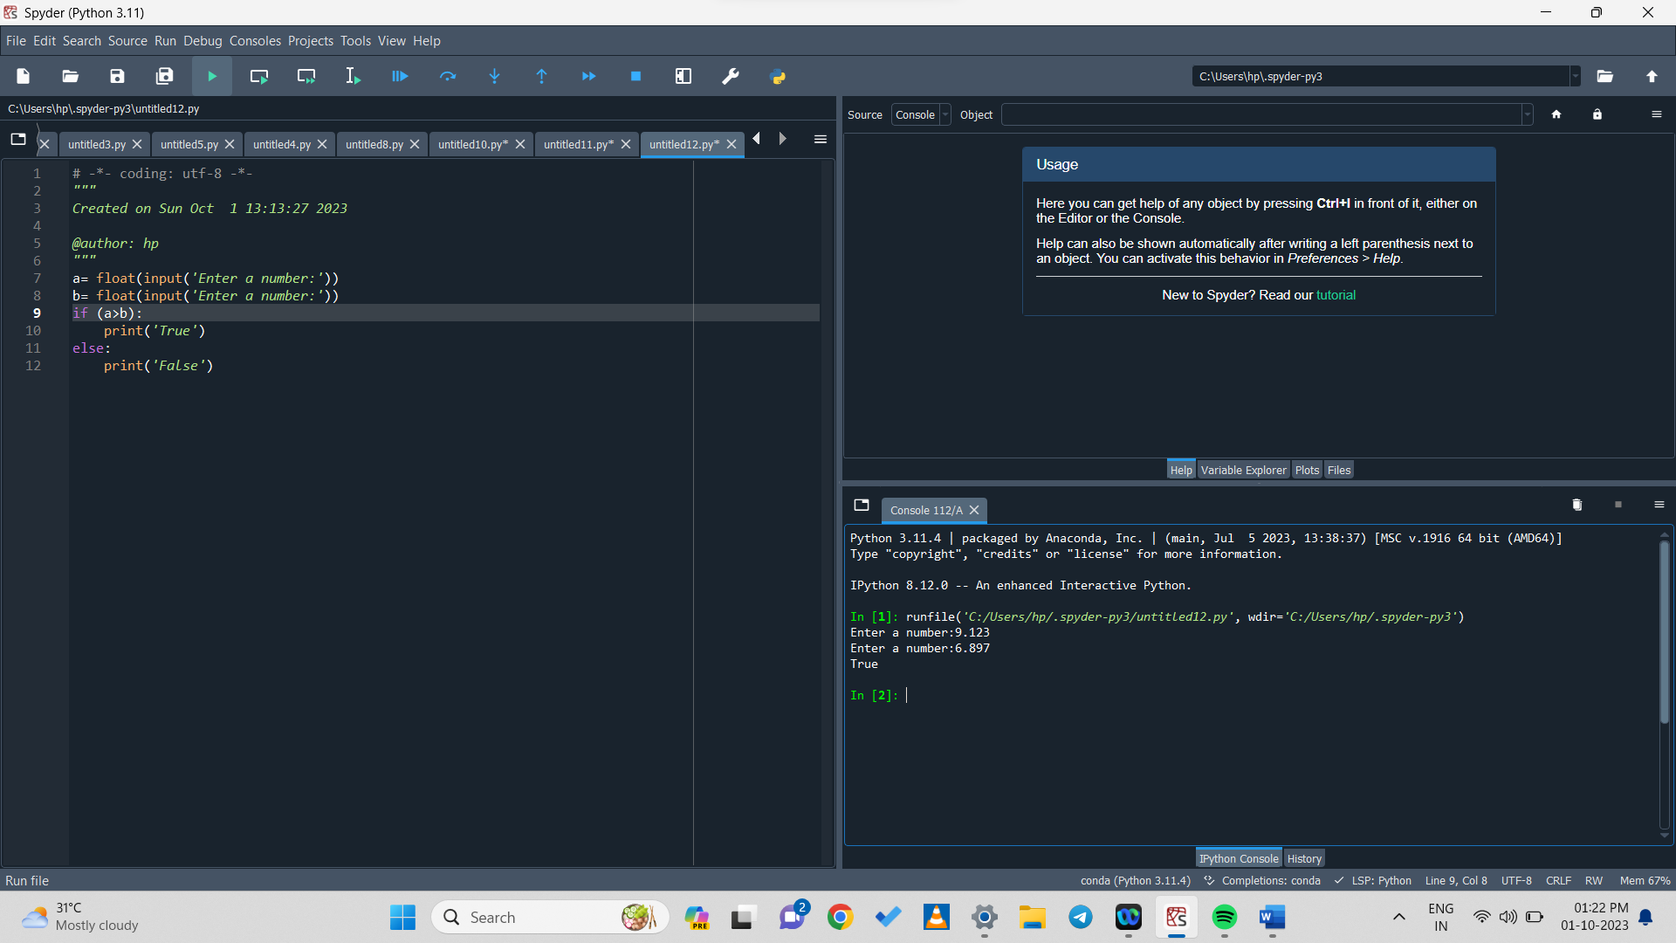

a= float(input('Enter a number:'))

b= float(input('Enter a number:'))

c= float(input('Enter a number:'))

if (a+b)>c:

print('True')

else:

print('False')

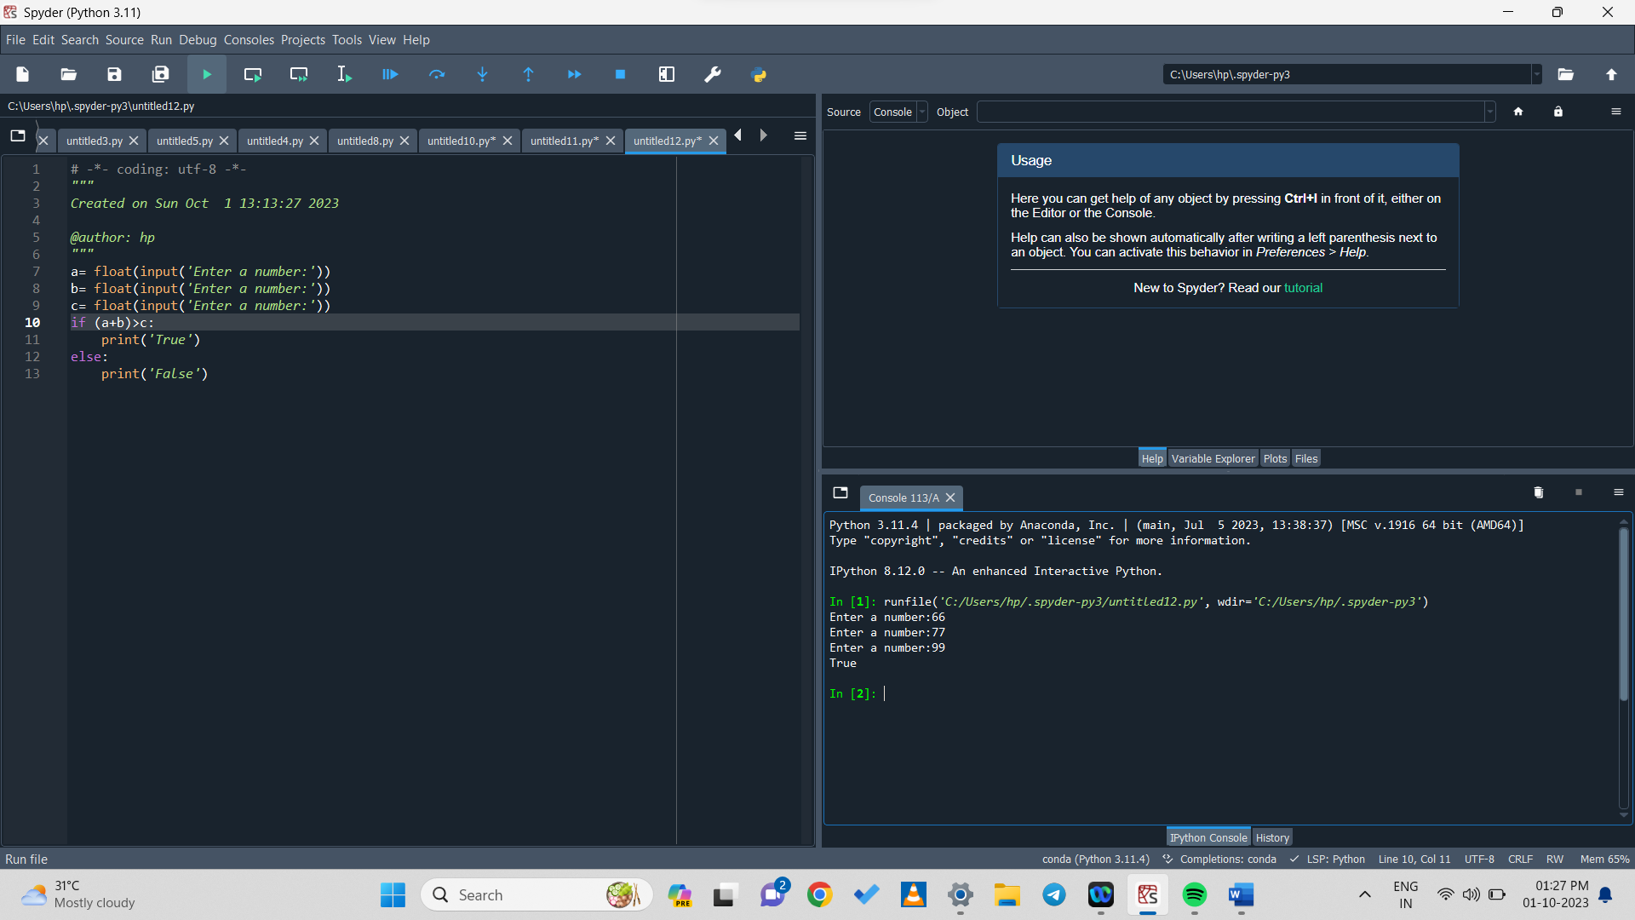

a= float(input('Enter a number:'))

b= float(input('Enter a number:'))

c= float(input('Enter a number:'))

if (a-b)<=c:

print('True')

else:

print('False')

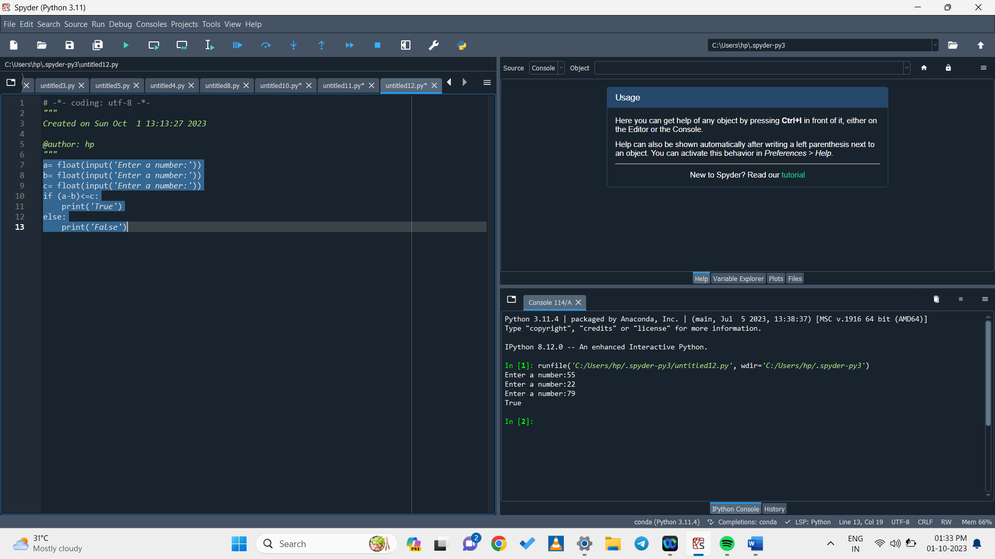

a= float(input('Enter a number:'))

b= float(input('Enter a number:'))

if (a==b):

print('Equal')

if (a!=b):

print('Not Equal')

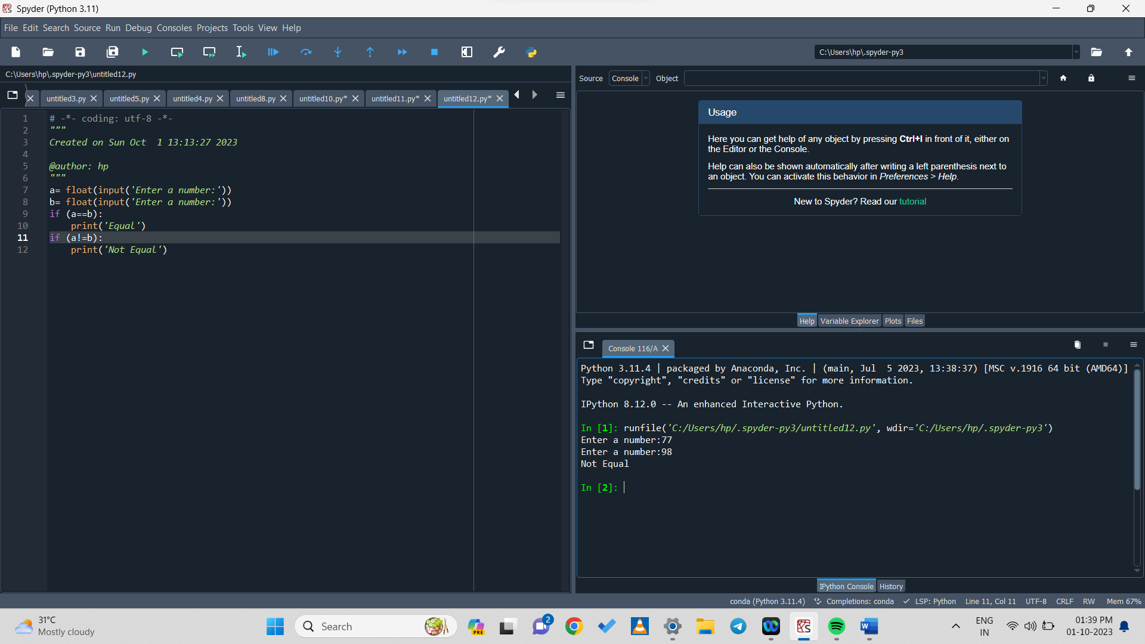

a= int(input('Enter a number:'))

b= int(input('Enter a number:'))

c= int(input('Enter a number:'))

if (b*c)-a!=c:

print('true')

else:

print('false')

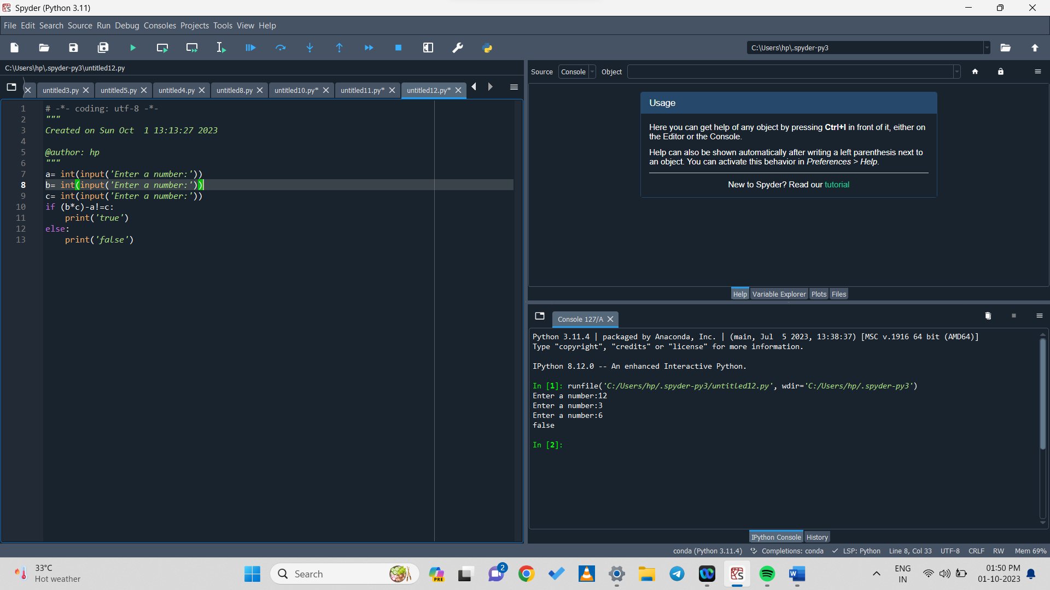

1. **POSITIVE OR NEGATIVE CHECK:-**

n=int(input('Enter a number:'))

if n>0:

print('The number is positive')

else:

print('The number is negative')

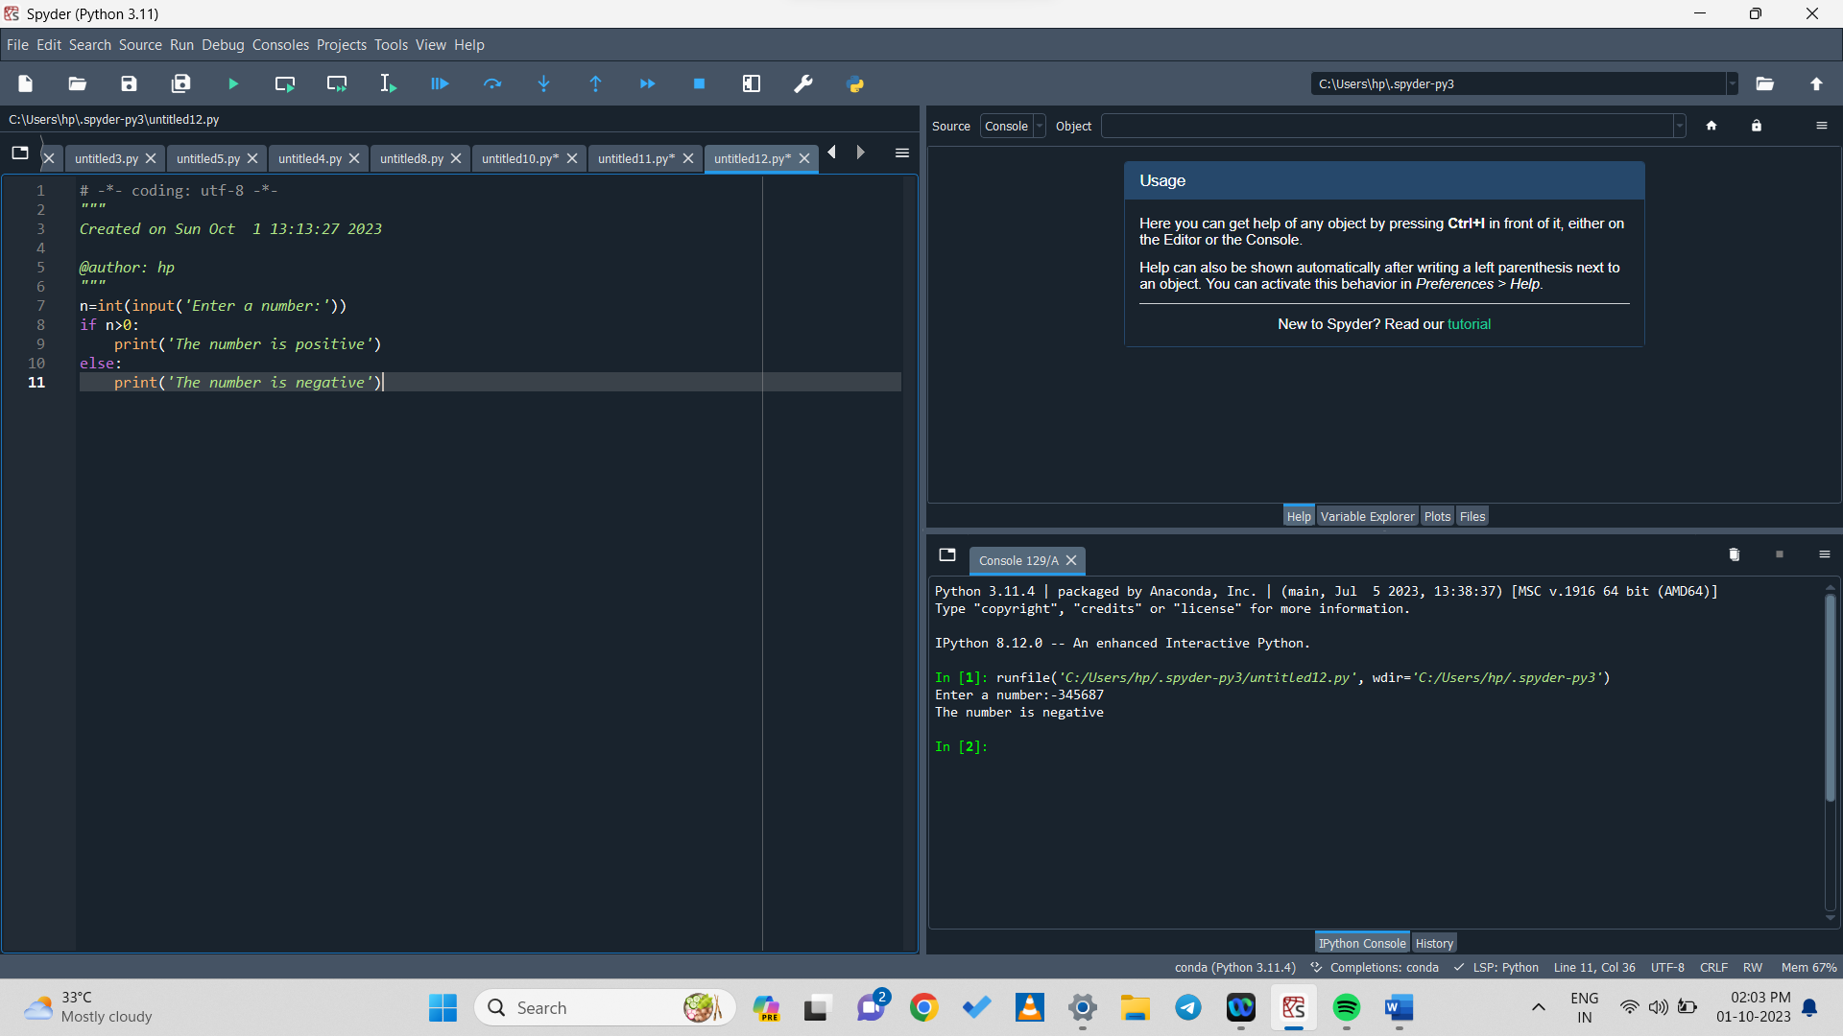

1. **LEAP YEAR CHECK:-**

year=int(input('Enter a year:'))

if (year%4) == 0:

print('It is a leap year')

else:

print('It is not a leap year')

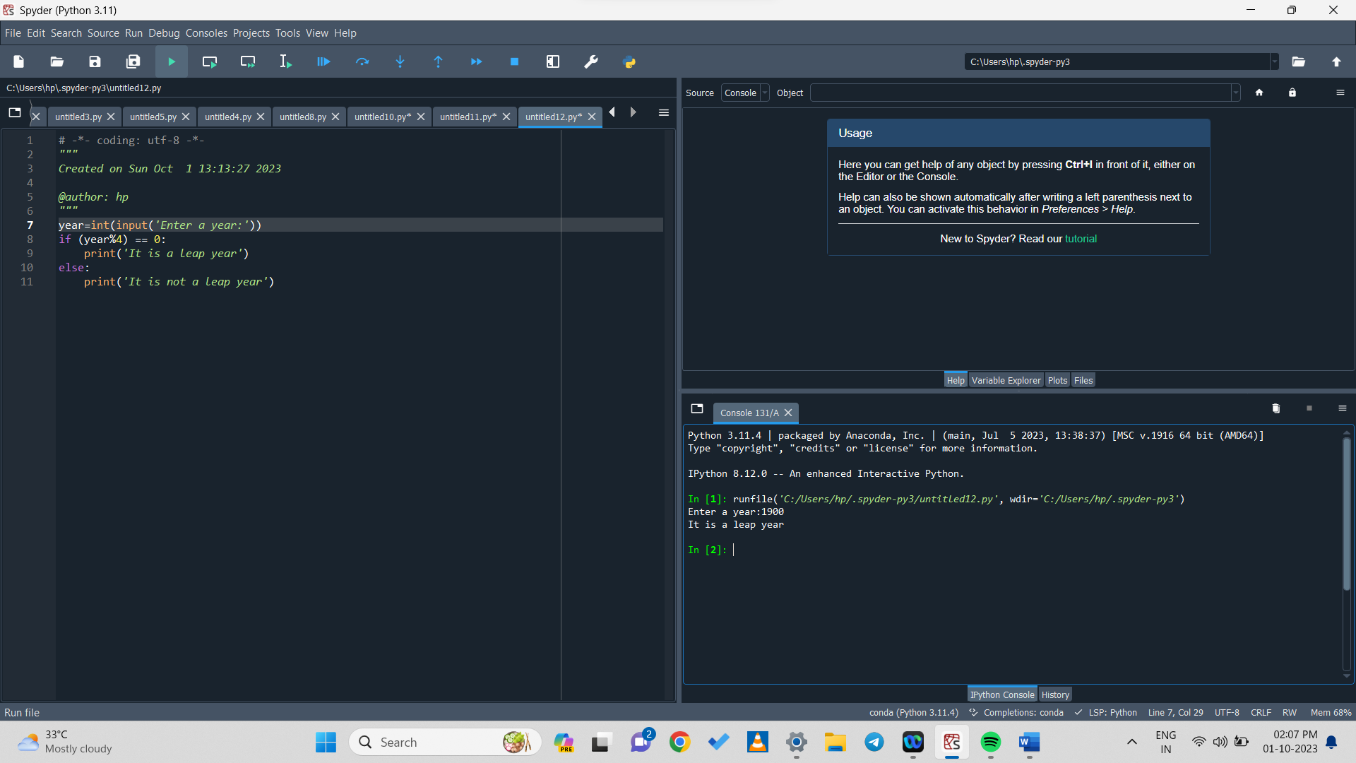

1. **HOMEWORK**

n=str(input('Enter your name:'))

s=str(input('Enter your surname:'))

a=int(input('Enter your age:'))

g=str(input('Enter your gender:'))

if (a>15):

print('hello, I am', n + s, '. My age is', a ,'and i am older than you.')

else:

('hello, I am', n + s, '. My age is', a ,'and i am younger than you.')

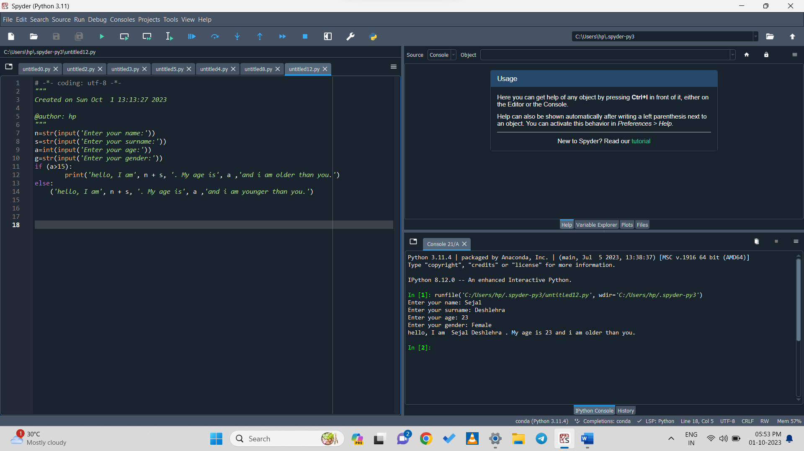

1. **Speed of a = 7m/sec , Speed of b = 3/sec. B has an extra start of 4 sec. When will they two meet?**

a=int(input('Enter the speed:'))

b=int(input('Enter the speed:'))

c=int(input('how many seconds prior does b started:'))

d=int(b*c)/(a-b)

print('a and b will meet after', d ,'sec.')

