1. **Test to check if a user can successfully login to the application.**

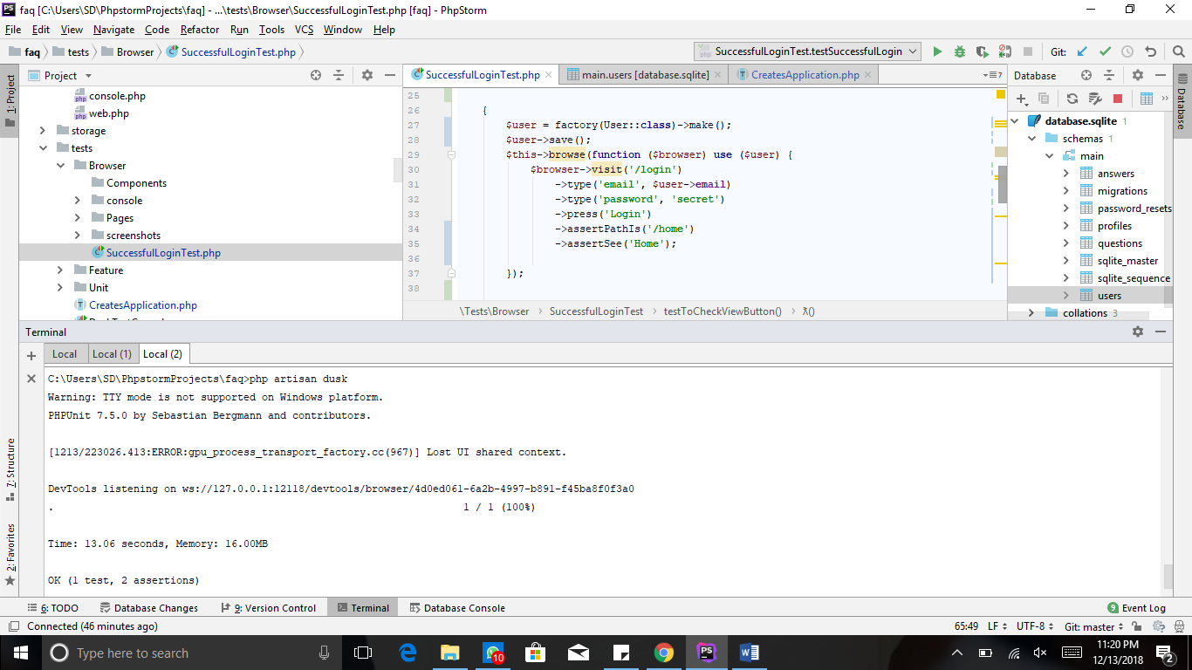

**View the results in the database.**

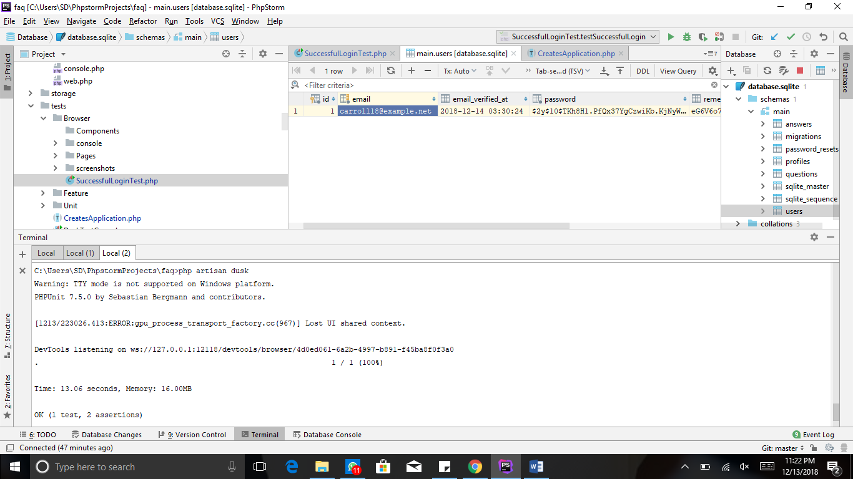

1. **Test to check if a user can successfully add a question.**

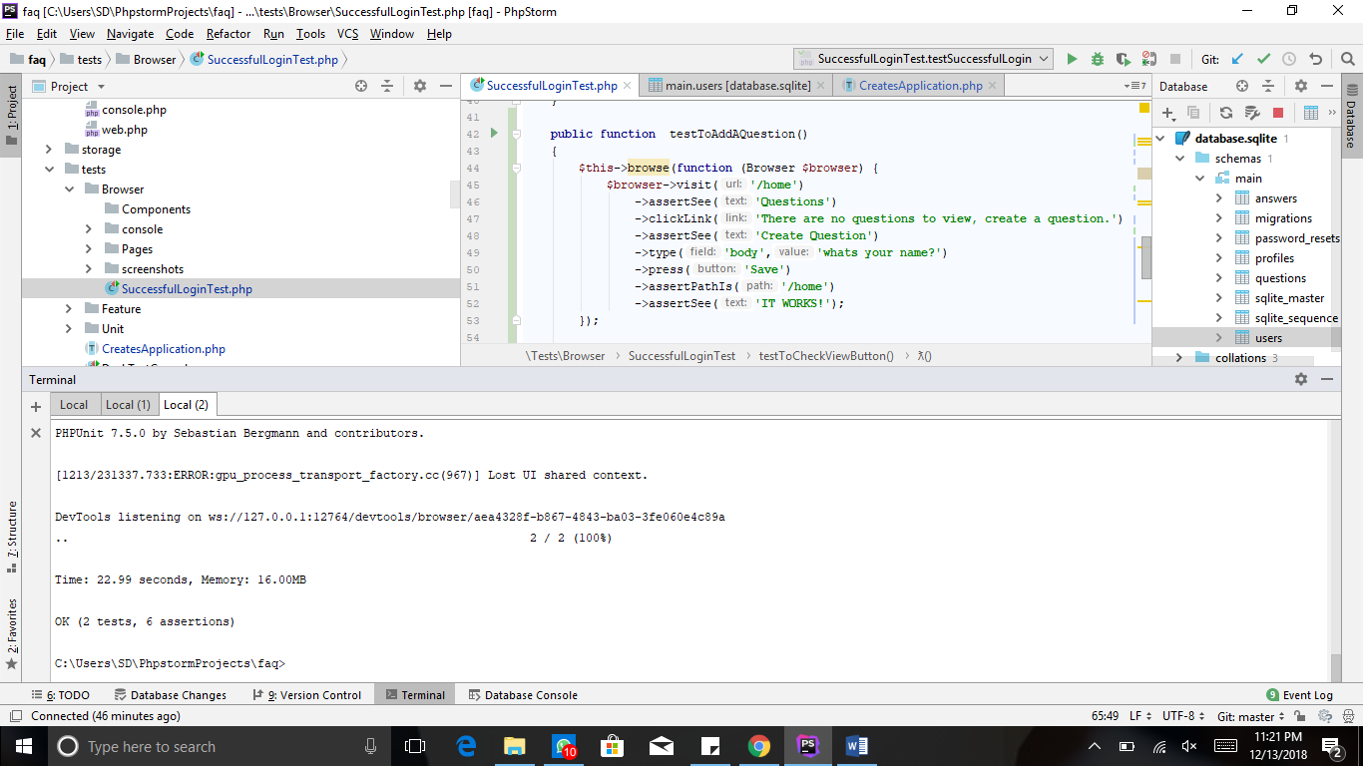

**View Results in the database.**

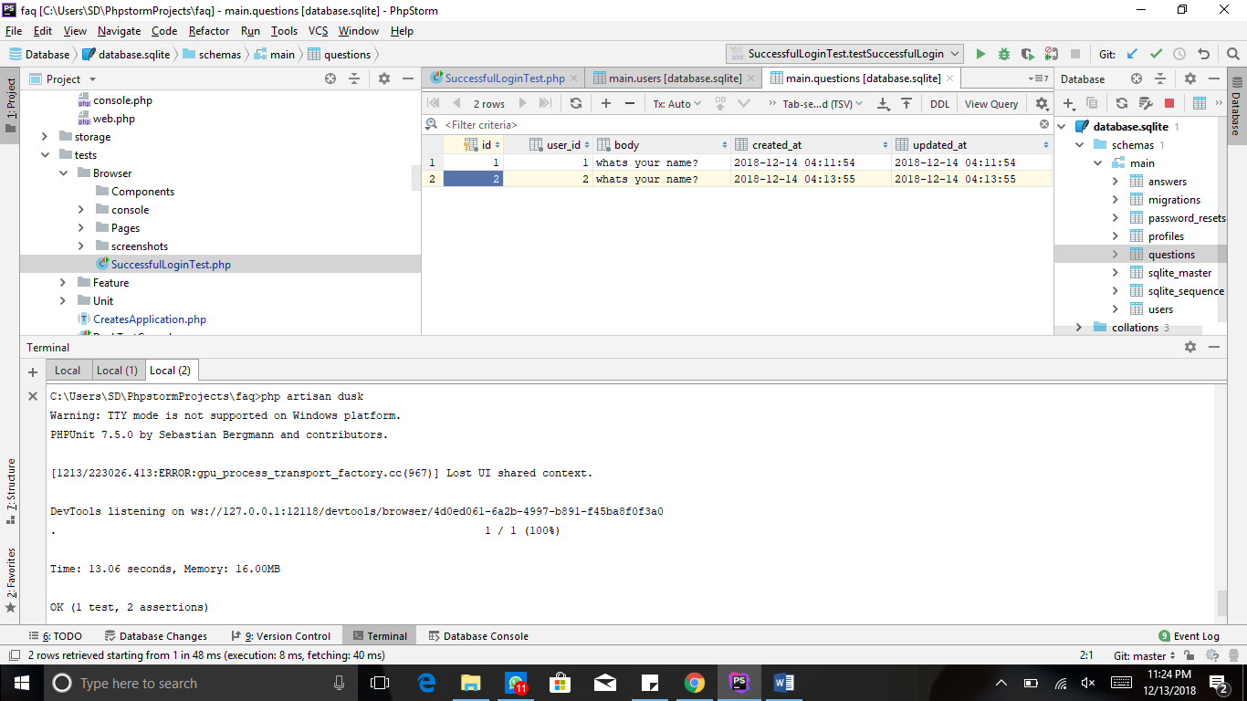

1. **Test to check if the user can view the question after clicking on view.**

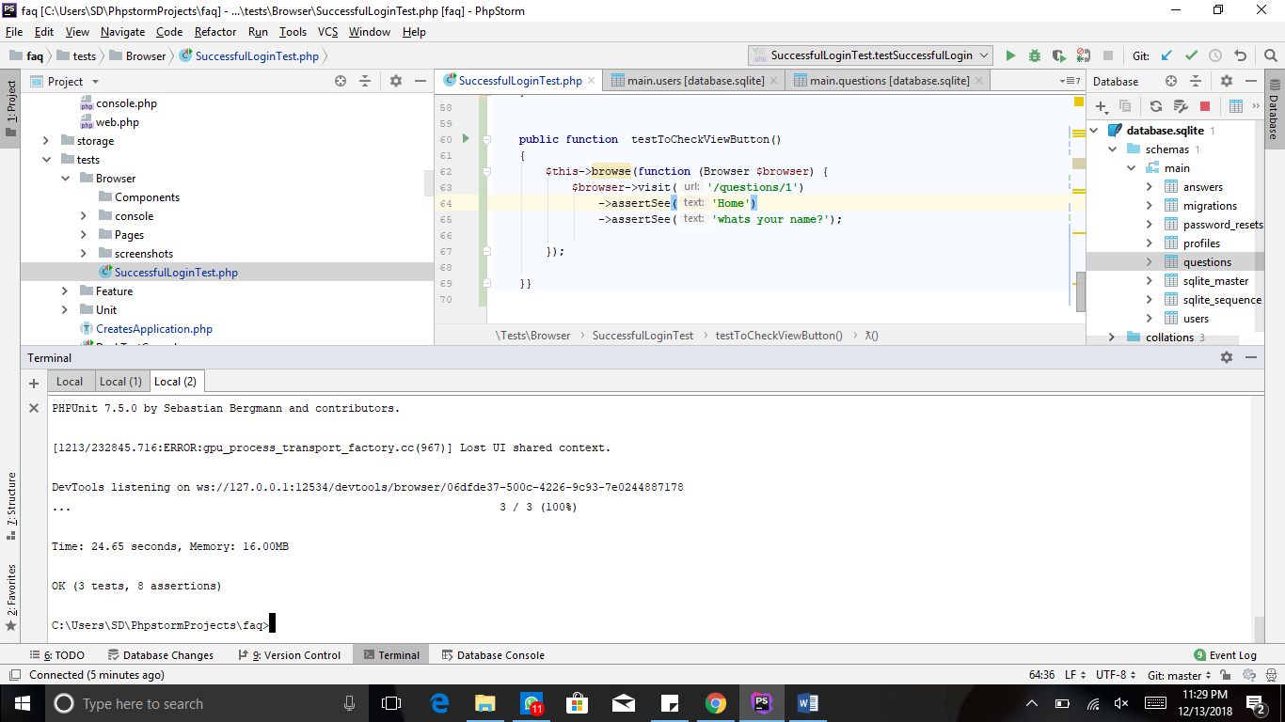

1. **Test to check if a user can successfully edit a question.**

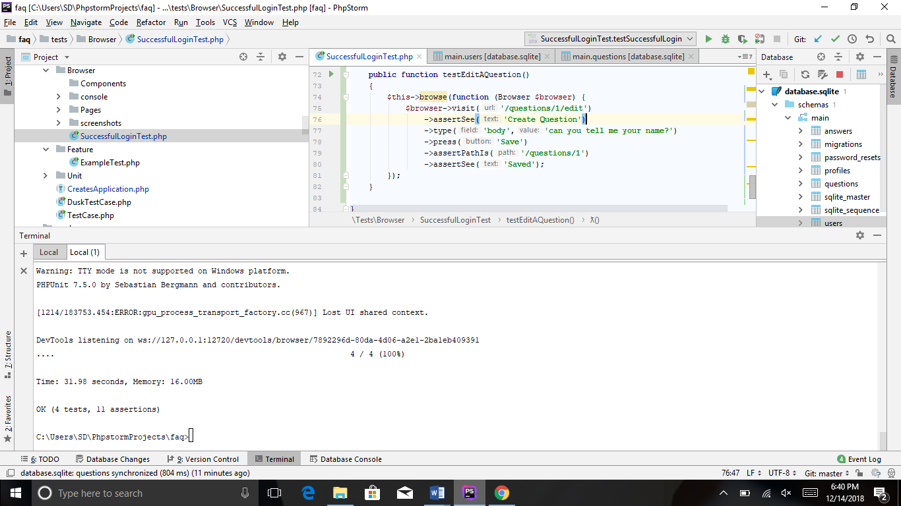

**View results in the database.**

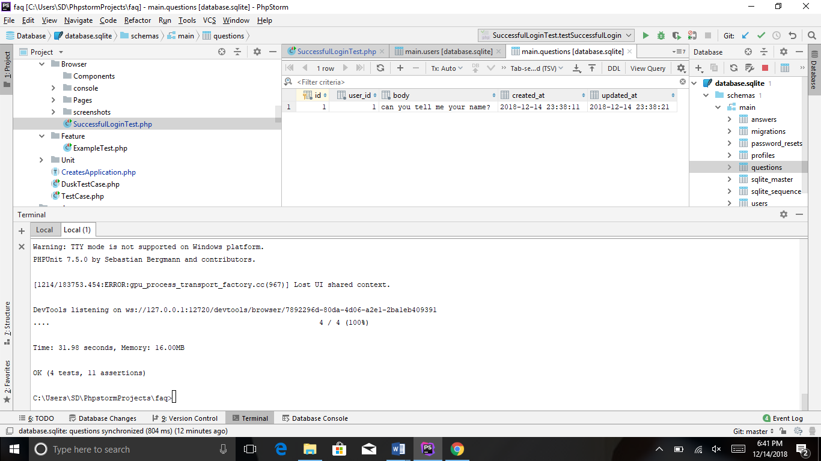

1. **Test to check if a user can answer a question.**

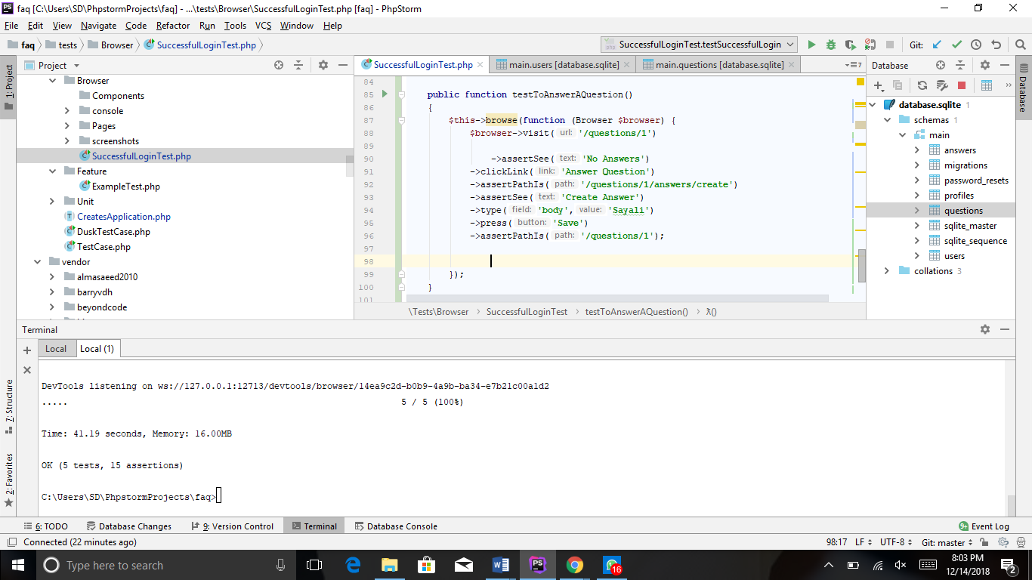

**View results in the database.**

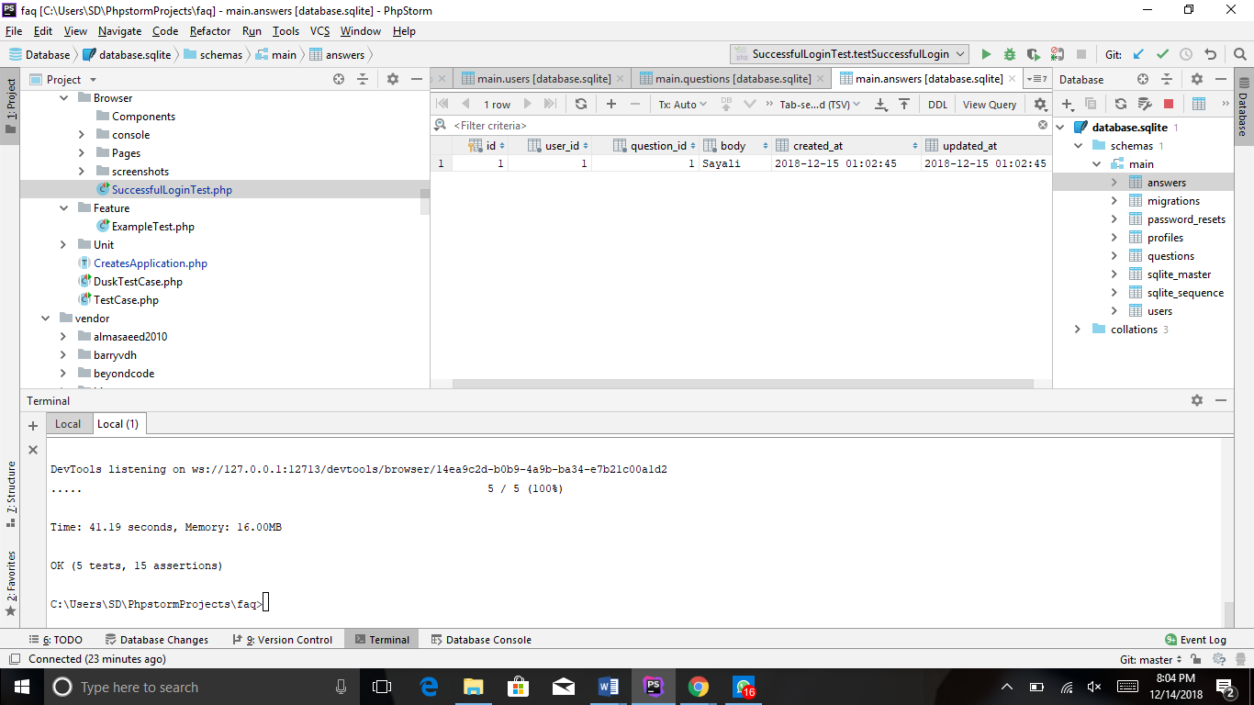

1. **Test to check if the user can view the answer in the application.**

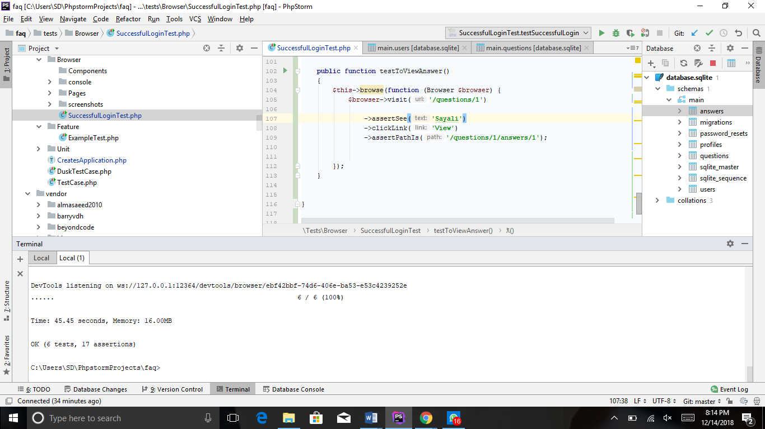

1. **Test to check if a user can edit an answer.**

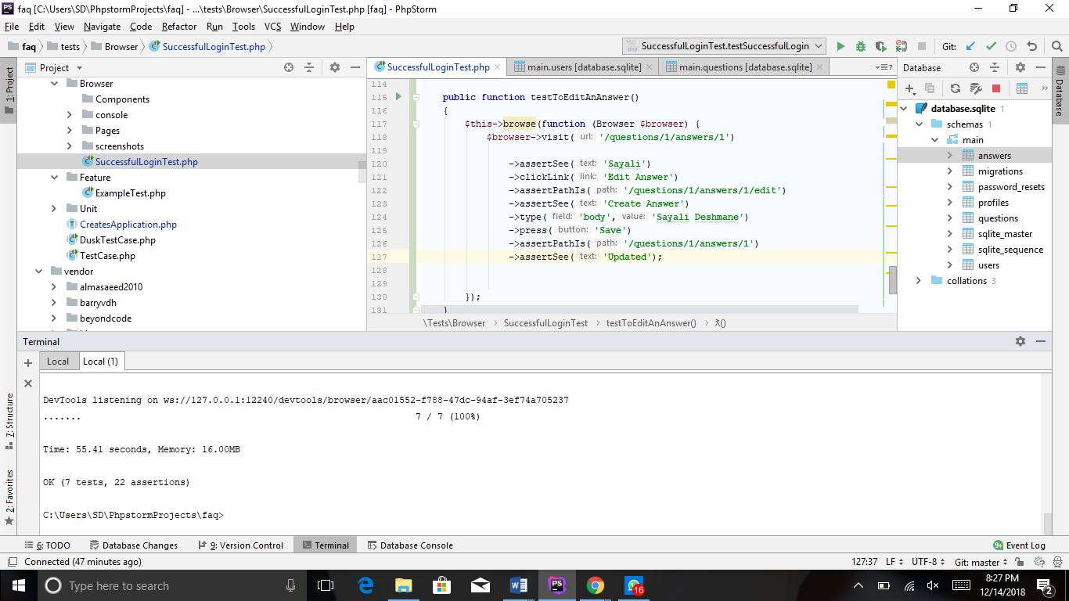

**View results in the database.**

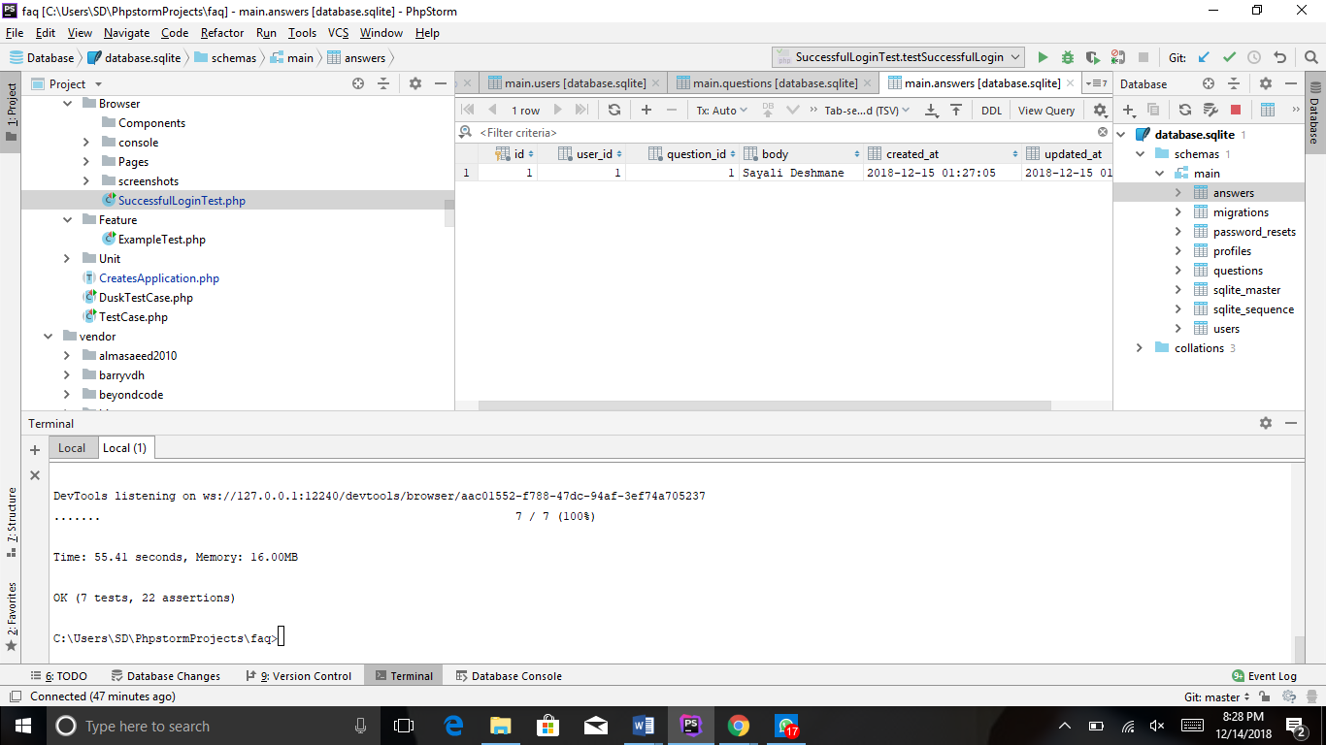

1. **Test to check if a user can delete an answer.**

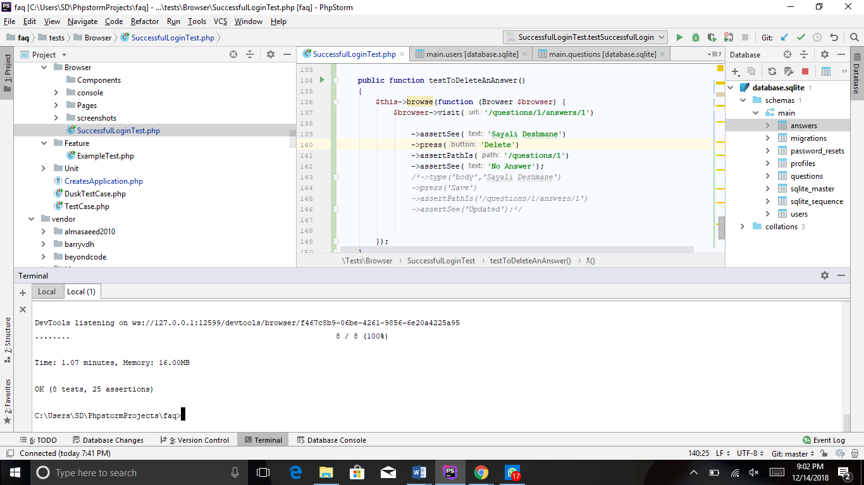

**View results in the database.**

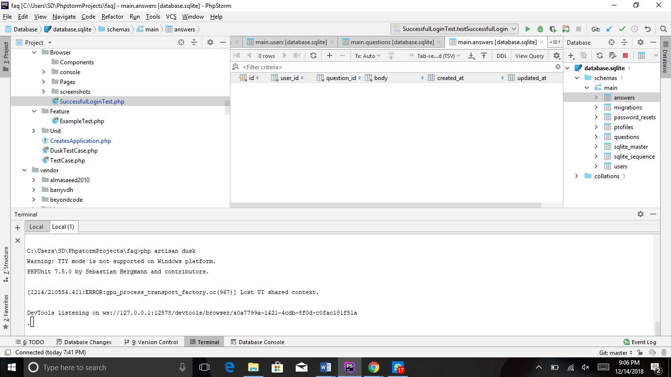

1. **Test to check if a user can delete a question.**

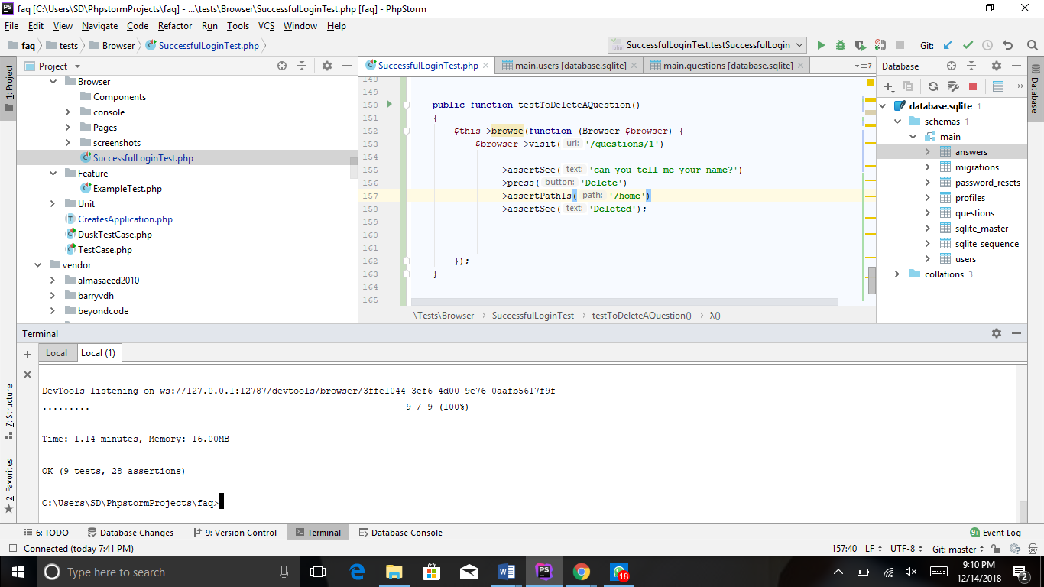

**View results in the database.**

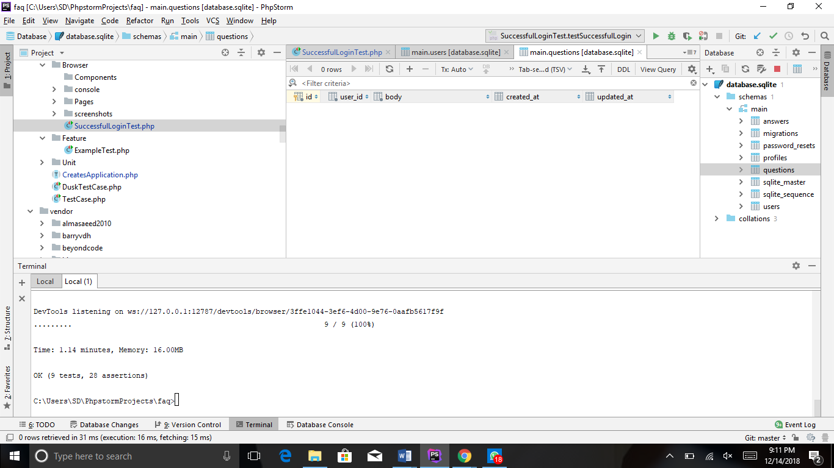

1. **Test to check if the user can successfully delete an answer.**



**View results in the database.**



1. **Test to check if a user can successfully logout of the application.**

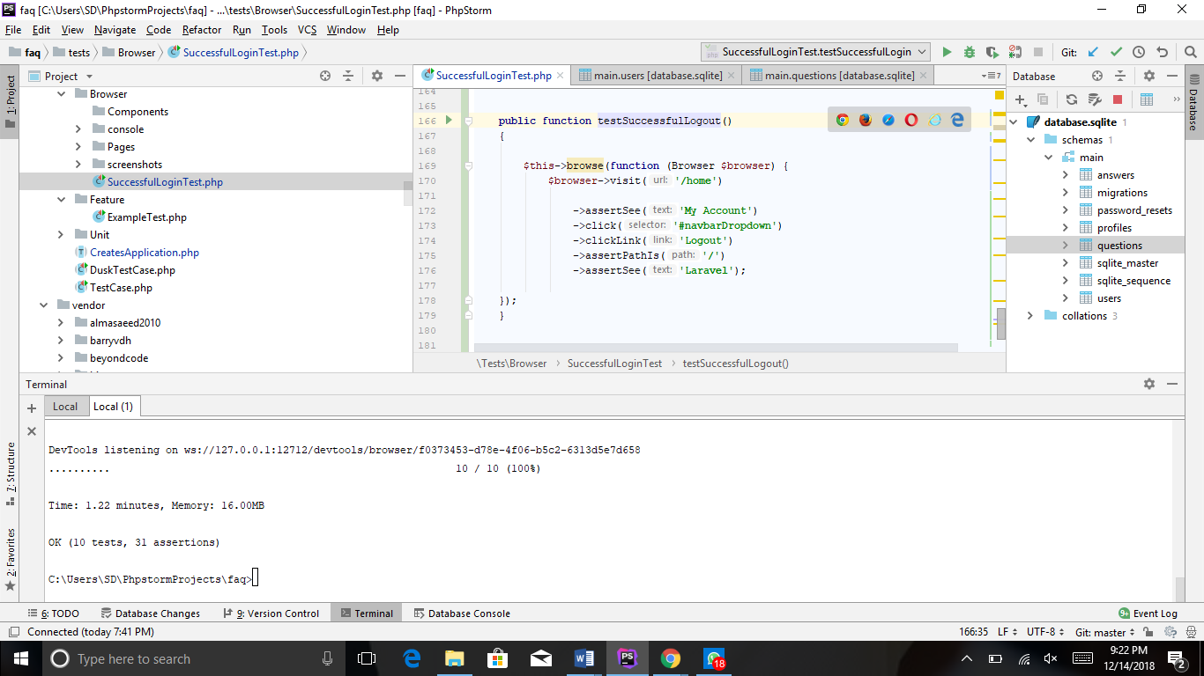

1. **Test to Register a new user into the application.**

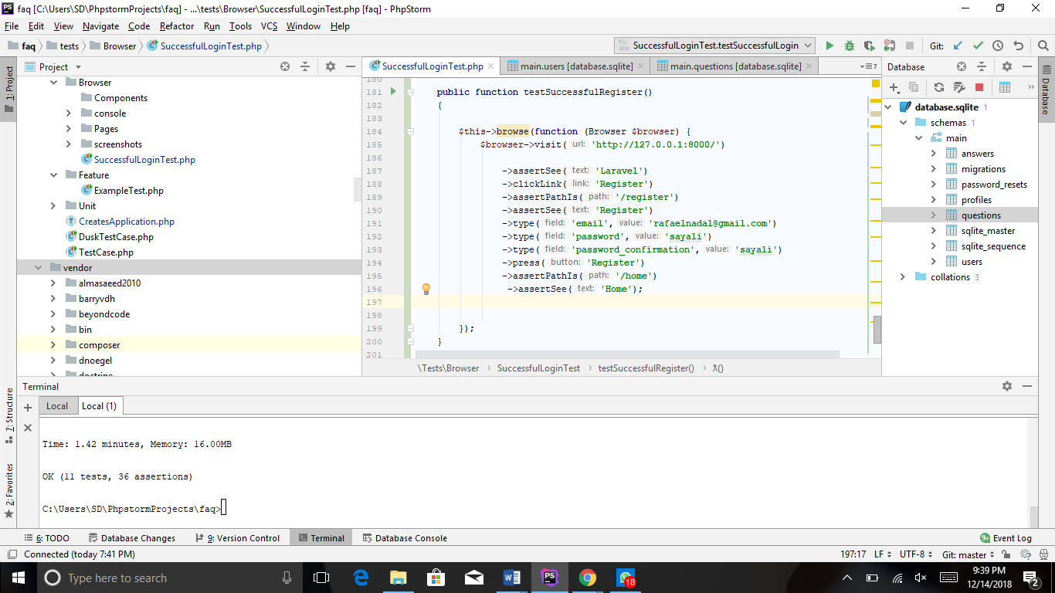

**View results in the database.**

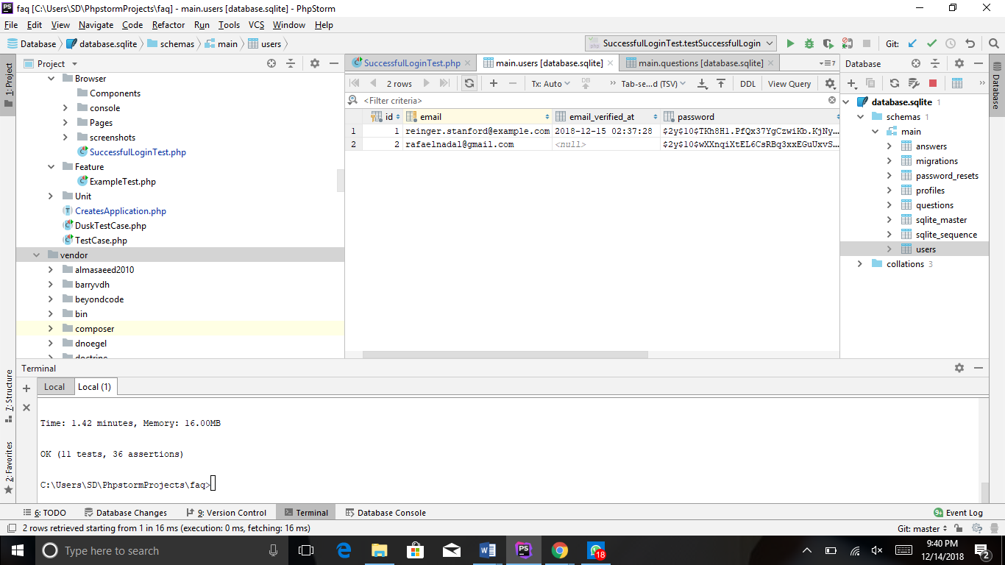

1. **Test to check if a profile can be created for a new user.**

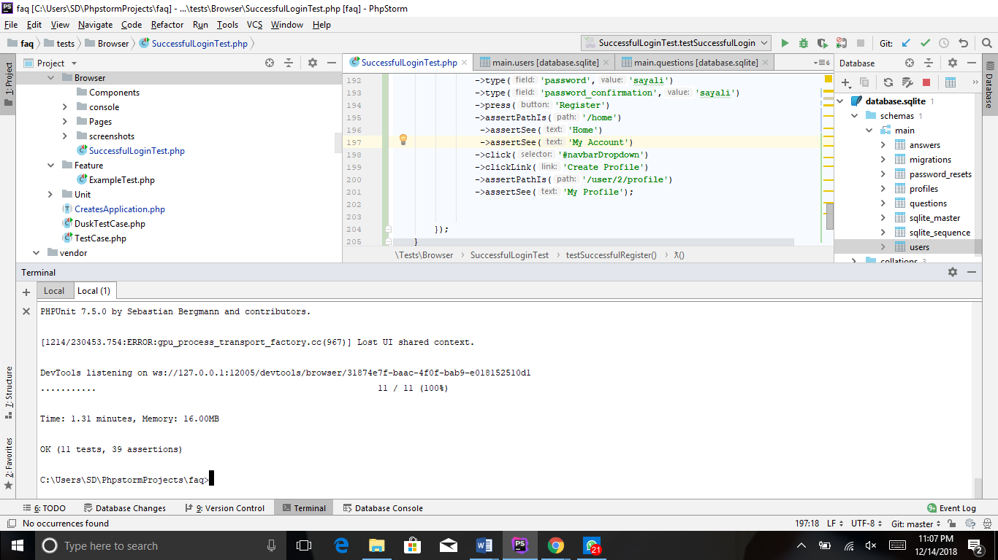

1. **Test to check if a user profile can be created by entering his credentials.**

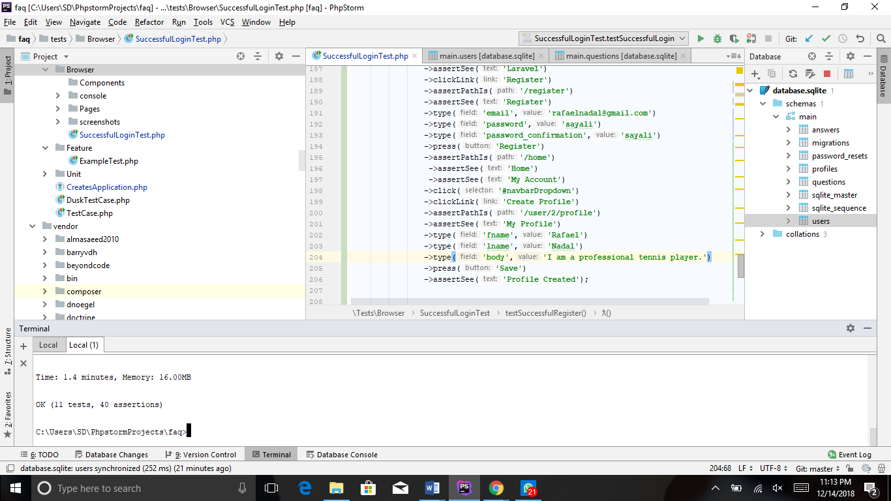

**View results in the database.**

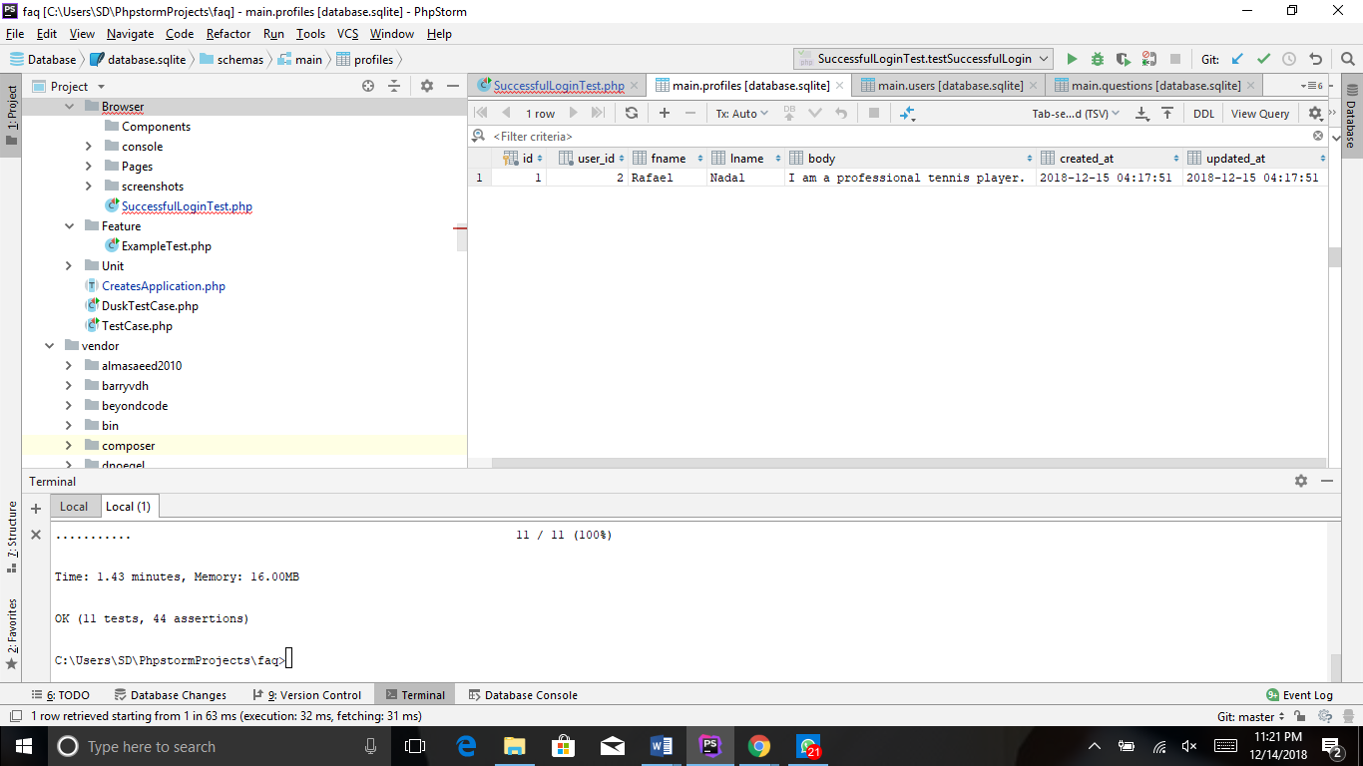

1. **Test to check if the user profile can be viewed on clicking the view button.**

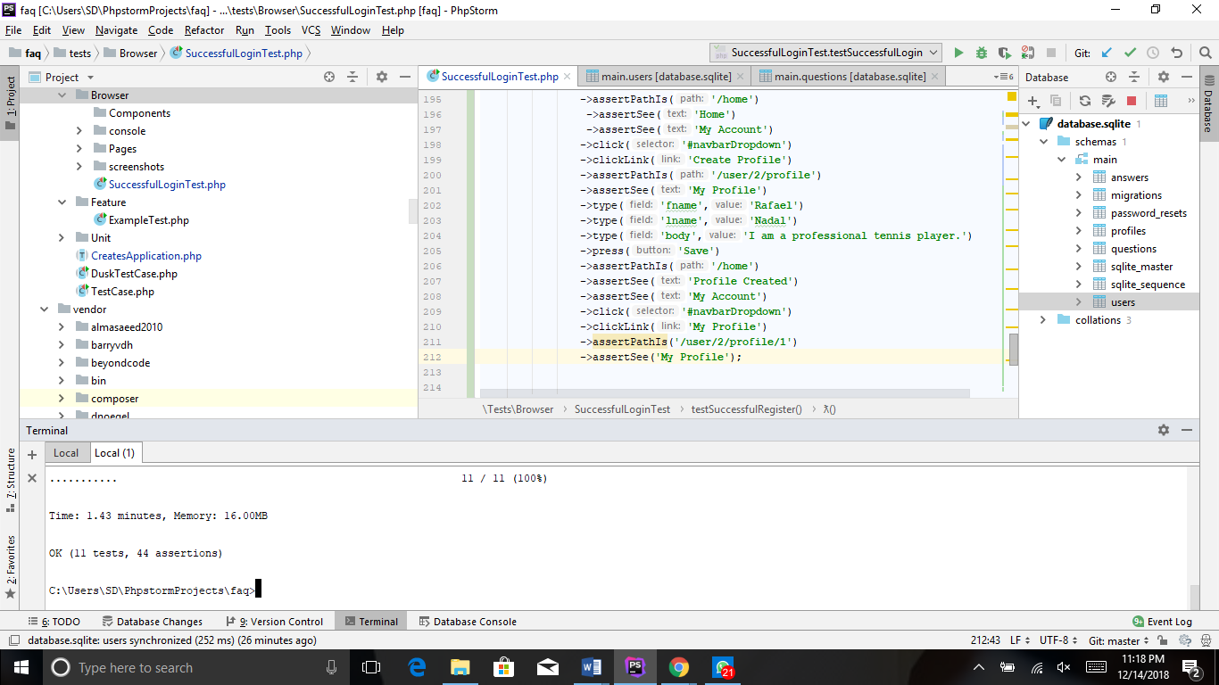

1. **Test to check if the user can update/edit his existing profile.**

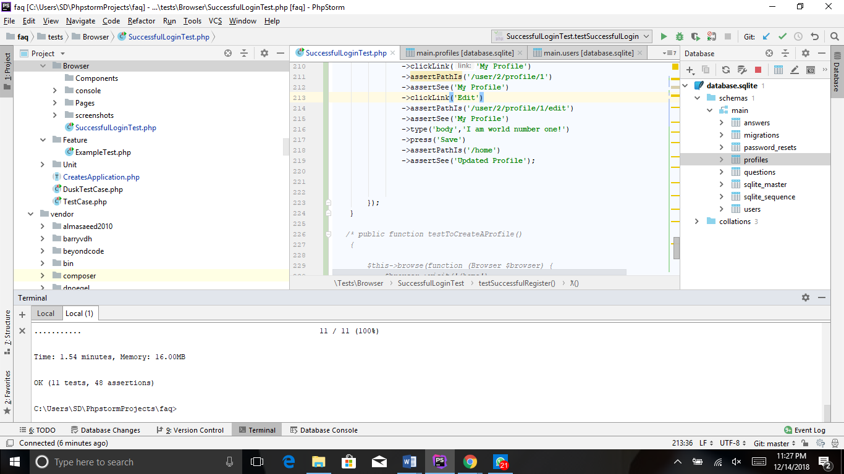

**View results in the database.**

