# Phase 2: Org Setup & Configuration - Smart Task & Email Summarizer for Executives

Purpose: This document is a step-by-step hands-on guide to set up a Salesforce Org for your project, with clear instructions, checklists, and placeholders where you should attach screenshots. Follow each step in order to minimize errors.

## A. Prerequisites (Before you begin)

- A valid Salesforce account (Developer Edition or company org).  
- Admin access in the org you will configure.  
- Access to the email account(s) you'll link for testing (Gmail/Outlook).  
- PC with a browser (Chrome recommended), and ability to install Salesforce CLI (optional but recommended).  
- A directory on your PC to store project screenshots named: ProjectScreenshots_Phase2/.

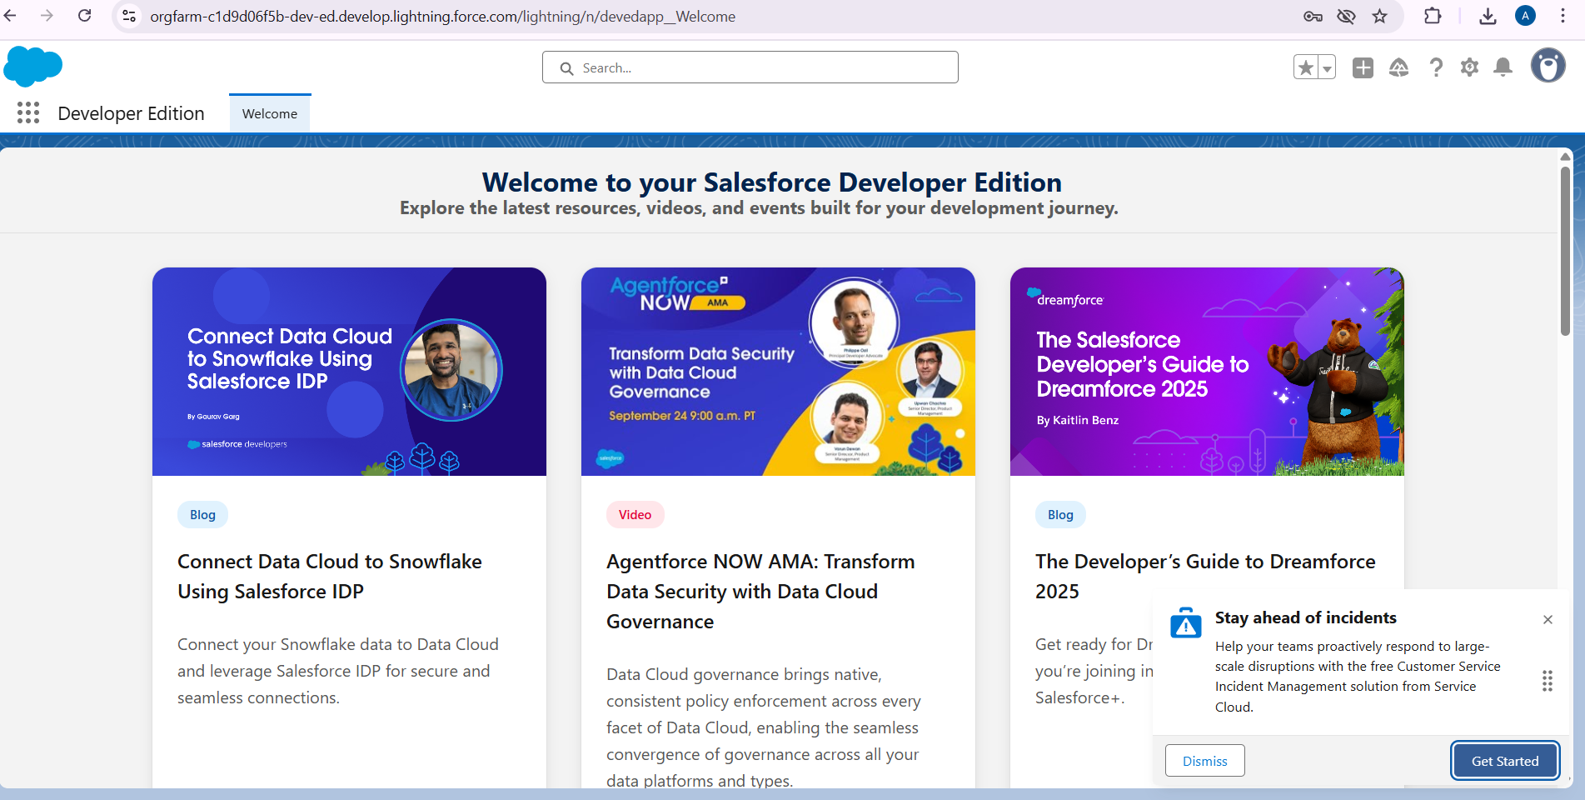

## 1. Salesforce Editions — choose the right edition

Why this matters:  
- Different Salesforce editions (Essentials, Professional, Enterprise, Unlimited) provide different features and limits. For most development and advanced automation (APIs, Sandboxes, Change Sets), Enterprise or higher is recommended; Developer Edition is fine for learning and the project prototype.  
  
How to check your edition:  
1. In Salesforce Setup, search for and open Company Information.  
2. Look for Organization Edition and Organization ID.  
  
What to capture (screenshot):  
- [Insert screenshot: 1_CompanyInformation.png] — capture the Organization Edition line. 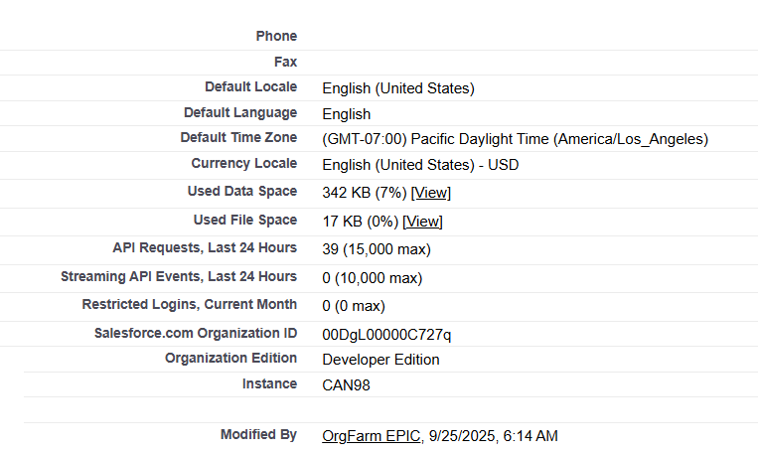

## 2. Company Profile Setup (Company Information)

Steps (hands-on):  
1. Setup → Quick Find → Company Information.  
2. Click Edit if you need to update address, phone, default locale, default time zone.  
3. Confirm the Default Locale, Language, and Currency, as these affect date/number formatting in reports.  
  
Tips:  
- Use the legal company name and exact address to avoid confusion in audit logs.  
  
Screenshot to attach:  
- [Insert screenshot: 2_CompanyInformation_Edit.png] (after you click Edit showing filled fields)

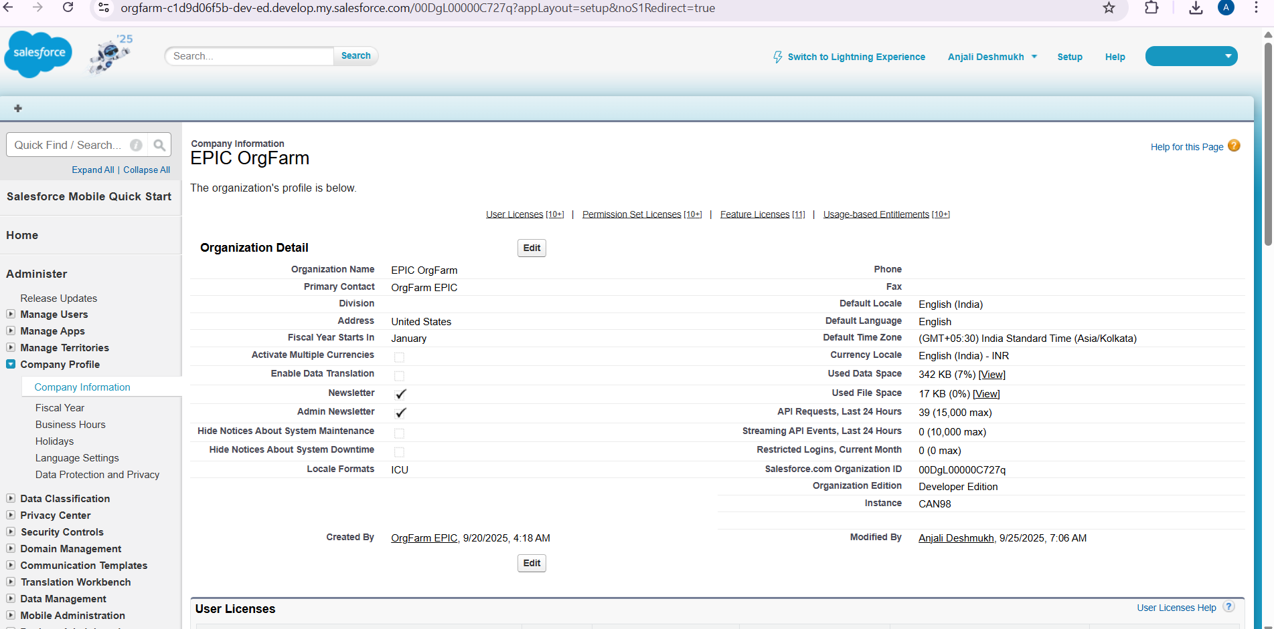

## 3. Business Hours & Holidays

Purpose: Business Hours influence Escalation Rules and case assignment timing.  
Steps:  
1. Setup → Quick Find → Business Hours → New.  
2. Create your organization's primary business hours (name, time zone, open/close times, holidays).  
3. Setup → Quick Find → Holidays → New to add public holidays.  
  
Screenshot to attach:  
- [Insert screenshot: 3_BusinessHours_List.png] (list view)  
- [Insert screenshot: 3_BusinessHours_Edit.png] (detail of created hours)

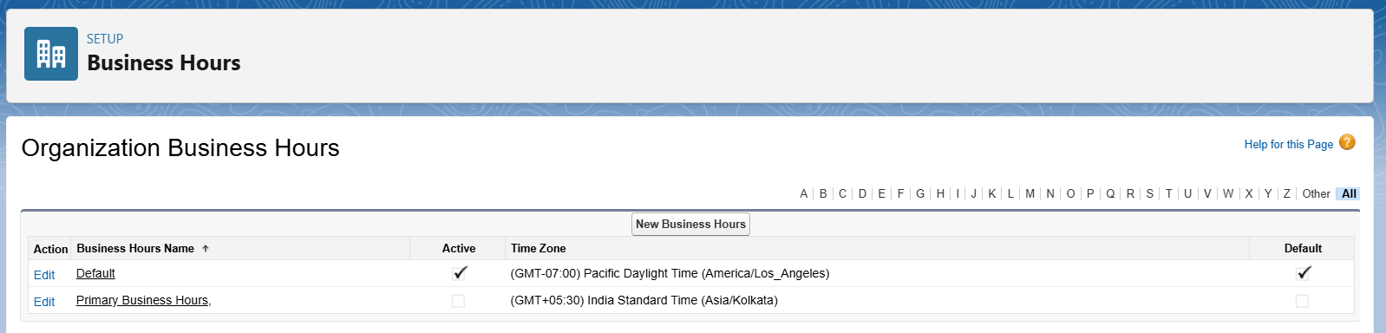

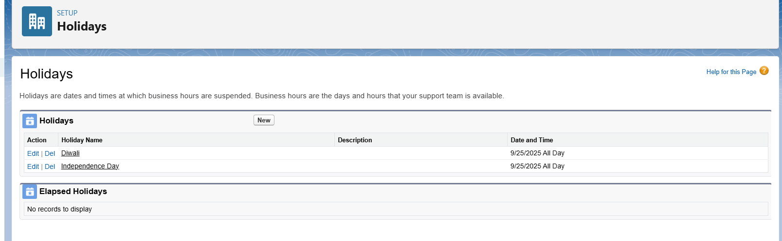

## 4. Fiscal Year Settings

Purpose: Set reporting quarters and fiscal calculations correctly.  
Steps:  
1. Setup → Quick Find → Fiscal Year.  
2. If your organization follows a standard Gregorian 12-month fiscal year, use the Standard Fiscal Year option and set the start month.  
3. If your business uses non-standard periods (13-week quarters or non-monthly boundaries), use Custom Fiscal Year (note: custom fiscal years are irreversible and can break some managed packages). Document this before changing.  
  
Screenshot to attach:  
- [Insert screenshot: 4_FiscalYear_Settings.png]

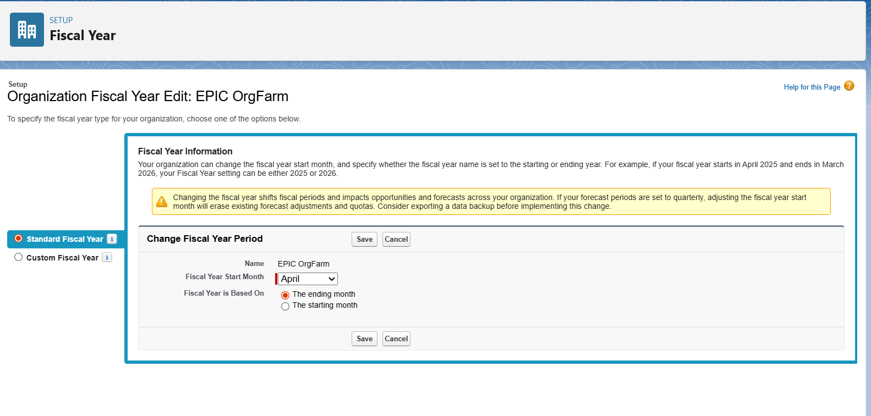

## 5. User Setup & Licenses

Purpose: Create users with the correct license types for your project's needs.  
Steps:  
1. Setup → Quick Find → Users → Users → New User (or Activate existing users).  
2. Choose the appropriate User License (Salesforce, Salesforce Platform, Chatter Free, etc.).  
3. Fill in required fields: First Name, Last Name, Alias, Email, Username (must be unique across Salesforce), Nickname, Role, Profile, and Active checkbox.  
  
Best practices:  
- Reserve full Salesforce licenses for admins and power users.  
- For testing, use Developer Edition or spare licenses in a sandbox.  
  
Screenshot to attach:  
- [Insert screenshot: 5_NewUser_Form.png] (after filling the form but before saving).

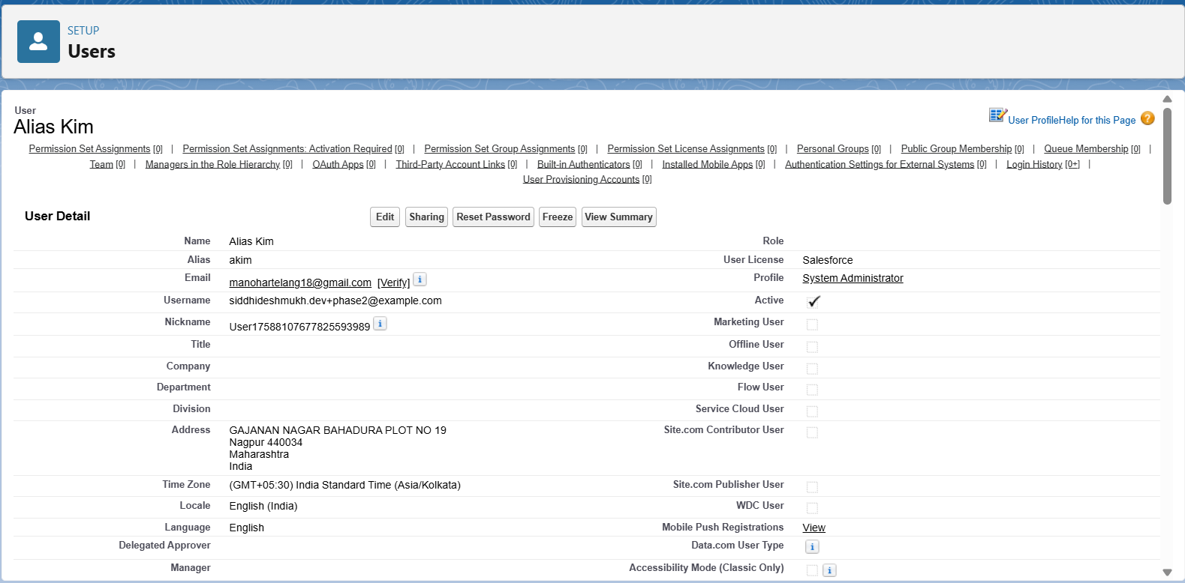

## 6. Profiles

Purpose: Profiles define baseline object and system permissions.  
Steps (create/adjust profile):  
1. Setup → Quick Find → Profiles → click the profile name (or New Profile to clone an existing one).  
2. Configure Object Settings, Field-Level Security, Login Hours, and IP Ranges as needed.  
3. Keep profiles minimal: give only baseline permissions necessary.  
  
Screenshot to attach:  
- [Insert screenshot: 6_Profiles_List.png]  
- [Insert screenshot: 6_Profile_ObjectSettings.png]

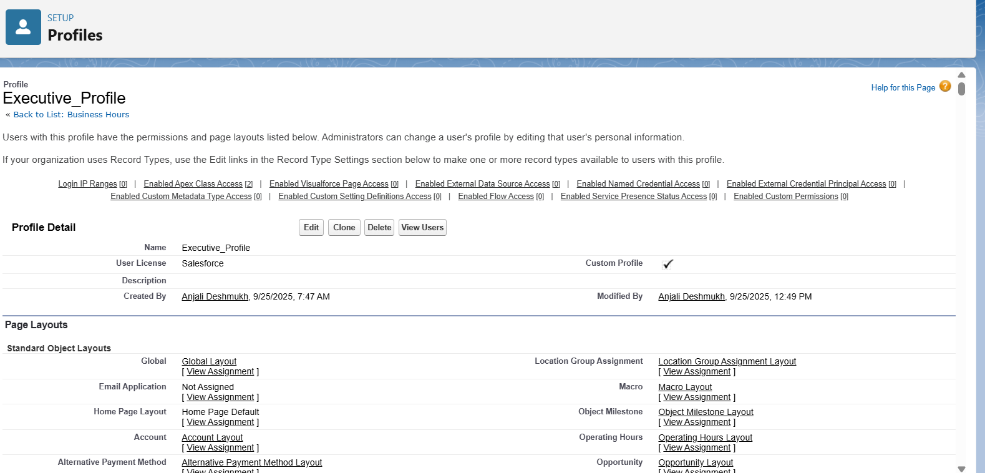

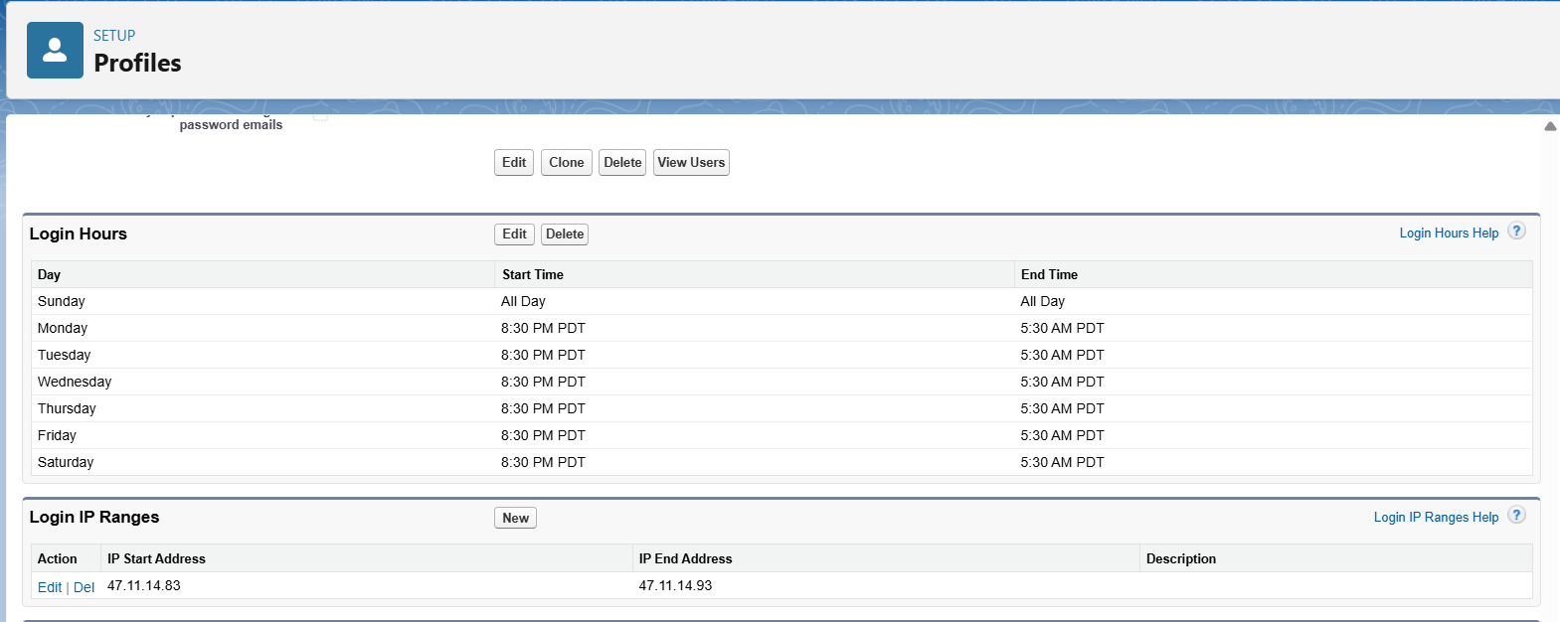

## 7. Roles (Role Hierarchy)

Purpose: Roles control record visibility via the role hierarchy.  
Steps:  
1. Setup → Quick Find → Roles → Set Up Roles.  
2. Create a clear hierarchy that reflects your organization's reporting lines (e.g., CEO > VP Sales > Regional Manager > Sales Rep).  
3. Assign users to roles when creating user records.  
  
Tips:  
- Keep the hierarchy focused on data visibility, not org chart details that don't affect record sharing.  
  
Screenshot to attach:  
- [Insert screenshot: 7_Roles_Hierarchy.png]

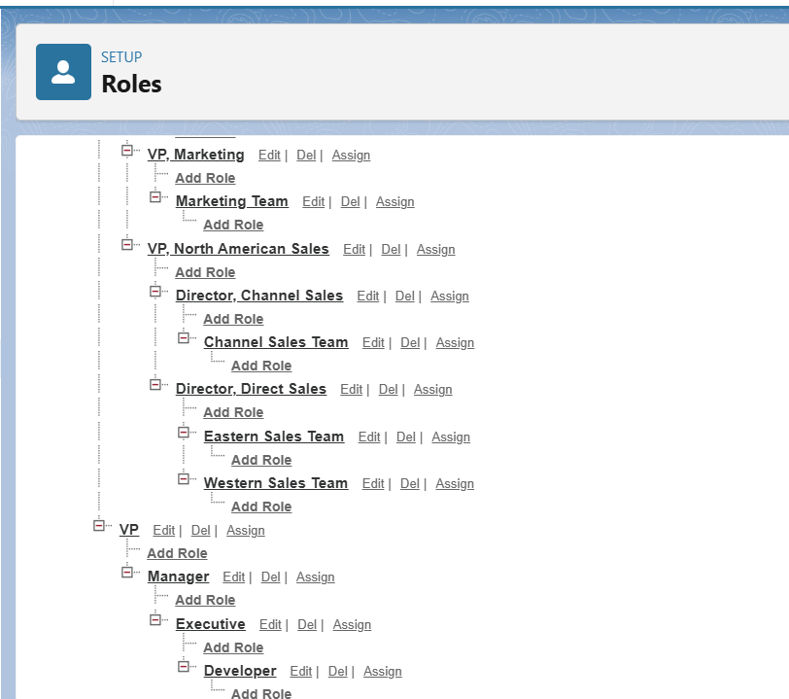

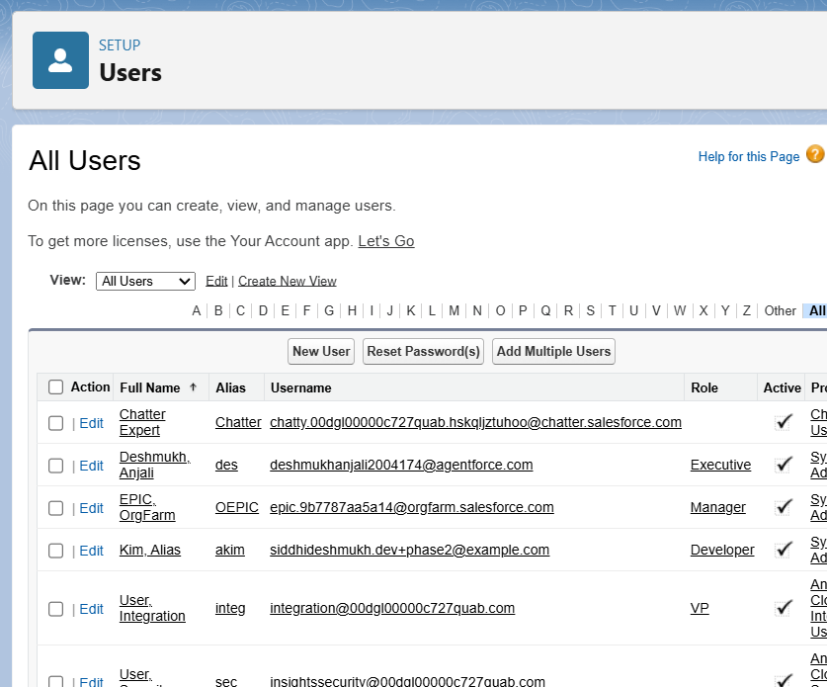

## 8. Permission Sets

Purpose: Permission Sets are additive permissions applied to users without changing their profile.  
Steps:  
1. Setup → Quick Find → Permission Sets → New.  
2. Name the permission set (e.g., 'Summarizer_Admin_Access'), set License (if required).  
3. Add granular permissions: Object Settings, Field Permissions, Apex Class Access, Visualforce Page Access, and System Permissions (e.g., 'Modify All Data' only if necessary).  
4. Assign permission sets to users via the Permission Set Assignment related list on the user record or via the Permission Set Assign page.  
  
Best practice:  
- Use permission sets to grant temporary or additional rights; use profiles for baseline.  
  
Screenshot to attach:  
- [Insert screenshot: 8_PermissionSet_Detail.png]  
- [Insert screenshot: 8_PermissionSet_Assign.png]

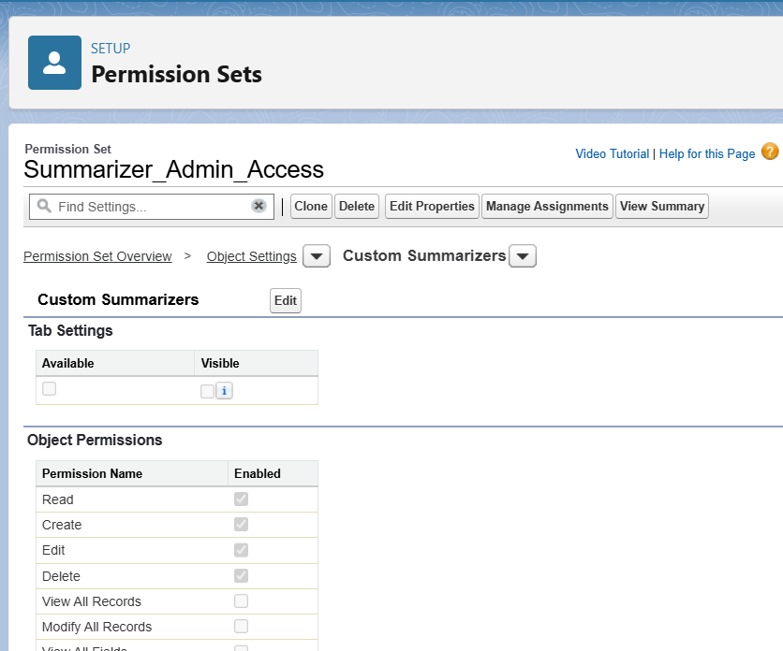

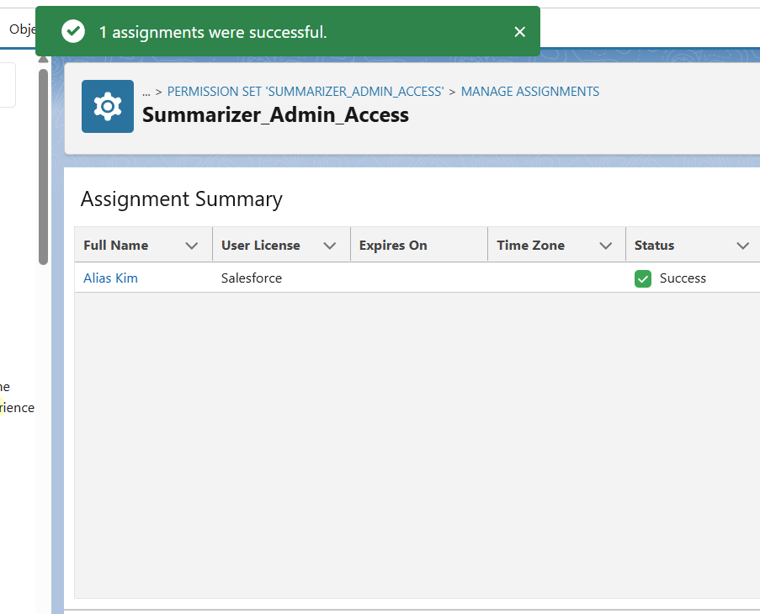

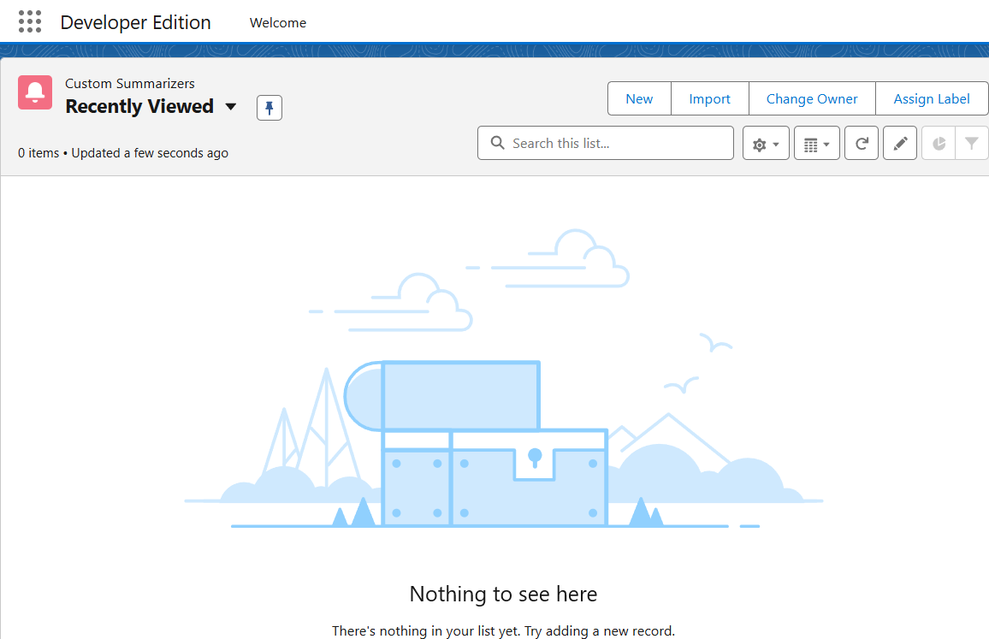

## 9. Organization-Wide Defaults (OWD)

Purpose: OWD sets the baseline record visibility for objects and is the most restrictive layer in the sharing model. You should plan OWD carefully before creating many records.  
Steps:  
1. Setup → Quick Find → Sharing Settings.  
2. Click Edit in the Organization-Wide Defaults area and set default access per object (Private, Public Read Only, Public Read/Write, Controlled by Parent).  
  
Tips:  
- Start with restrictive defaults (Private) and then open visibility using Role Hierarchy, Sharing Rules, and Permission Sets.  
  
Screenshot to attach:  
- [Insert screenshot: 9_SharingSettings_OWD.png]

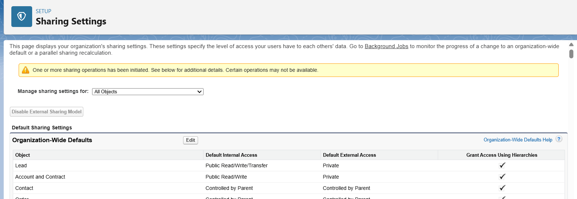

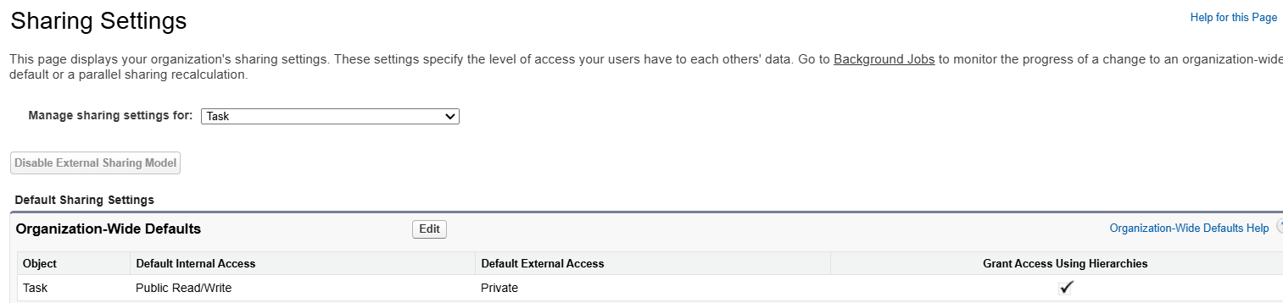

## 10. Sharing Rules

Purpose: Use sharing rules to expand access beyond OWD for particular groups or criteria.  
Types of sharing rules:  
- Owner-based sharing: share records owned by users in a role/public group.  
- Criteria-based sharing: share records matching certain field criteria.  
  
Steps:  
1. Setup → Quick Find → Sharing Settings → scroll to the object → New under Sharing Rules.  
2. Choose rule type, criteria or owner, and specify target users (Roles, Roles and Subordinates, Public Groups).  
  
Screenshot to attach:  
- [Insert screenshot: 10_SharingRule_Create.png]  
- [Insert screenshot: 10_SharingRule_List.png]

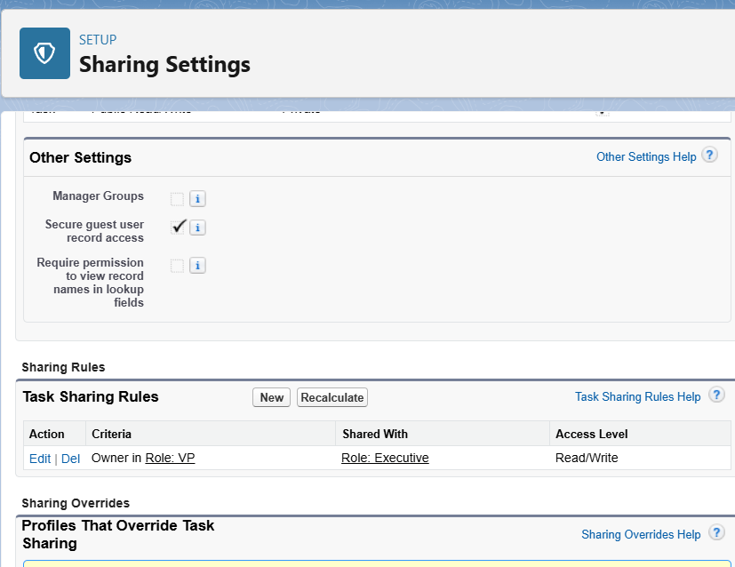

## 11. Login Access Policies & Security

Items to configure:  
- Session Settings (Timeouts): Setup → Quick Find → Session Settings.  
- Login IP Ranges for Profiles: in Profile settings → Login IP Ranges.  
- Login Hours for Profiles: in Profile settings → Login Hours.  
- Connected App policies (for integrations).  
- Two-Factor Authentication (2FA) enforcement for admins (recommended in production).  
  
Screenshot to attach:  
- [Insert screenshot: 11_SessionSettings.png]  
- [Insert screenshot: 11_Profile_LoginIP.png]

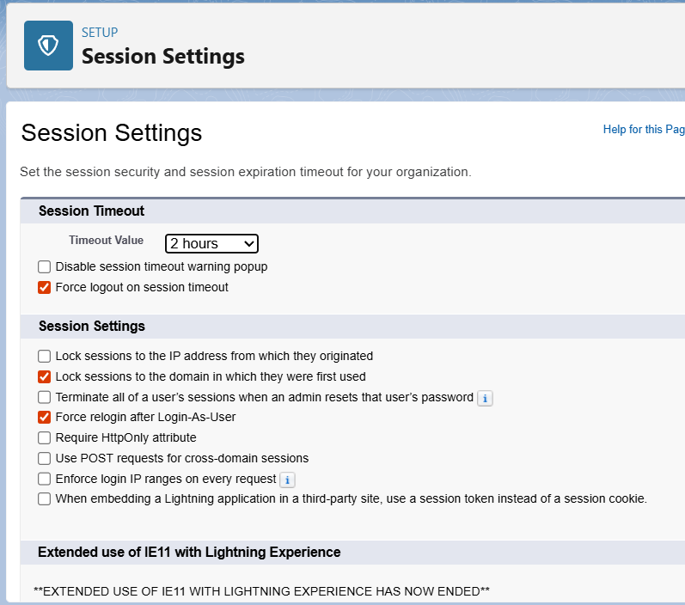

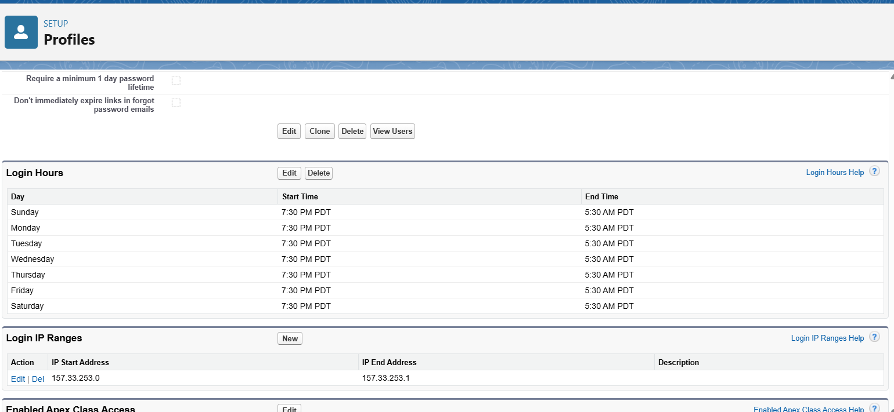

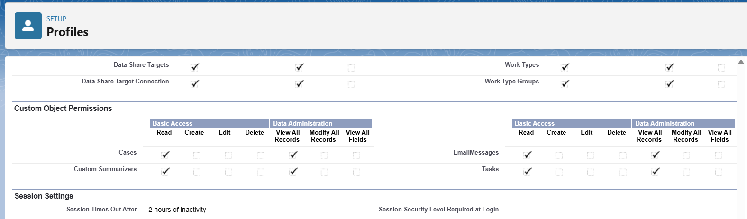

## 12. Dev Org Setup (Developer Edition)

Why use a Developer Org:  
- Developer Edition is free and provides most features for development and testing without impacting production.  
  
Steps:  
1. Go to https://developer.salesforce.com and sign up for a Developer Edition if you don't already have one.  
2. Note the username and password in a secure place.