# Phase 4 — Process Automation (Admin)

Project: Smart Email & Task Summarizer for Executives

## Overview (keep it minimal)

This document lists only the necessary, step-by-step actions to implement Phase 4 (Process Automation) for the Booking / Rental Booking object in Salesforce. Follow the steps in your Sandbox/Developer org, capture screenshots at the indicated steps, paste them into the screenshot placeholders, and then run the tests.

## Quick Checklist (must-do items)

* Create Validation Rule: End Date cannot be before Start Date (covers empty-checks).
* Create Record-Triggered Flow (Before-Save) to calculate Total Amount.
* Create Approval Process (or Flow-based approval) for bookings > ₹50,000.
* Add Final Approval Actions: Field Update (Status = Confirmed), Email Alert to customer, Create Task for Agent, Send Custom Notification to Agent.
* Create Screen Flow for manual booking creation (optional fast UI).
* Create Email Template(s) and Email Alerts used by the Approval Process/Flow.
* Create Notification Type and use Flow action 'Send Custom Notification'.
* Test end-to-end in Sandbox, capture screenshots for every completed step, embed them in this docx.

## Detailed Steps (necessary only — copy/paste where possible)

### 1) Validation Rule — End Date must be after Start Date

Where: Setup → Object Manager → Rental Booking (or Booking) → Validation Rules → New

Create a new validation rule with:

1. Rule Name: End_Date_After_Start_Date (or similar)
2. Formula (use this exact formula):

AND(  
 NOT(ISBLANK(Start_Date__c)),  
 NOT(ISBLANK(End_Date__c)),  
 End_Date__c < Start_Date__c  
)

Error Message: "End Date cannot be before Start Date."

Error Location: End Date (or Top of Page)

Screenshot: Take a screenshot after saving the validation rule — filename: 01_ValidationRule.png. Paste it below the "Validation Rule" heading in this docx and upload the same file to the Booking record Files related list.

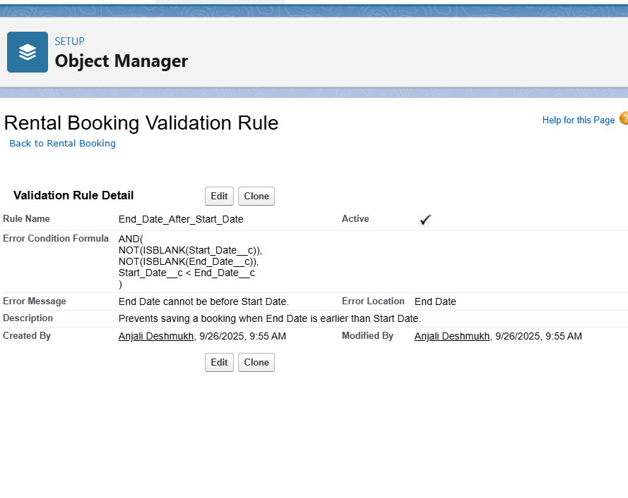

### 2) Record-Triggered Flow — Calculate Total Amount (Before-Save)

Where: Setup → Flow → New Flow → Record-Triggered Flow

Trigger: Object = Rental Booking; Trigger the Flow when: A record is created or updated; Run the Flow: Before Save (fast field update)

Purpose: Compute and set Total_Amount__c = (number-of-days) × Daily_Rate__c. Use a Formula Resource or Assignment.

1. Steps (quick):
2. Start: Select object 'Rental Booking'. Choose 'A record is created or updated'. Choose 'Before Save'.
3. Create a Formula Resource (Number) named Days_Booked: {!$Record.End_Date__c} - {!$Record.Start_Date__c} + 1
4. Create a Formula Resource (Currency/Number) named Calculated_Total: Days_Booked * {!$Record.Daily_Rate__c}
5. Assignment: Set $Record.Total_Amount__c = Calculated_Total (or directly assign expression to the field in Before Save update).
6. Save → Activate the Flow.

Notes: Use checks to avoid negative or blank dates. Add a Decision element only if you want to skip calculation when Start or End is blank.

Test: Create a booking with Start = 2025-10-01, End = 2025-10-03, Daily Rate = 1500 → Total = 3 × 1500 = 4500.

Screenshot: 02_Flow_BeforeSave_Calc.png — capture the Flow canvas showing the Formula Resource and Assignment. Paste it in this docx.

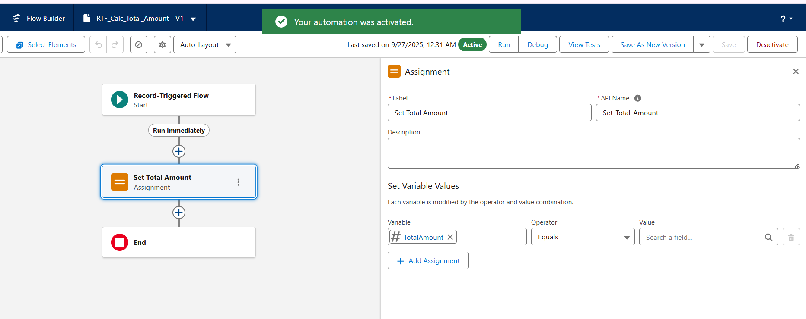

### 3) Approval Process — Bookings > ₹50,000

Where: Setup → Process Automation → Approval Processes → Create New Approval Process → For Rental Booking object

Entry Criteria: Total_Amount__c > 50000 (or formula)

Steps:

1. Create the approval process using "Use Standard Setup Wizard" (faster).
2. Step 1: Initial Submitters: Record Owner and users higher in role hierarchy (adjust as needed).
3. Step 2: Approval Steps: Send to manager (use Manager field or a lookup to Approver).
4. Final Approval Actions: Field Update (Booking_Status__c = "Confirmed"), Email Alert to Customer, Create Task for Agent, Send Custom Notification to Agent.
5. Final Rejection Actions: Field Update (Booking_Status__c = "Rejected") and Email Alert to customer (optional).

Tip: If you prefer Flow-based approvals (more flexible), you can model approval steps with Flows. Recent releases improved Flow Approvals.

Screenshot: 03_Approval_Process.png — capture the approval process summary page after creation. Paste it here and upload that image to the Approval Process documentation folder and Booking record Files.

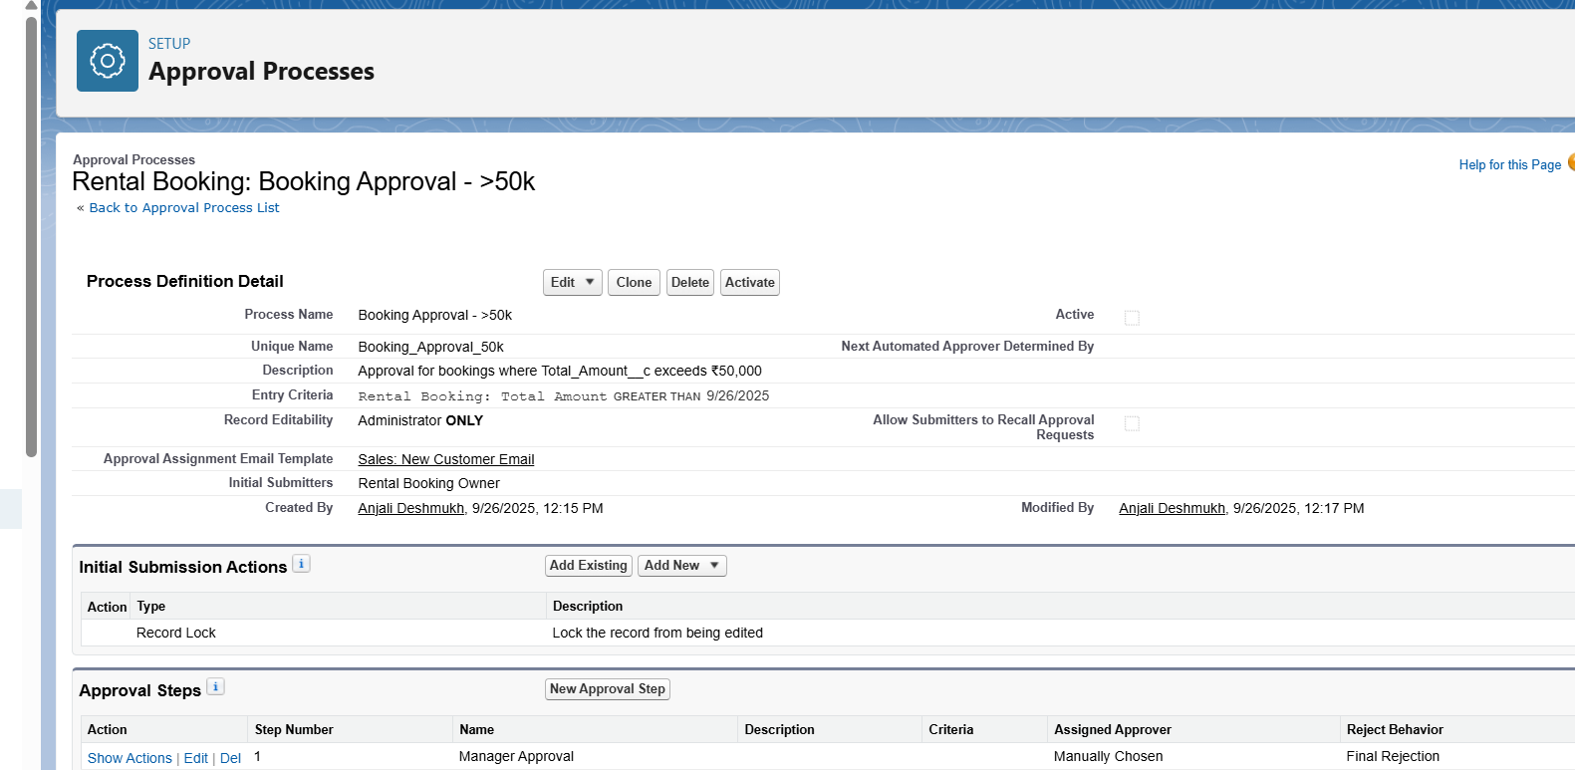

### 4) Email Templates and Email Alerts

Where: Setup → Email Templates → New Lightning Template (or Classic if your org uses classic templates)

Create two templates (examples):

1. Booking Approval Template (used for Final Approval) — merge fields: {!Booking.Name}, {!Booking.Start_Date__c}, {!Booking.End_Date__c}, {!Booking.Total_Amount__c}, {!Contact.Name}
2. Booking Rejection Template — short text explaining reason and next steps.

Create Email Alerts (Setup → Email Alerts) that reference the templates. Use Email Alerts in Approval Process final actions or Flow "Send Email" action.

Screenshot: 04_EmailTemplate.png

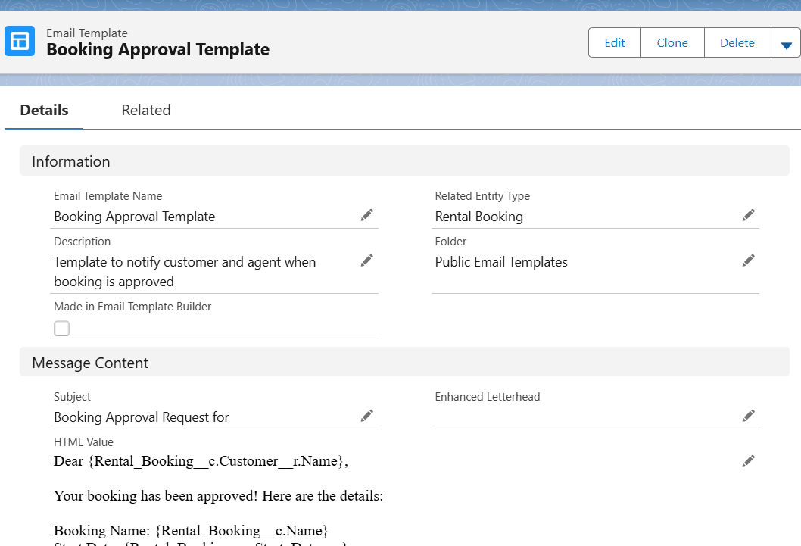

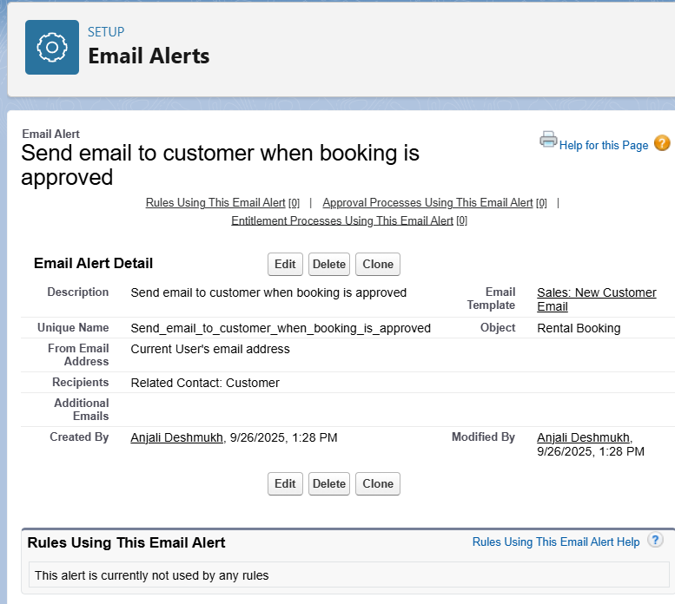

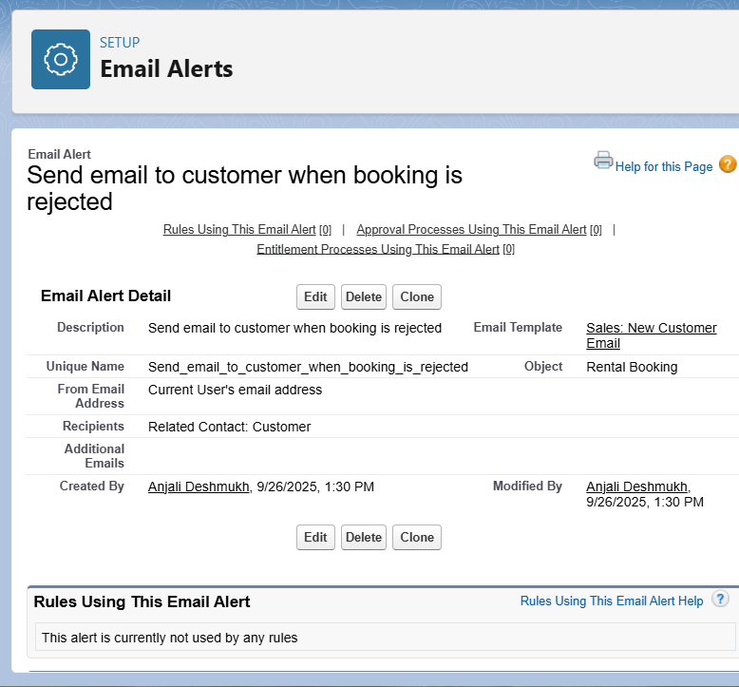

### 5) Field Update, Task Creation, and Custom Notification

Field Update (Final Approval Action): Set Booking_Status__c = "Confirmed".

Task Creation (Final Approval Action): Create a Task with the following sample fields:

Subject: Prepare car for booking {!Booking.Name} — use merge fields;

Assigned To: Agent (lookup on Booking record), Due Date: {!Booking.Start_Date__c} - 1 day, Status: Not Started, Priority: High.

Custom Notification:

1. Setup → Platform Tools → Notifications → Notification Builder (or Notification Types) → New Notification Type → Name: Agent Booking Approved.

2. In Flow (After-Save or Final Approval Action), add Action: Send Custom Notification. Pick the Notification Type, Title, Body and set Recipient = Booking.Agent__c.

Screenshot: 05_Task_Notification.png

