# Smart Task & Email Summarizer — Phase 3: Data Modeling & Relationships (Hands‑On Guide)

Goal: Build the Salesforce data structure for a Smart Task & Email Summarizer for Executives. This guide walks you through objects, fields, relationships, record types, layouts, compact layouts, schema builder usage, choice of relationship types, automation hints (Flows), validation rules, test cases, and where/how to attach screenshots to the DOCX.

## Quick Checklist (at-a-glance)

1. Create custom objects: Email__c, Summary__c, Action_Item__c (Task-like), Feedback__c (optional).  
2. Create fields (exact types & API names listed below).  
3. Create Lookup relationships between objects and to Contact/User.  
4. Create Record Types for Summary: Auto_Summary vs Manual_Edit; and for Action_Item: Action_Item vs Follow_Up.  
5. Create Page Layouts & Lightning record pages; add related lists and quick actions.  
6. Create Compact Layouts for mobile.  
7. Use Schema Builder to visualize relationships.  
8. Add validation rules, formula fields, and sample Flows to generate Action Items from summaries.  
9. Run the testing plan and capture screenshots into the screenshots/ folder; insert them into this doc.

## Prerequisites

• Salesforce Developer Edition or Sandbox with Lightning Experience.  
• Admin rights to create objects, fields, record types, layouts and Flows.  
• API access for integrations (e.g., Gmail/Microsoft Graph) if ingesting emails automatically.  
• (Optional) OpenAI/GPT integration credentials and a middleware (Heroku/Apex/Platform Events) for summarization.

## 1) Objects & API names (recommended)

Standard object: Contact (executives, senders, recipients) and User (internal users).  
  
Custom objects to create:  
A) Email  
 - Label: Email  
 - API Name: Email__c  
 - Record Name: Auto Number (EMAIL-{0000}) or Text (Subject snippet)  
  
B) Summary  
 - Label: Summary  
 - API Name: Summary__c  
 - Record Name: Auto Number (SUM-{0000})  
  
C) Action Item (for generated tasks / follow-ups)  
 - Label: Action Item  
 - API Name: Action_Item__c  
 - Record Name: Auto Number (AI-{0000})  
  
D) Feedback (optional — capture user feedback on summary quality)  
 - Label: Feedback  
 - API Name: Feedback__c  
 - Record Name: Auto Number

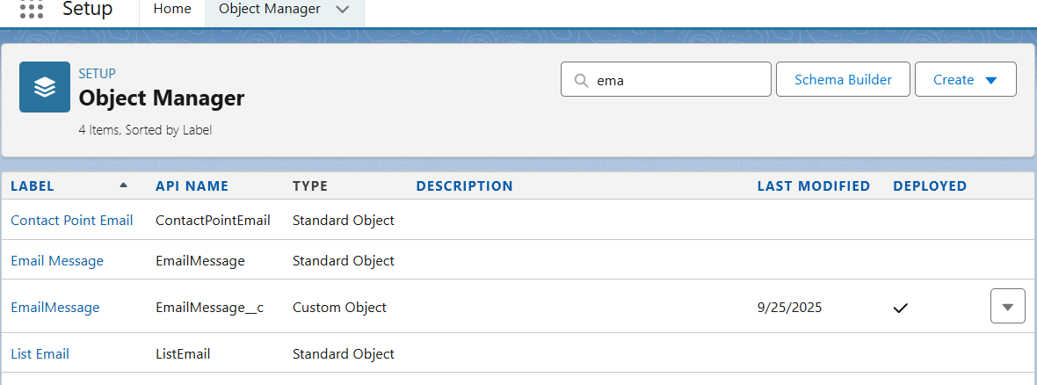

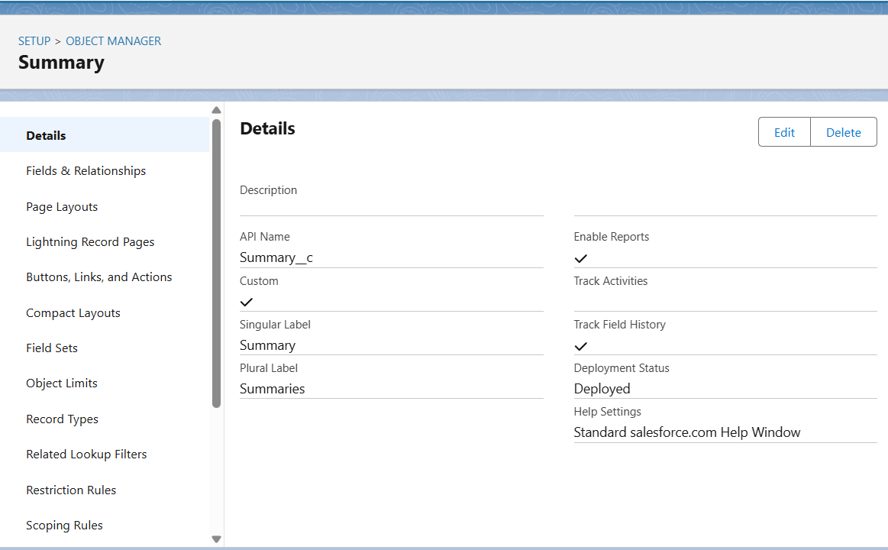

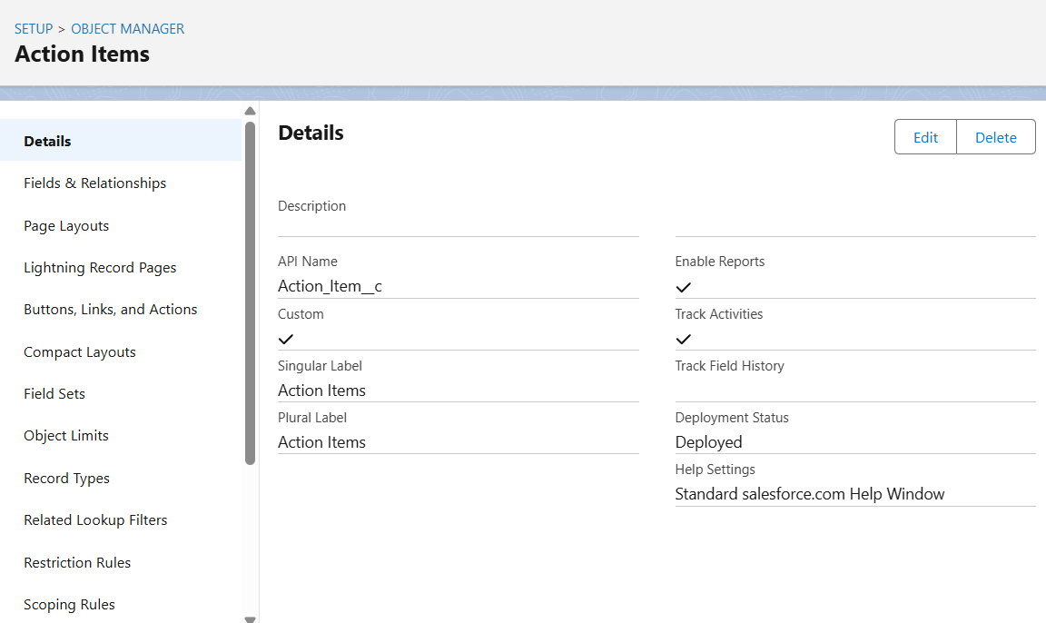

## 2) Fields (types, lengths & API names)

Email object fields (Email__c):

• Subject — Subject__c — Text (255)

• Body — Body__c — Long Text Area (32768)

• Sender Email — Sender_Email__c — Email

• Sender Contact — Sender_Contact__c — Lookup(Contact)

• Received Date — Received_Date__c — DateTime

• Thread Id — Thread_Id__c — Text (100) — for deduping/conversation grouping

• Attachment Links — Attachment_Links__c — Long Text Area

• Processing Status — Processing_Status__c — Picklist — Pending, Processing, Summarized, Error

• Source System — Source_System__c — Picklist — Gmail, Outlook, Manual Upload, API

• External Id — External_Id__c — Text (100) — set External ID if syncing from outside

Summary object fields (Summary__c):

• Short Summary — Short_Summary__c — Text (500) — short headline summary

• Full Summary — Full_Summary__c — Long Text Area (32768) — full AI-generated summary

• Key Action Items — Key_Action_Items__c — Long Text Area — list each action item on new line

• Confidence Score — Confidence_Score__c — Percent (3,2) — confidence from AI or heuristic

• Generated By — Generated_By__c — Picklist — AI, Human, Hybrid

• Source Email — Source_Email__c — Lookup(Email__c)

• Related Contact — Related_Contact__c — Lookup(Contact) — primary recipient/executive

• Status — Summary_Status__c — Picklist — Draft, Ready, Sent, Reviewed

• Created By System At — Generated_At__c — DateTime

Action Item object fields (Action_Item__c):

• Title — Title__c — Text (255)

• Description — Description__c — Long Text Area

• Due Date — Due_Date__c — Date

• Assigned To — Assigned_To__c — Lookup(User)

• Status — AI_Status__c — Picklist — Open, In Progress, Done, Deferred

• Priority — Priority__c — Picklist — Low, Medium, High

• Source Summary — Source_Summary__c — Lookup(Summary__c)

• Related Email — Related_Email__c — Lookup(Email__c) — optional

Feedback object fields (Feedback__c) — optional:

• Rating — Rating__c — Number (1,0)

• Comments — Comments__c — Long Text Area

• Related Summary — Related_Summary__c — Lookup(Summary__c)

• Submitted By — Submitted_By__c — Lookup(User or Contact)

## 3) Relationships & Data Model (recommended)

Recommended relationships (Lookup unless noted):  
• Summary__c → Email__c (Lookup) — each summary points to the source email.  
• Summary__c → Contact (Lookup) — primary executive/recipient the summary is for.  
• Action_Item__c → Summary__c (Lookup) — tasks generated from a summary.  
• Action_Item__c → User (Assigned_To__c) (Lookup to User).  
• Email__c → Contact (Sender_Contact__c) (Lookup) — optional if sender is in Contacts.  
  
If you want cascading deletes or roll-up summary fields (e.g., number of action items per summary), consider Master-Detail between Action_Item__c and Summary__c. Otherwise keep Lookup to preserve loose coupling.

Visual tip: Use Schema Builder (Setup → Schema Builder) to drag these objects and create the Lookup links visually.

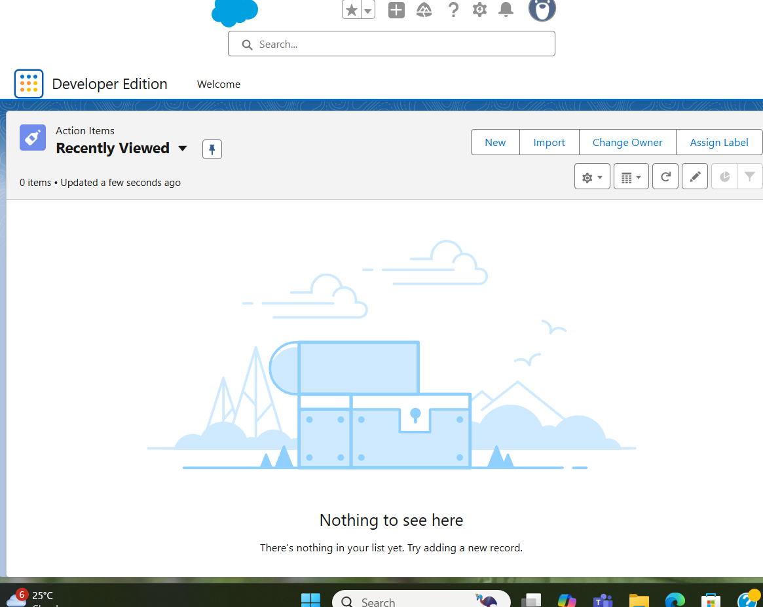

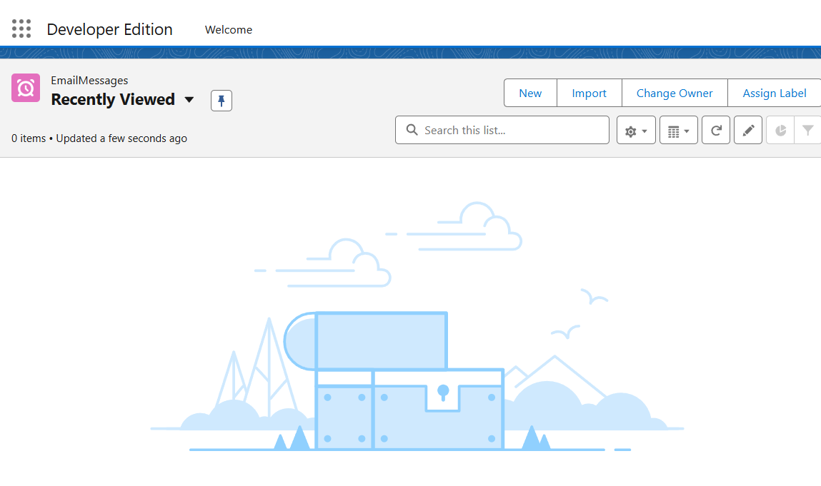

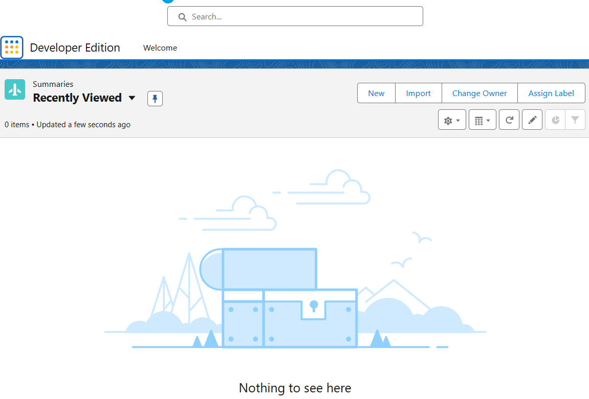

## 4) Useful Formula Fields & Example

A) Action_Item__c: Days Until Due — formula (Number):  
IF(ISBLANK(Due_Date__c), NULL, Due_Date__c - TODAY())  
  
B) Summary__c: Has_Action_Items (Checkbox formula):  
NOT(ISBLANK(Key_Action_Items__c))  
  
C) Summary__c: Short_Summary__c auto-generated via automation — not a formula if relying on external AI; use Apex/Flow to populate.

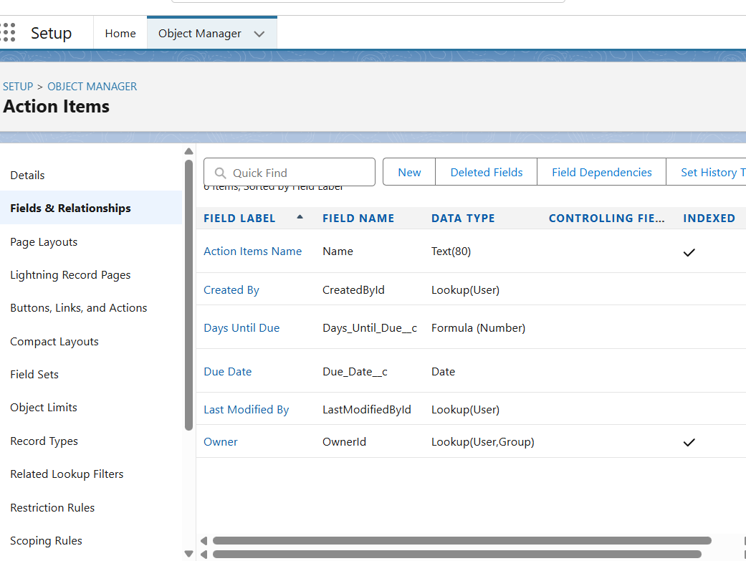

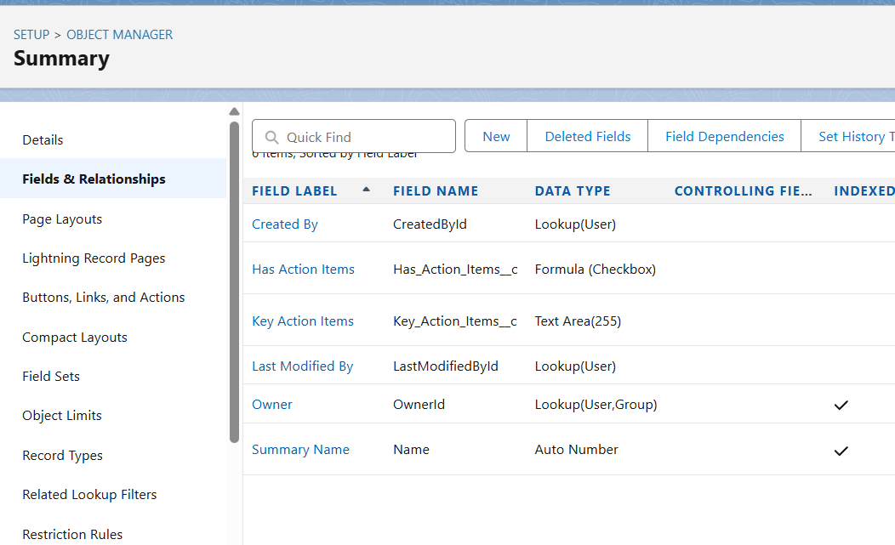

## 5) Validation Rules (samples)

A) Prevent setting Summary Status to Ready if Full Summary is blank:

Formula:  
AND(ISPICKVAL(Summary_Status__c, "Ready"), ISBLANK(Full_Summary__c))  
Error: "Full Summary must be present before marking Ready."

B) Action Item Due Date cannot be in the past when creating:

Formula:  
AND(NOT(ISBLANK(Due_Date__c)), Due_Date__c < TODAY())  
Error: "Due Date cannot be in the past." 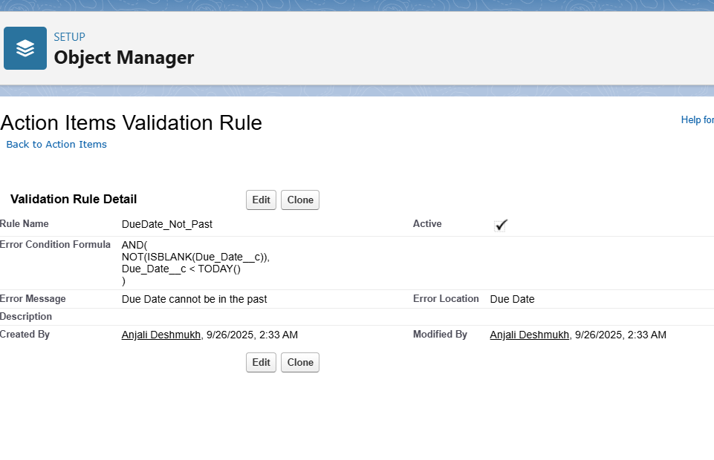

## 6) Record Types & Page Layouts

Record Types (recommended):  
• Summary__c: Auto_Summary (default) and Manual_Edit — use Manual_Edit for human-edited summaries.  
• Action_Item__c: Action_Item and Follow_Up (differences could change required fields or page layout).  
  
Page Layouts & Lightning Pages:  
• Email Layout: Subject, Sender, Received Date, Processing Status, Body (collapsed), Related Summaries (related list).  
• Summary Layout: Short Summary, Full Summary, Key Action Items, Confidence Score, Related Email (lookup), Related Action Items.  
• Action Item Layout: Title, Source Summary, Description, Due Date, Assigned To, Status, Priority.  
  
Add Quick Actions:  
• From Email record: 'Create Summary' (pre-fills Email lookup), 'Create Manual Summary'.  
• From Summary record: 'Create Action Items' (Flow button to parse Key Action Items and create Action_Item__c records).

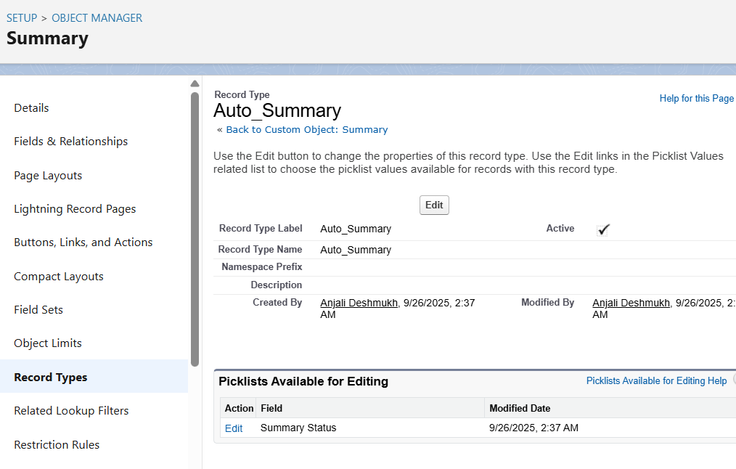

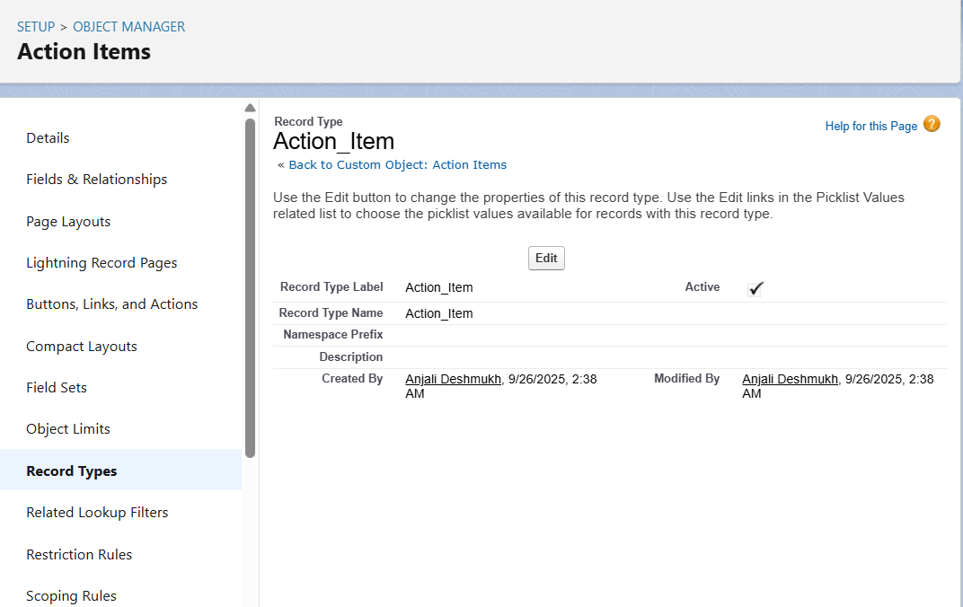

## 7) Compact Layouts (mobile)

Compact layouts to show on mobile where space is limited:  
• Email compact: Subject, Sender_Email__c, Processing_Status__c  
• Summary compact: Short_Summary__c, Confidence_Score__c, Summary_Status__c  
Assign these under the object's compact layout settings and on the lightning record page.

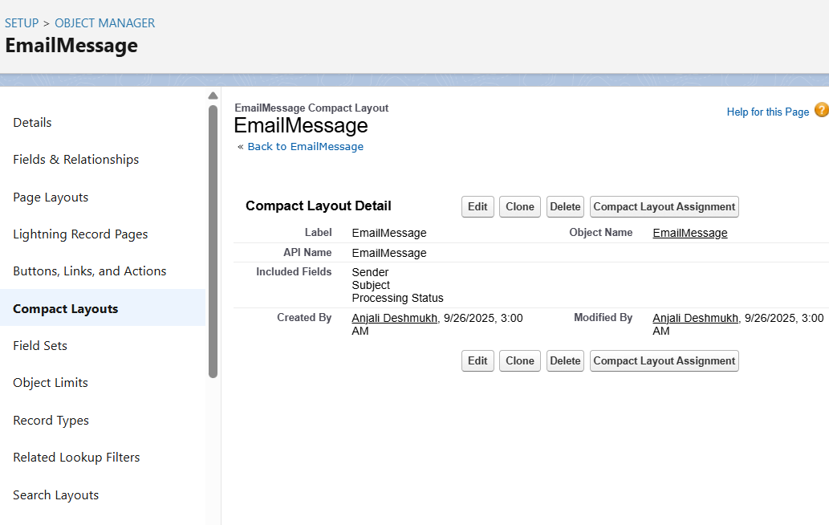

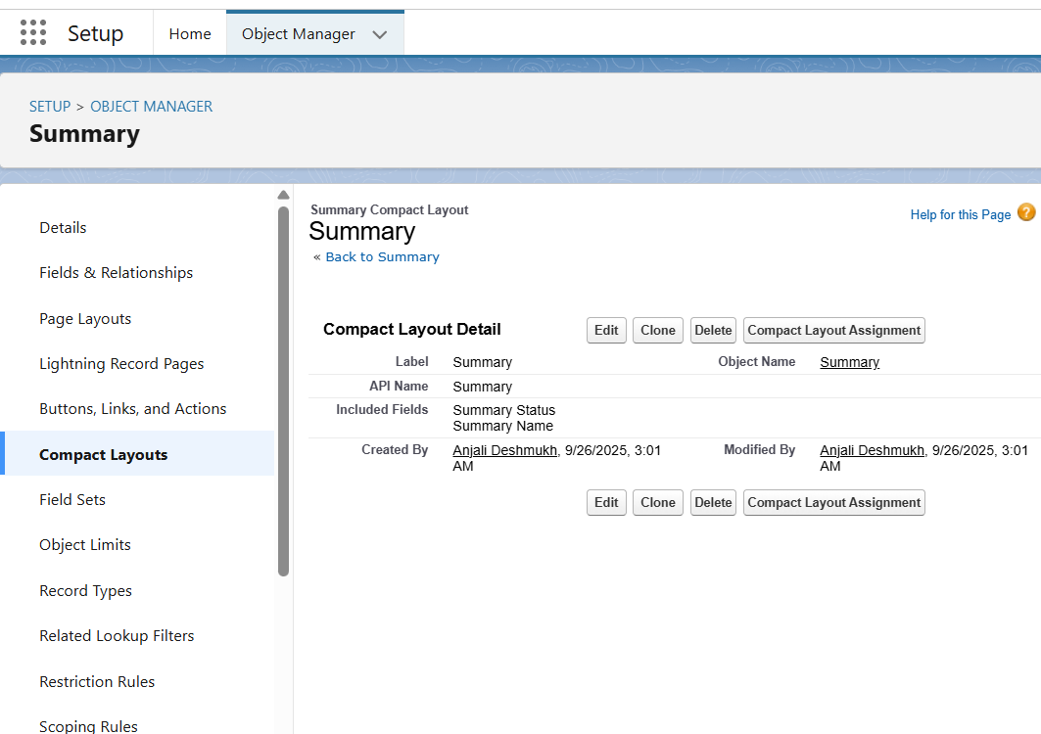

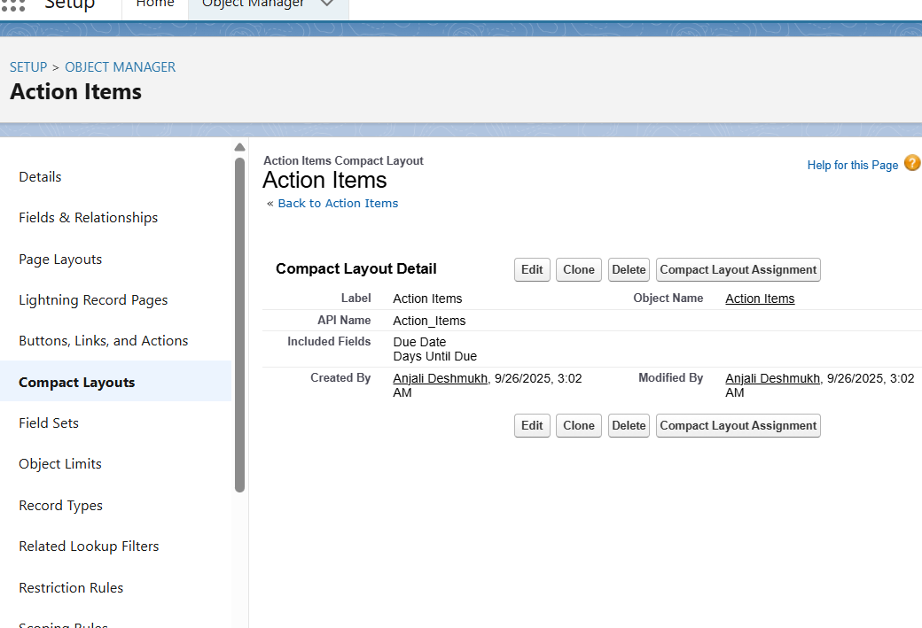

## 8) Schema Builder — steps

1. Setup → Schema Builder. Use the 'Objects' panel to show Email, Summary, Action Item, Contact, User.  
2. Drag objects to the canvas and create Lookup relationships visually, or create fields first in Object Manager and then refresh.  
3. Use Filters to reduce clutter and take a screenshot once complete.

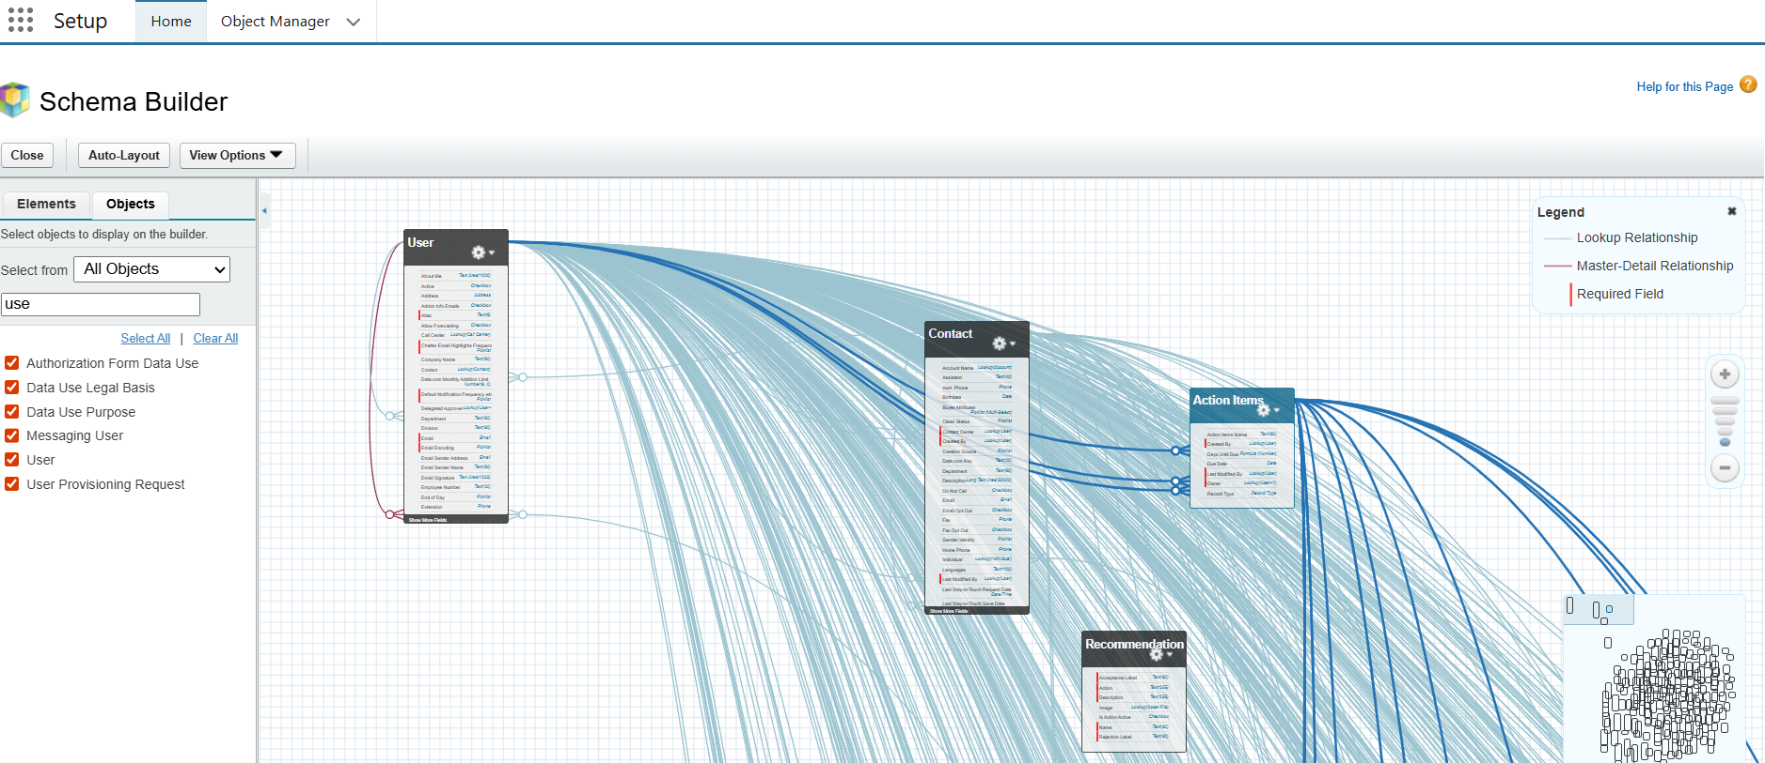

## 9) Lookup vs Master-Detail vs Hierarchical (guidance)

• Use Lookup for loose coupling: Email ↔ Summary, Summary ↔ Contact, Action Item ↔ Summary (unless you need roll-ups).  
• Use Master-Detail when you need roll-up summary fields, strict ownership, and cascade-delete (e.g., if Action Items must be deleted with the Summary).  
• Hierarchical relationships are only for User-to-User relationships and are not needed here.  
• Recommendation: Start with Lookup; move to Master-Detail only if roll-ups are required and data-model adjustments are acceptable.

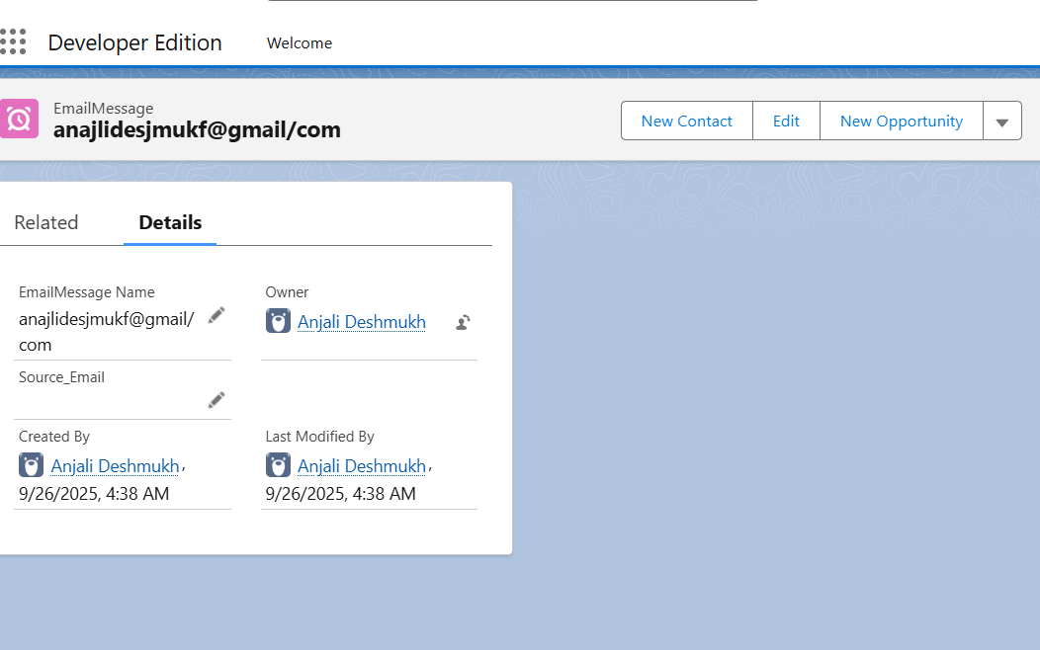

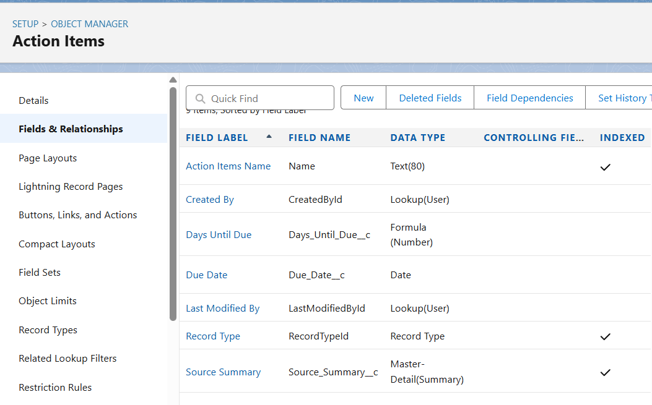

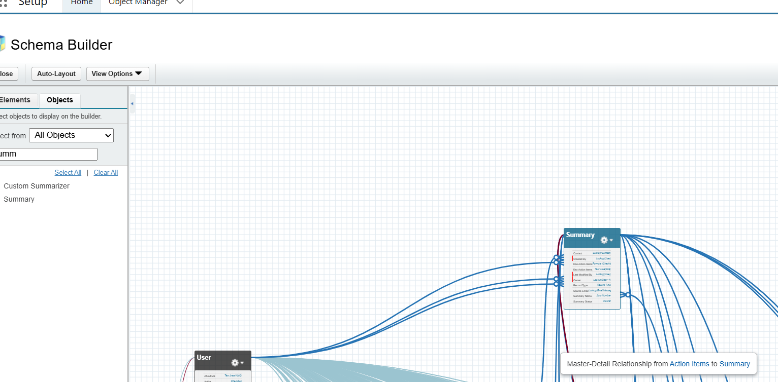

## 10) Junction Objects & External Objects

• Junction: If one summary needs to be related to many contacts and you need a normalized many-to-many, create Summary_Contact__c as a junction.  
• External Objects: If emails are stored in an external system and you don't want to sync them into Salesforce, use External Data Sources / External Objects. Alternatively, store a lightweight Email__c record with an External_Id and a link to the original system for full access.  
  
Integration tip: Consider using Platform Events or Middleware to stream incoming emails into Salesforce quickly.

## 11) Automation blueprint (Flow) — create Action Items from Key Action Items

Use a Record-Triggered Flow on Summary__c when Summary_Status__c changes to 'Ready':  
1. Trigger: When Summary__c is updated and Summary_Status__c equals 'Ready'.  
2. Get element: Parse Key_Action_Items__c (split by newline) — use Apex or a Collection loop in Flow to split lines.  
3. For Each action text: Create Action_Item__c record with Title (first 60 chars), Description (full text), Source_Summary__c = current Summary Id.  
4. Optionally assign to default user or use a mapping logic to assign based on keywords.  
5. Add error handling path to log failures in a custom Platform Event or Feedback__c.  
  
If you need advanced NLP splitting, perform it outside Salesforce and send ready-to-create Action Items via API.

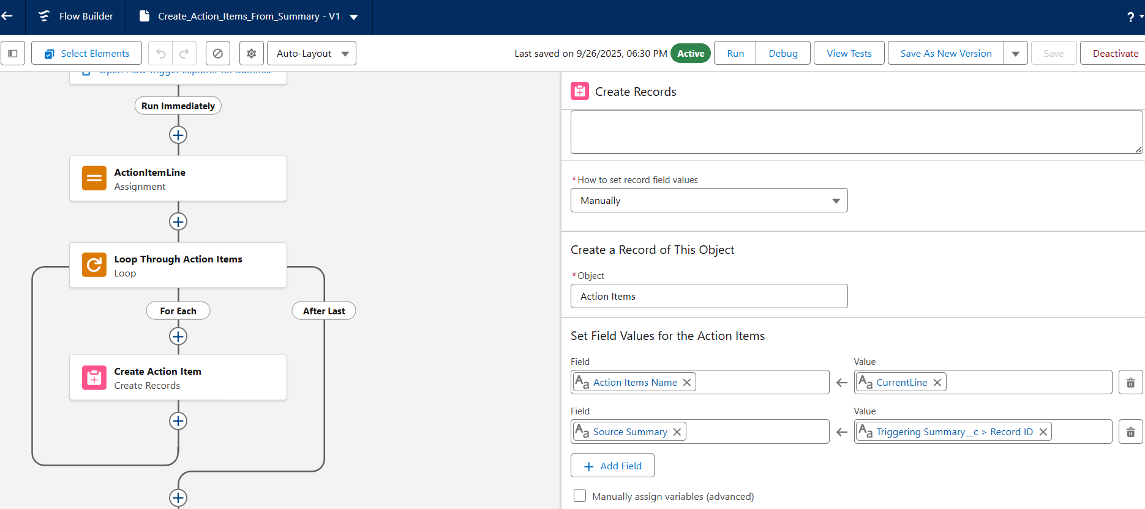

## 12) Testing Plan & Sample Records

Create sample records to verify behavior. Example test data:

Emails:  
• Email 1: Subject='Weekly Exec Briefing: Q3 results', Sender='ceo@example.com', Received Date=2025-09-24, Processing Status='Pending'  
• Email 2: Subject='Client meeting follow-up', Sender='pm@example.com', Received Date=2025-09-25, Processing Status='Pending'  
  
Summaries:  
• Summary A: Short='Q3 highlights', Full='Sales up 12%... Action items: 1) Review pricing. 2) Schedule meeting with ops.' Confidence 0.82, Generated_By='AI'  
  
Action Items:  
• AI-1: Title='Review pricing', Due Date='2025-10-01', Assigned To=executive assistant, Status='Open' (created by Flow from Summary A)  
