Predictive Modeling & Feature Engineering

1. Introduction
The Week 4 task focuses on predictive modeling and feature engineering for the Battery Health Analysis project. The objective is to build machine learning regression models that predict State of Health (SOH) from measurable battery characteristics. The workflow covers feature selection, data partitioning, scaling, model training, evaluation, comparison, and feature-importance analysis.
2. Problem Definition
Battery performance changes as a battery is used over repeated cycles. State of Health (SOH) is a useful indicator of current battery condition. In this task, SOH is treated as a continuous target, making the problem a supervised regression task.
3. Features and Target
The selected input features are cycle, voltage, temperature, and capacity. The target variable is soh. The battery_id column is excluded because it is an identifier rather than a measurement describing battery condition.
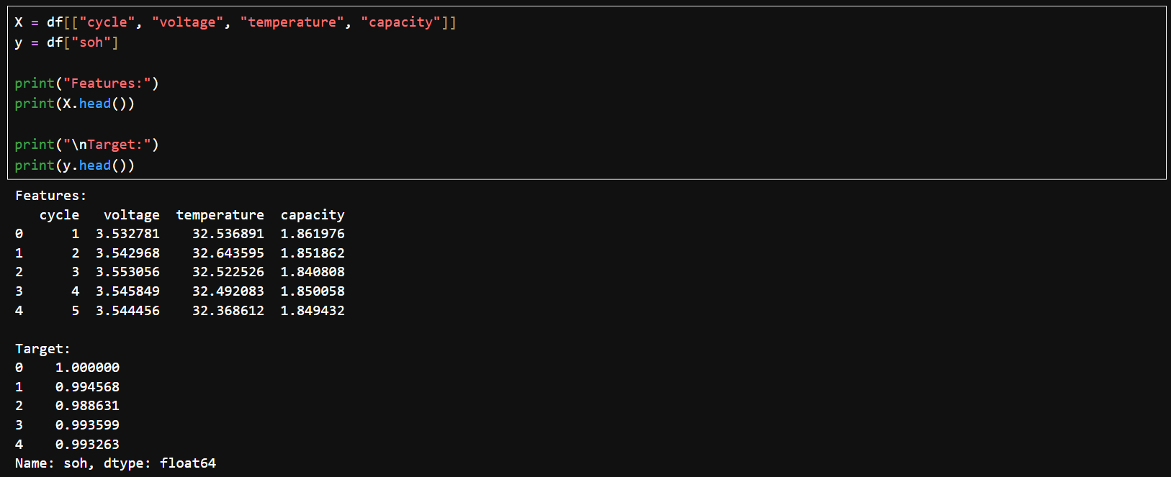
Figure 1. Feature and target variable selection in Python.

4. Train-Test Split
The dataset was divided into training and testing subsets using an 80:20 split with random_state=42. The training set contains 1,132 observations and the test set contains 283 observations. The test set was kept separate for evaluation on unseen observations.
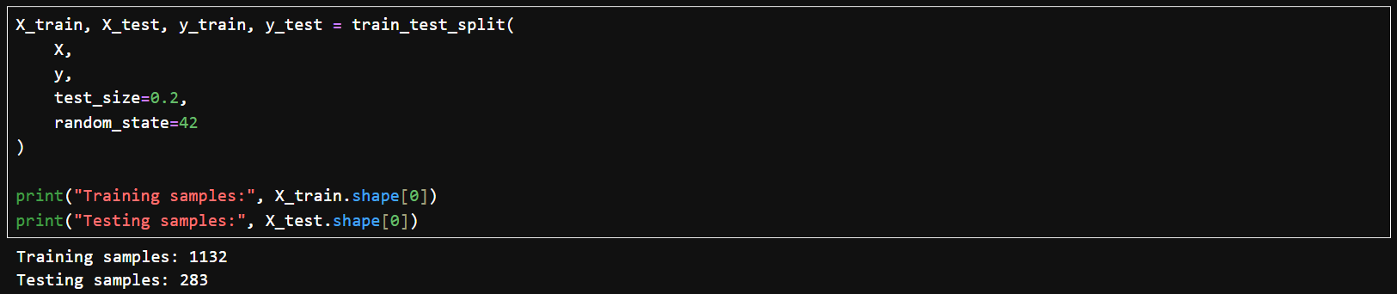
Figure 2. 80:20 training and testing data split.

5. Feature Scaling
StandardScaler was applied to the features used by Linear Regression. The scaler was fitted only on training data and then applied to both training and testing data, preventing test-set information from influencing preprocessing. Tree-based models do not require feature scaling.
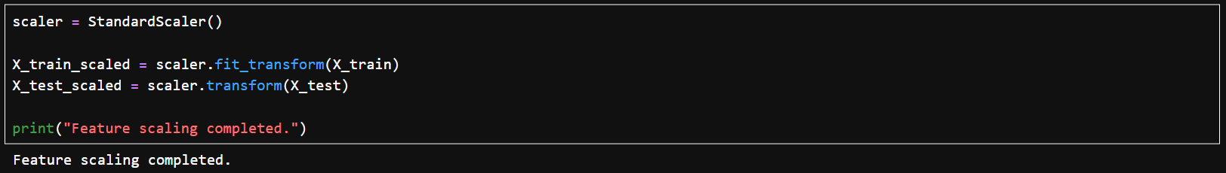
Figure 3. Feature scaling using StandardScaler.

6. Model Selection and Training
6.1 Linear Regression
Linear Regression was selected as a baseline model because it provides a simple and interpretable reference for the predictive task.
6.2 Decision Tree Regressor
Decision Tree Regression was selected because it can model nonlinear relationships without requiring feature scaling.
6.3 Random Forest Regressor
Random Forest Regression was selected as an ensemble approach that combines multiple decision trees, can capture nonlinear relationships, and provides feature-importance values.
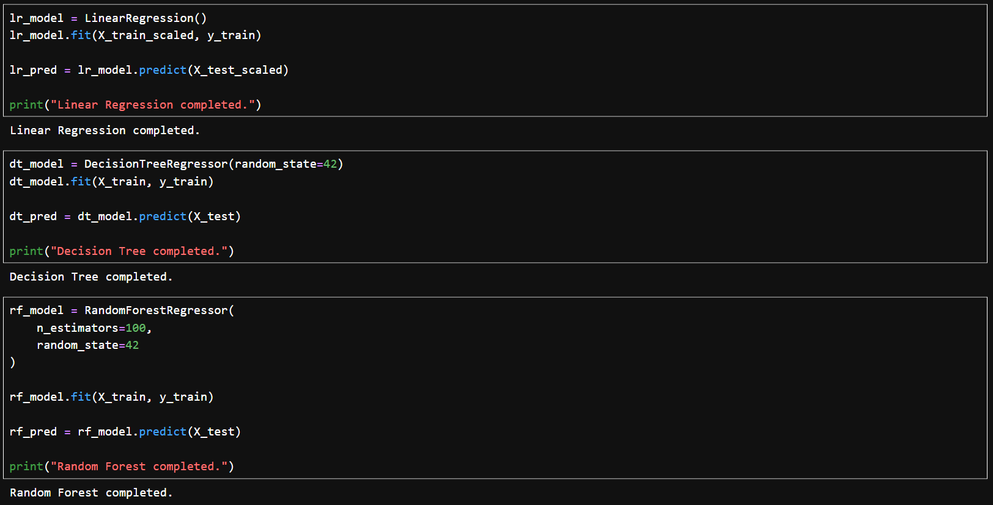
Figure 4. Training of Linear Regression, Decision Tree, and Random Forest models.

7. Evaluation Metrics
- MAE (Mean Absolute Error): average absolute difference between actual and predicted SOH.
- MSE (Mean Squared Error): penalizes larger errors more strongly.
- RMSE (Root Mean Squared Error): square root of MSE and expressed on the target scale.
- R² Score: proportion of variation in SOH explained by the model.

8. Model Performance Comparison
The three models were evaluated on the held-out test dataset.
Model | MAE | MSE | RMSE | R² Score
Linear Regression | 0.053367 | 0.005262 | 0.072539 | 0.622114
Decision Tree | 0.010274 | 0.000644 | 0.025381 | 0.953735
Random Forest | 0.008263 | 0.000360 | 0.018968 | 0.974161

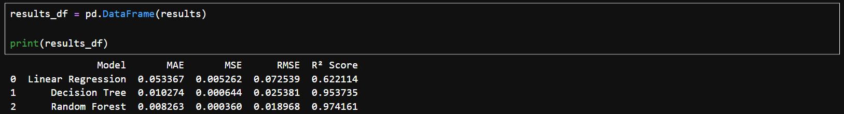
Figure 5. Model performance comparison output.

9. Best Model
Random Forest achieved the best performance. It produced the lowest MAE (0.008263), lowest MSE (0.000360), lowest RMSE (0.018968), and highest R² score (0.974161). Therefore, Random Forest was selected as the best-performing model among the three tested approaches. Its R² score indicates that approximately 97.4% of the variation in SOH is explained on the test dataset.

10. Feature Importance
Random Forest feature importance was used to understand the relative contribution of the selected predictors. The obtained importance values were:
Feature | Importance
capacity | 0.606647
cycle | 0.175475
temperature | 0.129407
voltage | 0.088471

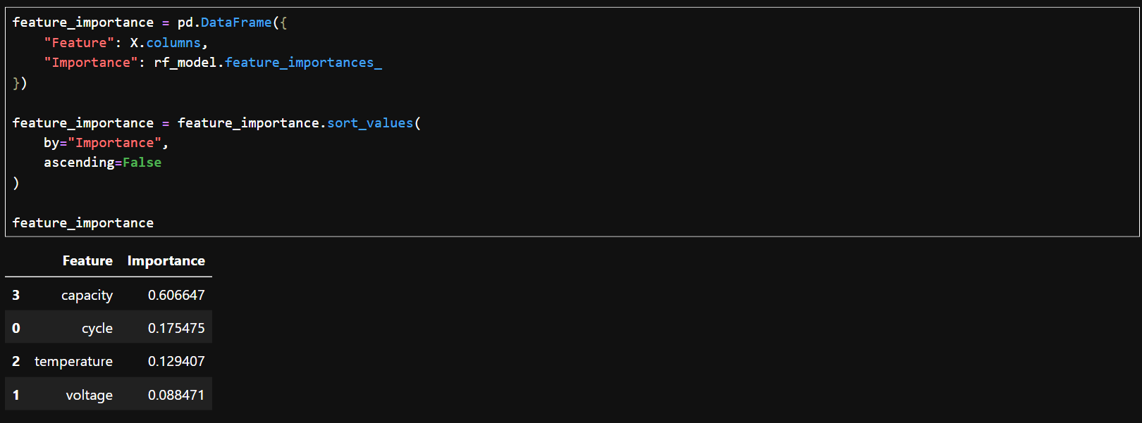
Figure 6. Random Forest feature-importance output.
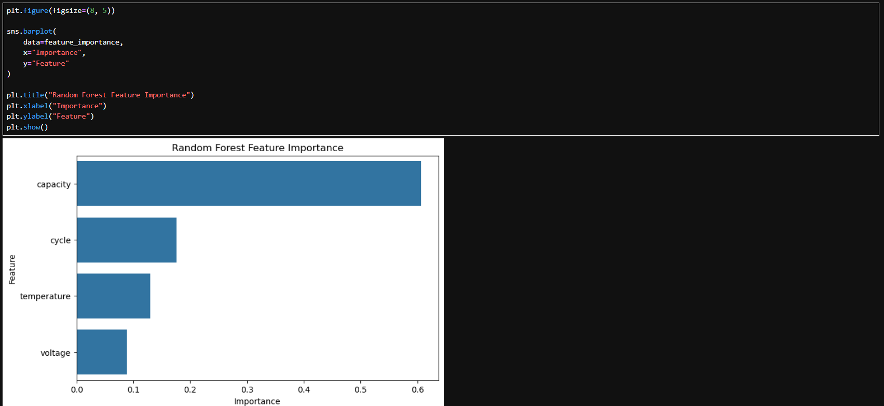
Figure 7. Random Forest feature-importance visualization.
Capacity was the most important feature, with an importance value of 0.606647. Cycle, temperature, and voltage followed with importance values of 0.175475, 0.129407, and 0.088471 respectively.

11. Actual vs Predicted SOH
An Actual vs Predicted SOH scatter plot was created for the Random Forest model. Points close to the diagonal reference line indicate accurate predictions. This visualization complements the numerical metrics by providing a direct visual check of prediction quality.

12. Feature Engineering Strategy
The current model uses cleaned numerical variables directly. Future iterations can explore cycle-based degradation indicators, temperature-derived measures, capacity degradation rates, and historical battery-level features. Feature engineering must be performed without introducing information from the test set.

13. Model Tuning and Validation Plan
- Tune Random Forest parameters such as n_estimators, max_depth, and minimum samples per split.
- Use cross-validation to assess consistency across different data subsets.
- Compare tuned models using MAE, RMSE, and R².
- Monitor training and validation performance to detect overfitting.

14. Challenges and Considerations
- A strong score on this dataset does not automatically guarantee the same performance on another battery dataset.
- Preprocessing and feature engineering must avoid test-set information to prevent data leakage.
- Random Forest is more complex than Linear Regression, so feature importance helps with interpretation.
- Battery measurements can depend on battery type and operating conditions.

15. Expected Outcomes
The modeling workflow provides a method for estimating battery SOH from measurable battery characteristics. The current results show that Random Forest substantially outperformed the Linear Regression baseline and Decision Tree on the held-out test set. Feature-importance analysis identified capacity as the strongest predictor among the selected variables.

16. Conclusion
Week 4 successfully implemented a predictive modeling workflow for Battery Health Analysis. Linear Regression, Decision Tree Regression, and Random Forest Regression were trained and evaluated using MAE, MSE, RMSE, and R². Random Forest produced the strongest results, with RMSE of 0.018968 and R² of 0.974161. Capacity was identified as the most influential feature. The workflow provides a foundation for future tuning, validation, and battery-health prediction.

17. Tools and Technologies
- Python
- Pandas – data handling
- NumPy – numerical calculations
- Matplotlib – visualization
- Seaborn – statistical visualization
- Scikit-learn – preprocessing, models, and evaluation
- Jupyter Notebook – development environment

