**Database Management**

**and**

**Database Design**

**INFO 6210**

**Project Documentation**

|  |  |  |
| --- | --- | --- |
| Version | Reviewer | Date |
| 1 | **Bhavna Menghrajani** | 11/18/2016 |
| 2 | **Antriksh** | 12/02/2016 |
| 3 | **Antriksh** | 12/13/2016 |

**Problem Statement**: Simulating a database design for a hospital management system with hospital branches in different cities. The project will try to accommodate and implement the things learnt during entire semester including but not limited to database design principles, EER diagram, relational model, queries, stored procedures, triggers, users, views, transactions, privileges, backups, subqueries, joins, normalization techniques, indexing and functions.

The database would basically consist of medical records of all the patients visiting hospital. It will hold employees’ data as well, i.e. the data of all the doctors, lab assistants, front desk employees, hospital administrator staff. All the crucial data modified by all the employees of hospital for patients would be stored and would be visible to only admin.

Patient will be assigned to a department and would be taken care of from different staff members. Data for patient could contain appointment details, prescription details, surgery details or procedure details.

**Entities:**

Hospital  
Departments  
Staff  
Person  
Patient  
Address  
Role  
Appointment  
Procedures  
Prescriptions  
Medicines  
Surgeries  
Billing  
Insurance

**EER Diagram:**

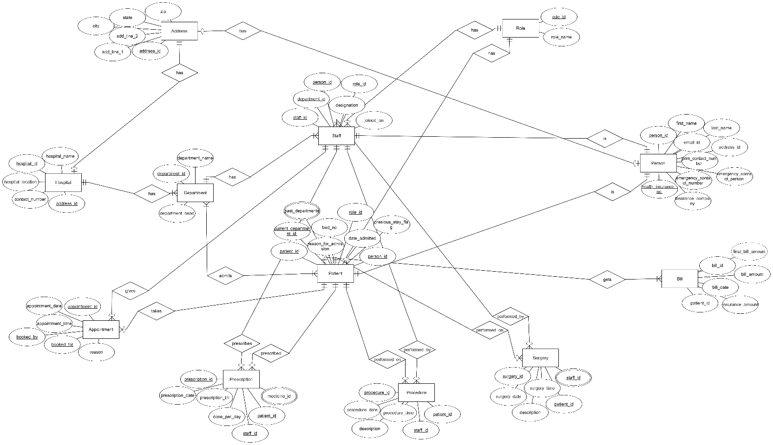

**Relational Model:**

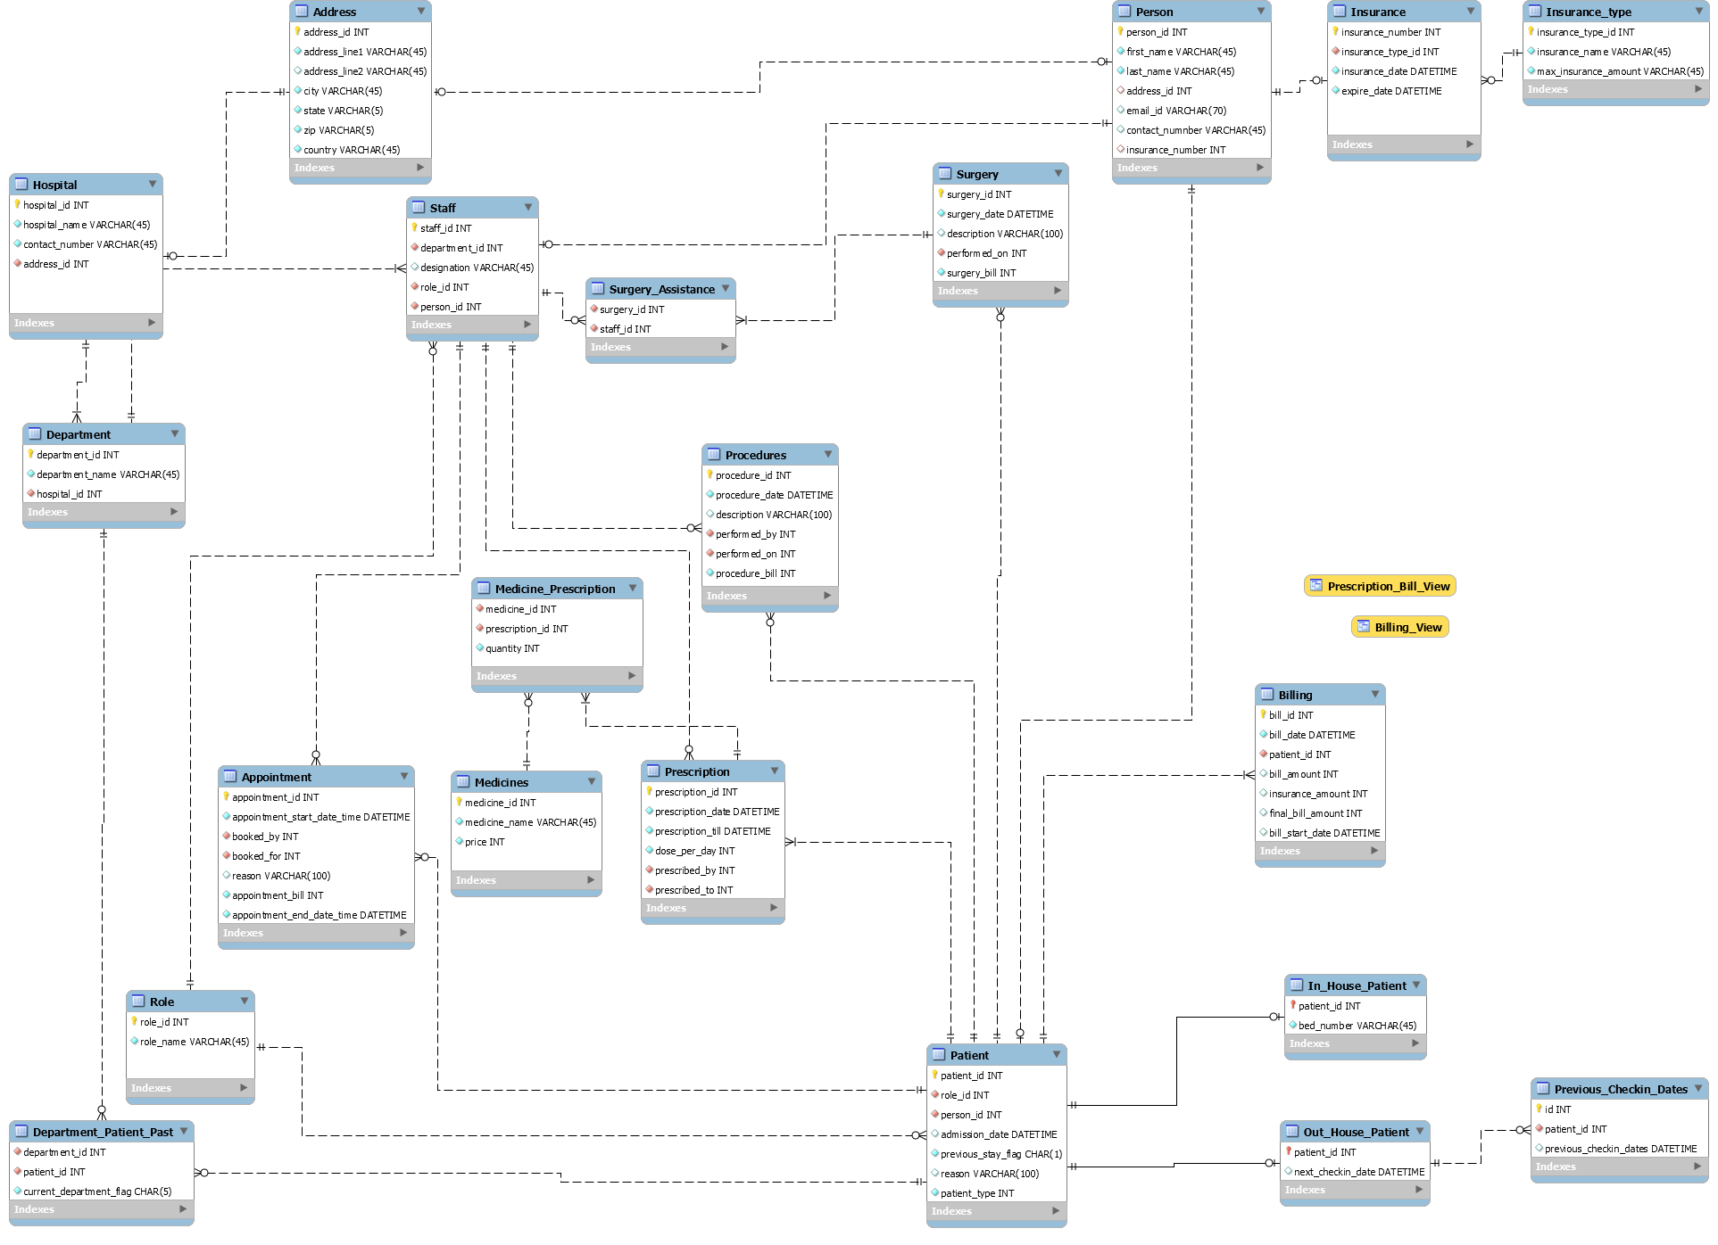

**Normalization techniques:**

Removed multivalued attributes by creating new table for them.  
Many-to-many relationships were handled by creating association table.  
Partial dependencies and transient dependencies are removed by normalizing it in 2NF and 3NF form.

**Important implementations:**

Kept the normalization up-to 3NF only.   
Tried to eliminate all insert, update and delete anomalies by cascading and/or restricting the update and delete operations in case of foreign key constraints.  
Created different users and granted respective privileges to each user  
Inserted data using csv import method  
Implemented Views for calculating prescription billing   
Implemented stored procedures to calculate bill for a patient   
Implemented stored procedure to debug a stored procedure  
Implemented triggers for auditing purposes, auto modification of data in next check-in date for patient on booking appointment and validating email and contact number in person table  
Implemented the backup features using command line, workbench, and shell scripts  
Uploaded the backed up files on AWS cluster  
The EER and relational model shows the before and after part of normalization process.  
Implemented mongodb as document database for storing patients  
Implemented indexing on patient and staff for person column  
Implemented queries that simulate transactions, subqueries, joins and functions

**MongoDB implementation:**

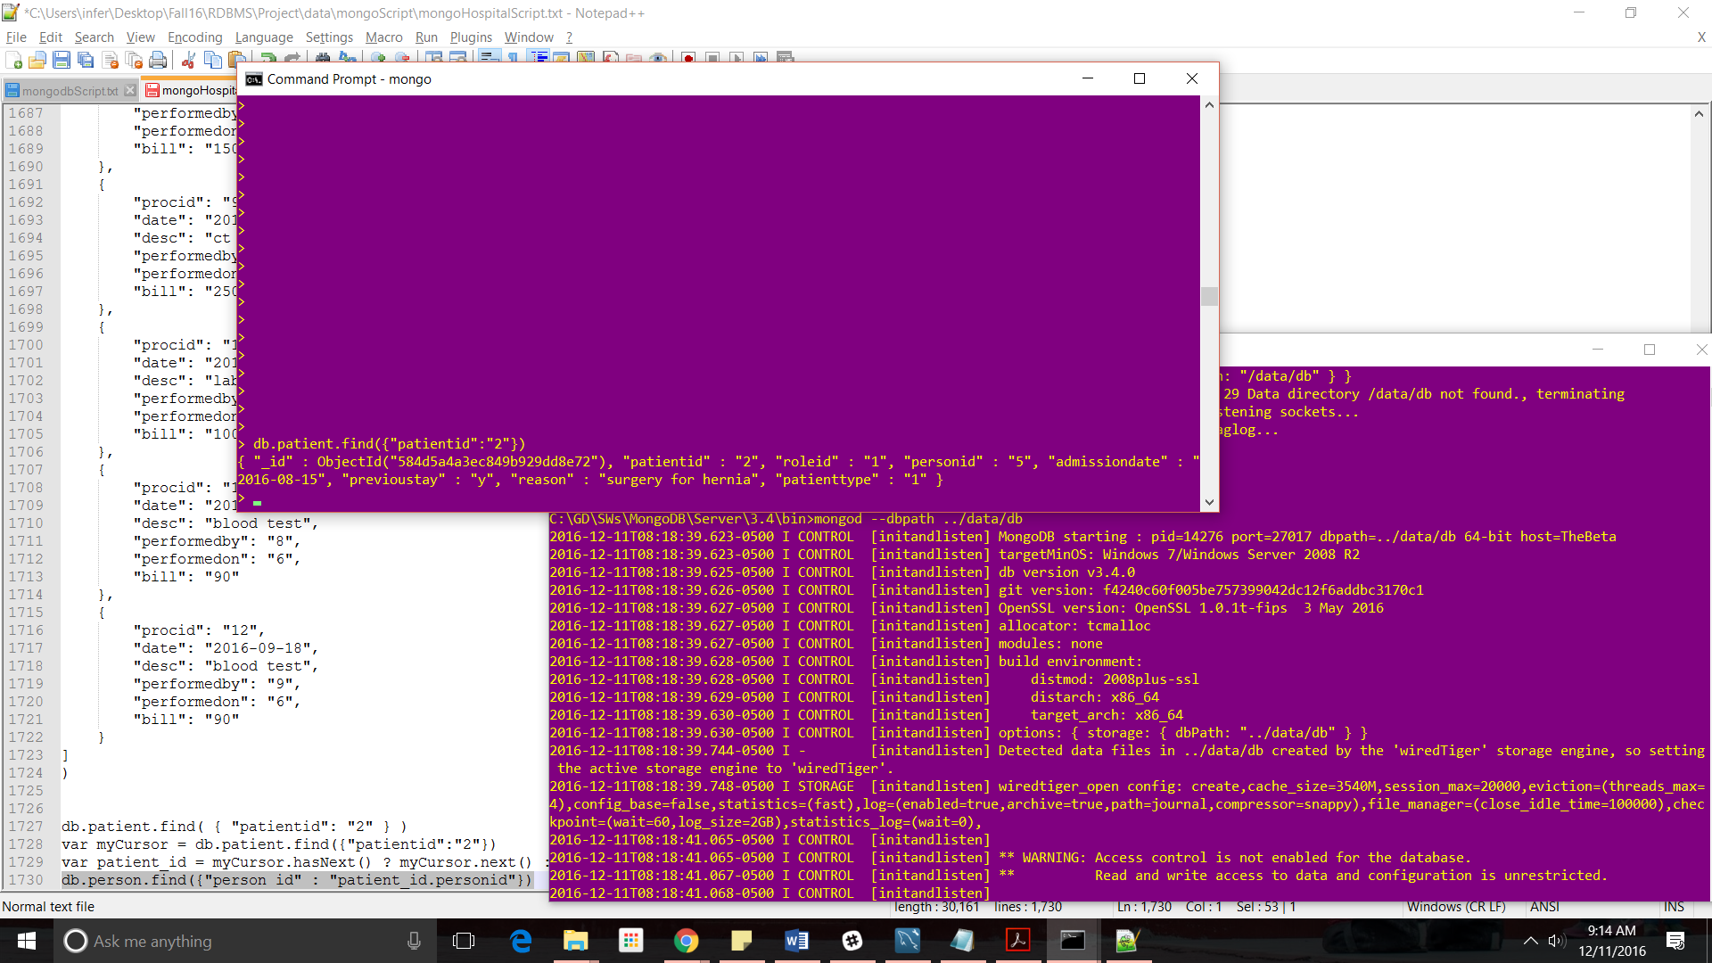

**AWS RDS instance connection:**

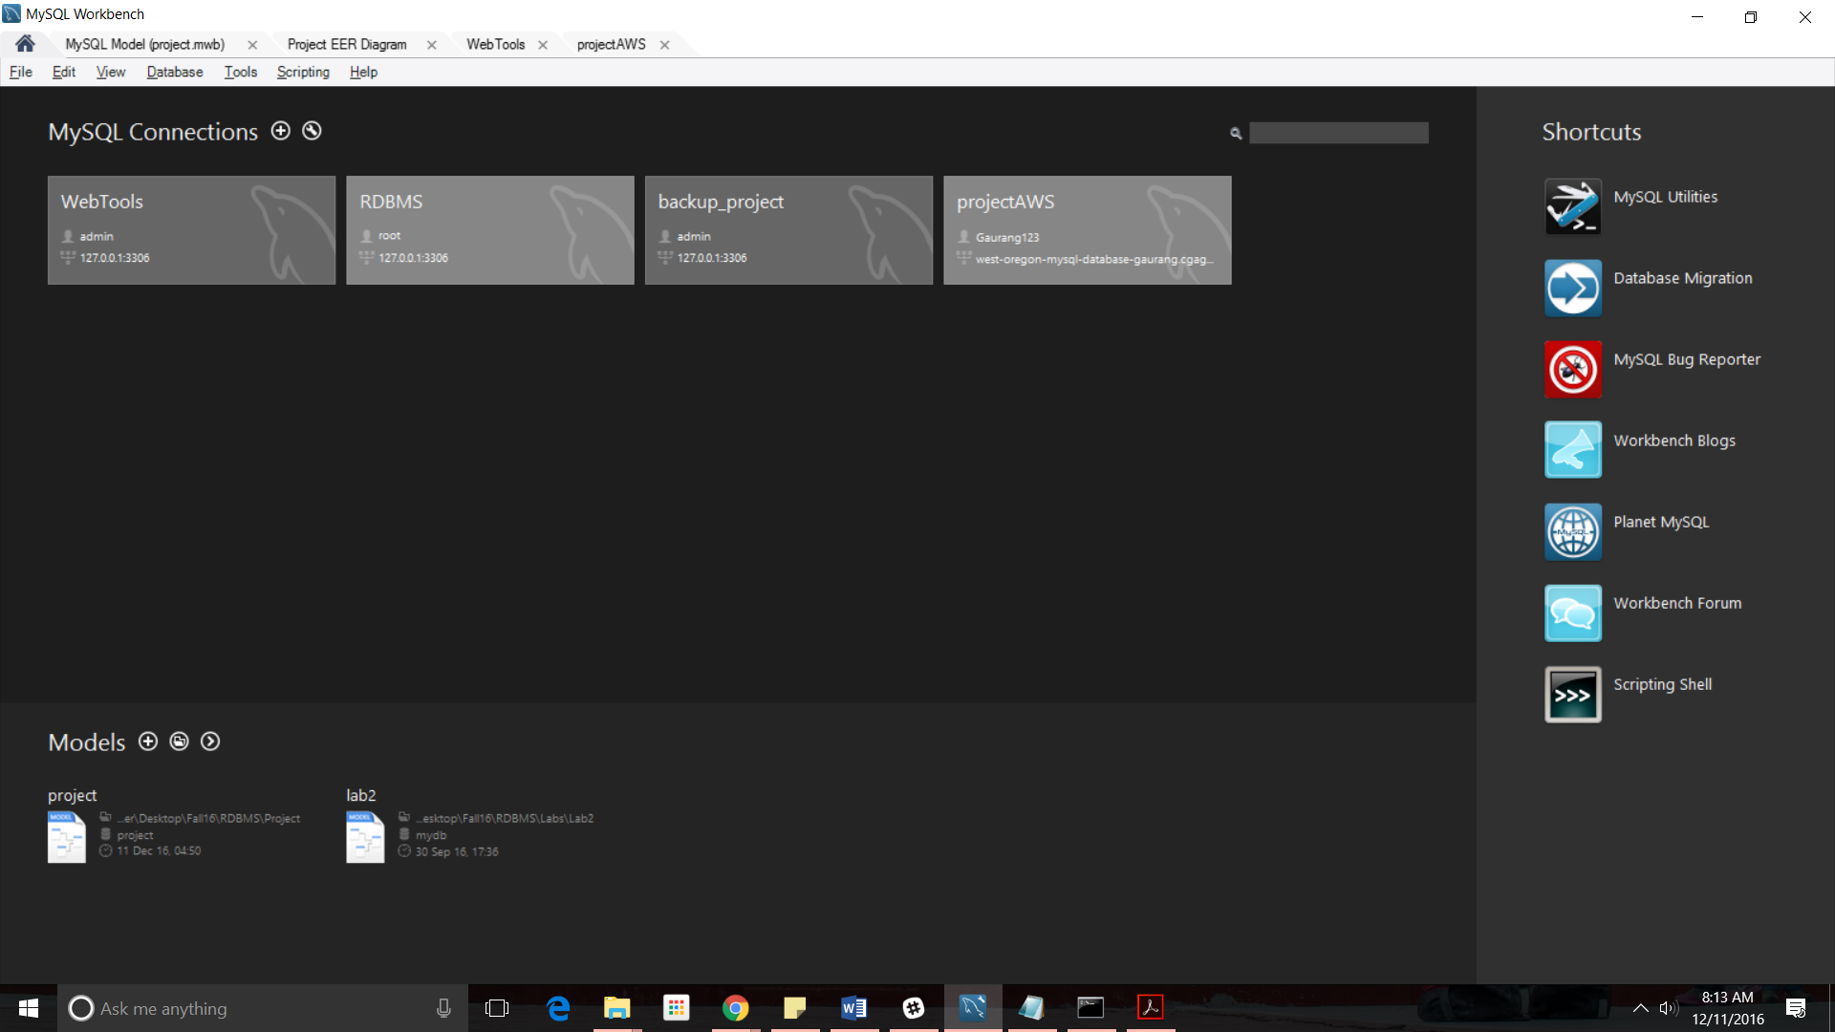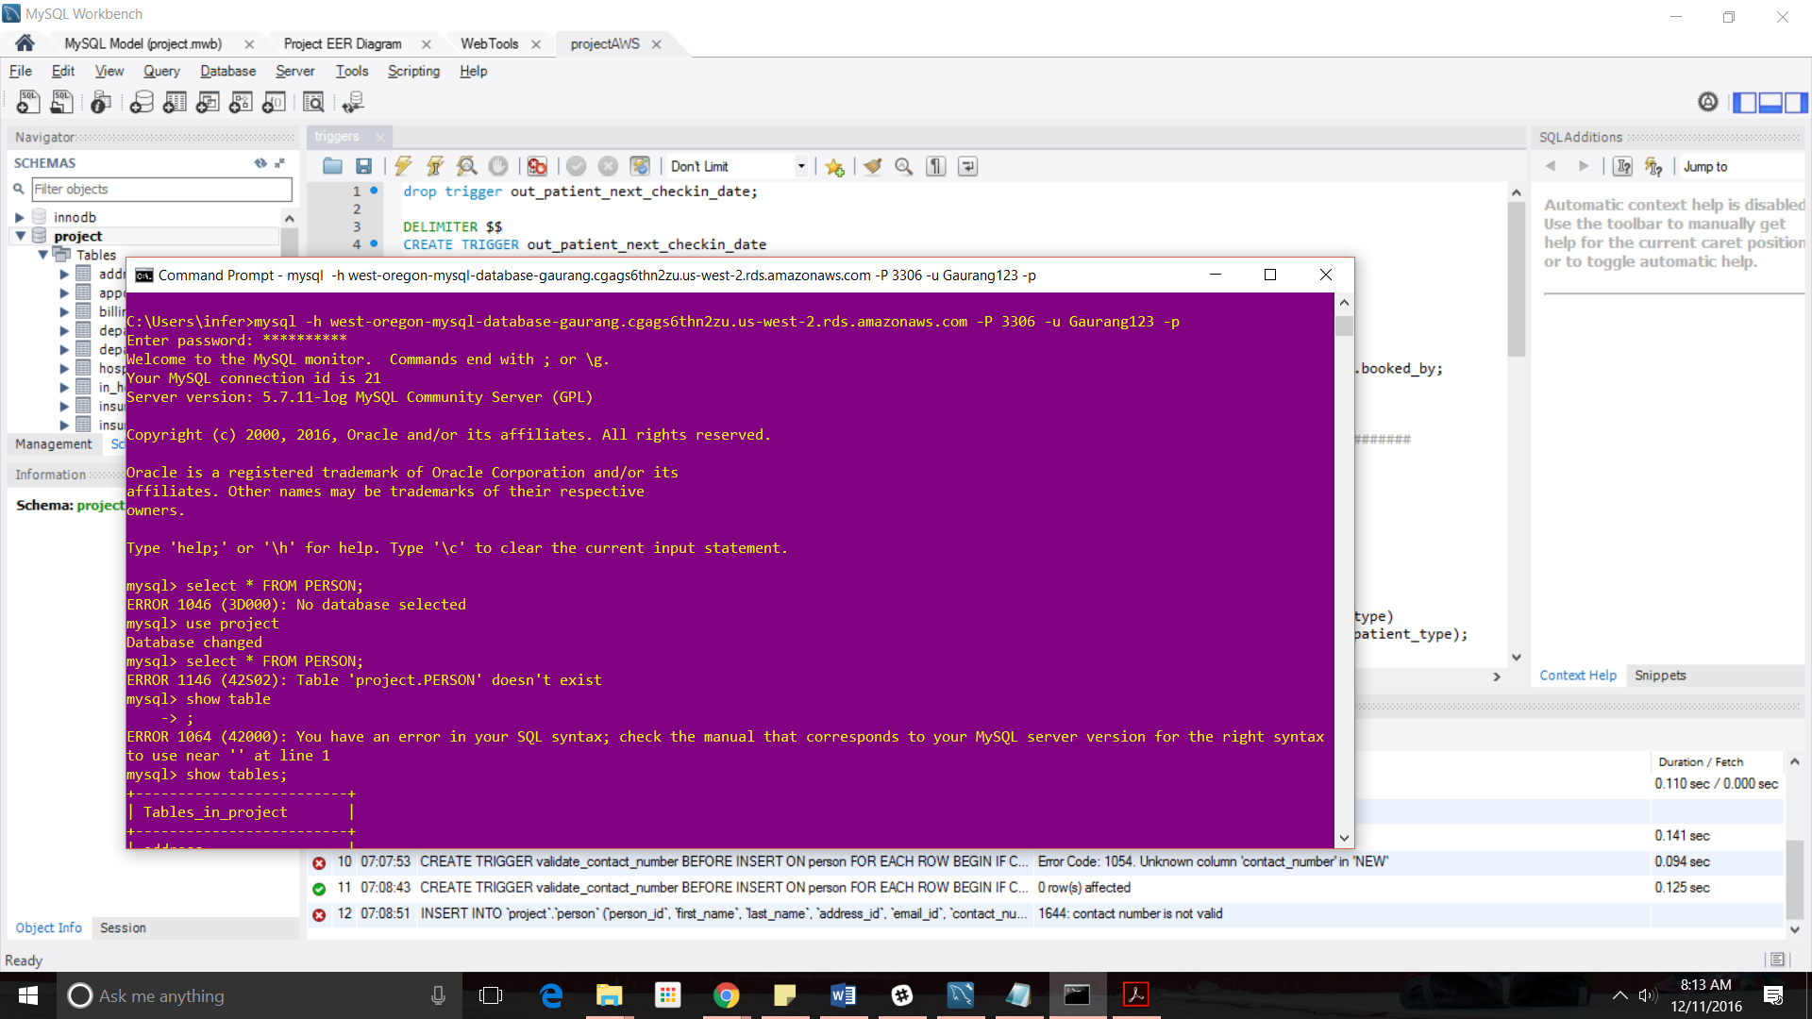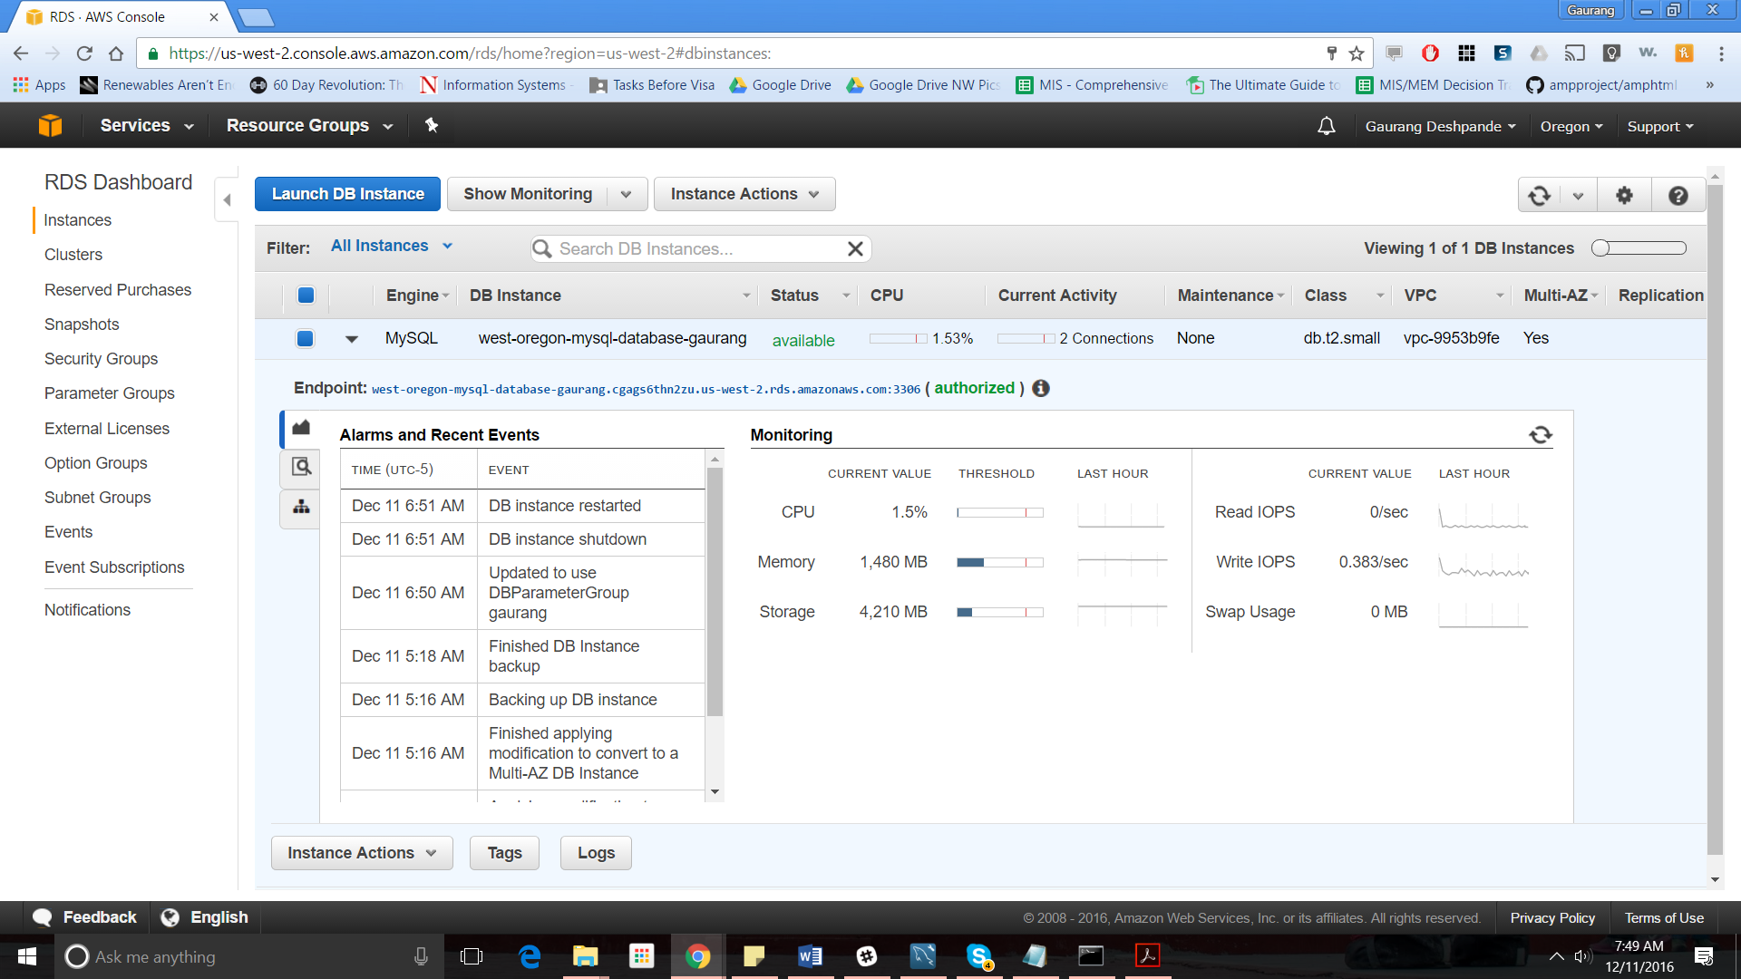

**Data backup:**

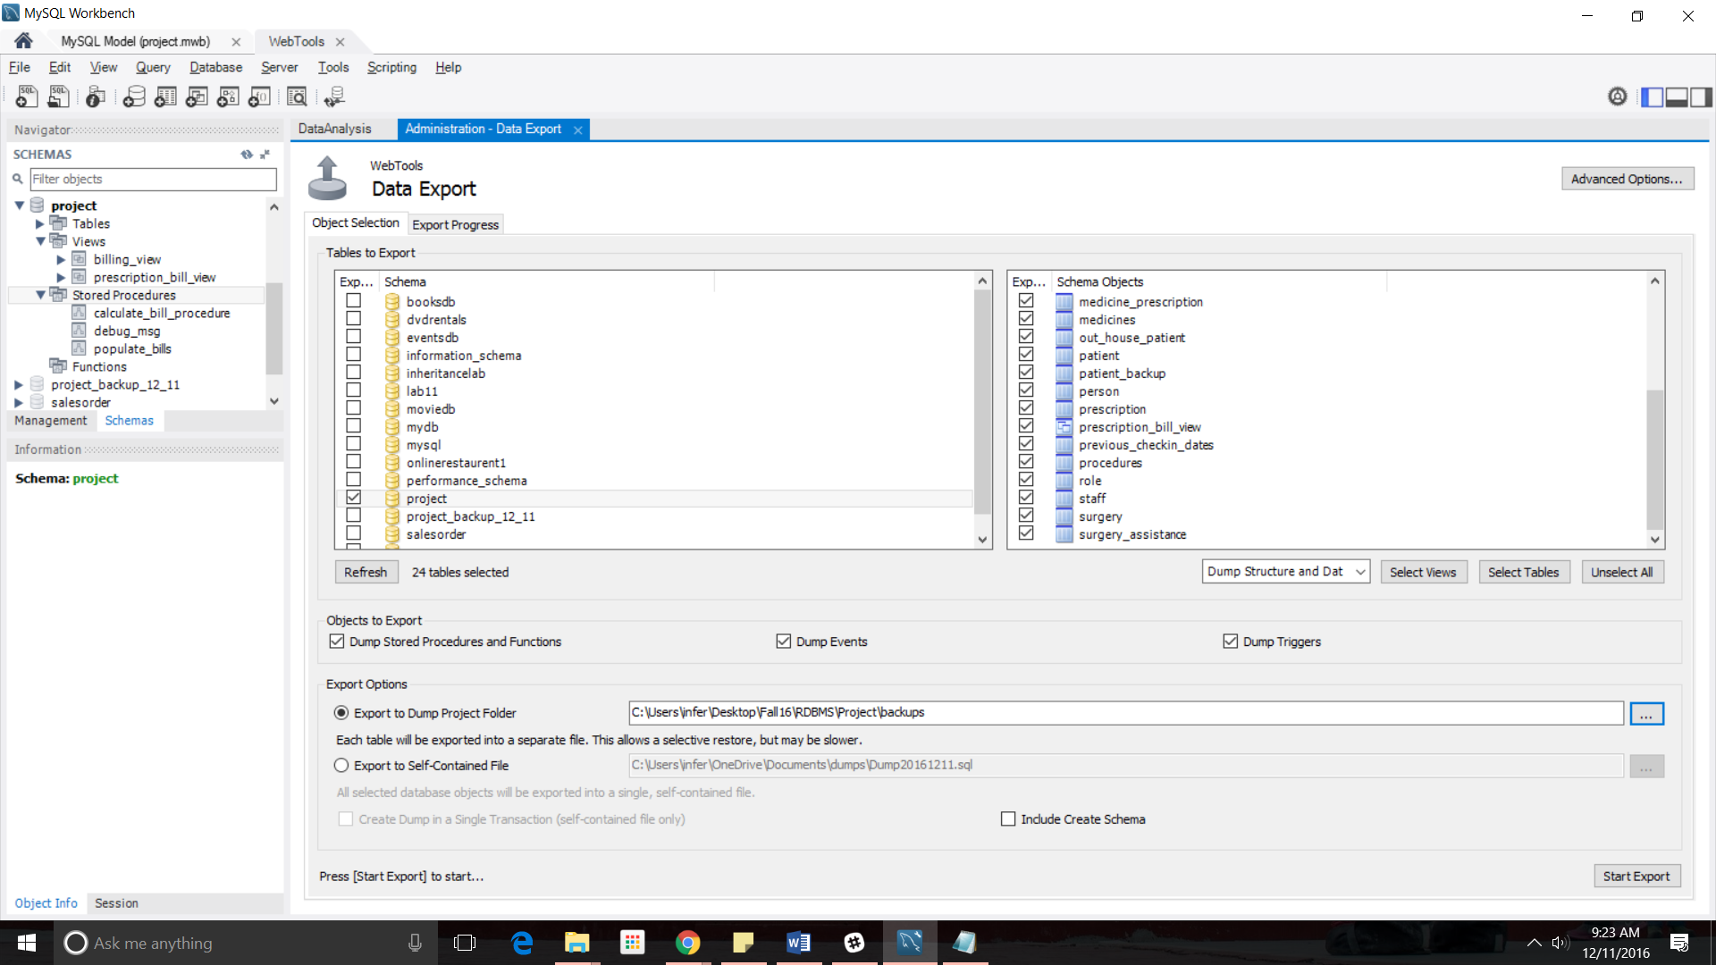

**Users and Privileges:**

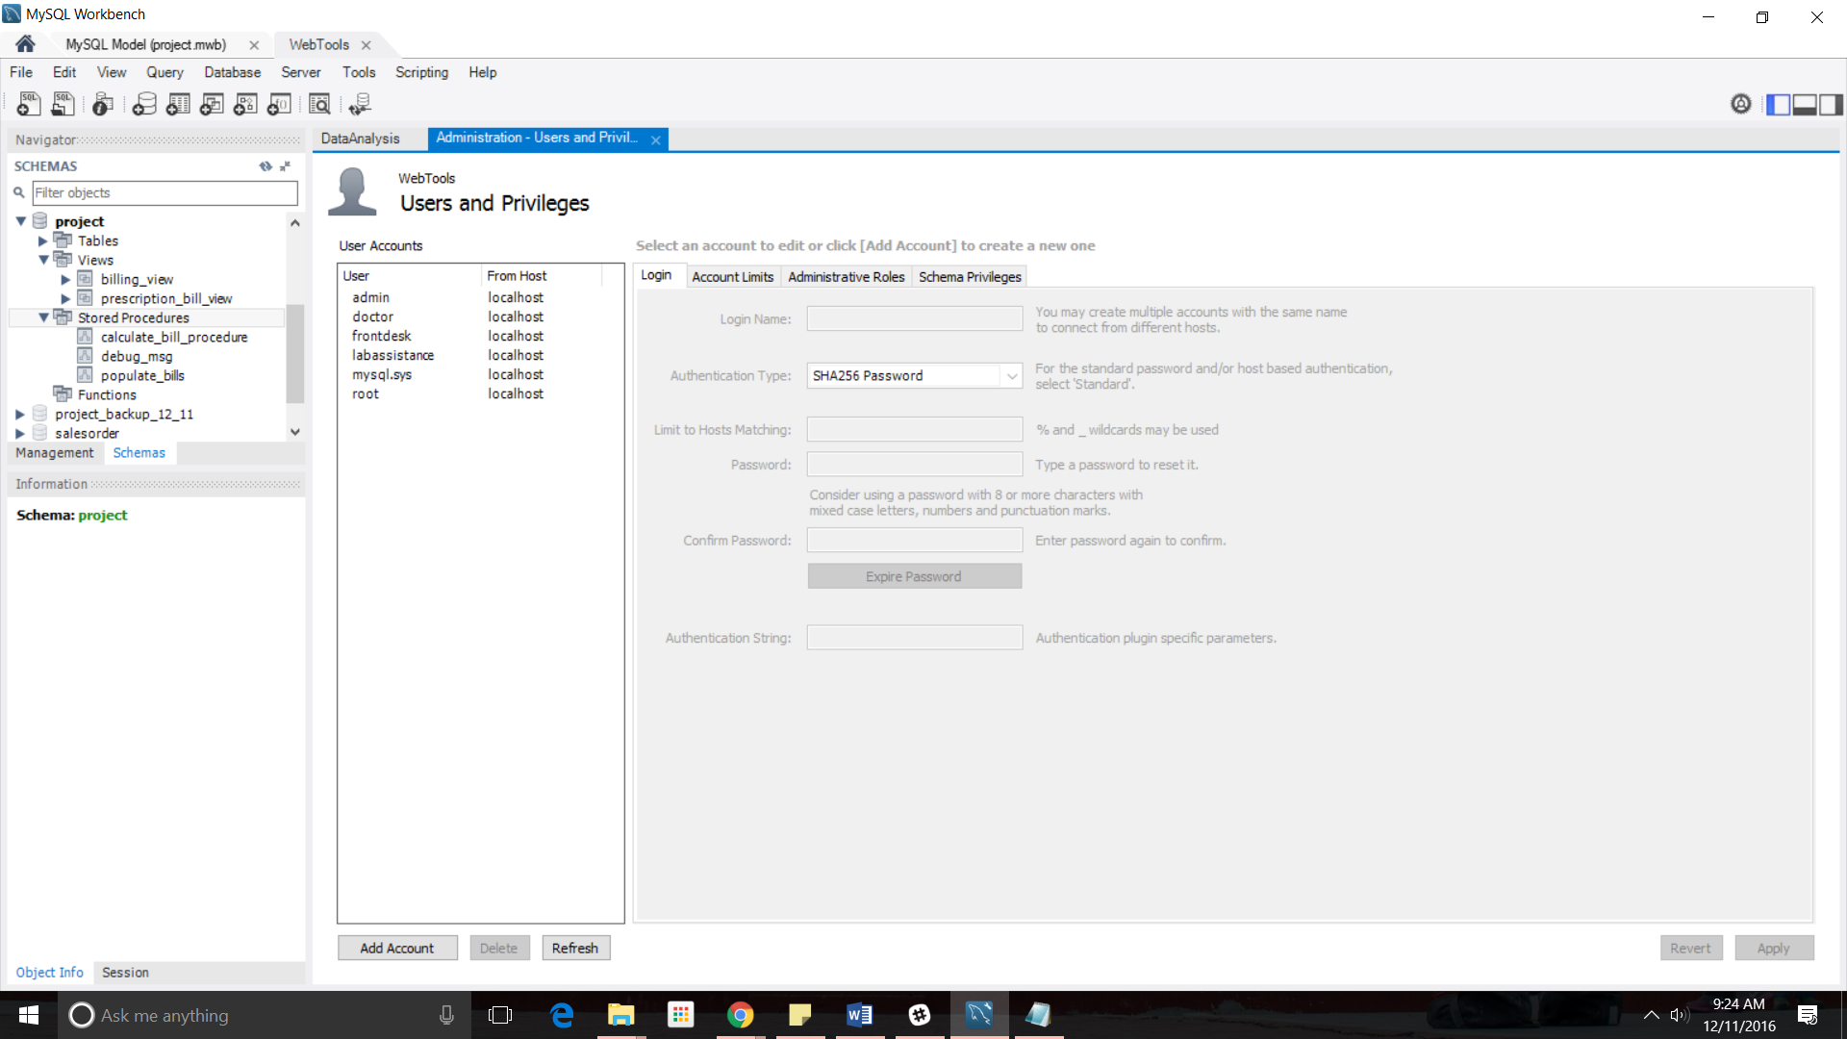

**APPENDIX**

-- MySQL dump 10.13 Distrib 5.7.9, for Win64 (x86_64)

--

-- Host: 127.0.0.1 Database: project

-- ------------------------------------------------------

-- Server version 5.7.12-log

/*!40101 SET @OLD_CHARACTER_SET_CLIENT=@@CHARACTER_SET_CLIENT */;

/*!40101 SET @OLD_CHARACTER_SET_RESULTS=@@CHARACTER_SET_RESULTS */;

/*!40101 SET @OLD_COLLATION_CONNECTION=@@COLLATION_CONNECTION */;

/*!40101 SET NAMES utf8 */;

/*!40103 SET @OLD_TIME_ZONE=@@TIME_ZONE */;

/*!40103 SET TIME_ZONE='+00:00' */;

/*!40014 SET @OLD_UNIQUE_CHECKS=@@UNIQUE_CHECKS, UNIQUE_CHECKS=0 */;

/*!40014 SET @OLD_FOREIGN_KEY_CHECKS=@@FOREIGN_KEY_CHECKS, FOREIGN_KEY_CHECKS=0 */;

/*!40101 SET @OLD_SQL_MODE=@@SQL_MODE, SQL_MODE='NO_AUTO_VALUE_ON_ZERO' */;

/*!40111 SET @OLD_SQL_NOTES=@@SQL_NOTES, SQL_NOTES=0 */;

--

-- Table structure for table `address`

--

DROP TABLE IF EXISTS `address`;

/*!40101 SET @saved_cs_client = @@character_set_client */;

/*!40101 SET character_set_client = utf8 */;

CREATE TABLE `address` (

`address_id` int(11) NOT NULL,

`address_line1` varchar(45) NOT NULL,

`address_line2` varchar(45) DEFAULT NULL,

`city` varchar(45) NOT NULL,

`state` varchar(5) NOT NULL,

`zip` varchar(5) NOT NULL,

`country` varchar(45) NOT NULL,

PRIMARY KEY (`address_id`)

) ENGINE=InnoDB DEFAULT CHARSET=utf8;

/*!40101 SET character_set_client = @saved_cs_client */;

--

-- Dumping data for table `address`

--

LOCK TABLES `address` WRITE;

/*!40000 ALTER TABLE `address` DISABLE KEYS */;

INSERT INTO `address` (`address_id`, `address_line1`, `address_line2`, `city`, `state`, `zip`, `country`) VALUES (1,'300 Longwood Ave','','Boston','MA','02115','USA'),(2,'60 St Germain Street','Apt 5','Boston','MA','02115','USA'),(3,'75 St Alphonsus Street','','Boston','MA','02120','USA'),(4,'15 Smith Street','B','Boston','MA','02120','USA'),(5,'30 Dalton Street','','Boston','MA','02115','USA'),(6,'40 St Alphonosus Street','C','Boston','MA','02120','USA'),(7,'28 St Alphonsus Street','B','Boston','MA','02120','USA'),(8,'Hyde Park Ave','1050','Boston','MA','02136','USA'),(9,'E Eighth St','671','Boston','MA','02127','USA'),(10,'Sanborn Ave','109','Boston','MA','02132','USA'),(11,'South St','5','Boston','MA','02135','USA'),(12,'Broadlawn Park','57','Boston','MA','02132','USA'),(13,'Paul Gore St','68','Boston','MA','02130','USA'),(14,'Florida St','90','Boston','MA','02124','USA'),(15,'E Eighth St','344','Boston','MA','02127','USA'),(16,'Middle St','42-44','Boston','MA','02127','USA'),(17,'Henry Sterling Sq','14','Boston','MA','02127','USA'),(18,'E Fourth St','905','Boston','MA','02127','USA'),(19,'Grew Ave','89A','Boston','MA','02131','USA'),(20,'Louder\'s Ln','21','Boston','MA','02130','USA'),(21,'Northdale Ter','10','Boston','MA','02132','USA'),(22,'Perkins St','111','Boston','MA','02130','USA'),(23,'Elmore St','35','Boston','MA','02119','USA'),(24,'Mountfort St','120','Boston','MA','02215','USA'),(25,'Beacon St','199','Boston','MA','02116','USA'),(26,'Tremont St','750','Boston','MA','02118','USA'),(27,'Washington St','1850','Boston','MA','02118','USA'),(28,'E Broadway','508','Boston','MA','02127','USA'),(29,'Huntington Ave','660','Boston','MA','02120','USA'),(30,'Folsom St','18','Boston','MA','02125','USA'),(31,'Lawley St','29','Boston','MA','02122','USA'),(32,'Adams St','596','Boston','MA','02122','USA'),(33,'Eliot Pl','7-8 ','Boston','MA','02130','USA'),(34,'330 Mount Auburn Street','','Cambridge','MA','02138','USA'),(35,'Boston Meducal Center Place','1','Boston','MA','02118','USA'),(36,'330 Brookline Avenue','','Boston','MA','02115','USA'),(37,'55 Fruit Street','','Boston','MA','02114','USA'),(38,'800 Washington Street','','Boston','MA','02111','USA');

/*!40000 ALTER TABLE `address` ENABLE KEYS */;

UNLOCK TABLES;

--

-- Table structure for table `appointment`

--

DROP TABLE IF EXISTS `appointment`;

/*!40101 SET @saved_cs_client = @@character_set_client */;

/*!40101 SET character_set_client = utf8 */;

CREATE TABLE `appointment` (

`appointment_id` int(11) NOT NULL,

`appointment_start_date_time` datetime NOT NULL,

`booked_by` int(11) NOT NULL,

`booked_for` int(11) NOT NULL,

`reason` varchar(100) DEFAULT NULL,

`appointment_bill` int(11) NOT NULL,

`appointment_end_date_time` datetime NOT NULL,

PRIMARY KEY (`appointment_id`),

KEY `booked_by_idx` (`booked_by`),

KEY `booked_for_idx` (`booked_for`),

CONSTRAINT `fk_app_booked_by` FOREIGN KEY (`booked_by`) REFERENCES `patient` (`patient_id`) ON UPDATE CASCADE,

CONSTRAINT `fk_app_booked_for` FOREIGN KEY (`booked_for`) REFERENCES `staff` (`staff_id`) ON UPDATE CASCADE

) ENGINE=InnoDB DEFAULT CHARSET=utf8;

/*!40101 SET character_set_client = @saved_cs_client */;

--

-- Dumping data for table `appointment`

--

LOCK TABLES `appointment` WRITE;

/*!40000 ALTER TABLE `appointment` DISABLE KEYS */;

INSERT INTO `appointment` (`appointment_id`, `appointment_start_date_time`, `booked_by`, `booked_for`, `reason`, `appointment_bill`, `appointment_end_date_time`) VALUES (1,'2016-08-14 13:00:00',1,4,'regular checkup',50,'2016-08-14 13:30:00'),(2,'2016-10-19 14:00:00',8,4,'general checkup',50,'2016-10-19 14:30:00'),(3,'2016-08-31 12:00:00',1,4,'regular checkup',50,'2016-08-31 12:30:00'),(4,'2016-08-16 09:00:00',2,6,'general checkup',40,'2016-08-16 09:30:00'),(5,'2016-09-01 10:30:00',3,6,'general checkup',40,'2016-09-01 11:00:00'),(6,'2016-09-14 11:00:00',5,9,'regular checkup',40,'2016-09-14 11:30:00'),(7,'2016-08-25 09:00:00',2,2,'regular checkup',50,'2016-08-25 09:30:00'),(8,'2016-10-30 20:00:00',9,6,'general checkup',50,'2016-10-30 20:30:00'),(9,'2016-09-13 20:30:00',6,2,'regular checkup',40,'2016-09-13 21:00:00'),(10,'2016-09-14 12:00:00',5,7,'general checkup',40,'2016-09-14 12:30:00'),(11,'2016-09-26 09:00:00',7,7,'regular checkup',100,'2016-09-26 09:00:00'),(12,'2016-09-07 10:00:00',4,9,'regular checkup',40,'2016-09-07 10:30:00'),(13,'2016-09-10 12:00:00',4,1,'general checkup',40,'2016-09-10 12:00:00'),(14,'2016-11-22 08:00:00',10,4,'general checkup',50,'2016-11-22 08:30:00'),(15,'2016-11-24 09:00:00',11,2,'general checkup',80,'2016-11-24 09:30:00'),(16,'2016-12-11 11:00:00',3,6,'general checkup',40,'2016-12-11 11:30:00'),(17,'2016-12-12 09:00:00',5,7,'regular checkup',50,'2016-12-12 09:30:00');

/*!40000 ALTER TABLE `appointment` ENABLE KEYS */;

UNLOCK TABLES;

/*!50003 SET @saved_cs_client = @@character_set_client */ ;

/*!50003 SET @saved_cs_results = @@character_set_results */ ;

/*!50003 SET @saved_col_connection = @@collation_connection */ ;

/*!50003 SET character_set_client = utf8 */ ;

/*!50003 SET character_set_results = utf8 */ ;

/*!50003 SET collation_connection = utf8_general_ci */ ;

/*!50003 SET @saved_sql_mode = @@sql_mode */ ;

/*!50003 SET sql_mode = 'STRICT_TRANS_TABLES,NO_AUTO_CREATE_USER,NO_ENGINE_SUBSTITUTION' */ ;

DELIMITER ;;

/*!50003 CREATE*/ /*!50017 DEFINER=`admin`@`localhost`*/ /*!50003 TRIGGER out_patient_next_checkin_date

AFTER INSERT

ON appointment

FOR EACH ROW

BEGIN

CASE

WHEN (SELECT distinct patient.patient_type FROM patient WHERE NEW.booked_by = patient.patient_id) = 0 THEN

UPDATE out_house_patient SET next_checkin_date = NEW.appointment_start_date_time WHERE patient_id = NEW.booked_by;

END CASE;

END */;;

DELIMITER ;

/*!50003 SET sql_mode = @saved_sql_mode */ ;

/*!50003 SET character_set_client = @saved_cs_client */ ;

/*!50003 SET character_set_results = @saved_cs_results */ ;

/*!50003 SET collation_connection = @saved_col_connection */ ;

--

-- Table structure for table `billing`

--

DROP TABLE IF EXISTS `billing`;

/*!40101 SET @saved_cs_client = @@character_set_client */;

/*!40101 SET character_set_client = utf8 */;

CREATE TABLE `billing` (

`bill_id` int(11) NOT NULL,

`bill_date` datetime NOT NULL,

`patient_id` int(11) NOT NULL,

`bill_amount` int(11) DEFAULT NULL,

`insurance_amount` int(11) DEFAULT NULL,

`final_bill_amount` int(11) DEFAULT NULL,

`bill_start_date` datetime DEFAULT NULL,

PRIMARY KEY (`bill_id`),

KEY `fk_bill_patient_id_idx` (`patient_id`),

CONSTRAINT `fk_bill_patient_id` FOREIGN KEY (`patient_id`) REFERENCES `patient` (`patient_id`) ON DELETE NO ACTION ON UPDATE NO ACTION

) ENGINE=InnoDB DEFAULT CHARSET=utf8;

/*!40101 SET character_set_client = @saved_cs_client */;

--

-- Dumping data for table `billing`

--

LOCK TABLES `billing` WRITE;

/*!40000 ALTER TABLE `billing` DISABLE KEYS */;

INSERT INTO `billing` (`bill_id`, `bill_date`, `patient_id`, `bill_amount`, `insurance_amount`, `final_bill_amount`, `bill_start_date`) VALUES (1,'2016-12-10 15:47:15',1,90340,150000,0,'2016-08-13 00:00:00'),(2,'2016-12-10 15:58:29',2,90190,150000,0,'2016-08-15 00:00:00'),(3,'2016-12-10 16:06:15',3,230,150000,0,'2016-08-31 00:00:00'),(4,'2016-12-10 16:33:58',4,270,150000,0,'2016-09-05 00:00:00'),(5,'2016-12-10 16:35:55',6,220,150000,0,'2016-09-13 00:00:00');

/*!40000 ALTER TABLE `billing` ENABLE KEYS */;

UNLOCK TABLES;

--

-- Temporary view structure for view `billing_view`

--

DROP TABLE IF EXISTS `billing_view`;

/*!50001 DROP VIEW IF EXISTS `billing_view`*/;

SET @saved_cs_client = @@character_set_client;

SET character_set_client = utf8;

/*!50001 CREATE VIEW `billing_view` AS SELECT

1 AS `patient_id`,

1 AS `Procedure_Expense`,

1 AS `Surgery_Expense`,

1 AS `Appointment_Expense`,

1 AS `Prescription_Expense`*/;

SET character_set_client = @saved_cs_client;

--

-- Table structure for table `department`

--

DROP TABLE IF EXISTS `department`;

/*!40101 SET @saved_cs_client = @@character_set_client */;

/*!40101 SET character_set_client = utf8 */;

CREATE TABLE `department` (

`department_id` int(11) NOT NULL AUTO_INCREMENT,

`department_name` varchar(45) NOT NULL,

`hospital_id` int(11) NOT NULL,

PRIMARY KEY (`department_id`),

KEY `hospital_id_idx` (`hospital_id`),

CONSTRAINT `fk_dep_hospital_id` FOREIGN KEY (`hospital_id`) REFERENCES `hospital` (`hospital_id`) ON UPDATE CASCADE

) ENGINE=InnoDB AUTO_INCREMENT=12 DEFAULT CHARSET=utf8;

/*!40101 SET character_set_client = @saved_cs_client */;

--

-- Dumping data for table `department`

--

LOCK TABLES `department` WRITE;

/*!40000 ALTER TABLE `department` DISABLE KEYS */;

INSERT INTO `department` (`department_id`, `department_name`, `hospital_id`) VALUES (1,'Anaesthetics',1),(2,'Cardiology',1),(3,'Ear nose and throat',1),(4,'Gastroenterology',1),(5,'Gynaecology',1),(6,'General surgery',1),(7,'Neurology',1),(8,'Orthopaedics',1),(9,'Physiotherapy',1),(10,'Radiotherapy',1),(11,'HR',1);

/*!40000 ALTER TABLE `department` ENABLE KEYS */;

UNLOCK TABLES;

--

-- Table structure for table `department_patient_past`

--

DROP TABLE IF EXISTS `department_patient_past`;

/*!40101 SET @saved_cs_client = @@character_set_client */;

/*!40101 SET character_set_client = utf8 */;

CREATE TABLE `department_patient_past` (

`department_id` int(11) NOT NULL,

`patient_id` int(11) NOT NULL,

`current_department_flag` char(5) NOT NULL,

KEY `department_id_idx` (`department_id`),

KEY `patient_id_idx` (`patient_id`),

CONSTRAINT `fk_deppat_department_id` FOREIGN KEY (`department_id`) REFERENCES `department` (`department_id`) ON UPDATE CASCADE,

CONSTRAINT `fk_deppat_patient_id` FOREIGN KEY (`patient_id`) REFERENCES `patient` (`patient_id`) ON UPDATE CASCADE

) ENGINE=InnoDB DEFAULT CHARSET=utf8;

/*!40101 SET character_set_client = @saved_cs_client */;

--

-- Dumping data for table `department_patient_past`

--

LOCK TABLES `department_patient_past` WRITE;

/*!40000 ALTER TABLE `department_patient_past` DISABLE KEYS */;

INSERT INTO `department_patient_past` (`department_id`, `patient_id`, `current_department_flag`) VALUES (8,1,'Y'),(2,2,'N'),(5,2,'Y'),(10,3,'N'),(6,3,'Y'),(6,4,'Y'),(3,4,'N'),(4,4,'N'),(7,5,'Y'),(2,6,'Y'),(9,6,'N'),(2,7,'Y'),(6,7,'N'),(4,8,'Y'),(7,9,'N'),(2,9,'Y'),(2,10,'N'),(10,10,'Y'),(6,11,'Y'),(7,11,'N');

/*!40000 ALTER TABLE `department_patient_past` ENABLE KEYS */;

UNLOCK TABLES;

--

-- Table structure for table `hospital`

--

DROP TABLE IF EXISTS `hospital`;

/*!40101 SET @saved_cs_client = @@character_set_client */;

/*!40101 SET character_set_client = utf8 */;

CREATE TABLE `hospital` (

`hospital_id` int(11) NOT NULL AUTO_INCREMENT,

`hospital_name` varchar(45) NOT NULL,

`contact_number` varchar(45) NOT NULL,

`address_id` int(11) NOT NULL,

PRIMARY KEY (`hospital_id`),

KEY `fk_Hospital_Address1_idx` (`address_id`),

CONSTRAINT `fk_hosp_address_id` FOREIGN KEY (`address_id`) REFERENCES `address` (`address_id`) ON UPDATE CASCADE

) ENGINE=InnoDB AUTO_INCREMENT=7 DEFAULT CHARSET=utf8;

/*!40101 SET character_set_client = @saved_cs_client */;

--

-- Dumping data for table `hospital`

--

LOCK TABLES `hospital` WRITE;

/*!40000 ALTER TABLE `hospital` DISABLE KEYS */;

INSERT INTO `hospital` (`hospital_id`, `hospital_name`, `contact_number`, `address_id`) VALUES (1,'Boston Children Hospital','(617) 355-6000',1),(2,'Mount Auburn Hospital','(617) 492-3500',34),(3,'Boston Medical Center Corporation','(617) 638-8000',35),(4,'Beth Israel Deaconess Medical Center','(617) 667-7000',36),(5,'Massachusetts GeneralJHospital','(617) 726-2000',37),(6,'Tufts Medical Center','(617) 636-5000',38);

/*!40000 ALTER TABLE `hospital` ENABLE KEYS */;

UNLOCK TABLES;

--

-- Table structure for table `in_house_patient`

--

DROP TABLE IF EXISTS `in_house_patient`;

/*!40101 SET @saved_cs_client = @@character_set_client */;

/*!40101 SET character_set_client = utf8 */;

CREATE TABLE `in_house_patient` (

`patient_id` int(11) NOT NULL,

`bed_number` varchar(45) NOT NULL,

PRIMARY KEY (`patient_id`),

CONSTRAINT `fk_inpat_patient_id` FOREIGN KEY (`patient_id`) REFERENCES `patient` (`patient_id`) ON UPDATE CASCADE

) ENGINE=InnoDB DEFAULT CHARSET=utf8;

/*!40101 SET character_set_client = @saved_cs_client */;

--

-- Dumping data for table `in_house_patient`

--

LOCK TABLES `in_house_patient` WRITE;

/*!40000 ALTER TABLE `in_house_patient` DISABLE KEYS */;

INSERT INTO `in_house_patient` (`patient_id`, `bed_number`) VALUES (1,'B52'),(2,'A30'),(6,'C30'),(7,'D20'),(9,'B12'),(11,'A3');

/*!40000 ALTER TABLE `in_house_patient` ENABLE KEYS */;

UNLOCK TABLES;

--

-- Table structure for table `insurance`

--

DROP TABLE IF EXISTS `insurance`;

/*!40101 SET @saved_cs_client = @@character_set_client */;

/*!40101 SET character_set_client = utf8 */;

CREATE TABLE `insurance` (

`insurance_number` int(11) NOT NULL,

`insurance_type_id` int(11) NOT NULL,

`insurance_date` datetime NOT NULL,

`expire_date` datetime NOT NULL,

PRIMARY KEY (`insurance_number`),

KEY `insurance_type_id_idx` (`insurance_type_id`),

CONSTRAINT `fk_ins_insurance_type_id` FOREIGN KEY (`insurance_type_id`) REFERENCES `insurance_type` (`insurance_type_id`) ON UPDATE CASCADE

) ENGINE=InnoDB DEFAULT CHARSET=utf8;

/*!40101 SET character_set_client = @saved_cs_client */;

--

-- Dumping data for table `insurance`

--

LOCK TABLES `insurance` WRITE;

/*!40000 ALTER TABLE `insurance` DISABLE KEYS */;

INSERT INTO `insurance` (`insurance_number`, `insurance_type_id`, `insurance_date`, `expire_date`) VALUES (1,1,'2012-12-03 00:00:00','2016-09-25 00:00:00'),(2,1,'2012-12-02 00:00:00','2016-10-19 00:00:00'),(3,2,'2013-01-18 00:00:00','2016-10-30 00:00:00'),(4,1,'2013-01-19 00:00:00','2016-11-21 00:00:00'),(5,2,'2013-04-06 00:00:00','2016-11-23 00:00:00'),(6,1,'2013-05-17 00:00:00','2017-01-05 00:00:00'),(7,2,'2013-06-03 00:00:00','2017-01-26 00:00:00'),(8,2,'2013-06-11 00:00:00','2017-02-16 00:00:00'),(9,1,'2013-07-22 00:00:00','2017-03-05 00:00:00'),(10,3,'2013-07-28 00:00:00','2017-03-21 00:00:00'),(11,5,'2013-08-07 00:00:00','2017-04-03 00:00:00'),(12,3,'2013-08-08 00:00:00','2017-05-06 00:00:00'),(13,4,'2013-09-10 00:00:00','2017-05-13 00:00:00'),(14,3,'2013-09-21 00:00:00','2017-07-01 00:00:00'),(15,5,'2013-10-04 00:00:00','2017-07-18 00:00:00'),(16,3,'2013-10-09 00:00:00','2017-08-01 00:00:00'),(17,4,'2013-10-15 00:00:00','2017-08-09 00:00:00'),(18,3,'2013-11-12 00:00:00','2017-09-11 00:00:00'),(19,2,'2013-11-16 00:00:00','2017-10-05 00:00:00'),(20,4,'2013-11-17 00:00:00','2017-10-21 00:00:00'),(21,1,'2013-11-21 00:00:00','2017-10-23 00:00:00'),(22,4,'2013-11-28 00:00:00','2017-11-13 00:00:00'),(23,1,'2013-12-05 00:00:00','2017-11-16 00:00:00');

/*!40000 ALTER TABLE `insurance` ENABLE KEYS */;

UNLOCK TABLES;

--

-- Table structure for table `insurance_type`

--

DROP TABLE IF EXISTS `insurance_type`;

/*!40101 SET @saved_cs_client = @@character_set_client */;

/*!40101 SET character_set_client = utf8 */;

CREATE TABLE `insurance_type` (

`insurance_type_id` int(11) NOT NULL,

`insurance_name` varchar(45) NOT NULL,

`max_insurance_amount` varchar(45) NOT NULL,

PRIMARY KEY (`insurance_type_id`)

) ENGINE=InnoDB DEFAULT CHARSET=utf8;

/*!40101 SET character_set_client = @saved_cs_client */;

--

-- Dumping data for table `insurance_type`

--

LOCK TABLES `insurance_type` WRITE;

/*!40000 ALTER TABLE `insurance_type` DISABLE KEYS */;

INSERT INTO `insurance_type` (`insurance_type_id`, `insurance_name`, `max_insurance_amount`) VALUES (1,'Accidental','150000'),(2,'Acute Care','50000'),(3,'Dependent Coverage','100000'),(4,'Indemnity Plan','80000'),(5,'Long-Term Care','200000'),(6,'Medicare','60000'),(7,'Vision Care Coverage','10000');

/*!40000 ALTER TABLE `insurance_type` ENABLE KEYS */;

UNLOCK TABLES;

--

-- Table structure for table `medicine_prescription`

--

DROP TABLE IF EXISTS `medicine_prescription`;

/*!40101 SET @saved_cs_client = @@character_set_client */;

/*!40101 SET character_set_client = utf8 */;

CREATE TABLE `medicine_prescription` (

`medicine_id` int(11) NOT NULL,

`prescription_id` int(11) NOT NULL,

`quantity` int(11) NOT NULL DEFAULT '0',

KEY `medicine_id_idx` (`medicine_id`),

KEY `prescription_id_idx` (`prescription_id`),

CONSTRAINT `fk_medPr_medicine_id` FOREIGN KEY (`medicine_id`) REFERENCES `medicines` (`medicine_id`) ON UPDATE CASCADE,

CONSTRAINT `fk_medPr_prescription_id` FOREIGN KEY (`prescription_id`) REFERENCES `prescription` (`prescription_id`) ON UPDATE CASCADE

) ENGINE=InnoDB DEFAULT CHARSET=utf8;

/*!40101 SET character_set_client = @saved_cs_client */;

--

-- Dumping data for table `medicine_prescription`

--

LOCK TABLES `medicine_prescription` WRITE;

/*!40000 ALTER TABLE `medicine_prescription` DISABLE KEYS */;

INSERT INTO `medicine_prescription` (`medicine_id`, `prescription_id`, `quantity`) VALUES (1,1,2),(2,1,2),(3,1,3),(1,2,2),(5,2,3),(2,3,1),(3,3,2),(8,3,4),(14,3,1),(1,4,2),(15,4,3),(6,4,1),(8,5,2),(4,5,2),(1,6,1),(9,7,4),(11,7,2),(12,7,3),(4,8,1),(7,8,2),(2,9,3),(6,9,1),(14,9,4),(2,10,1),(1,10,2),(13,10,3),(12,10,1),(3,11,2),(4,11,1),(8,12,2),(6,12,2),(9,12,3),(15,12,3),(15,13,1),(1,13,2),(7,13,2),(5,14,1);

/*!40000 ALTER TABLE `medicine_prescription` ENABLE KEYS */;

UNLOCK TABLES;

--

-- Table structure for table `medicines`

--

DROP TABLE IF EXISTS `medicines`;

/*!40101 SET @saved_cs_client = @@character_set_client */;

/*!40101 SET character_set_client = utf8 */;

CREATE TABLE `medicines` (

`medicine_id` int(11) NOT NULL,

`medicine_name` varchar(45) NOT NULL,

`price` int(11) NOT NULL,

PRIMARY KEY (`medicine_id`)

) ENGINE=InnoDB DEFAULT CHARSET=utf8;

/*!40101 SET character_set_client = @saved_cs_client */;

--

-- Dumping data for table `medicines`

--

LOCK TABLES `medicines` WRITE;

/*!40000 ALTER TABLE `medicines` DISABLE KEYS */;

INSERT INTO `medicines` (`medicine_id`, `medicine_name`, `price`) VALUES (1,'Aspirin',3),(2,'abacavir',6),(3,'Abenol',10),(4,'Acova',35),(5,'Caduet',15),(6,'Cycloset',20),(7,'Gabitril',5),(8,'Gynodiol',9),(9,'Ibudone',10),(10,'Macitentan',18),(11,'methadone',22),(12,'Pacerone',20),(13,'Phlemex',26),(14,'Sabril',5),(15,'Soma',30);

/*!40000 ALTER TABLE `medicines` ENABLE KEYS */;

UNLOCK TABLES;

--

-- Table structure for table `out_house_patient`

--

DROP TABLE IF EXISTS `out_house_patient`;

/*!40101 SET @saved_cs_client = @@character_set_client */;

/*!40101 SET character_set_client = utf8 */;

CREATE TABLE `out_house_patient` (

`patient_id` int(11) NOT NULL,

`next_checkin_date` datetime DEFAULT NULL,

PRIMARY KEY (`patient_id`),

CONSTRAINT `fk_outpat_patient_id` FOREIGN KEY (`patient_id`) REFERENCES `patient` (`patient_id`) ON UPDATE CASCADE

) ENGINE=InnoDB DEFAULT CHARSET=utf8;

/*!40101 SET character_set_client = @saved_cs_client */;

--

-- Dumping data for table `out_house_patient`

--

LOCK TABLES `out_house_patient` WRITE;

/*!40000 ALTER TABLE `out_house_patient` DISABLE KEYS */;

INSERT INTO `out_house_patient` (`patient_id`, `next_checkin_date`) VALUES (3,'2016-12-11 11:00:00'),(4,'2016-09-15 00:00:00'),(5,'2016-12-12 09:00:00'),(8,'2016-10-29 00:00:00'),(10,'2016-11-29 00:00:00');

/*!40000 ALTER TABLE `out_house_patient` ENABLE KEYS */;

UNLOCK TABLES;

--

-- Table structure for table `patient`

--

DROP TABLE IF EXISTS `patient`;

/*!40101 SET @saved_cs_client = @@character_set_client */;

/*!40101 SET character_set_client = utf8 */;

CREATE TABLE `patient` (

`patient_id` int(11) NOT NULL,

`role_id` int(11) NOT NULL,

`person_id` int(11) NOT NULL,

`admission_date` datetime DEFAULT NULL,

`previous_stay_flag` char(1) NOT NULL,

`reason` varchar(100) DEFAULT NULL,

`patient_type` int(11) NOT NULL,

PRIMARY KEY (`patient_id`),

UNIQUE KEY `person_for_patient` (`person_id`),

KEY `person_id_idx` (`person_id`),

KEY `role_id_idx` (`role_id`),

CONSTRAINT `fk_pat_person_id` FOREIGN KEY (`person_id`) REFERENCES `person` (`person_id`) ON UPDATE CASCADE,

CONSTRAINT `fk_pat_role_id` FOREIGN KEY (`role_id`) REFERENCES `role` (`role_id`) ON DELETE NO ACTION ON UPDATE NO ACTION

) ENGINE=InnoDB DEFAULT CHARSET=utf8;

/*!40101 SET character_set_client = @saved_cs_client */;

--

-- Dumping data for table `patient`

--

LOCK TABLES `patient` WRITE;

/*!40000 ALTER TABLE `patient` DISABLE KEYS */;

INSERT INTO `patient` (`patient_id`, `role_id`, `person_id`, `admission_date`, `previous_stay_flag`, `reason`, `patient_type`) VALUES (1,1,1,'2016-08-13 00:00:00','N','surgery for broken leg',1),(2,1,5,'2016-08-15 00:00:00','Y','surgery for hernia',1),(3,1,6,'2016-08-31 00:00:00','Y','blood test',0),(4,1,7,'2016-09-05 00:00:00','Y','xray for ankle',0),(5,1,9,'2016-09-13 00:00:00','N','Pneumonia',0),(6,1,10,'2016-09-13 00:00:00','Y','Pulmonary heart disease',1),(7,1,11,'2016-09-25 00:00:00','N','Pulmonary heart disease',1),(8,1,12,'2016-10-19 00:00:00','N','Intestinal infection',0),(9,1,13,'2016-10-30 00:00:00','Y','Pulmonary heart disease',1),(10,1,14,'2016-11-21 00:00:00','Y','xray for little finger',0),(11,1,15,'2016-11-23 00:00:00','Y','surgery for neck',1);

/*!40000 ALTER TABLE `patient` ENABLE KEYS */;

UNLOCK TABLES;

/*!50003 SET @saved_cs_client = @@character_set_client */ ;

/*!50003 SET @saved_cs_results = @@character_set_results */ ;

/*!50003 SET @saved_col_connection = @@collation_connection */ ;

/*!50003 SET character_set_client = utf8 */ ;

/*!50003 SET character_set_results = utf8 */ ;

/*!50003 SET collation_connection = utf8_general_ci */ ;

/*!50003 SET @saved_sql_mode = @@sql_mode */ ;

/*!50003 SET sql_mode = 'STRICT_TRANS_TABLES,NO_AUTO_CREATE_USER,NO_ENGINE_SUBSTITUTION' */ ;

DELIMITER ;;

/*!50003 CREATE*/ /*!50017 DEFINER=`admin`@`localhost`*/ /*!50003 TRIGGER patient_accounting

BEFORE UPDATE

ON patient

FOR EACH ROW

BEGIN

INSERT INTO patient_backup(patient_id, role_id, person_id, admission_date, previous_stay_flag, reason, patient_type) value (OLD.patient_id, OLD.role_id, OLD.person_id, OLD.admission_date, OLD.previous_stay_flag, OLD.reason, OLD.patient_type);

END */;;

DELIMITER ;

/*!50003 SET sql_mode = @saved_sql_mode */ ;

/*!50003 SET character_set_client = @saved_cs_client */ ;

/*!50003 SET character_set_results = @saved_cs_results */ ;

/*!50003 SET collation_connection = @saved_col_connection */ ;

--

-- Table structure for table `patient_backup`

--

DROP TABLE IF EXISTS `patient_backup`;

/*!40101 SET @saved_cs_client = @@character_set_client */;

/*!40101 SET character_set_client = utf8 */;

CREATE TABLE `patient_backup` (

`id` int(11) NOT NULL AUTO_INCREMENT,

`patient_id` int(11) NOT NULL,

`role_id` int(11) DEFAULT NULL,

`person_id` int(11) DEFAULT NULL,

`admission_date` datetime DEFAULT NULL,

`previous_stay_flag` char(1) DEFAULT NULL,

`reason` varchar(100) DEFAULT NULL,

`patient_type` int(11) DEFAULT NULL,

PRIMARY KEY (`id`)

) ENGINE=InnoDB AUTO_INCREMENT=5 DEFAULT CHARSET=utf8;

/*!40101 SET character_set_client = @saved_cs_client */;

--

-- Dumping data for table `patient_backup`

--

LOCK TABLES `patient_backup` WRITE;

/*!40000 ALTER TABLE `patient_backup` DISABLE KEYS */;

INSERT INTO `patient_backup` (`id`, `patient_id`, `role_id`, `person_id`, `admission_date`, `previous_stay_flag`, `reason`, `patient_type`) VALUES (1,11,1,15,'2016-11-23 00:00:00','Y','surgery for neck',1),(2,11,1,15,'2016-11-23 00:00:00','Y','surgery for neck',0),(3,11,1,15,'2016-11-23 00:00:00','Y','surgery for neck',1),(4,11,1,15,'2016-11-23 00:00:00','Y','surgery for neck',0);

/*!40000 ALTER TABLE `patient_backup` ENABLE KEYS */;

UNLOCK TABLES;

--

-- Table structure for table `person`

--

DROP TABLE IF EXISTS `person`;

/*!40101 SET @saved_cs_client = @@character_set_client */;

/*!40101 SET character_set_client = utf8 */;

CREATE TABLE `person` (

`person_id` int(11) NOT NULL,

`first_name` varchar(45) NOT NULL,

`last_name` varchar(45) NOT NULL,

`address_id` int(11) DEFAULT NULL,

`email_id` varchar(70) DEFAULT NULL,

`contact_numnber` varchar(45) DEFAULT NULL,

`insurance_number` int(11) DEFAULT NULL,

PRIMARY KEY (`person_id`),

KEY `address_id_idx` (`address_id`),

KEY `insurance_number_idx` (`insurance_number`),

CONSTRAINT `fk_per_address_id` FOREIGN KEY (`address_id`) REFERENCES `address` (`address_id`) ON UPDATE CASCADE,

CONSTRAINT `fk_per_insurance_number` FOREIGN KEY (`insurance_number`) REFERENCES `insurance` (`insurance_number`) ON UPDATE CASCADE

) ENGINE=InnoDB DEFAULT CHARSET=utf8;

/*!40101 SET character_set_client = @saved_cs_client */;

--

-- Dumping data for table `person`

--

LOCK TABLES `person` WRITE;

/*!40000 ALTER TABLE `person` DISABLE KEYS */;

INSERT INTO `person` (`person_id`, `first_name`, `last_name`, `address_id`, `email_id`, `contact_numnber`, `insurance_number`) VALUES (1,'Gaurang','Deshpande',NULL,'gaurang.deshpande@gmail.com','4016631737',NULL),(2,'Shamal','Bhole',2,'shamal.bhole@gmail.com','4092814850',2),(3,'Vandana','Tiwari',3,'vandana.tiwari@gmail.com','4324058361',3),(4,'Vihar','Raul',4,'vihar.raul@gmail.com','3456783245',7),(5,'Amita','Murali',5,'amita.murali@gmail.com','7629274212',4),(6,'Rutika','Araokar',6,'rutika.araokar@gmail.com','5024591098',9),(7,'Bhavesh','Sachdev',7,'bhavesh.sachdev@gmail.com','6720018901',NULL),(8,'Shritu','Mehta',8,'shritu.mehta@gmail.com','2013948564',8),(9,'Sneha','Shetty',NULL,'sneha.shetty@gmail.com','9387120301',5),(10,'Manish','Patil',9,'manish.patil@gmail.com','3839205968',1),(11,'Shailesh','Hegde',10,'shailesh.hegde@gmail.com','3895048271',6),(12,'Antriksh','Sharma',NULL,'antriksh.sharma@gmail.com','2372335802',11),(13,'Avee','Arora',11,'avee.arora@gmail.com','5643567765',16),(14,'Ketki','Deshpande',12,'ketki.deshpande@gmail.com','9876523464',19),(15,'Neeraj','Rajput',NULL,'neeraj.rajput@gmail.com','3245677654',12),(16,'Saurabh','Rao',13,'saurabh.rao@gmail.com','3567876545',NULL),(17,'Pratiksha','Shetty',14,'pratiksha.shetty@gmail.com','8972439875',10),(18,'Suprita','Puned',15,'suprita.puned@gmail.com','8762376864',13),(19,'Shivam','Negi',NULL,'shivam.negi@gmail.com','9876132425',15),(20,'Shrikant','Mudholkar',16,'shrikant.mudholkar@gmail.com','3245678765',14),(21,'Sushrut','Tadwalkar',17,'sushrut.tadwalkar@gmail.com','4369876524',19),(22,'Kedar','Deshmukh',18,'kedar.deshmukh@gmail.com','4328762436',22),(23,'Rohan','Jahagirdar',NULL,'rohan.jahagirdar@gmail.com','9876543212',NULL),(24,'Lahari','Palle',19,'lahari.palle@gmail.com','2436776543',20),(25,'Akansha','Harshe',20,'akansha.harshe@gmail.com','3425678765',21),(26,'Shephali','Mahajan',21,'shephali.mahajan@gmail.com','4368756442',NULL),(27,'Priyal','Chaudhari',22,'priyal.chaudhari@gmail.com','5786435456',23);

/*!40000 ALTER TABLE `person` ENABLE KEYS */;

UNLOCK TABLES;

/*!50003 SET @saved_cs_client = @@character_set_client */ ;

/*!50003 SET @saved_cs_results = @@character_set_results */ ;

/*!50003 SET @saved_col_connection = @@collation_connection */ ;

/*!50003 SET character_set_client = utf8 */ ;

/*!50003 SET character_set_results = utf8 */ ;

/*!50003 SET collation_connection = utf8_general_ci */ ;

/*!50003 SET @saved_sql_mode = @@sql_mode */ ;

/*!50003 SET sql_mode = 'STRICT_TRANS_TABLES,NO_AUTO_CREATE_USER,NO_ENGINE_SUBSTITUTION' */ ;

DELIMITER ;;

/*!50003 CREATE*/ /*!50017 DEFINER=`admin`@`localhost`*/ /*!50003 TRIGGER validate_email

BEFORE INSERT

ON person

FOR EACH ROW

BEGIN

IF NEW.email_id NOT LIKE '%_@%_.__%'

THEN

SIGNAL SQLSTATE VALUE '45000'

SET MESSAGE_TEXT = 'email column is not valid';

END IF;

END */;;

DELIMITER ;

/*!50003 SET sql_mode = @saved_sql_mode */ ;

/*!50003 SET character_set_client = @saved_cs_client */ ;

/*!50003 SET character_set_results = @saved_cs_results */ ;

/*!50003 SET collation_connection = @saved_col_connection */ ;

--

-- Table structure for table `prescription`

--

DROP TABLE IF EXISTS `prescription`;

/*!40101 SET @saved_cs_client = @@character_set_client */;

/*!40101 SET character_set_client = utf8 */;

CREATE TABLE `prescription` (

`prescription_id` int(11) NOT NULL,

`prescription_date` datetime NOT NULL,

`prescription_till` datetime NOT NULL,

`dose_per_day` int(11) NOT NULL,

`prescribed_by` int(11) NOT NULL,

`prescribed_to` int(11) NOT NULL,

PRIMARY KEY (`prescription_id`),

KEY `prescribed_by_idx` (`prescribed_by`),

KEY `prescribed_to_idx` (`prescribed_to`),

CONSTRAINT `fk_pre_prescribed_by` FOREIGN KEY (`prescribed_by`) REFERENCES `staff` (`staff_id`) ON UPDATE CASCADE,

CONSTRAINT `fk_pre_prescribed_to` FOREIGN KEY (`prescribed_to`) REFERENCES `patient` (`patient_id`) ON UPDATE CASCADE

) ENGINE=InnoDB DEFAULT CHARSET=utf8;

/*!40101 SET character_set_client = @saved_cs_client */;

--

-- Dumping data for table `prescription`

--

LOCK TABLES `prescription` WRITE;

/*!40000 ALTER TABLE `prescription` DISABLE KEYS */;

INSERT INTO `prescription` (`prescription_id`, `prescription_date`, `prescription_till`, `dose_per_day`, `prescribed_by`, `prescribed_to`) VALUES (1,'2016-08-13 00:00:00','2016-08-28 00:00:00',2,4,1),(2,'2016-08-15 00:00:00','2016-08-31 00:00:00',2,5,2),(3,'2016-08-31 00:00:00','2016-09-21 00:00:00',3,6,3),(4,'2016-09-05 00:00:00','2016-09-24 00:00:00',2,6,4),(5,'2016-09-13 00:00:00','2016-09-29 00:00:00',3,7,5),(6,'2016-09-13 00:00:00','2016-09-23 00:00:00',3,2,6),(7,'2016-09-25 00:00:00','2016-10-05 00:00:00',2,2,7),(8,'2016-10-19 00:00:00','2016-11-09 00:00:00',1,5,8),(9,'2016-10-30 00:00:00','2016-11-15 00:00:00',2,2,9),(10,'2016-11-21 00:00:00','2016-12-21 00:00:00',1,4,10),(11,'2016-11-23 00:00:00','2016-12-23 00:00:00',1,6,11),(12,'2016-09-01 00:00:00','2016-09-21 00:00:00',3,5,2),(13,'2016-09-25 00:00:00','2016-10-15 00:00:00',2,1,4),(14,'2016-09-30 00:00:00','2016-10-20 00:00:00',2,7,5);

/*!40000 ALTER TABLE `prescription` ENABLE KEYS */;

UNLOCK TABLES;

--

-- Temporary view structure for view `prescription_bill_view`

--

DROP TABLE IF EXISTS `prescription_bill_view`;

/*!50001 DROP VIEW IF EXISTS `prescription_bill_view`*/;

SET @saved_cs_client = @@character_set_client;

SET character_set_client = utf8;

/*!50001 CREATE VIEW `prescription_bill_view` AS SELECT

1 AS `patient_id`,

1 AS `prescription_id`,

1 AS `prescription_bill`*/;

SET character_set_client = @saved_cs_client;

--

-- Table structure for table `previous_checkin_dates`

--

DROP TABLE IF EXISTS `previous_checkin_dates`;

/*!40101 SET @saved_cs_client = @@character_set_client */;

/*!40101 SET character_set_client = utf8 */;

CREATE TABLE `previous_checkin_dates` (

`id` int(11) NOT NULL,

`patient_id` int(11) NOT NULL,

`previous_checkin_dates` datetime DEFAULT NULL,

PRIMARY KEY (`id`),

KEY `patient_id_idx` (`patient_id`),

CONSTRAINT `fk_prevch_patient_id` FOREIGN KEY (`patient_id`) REFERENCES `out_house_patient` (`patient_id`) ON UPDATE CASCADE

) ENGINE=InnoDB DEFAULT CHARSET=utf8;

/*!40101 SET character_set_client = @saved_cs_client */;

--

-- Dumping data for table `previous_checkin_dates`

--

LOCK TABLES `previous_checkin_dates` WRITE;

/*!40000 ALTER TABLE `previous_checkin_dates` DISABLE KEYS */;

INSERT INTO `previous_checkin_dates` (`id`, `patient_id`, `previous_checkin_dates`) VALUES (1,3,'2016-08-31 00:00:00'),(2,3,'2016-09-11 00:00:00'),(3,3,'2016-09-18 00:00:00'),(4,3,'2016-09-26 00:00:00'),(5,3,'2016-10-05 00:00:00'),(6,3,'2016-10-26 00:00:00'),(7,3,'2016-11-18 00:00:00'),(8,4,'2016-09-05 00:00:00'),(9,4,'2016-09-15 00:00:00'),(10,4,'2016-09-25 00:00:00'),(11,4,'2016-10-05 00:00:00'),(12,4,'2016-10-15 00:00:00'),(13,4,'2016-11-05 00:00:00'),(14,4,'2016-12-05 00:00:00'),(15,5,'2016-09-13 00:00:00'),(16,5,'2016-09-23 00:00:00'),(17,5,'2016-09-30 00:00:00'),(18,5,'2016-10-10 00:00:00'),(19,5,'2016-10-29 00:00:00'),(20,5,'2016-11-22 00:00:00'),(21,8,'2016-10-19 00:00:00'),(22,8,'2016-10-29 00:00:00'),(23,8,'2016-11-09 00:00:00'),(24,8,'2016-11-19 00:00:00'),(25,8,'2016-11-25 00:00:00'),(26,8,'2016-12-09 00:00:00'),(27,10,'2016-11-21 00:00:00'),(28,10,'2016-11-25 00:00:00'),(29,10,'2016-11-29 00:00:00'),(30,10,'2016-12-03 00:00:00'),(31,10,'2016-12-09 00:00:00');

/*!40000 ALTER TABLE `previous_checkin_dates` ENABLE KEYS */;

UNLOCK TABLES;

--

-- Table structure for table `procedures`

--

DROP TABLE IF EXISTS `procedures`;

/*!40101 SET @saved_cs_client = @@character_set_client */;

/*!40101 SET character_set_client = utf8 */;

CREATE TABLE `procedures` (

`procedure_id` int(11) NOT NULL,

`procedure_date` datetime NOT NULL,

`description` varchar(100) DEFAULT NULL,

`performed_by` int(11) NOT NULL,

`performed_on` int(11) NOT NULL,

`procedure_bill` int(11) NOT NULL,

PRIMARY KEY (`procedure_id`),

KEY `performed_by_idx` (`performed_by`),

KEY `performed_on_idx` (`performed_on`),

CONSTRAINT `fk_pro_performed_by` FOREIGN KEY (`performed_by`) REFERENCES `staff` (`staff_id`) ON UPDATE CASCADE,

CONSTRAINT `fk_pro_performed_on` FOREIGN KEY (`performed_on`) REFERENCES `patient` (`patient_id`) ON UPDATE CASCADE

) ENGINE=InnoDB DEFAULT CHARSET=utf8;

/*!40101 SET character_set_client = @saved_cs_client */;

--

-- Dumping data for table `procedures`

--

LOCK TABLES `procedures` WRITE;

/*!40000 ALTER TABLE `procedures` DISABLE KEYS */;

INSERT INTO `procedures` (`procedure_id`, `procedure_date`, `description`, `performed_by`, `performed_on`, `procedure_bill`) VALUES (1,'2016-08-15 00:00:00','blood test',3,1,90),(2,'2016-08-18 00:00:00','x ray scanning',9,1,150),(3,'2016-08-18 00:00:00','lab test',9,2,100),(4,'2016-09-02 00:00:00','blood test',5,3,90),(5,'2016-09-06 00:00:00','lab test',9,3,100),(6,'2016-09-06 00:00:00','blood test',8,4,90),(7,'2016-09-09 00:00:00','lab test',9,4,100),(8,'2016-11-24 00:00:00','x ray scanning',9,10,150),(9,'2016-09-15 00:00:00','CT scan',1,5,250),(10,'2016-10-21 00:00:00','lab test',9,8,100),(11,'2016-09-15 00:00:00','blood test',8,6,90),(12,'2016-09-18 00:00:00','blood test',9,6,90);

/*!40000 ALTER TABLE `procedures` ENABLE KEYS */;

UNLOCK TABLES;

--

-- Table structure for table `role`

--

DROP TABLE IF EXISTS `role`;

/*!40101 SET @saved_cs_client = @@character_set_client */;

/*!40101 SET character_set_client = utf8 */;

CREATE TABLE `role` (

`role_id` int(11) NOT NULL,

`role_name` varchar(45) NOT NULL,

PRIMARY KEY (`role_id`)

) ENGINE=InnoDB DEFAULT CHARSET=utf8;

/*!40101 SET character_set_client = @saved_cs_client */;

--

-- Dumping data for table `role`

--

LOCK TABLES `role` WRITE;

/*!40000 ALTER TABLE `role` DISABLE KEYS */;

INSERT INTO `role` (`role_id`, `role_name`) VALUES (1,'patient'),(2,'doctor'),(3,'lab assistant'),(4,'front desk attendant'),(5,'hostAdmin'),(6,'nurse');

/*!40000 ALTER TABLE `role` ENABLE KEYS */;

UNLOCK TABLES;

--

-- Table structure for table `staff`

--

DROP TABLE IF EXISTS `staff`;

/*!40101 SET @saved_cs_client = @@character_set_client */;

/*!40101 SET character_set_client = utf8 */;

CREATE TABLE `staff` (

`staff_id` int(11) NOT NULL AUTO_INCREMENT,

`department_id` int(11) NOT NULL,

`designation` varchar(45) DEFAULT NULL,

`role_id` int(11) NOT NULL,

`person_id` int(11) NOT NULL,

PRIMARY KEY (`staff_id`),

UNIQUE KEY `person_for_staff` (`person_id`),

KEY `department_id_idx` (`department_id`),

KEY `person_id_idx` (`person_id`),

KEY `role_id_idx` (`role_id`),

CONSTRAINT `fk_st_department_id` FOREIGN KEY (`department_id`) REFERENCES `department` (`department_id`) ON UPDATE CASCADE,

CONSTRAINT `fk_st_person_id` FOREIGN KEY (`person_id`) REFERENCES `person` (`person_id`) ON UPDATE CASCADE,

CONSTRAINT `fk_st_role_id` FOREIGN KEY (`role_id`) REFERENCES `role` (`role_id`) ON DELETE NO ACTION ON UPDATE NO ACTION

) ENGINE=InnoDB AUTO_INCREMENT=13 DEFAULT CHARSET=utf8;

/*!40101 SET character_set_client = @saved_cs_client */;

--

-- Dumping data for table `staff`

--

LOCK TABLES `staff` WRITE;

/*!40000 ALTER TABLE `staff` DISABLE KEYS */;

INSERT INTO `staff` (`staff_id`, `department_id`, `designation`, `role_id`, `person_id`) VALUES (1,1,'MD',2,3),(2,2,'MS',2,2),(3,2,NULL,6,4),(4,5,'MBBS',2,8),(5,5,NULL,6,19),(6,6,'MBBS',2,21),(7,7,'MS',2,22),(8,10,NULL,6,18),(9,10,'BDS',3,17),(10,8,'MS',2,27),(11,6,'',6,26),(12,11,'Attendant',4,20);

/*!40000 ALTER TABLE `staff` ENABLE KEYS */;

UNLOCK TABLES;

--

-- Table structure for table `surgery`

--

DROP TABLE IF EXISTS `surgery`;

/*!40101 SET @saved_cs_client = @@character_set_client */;

/*!40101 SET character_set_client = utf8 */;

CREATE TABLE `surgery` (

`surgery_id` int(11) NOT NULL,

`surgery_date` datetime NOT NULL,

`description` varchar(100) DEFAULT NULL,

`performed_on` int(11) NOT NULL,

`surgery_bill` int(11) NOT NULL,

PRIMARY KEY (`surgery_id`),

KEY `performed_on_idx` (`performed_on`),

CONSTRAINT `fk_sur_performed_on` FOREIGN KEY (`performed_on`) REFERENCES `patient` (`patient_id`) ON UPDATE CASCADE

) ENGINE=InnoDB DEFAULT CHARSET=utf8;

/*!40101 SET character_set_client = @saved_cs_client */;

--

-- Dumping data for table `surgery`

--

LOCK TABLES `surgery` WRITE;

/*!40000 ALTER TABLE `surgery` DISABLE KEYS */;

INSERT INTO `surgery` (`surgery_id`, `surgery_date`, `description`, `performed_on`, `surgery_bill`) VALUES (1,'2016-09-13 00:00:00','aligning the broken bone',1,40000),(2,'2016-10-13 00:00:00','inserting the screws',1,50000),(3,'2016-09-10 00:00:00','normal hernia operation',2,90000),(4,'2016-11-30 00:00:00','surgery for vertibra alignment',11,10000),(5,'2016-12-02 00:00:00','surgery for inserting screws to fix the neck',11,50000),(6,'2016-12-10 00:00:00','surgery to remove the screws',11,60000);

/*!40000 ALTER TABLE `surgery` ENABLE KEYS */;

UNLOCK TABLES;

--

-- Table structure for table `surgery_assistance`

--

DROP TABLE IF EXISTS `surgery_assistance`;

/*!40101 SET @saved_cs_client = @@character_set_client */;

/*!40101 SET character_set_client = utf8 */;

CREATE TABLE `surgery_assistance` (

`surgery_id` int(11) NOT NULL,

`staff_id` int(11) NOT NULL,

KEY `surgery_id_idx` (`surgery_id`),

KEY `staff_id_idx` (`staff_id`),

CONSTRAINT `fk_sras_staff_id` FOREIGN KEY (`staff_id`) REFERENCES `staff` (`staff_id`) ON DELETE NO ACTION ON UPDATE NO ACTION,

CONSTRAINT `fk_suas_surgery_id` FOREIGN KEY (`surgery_id`) REFERENCES `surgery` (`surgery_id`) ON DELETE NO ACTION ON UPDATE NO ACTION

) ENGINE=InnoDB DEFAULT CHARSET=utf8;

/*!40101 SET character_set_client = @saved_cs_client */;

--

-- Dumping data for table `surgery_assistance`

--

LOCK TABLES `surgery_assistance` WRITE;

/*!40000 ALTER TABLE `surgery_assistance` DISABLE KEYS */;

INSERT INTO `surgery_assistance` (`surgery_id`, `staff_id`) VALUES (1,1),(1,10),(1,11),(2,1),(2,10),(2,11),(3,4),(3,5),(3,1),(4,1),(4,7),(4,4),(4,6),(4,11),(5,1),(5,7),(5,4),(5,6),(5,11),(6,1),(6,7),(6,4),(6,6),(6,11);

/*!40000 ALTER TABLE `surgery_assistance` ENABLE KEYS */;

UNLOCK TABLES;

--

-- Dumping events for database 'project'

--

--

-- Dumping routines for database 'project'

--

/*!50003 DROP PROCEDURE IF EXISTS `calculate_bill_procedure` */;

/*!50003 SET @saved_cs_client = @@character_set_client */ ;

/*!50003 SET @saved_cs_results = @@character_set_results */ ;

/*!50003 SET @saved_col_connection = @@collation_connection */ ;

/*!50003 SET character_set_client = utf8 */ ;

/*!50003 SET character_set_results = utf8 */ ;

/*!50003 SET collation_connection = utf8_general_ci */ ;

/*!50003 SET @saved_sql_mode = @@sql_mode */ ;

/*!50003 SET sql_mode = 'STRICT_TRANS_TABLES,NO_AUTO_CREATE_USER,NO_ENGINE_SUBSTITUTION' */ ;

DELIMITER ;;

CREATE DEFINER=`root`@`localhost` PROCEDURE `calculate_bill_procedure`(In patient_id INT)

BEGIN

SET @enabled = TRUE;

#call debug_msg(@enabled, (SELECT concat_ws('', "patient ID - ",patient_id)));

IF patient_id IN (SELECT patient_id FROM patient) THEN

SELECT count(*)+1 INTO @bill_id FROM billing;

SET @bill_date = NOW();

SELECT billing_view.Procedure_Expense+billing_view.Surgery_Expense+billing_view.Appointment_Expense+billing_view.Prescription_Expense

INTO @bill_amount FROM billing_view WHERE billing_view.patient_id = patient_id;

SELECT it.max_insurance_amount INTO @insurance_amount

FROM insurance_type it, insurance ins, person per, patient pat

WHERE it.insurance_type_id = ins.insurance_type_id

AND ins.insurance_number = per.insurance_number

AND per.person_id = pat.person_id

AND pat.patient_id = patient_id;

IF @insurance_amount IS NULL THEN

SET @insurance_amount = 0;

END IF;

IF @bill_amount > @insurance_amount THEN

SET @final_bill_amount = @bill_amount - @insurance_amount;

ELSEIF @bill_amount <= @insurance_amount THEN

SET @final_bill_amount = 0;

END IF;

SELECT patient.admission_date INTO @bill_start_date FROM patient WHERE patient.patient_id = patient_id;

SELECT @bill_id, @bill_date, patient_id, @bill_amount, @insurance_amount, @final_bill_amount, @bill_start_date;

IF patient_id NOT IN (SELECT b.patient_id FROM billing b) THEN

call debug_msg(@enabled, (SELECT concat_ws('', "Bill ID 2 - ",@bill_id)));

INSERT INTO `project`.`billing` (`bill_id`, `bill_date`, `patient_id`, `bill_amount`, `insurance_amount`, `final_bill_amount`, `bill_start_date`)

VALUES (@bill_id, @bill_date, patient_id, @bill_amount, @insurance_amount, @final_bill_amount, @bill_start_date);

ELSE

IF (SELECT patient.admission_date FROM patient WHERE patient.patient_id = patient_id) > (SELECT billing.bill_date FROM billing WHERE billing.patient_id = patient_id) THEN

INSERT INTO `project`.`billing` (`bill_id`, `bill_date`, `patient_id`, `bill_amount`, `insurance_amount`, `final_bill_amount`, `bill_start_date`)

VALUES (@bill_id, @bill_date, patient_id, @bill_amount, @insurance_amount, @final_bill_amount, @bill_start_date);

END IF;

END IF;

END IF;

END ;;

DELIMITER ;

/*!50003 SET sql_mode = @saved_sql_mode */ ;

/*!50003 SET character_set_client = @saved_cs_client */ ;

/*!50003 SET character_set_results = @saved_cs_results */ ;

/*!50003 SET collation_connection = @saved_col_connection */ ;

/*!50003 DROP PROCEDURE IF EXISTS `debug_msg` */;

/*!50003 SET @saved_cs_client = @@character_set_client */ ;

/*!50003 SET @saved_cs_results = @@character_set_results */ ;

/*!50003 SET @saved_col_connection = @@collation_connection */ ;

/*!50003 SET character_set_client = utf8 */ ;

/*!50003 SET character_set_results = utf8 */ ;

/*!50003 SET collation_connection = utf8_general_ci */ ;

/*!50003 SET @saved_sql_mode = @@sql_mode */ ;

/*!50003 SET sql_mode = 'STRICT_TRANS_TABLES,NO_AUTO_CREATE_USER,NO_ENGINE_SUBSTITUTION' */ ;

DELIMITER ;;

CREATE DEFINER=`root`@`localhost` PROCEDURE `debug_msg`(enabled INTEGER, msg VARCHAR(255))

BEGIN

IF enabled THEN

BEGIN

select concat("** ", msg) AS '** DEBUG:';

END;

END IF;

END ;;

DELIMITER ;

/*!50003 SET sql_mode = @saved_sql_mode */ ;

/*!50003 SET character_set_client = @saved_cs_client */ ;

/*!50003 SET character_set_results = @saved_cs_results */ ;

/*!50003 SET collation_connection = @saved_col_connection */ ;

/*!50003 DROP PROCEDURE IF EXISTS `populate_bills` */;

/*!50003 SET @saved_cs_client = @@character_set_client */ ;

/*!50003 SET @saved_cs_results = @@character_set_results */ ;

/*!50003 SET @saved_col_connection = @@collation_connection */ ;

/*!50003 SET character_set_client = utf8 */ ;

/*!50003 SET character_set_results = utf8 */ ;

/*!50003 SET collation_connection = utf8_general_ci */ ;

/*!50003 SET @saved_sql_mode = @@sql_mode */ ;

/*!50003 SET sql_mode = 'STRICT_TRANS_TABLES,NO_AUTO_CREATE_USER,NO_ENGINE_SUBSTITUTION' */ ;

DELIMITER ;;

CREATE DEFINER=`root`@`localhost` PROCEDURE `populate_bills`(In patient_id INT)

BEGIN

SET @pat_id = patient_id;

population : LOOP

IF @pat_id IN (SELECT patient_id FROM patient) THEN

call debug_msg(@enabled, (SELECT concat_ws('', "patient ID - ",@pat_id)));

CALL calculate_bill_procedure(@pat_id);

SET @pat_id = @pat_id + 1;

call debug_msg(@enabled, (SELECT concat_ws('', "patient ID after calculation- ",@pat_id)));

ITERATE population;

END IF;

LEAVE population;

END LOOP;

END ;;

DELIMITER ;

/*!50003 SET sql_mode = @saved_sql_mode */ ;

/*!50003 SET character_set_client = @saved_cs_client */ ;

/*!50003 SET character_set_results = @saved_cs_results */ ;

/*!50003 SET collation_connection = @saved_col_connection */ ;

--

-- Final view structure for view `billing_view`

--

/*!50001 DROP VIEW IF EXISTS `billing_view`*/;

/*!50001 SET @saved_cs_client = @@character_set_client */;

/*!50001 SET @saved_cs_results = @@character_set_results */;

/*!50001 SET @saved_col_connection = @@collation_connection */;

/*!50001 SET character_set_client = utf8 */;

/*!50001 SET character_set_results = utf8 */;

/*!50001 SET collation_connection = utf8_general_ci */;

/*!50001 CREATE ALGORITHM=UNDEFINED */

/*!50013 DEFINER=`root`@`localhost` SQL SECURITY DEFINER */

/*!50001 VIEW `billing_view` AS select `p`.`patient_id` AS `patient_id`,(case when isnull((select sum(`procedures`.`procedure_bill`) from `procedures` where ((`procedures`.`performed_on` = `p`.`patient_id`) and (`procedures`.`procedure_date` > `p`.`admission_date`)))) then 0 else (select sum(`procedures`.`procedure_bill`) from `procedures` where ((`procedures`.`performed_on` = `p`.`patient_id`) and (`procedures`.`procedure_date` > `p`.`admission_date`))) end) AS `Procedure_Expense`,(case when isnull((select sum(`surgery`.`surgery_bill`) from `surgery` where ((`surgery`.`performed_on` = `p`.`patient_id`) and (`surgery`.`surgery_date` > `p`.`admission_date`)))) then 0 else (select sum(`surgery`.`surgery_bill`) from `surgery` where ((`surgery`.`performed_on` = `p`.`patient_id`) and (`surgery`.`surgery_date` > `p`.`admission_date`))) end) AS `Surgery_Expense`,(case when isnull((select sum(`appointment`.`appointment_bill`) from `appointment` where ((`appointment`.`booked_by` = `p`.`patient_id`) and (`appointment`.`appointment_end_date_time` > `p`.`admission_date`)))) then 0 else (select sum(`appointment`.`appointment_bill`) from `appointment` where ((`appointment`.`booked_by` = `p`.`patient_id`) and (`appointment`.`appointment_end_date_time` > `p`.`admission_date`))) end) AS `Appointment_Expense`,(case when isnull((select sum(`prescription_bill_view`.`prescription_bill`) from (`prescription_bill_view` join `prescription`) where ((`prescription_bill_view`.`prescription_id` = `prescription`.`prescription_id`) and (`prescription`.`prescribed_to` = `p`.`patient_id`) and (`prescription`.`prescription_date` > `p`.`admission_date`)))) then 0 else (select sum(`prescription_bill_view`.`prescription_bill`) from (`prescription_bill_view` join `prescription`) where ((`prescription_bill_view`.`prescription_id` = `prescription`.`prescription_id`) and (`prescription`.`prescribed_to` = `p`.`patient_id`) and (`prescription`.`prescription_date` > `p`.`admission_date`))) end) AS `Prescription_Expense` from `patient` `p` group by `p`.`patient_id` */;

/*!50001 SET character_set_client = @saved_cs_client */;

/*!50001 SET character_set_results = @saved_cs_results */;

/*!50001 SET collation_connection = @saved_col_connection */;

--

-- Final view structure for view `prescription_bill_view`

--

/*!50001 DROP VIEW IF EXISTS `prescription_bill_view`*/;

/*!50001 SET @saved_cs_client = @@character_set_client */;

/*!50001 SET @saved_cs_results = @@character_set_results */;

/*!50001 SET @saved_col_connection = @@collation_connection */;

/*!50001 SET character_set_client = utf8 */;

/*!50001 SET character_set_results = utf8 */;

/*!50001 SET collation_connection = utf8_general_ci */;

/*!50001 CREATE ALGORITHM=UNDEFINED */

/*!50013 DEFINER=`root`@`localhost` SQL SECURITY DEFINER */

/*!50001 VIEW `prescription_bill_view` AS select `p`.`prescribed_to` AS `patient_id`,`p`.`prescription_id` AS `prescription_id`,sum((`mp`.`quantity` * `m`.`price`)) AS `prescription_bill` from ((`prescription` `p` join `medicine_prescription` `mp` on((`p`.`prescription_id` = `mp`.`prescription_id`))) join `medicines` `m` on((`m`.`medicine_id` = `mp`.`medicine_id`))) group by `p`.`prescribed_to` */;

/*!50001 SET character_set_client = @saved_cs_client */;

/*!50001 SET character_set_results = @saved_cs_results */;

/*!50001 SET collation_connection = @saved_col_connection */;

/*!40103 SET TIME_ZONE=@OLD_TIME_ZONE */;

/*!40101 SET SQL_MODE=@OLD_SQL_MODE */;

/*!40014 SET FOREIGN_KEY_CHECKS=@OLD_FOREIGN_KEY_CHECKS */;

/*!40014 SET UNIQUE_CHECKS=@OLD_UNIQUE_CHECKS */;

/*!40101 SET CHARACTER_SET_CLIENT=@OLD_CHARACTER_SET_CLIENT */;

/*!40101 SET CHARACTER_SET_RESULTS=@OLD_CHARACTER_SET_RESULTS */;

/*!40101 SET COLLATION_CONNECTION=@OLD_COLLATION_CONNECTION */;

/*!40111 SET SQL_NOTES=@OLD_SQL_NOTES */;

-- ----------------------------------------------------------------------------

-- INDEX project.person_for_patient

-- ----------------------------------------------------------------------------

CREATE UNIQUE INDEX person_for_patient ON patient (person_id);

-- ----------------------------------------------------------------------------

-- INDEX project.person_for_staff

-- ----------------------------------------------------------------------------

CREATE UNIQUE INDEX person_for_staff ON staff (person_id);

-- ----------------------------------------------------------------------------

-- Trigger project.out_patient_next_checkin_date

-- ----------------------------------------------------------------------------

drop trigger out_patient_next_checkin_date;

DELIMITER $$

CREATE TRIGGER out_patient_next_checkin_date

AFTER INSERT

ON appointment

FOR EACH ROW

BEGIN

CASE

WHEN (SELECT distinct patient.patient_type FROM patient WHERE NEW.booked_by = patient.patient_id) = 0 THEN

UPDATE out_house_patient SET next_checkin_date = NEW.appointment_start_date_time WHERE patient_id = NEW.booked_by;

END CASE;

END;

$$

##########################################################################################################################

-- ----------------------------------------------------------------------------

-- Trigger project.patient_accounting

-- ----------------------------------------------------------------------------

drop trigger patient_accounting;

DELIMITER $$

CREATE TRIGGER patient_accounting

BEFORE UPDATE

ON patient

FOR EACH ROW

BEGIN

INSERT INTO patient_backup(patient_id, role_id, person_id, admission_date, previous_stay_flag, reason, patient_type)

value (OLD.patient_id, OLD.role_id, OLD.person_id, OLD.admission_date, OLD.previous_stay_flag, OLD.reason, OLD.patient_type);

END;

$$

###########################################################################################################################

-- ----------------------------------------------------------------------------

-- Trigger project.validate_email

-- ----------------------------------------------------------------------------

drop trigger validate_email;

DELIMITER $$

CREATE TRIGGER validate_email

BEFORE INSERT

ON person

FOR EACH ROW

BEGIN

IF NEW.email_id NOT LIKE '%_@%_.__%'

THEN

SIGNAL SQLSTATE VALUE '45000'

SET MESSAGE_TEXT = 'email column is not valid';

END IF;

END;

$$

##########################################################################################################################

-- ----------------------------------------------------------------------------

-- Trigger project.validate_contact_number

-- ----------------------------------------------------------------------------

drop trigger validate_contact_number;

DELIMITER $$

CREATE TRIGGER validate_contact_number

BEFORE INSERT

ON person

FOR EACH ROW

BEGIN

IF CHAR_LENGTH(NEW.contact_numnber) <> 10

THEN

SIGNAL SQLSTATE VALUE '45000'

SET MESSAGE_TEXT = 'contact number is not valid';

END IF;

END;

$$

##########################################################################################################################

#Top 3 Most Expensive surgeries

SELECT surgery_id, surgery_date, description, surgery_bill FROM surgery ORDER BY surgery_bill DESC LIMIT 3;

#People who paid the amount for a single surgery

SELECT sur.surgery_id, concat(p.first_name, ' ', p.last_name), sur.description, concat('$',sur.surgery_bill ) FROM person p

JOIN patient pt ON (pt.person_id = p.person_id)

JOIN surgery sur ON (pt.patient_id = sur.performed_on)

GROUP BY sur.surgery_id

ORDER BY sur.surgery_bill DESC;

#People who are neither Staff members nor Patients

SELECT p.person_id, concat(p.first_name, ' ', p.last_name)

FROM person p WHERE p.person_id

NOT IN (SELECT patient.person_id FROM patient)

AND p.person_id NOT IN (SELECT staff.person_id FROM staff);

#

Start TRANSACTION;

SET @appointment_ID = (SELECT COUNT(appointment_id) FROM appointment) + 1;

INSERT INTO appointment () VALUES (@appointment_ID, '2016-12-12 09:00:00', '5', '7', 'regular checkup', '50', '2016-12-12 09:30:00');

UPDATE out_house_patient SET next_checkin_date='2016-12-12 09:00:00' WHERE patient_id='5';

COMMIT;

CREATE USER 'admin'@'localhost' IDENTIFIED BY 'admin';

GRANT ALL PRIVILEGES ON *.* to 'admin'@'localhost' with grant option;

SHOW GRANTS FOR 'admin'@'localhost';

SELECT user FROM mysql.user;

DROP USER 'anotheruser'@'localhost';

DROP USER 'adminuser'@'localhost';

DROP USER 'customuser'@'localhost';

CREATE USER 'frontdesk'@'localhost' IDENTIFIED BY 'frontdesk';

GRANT INSERT, SELECT, DELETE, UPDATE on project.patient to 'frontdesk'@'localhost';

GRANT INSERT, SELECT, DELETE, UPDATE on project.billing to 'frontdesk'@'localhost';

GRANT INSERT, SELECT, DELETE, UPDATE on project.person to 'frontdesk'@'localhost';

GRANT INSERT, SELECT, DELETE, UPDATE on project.address to 'frontdesk'@'localhost';

GRANT INSERT, SELECT, DELETE, UPDATE on project.in_house_patient to 'frontdesk'@'localhost';

GRANT INSERT, SELECT, DELETE, UPDATE on project.out_house_patient to 'frontdesk'@'localhost';

GRANT INSERT, SELECT, DELETE, UPDATE on project.previous_checkin_dates to 'frontdesk'@'localhost';

GRANT INSERT, SELECT, DELETE, UPDATE on project.department_patient_past to 'frontdesk'@'localhost';

GRANT SELECT on project.staff to 'frontdesk'@'localhost';

GRANT SELECT on project.surgery_assistance to 'frontdesk'@'localhost';

GRANT SELECT on project.insurance to 'frontdesk'@'localhost';

GRANT SELECT on project.surgery to 'frontdesk'@'localhost';

GRANT SELECT on project.procedures to 'frontdesk'@'localhost';

GRANT SELECT on project.prescription to 'frontdesk'@'localhost';

GRANT SELECT on project.medicines to 'frontdesk'@'localhost';

GRANT SELECT on project.medicine_prescription to 'frontdesk'@'localhost';

GRANT SELECT on project.appointment to 'frontdesk'@'localhost';

SHOW GRANTS FOR 'frontdesk'@'localhost';

CREATE USER 'doctor'@'localhost' IDENTIFIED BY 'doctor';

GRANT INSERT, SELECT, DELETE, UPDATE on project.surgery to 'doctor'@'localhost';

#REVOKE INSERT, DELETE, UPDATE on project.procedures FROM 'doctor'@'localhost';

GRANT SELECT on project.procedures to 'doctor'@'localhost';

GRANT INSERT, SELECT, DELETE, UPDATE on project.prescription to 'doctor'@'localhost';

GRANT INSERT, SELECT, DELETE, UPDATE on project.medicines to 'doctor'@'localhost';

GRANT INSERT, SELECT, DELETE, UPDATE on project.appointment to 'doctor'@'localhost';

GRANT INSERT, SELECT, DELETE, UPDATE on project.medicine_prescription to 'doctor'@'localhost';

GRANT INSERT, SELECT, DELETE, UPDATE on project.surgery_assistance to 'doctor'@'localhost';

GRANT SELECT on project.patient to 'doctor'@'localhost';

GRANT SELECT on project.in_house_patient to 'doctor'@'localhost';

GRANT SELECT on project.out_house_patient to 'doctor'@'localhost';

GRANT SELECT on project.previous_checkin_dates to 'doctor'@'localhost';

SHOW GRANTS FOR 'doctor'@'localhost';

CREATE USER 'labassistance'@'localhost' IDENTIFIED BY 'labassistance';

GRANT SELECT on project.surgery to 'labassistance'@'localhost';

GRANT INSERT, SELECT, DELETE, UPDATE on project.procedures to 'labassistance'@'localhost';

GRANT SELECT on project.prescription to 'labassistance'@'localhost';

GRANT SELECT on project.medicines to 'labassistance'@'localhost';

GRANT INSERT, SELECT, DELETE, UPDATE on project.appointment to 'labassistance'@'localhost';

GRANT SELECT on project.medicine_prescription to 'labassistance'@'localhost';

GRANT SELECT on project.surgery_assistance to 'labassistance'@'localhost';

GRANT SELECT on project.patient to 'labassistance'@'localhost';

GRANT SELECT on project.in_house_patient to 'labassistance'@'localhost';

GRANT SELECT on project.out_house_patient to 'labassistance'@'localhost';

GRANT SELECT on project.previous_checkin_dates to 'labassistance'@'localhost';

SHOW GRANTS FOR 'labassistance'@'localhost';

-- Dump completed on 2016-12-11 13:24:38

**Mongo DB scripts**

use hospitals

db.hospitals.insertMany(

[

{

"id": "1",

"name": "boston children hospital",

"contactnumber": "(617) 355-6000",

"add_id": "1"

},

{

"id": "2",

"name": "mount auburn hospital",

"contactnumber": "(617) 492-3500",

"add_id": "34"

},

{

"id": "3",

"name": "boston medical center corporation",

"contactnumber": "(617) 638-8000",

"add_id": "35"

},

{

"id": "4",

"name": "beth israel deaconess medical center",

"contactnumber": "(617) 667-7000",

"add_id": "36"

},

{

"id": "5",

"name": "massachusetts generaljhospital",

"contactnumber": "(617) 726-2000",

"add_id": "37"

},

{

"id": "6",

"name": "tufts medical center",

"contactnumber": "(617) 636-5000",

"add_id": "38"

}

]

)

use address

db.address.insertMany(

[

{

"id": "1",

"line1": "300 longwood ave",

"line2": "",

"city": "boston",

"state": "ma",

"zip": "2115",

"country": "usa"

},

{

"id": "2",

"line1": "60 st germain street",

"line2": "apt 5",

"city": "boston",

"state": "ma",

"zip": "2115",

"country": "usa"

},

{

"id": "3",

"line1": "75 st alphonsus street",

"line2": "",

"city": "boston",

"state": "ma",

"zip": "2120",

"country": "usa"

},

{

"id": "4",

"line1": "15 smith street",

"line2": "b",

"city": "boston",

"state": "ma",

"zip": "2120",

"country": "usa"

},

{

"id": "5",

"line1": "30 dalton street",

"line2": "",

"city": "boston",

"state": "ma",

"zip": "2115",

"country": "usa"

},

{

"id": "6",

"line1": "40 st alphonosus street",

"line2": "c",

"city": "boston",

"state": "ma",

"zip": "2120",

"country": "usa"

},

{

"id": "7",

"line1": "28 st alphonsus street",

"line2": "b",

"city": "boston",

"state": "ma",

"zip": "2120",

"country": "usa"

},

{

"id": "8",

"line1": "hyde park ave",

"line2": "1050",

"city": "boston",

"state": "ma",

"zip": "2136",

"country": "usa"

},

{

"id": "9",

"line1": "e eighth st",

"line2": "671",

"city": "boston",

"state": "ma",

"zip": "2127",

"country": "usa"

},

{

"id": "10",

"line1": "sanborn ave",

"line2": "109",

"city": "boston",

"state": "ma",

"zip": "2132",

"country": "usa"

},

{

"id": "11",

"line1": "south st",

"line2": "5",

"city": "boston",

"state": "ma",

"zip": "2135",

"country": "usa"

},

{

"id": "12",

"line1": "broadlawn park",

"line2": "57",

"city": "boston",

"state": "ma",

"zip": "2132",

"country": "usa"

},

{

"id": "13",

"line1": "paul gore st",

"line2": "68",

"city": "boston",

"state": "ma",

"zip": "2130",

"country": "usa"

},

{

"id": "14",

"line1": "florida st",

"line2": "90",

"city": "boston",

"state": "ma",

"zip": "2124",

"country": "usa"

},

{

"id": "15",

"line1": "e eighth st",

"line2": "344",

"city": "boston",

"state": "ma",

"zip": "2127",

"country": "usa"

},

{

"id": "16",

"line1": "middle st",

"line2": "42-44",

"city": "boston",

"state": "ma",

"zip": "2127",

"country": "usa"

},

{

"id": "17",

"line1": "henry sterling sq",

"line2": "14",

"city": "boston",

"state": "ma",

"zip": "2127",

"country": "usa"

},

{

"id": "18",

"line1": "e fourth st",

"line2": "905",

"city": "boston",

"state": "ma",

"zip": "2127",

"country": "usa"

},

{

"id": "19",

"line1": "grew ave",

"line2": "89a",

"city": "boston",

"state": "ma",

"zip": "2131",

"country": "usa"

},

{

"id": "20",

"line1": "louder's ln",

"line2": "21",

"city": "boston",

"state": "ma",

"zip": "2130",

"country": "usa"

},

{

"id": "21",

"line1": "northdale ter",

"line2": "10",

"city": "boston",

"state": "ma",

"zip": "2132",

"country": "usa"

},

{

"id": "22",

"line1": "perkins st",

"line2": "111",

"city": "boston",

"state": "ma",

"zip": "2130",

"country": "usa"

},

{

"id": "23",

"line1": "elmore st",

"line2": "35",

"city": "boston",

"state": "ma",

"zip": "2119",

"country": "usa"

},

{

"id": "24",

"line1": "mountfort st",

"line2": "120",

"city": "boston",

"state": "ma",

"zip": "2215",

"country": "usa"

},

{

"id": "25",

"line1": "beacon st",

"line2": "199",

"city": "boston",

"state": "ma",

"zip": "2116",

"country": "usa"

},

{

"id": "26",

"line1": "tremont st",

"line2": "750",

"city": "boston",

"state": "ma",

"zip": "2118",

"country": "usa"

},

{

"id": "27",

"line1": "washington st",

"line2": "1850",

"city": "boston",

"state": "ma",

"zip": "2118",

"country": "usa"

},

{

"id": "28",

"line1": "e broadway",

"line2": "508",

"city": "boston",

"state": "ma",

"zip": "2127",

"country": "usa"

},

{

"id": "29",

"line1": "huntington ave",

"line2": "660",

"city": "boston",

"state": "ma",

"zip": "2120",

"country": "usa"

},

{

"id": "30",

"line1": "folsom st",

"line2": "18",

"city": "boston",

"state": "ma",

"zip": "2125",

"country": "usa"

},

{

"id": "31",

"line1": "lawley st",

"line2": "29",

"city": "boston",

"state": "ma",

"zip": "2122",

"country": "usa"

},

{

"id": "32",

"line1": "adams st",

"line2": "596",

"city": "boston",

"state": "ma",

"zip": "2122",

"country": "usa"

},

{

"id": "33",

"line1": "eliot pl",

"line2": "7-8 ",

"city": "boston",

"state": "ma",

"zip": "2130",

"country": "usa"

},

{

"id": "34",

"line1": "330 mount auburn street",

"line2": "",

"city": "cambridge",

"state": "ma",

"zip": "2138",

"country": "usa"

},

{

"id": "35",

"line1": "boston meducal center place",

"line2": "1",

"city": "boston",

"state": "ma",

"zip": "2118",

"country": "usa"

},

{

"id": "36",

"line1": "330 brookline avenue",

"line2": "",

"city": "boston",

"state": "ma",

"zip": "2115",

"country": "usa"

},

{

"id": "37",

"line1": "55 fruit street",

"line2": "",

"city": "boston",

"state": "ma",

"zip": "2114",

"country": "usa"

},

{

"id": "38",

"line1": "800 washington street",

"line2": "",

"city": "boston",

"state": "ma",

"zip": "2111",

"country": "usa"

}

]

)

use appointment

db.appointment.insertMany(

[

{

"appointid": "1",

"appstartdate": "2016-08-14 13:00:00",

"bookedby": "1",

"bookedfor": "4",

"reason": "regular checkup",

"appbill": "50",

"appenddate": "2016-08-14 13:30:00"

},

{

"appointid": "2",

"appstartdate": "2016-10-19 14:00:00",

"bookedby": "8",

"bookedfor": "4",

"reason": "general checkup",

"appbill": "50",

"appenddate": "2016-10-19 14:30:00"

},

{

"appointid": "3",

"appstartdate": "2016-08-31 12:00:00",

"bookedby": "1",

"bookedfor": "4",

"reason": "regular checkup",

"appbill": "50",

"appenddate": "2016-08-31 12:30:00"

},

{

"appointid": "4",

"appstartdate": "2016-08-16 09:00:00",

"bookedby": "2",

"bookedfor": "6",

"reason": "general checkup",

"appbill": "40",

"appenddate": "2016-08-16 09:30:00"

},

{

"appointid": "5",

"appstartdate": "2016-09-01 10:30:00 ",

"bookedby": "3",

"bookedfor": "6",

"reason": "general checkup",

"appbill": "40",

"appenddate": "2016-09-01 11:00:00 "

},

{

"appointid": "6",

"appstartdate": "2016-09-14 11:00:00 ",

"bookedby": "5",

"bookedfor": "9",

"reason": "regular checkup",

"appbill": "40",

"appenddate": "2016-09-14 11:30:00 "

},

{

"appointid": "7",

"appstartdate": "2016-08-25 09:00:00",

"bookedby": "2",

"bookedfor": "2",

"reason": "regular checkup",

"appbill": "50",

"appenddate": "2016-08-25 09:30:00"

},

{

"appointid": "8",

"appstartdate": "2016-10-30 20:00:00",

"bookedby": "9",

"bookedfor": "6",

"reason": "general checkup",

"appbill": "50",

"appenddate": "2016-10-30 20:30:00"

},

{

"appointid": "9",

"appstartdate": "2016-09-13 20:30:00",

"bookedby": "6",

"bookedfor": "2",

"reason": "regular checkup",

"appbill": "40",

"appenddate": "2016-09-13 21:00:00"

},

{

"appointid": "10",

"appstartdate": "2016-09-14 12:00:00",

"bookedby": "5",

"bookedfor": "7",

"reason": "general checkup",

"appbill": "40",

"appenddate": "2016-09-14 12:30:00"

},

{

"appointid": "11",

"appstartdate": "2016-09-26 09:00:00",

"bookedby": "7",

"bookedfor": "7",

"reason": "regular checkup",

"appbill": "100",

"appenddate": "2016-09-26 09:00:00"

},

{

"appointid": "12",

"appstartdate": "2016-09-07 10:00:00",

"bookedby": "4",

"bookedfor": "9",

"reason": "regular checkup",

"appbill": "40",

"appenddate": "2016-09-07 10:30:00"

},

{

"appointid": "13",

"appstartdate": "2016-09-10 12:00:00",

"bookedby": "4",

"bookedfor": "1",

"reason": "general checkup",

"appbill": "40",

"appenddate": "2016-09-10 12:00:00"

},

{

"appointid": "14",

"appstartdate": "2016-11-22 08:00:00",

"bookedby": "10",

"bookedfor": "4",

"reason": "general checkup",

"appbill": "50",

"appenddate": "2016-11-22 08:30:00"

},

{

"appointid": "15",

"appstartdate": "2016-11-24 09:00:00",

"bookedby": "11",

"bookedfor": "2",

"reason": "general checkup",

"appbill": "80",

"appenddate": "2016-11-24 09:30:00"

}

]

)

use department

db.department.insertMany([

{

"depid": "1",

"depname": "anaesthetics",

"hospid": "1"

},

{

"depid": "2",

"depname": "cardiology",

"hospid": "1"

},

{

"depid": "3",

"depname": "ear nose and throat",

"hospid": "1"

},

{

"depid": "4",

"depname": "gastroenterology",

"hospid": "1"

},

{

"depid": "5",

"depname": "gynaecology",

"hospid": "1"

},

{

"depid": "6",

"depname": "general surgery",

"hospid": "1"

},

{

"depid": "7",

"depname": "neurology",

"hospid": "1"

},

{

"depid": "8",

"depname": "orthopaedics",

"hospid": "1"

},

{

"depid": "9",

"depname": "physiotherapy",

"hospid": "1"

},

{

"depid": "10",

"depname": "radiotherapy",

"hospid": "1"

},

{

"depid": "11",

"depname": "hr",

"hospid": "1"

}

])

use patient

db.patient.insertMany(

[

{

"patientid": "1",

"roleid": "1",

"personid": "1",

"admissiondate": "2016-08-13",

"previoustay": "n",

"reason": "surgery for broken leg",

"patienttype": "1"

},

{

"patientid": "2",

"roleid": "1",

"personid": "5",

"admissiondate": "2016-08-15",

"previoustay": "y",

"reason": "surgery for hernia",

"patienttype": "1"

},

{

"patientid": "3",

"roleid": "1",

"personid": "6",

"admissiondate": "2016-08-31",

"previoustay": "y",

"reason": "blood test",

"patienttype": "0"

},

{

"patientid": "4",

"roleid": "1",

"personid": "7",

"admissiondate": "2016-09-05",

"previoustay": "y",

"reason": "xray for ankle",

"patienttype": "0"

},

{

"patientid": "5",

"roleid": "1",

"personid": "9",

"admissiondate": "2016-09-13",

"previoustay": "n",

"reason": "pneumonia",

"patienttype": "0"

},

{

"patientid": "6",

"roleid": "1",

"personid": "10",

"admissiondate": "2016-09-13",

"previoustay": "y",

"reason": "pulmonary heart disease",

"patienttype": "1"

},

{

"patientid": "7",

"roleid": "1",

"personid": "11",

"admissiondate": "2016-09-25",

"previoustay": "n",

"reason": "pulmonary heart disease",

"patienttype": "1"

},

{

"patientid": "8",

"roleid": "1",

"personid": "12",

"admissiondate": "2016-10-19",

"previoustay": "n",

"reason": "intestinal infection",

"patienttype": "0"

},

{

"patientid": "9",

"roleid": "1",

"personid": "13",

"admissiondate": "2016-10-30",

"previoustay": "y",

"reason": "pulmonary heart disease",

"patienttype": "1"

},

{

"patientid": "10",

"roleid": "1",

"personid": "14",

"admissiondate": "2016-11-21",

"previoustay": "y",

"reason": "xray for little finger",

"patienttype": "0"

},

{

"patientid": "11",

"roleid": "1",

"personid": "15",

"admissiondate": "2016-11-23",

"previoustay": "y",

"reason": "surgery for neck",

"patienttype": "1"

}

]

)

use person

db.person.insertMany(

[

{

"person id": "1",

"fname": "gaurang",

"lname": "deshpande",

"address id": "",

"email id": "gaurang.deshpande@gmail.com",

"contact": "4016631737",

"insurance no": ""

},

{

"person id": "2",

"fname": "shamal",

"lname": "bhole",

"address id": "2",

"email id": "shamal.bhole@gmail.com",

"contact": "4092814850",

"insurance no": "2"

},

{

"person id": "3",

"fname": "vandana",

"lname": "tiwari",

"address id": "3",

"email id": "vandana.tiwari@gmail.com",

"contact": "4324058361",

"insurance no": "3"

},

{

"person id": "4",

"fname": "vihar",

"lname": "raul",

"address id": "4",

"email id": "vihar.raul@gmail.com",

"contact": "3456783245",

"insurance no": "7"

},

{

"person id": "5",

"fname": "amita",

"lname": "murali",

"address id": "5",

"email id": "amita.murali@gmail.com",

"contact": "7629274212",

"insurance no": "4"

},

{

"person id": "6",

"fname": "rutika",

"lname": "araokar",

"address id": "6",

"email id": "rutika.araokar@gmail.com",

"contact": "5024591098",

"insurance no": "9"

},

{

"person id": "7",

"fname": "bhavesh",

"lname": "sachdev",

"address id": "7",

"email id": "bhavesh.sachdev@gmail.com",

"contact": "6720018901",

"insurance no": ""

},

{

"person id": "8",

"fname": "shritu",

"lname": "mehta",

"address id": "8",

"email id": "shritu.mehta@gmail.com",

"contact": "2013948564",

"insurance no": "8"

},

{

"person id": "9",

"fname": "sneha",

"lname": "shetty",

"address id": "",

"email id": "sneha.shetty@gmail.com",

"contact": "9387120301",

"insurance no": "5"

},

{

"person id": "10",

"fname": "manish",

"lname": "patil",

"address id": "9",

"email id": "manish.patil@gmail.com",

"contact": "3839205968",

"insurance no": "1"

},

{

"person id": "11",

"fname": "shailesh",

"lname": "hegde",

"address id": "10",

"email id": "shailesh.hegde@gmail.com",

"contact": "3895048271",

"insurance no": "6"

},

{

"person id": "12",

"fname": "antriksh",

"lname": "sharma",

"address id": "",

"email id": "antriksh.sharma@gmail.com",

"contact": "2372335802",

"insurance no": "11"

},

{

"person id": "13",

"fname": "avee",

"lname": "arora",

"address id": "11",

"email id": "avee.arora@gmail.com",

"contact": "5643567765",

"insurance no": "16"

},

{

"person id": "14",

"fname": "ketki",

"lname": "deshpande",

"address id": "12",

"email id": "ketki.deshpande@gmail.com",

"contact": "9876523464",

"insurance no": "19"

},

{

"person id": "15",

"fname": "neeraj",

"lname": "rajput",

"address id": "",

"email id": "neeraj.rajput@gmail.com",

"contact": "3245677654",

"insurance no": "12"

},

{

"person id": "16",

"fname": "saurabh",

"lname": "rao",

"address id": "13",

"email id": "saurabh.rao@gmail.com",

"contact": "3567876545",

"insurance no": ""

},

{

"person id": "17",

"fname": "pratiksha",

"lname": "shetty",

"address id": "14",

"email id": "pratiksha.shetty@gmail.com",

"contact": "8972439875",

"insurance no": "10"

},

{

"person id": "18",

"fname": "suprita",

"lname": "puned",

"address id": "15",

"email id": "suprita.puned@gmail.com",

"contact": "8762376864",

"insurance no": "13"

},

{

"person id": "19",

"fname": "shivam",

"lname": "negi",

"address id": "",

"email id": "shivam.negi@gmail.com",

"contact": "9876132425",

"insurance no": "15"

},

{

"person id": "20",

"fname": "shrikant",

"lname": "mudholkar",

"address id": "16",

"email id": "shrikant.mudholkar@gmail.com",

"contact": "3245678765",

"insurance no": "14"

},

{

"person id": "21",

"fname": "sushrut",

"lname": "tadwalkar",

"address id": "17",

"email id": "sushrut.tadwalkar@gmail.com",

"contact": "4369876524",

"insurance no": "19"

},

{

"person id": "22",

"fname": "kedar",

"lname": "deshmukh",

"address id": "18",

"email id": "kedar.deshmukh@gmail.com",

"contact": "4328762436",

"insurance no": "22"

},

{

"person id": "23",

"fname": "rohan",

"lname": "jahagirdar",

"address id": "",

"email id": "rohan.jahagirdar@gmail.com",

"contact": "9876543212",

"insurance no": ""

},

{

"person id": "24",

"fname": "lahari",

"lname": "palle",

"address id": "19",

"email id": "lahari.palle@gmail.com",

"contact": "2436776543",

"insurance no": "20"

},

{

"person id": "25",

"fname": "akansha",

"lname": "harshe",

"address id": "20",

"email id": "akansha.harshe@gmail.com",

"contact": "3425678765",

"insurance no": "21"

},

{

"person id": "26",

"fname": "shephali",

"lname": "mahajan",

"address id": "21",

"email id": "shephali.mahajan@gmail.com",

"contact": "4368756442",

"insurance no": ""

},

{

"person id": "27",

"fname": "priyal",

"lname": "chaudhari",

"address id": "22",

"email id": "priyal.chaudhari@gmail.com",

"contact": "5786435456",

"insurance no": "23"

}

]

)

use staff

db.staff.insertMany(

[

{

"staffid": "1",

"depid": "1",

"designa": "md",

"roleid": "2",

"person": "3"

},

{

"staffid": "2",

"depid": "2",

"designa": "ms",

"roleid": "2",

"person": "2"

},

{

"staffid": "3",

"depid": "2",

"designa": "",

"roleid": "6",

"person": "4"

},

{

"staffid": "4",

"depid": "6",

"designa": "mbbs",

"roleid": "2",

"person": "8"

},

{

"staffid": "5",

"depid": "5",

"designa": "",

"roleid": "6",

"person": "19"

},

{

"staffid": "6",

"depid": "6",

"designa": "mbbs",

"roleid": "2",

"person": "21"

},

{

"staffid": "7",

"depid": "7",

"designa": "ms",

"roleid": "2",

"person": "22"

},

{

"staffid": "8",

"depid": "10",

"designa": "",

"roleid": "6",

"person": "18"

},

{

"staffid": "9",

"depid": "10",

"designa": "",

"roleid": "3",

"person": "17"

},

{

"staffid": "10",

"depid": "8",

"designa": "ms",

"roleid": "2",

"person": "27"

},

{

"staffid": "11",

"depid": "6",

"designa": "",

"roleid": "6",

"person": "26"

},

{

"staffid": "12",

"depid": "11",

"designa": "attendant",

"roleid": "4",

"person": "20"

}

]

)

use role

db.role.insertMany(

[

{

"roleid": "1",

"rolename": "patient"

},

{

"roleid": "2",

"rolename": "doctor"

},

{

"roleid": "3",

"rolename": "lab assistant"

},

{

"roleid": "4",

"rolename": "front desk attendant"

},

{

"roleid": "5",

"rolename": "hostadmin"

},

{

"roleid": "6",

"rolename": "nurse"

}

]

)

use insurance

db.insurance.insertMany(

[

{

"insuranceno": "1",

"insutype": "1",

"insudate": "2012-12-03",

"expdate": "2016-09-25"

},

{

"insuranceno": "2",

"insutype": "1",

"insudate": "2012-12-02",

"expdate": "2016-10-19"

},

{

"insuranceno": "3",

"insutype": "2",

"insudate": "2013-01-18",

"expdate": "2016-10-30"

},

{

"insuranceno": "4",

"insutype": "1",

"insudate": "2013-01-19",

"expdate": "2016-11-21"

},

{

"insuranceno": "5",

"insutype": "2",

"insudate": "2013-04-06",

"expdate": "2016-11-23"

},

{

"insuranceno": "6",

"insutype": "1",

"insudate": "2013-05-17",

"expdate": "2017-01-05"

},

{

"insuranceno": "7",

"insutype": "2",

"insudate": "2013-06-03",

"expdate": "2017-01-26"

},

{

"insuranceno": "8",

"insutype": "2",

"insudate": "2013-06-11",

"expdate": "2017-02-16"

},

{

"insuranceno": "9",

"insutype": "1",

"insudate": "2013-07-22",

"expdate": "2017-03-05"

},

{

"insuranceno": "10",

"insutype": "3",

"insudate": "2013-07-28",

"expdate": "2017-03-21"

},

{

"insuranceno": "11",

"insutype": "5",

"insudate": "2013-08-07",

"expdate": "2017-04-03"

},

{

"insuranceno": "12",

"insutype": "3",

"insudate": "2013-08-08",

"expdate": "2017-05-06"

},

{

"insuranceno": "13",

"insutype": "4",

"insudate": "2013-09-10",

"expdate": "2017-05-13"

},

{

"insuranceno": "14",

"insutype": "3",

"insudate": "2013-09-21",

"expdate": "2017-07-01"

},

{

"insuranceno": "15",

"insutype": "5",

"insudate": "2013-10-04",

"expdate": "2017-07-18"

},

{

"insuranceno": "16",

"insutype": "3",

"insudate": "2013-10-09",

"expdate": "2017-08-01"

},

{

"insuranceno": "17",

"insutype": "4",

"insudate": "2013-10-15",

"expdate": "2017-08-09"

},

{

"insuranceno": "18",

"insutype": "3",

"insudate": "2013-11-12",

"expdate": "2017-09-11"

},

{

"insuranceno": "19",

"insutype": "2",

"insudate": "2013-11-16",

"expdate": "2017-10-05"

},

{

"insuranceno": "20",

"insutype": "4",

"insudate": "2013-11-17",

"expdate": "2017-10-21"

},

{

"insuranceno": "21",

"insutype": "1",

"insudate": "2013-11-21",

"expdate": "2017-10-23"

},

{

"insuranceno": "22",

"insutype": "4",

"insudate": "2013-11-28",

"expdate": "2017-11-13"

},

{

"insuranceno": "23",

"insutype": "1",

"insudate": "2013-12-05",

"expdate": "2017-11-16"

}

]

)

use insuranceType

db.insuranceType.insertMany(

[

{

"insurance type id": "1",

"insu name": "accidental",

"max amount": "150000"

},

{

"insurance type id": "2",

"insu name": "acute care",

"max amount": "50000"

},

{

"insurance type id": "3",

"insu name": "dependent coverage",

"max amount": "100000"

},

{

"insurance type id": "4",

"insu name": "indemnity plan",

"max amount": "80000"

},

{

"insurance type id": "5",

"insu name": "long-term care",

"max amount": "200000"

},

{

"insurance type id": "6",

"insu name": "medicare",

"max amount": "60000"

},

{

"insurance type id": "7",

"insu name": "vision care coverage",

"max amount": "10000"

}

]

)

use medicinePrescription

db.medicinePrescription.insertMany([

{

"medid": "1",

"presid": "1",

"qty": "2"

},

{

"medid": "2",

"presid": "1",

"qty": "2"

},

{

"medid": "3",

"presid": "1",

"qty": "3"

},

{

"medid": "1",

"presid": "2",

"qty": "2"

},

{

"medid": "5",

"presid": "2",

"qty": "3"

},

{

"medid": "2",

"presid": "3",

"qty": "1"

},

{

"medid": "3",

"presid": "3",

"qty": "2"

},

{

"medid": "8",

"presid": "3",

"qty": "4"

},

{

"medid": "14",

"presid": "3",

"qty": "1"

},

{

"medid": "1",

"presid": "4",

"qty": "2"

},

{

"medid": "15",

"presid": "4",

"qty": "3"

},

{

"medid": "6",

"presid": "4",

"qty": "1"

},

{

"medid": "8",

"presid": "5",

"qty": "2"

},

{

"medid": "4",

"presid": "5",

"qty": "2"

},

{

"medid": "1",

"presid": "6",

"qty": "1"

},

{

"medid": "9",

"presid": "7",

"qty": "4"

},

{

"medid": "11",

"presid": "7",

"qty": "2"

},

{

"medid": "12",

"presid": "7",

"qty": "3"

},

{

"medid": "4",

"presid": "8",

"qty": "1"

},

{

"medid": "7",

"presid": "8",

"qty": "2"

},

{

"medid": "2",

"presid": "9",

"qty": "3"

},

{

"medid": "6",

"presid": "9",

"qty": "1"

},

{

"medid": "14",

"presid": "9",

"qty": "4"

},

{

"medid": "2",

"presid": "10",

"qty": "1"

},

{

"medid": "1",

"presid": "10",

"qty": "2"

},

{

"medid": "13",

"presid": "10",

"qty": "3"

},

{

"medid": "12",

"presid": "10",

"qty": "1"

},

{

"medid": "3",

"presid": "11",

"qty": "2"

},

{

"medid": "4",

"presid": "11",

"qty": "1"

},

{

"medid": "8",

"presid": "12",

"qty": "2"

},

{

"medid": "6",

"presid": "12",

"qty": "2"

},

{

"medid": "9",

"presid": "12",

"qty": "3"

},

{

"medid": "15",

"presid": "12",

"qty": "3"

},

{

"medid": "15",

"presid": "13",

"qty": "1"

},

{

"medid": "1",

"presid": "13",

"qty": "2"

},

{

"medid": "7",

"presid": "13",

"qty": "2"

},

{

"medid": "5",

"presid": "14",

"qty": "1"

}

])

use medicine

db.medicine.insertMany(

[

{

"medid": "1",

"medname": "aspirin",

"price": "3"

},

{

"medid": "2",

"medname": "abacavir",

"price": "6"

},

{

"medid": "3",

"medname": "abenol",

"price": "10"

},

{

"medid": "4",

"medname": "acova",

"price": "35"

},

{

"medid": "5",

"medname": "caduet",

"price": "15"

},

{

"medid": "6",

"medname": "cycloset",

"price": "20"

},

{

"medid": "7",

"medname": "gabitril",

"price": "5"

},

{

"medid": "8",

"medname": "gynodiol",

"price": "9"

},

{

"medid": "9",

"medname": "ibudone",

"price": "10"

},

{

"medid": "10",

"medname": "macitentan",

"price": "18"

},

{

"medid": "11",

"medname": "methadone",

"price": "22"

},

{

"medid": "12",

"medname": "pacerone",

"price": "20"

},

{

"medid": "13",

"medname": "phlemex",

"price": "26"

},

{

"medid": "14",

"medname": "sabril",

"price": "5"

},

{

"medid": "15",

"medname": "soma",

"price": "30"

}

]

)

use prescription

db.prescription.insertMany([

{

"pid": "1",

"pstartdate": "2016-08-13",

"penddate": "2016-08-28",

"dose": "2",

"presby": "4",

"presto": "1"

},

{

"pid": "2",

"pstartdate": "2016-08-15",

"penddate": "2016-08-31",

"dose": "2",

"presby": "5",

"presto": "2"

},

{

"pid": "3",

"pstartdate": "2016-08-31",

"penddate": "2016-09-21",

"dose": "3",

"presby": "6",

"presto": "3"

},

{

"pid": "4",

"pstartdate": "2016-09-05",

"penddate": "2016-09-24",

"dose": "2",

"presby": "6",

"presto": "4"

},

{

"pid": "5",

"pstartdate": "2016-09-13",

"penddate": "2016-09-29",

"dose": "3",

"presby": "7",

"presto": "5"

},

{

"pid": "6",

"pstartdate": "2016-09-13",

"penddate": "2016-09-23",

"dose": "3",

"presby": "2",

"presto": "6"

},

{

"pid": "7",

"pstartdate": "2016-09-25",

"penddate": "2016-10-05",

"dose": "2",

"presby": "2",

"presto": "7"

},

{

"pid": "8",

"pstartdate": "2016-10-19",

"penddate": "2016-11-09",

"dose": "1",

"presby": "5",

"presto": "8"

},

{

"pid": "9",

"pstartdate": "2016-10-30",

"penddate": "2016-11-15",

"dose": "2",

"presby": "2",

"presto": "9"

},

{

"pid": "10",

"pstartdate": "2016-11-21",

"penddate": "2016-12-21",

"dose": "1",

"presby": "4",

"presto": "10"

},

{

"pid": "11",

"pstartdate": "2016-11-23",

"penddate": "2016-12-23",

"dose": "1",

"presby": "6",

"presto": "11"

},

{

"pid": "12",

"pstartdate": "2016-09-01",

"penddate": "2016-09-21",

"dose": "3",

"presby": "5",

"presto": "2"

},

{

"pid": "13",

"pstartdate": "2016-09-25",

"penddate": "2016-10-15",

"dose": "2",

"presby": "1",

"presto": "4"

},

{

"pid": "14",

"pstartdate": "2016-09-30",

"penddate": "2016-10-20",

"dose": "2",

"presby": "7",

"presto": "5"

}

])

use process

db.process.insertMany(

[

{

"procid": "1",

"date": "2016-08-15",

"desc": "blood test",

"performedby": "3",

"performedon": "1",

"bill": "90"

},

{

"procid": "2",

"date": "2016-08-18",

"desc": "x ray scanning",

"performedby": "9",

"performedon": "1",

"bill": "150"

},

{

"procid": "3",

"date": "2016-08-18",

"desc": "lab test",

"performedby": "9",

"performedon": "2",

"bill": "100"

},

{

"procid": "4",

"date": "2016-09-02",

"desc": "blood test",

"performedby": "5",

"performedon": "3",

"bill": "90"

},

{

"procid": "5",

"date": "2016-09-06",

"desc": "lab test",

"performedby": "9",

"performedon": "3",

"bill": "100"

},

{

"procid": "6",

"date": "2016-09-06",

"desc": "blood test",

"performedby": "8",

"performedon": "4",

"bill": "90"

},

{

"procid": "7",

"date": "2016-09-09",

"desc": "lab test",

"performedby": "9",

"performedon": "4",

"bill": "100"

},

{

"procid": "8",

"date": "2016-11-24",

"desc": "x ray scanning",

"performedby": "9",

"performedon": "10",

"bill": "150"

},

{

"procid": "9",

"date": "2016-09-15",

"desc": "ct scan",

"performedby": "1",

"performedon": "5",

"bill": "250"

},

{

"procid": "10",

"date": "2016-10-21",

"desc": "lab test",

"performedby": "9",

"performedon": "8",

"bill": "100"

},

{

"procid": "11",

"date": "2016-09-15",

"desc": "blood test",

"performedby": "8",

"performedon": "6",

"bill": "90"

},

{

"procid": "12",

"date": "2016-09-18",

"desc": "blood test",

"performedby": "9",

"performedon": "6",

"bill": "90"

}

]

)

db.patient.find( { "patientid": "2" } )

var myCursor = db.patient.find({"patientid":"2"})

var patient_id = myCursor.hasNext() ? myCursor.next() : null

db.person.find({"person id" : "patient_id.personid"})