**Priyanka**

*“I don’t have time to open so many pages*

*and tabs to get the list of all courses offered*

*in IS department.”*

Age: 24

Occupation: Northeastern University IS Graduate Student

Experience: 3 years

Status: Single

Priyanka is a very busy and impatient student. She likes to get the results immediately. Whenever she wants to look at the courses offered in IS department, she has to open myneu and login to the portal, then navigate to different tabs. Even the CRN number and the course description are not shown immediately on one page.

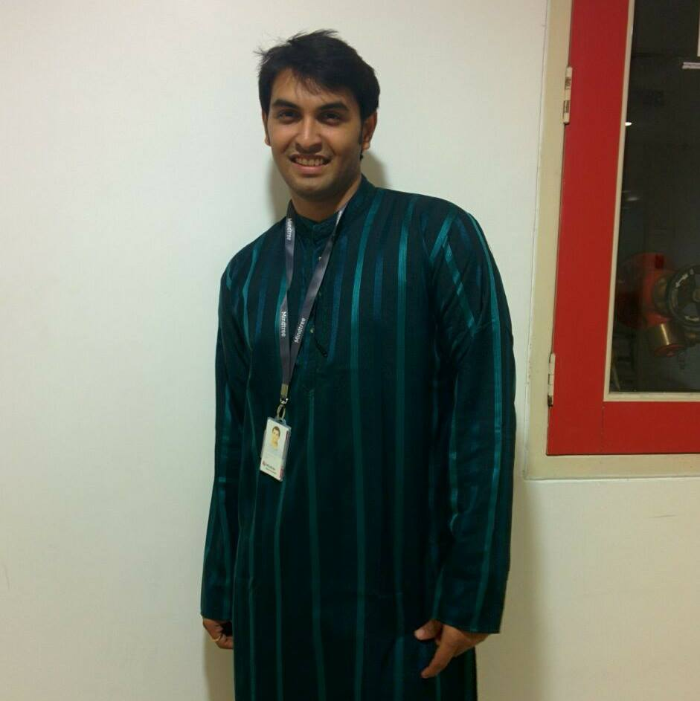**Shailesh**

*“I can’t find all the information about*

*IS department in one place!”*

Age: 24

Occupation: Northeastern University IS Graduate Student

Experience: 2.5 years

Status: Single

Shailesh is always looking for different information about IS department. If he wants to know about alumni, he has to visit Alumni Center website; if he wants to book an appointment with a professor, he has to visit myneu portal; if he wants to check the fellowship details, he has to visit Northeastern University website. If he wants to know about events going on in IS department, he has to login to Facebook and explore all through events. He wants all such information to be clubbed together into one website.

**Suprita**

*“I want to know about the admission requirements,*

*course fees and number of courses to be*

*completed for graduation.”*

Age: 23

Occupation: Prospective Student

Experience: 3 years

Status: Single

Suprita is a prospective student seeking admission in IS department at NEU. She wants to know the exact criteria for application. She wants to know the course structure, course fees and any scholarship being offered at NEU. She visited NEU website but couldn’t find the basic information about course structure, course fees and number of credits to be completed. Also she needed more information about the co-op opportunities being present for IS students in future before making any decision.

**Rajesh**

*“I want to know about the current trends in IS and the future scope to keep me updated.”*

Age: 25

Occupation: Current Student

Experience: 4 years

Status: Single

Hitesh is a current student who likes to know about the emerging trends in IS. He is also interested in knowing about the future scope so that he can keep himself updated with the current trends. He wants to know all this information to choose the right course and excel in the interview and find a good job that matches his desire.

**Naina**

*“I am applying for Co-op/ internship this fall. I want to know about the information about career fairs, big companies visiting at one place and at right time.”*

Age: 25

Occupation: Current Student

Experience: 3 years

Status: Single

Naina joined Northeastern University IS department in Fall 2015, and now she is applying for co-op/ internship opportunities this summer. She cannot get all the information about the career fairs and the big companies visiting to the campus in one place. Last week, when Apple and Google visited the campus, she did not have an idea about it and so missed the opportunity to apply there and to interact with the company representatives.