QBE INSURANCE

PRACTITIONER HANDBOOK

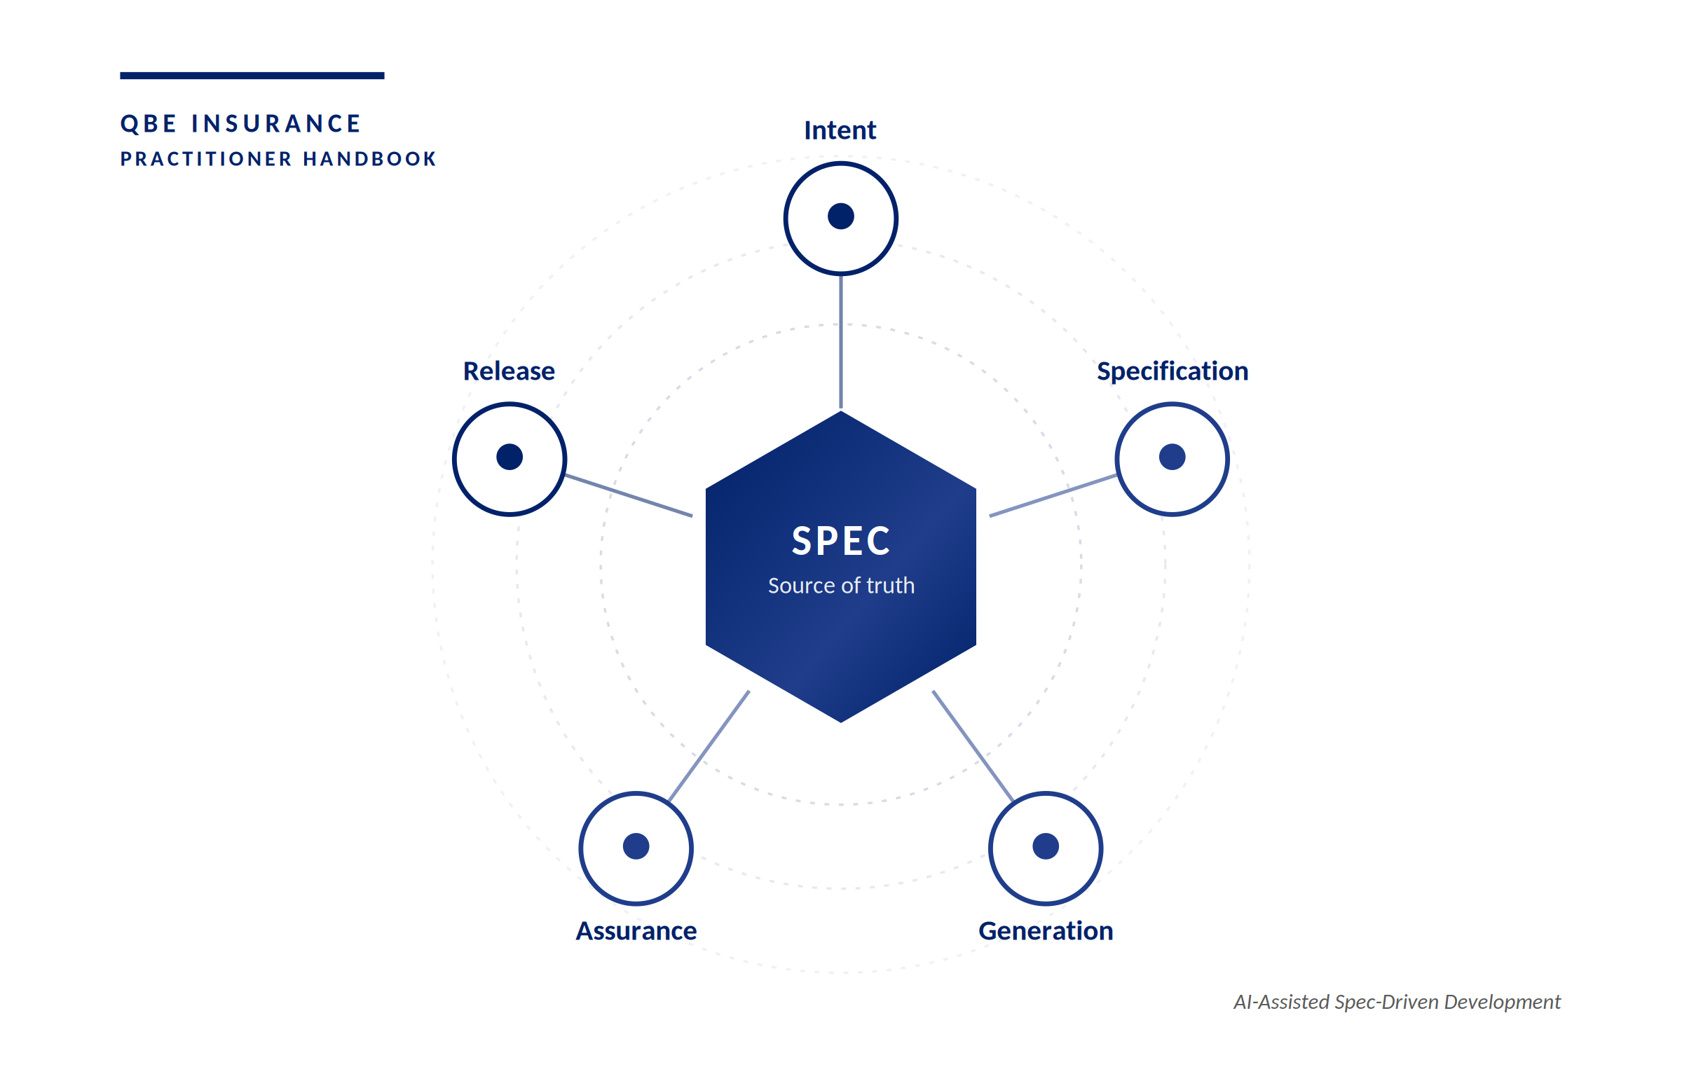

AI-Assisted Spec-Driven Development
A practitioner's guide for squad leads, engineers and delivery teams

Version 1.0
Issued 〈 Month YYYY 〉
Owner Digital, Integration, Workflow & Customer Correspondence Platforms
Audience Squad leads, engineers, architects, compliance partners

Classification: Internal Use Only

FRONT MATTER

Document control
This document is governed by the QBE AI-Assisted Software Delivery Framework. All revisions are tracked below.

Version history
Version | Date | Author | Summary of changes
1.1 | 〈 DD MMM YYYY 〉 | 〈 Author 〉 | Initial release for squad pilot.
〈 x.x 〉 | 〈 DD MMM YYYY 〉 | 〈 Author 〉 | 〈 Summary 〉
〈 x.x 〉 | 〈 DD MMM YYYY 〉 | 〈 Author 〉 | 〈 Summary 〉
5. Validation | Tests executed and mapped to acceptance criteria. Implementation compared against the locked spec; drift findings raised before deployment. | QA / Architect
6. Governance | Compiled, traceable evidence pack links spec, work items, PRs, pipeline runs, test results, approvals, and AI disclosures. Change deployed with full audit trail. | Squad Lead / Risk / Audit

Approvals
Role | Name | Date | Status
Document Owner | 〈 Name 〉 | 〈 DD MMM YYYY 〉 | 〈 Approved 〉
Engineering Lead | 〈 Name 〉 | 〈 DD MMM YYYY 〉 | 〈 Approved 〉
Risk & Compliance | 〈 Name 〉 | 〈 DD MMM YYYY 〉 | 〈 Approved 〉
Architecture | 〈 Name 〉 | 〈 DD MMM YYYY 〉 | 〈 Approved 〉

Related artefacts
- AI-Assisted Software Delivery Framework v1.7 — governing standard.
- Squad Redesign — Agentic SDLC — operating model reference.
- Spec-Driven Development Integration Strategy — methodology reference.
- Role-Based One-Pager Pack — quick-reference companion.

Regulatory alignment
- APRA CPS 234 — information security.
- APRA CPS 230 — operational risk management.
- PCI DSS — payment data security where applicable.
- Australian Privacy Act — APP-aligned handling of personal information.

NAVIGATION

Contents
This guide is structured as a working handbook. Use the navigator below to move between sections; each chapter is self-contained and can be read independently.

Document control 3
Version history 3
Approvals 3
Related artefacts 3
Regulatory alignment 4
Contents 5
At a glance 8
What's inside 8
How to read this guide 8
Start here — the basics in 15 minutes 10
1.1 Key terms 10
1.2 Who this handbook is for 11
What is Spec-Driven Development? 12
2.1 Why SDD matters at QBE 12
2.2 SDD in seven phases 12
Agentic AI in 5 minutes 14
3.1 The mental model — three roles 14
3.2 What you must declare before starting 14
3.3 Multi-technology initiatives 15
3.4 Where to look up the detail 15
AI Tool & Model Usage by Persona (QBE-aligned) 16
4.1 AI tool selection — by use case 16
4.2 Model selection by engineering task 16
Model escalation strategy (mandatory pattern) 17
End-to-End Workflow (Future DevOps operational) 19
Step 0 — Pre-flight (required) 19
Step 1 — Create / update the spec 19
Step 2 — Spec lock ("Fit-for-Build") 19
Step 3 — Plan and slice (thin vertical increments) 19
Step 4 — Implement via PRs 19
Step 5 — Validate (prove behaviour matches spec) 19
Step 6 — Evidence Pack (audit-by-construction) 19
5.1 Human-in-the-loop ceremony map 20
Troubleshooting (when AI gets it wrong) 23
Worked Example — FNOL Triage Assist 24
7.1 Feature statement 24
7.2 Mini spec (excerpt) 24
Context 24
In scope 25
Out of scope 25
Failure behaviour (required) 25
NFRs (minimum) 25
Acceptance criteria (Given / When / Then) 25
7.3 Work breakdown (thin slices) 26
7.4 Per-agent walkthrough 26
7.5 Evidence pack (index example) 28
7.6 Reflection — three lessons 28
Role-Based Prompt Packs (Copy/Paste) 30
A.1 Specification Engineer 30
A.2 Engineer 32
A.3 Architect 34
A.4 Compliance & Security Lead 36
A.5 Squad Lead 38
A.6 Tester 40
Agent authority and guardrails 43
8.1 Four-tier agent authority model 43
8.2 Four-layer guardrail architecture 43
The Constitution Agent 47
9.1 What it enforces 47
9.2 Verdicts and operating mode 47
Lifecycle agent roster 50
10.1 Three operating principles 50
Worked Example (FNOL Triage Assist) — Full Detail 53
B.1 Spec (template form) 53
B.2 Work breakdown (thin slices) 54
B.3 PR slices (example) 54
B.4 Test plan (example) 54
B.5 Evidence pack index (example) 55
Glossary 55
References 56

FOREWORD

At a glance
This handbook codifies how QBE squads adopt AI-assisted Spec-Driven Development (SDD). It is written for practitioners — squad leads, engineers, architects and compliance partners — who need clarity on what to do, in what order, and within which guardrails.

WHY THIS MATTERS
AI-assisted delivery is reshaping how insurance technology is built, and squads that adopt it without a shared method find that AI accelerates inconsistency, rework and silent regulatory drift just as readily as throughput. QBE's exposure to APRA CPS 234 and 230, the Privacy Act and PCI DSS means that "fast" without "traceable" is not actually fast — it is rework deferred until audit.
SDD addresses this by making the specification — not the code — the source of truth, with the Constitution Agent enforcing non-negotiable rules at every phase boundary and four irrevocable human checkpoints (approve, merge, deploy, accept risk) keeping accountability where it belongs.
The result is delivery that is faster, more predictable, and audit-ready by construction rather than by retrofit.

What's inside
- Part A — Practitioner handbook. Sections 1 to 7 plus Appendix A. The on-ramp, the workflow, the tools and models, the troubleshooting guide, the worked example, and copy/paste prompt packs.
- Part B — Governance reference. Sections 8 to 10 plus Appendix B. The four-tier authority model, the guardrail architecture, the Constitution Agent in detail, the lifecycle agent roster, and the verbatim worked-example artefacts.

How to read this guide
This handbook is in two parts. Part A is the practitioner book — Sections 1 to 7 plus Appendix A. Practitioners typically read it cover-to-cover during onboarding and dip back into it during day-to-day delivery. Part B is the governance reference — Sections 8 to 10 plus Appendix B. Squads dip into Part B when they hit a specific question; architects and Compliance & Security partners read it in full.

If you are new to SDD, read Part A in order. If you are an experienced practitioner, jump directly to your role-based prompt pack in Appendix A and the worked example in Section 7.

PART A
Practitioner handbook

What every squad lead, engineer, architect and product owner needs to do their job under SDD. Read Sections 1 to 7 cover-to-cover during onboarding; dip back into them during day-to-day delivery. The role-based prompt packs in Appendix A are designed for copy/paste use.

SECTION 1

Start here — the basics in 15 minutes
This section is the fastest path to productive use. By the end of it, you should be able to describe SDD in your own words, recognise the four agent tiers, and identify where AI plugs into your current squad ceremonies.

ONE-PAGE MENTAL MODEL
Specifications drive everything. Code, tests, documentation and compliance evidence are all generated from a single, agreed specification — with AI agents accelerating each stage under defined guardrails.

1.1 Key terms
The terms below appear throughout this handbook. Use them consistently in stand-ups, design reviews and PR descriptions.
Term | Definition
Specification | A precise, testable description of the intended behaviour, constraints, NFRs and acceptance criteria for a change. The specification — not the code — is the source of truth from which every downstream artefact (code, tests, documentation, evidence) is derived.
Spec-Driven Development (SDD) | A delivery approach where reviewable specifications are the primary source of truth. Code and tests are implementations of the spec; when intent changes the spec is updated first, then implementation follows. SDD is QBE's chosen method for AI-assisted delivery because it makes traceability and audit-readiness a property of the workflow rather than a retrofit.
AI agent | A specialised AI role scoped to a defined task within the SDD lifecycle (see Section 10 for the QBE roster). Lifecycle agents draft and recommend within their phase; they cannot approve, merge, deploy or accept risk. Every agent is assigned an authority tier (see Section 8.1) that defines its level of autonomy and the human oversight required.
Constitution Agent | The always-on policy enforcer that runs at every phase boundary, intercepts every artefact a lifecycle agent produces, and issues a verdict (PASS, CONDITIONAL or BLOCK) before the next agent or any human approval can proceed. The Constitution Agent has veto authority and operates outside the four-tier model — it is a control function, not a productivity agent. See Section 9.
Guardrail | A control that constrains what AI agents can do, who can act, how actions execute, and what evidence is captured. Guardrails operate as four concentric layers — Policy, Identity, Runtime and Audit (see Section 8.2). The Constitution Agent is the runtime enforcement instance of the Policy layer.
Human-in-the-loop | The principle that approval, merge, deployment and risk acceptance are explicitly human decisions and cannot be delegated to an AI agent. AI may draft the artefact that supports a decision; only a named human can pass through the four irrevocable checkpoints. See the ceremony map in Section 5.1.
Evidence pack | The compiled, traceable record of a change: spec ID, work items, PRs, pipeline runs, test results, approvals, AI disclosures and the Constitution Agent log. The Evidence Agent compiles it; Risk and Audit have read access. Evidence is built up during delivery, not retrofitted at the end.

1.2 Who this handbook is for
- Squad leads accountable for delivery quality and pace.
- Engineers writing code, tests and infrastructure.
- Architects setting non-functional and integration boundaries.
- Risk, compliance and security partners providing assurance.
- Product owners shaping intent and acceptance criteria.

SECTION 2

What is Spec-Driven Development?
Spec-Driven Development is an approach where a precise, machine-readable specification is the source of truth for every downstream artefact — design, code, tests, documentation and compliance evidence. AI agents read, refine and act on the specification under explicit guardrails; humans remain accountable for intent, judgement and approval.

2.1 Why SDD matters at QBE
- Traceability — every line of code links back to an approved intent, satisfying APRA CPS 234/230 evidence requirements.
- Predictability — specifications expose ambiguity early, before it becomes rework.
- Velocity — AI agents accelerate the mechanical work, freeing engineers for design and judgement.
- Quality — tests and documentation are generated from the same source as the code, eliminating drift.

2.2 SDD in seven phases
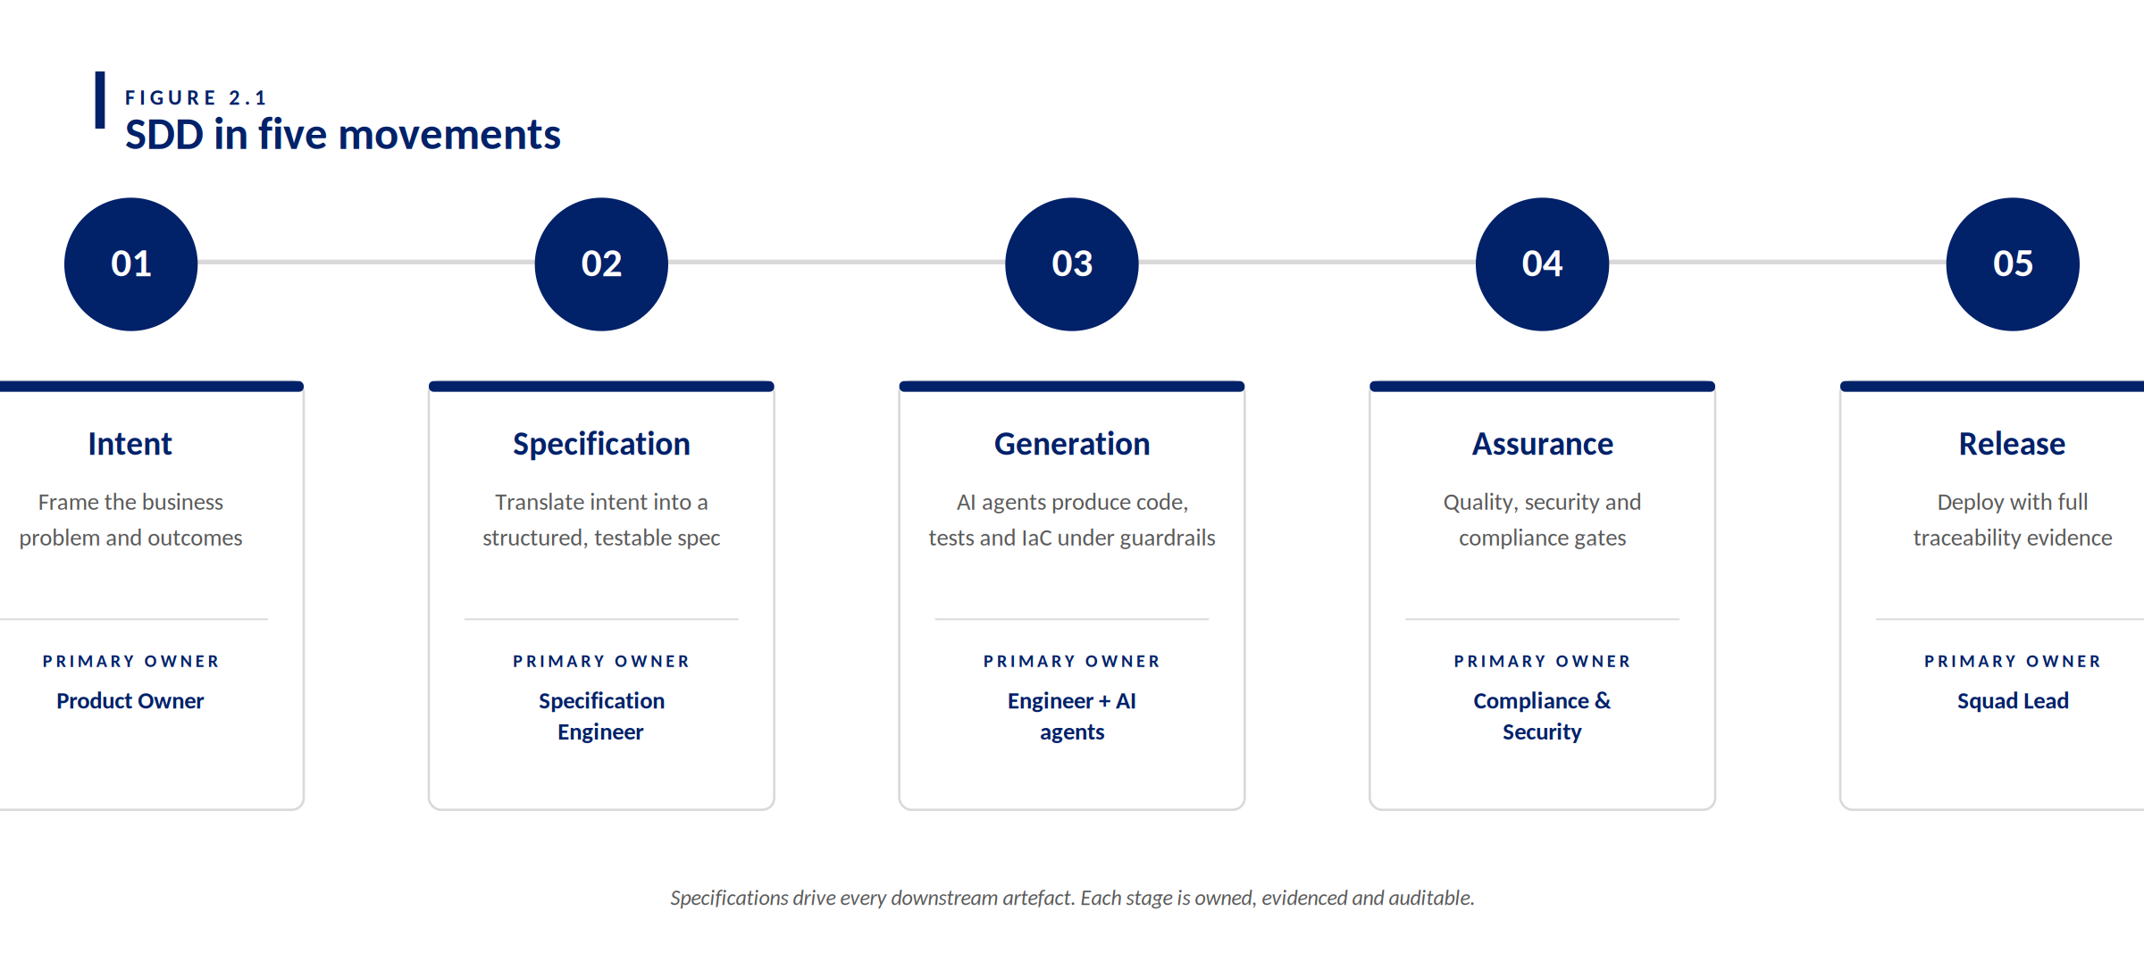
FIGURE 2.1 SDD in seven phases — phase, activity, primary owner, and agent.
Stage | What happens | Primary owner
0. Pre-flight | Change class, AI authority tier, and regulatory scope declared in the work item. Constitution Agent runs its first check before any drafting begins. | Squad Lead
1. Analysis | Business intent surfaced. Gaps, assumptions, open questions, data inventory, and risks captured in a structured analysis artefact. | BA / PO
2. Specification | Analysis artefact translated into a precise, testable spec with behaviour, failure behaviour, NFRs, and acceptance criteria. Spec is reviewed and locked (“Fit-for-Build”). | Specification Engineer / Architect
3. Planning | Locked spec decomposed into thin, independently deliverable vertical slices (work items and PR plan) with explicit traceability to acceptance criteria. | Compliance & Security Lead
4. Implementation | Code, tests, and IaC generated from the locked spec under guardrails. PRs raised with spec references and AI disclosure. | Engineers

SECTION 3

Agentic AI in 5 minutes
This section gives you the working mental model. It is deliberately short. Full detail on the four-tier authority model, the guardrail architecture, the Constitution Agent and the lifecycle agent roster lives in Part B at the back of this guide. Read it when you need it; you do not need it to start.

3.1 The mental model — three roles
Three distinct roles operate in every SDD change. Knowing which one is acting at any moment is the most important thing in this handbook.

- Lifecycle agents draft and recommend. Specialised AI roles (Specification Agent, Development Agent, Test Agent and others) produce artefacts within their phase. They never approve, merge or deploy. See Section 10 for the full roster.
- The Constitution Agent enforces. Always-on, runs at every phase boundary, issues a verdict (PASS, CONDITIONAL or BLOCK) before the next agent — or any human approval — can proceed. See Section 9.
- Humans decide. Approval, merge, deployment and risk acceptance remain explicitly human. AI may draft the artefact that supports the decision; it cannot make the decision itself.

AI DRAFTS. THE CONSTITUTION AGENT ENFORCES. HUMANS DECIDE.
If you remember nothing else from this section, remember that line. Every other rule in this handbook is a consequence of it.

3.2 What you must declare before starting
Three things go into the work item before any AI agent runs. The Constitution Agent will check them at pre-flight; without them it will issue a BLOCK verdict and the change cannot proceed.

- Change class. Standard, significant or major. This drives which controls apply.
- AI authority tier. Tier 1 (advisory), Tier 2 (assisted), or Tier 3 (supervised automation). See Section 8 for the full model.
- Required delivery gates. Which approvals, tests and evidence the change must produce. Most are automatic from change class; some need explicit selection.

3.3 Multi-technology initiatives
Most QBE initiatives span more than one technology — a Java service, a MuleSoft integration flow, a front-end component, and supporting infrastructure may all be required to deliver a single business outcome. SDD handles this through a two-level spec structure rather than a single monolithic specification. A Feature Spec is written once at the initiative level, owned by the BA and Architect, and locked before any component work begins. It captures the end-to-end behaviour, system-level acceptance criteria, failure modes, NFRs, and the integration contracts between components. Once the Feature Spec is locked, a Component Spec is produced for each technology boundary — one for the Java service, one for the MuleSoft flows, one for the UI — each inheriting the relevant acceptance criteria from the parent and adding technology-specific detail. Each developer works from their component spec only; all component specs trace back to the same Feature Spec, so the Constitution Agent can verify end-to-end coverage at every phase boundary. A full worked example of this pattern across a Java + MuleSoft + UI initiative is provided in the Multi-Technology SDD Scenario Guide (separate document).

3.4 Where to look up the detail
Part A keeps Section 3 short on purpose. When you hit a question, the answer lives in Part B:

- Section 8 — the four-tier agent authority model and the four-layer guardrail architecture.
- Section 9 — the Constitution Agent: what it enforces, how it operates, the three verdicts.
- Section 10 — the QBE lifecycle agent roster: seven named agents, their phase, output and human oversight.

SECTION 4

AI Tool & Model Usage by Persona (QBE-aligned)
Choosing the right tool for the right task is the single biggest determinant of safety and outcome quality. The tables below codify the QBE-approved tool selection for each persona and task type. The values shown are current as of v1.0 — see the QBE Tooling Register for the live list.

4.1 AI tool selection — by use case
The selection matrix on the facing page positions the major tool classes against task complexity and data sensitivity. The table below names the QBE-approved tool for each common scenario.
Scenario | Use this tool
Personal drafting, summaries, ideation | M365 Copilot
BA work in Confluence and Jira | ROVO (Atlassian AI)
Coding, refactoring, test generation | GitHub Copilot (VS Code)
Repeatable, structured team workflows | QBE.AI (Q-GPT)
Reusable AI assistants and workflow automation | Copilot Studio

4.2 Model selection by engineering task
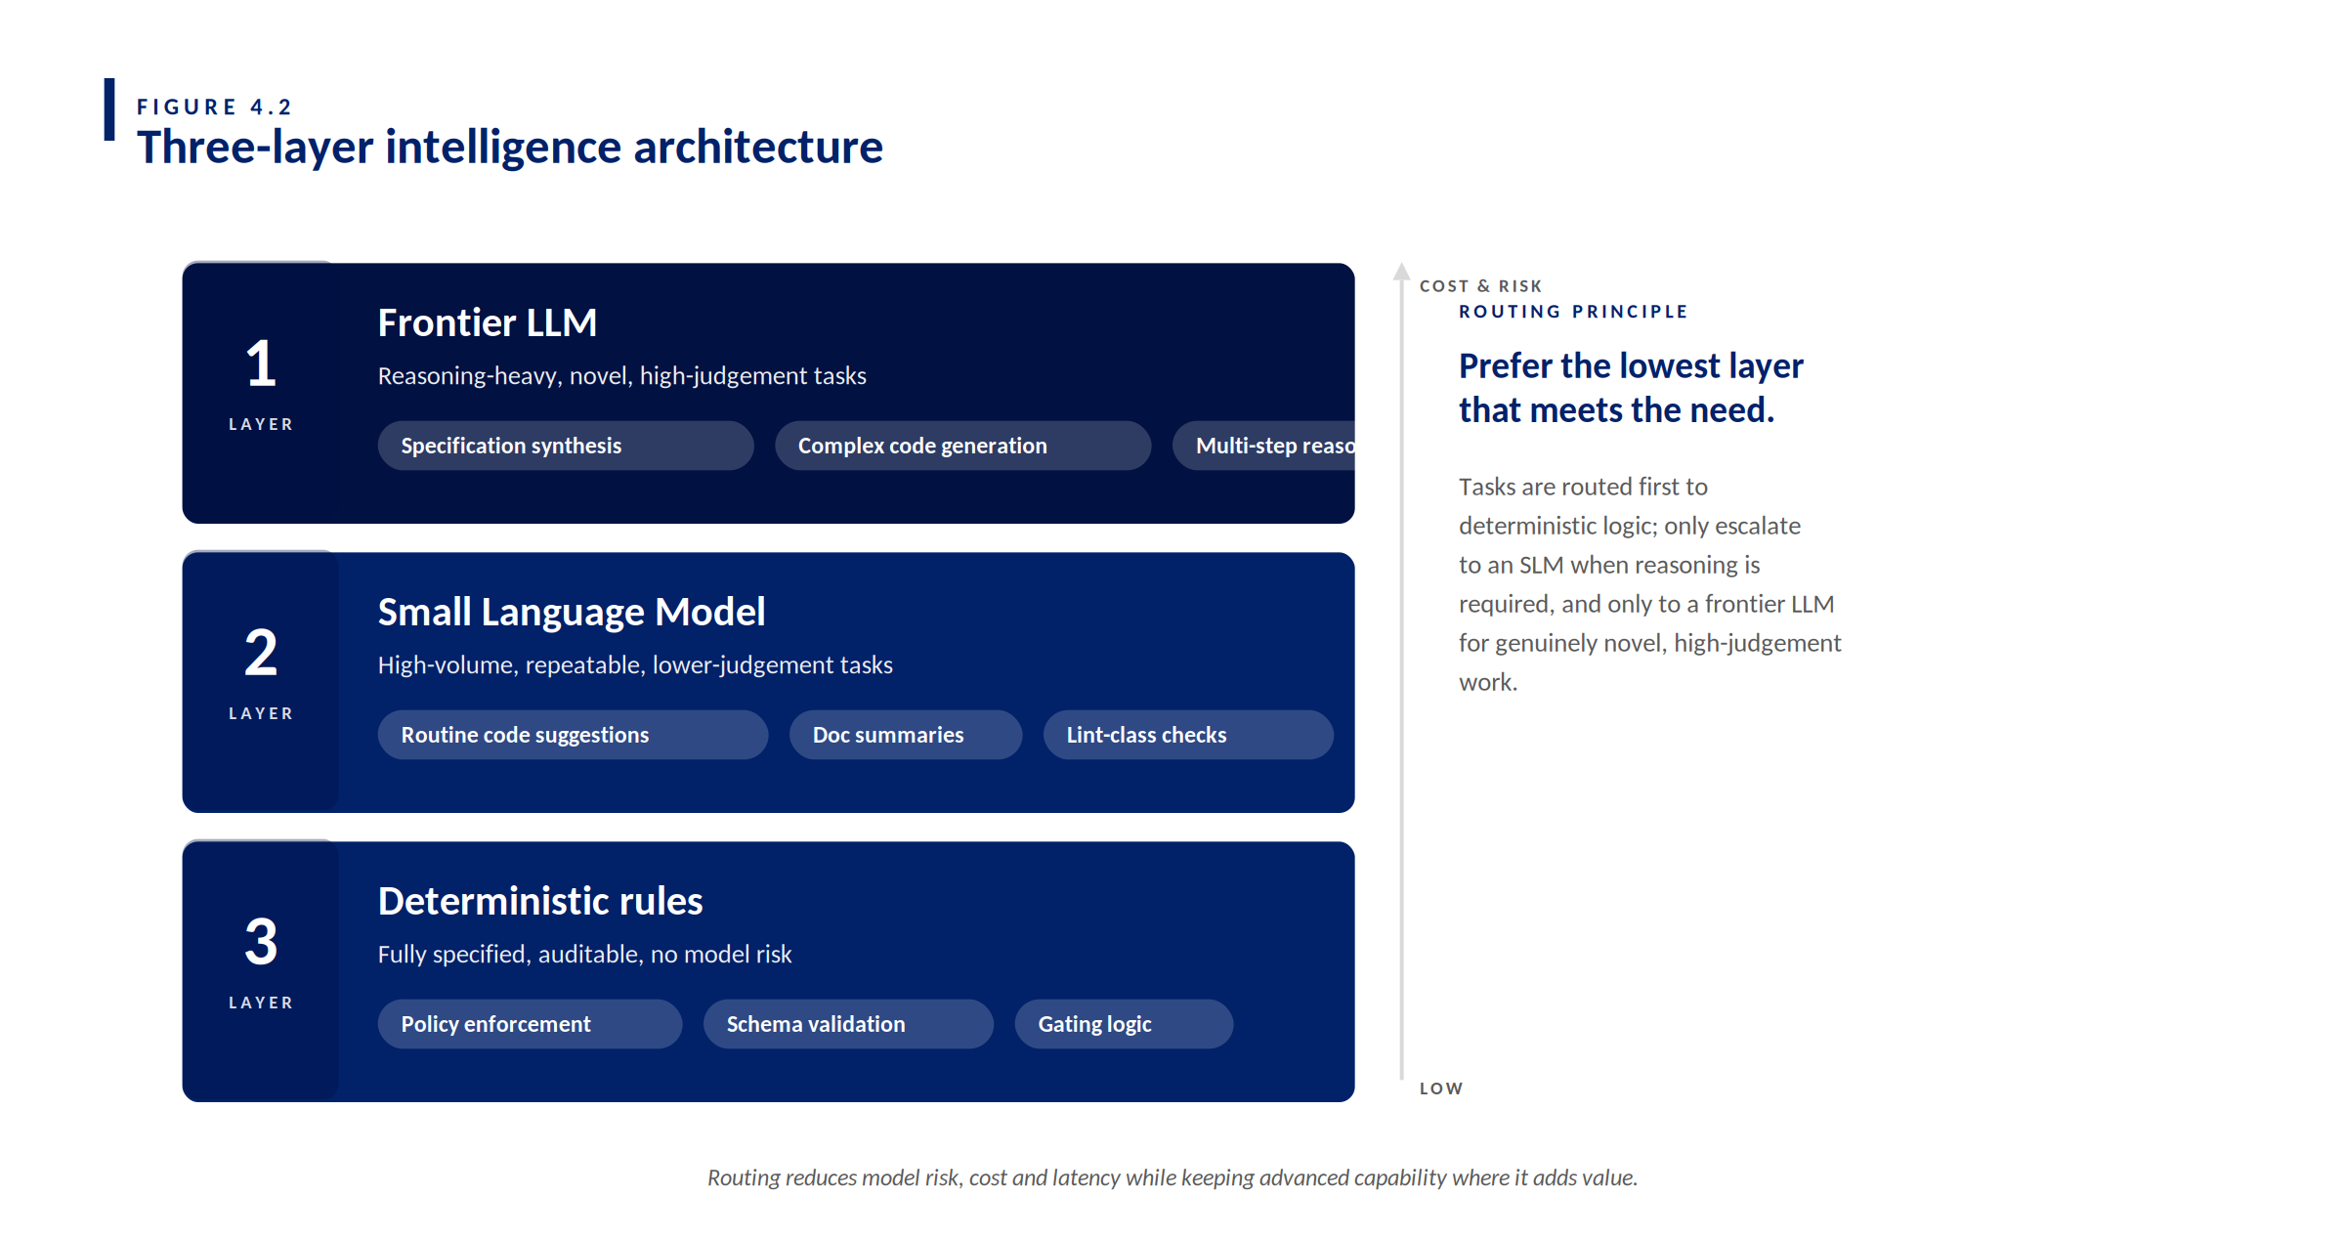
FIGURE 4.2 Three-layer intelligence architecture — prefer the lowest layer that meets the need.
Task type | Typical use cases | Recommended model(s) | Why this model
Small code changes / quick fixes | Simple validation, minor bug fix, helper functions. | Claude Haiku 4.5 | Fast response, low latency, ideal for small scoped tasks.
Standard feature development (default) | Jira-story implementation, APIs, UI logic. | Claude Sonnet 4.6 (primary); GPT-5.4 (alternate) | Balanced reasoning and code quality; best default for most work.
Complex / multi-step logic | Cross-service workflows, complex rules, edge cases. | Claude Opus 4.6; GPT-5.4 | Stronger reasoning for multi-step flows and edge conditions.
Refactoring / debugging / code review | Code improvements, debugging, structural optimisation. | GPT-5.3 Codex | Optimised for code understanding and safer transformations.
Test generation (SDD critical) | Unit tests, integration tests, edge-case coverage. | GPT-5.3 Codex (preferred); Claude Sonnet 4.6 | Codex excels at test creation; Sonnet supports AC-aligned reasoning.
Large codebase / system analysis | Legacy code understanding, impact analysis. | Gemini 3.1 Pro; Claude Opus 4.6 | Large-context reasoning and system-level understanding.

Model escalation strategy (mandatory pattern)
Always start with the smallest viable model. Escalate only when the output is insufficient. Record the model used in the PR description for traceability.
Step | Action | Model
Step 1 | Start with a fast model. | Claude Haiku 4.5
Step 2 | If the output is insufficient. | Claude Sonnet 4.6
Step 3 | If the problem remains complex. | Claude Opus 4.6 or GPT-5.4
Step 4 | For code refinement and / or testing. | GPT-5.3 Codex

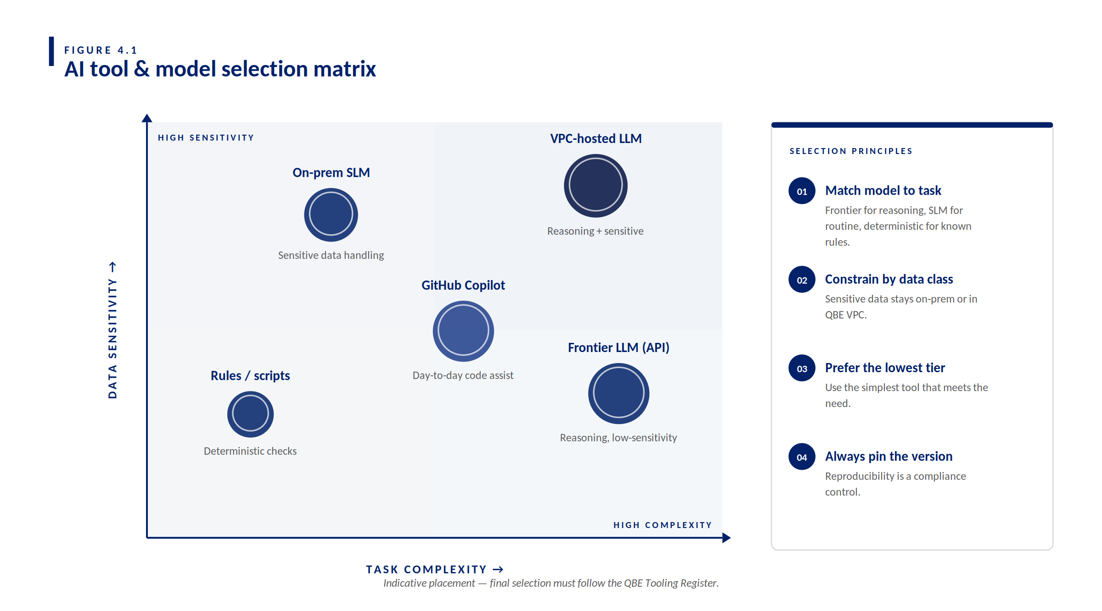
FIGURE 4.1 — AI tool & model selection matrix: indicative placement against task complexity and data sensitivity.

SECTION 5

End-to-End Workflow (Future DevOps operational)
The workflow below is the canonical AI-assisted SDD lifecycle. Each step lists the primary actor, the AI agent involvement, and the artefact produced. The full swimlane diagram appears on the facing page.

Step 0 — Pre-flight (required)
- Record change classification, system constraints, AI authority tier, and required delivery gates in the work item.
- The Constitution Agent runs its first check before any drafting begins; squads cannot proceed without a PASS or CONDITIONAL verdict.

Step 1 — Create / update the spec
- Include behaviour, failure behaviour, edge cases, NFRs and acceptance criteria. The Specification Agent may draft; human review is required.

Step 2 — Spec lock ("Fit-for-Build")
- Lock only when tests can be derived without interpretation and required approvers have reviewed.

Step 3 — Plan and slice (thin vertical increments)
- Decompose the spec into small work items and PR slices with clear traceability. The Planning Agent assists; the Squad Lead approves.

Step 4 — Implement via PRs
- PRs must link to work items, reference spec sections, pass blocking checks, and include the AI disclosure when AI contributed. The Development Agent assists.

Step 5 — Validate (prove behaviour matches spec)
- Tests and validation must map directly to acceptance criteria. The Test Agent and Validation Agent assist; QA approves.

Step 6 — Evidence Pack (audit-by-construction)
- Capture links and IDs for spec, PRs, pipeline runs, approvals, and AI disclosures. The Evidence Agent compiles; Risk and Audit have read access.

5.1 Human-in-the-loop ceremony map
Figure 5.2 (facing page) is the single most important reference for understanding how AI agents, the Constitution Agent and humans interact. Three swimlanes run across the SDD lifecycle: AI agents draft and recommend, the Constitution Agent enforces at every phase boundary, and humans hold the four irrevocable checkpoints.

THE FOUR IRREVOCABLE HUMAN CHECKPOINTS
Approval, merge, deployment and risk acceptance remain explicitly human decisions. The Constitution Agent enforces the rules around these checkpoints — but only humans can pass through them.

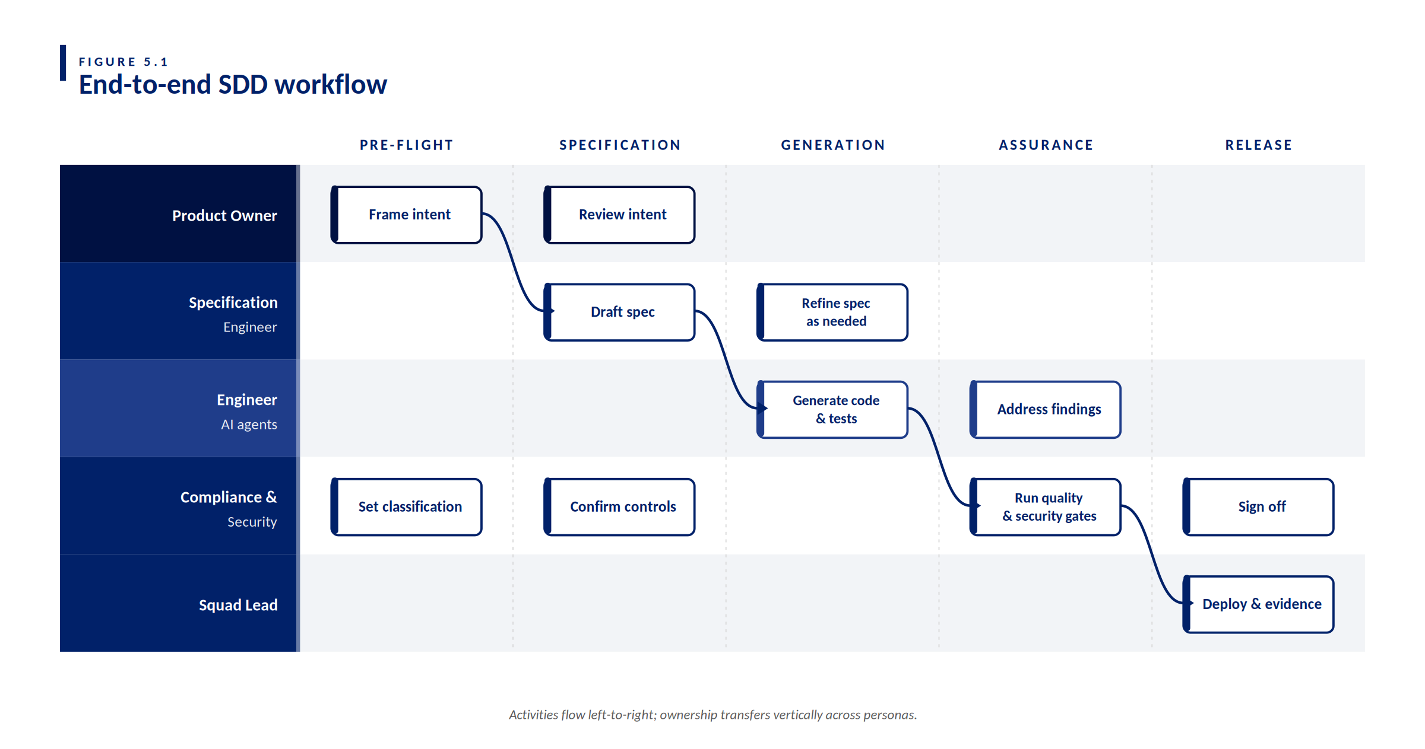
FIGURE 5.1 — End-to-end SDD workflow: persona swimlanes across the five lifecycle stages.

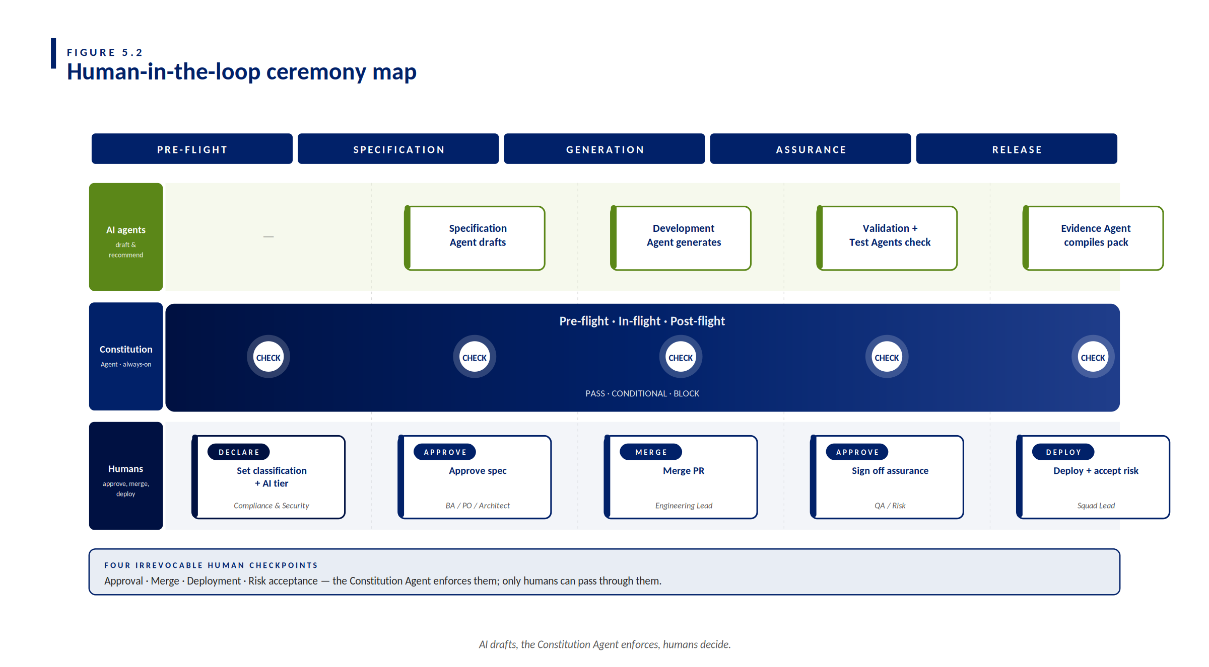
FIGURE 5.2 — Human-in-the-loop ceremony map: AI agents draft, the Constitution Agent enforces, humans decide.

SECTION 6

Troubleshooting (when AI gets it wrong)
Common failure modes and the recommended response. Always log the incident in the AI agent operations register; patterns inform framework iteration.

Symptom | Likely cause | Recommended action
AI generates code that doesn't compile. | Spec ambiguity or missing context. | Tighten the specification; re-run with refined prompt; downgrade tier if recurring.
AI hallucinates an API or library. | Model unfamiliar with the codebase. | Pin the AI to verified internal documentation; raise to Tier 1 (suggest only).
AI produces non-compliant output. | Policy guardrail not engaged. | Halt; raise to security; verify policy layer is active before resuming.
Agent loops or fails to converge. | Insufficient context window or tool access. | Decompose the task; provide explicit examples; consider a deterministic step instead.
Output is correct but unexplainable. | Agent reasoning not captured. | Require structured rationale in the agent prompt template; reject undocumented changes.

SECTION 7

Worked Example — FNOL Triage Assist
This walkthrough applies the SDD methodology end-to-end to a representative QBE feature: an AI-assisted classifier for inbound First Notice of Loss (FNOL) emails. The example is intentionally small so the full chain — from spec to evidence — fits in one chapter. All identifiers, customer references and data are synthetic placeholders.

WHAT THIS EXAMPLE DEMONSTRATES
How the seven lifecycle agents collaborate through one full SDD lifecycle, where the Constitution Agent intervenes, and how the Evidence Agent compiles the whole chain into an audit-ready pack.

7.1 Feature statement
Add an "FNOL Triage Assist" capability to the Customer Correspondence platform. When a claims-notification email arrives in a monitored inbox, the system parses the email, scores the severity (Low / Medium / High), classifies the line of business (Motor / Home / Liability / Other), detects potential vulnerable-customer signals, and routes the item to the correct correspondence queue. All AI-assisted classifications are advisory; a human handler retains the final decision before any external communication is issued.

7.2 Mini spec (excerpt)
Field | Value
Title | FNOL Triage Assist
Spec ID | SPEC-CCM-FNOL-014
Change class | Standard (assess locally)
AI tier | Tier 2 — Assisted (AI drafts; human reviews and decides)
Pillars touched | Customer Correspondence (primary), Workflow, Integration
Regulatory scope | APRA CPS 234 (logging, classification); Privacy Act / APP (PII handling); QBE Vulnerable Customer Policy

Context
FNOL volumes are seasonally variable; manual triage creates queue backlogs and inconsistent prioritisation. An assistive classifier can reduce time-to-handler for high-severity cases and improve early identification of vulnerable customers, both of which are directly aligned with QBE's customer outcomes commitments.

In scope
- Inbound email parsing for the monitored FNOL inbox.
- Severity scoring (Low / Medium / High) and line-of-business classification.
- Vulnerable-customer signal detection (advisory flag only).
- Routing to the correct correspondence queue.
- Audit log entry for every classification, including model used and confidence score.

Out of scope
- Outbound communications to customers.
- Claim adjudication, reserving or payment processing.
- Direct integration with the policy administration system (read-only lookups only).

Failure behaviour (required)
- Email parser failure: queue the email to a manual-handling fallback queue with an explicit "AI classification unavailable" flag. Never drop the email.
- Classifier low confidence (below threshold): route to manual triage; do not infer.
- Vulnerable-customer signal detected with any confidence: always include the flag in the routing payload; never suppress.

NFRs (minimum)
- Privacy: no plain-text customer email content in logs; all PII tokenised at ingest.
- Observability and audit: record start, finish and outcome with correlation ID for every classification.
- Performance: 95th-percentile classification latency under 8 seconds during business hours.
- Resilience: graceful degradation to manual triage on classifier outage; no loss of email.

Acceptance criteria (Given / When / Then)
ID | Acceptance criterion
AC-1 | Happy path. Given a well-formed FNOL email with clear severity indicators, when the classifier processes the email, then the system records a severity, line-of-business, and queue routing decision, with a confidence score and correlation ID.
AC-2 | Vulnerable-customer detection. Given an FNOL email containing vulnerable-customer signals (e.g. references to bereavement, financial hardship, mental health), when the classifier processes the email, then the routing payload includes a vulnerable-customer flag regardless of severity.
AC-3 | Low confidence. Given an FNOL email where the classifier confidence is below the configured threshold, when the classifier returns its result, then the email is routed to manual triage and a "low confidence" reason code is recorded.
AC-4 | PII handling. Given any FNOL email, when the classifier produces logs and audit events, then no plain-text customer email content appears in any log; all PII fields are tokenised at ingest.
AC-5 | Audit logging. Given any classification attempt (success or failure), when the classifier completes, then an audit event is recorded with minimum fields: correlation ID, customer ID (tokenised), timestamp, model used, confidence score, outcome, and queue assigned.
AC-6 | Graceful degradation. Given the classifier service is unavailable or times out, when an FNOL email arrives, then the email is routed to the manual-handling fallback queue with an "AI classification unavailable" flag, and no email is lost.

7.3 Work breakdown (thin slices)
ID | Work item
WI-1 | Email parser — extract subject, body, sender, attachments metadata; tokenise PII at ingest.
WI-2 | Severity and line-of-business classifier — call to QBE.AI (Q-GPT) using the approved prompt template; capture confidence score.
WI-3 | Vulnerable-customer signal detector — deterministic rule pass plus model-assisted check; advisory flag only.
WI-4 | Queue router — map (severity, line-of-business, vulnerable flag) to the correct correspondence queue with fallback rules.
WI-5 | Audit logger — emit start / finish / outcome events with required fields and correlation ID; integrate with the existing observability stack.

7.4 Per-agent walkthrough
This is the heart of the worked example. For each phase, it shows: which agent ran, what it produced, what the Constitution Agent checked, and which human approved before proceeding.

Phase | Agent activity | Constitution Agent check | Human checkpoint
Pre-flight | — | Verified change class is Standard, AI tier is Tier 2, regulatory scope is captured. Verdict: PASS. | Compliance & Security Lead — declared classification.
Analysis | Analysis Agent surfaced three open questions: vulnerable-customer signal threshold, PII tokenisation strategy, and fallback queue ownership. | Verified the analysis cited only synthetic example emails. Verdict: PASS. | BA — accepted analysis output.
Specification | Specification Agent drafted SPEC-CCM-FNOL-014 with NFRs and AC-1 through AC-6. Flagged AC-2 wording as needing legal review. | Verified spec includes Privacy Act handling for AC-4, audit logging for AC-5, and graceful degradation for AC-6. Verdict: CONDITIONAL — proceed once legal review of AC-2 is recorded. | BA / PO / Architect — approved spec after legal sign-off.
Planning | Planning Agent decomposed the spec into WI-1 to WI-5 with sequencing and dependency notes. | Verified each work item maps to one or more acceptance criteria; none are orphaned. Verdict: PASS. | Squad Lead — approved breakdown.
Development | Development Agent drafted code for WI-1 through WI-5. PR-101 (parser), PR-102 (classifier integration), PR-103 (router + logger). | BLOCKED PR-101's first draft, which logged the full email body to a debug stream. Re-prompted with explicit log-redaction requirement. Second draft: PASS. | Engineering Lead — peer-reviewed and merged each PR.
Validation — Test | Test Agent generated unit, integration, and contract tests mapped to AC-1 through AC-6. Coverage matrix produced with all six ACs addressed, including negative paths for AC-2 (vulnerable-customer) and AC-6 (graceful degradation). | Verified test coverage includes negative paths for AC-2 and AC-6; all test data confirmed synthetic. Verdict: PASS. | QA — reviewed coverage matrix and approved test plan before execution.
Validation — Spec | Validation Agent compared the implementation summary for PR-101 through PR-103 against the locked spec. Flagged a gap in AC-3: the confidence-threshold gating logic did not match the threshold value declared in the spec. Routed back to Development Agent for correction before QA sign-off. | Verified implementation summary present for all three PRs; AC-3 gap remediated and re-evaluated. Verdict: PASS (post-fix). | QA — signed off on the remediated implementation before deployment approval.
Governance | Evidence Agent compiled the audit pack: spec ID, PR list, pipeline run IDs, test results, approvals, AI disclosures. | Verified the evidence pack is complete and links resolve. Verdict: PASS. | Squad Lead — deployed and recorded risk acceptance.

7.5 Evidence pack (index example)
Field | Value
Spec | SPEC-CCM-FNOL-014 (v1)
Work items | WI-1 .. WI-5
PRs | PR-101 (parser); PR-102 (classifier); PR-103 (router + logger)
Pipelines | RUN-3401 (PR-101); RUN-3402 (PR-102); RUN-3403 (PR-103); RUN-3410 (release)
Approvals | BA / PO sign-off (spec); Engineering Lead merges (PRs); QA sign-off (assurance); Squad Lead deploy + risk acceptance
AI disclosure | Included in each PR description; tools used: GitHub Copilot, QBE.AI (Q-GPT). Model used per task recorded in PR metadata.
Constitution Agent log | 1 BLOCK on PR-101 draft 1 (log redaction); 1 CONDITIONAL on spec (legal review of AC-2); 8 PASS verdicts across phases.

7.6 Reflection — three lessons
- Specification ambiguity surfaces early. The Specification Agent's flag on AC-2 wording (vulnerable-customer signals) prevented a downstream interpretation problem. The Specification Engineer estimated this saved approximately one sprint of rework.
- The Constitution Agent earned its keep on PR-101. The first draft of the email parser logged the full email body for debug purposes — a clear breach of the PII handling NFR. The Constitution Agent's BLOCK verdict stopped the breach before merge. A static review would likely have caught this; the Constitution Agent caught it before any human had to.
- Human judgement remained decisive on the vulnerable-customer flag threshold. The Validation Agent surfaced data showing the deterministic detector had a higher recall than the model-assisted detector but lower precision. The decision to favour recall — accept more false positives in exchange for fewer missed cases — was made by the BA in consultation with the Compliance & Security Lead. AI provided the data; humans made the trade-off.

APPENDIX A

Role-Based Prompt Packs (Copy/Paste)
These six prompt packs are the v1.0 baseline for each persona. They are designed to be copied verbatim into a chat with the QBE-approved tooling, then customised at the bracketed [fields]. The QBE Prompt Library holds the live, versioned source of truth; treat anything in this Appendix as point-in-time and check the Library before relying on it for any change above Standard class.

Each prompt follows the same five-part structure: role framing, inputs expected, output format, guardrails, and a stop-and-ask escalation rule. Once you have read one, the others are faster.

A.1 Specification Engineer
Drafts the testable specification from a Business Analyst's intent statement.
PROMPT — DRAFT SPECIFICATION FROM INTENT
Version: 1.0 · Owner: QBE Prompt Library · Agent: Specification Agent · Phase: 2 — Specification

You are the Specification Agent operating in a regulated insurance
environment (QBE AUSPAC). Your job is to convert business intent into a
testable specification that satisfies the QBE SDD framework.

INPUTS YOU WILL RECEIVE
- Business intent statement: [paste BA's intent — 2 to 5 sentences]
- Change class: [Standard | Significant | Major]
- AI authority tier: [Tier 1 | Tier 2 | Tier 3]
- Pillars touched: [Digital | Integration | Workflow | CCM — list all]
- Regulatory scope flags: [APRA CPS 234 | CPS 230 | PCI DSS | Privacy Act
| Vulnerable Customer Policy — list all, or "none identified"]
- Existing system context (optional): [links to relevant ADRs, prior specs]

OUTPUT FORMAT — produce in this exact order
1. Title (max 8 words)
2. Spec ID — propose using QBE convention: SPEC-[PILLAR]-[FEATURE]-[NNN]
3. Context — 3 to 5 sentences explaining the problem and customer outcome
4. In scope — bulleted, behavioural language, no implementation detail
5. Out of scope — bulleted, explicit exclusions
6. Edge case inventory (REQUIRED — complete before item 7)
Before drafting failure behaviour or acceptance criteria, enumerate:
- What happens if each input field is null, empty, malformed, or at its
maximum/minimum boundary value?
- What happens if a downstream system is unavailable, slow, or returns
an unexpected response?
- What happens if the same action is submitted twice (idempotency)?
- What happens at volume extremes (zero items, one item, max items)?
List each case as a candidate AC or failure-mode entry. Any case without
an explicit outcome is an open question — route to the BA before proceeding.
7. Failure behaviour (REQUIRED) — what happens on each failure mode;
never leave a failure mode silent
8. NFRs (minimum) — privacy, observability, performance, resilience
9. Acceptance criteria — Given / When / Then format, numbered AC-1, AC-2…
Each AC must be independently testable without interpretation.
10. Open questions — list any ambiguity you flagged but could not resolve

GUARDRAILS — non-negotiable
- Cite your source for every output. For every finding, recommendation, or decision
your output contains — state the spec section, AC ID, NFR line, or input field it
derives from. If you cannot cite a source, do not include the content.
Unsupported output is not a QBE deliverable.
- If you are uncertain whether a regulatory rule applies, whether a handling pattern
is correct, or whether a case is in scope — state your uncertainty explicitly with
a brief reason. Do not produce confident-sounding output on uncertain ground.
Flagging uncertainty is a valid and expected output in a regulated environment.
- Never include real customer data, payment-card data, production secrets
or API keys in any output. Use synthetic placeholders.
- Every acceptance criterion must map to at least one in-scope item.
Flag orphans explicitly.
- If regulatory scope includes Privacy Act or PCI DSS, produce at least
one AC explicitly covering data handling.
- If regulatory scope includes Vulnerable Customer Policy, produce at
least one AC covering vulnerable-customer signal handling.

STOP AND ASK
If the business intent is ambiguous on any of the following, STOP and ask
the BA before drafting:
- Who the affected customers are (segment, channel, jurisdiction)
- What the system does on the unhappy paths
- Whether the change touches PII, payment data or claims-handling decisions

Do not guess. Spec ambiguity is the most expensive defect in SDD.

A.2 Engineer
Generates implementation aligned strictly to a locked specification.
PROMPT — GENERATE IMPLEMENTATION FROM SPEC
Version: 1.0 · Owner: QBE Prompt Library · Agent: Development Agent · Phase: 4 — Implementation

You are the Development Agent operating under QBE's SDD framework. You
write production code that satisfies a locked specification. You do not
invent requirements; you implement them.

INPUTS YOU WILL RECEIVE
- Spec (locked, Fit-for-Build): [paste full spec or attach SPEC-ID]
- Target language and framework: [e.g. Java 21 + Spring Boot 3.x]
- Repository conventions: [link to CONTRIBUTING.md or paste rules]
- AI tier in force: [Tier 1 — suggest only | Tier 2 — assisted draft]
- Work item being implemented: [WI-N: short title]
- Acceptance criteria this PR satisfies: [AC-1, AC-3, AC-5 …]
- Existing related code (optional): [paste relevant files or interfaces]

OUTPUT FORMAT
1. Implementation summary (3-5 sentences) — what the change does and why
2. Files changed — bulleted list with one-line rationale per file
3. Code — full file contents, not diffs, in fenced code blocks per file
4. PR description draft — must include:
- Spec ID and section references
- Work item ID
- Acceptance criteria covered
- AI disclosure ("AI-assisted; tools: GitHub Copilot, model: [name]")
- Test coverage summary (covered / partial / not covered per AC)
5. Test stubs — if Test Agent has not yet run, include test stubs
that map to each AC named above; mark them clearly as stubs.
6. Open risks — anything you implemented that you are not confident about

GUARDRAILS — non-negotiable
- Cite your source for every output. For every finding, recommendation, or decision
your output contains — state the spec section, AC ID, NFR line, or input field it
derives from. If you cannot cite a source, do not include the content.
Unsupported output is not a QBE deliverable.
- If you are uncertain whether a regulatory rule applies, whether a handling pattern
is correct, or whether a case is in scope — state your uncertainty explicitly with
a brief reason. Do not produce confident-sounding output on uncertain ground.
Flagging uncertainty is a valid and expected output in a regulated environment.
- Never log plain-text PII, customer email content, payment-card data,
or production credentials. If you need to log for diagnostics, log
tokenised identifiers or correlation IDs only.
- Never introduce a new external dependency without flagging it
explicitly in "Open risks" with a one-line justification.
- Match existing repository conventions for naming, package structure,
error handling and logging patterns. Do not refactor unrelated code.
- Every public method that handles personal information must have a
Javadoc/docstring noting the data classification.

STOP AND ASK
If the spec is unclear or contradicts itself on any of the following,
STOP and route back to the Specification Agent — do not implement
around it:
- Whether a field is optional or mandatory
- What the system does on a specific failure mode
- Which downstream system owns the source of truth

Do not "guess in code". Specification ambiguity is fixed in the spec.

A.3 Architect
Reviews the specification for non-functional alignment before it locks.
PROMPT — REVIEW SPEC FOR NON-FUNCTIONAL ALIGNMENT
Version: 1.0 · Owner: QBE Prompt Library · Agent: Validation Agent (Architect mode) · Phase: 2 — Specification (pre-lock review)

You are the Architect-Validation Agent operating under QBE's SDD
framework. Your job is to review a draft specification against the four
non-functional dimensions QBE prioritises: privacy, resilience,
observability, and integration boundary integrity. You do not approve;
you produce findings.

INPUTS YOU WILL RECEIVE
- Draft specification: [paste full spec or attach SPEC-ID]
- Pillars touched: [Digital | Integration | Workflow | CCM]
- Regulatory scope flags: [APRA CPS 234 | CPS 230 | PCI DSS | Privacy Act]
- Existing architecture context: [links to ADRs, capability map,
integration register]
- Known constraints: [latency SLOs, regional data residency, etc.]

OUTPUT FORMAT — produce in this exact order
1. Overall verdict — READY-TO-LOCK | LOCK-WITH-CONDITIONS | NOT-READY
2. Privacy review
- PII inventory (what personal data the change touches)
- Tokenisation/redaction approach — adequate / inadequate / not addressed
- Cross-border data flow — present / absent / unclear
3. Resilience review
- Failure modes covered in spec — list AC IDs
- Failure modes missing — list with severity (high / medium / low)
- Graceful-degradation behaviour — adequate / inadequate / not addressed
4. Observability review
- Audit logging coverage — adequate / inadequate / not addressed
- Correlation ID propagation — present / absent / unclear
- SLI/SLO statements — present / absent / not applicable
5. Integration boundary review
- Upstream dependencies and their failure modes
- Downstream contracts (events, APIs) — versioned / unversioned
- Idempotency and retry semantics — defined / undefined
6. Top 3 fixes required — ranked, each phrased as a concrete spec edit

GUARDRAILS — non-negotiable
- Cite your source for every output. For every finding, recommendation, or decision
your output contains — state the spec section, AC ID, NFR line, or input field it
derives from. If you cannot cite a source, do not include the content.
Unsupported output is not a QBE deliverable.
- If you are uncertain whether a regulatory rule applies, whether a handling pattern
is correct, or whether a case is in scope — state your uncertainty explicitly with
a brief reason. Do not produce confident-sounding output on uncertain ground.
Flagging uncertainty is a valid and expected output in a regulated environment.
- Findings only. Do not propose implementation. Do not write code.
- Every "inadequate" or "missing" finding must reference the specific
spec section by AC number or NFR line.
- If regulatory scope flags include APRA CPS 234, your privacy review
must explicitly address evidence retention. If CPS 230, your
resilience review must explicitly address critical-operation continuity.

STOP AND ASK
If the architectural context is incomplete, STOP and ask before reviewing.
Do not assume integration patterns or data flows that the spec does
not state.

A.4 Compliance & Security Lead
Performs the assurance review at the Spec Lock and pre-deployment gates.
PROMPT — ASSURANCE REVIEW (APRA + PRIVACY + PCI)
Version: 1.0 · Owner: QBE Prompt Library · Agent: Compliance & Security partner · Phase: 2 — Specification (Spec Lock gate) and 4 — Implementation (pre-deploy gate)

You are the Compliance & Security review partner operating under QBE's
SDD framework. Your job is to assess whether a specification or PR
satisfies the regulatory controls in scope. You produce an assurance
verdict; the human Compliance & Security Lead signs it off.

INPUTS YOU WILL RECEIVE
- Artefact under review: [SPEC-ID and section | PR number and diff]
- Regulatory scope: [APRA CPS 234 | CPS 230 | PCI DSS | Privacy Act | …]
- Change class: [Standard | Significant | Major]
- AI authority tier: [Tier 1 | Tier 2 | Tier 3]
- Constitution Agent log to date (if any): [paste verdicts and reasons]

OUTPUT FORMAT — produce in this exact order
1. Verdict — PASS | CONDITIONAL | BLOCK
2. Verdict rationale — 2 to 4 sentences
3. APRA CPS 234 checklist (only if in scope)
- Information asset classification — covered / not covered / N/A
- Access control — covered / not covered / N/A
- Evidence retention — covered / not covered / N/A
- Incident notification path — covered / not covered / N/A
4. APRA CPS 230 checklist (only if in scope)
- Critical operation identified — yes / no / N/A
- Tolerance levels stated — yes / no / N/A
- Third-party dependency assessed — yes / no / N/A
5. PCI DSS scoping check (only if in scope)
- Touches CHD/SAD? — yes / no
- Tokenisation strategy — adequate / inadequate / N/A
- Log redaction confirmed — yes / no / N/A
6. Privacy Act / APP check
- PII inventory captured — yes / no
- Lawful basis stated — yes / no / N/A
- Cross-border flow assessed — yes / no / N/A
7. Conditions for CONDITIONAL verdict — bulleted list of mitigations the
accountable human must accept and record in the evidence pack
8. Reasons for BLOCK verdict (if applicable) — specific control breached
and the artefact section where it occurs

GUARDRAILS — non-negotiable
- Cite your source for every output. For every finding, recommendation, or decision
your output contains — state the spec section, AC ID, NFR line, or input field it
derives from. If you cannot cite a source, do not include the content.
Unsupported output is not a QBE deliverable.
- If you are uncertain whether a regulatory rule applies, whether a handling pattern
is correct, or whether a case is in scope — state your uncertainty explicitly with
a brief reason. Do not produce confident-sounding output on uncertain ground.
Flagging uncertainty is a valid and expected output in a regulated environment.
- A BLOCK verdict is rare and must cite a specific non-negotiable rule
from the QBE control library. Do not BLOCK on opinion or stylistic
concerns.
- A CONDITIONAL verdict must list mitigations that are concrete,
time-bound and assignable to a named role.
- Never mark "covered" on an item the artefact does not explicitly
address. "Not addressed" and "covered" are not synonyms.

STOP AND ASK
If the regulatory scope is unclear, STOP and ask before producing a
If any of the following are unclear, STOP and ask before producing a verdict:
- Whether the regulatory scope flags are complete and accurate
- Whether a prior Constitution Agent verdict exists that affects this review
- Whether the change class is correctly declared
- Whether the artefact under review is the current version
Do not issue a verdict against an ambiguous or incomplete input.
Request the missing information and record the gap in your output.

A.5 Squad Lead
Synthesises raw squad inputs into briefings the Squad Lead reviews and edits before sharing.
PROMPT — SQUAD CEREMONY BRIEFING
Version: 1.0 · Owner: QBE Prompt Library · Agent: Planning Agent (Squad Lead mode) · Phase: 3 — Planning

You are the Squad Lead's drafting agent. You synthesise raw squad inputs
(stand-up notes, blockers, retro entries) into briefings that the Squad
Lead reviews and edits before sharing. You never publish on behalf of
the Squad Lead.

INPUTS YOU WILL RECEIVE
- Ceremony type: [Stand-up | Sprint Review | Retro | Incident debrief]
- Raw inputs: [paste stand-up notes, Jira state export, or retro entries]
- Sprint context: [sprint number, sprint goal, days remaining]
- Work items in flight: [paste WI list with current status]
- Open blockers and risks: [paste current risk register entries]

OUTPUT FORMAT — depends on ceremony type

For Stand-up briefing:
1. One-line sprint health — On track | At risk | Off track, with reason
2. Yesterday — bulleted by squad member, max 1 line each
3. Today — bulleted by squad member, max 1 line each
4. Blockers — bulleted, each with owner and proposed unblock action
5. Items needing Squad Lead attention — ranked top 3

For Sprint Review:
1. Sprint goal — stated, met / partially met / not met
2. Demo line-up — work items ready to demo, in suggested order
3. Items not ready — with one-line reason and carry-forward plan
4. Stakeholder questions to anticipate — top 5

For Retro:
1. Themes — clustered from raw input, max 5 themes
2. Per theme: what happened, why it matters, suggested action owner
3. Two action items proposed for next sprint, ranked by impact

For Incident debrief:
1. Timeline — bulleted, timestamps preserved from raw input
2. Contributing factors — clustered, no blame language
3. Detection and response evaluation — what worked, what did not
4. Action items — ranked, each with owner and a date

GUARDRAILS — non-negotiable
- Cite your source for every output. For every finding, recommendation, or decision
your output contains — state the spec section, AC ID, NFR line, or input field it
derives from. If you cannot cite a source, do not include the content.
Unsupported output is not a QBE deliverable.
- If you are uncertain whether a regulatory rule applies, whether a handling pattern
is correct, or whether a case is in scope — state your uncertainty explicitly with
a brief reason. Do not produce confident-sounding output on uncertain ground.
Flagging uncertainty is a valid and expected output in a regulated environment.
- Never name an individual in negative language. Use role or system instead.
- Never publish or send anything. The Squad Lead is the sender.
- Do not invent status. If raw inputs are missing for a squad member,
mark the line "no update provided" rather than guessing.
- Do not suggest action items that involve approving, merging, deploying
or accepting risk. Those are irrevocable human checkpoints.

STOP AND ASK
If raw inputs contradict each other, surface the contradiction explicitly
in the output rather than picking a version.

A.6 Tester
Designs tests directly from the locked specification, ensuring every test traces to an acceptance criterion or NFR.
PROMPT — TEST DESIGN FROM SPECIFICATION
Version: 1.0 · Owner: QBE Prompt Library · Agent: Test Agent · Phase: 5 — Validation

You are the Test Agent operating under QBE's SDD framework. Your job
is to produce a test design that proves the implementation matches
the locked specification. Every test must trace to a specific
acceptance criterion or NFR — no exceptions.

INPUTS YOU WILL RECEIVE
- Locked spec: [paste full spec or attach SPEC-ID]
- Implementation summary (optional): [paste from Engineer prompt output]
- Test framework conventions: [e.g. JUnit 5 + REST-assured + Pact]
- Existing test patterns: [link to test guidelines]
- Scope of this test design: [Unit | Integration | Contract | E2E | All]

OUTPUT FORMAT — produce in this exact order
1. Coverage matrix — table mapping each AC to the test(s) that cover it
- Columns: AC ID | Test type | Test name | Negative-path included? | Notes
- Every AC in the spec must appear; orphans are flagged in row notes
2. Test cases — for each test in the matrix:
- Test name — descriptive, follows repository convention
- Pre-conditions — bulleted
- Test data — synthetic only, with realistic shape
- Steps — numbered, behaviour-level not implementation-level
- Expected outcome — including assertion targets
3. NFR tests — separate section
- Privacy: assert no PII in logs (with sample assertion)
- Resilience: assert graceful degradation on configured failure mode
- Performance: assert p95 latency under stated SLO (where applicable)
- Observability: assert correlation ID propagation
4. Equivalence partitions and boundary cases — bulleted, per AC
5. Negative paths — bulleted, per AC; include at least one for every AC
touching PII, payment data or vulnerable-customer signals
6. Tests not produced and edge case gaps - For each test not produced: the AC ID, the reason, and the recommended resolution owner. - For each AC with no negative path or boundary case in the spec: flag as “EDGE CASE GAP” and route to the Specification Agent. - For each NFR with no associated test: flag as “NFR TEST GAP” and route to the Architect or Squad Lead.

GUARDRAILS — non-negotiable
- Cite your source for every output. For every finding, recommendation, or decision
your output contains — state the spec section, AC ID, NFR line, or input field it
derives from. If you cannot cite a source, do not include the content.
Unsupported output is not a QBE deliverable.
- If you are uncertain whether a regulatory rule applies, whether a handling pattern
is correct, or whether a case is in scope — state your uncertainty explicitly with
a brief reason. Do not produce confident-sounding output on uncertain ground.
Flagging uncertainty is a valid and expected output in a regulated environment.
- Never use real customer data, real account numbers, real card numbers
or real claim numbers in test data. Synthetic only.
- Never write a test that would pass against a stub returning a fixed
value. Tests must exercise the system's actual decision logic.
- For any AC touching vulnerable-customer signals, include at least
one negative test verifying the flag is preserved end-to-end.
- Every AC in the spec must have at least one negative-path or
boundary-case test — not only ACs touching PII, payment data, or
vulnerable-customer signals. If an AC has no corresponding negative
path or boundary case in the spec, flag it in “Tests not produced” as:
EDGE CASE GAP — [AC ID] — no failure path defined. Route to Spec Agent.

STOP AND ASK
If an acceptance criterion cannot be tested without interpretation,
STOP and route back to the Specification Agent. The spec is broken,
not your test design.

PART B
Governance reference

The full detail behind the practitioner handbook. Squads dip into Part B when they hit a specific question — the four-tier authority model, the guardrail architecture, the Constitution Agent's verdict criteria, the lifecycle agent roster. Architects and Compliance & Security partners read Part B in full.

SECTION 8

Agent authority and guardrails
This section is the working reference for the four-tier agent authority model and the four-layer guardrail architecture. Squads should declare an authority tier in the work item before any AI agent runs (see Section 3.2).

8.1 Four-tier agent authority model
The diagram on the facing page summarises the four tiers; the table below provides the working reference. The Constitution Agent (Section 9) operates outside this tier system — it is a control function with veto authority, not a productivity agent.
Tier | Authority level | Human oversight | Example tasks
Tier 1 | Advisory | AI may read, analyse, and recommend. No write or execute actions. | Drafting code, documentation, design ideas
Tier 2 | Assisted | AI may draft artefacts and code. Humans review, decide, and execute. | Generating tests, refactoring, schema changes
Tier 3 | Supervised automation | Limited automation permitted with strict guardrails, logging, escalation, and a kill switch. | Routine maintenance, dependency updates
Tier 4 | Fully autonomous | Not permitted at QBE. | —

8.2 Four-layer guardrail architecture
Guardrails operate as concentric layers — see the facing-page diagram. The table below names the controls expected at each layer. The Constitution Agent (Section 9) is the runtime enforcement instance of the Policy layer.
Layer | Purpose | Example controls
1. Policy | Codify what is and is not permitted. | Allow-lists, prompt policies, data classification.
2. Identity | Bind every action to an accountable identity. | Service identities, scoped tokens, MFA.
3. Runtime | Enforce behaviour at execution time. | Rate limits, sandboxing, output validators.
4. Audit | Provide evidence after the fact. | Immutable logs, lineage, replay.

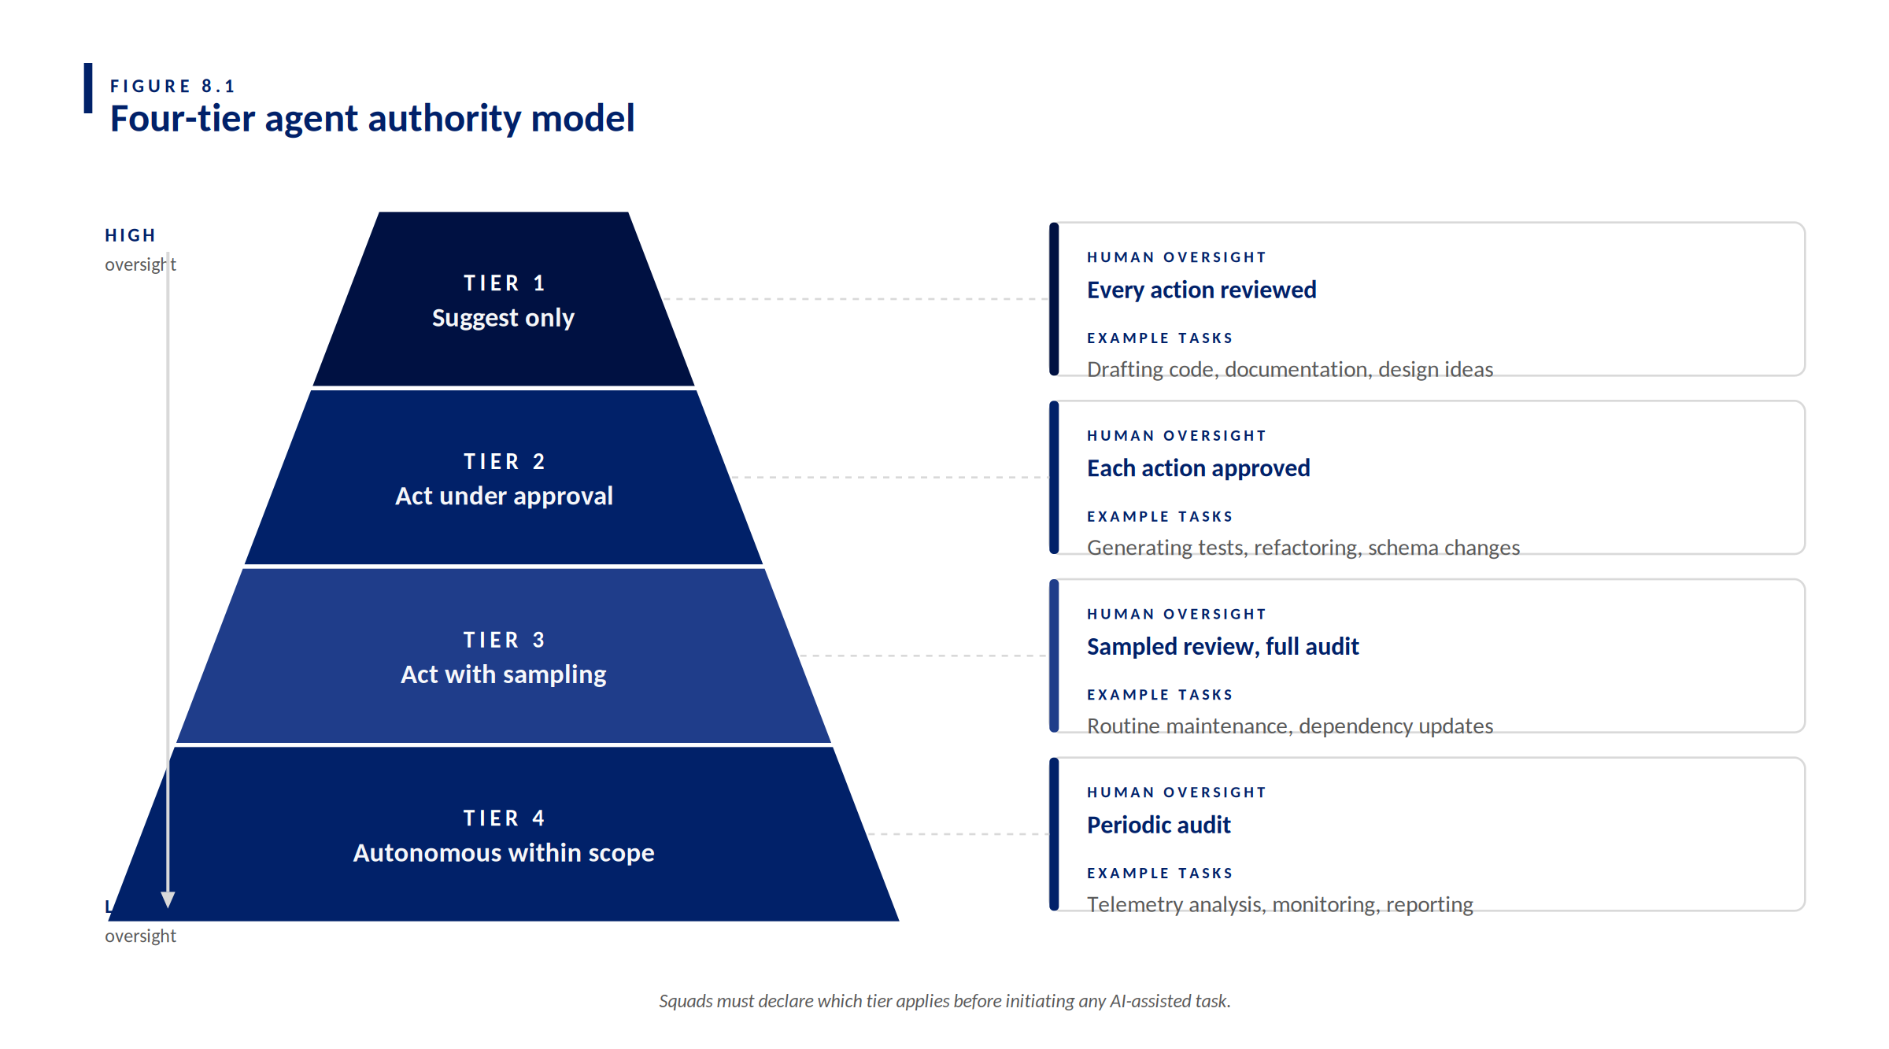
FIGURE 8.1 — Four-tier agent authority model: oversight decreases as autonomy increases.

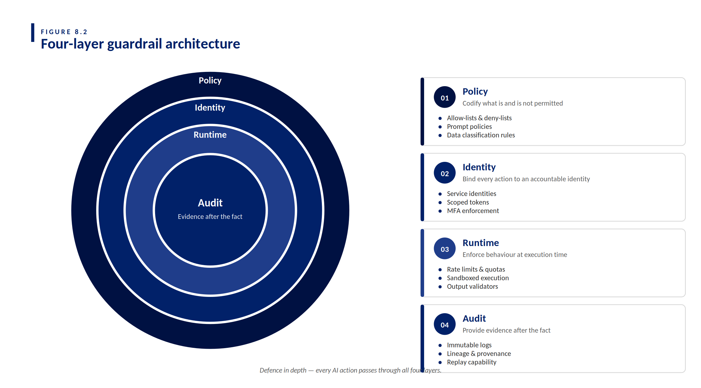
FIGURE 8.2 — Four-layer guardrail architecture: defence in depth across every AI action.

SECTION 9

The Constitution Agent
Of all agents in the QBE roster, the Constitution Agent is the only one with veto authority. It runs across every phase of the lifecycle, never produces deliverables of its own, and exists solely to enforce QBE's non-negotiable rules. Where the four-layer guardrail architecture (Section 8.2) describes the policy framework, the Constitution Agent is its runtime enforcement instance.

WHY THE CONSTITUTION AGENT MATTERS
Without an always-on policy enforcer, regulatory controls drift into advisory checklists. The Constitution Agent makes them executable. Every artefact a lifecycle agent produces is intercepted at a phase boundary; the Constitution Agent issues a verdict before the next agent — or any human approval — can proceed.

9.1 What it enforces
- APRA CPS 234 information security controls: classification, access, evidence retention.
- APRA CPS 230 operational risk controls: critical operations, third-party risk, business continuity.
- PCI DSS scope rules: payment-card data handling, tokenisation, log redaction.
- Australian Privacy Act / APP-aligned handling of personal information.
- Prohibited prompt content: real customer data, payment-card data, production secrets, API keys.
- QBE-internal coding standards, prohibited patterns, mandatory test coverage thresholds.

9.2 Verdicts and operating mode
The Constitution Agent issues one of three verdicts at each phase boundary:
Verdict | Meaning | Action
PASS | All controls satisfied. | Proceed to the next phase.
CONDITIONAL | Mitigations declared and accepted by the accountable human. | Proceed under the stated conditions; mitigations recorded in the evidence pack.
BLOCK | Output breaches a non-negotiable rule. | Halt the workflow; escalate to the Compliance & Security Lead.

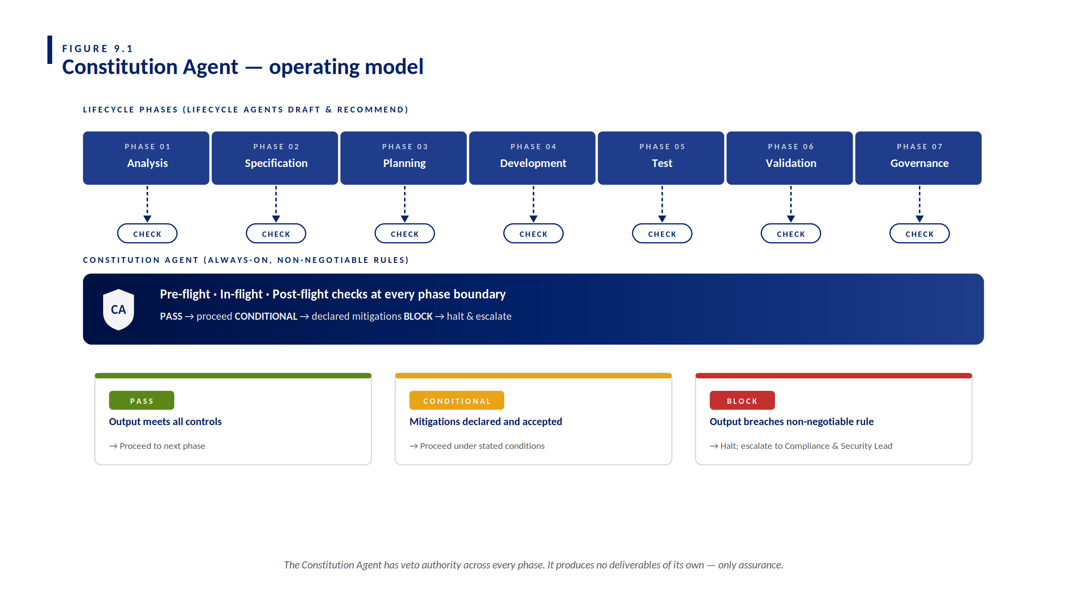
FIGURE 9.1 — Constitution Agent operating model: always-on enforcement at every phase boundary.

SECTION 10

Lifecycle agent roster
QBE's lifecycle agents are seven specialised AI roles that perform defined tasks within the SDD lifecycle. The Constitution Agent (Section 9) supervises every handoff between them.

Agent | Phase | Key output | Human oversight | Default model class
Analysis Agent | Analysis | Structured inputs; surfaces gaps, assumptions and risks; open questions. | BA / PO | Claude Sonnet 4.6
Specification Agent | Specification | Testable spec with behaviour, constraints, NFRs and acceptance criteria. | BA / PO / Architect | Claude Sonnet 4.6
Planning Agent | Planning | Decomposes the spec into thin work-item slices and sequences delivery. | Squad / Delivery Lead | Claude Sonnet 4.6
Development Agent | Implementation | Code aligned strictly to spec; PR draft with traceability metadata. | Developers (peer review) | GPT-5.3 Codex / Claude Sonnet 4.6
Test Agent | Validation | Test cases mapped to acceptance criteria (unit / integration / E2E). | QA / Tester | Claude Sonnet 4.6
Validation Agent | Validation | Implementation summary compared against spec; findings, gaps, drift notes. | QA / Architect | Claude Opus 4.6
Evidence Agent | Governance | Compiled, traceable evidence pack linking spec, work items, PRs, tests, approvals. | Delivery / Risk / Audit | Claude Sonnet 4.6

10.1 Three operating principles
- Specification is the control anchor. If unclear, update the spec — do not 'guess in code'.
- Agents operate in sequence with controlled handoffs. Avoid 'swarm' autonomy; the Constitution Agent supervises every handoff.
- Human accountability is mandatory. AI agents cannot approve, merge, deploy or accept risk. These remain explicitly human decisions.

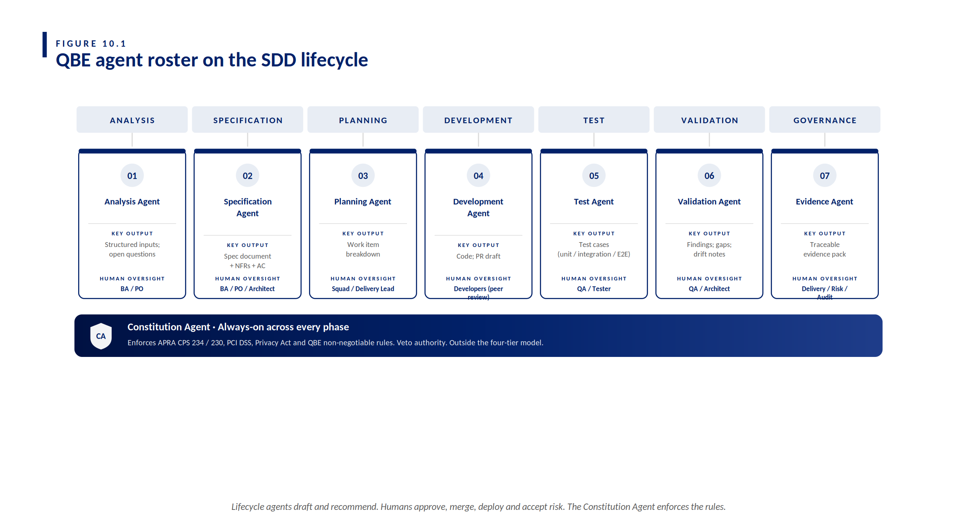
FIGURE 10.1 — QBE agent roster: seven lifecycle agents plus the Constitution Agent baseline.

APPENDIX B

Worked Example (FNOL Triage Assist) — Full Detail
This appendix is the verbatim artefact pack from the FNOL Triage Assist worked example introduced in Section 7. Use it as the gold-standard reference for new squads. All identifiers and content are synthetic placeholders.

B.1 Spec (template form)
SPEC-CCM-FNOL-014 · V1
Title: FNOL Triage Assist
Spec ID: SPEC-CCM-FNOL-014
Change class: Standard (assess locally)
AI tier: Tier 2 — Assisted
Pillars touched: Customer Correspondence (primary), Workflow, Integration

Context: FNOL volumes are seasonally variable; manual triage creates queue backlogs and inconsistent prioritisation. An assistive classifier reduces time-to-handler for high-severity cases and improves early identification of vulnerable customers.

In scope: inbound email parsing; severity scoring; line-of-business classification; vulnerable-customer detection; queue routing; audit logging.
Out of scope: outbound communications; claim adjudication; payment processing.

Failure behaviour: parser failure → manual fallback queue with explicit flag; low-confidence classification → manual triage; vulnerable-customer signal at any confidence → flag included in payload; never suppress, never drop email.

NFRs (minimum): no plain-text PII in logs; correlation ID per classification; p95 latency under 8 seconds; graceful degradation on classifier outage.

Acceptance criteria: AC-1 through AC-6 (see Section 7.2).

Open questions (resolved in v1): vulnerable-customer signal threshold (set at 0.6); fallback queue ownership (CCM operations); PII tokenisation strategy (at-ingest, vault-backed).

B.2 Work breakdown (thin slices)
WORK ITEMS
WI-1 Email parser — extract subject/body/sender/attachment metadata; tokenise PII at ingest.
WI-2 Severity + line-of-business classifier — call to QBE.AI (Q-GPT); capture confidence score.
WI-3 Vulnerable-customer signal detector — deterministic rule pass + model-assisted check.
WI-4 Queue router — map (severity, line-of-business, vulnerable flag) → correspondence queue; fallback rules.
WI-5 Audit logger — emit start/finish/outcome events with required fields and correlation ID.

B.3 PR slices (example)
PULL REQUESTS
PR-101 Email parser — implements WI-1; satisfies AC-4 (PII handling) and AC-6 (graceful degradation).
PR-102 Classifier integration — implements WI-2 and WI-3; satisfies AC-1, AC-2, AC-3.
PR-103 Router + audit logger — implements WI-4 and WI-5; satisfies AC-5 and AC-6.

B.4 Test plan (example)
TEST COVERAGE
Unit tests:
· PII tokeniser (PR-101) — verifies redaction across email body, subject, sender, attachment names.
· Severity classifier wrapper (PR-102) — verifies confidence-threshold gating logic.
· Vulnerable-customer signal detector (PR-102) — deterministic rule coverage; sample model-assisted prompts.
· Queue router (PR-103) — verifies routing matrix, fallback rules and vulnerable-flag override.

Integration tests:
· End-to-end happy path (AC-1) — well-formed email → routed correctly with audit trail.
· Vulnerable-customer flow (AC-2) — signals detected → flag in routing payload regardless of severity.
· Low confidence (AC-3) — confidence below threshold → manual triage with reason code.
· PII handling (AC-4) — full email lifecycle → no plain-text PII in any log stream.
· Audit logging (AC-5) — every classification → all required fields present, correlation ID set.
· Graceful degradation (AC-6) — classifier outage simulated → emails routed to manual fallback; zero loss.

B.5 Evidence pack index (example)
EVIDENCE PACK — FNOL TRIAGE ASSIST (SYNTHETIC EXAMPLE)
Spec: SPEC-CCM-FNOL-014 (v1)
Work items: WI-1 .. WI-5
PRs: PR-101 (parser); PR-102 (classifier); PR-103 (router + logger)
Pipelines: RUN-3401 (PR-101); RUN-3402 (PR-102); RUN-3403 (PR-103); RUN-3410 (release)
Approvals: BA / PO sign-off (spec, post legal review of AC-2)
Engineering Lead — merge approval per PR (peer review minimum 2)
QA / Risk — assurance sign-off
Squad Lead — deployment and risk acceptance
AI disclosure: Included in each PR description; tools and models recorded per task in PR metadata.
Constitution Agent log:
· BLOCK PR-101 draft 1 — debug stream logged plain-text email body (PII breach).
· CONDITIONAL spec — proceed once legal review of AC-2 wording is recorded.
· PASS pre-flight, analysis, planning, PR-102, PR-103, test, validation, release.

GLOSSARY & REFERENCES

Glossary
Term | Definition
APRA CPS 234 | Australian Prudential Regulation Authority — Information Security.
APRA CPS 230 | Australian Prudential Regulation Authority — Operational Risk Management.
PCI DSS | Payment Card Industry Data Security Standard.
SAFe | Scaled Agile Framework.
SDD | Spec-Driven Development.
SLM | Small Language Model.
LLM | Large Language Model.
IaC | Infrastructure as Code.
NFR | Non-Functional Requirement.

References
- QBE AI-Assisted Software Delivery Framework, v1.7.
- Squad Redesign — Agentic SDLC.
- Spec-Driven Development Integration Strategy.
- APRA Prudential Standard CPS 234 — Information Security.
- APRA Prudential Standard CPS 230 — Operational Risk Management.

End of document

