RAMDEOBABA UNIVERSITY, NAGPUR
DEPARTMENT OF COMPUTER SCIENCE AND ENGINEERING
B.Tech. CSE (Data Science and Analytics)

SEMESTER V
LAB
PROJECT REPORT
SOCIAL MEDIA ENGAGEMENT ANALYTICS DASHBOARD USING TABLEAU
Submitted by
Rucha Deshpande
Academic Year: 2026–27
SOCIAL MEDIA ENGAGEMENT ANALYTICS DASHBOARD USING TABLEAU
DST Lab Project Report

1. PROJECT OBJECTIVE
The main purpose of this project is to design and build an interactive analytics dashboard in Tableau that explains how social media posts perform across platforms, content formats, posting times and audience sentiment. The dashboard converts raw post-level records (likes, comments and shares) into key performance indicators and visual summaries that help a content team decide what to post, where to post and when to post.
The specific objectives of the project are:
- Load and explore the selected social media engagement dataset.
- Preprocess the data and prepare it for dashboard building (data types, date parsing and derived measures).
- Create calculated fields for Total Engagement, Total Posts, Total Likes and Average Engagement per Post.
- Build individual worksheets for KPIs, platform performance, monthly trend, content type, posting hour, sentiment and top-performing posts.
- Prepare a single interactive dashboard with a platform filter and communicate the findings.

2. INTRODUCTION
Social media platforms are now a primary channel through which organisations and creators reach their audience. Every post produces measurable reactions such as likes, comments and shares, and together these reactions indicate how well the content resonated with people. However, in raw spreadsheet form these numbers are difficult to compare across platforms, content formats and time periods.
Data visualisation addresses this problem. By aggregating post-level data and presenting it in charts and summary cards, patterns such as the strongest platform, the best-performing content type, the most effective hours of the day and the overall audience mood become visible at a glance. Tableau was chosen for this project because it provides drag-and-drop analysis, calculated fields and dashboard interactivity without extensive programming.
The motivation of this project is to give a social media manager a single-page view of performance so that posting strategy can be guided by evidence rather than guesswork. The expected usefulness is a reusable dashboard that can be refreshed with new data and filtered by platform.

2.1 Problem Statement
Post-level engagement data for several social media platforms is available only as a flat table of likes, comments, shares, post type, post time, post day and sentiment. The problem is to analyse this data and present it in an interactive dashboard that answers: How much engagement are the posts generating overall? Which platform and content type perform best? How does engagement change over the months and across the hours of the day? What is the sentiment distribution of the audience? Which individual posts are the top performers?

3. PROJECT METHODOLOGY
The project followed a standard analytics workflow: the dataset was loaded and explored, preprocessed, enriched with calculated fields, visualised in individual worksheets and finally assembled into one dashboard.

3.1 Dataset Loading and Exploration
- Dataset name: social_media_engagement1.xlsx (worksheet “Sheet1”), connected to Tableau as an Excel data source.
- Size: 100 records (rows) and 9 columns (fields), with the first row used as the header.
- Target variable: this is a descriptive analytics project, so there is no model target. The central measure of interest is Total Engagement, derived as likes + comments + shares.
The fields and their data types are listed in Table 1.
Table 1: Dataset fields and data types
Field | Data Type | Role in Tableau | Description
post_id | Integer | Dimension | Unique identifier of each post
platform | String | Dimension | Social media platform on which the post was published
post_type | String | Dimension | Content format of the post
post_time | Date & time | Dimension | Date and time of posting (format MM/dd/yyyy HH:mm)
likes | Integer | Measure | Number of likes received
comments | Integer | Measure | Number of comments received
shares | Integer | Measure | Number of shares received
post_day | String | Dimension | Day of the week on which the post was published
sentiment_score | String | Dimension | Sentiment category of the audience response

The first five rows, the data types and the structure of the data were inspected in Tableau’s Data Source tab (Figure 1). Missing values and duplicate records were checked by reviewing the data grid and by comparing the number of records with the distinct count of post_id.
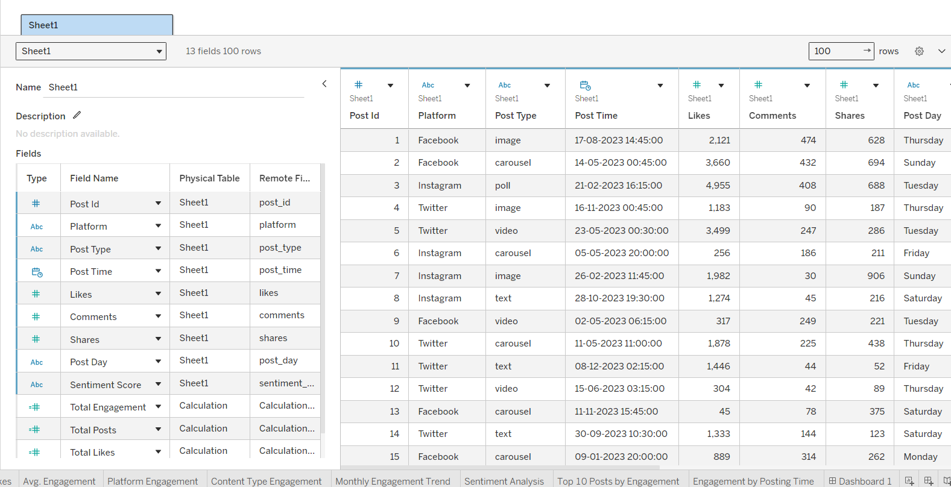
Figure 1: Dataset preview in the Tableau Data Source tab
The figure shows the Excel file connected to Tableau with all nine fields and their detected data types.

3.2 Data Preprocessing
- Missing values and duplicates: the data was checked for blank cells and repeated post_id values.
- Date handling: post_time was parsed as a date-time field using the MM/dd/yyyy HH:mm format so that it could be broken down into month and hour.
- Data type verification: likes, comments and shares were kept as numeric measures; platform, post_type, post_day and sentiment_score were kept as categorical dimensions; post_id was treated as a dimension (identifier) rather than a measure.
- Derived measures: Total Engagement and the KPI fields were created as calculated fields (Section 5) instead of altering the source data.

4. PROJECT IMPLEMENTATION

4.1 Tools and Technologies
Table 2: Tools and technologies used
Tool / Technology | Version | Purpose
Tableau Desktop | 2026.2.3 (workbook format 18.1) | Data connection, calculated fields, worksheets and dashboard design
Microsoft Excel (.xlsx) |  | Storage of the social media engagement dataset used as the data source
GitHub | — | Version control and submission of the workbook, dataset and dashboard screenshot

4.2 Step-wise Implementation
- Connect to data: the Excel file social_media_engagement1.xlsx was connected in Tableau and Sheet1 was loaded as the data source.
- Verify fields: data types were confirmed (Table 1) and post_time was interpreted as a date-time field.
- Create calculated fields: Total Engagement, Total Posts, Total Likes and Average Engagement per Post were defined (Section 5).
- Build KPI worksheets: four single-value text cards (Total Posts, Total Engagement, Total Likes and Avg. Engagement) were created to summarise overall performance.
- Build analysis worksheets: six chart worksheets were created, as summarised in Table 3.
- Apply the Top 10 filter: on the Top 10 Posts by Engagement worksheet, Post Id was filtered to the top 10 records by the sum of Total Engagement.
- Assemble the dashboard: all ten worksheets were placed on one fixed-size dashboard (1600 × 1200 pixels). A title banner reads “SOCIAL MEDIA ENGAGEMENT ANALYTICS” with the subtitle “Performance Overview · Content Insights · Audience Sentiment”.
- Add interactivity: a Platform filter was added to the dashboard so that all worksheets using the same data source respond to the selected platform(s).
- Format and review: a consistent colour scheme (dark navy header with blue, orange and red chart colours) and clear sheet titles were applied, and the dashboard was checked for readability.
The dashboard layout places the four KPI cards at the top, followed by Platform Engagement and Top 10 Posts, then Monthly Engagement Trend and Engagement by Posting Time, then the Platform filter with Content Type Engagement, and finally the Sentiment Distribution across the bottom.
Table 3: Worksheets used in the dashboard
Worksheet | Visual Type | Fields Used | Purpose
Total Posts | KPI card | Total Posts | Count of unique posts
Total Engagement | KPI card | SUM(Total Engagement) | Overall likes + comments + shares
Total Likes | KPI card | Total Likes | Overall likes received
Avg. Engagement | KPI card | Average Engagement per Post | Engagement earned by a typical post
Platform Engagement | Bar chart | Platform; SUM(Total Engagement) | Compare platforms by engagement
Monthly Engagement Trend | Line chart | MONTH(Post Time); SUM(Total Engagement) | Engagement trend across 2023
Content Type Engagement | Bar chart | Post Type; SUM(Total Engagement) | Compare content formats
Engagement by Posting Time | Bar chart | HOUR(Post Time); AVG(Total Engagement) | Find best hours to post
Sentiment Analysis | Bar chart (coloured by sentiment) | Sentiment Score; COUNTD(Post Id) | Distribution of audience sentiment
Top 10 Posts by Engagement | Bar chart | Post Id (Top 10); SUM(Total Engagement) | Identify best-performing posts

5. DAX QUERIES / CALCULATED FIELDS
Since the project was implemented in Tableau, calculated fields were used instead of DAX queries. The four calculated fields created in the workbook are listed in Table 4.
Table 4: Calculated fields
Calculated Field | Formula | Explanation
Total Engagement | [likes] + [comments] + [shares] | Row-level measure that adds all three reactions of a post into one engagement value.
Total Posts | COUNTD([post_id]) | Counts the number of distinct posts, so that no post is counted twice.
Total Likes | SUM([likes]) | Adds the likes of all posts in the current filter context.
Average Engagement per Post | SUM([Total Engagement]) / COUNTD([post_id]) | Total engagement divided by the number of distinct posts; shows the engagement of an average post.

In addition to these fields, Tableau’s built-in date parts MONTH() and HOUR() were applied to post_time, AVG() was applied to Total Engagement for the posting-hour chart, and a Top N filter (top 10 by SUM of Total Engagement) was applied to Post Id.

6. RESULTS AND DISCUSSION
This section presents the outputs of the implemented dashboard. Each figure is followed by a short explanation of what it shows and how it should be read.
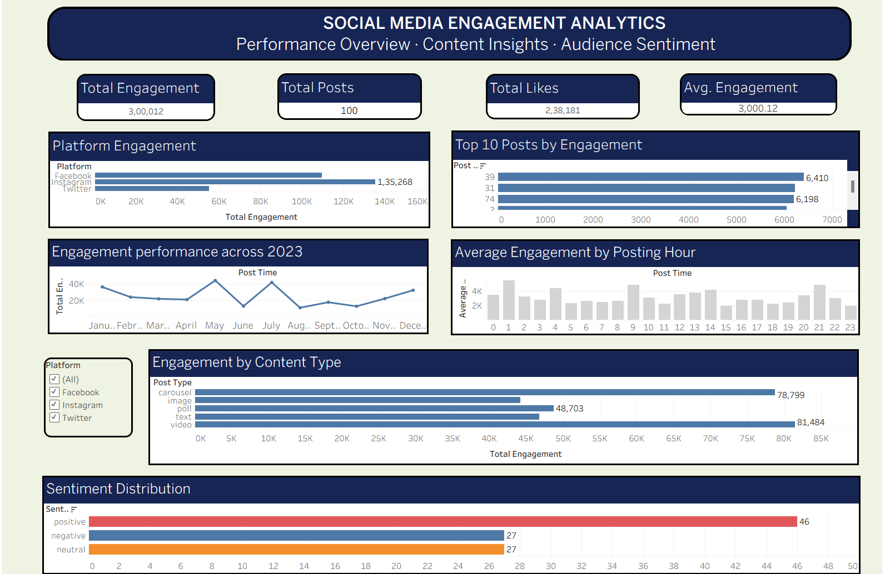
Figure 2: Complete Social Media Engagement Analytics dashboard
The dashboard combines KPI cards, platform comparison, monthly trend, posting-hour analysis, content-type analysis, sentiment distribution and the top ten posts on a single page, so that overall performance and its drivers can be understood together.

Figure 3: KPI cards: Total Posts, Total Engagement, Total Likes and Avg. Engagement
The KPI cards give the headline numbers of the analysis. Total Posts shows the volume of content published, Total Engagement and Total Likes show the size of the audience reaction, and Avg. Engagement indicates how much engagement a typical post achieves.

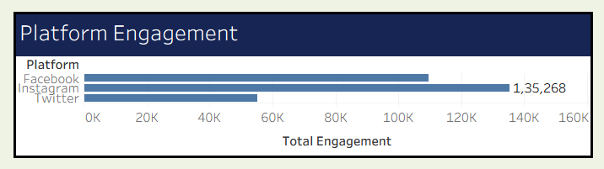
Figure 4: Platform Engagement
This bar chart compares the total engagement generated by each platform. A longer bar means the platform contributes more of the overall engagement, which helps to decide where to concentrate posting effort.

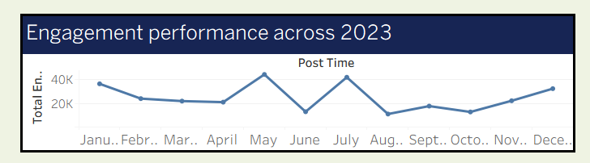
Figure 5: Monthly Engagement Trend (2023)
The line chart shows how total engagement changed from month to month during 2023. Rises indicate months in which content performed well, while dips highlight periods that need review.

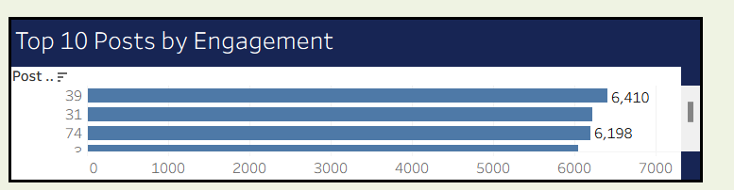
Figure 6: Top 10 Posts by Engagement
This chart lists the ten posts with the highest total engagement. Studying these posts helps to find common features of successful content, such as format, platform or time of posting.

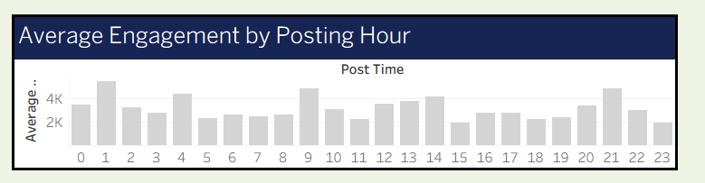
Figure 7: Average Engagement by Posting Hour
The chart shows the average engagement of posts published in each hour of the day. It identifies the time windows in which the audience is most responsive and therefore the best hours to publish.

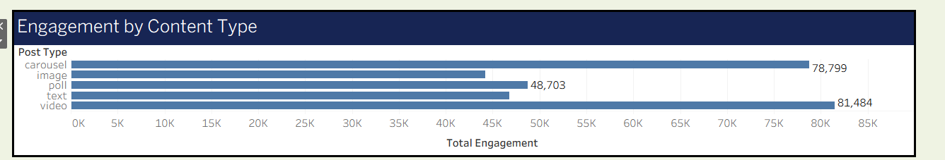
Figure 8: Engagement by Content Type
The chart compares the total engagement of the different post types, showing which content formats the audience prefers and which formats deserve more or less investment.

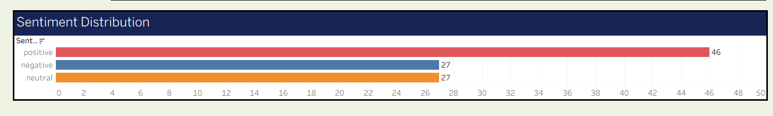
Figure 9: Sentiment Distribution
The chart shows the number of distinct posts in each sentiment category, with each category in its own colour. It indicates whether the overall audience response is mostly positive, neutral or negative.

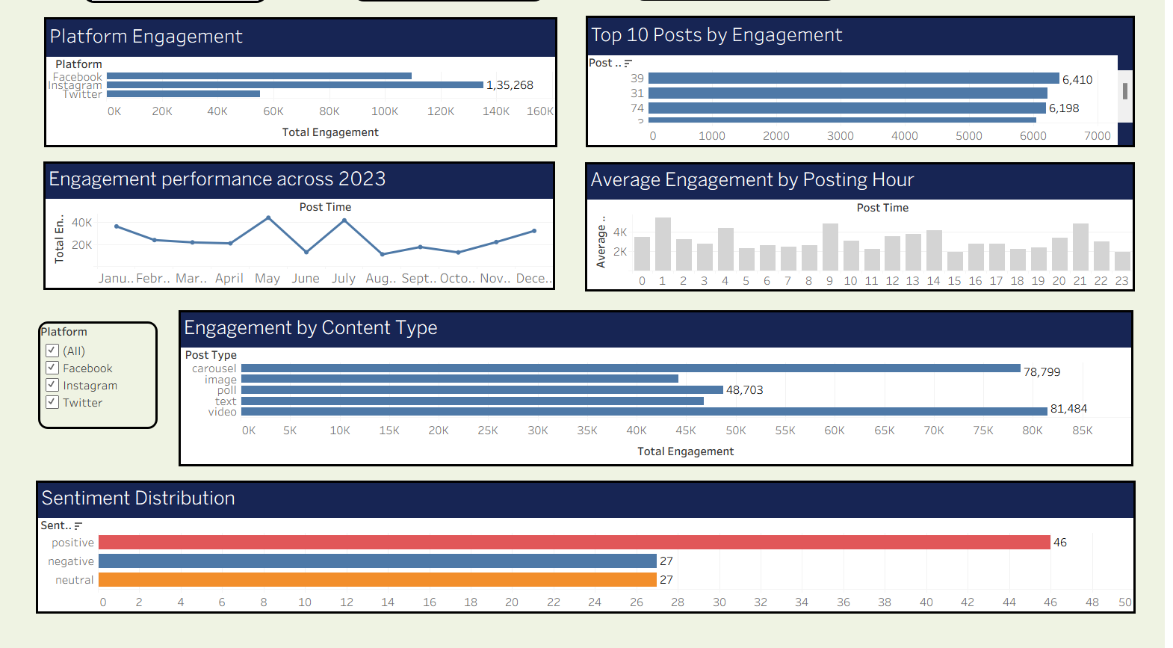
Figure 10: Dashboard with the Platform filter applied
When one or more platforms are selected in the Platform filter, the KPI cards and charts update to show only the selected platform(s). This interactivity allows platform-specific analysis without building separate dashboards.

7. CONCLUSION
In this project, a social media engagement dataset of 100 posts with nine fields was loaded into Tableau, prepared for analysis and converted into an interactive dashboard of ten worksheets. Calculated fields were used to derive Total Engagement and the KPI measures, Tableau aggregations such as sum, average and distinct count were used to summarise the data, a Top N filter was used to find the best posts, and a platform filter was added to make the dashboard interactive. The dashboard answers the questions raised in the problem statement about platform performance, content type, timing, trend and sentiment.
Limitations:
- The dataset is small (100 records) and covers a single year, so the patterns may not generalise.
- The data is loaded from a static Excel file and has to be refreshed manually.
- Sentiment is available only as a category label; no text-level sentiment analysis was performed.
- The project is descriptive; it does not include statistical testing or predictive modelling.

Possible improvements:
- Use a larger, multi-year dataset connected through a live or scheduled-refresh connection.
- Add filters for date range, post type and sentiment, and drill-down from platform to individual posts.
- Include reach and impression data to calculate engagement rate.
- Add forecasting or predictive models for engagement, and publish the dashboard to Tableau Public or Tableau Server for sharing.

8. GITHUB LINK
GitHub Repository URL:
The repository contains the Tableau workbook (DST_LA_02.twb), the dataset (social_media_engagement1.xlsx), the dashboard screenshot and this report.

9. REFERENCES
[1] Dataset name: social_media_engagement1.xlsx
[2] Tableau Software, “Tableau Desktop and Web Authoring Help.” https://help.tableau.com/current/pro/desktop/en-us/default.htm
[3] Tableau Software, “Create a Calculated Field.” https://help.tableau.com/current/pro/desktop/en-us/calculations_calculatedfields_create.htm
[4] Tableau Software, “Filter Data from Your Views (Top N filters).” https://help.tableau.com/current/pro/desktop/en-us/filtering_topn.htm
[5] Tableau Software, “Create a Dashboard.” https://help.tableau.com/current/pro/desktop/en-us/dashboards_create.htm

