Garbage Classifier

Abstract
This report includes the detailed theoretical idea, practical approach, tool based implementation and the through explanation of the results of the Garbage Classification method using Deep Learning [1]. We have implemented 2 approaches our own Convolution Neural Network or CNN [2] and the reinforced VGG-19 [3] model under very strict constraints like Early Stopping Callback and a maximum of 30 epochs which gave us a decent validation accuracy around 0.6 given we had around 2000 images for the training purpose from Garbage Data Set [4]. Model building is done using Python [5] based Deep Learning Framework, Keras [6]. We have used numpy [7] for data handling, Open-CV [8] for image processing and matplotlib [9] for the visualizations of graphs and plots. In the end, we have implemented the Object Segmentation [10] using the Watershed Algorithm [11] as well as Canny Edge Detection [12] algorithms to explain how to increase the efficiency of the model with such constrained environments. We shall be discussing the procedure, implementation, result and future scope for improvements in the coming sections one by one.

Introduction
As the humans are evolving and reaching towards big things of life with time, they sure do not have the time to do mere but essential tasks and proper disposal of garbage is one such task which penetrates the above domain very deeply. With increase in the vastness of industries, better lifestyle and less time, we are on the verge of exhausting our resources which happens to be a bane of technology, advancement and lifestyle or any name you would like to give to the prospering society. We are running out of metal ores, forests and other natural resources day by day and the day is not unforeseeable when we’ll run out of all those resources in the name of advancement. To overcome the problem, our most intelligent brains have been constantly on the re usability of the products in the best efficient manner and to tackle this problem, recycling was invented.
Recycling suffers from a lot of problems itself such as type of products, cost of the process, impurities, availability of recyclable products and so on. For an instance, a bottle which has a lot s of impurities embedded in it can be more costly to recycle than to make a new one or what if there are only a little amount of some material that we have to set up a plat for recycling and then people stop using it afterwards. We can not address each and every problem in our case but the the one which happens to be the mixing of products which can be separable physically. It is just a problem of time and effort if not something of big concern.
There are a myriad of problems arousing everyday due to the improper treatment of garbage which all come to the root cause of improper disposal of waste. If a poly bag is treated the same way or in addition with cardboard or a glass is treated, it can result in very disastrous results because the burning of plastic is accountable to a huge percentage of the pollution on earth. In the same manner, if plastic or glass is dumped for the agriculture to be used as compost like a paper or cardboard, it can lead to barren lands and injuries due to the fact that these two are not bio degradable by the micro organisms.
Now we ask ourselves the question that why is this happening in the first place and the answer is as clear as the shining glass in the paper waste. It is because that the trash was not sorted properly before throwing and had the trash been sorted at any place starting from home to recycling, this would have been avoided. People do not have time for do these kind of things and even they do have, all we know is “to err is human” and people do it quite often, sometimes deliberately.
In this era of technology where people are getting luxuries of life, education and recommendations from an intelligent computer system, the least we can try to do is to build a moderate version of an intelligent system which can classify the garbage and help a robot or machine to properly put the garbage in the categories or bins where they belong .This was the idea and motivation of the project. There are a lot of problems in the process and solution to almost each one of them which are discussed in the coming sections.

Deep Learning
Deep Learning is the branch of Artificial Intelligence [13] and Machine Learning [14] which deals with decision making with the help of Artificial Neural Networks [15] which in turns are inspired by the working of brains. Just like the neurons in brain, neurons in Neural Networks are basically a unit which is directly or indirectly related to the final decision of the model given if it is active or not.
- Neural Networks (Fully Connected Neural Networks/ Dense Neural Networks):
A Neural Network is a collection of Neurons connected in the form of layers. In the most broadest form possible, layers are of three types basically an Input, Hidden and Output layer. A layer can have a minimum of 1 neuron to any number of neurons. A neuron is basically a logical function which takes any number of inputs and provides the output and the notable thing about neurons is that they can act as any logical gate given the type of inputs bias associated with the neuron. A weight is a scalar unit which acts as the input to the current neuron and tells us the significance or the impact of the output from the previous neuron to which it is connected. Bias is a random scalar which is used with neuron optionally. A single neuron with weight can be represented as in the Figure -1.

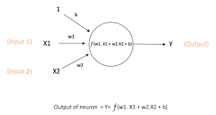Figure 1: Functioning of neuron with weights and inputs

A neural network learns with the help of memorization just like we humans do in real life by looking at the instances over the life and then predicting based on those instances. Dense or Fully connected networks are shown in the Figure-2 where each and every neuron of current layer is directly connected to each and every neuron from previous as well as the coming layer contributing to the final output of the network.
There are limitations of Dense Neural Networks such as the specific details recognition and the most troublesome exploding of dimension space because images are girds of pixels and in a (2x2) colored image, there are 12 numbers to define a single image and we deal with the images of dimension (32x32) at the least. To overcome this problem, we use the CNN or Convolution Neural Networks.

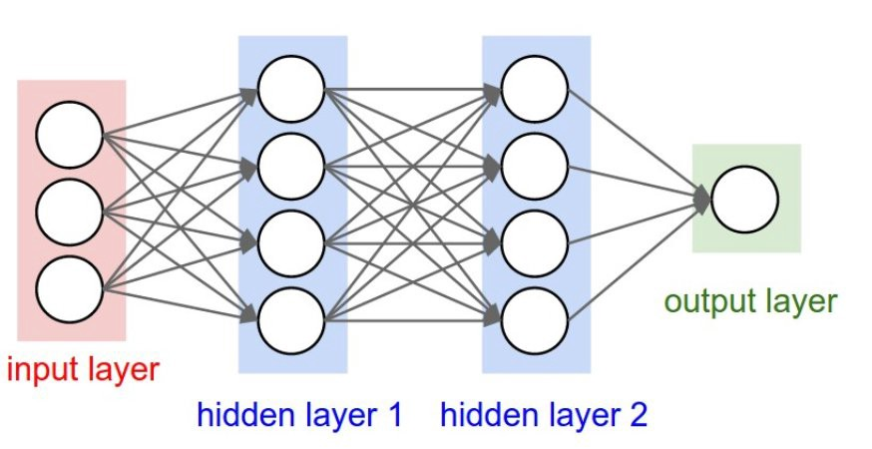Figure 2: Dense Neural Network

- Convolution Neural Network
In CNN, we use Convolution layers which extract the feature maps from the input image after applying a kernel. A kernel is a (NxN) function which slides over the whole image to get a feature map. This feature map can be considered as the extracted features from the image such as border, lines, edges etc. With each convolution layer, some new features are detected from the image. An activation is always attached to the layer which keeps the output value in the range [0,1] both included generally and [-1,1] in some cases. A value of 0 means that the neuron is inactive for the decision making and 1 means it is active and impact is decided by the weight.
A pooling layer is added often times to reduce the dimension of the feature maps else the whole purpose of using the CNN due to dimensionality explosion will be futile. Sometimes a couple of Convolution layers are used in continuation before using the pooling layers. A pooling such as Average Pooling of (2x2) gets the average of every pixel which come in a 2 by 2 grid for each row and column and save it in a new matrix. Just like Average, a Max Pooling takes the maximum values of those pixels because it is thought that the pixel with the highest value around an area can define the whole area. Working of CNN can be seen by Figure-1. The result is output of a softmax activation function which is the probability of the data belonging to each class. Our goal of this process is to get the loss as minimum as possible where loss id defined in the terms of categorical cross entropy which is in simple terms, a number which tells us that how far is the probability of the expected class from the actual class. Neuron with the maximum probability is the class to which the data point or the test image in our case belongs to. We can see the whole process in the single figure given below. A Flatten layer is applied after the last Pooling and the first dense layer to get the data from 3 Dimensional to 1 Dimension for the Dense layer and then to last output layer.

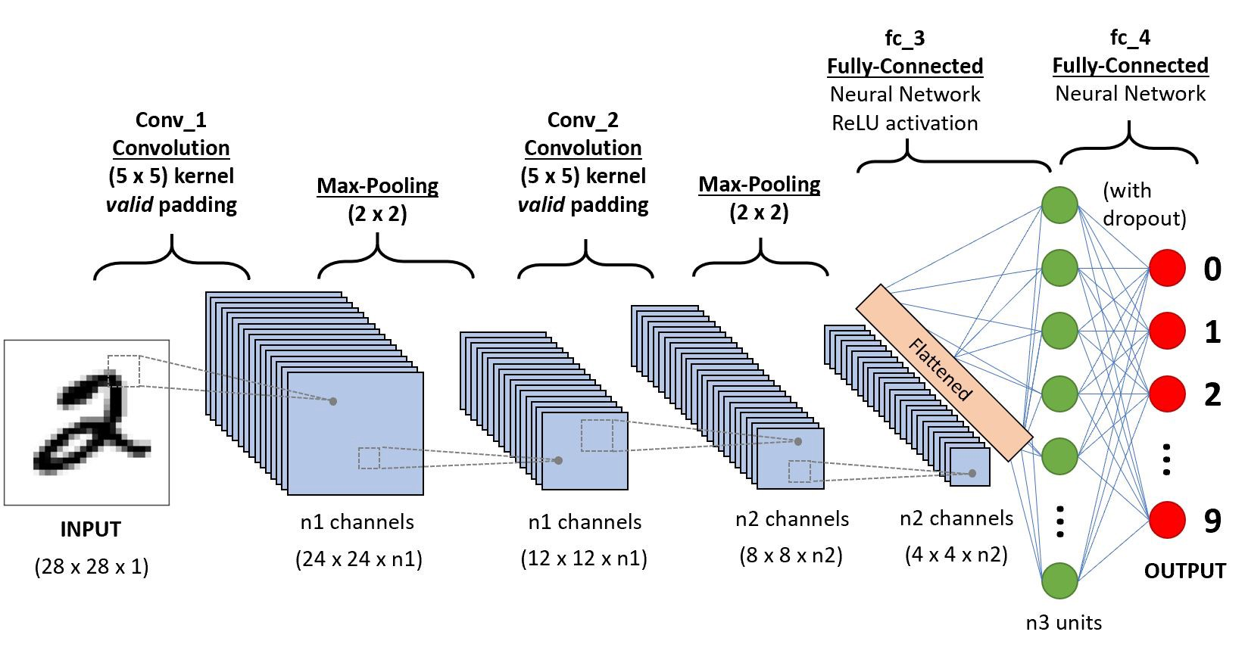Figure 3: Working of CNN

Exploratory Data Analysis
EDA or Exploratory Data analysis tells us the first things about the data. After analyzing the data, we found out that we have 2527 images belonging to 6 different type of classes. Each class is Label Encoded by the number from 0 to 5 and the mapping of class name is as follows:
{'cardboard': 0, 'glass': 1, 'metal': 2, 'paper': 3, 'plastic': 4, 'trash': 5}
Figure- 4 describes the distribution of the classes or the fraction of each type of image in the data set. Most numbers of images belong to the images where there is paper as the garbage and the trash is there for just 5.42% of the whole data.
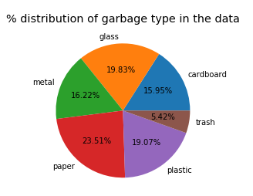Figure 4: Distribution of Classes inside data

Computers do not perceive the images like we humans do in plain format. For computers, everything revolves around a binary number system and the challenging task to create a system of conversion. So to overcome the problem, scientists had discovered a way to store images digitally by using matrices. An image is represented by a 3 dimensional matrix consisting the shortest unit in computer graphics called ‘pixel’. A single pixel can be seen as a tiny colored (or black and white) dot which occupies around 1/96 part of an inch or 0.26 millimeters.
We know that the colors are seen by the RGB (Red Green Blue) values and the combination can produce any number of colors. In digital images, Red,Green and Blue are defined by 0-255 (or 0 to 1 in floating) where 0 means the intensity is lowest for that color (dull) and 1 is for full intensity. Grayscale or Black & White images are described by 0 and 1. Value of all the colors at a position (i,j) in the (WxH) dimension matrix define the color of the individual pixel and (WxH) colored pixels when seen in the same order make an image in the screen which has a dimension of (W,H,C) where W is width of image, H is Height of image and C is number Channels (RGB or Grayscale) in the image.
Each image in our data set is of dimension (512x384x3) and 3 means RGB values ranging from 0 to 255 where 0 represents black and 255 represents white. So each image in our data set is an individual 3 Dimensional matrix or 3 Dimensional array of shape (512,384,3)
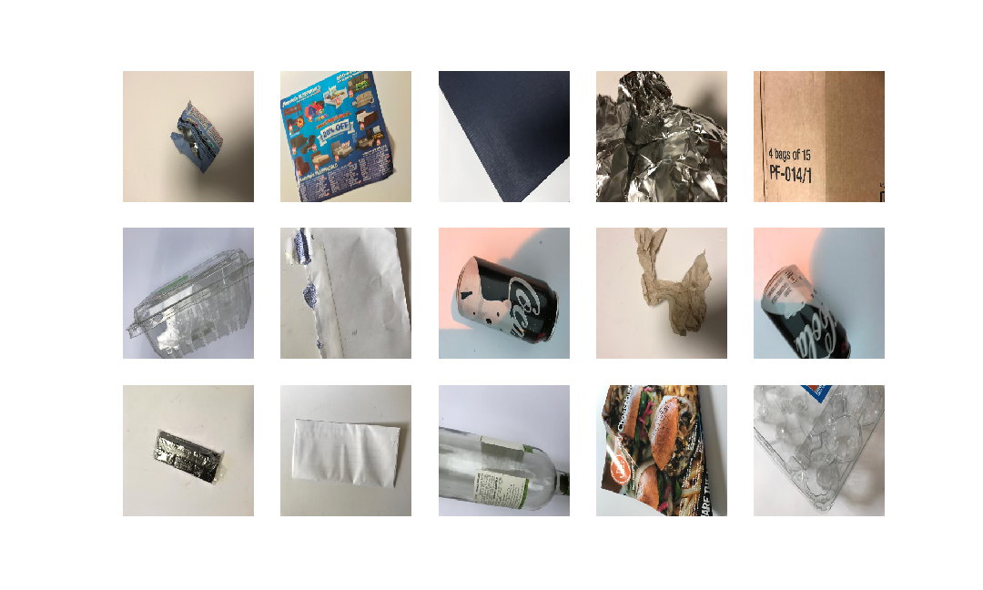Figure 5: Random images from data
We have many problems here starting from the very basic requirement of AI demanding lots of data for model to train to the very end of distribution of classes i.e. unbalanced data set. We plotted random 16 images from the data set to get what the data images actually looks like and Figure-5 describes that. There are random images of from each class such as paper,cardboard, glass and so on. These images have been plotted using matplotlib’s imshow() method. A thing to be noted here is that these images do not have the original size by the resized version as (254,254,3) which is used default by Keras’ generator to make the images of common shape and size. As we can see that a single object has been captured from the camera from different angles which will surely make our problem of over fitting even worse.

Pre-processing
To tackle the problem of less images as well as to handle the over fitting that will arise due to the lack of data as the model will cram the data as it is, we will use augmentation. We will augment our data based on range of some parameters such as horizontal and vertical flipping, zoom in and out, rotation, shearing etc. It’ll help us in making the model robust. We can theoretically get an infinite number of images from a single image because with parameter we have lots of options to chose from. We should not use too much augmentation on less data because then the model will tend to cram the data instead of generalizing it and that is what we do not want. ImageDataGenerator class of Keras pre-processing will be helping us in finding the goal. It’ll not create extra images but just augment the images that are already in the data. We have used a low range for the arguments (in between 0.1 to 0.19) because shearing or zooming in or out too much can make the model worse. Figure - 6 depicts how the augmented images will look like.
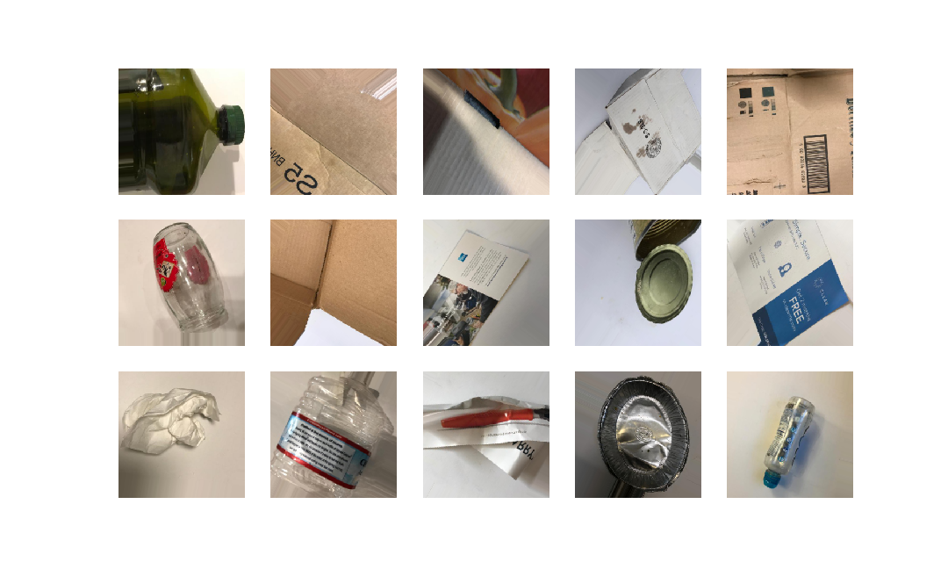Figure 6: Augmented Random Images
Each of these images are rotated, flipped, sheared at random. Width and heights have also been shifted for the images. We have used 0.13 of the training data as the validation data so that we can test how our model is performing in terms of accuracy so it leaves us with even lesser images for training than before.
Images have been re scaled to have a common range from 0-1 (both included) where 0 represents a black colored and 1 represents white color. It helps the model converge faster when all the values are in the same range. We have also reshaped the images from the original (512x384) to (384x384) so that each and every image is on the common scale and we get a square image.

Model Building
For the training of model, we have chosen 2 different methods. First one is our own CNN model which is based on Convolution, Max Pooling and Dense layers. Other one is VGG-16 which we have used for reinforced learning. We’ll be discussing the workings and methodology of both the models one by one.
We can build our model by 2 different styles. Sequential Model (Easy to implement but not customizable) and using Functional API (Very customizable and relatively not so difficult to implement). So we'll be using Functional API. from Keras.
Layers in Keras are by default named as layer_type_position such as first Conv2d() and Dense() are named as conn2d_1 and dense_1 respectively unless specified by name='something_else in layer. We can access flattened layers by model.layers.
We used a bunch of models in terms of layers, activation functions and other changes before declaring the given model as final model. Let us just get the summary of layers and activation functions as they appear in our network.
Input Layer (Input(): The input layer of a neural network is composed of artificial input neurons, and brings the initial data into the system for further processing by subsequent layers of artificial neurons. The input layer is the very beginning of the workflow for the artificial neural network.
Convolution Layer (Conv2D()): Convolution layers are the layers where filters are applied to the original image, or to other feature maps in a deep CNN. In other words, these layers summarize the presence of features in an input image or extract the features from the image. A kernel (s) or so called filter (s) is a specialized matrix of size (NxN) which is applied to the whole image. A single filter can detect a unique pattern such as extracting boundary, shapes, color patterns or any other uniqueness which is present in the image. These kernels act as a masking matrix which are iterated over the whole image. For example, in the Figure-7 given below, a kernel is acting differently with different RGB channels and extracting different features from it where we can see the difference in brightness, smoothness and saturation qualities. Convolution Layer only affects the last dimension which is Channels of the image but do not interact with width or height. In other very simple words, it makes the different colored versions of the same image. At the very beginning of default image, we have 3 channels that is 3 colored versions Red version, Blue version and Green version of same image. After passing the image to Convolution layer, these 3 versions can change to a different version depending on the kernel and size of kernel used.
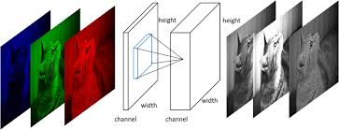Figure 7: Working of Convolution Layer
There is a unique quality of Deep CNN is the act of finding very minute details with every layer. For example, first layer can find the boundaries followed by second which can then detect the joints and then the third layer which can find the whole face.
ReLu (activation='relu'): ReLu is an linear activation function which takes an input x_input and gives the output of same degree. In simple terms, it will convert every negative value to 0 and use the +ive value as it is. All of the {-1,0,-12.9} will be outputted to 0 but {1,2,76,0.1} will be outputted as they are I.e. {1,2,76,0.1}. Mathematical notation of ReLu is given below and the line chart can be seen in the Figure-8.
Y = MAX{0,x_input}
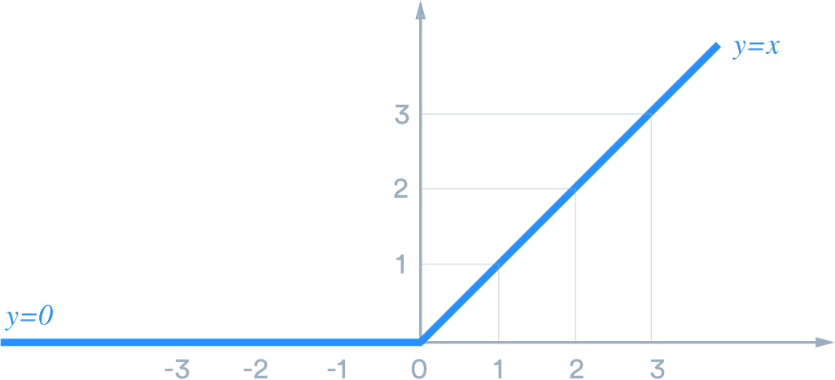Figure 8: Relu Activation Function

Pooling (MaxPool2D()): Pooling layers provide an approach to down sampling feature maps by summarizing the presence of features in patches of the feature map. Max Pooling calculate the maximum value for each patch of the feature map or in very very simple words for example, it'll return a Maximum value of each (2x2) matrix, for example Max(00,01,10,11) that is present in each (NxN) it encounters if and only if step=1. For images we use 2D and for videos and sound, 3D. Working of both Average and Max Pooling layers are shown in the Figure – 9 where kernel size is (2x2) and stride is 1.
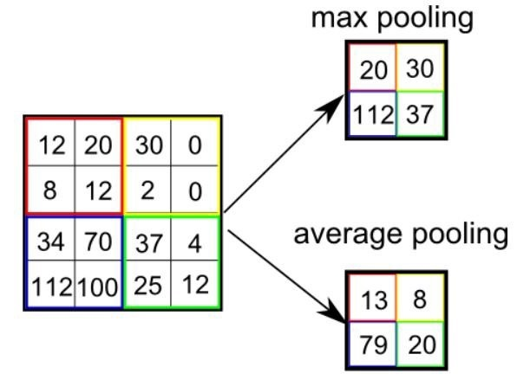Figure 9: Working of Pooling Layers

Dropout (Dropout()): Dropout Layer will drop n proportion of values it gets from the previous layers. It is a method of preventing Overfitting. If Dropout is set to 0.4, it'll randomly drop the 40% of weights which were provided by the previous layer, making them inactive for the prediction. Dropout can be implemented on any or all hidden layers in the network as well as the visible or input layer. It is not used with output, Convolution and Pooling layers.
Flatten (Flatten()): Flatten layer performs a flatten operation on a tensor, reshapes the tensor to have the shape that is equal to the number of elements contained in tensor non including the batch dimension. Not getting it right? Well for example, Flatten() will take a tensor of any shape and transform it into a one dimensional tensor (plus the samples dimension) but keeping all values in the tensor. For example a tensor (samples, 10, 20, 1) will be flattened to (samples,200 ). Simply,(N-Dimension tensor collapsed into 1-Dimension).
Sotmax (activation='softmax'): Softmax is linear activation function which gives the probability of each class to an input. Let us suppose that in each class (in our problem we have 6 classes respectively for each label) we get a probability, the class assigned to the image will be the class with the highest probability. Sum of all of the probabilities will be equal to 1. Mathematical notation for the softmax function, S(x) for an element x is described as:

where i=1 to n are all the points in the set.
Output of softmax can range in between 0 and 1 (both excluded) and can be seen in Figure-10 below.
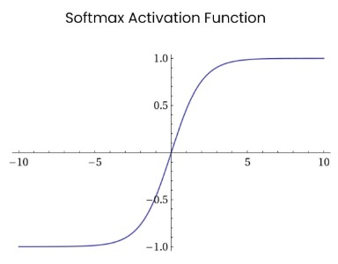Figure 10: Softmax Activation Function

Model Summary
Our model has a total of 13 layers with 9522118 parameters all of which are trainable. Parameters include all of the weights and biases of the eligible layers such as Convolution, Pooling and Dense. Flatten and Dropout layers do not have weights and these can be referred as Functions rather than layers because by the general definition of layers, layers possess weights and gradients to update those weights. A detailed summary of the name, input and the output shape of each layer can be seen in the Figure-11 given below. Just as we expected, the first Convolution has found 32 features from 3 Color Channels and changed the shape from (384,384,3) to
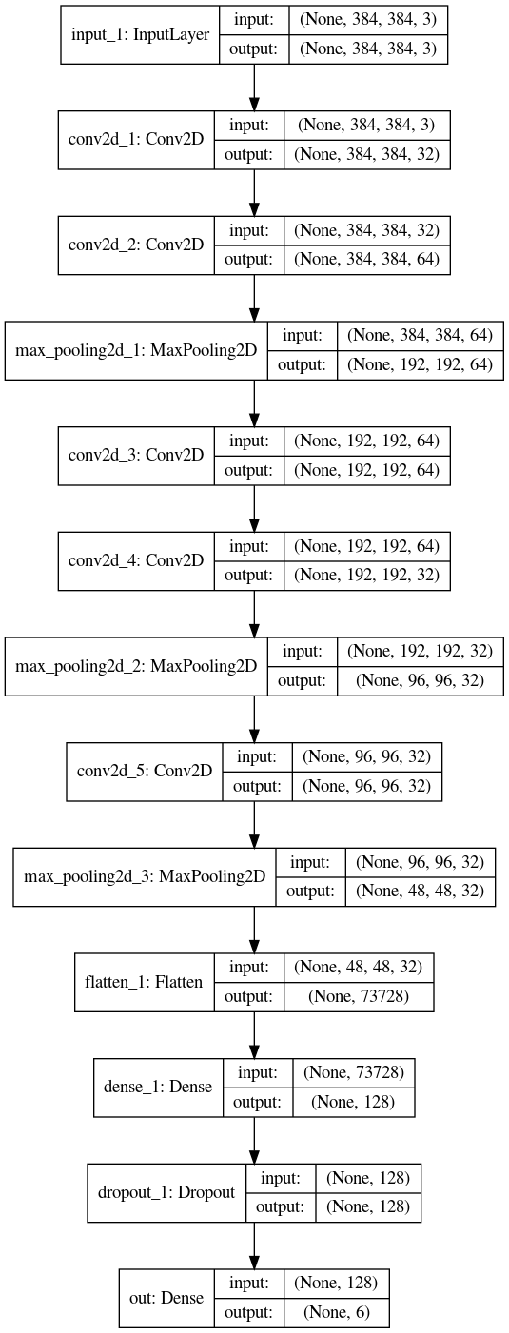Figure 11: Input, Output and reshaped summary of layers

(384,384,32) and the first Pooling layer has decreased the shape of height and width from (384,384) to (192,192). One thing has to be noted here that the Convolution layer does not add extra feature maps to the image but find new features from the existing images. This can be seen in the process of 3rd and 4th Convolution layer where the 3rd Convolution got an input of (192,192,64) and produced an output of same size. It does not mean that input and output are the same. Convolution layer affects the color channels and it has extracted new 64 features from the existing 64 features. Same process is with 4th Convolution layer where the size of color channel is decreased from 64 to 32 but it means that new 32 features are extracted from old 64 features. By the time out tensors reaches the first Dense layer, it has a shape of (48,48,32) i.e a tensor of 73728 neurons in 1 dimension.
Input and outputs are shown in the form of (None, x,y,z) which represent (batch_size,height,width,channels) with channels_last format. Training the model in batches decreases the training time because the gradients and losses are calculated on the whole batch rather than an individual image. A list of individual parameters and their details for each layers are given in Table-1.
NA = Not Applicable to the layer
N Parameters = Number of parameters in the layer
Layer Index | Layer Type | N Parameters | Trainable | Activation
1 | Input | 0 | NA | None
2 | Convolution | 896 | All | ReLU
3 | Convolution | 18496 | All | ReLU
4 | Pooling | 0 | NA | None
5 | Convolution | 36928 | All | ReLU
6 | Convolution | 18464 | All | ReLU
7 | Pooling | 0 | NA | None
8 | Convolution | 9248 | All | ReLU
9 | Pooling | 0 | NA | None
10 | Flatten | 0 | NA | None
11 | Dense | 9437312 | All | ReLU
12 | Dropout | 0 | NA | None
13 | Output | 774 | All | Softmax

As we can see from the table above, the dimensionality has been reduced to a level where we can actually process all the data within the hardware constraints else had we been using the Dense or Fully Connected Neural Networks, it would have been impossible to train the model let alone get the good predictions.

Model Training
We have our model fully prepared. Before compiling our model, there are 3 things that are the most important for training and crucial for the model to run because in absence or wrong implementations of any of those, our could produce bad results, no results and even produce an error. These three are:
- Loss Function
- Optimizer
- Performance Metric
- Loss Function: All of the ML or Deep Learning tasks are leaning towards one and only one goal, that is decreasing the loss function. For a classification process, it is basically Categorical Cross entropy for multi class classification and log loss for binary class classification. For our project, we can think of categorical cross entropy as the difference between actual probabilities of all the 6 classes and predicted probabilities of the 6 classes, represented by a single number. A cross entropy H(P,Q) can be represented as:
H(P, Q) = – sum x in X P(x) * log(Q(x))
where P(x) is the probability of x occurring in the event P (predicted probability in our case) and Q(x) is the probability of occurring x in event Q (actual probability of x in Q).

- Optimizer: Optimizer calculates the gradient descent of the weights based on the loss function. A gradient descent is the slope of the direction which provides the fastest convergence of model while minimizing the loss function. In simple terms, with the help of gradient descent, we can choose if weights associated with the neurons have to be increased or decreased and by how much for each and every neuron during back propagation process so that the updated weights result in the minimum loss function. We have chosen the Adam optimizer function as our usher. An optimizer takes a step in calculating the gradients by using a parameter called learning rate. It defines by how much pace should an optimizer be calculating the gradients. Learning rate which is too high can make a mode the worse because it’ll not learn at all and if the learning rate is tool ow, it can take forever before the model converges. To choose the “best” learning rate, we have to deal with the speed - performance trade off so that it neither makes the too slow by learning very slowly nor makes it worse by learning too fast by stepping further than it was expected.
- Performance Metric: A best model without a performance metric is nothing but a runner without score that serves no purpose at all. To know how good our model is, we have to have performance metric and accuracy is the one chosen for the project. Accuracy is the ratio of correctly predicted classes to the total prediction done by model in our case. Accuracy can be in between 0 and 1.

We have chosen 20 epoch for the first run with a learning rate of 0.01 with a batch size of 64. Or initial run did not provide any significance results with a maximum test data validation accuracy of mere 0.4. After that, the model started over fitting where the validation accuracy started decreasing and the categorical cross entropy or the loss value started increasing. We have few solutions to improve the behavior including batch size, learning rate and number of epoch to increase the accuracy in place of changing the whole model again and again. This is referred to as Hyper Parameters Tuning which we’ll be discussing in next section.

Hyper Parameter Tuning:
There are two types of parameters in the network. One which we can not manipulate and are learned during the training phase are called trainable or learn able Parameters such as bias and weights. Another ones which we control directly and are a part of training phase are called non trainable parameters such as epoch,learning rate etc. We can change the trainable parameters but we should never alter because those are the ones which are responsible towards the prediction. Second one the parameters which affects the final output of trainable parameters in their own unique ways. For example if a learning rate is high, our model will learn faster but not effectively and vice versa. Same thing applies to batch size that if we pass single image per epoch, our model will learn gradient for each individual image rather than a batch making the model better but very slow and vice versa. Epoch also contributes towards the model accuracy. If we train model for more and more epoch, our model will cram or learn too much from the training data and change the weights according to the loss function which is directly a reflection of training data only. By doing so, our model will be providing a good training accuracy but it’ll act very badly when it comes to real world test data because the weights which directly influence the outcome are based on the training data. On the other hand, if we train model for very less epoch, it would have learned very little from data to provide any satisfactory results. So here is a trade off going on for every parameter.
We practiced tuning the parameters under a restricted domain because it is not feasible to apply grid search on each and every parameter. To get a decent result, we used the methods referred to callbacks in Keras. They change the parameters when certain requirements are met.
ModelCheckPoint saves the best model or it’s weights under given condition. Condition provided by us was that if validation is minimum until now, consider the weights as final weights and save until a version with lesser validation loss comes to light.
ReduceLRonPleatu decreases the learning rate while being in training if a condition is met just like the validation loss in our case. If for 4 consecutive epochs, the validation loss is not decreasing by a value of 0.03 from the previous epoch’s value, decrease the learning rate by a factor or 0.05 until it reaches a minimum of 0.0001.
EarlyStopping stops the model from over training if ti feels like the model is being trained is getting worse by time and restores the weights to last known best model. We have defined our condition to be validation accuracy and condition that if the model after 10 consecutive epochs is producing a worse validation accuracy than the best known model, stop the training process before the completion of whole epochs.
Our best known model under given circumstances gave us results of as depicted in Figure-12,13 shows the training and test accuracy as well as losses respectively.
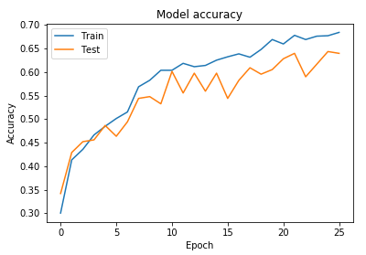Figure 12: Model Training and Test Accuracy

As we can see in Figure-12 that in just 10 epochs, our model gave an accuracy which is equal for both training and testing touching the mark of 0.60. After that, the model started over fitting but it was again reaching for the higher accuracy before the termination cause by the EarlyStopping Callback. Losses are inversely proportional to the accuracy so lower training and validation losses means highest accuracy for both. As we can clearly see the statement being true in implementation as in Figure-13 as the validation loss is touching the minima of the graph in the 10th epoch. In fact, the validation loss as lesser than the training loss providing a better model overall.
We have successfully demonstrated the working of the our CNN model but let us just try and check the VGG-19 model which has huge numbers of parameters reaching more than 1.4 billions belonging to 19 layers which makes the use of 19 in the name justifiable. In VGG-19 model, out of the 19 designed layers, it has 16 convolution layers, 3 Fully connected layer, 5 MaxPool layers and 1 SoftMax layer. It has been trained on more than millions of images belonging to 1000 classes using the Imagenet [16] data. If we had the exact same type of image classes, we could have used the VGG-19 model as it is and it would be a classic and perfect example of transfer learning.
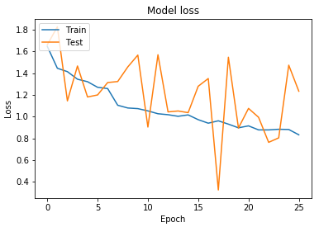Figure 13: Model Training and Test Loss

There are some points preventing us from doing that which include the totally different classes and types of images than the original data it has been trained on. Last layer of VGG-19 is having 1000 neurons with softmax but we want only 6 so we have to exclude the top layer. On top of that, weights in the VGG-19 are tuned according to the Imagenet Dataset so it’ll give trash predictions if we predict our garbage data using those weights so we have to train our weights again using random weights for first epoch and tweaking and updating weights as the model learn from our data. A detailed layer description is depicted in Figure-14.
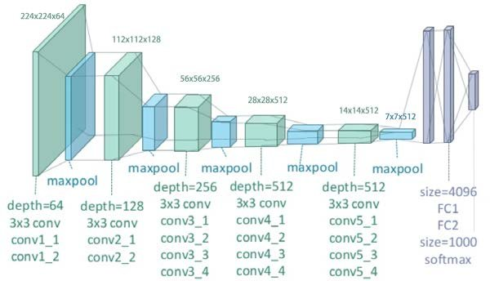Figure 14: VGG-19 Architecture
We want to show the limitations of transfer learning specially due to the lack of enough data to train on. Less data and/or bad quality data beats the best and precisely hyper tuned model at every step and this reason we had maximum training and validation accuracy of not more than .25 before forceful termination of training using Early Stopping Callback. In order to use the benefits of transfer learning, the data should be as close to the original data the model was trained upon and the number of images should be more in the range at lest more than ten thousands because billions of parameters have to be trained and updated using the exact same model and if we do not have enough data, we do not have enough information to cause any ground breaking path in terms of finding our goal which is the minimization of loss function.

Future Improvements
Our model is performing satisfactory results within such constrained environments providing around 0.6 validation accuracy within 10 epochs. We can improve the accuracy to a greater level by using a few more techniques at our disposal basically starting from adding more layers and changing the pattern of how layers appear in our model. We have to change the model pattern a couple of times more before declaring the final model because we never know what works for which kind of data. Apart from that, we can add a few more layer to mitigate the over fitting problem. These layers include the Batch Normalization which normalizes the output of a single layer for the whole batch. Batch Normalization works by keeping the values of a batch in a common range so that model converges faster and next layer has a range of values as the input so that change in weights are common for each and every image.
We can also work with regularization inside Neural Networks like we do with regression. Our regularization function can impose a penalty on the wrong outputs of the layers and neurons so that the neurons which were related to the wrong output are less credible in future.
Another method related to the pre-processing of data is object segmentation. In object segmentation, we extract the object from the background. It is the best practice for our case because the background and the objects are similar most of the times in our case and model treats the background as the essential part of image. For example a white piece of paper laying on a white background will have no meaning to model because it will not be able to distinguish the differences which one is important. We can use either Canny or Watershed Algorithms to have the object background separation boundary to extract the object. We can either mask the background with a unique color that does not exist in any of the images, get a mean value of background color by extracting all the background colors and having the mean for those or we can develop a model which works on the 4 color channels. We can add an alpha mask of 1 to the background and 1 to the object so that the background is transparent instead of color. A demo example of extracting the object, plotting decision boundary and masking the background using both Canny and Watershed algorithms is shown in Figure-15.
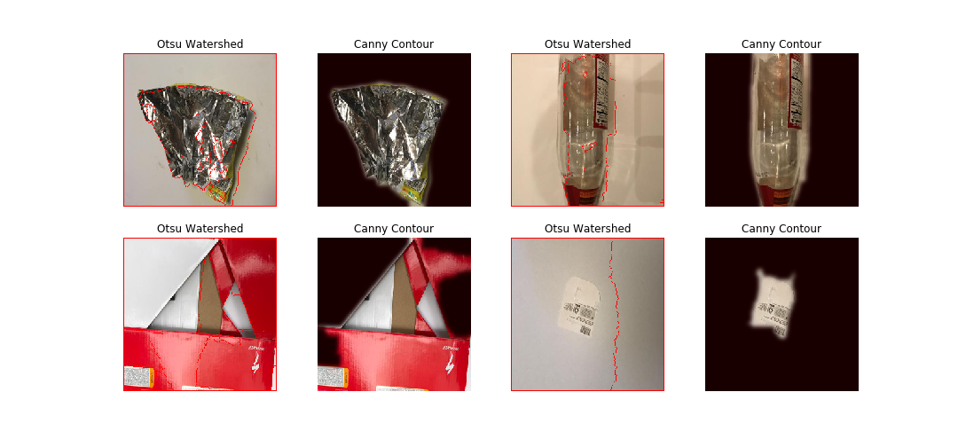Figure 15: Object separation using Canny and Watershed

