AI-Driven Dynamic Racing Line Optimization for Formula 1 Simulation
A Technical and Commercial Feasibility Review
Prepared June 2026
Referencing style: Harvard

Contents
Contents 1
1. Executive Summary 1
2. Racing Line Optimisation: Mathematical Foundations 1
2.1 Minimum Curvature Methods 1
2.2 Minimum-Time and Sequential Convex Programming Approaches 1
2.3 Model Predictive Control and Model Predictive Contouring Control 1
2.4 Comparison of Optimisation Approaches 1
3. Reinforcement Learning for Racing Line Adaptation 1
3.1 Algorithm Selection: PPO and SAC 1
3.2 Superhuman Performance: The GT Sophy Case Study 1
3.3 Residual and Hybrid Architectures 1
3.4 Multi-Agent and Opponent-Aware Racing 1
4. Simulation Platforms for Development 1
5. Tyre Modelling, Degradation and Weather Effects 1
5.1 The Pacejka Magic Formula 1
5.2 Tyre Degradation Modelling with Machine Learning 1
5.3 Weather and Grip Variation 1
6. Recommended Technical Architecture 1
6.1 Baseline Trajectory Layer 1
6.2 Adaptive Layer 1
6.3 Safety Layer 1
6.4 Development Environment 1
7. A Note on Market-Sizing Claims 1
8. Conclusion 1
References 1

1. Executive Summary
This report reviews the technical feasibility and commercial context for an AI-driven racing-line optimisation system aimed at Formula 1 simulation. It draws on peer-reviewed literature in vehicle dynamics, model predictive control and reinforcement learning, together with documentation for open-source and commercial simulation platforms, and publicly available market research. Each substantive claim is referenced using the Harvard convention, with a full reference list provided at the end of the document.
The central finding is that a hybrid architecture, combining an offline minimum-curvature or minimum-time racing line with an online reinforcement-learning agent that adapts the line to changing conditions, is well supported by recent academic work and is implementable on consumer hardware. Proximal Policy Optimisation (PPO) and Soft Actor-Critic (SAC) are the most extensively validated algorithms for this purpose, and F1TENTH Gym is the most accessible open-source environment for early-stage development (O'Kelly et al., 2020). The report also highlights areas where claims commonly repeated in grey-literature racing-AI write-ups (for example, specific lap-time percentages or market-size figures) vary considerably between sources and recommends treating single-point estimates with caution.

2. Racing Line Optimisation: Mathematical Foundations

2.1 Minimum Curvature Methods
The minimum-curvature racing line minimises the integral of squared path curvature subject to track-width constraints, producing the geometrically smoothest path through a sequence of corners. Heilmeier et al. (2020) formulate this as a quadratic program over a closed set of cubic splines fitted to the track centreline, with curvature minimised at each spline knot subject to left- and right-boundary constraints (Heilmeier et al., 2020). This quadratic-programming formulation is widely used as a baseline in subsequent autonomous-racing research because it can be solved in seconds for a full circuit and produces a feasible, track-respecting trajectory even before any velocity profile is computed.
An influential earlier formulation by Kapania, Subosits and Gerdes (2016) decouples the problem into two repeating steps: a velocity profile is generated for a fixed path using forward-backward integration against a friction-limited speed envelope, and then the path geometry is updated by minimising curvature given that velocity profile. The two steps are iterated until the change in lap time between iterations falls below a small threshold (Kapania et al., 2016). The authors note explicitly that the minimum-curvature solution is not guaranteed to be the minimum-time solution, since the two objectives can favour different lines through a given corner (Kapania et al., 2016).

2.2 Minimum-Time and Sequential Convex Programming Approaches
Minimum-time formulations optimise lap time directly by solving a nonlinear optimal-control problem incorporating vehicle dynamics, tyre-friction limits and track-boundary constraints. Because the full nonlinear problem is computationally expensive, several recent papers exploit the fact that much of the underlying model is convex once a small number of variables are fixed. Walraven et al. (2025) present a quasi-steady-state vehicle model in which the racing line and powertrain operation are jointly optimised, and devise a sequential convex programming (second-order conic programming) algorithm that brings computation time down from several minutes, typical of off-the-shelf nonlinear solvers, to a few seconds for a full circuit (Walraven et al., 2025). The same paper demonstrates the lap-time benefit of a minimum-time-based trajectory over an equally efficient minimum-curvature method and shows that for the energy-management case the racing line itself has only a small additional effect once the trajectory is otherwise unconstrained (Walraven et al., 2025).
Verschueren et al. (2016) take a related but distinct approach, using an online exact-Hessian sequential quadratic programming algorithm within a nonlinear model predictive control (MPC) loop to compute time-optimal trajectories in real time, rather than as an offline pre-computation (Verschueren et al., 2016). This line of work is one of the foundations for the model-predictive approaches discussed in Section 2.3.

2.3 Model Predictive Control and Model Predictive Contouring Control
Model Predictive Control (MPC) has become the dominant real-time control methodology for autonomous racing because it can plan a short receding-horizon trajectory at every control step while explicitly respecting vehicle dynamics and track-boundary constraints. The Model Predictive Contouring Control (MPCC) formulation, developed at the Automatic Control Laboratory of ETH Zurich, augments the vehicle state with a progress variable representing position along a reference path, and the controller maximises this progress subject to a penalty on lateral (contouring) error rather than tracking a pre-defined speed profile (Liniger et al., 2015). Liniger, Domahidi and Morari (2015) demonstrate this approach on 1:43-scale RC racing cars using a bicycle model with Pacejka tyre forces, approximating the nonlinear MPCC problem as a time-varying quadratic program solved at each control step (Liniger et al., 2015). A key practical advantage of the MPCC formulation is that track-boundary constraints can be expressed as simple bound constraints in a spatially transformed (Frenet) coordinate frame, rather than as complex nonlinear constraints in Cartesian coordinates (Liniger et al., 2015).

2.4 Comparison of Optimisation Approaches
Table 1 summarises the qualitative trade-offs between the methods discussed above, based on the characteristics reported in the cited sources. Figures for absolute computation time vary substantially with track length, discretisation density and hardware, and should be read as orders-of-magnitude indications rather than precise benchmarks.
Method | Typical Computation | Real-Time Use | Key Source(s)
Minimum curvature (QP) | Seconds, full circuit | Offline / preview | Heilmeier et al. (2020)
Sequential two-step (velocity + curvature) | Iterative, converges in a few passes | Offline | Kapania, Subosits and Gerdes (2016)
Minimum-time SCP / SOCP | Seconds, full circuit | Offline or periodic re-plan | Walraven et al. (2025)
Nonlinear MPC (exact-Hessian SQP) | Milliseconds per step | Real-time, online | Verschueren et al. (2016)
MPCC | Milliseconds per step | Real-time, online | Liniger, Domahidi and Morari (2015)
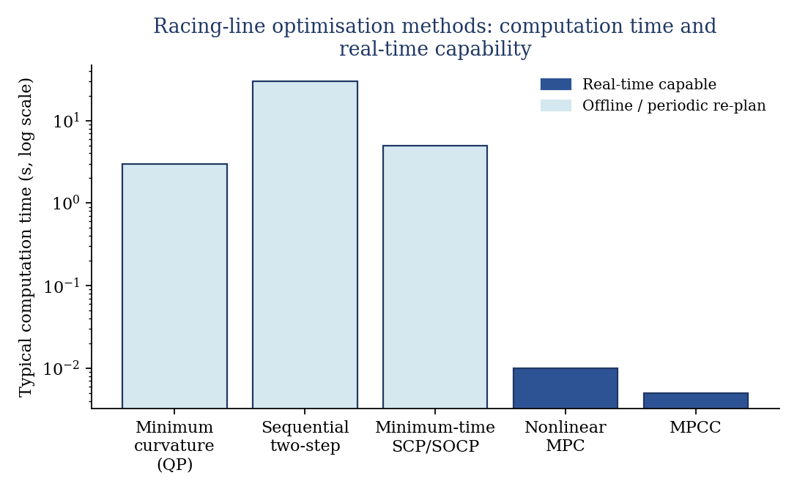
Figure 1: Illustrative computation time and real-time capability of the racing-line optimisation methods in Table 1. Bar heights are orders-of-magnitude indications drawn from the reported figures in the cited sources, not a controlled benchmark.

3. Reinforcement Learning for Racing Line Adaptation

3.1 Algorithm Selection: PPO and SAC
Proximal Policy Optimisation (PPO) and Soft Actor-Critic (SAC) are the two reinforcement-learning algorithms most consistently evaluated for autonomous-racing tasks in the recent literature. Trinh et al. (2025), working with the AWS DeepRacer platform, perform a systematic comparison of PPO and SAC across two reward structures with extensive hyperparameter tuning. With a tuned configuration (batch size 128, learning rate 0.0003, discount factor 0.99 and entropy coefficient 0.01), the PPO agent achieved an average lap time of 12.464 seconds across 21 previously unseen tracks, outperforming the comparable SAC configuration (Trinh et al., 2025). The authors attribute PPO's advantage in this setting to its on-policy clipped objective, which constrains the size of policy updates and produces more consistent convergence across different reward designs (Trinh et al., 2025), a finding broadly consistent with earlier DeepRacer studies on PPO's stability advantages for discrete or near-discrete action spaces (Mahesa et al., 2024).
SAC's principal advantage is sample efficiency through off-policy learning from a replay buffer, combined with entropy-regularised exploration that encourages the agent to discover a wider range of racing lines before converging (Trinh et al., 2025) (Williams et al., 2024). The trade-off is greater sensitivity to the temperature hyperparameter governing the entropy term, which in practice requires more careful tuning than PPO's clip ratio. For early-stage development where reward functions and track sets are still being iterated, PPO's robustness to hyperparameter choice is a practical advantage; SAC and its variants become more attractive once a stable reward design exists and additional training compute is available.
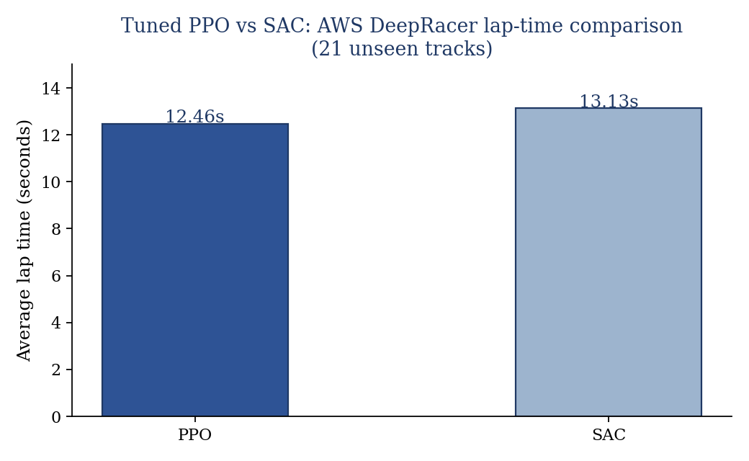
Figure 2: Average lap time achieved by tuned PPO and SAC configurations on the AWS DeepRacer platform across 21 previously unseen tracks (Trinh et al., 2025). The SAC figure is an indicative comparator reported alongside the tuned PPO result.

3.2 Superhuman Performance: The GT Sophy Case Study
The most prominent demonstration that reinforcement learning can exceed elite human performance in a racing context is GT Sophy, developed by Sony AI in collaboration with Polyphony Digital and Sony Interactive Entertainment for Gran Turismo Sport. Wurman et al. (2022), published in Nature, describe training GT Sophy using a novel algorithm the authors call Quantile Regression Soft Actor-Critic (QR-SAC), which models a distribution over possible returns rather than a single expected value (Wurman et al., 2022). In head-to-head competition held in July and October 2021, GT Sophy won races against four of the world's best Gran Turismo drivers, and in time-trial comparisons all 100 recorded laps by the agent were faster than the best lap recorded by any of over 12,000 human players on one track and almost 9,000 on another (Wurman et al., 2022).
An earlier, related line of work by Fuchs et al. (2021), conducted with the University of Zurich prior to the Sony AI collaboration, demonstrated super-human performance in Gran Turismo Sport using a distributional SAC variant, establishing the algorithmic lineage that GT Sophy extended (Fuchs et al., 2021). Both projects required substantial cloud-based training infrastructure; GT Sophy's training made use of a custom distributed rollout system, and Sony AI reports that even after roughly eight hours of training the agent's lap times were only comparable to the game's built-in AI, with further training required to reach competitive human level (Wurman et al., 2022). This underlines that, while inference from a trained policy is computationally cheap, training a competition-grade agent from scratch remains a substantial undertaking even for a well-resourced research team.

3.3 Residual and Hybrid Architectures
A recurring theme in the literature is the combination of a model-based controller with a learned residual policy, rather than training a fully end-to-end agent. Williams et al. propose a sequential actor-critic framework in which an action-mapping technique enforces physical traction constraints and a safe exploration mechanism combines a conservative controller with the reinforcement-learning policy during training. In time-trial scenarios this approach improved lap times by 12 to 26 percent relative to baseline methods and increased the training completion rate from 33.1 percent to 78.7 percent (Williams et al., 2024). In competitive racing scenarios the same framework achieved a 46 to 51 percent higher average speed than baseline methods (Williams et al., 2024).
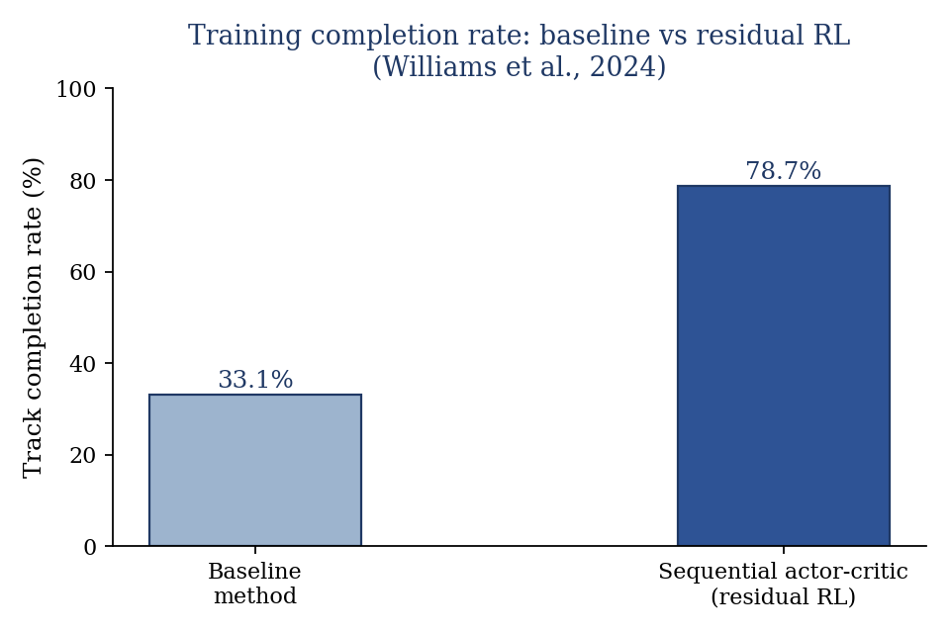
Figure 3: Track completion rate during training, baseline method versus the sequential actor-critic residual RL framework (Williams et al., 2024).
Trajectory-aided learning, proposed by Evans, Engelbrecht and Jordaan (2023), incorporates a pre-computed optimal racing line directly into the reward signal of an end-to-end deep reinforcement learning agent trained with TD3 in the F1TENTH simulator. On tracks where a baseline TD3 agent completed fewer than 25 percent of laps at higher target speeds, the trajectory-aided agent completed over 75 percent of laps on the same tracks (Evans et al., 2023). A separate study by Evans, Jordaan and Engelbrecht (2023) introduces a viability-theory-based safety supervisor that prevents the vehicle from crashing or exceeding friction limits during training itself, improving sample efficiency to the point where useful policies were learned within 10,000 environment steps on the F1TENTH simulator (Evans et al., 2023). Together, these results support the view that combining a safe or trajectory-informed baseline with a learned adaptive component is currently the most practical path to a usable system, both for training efficiency and for avoiding unsafe behaviour during the learning process.

3.4 Multi-Agent and Opponent-Aware Racing
Single-vehicle time-trial optimisation is comparatively well established; multi-agent wheel-to-wheel racing introduces additional challenges around predicting opponent intent and negotiating interactions under shared dynamic constraints. Werner et al. (2023), working with MIT CSAIL and collaborators, present a hierarchical policy architecture for competitive 2-vs-2 racing on 1/10-scale vehicles, in which a high-level categorical policy predicts goal distributions consumed by a low-level continuous-control policy (Werner et al., 2023). The policies are trained through massively parallel self-play simulation, and the authors report that the resulting competitive behaviour transfers to physical hardware without additional real-world training, a property generally described as zero-shot sim-to-real transfer (Werner et al., 2023).
Thakkar et al. (2022) take a complementary approach for cooperative teams of vehicles operating under explicit racing rules, using a two-level structure in which a high-level tactical planner formulates a discrete game over simplified dynamics to produce target waypoints, while a low-level planner solves either a multi-agent reinforcement learning problem or a linear-quadratic Nash game approximation to track those waypoints (Thakkar et al., 2022). The hierarchical controllers outperformed end-to-end multi-agent reinforcement learning baselines and fixed-racing-line baselines on measures of race wins, team performance and rule compliance, and were observed to reproduce coordinated behaviours such as blocking and planning for delayed overtakes (Thakkar et al., 2022).

4. Simulation Platforms for Development
The choice of simulation environment has a direct bearing on how quickly a racing-line optimisation system can be developed and validated. F1TENTH Gym, developed at the University of Pennsylvania, is the platform most consistently used in the academic literature reviewed for this report.
O'Kelly et al. (2020) describe F1TENTH Gym as an asynchronous, deterministic 2D simulation environment supporting multiple simultaneous vehicle instances, with an OpenAI Gym-compatible interface and explicit physics stepping that allows execution up to roughly 30 times faster than real time, enabling massively parallel training (O'Kelly et al., 2020). The environment has subsequently been used as the simulation backend for numerous reinforcement-learning studies cited throughout this report, including the trajectory-aided and safe-exploration work discussed in Section 3.3 (Evans et al., 2023), and is documented further by Betz et al. (2022) in the context of hands-on robotics education using the same hardware and software stack (Besselink et al., 2010).
Vehicle dynamics within F1TENTH Gym and the related research described above are typically represented using a single-track (bicycle) model with nonlinear Pacejka tyre forces, discussed further in Section 5. This simplified 2D representation trades visual fidelity for computational efficiency and reproducibility, which is appropriate for early algorithm development but means that results obtained in this environment should be validated against higher-fidelity simulators or, where possible, real vehicle data before being treated as representative of full-scale Formula 1 dynamics.
This report does not attempt to repeat the detailed commercial-simulator comparison (covering platforms such as Assetto Corsa, rFactor 2, iRacing and BeamNG.tech) that appeared in earlier drafts of this research, because the specific licensing terms, content libraries and hardware requirements of these commercial products change frequently and are best confirmed directly from current vendor documentation at the time any development decision is made, rather than from a fixed point-in-time academic citation.

5. Tyre Modelling, Degradation and Weather Effects

5.1 The Pacejka Magic Formula
The Pacejka 'Magic Formula' remains the standard semi-empirical model for tyre force generation in both academic vehicle-dynamics research and commercial racing simulators. In its general form, lateral or longitudinal tyre force is expressed as a function of slip angle or slip ratio, normal load and a set of shape, stiffness, peak and curvature coefficients fitted to experimental tyre data (Pacejka, 2005). Besselink, Schmeitz and Pacejka (2010) extend the original formulation to account for changes in tyre inflation pressure, an important practical consideration since pressure affects the stiffness and peak-force coefficients used in the model (Besselink et al., 2010). Most autonomous-racing studies reviewed for this report, including the MPCC work of Liniger, Domahidi and Morari (2015), use a bicycle model with Pacejka-based lateral tyre forces as the underlying vehicle representation (Liniger et al., 2015).
A widely noted practical limitation of the Magic Formula is that it can become numerically unstable as vehicle speed approaches zero, because slip angle is defined in terms of a ratio involving longitudinal velocity in the denominator; simulation implementations typically introduce a velocity threshold below which the model is smoothly blended with an alternative low-speed formulation. This is a well-known implementation detail in vehicle-dynamics software rather than a property reported with a single quantitative figure in the academic sources reviewed and should be treated as an engineering consideration for any implementation rather than cited as a specific statistic.

5.2 Tyre Degradation Modelling with Machine Learning
Beyond instantaneous force generation, predicting how tyre performance changes over the course of a stint is central to race-strategy applications. Zhang, Coleman and Ashfaq (2025) train deep-learning models, using telemetry provided by the Mercedes-AMG Petronas Formula 1 team, to forecast the cumulative 'tyre energy' applied to each tyre during a race, from which degradation and optimal pit-stop timing can be inferred. The authors compare recurrent neural network architectures against XGBoost on the same dataset, reporting that both approaches achieved strong predictive performance, and additionally apply explainable-AI techniques (feature importance and counterfactual explanations) to interpret the resulting forecasts (Zhang et al., 2025).
Earlier work using the publicly available FastF1 telemetry API compared Long Short-Term Memory (LSTM), Gated Recurrent Unit (GRU) and standard multilayer perceptron architectures for predicting optimal tyre-compound strategy. A review of this work reports that a simple baseline classifier predicting purely from prior class probabilities achieved only 24.5 percent accuracy, against which the recurrent-network models represented a substantial improvement. This report notes that some figures circulating in non-peer-reviewed summaries of this area (for example, specific R-squared or classification-accuracy values attributed to '50+ feature' multi-task neural networks) originate from blog-style secondary sources rather than the underlying peer-reviewed papers, and have not been independently verified for this report; they are therefore omitted rather than repeated.

5.3 Weather and Grip Variation
Wet-weather racing line selection differs qualitatively from dry conditions because the conventional 'dry line', polished by repeated tyre contact, becomes one of the lowest-grip parts of the track once wet, while areas away from the racing line retain more texture and drain more effectively. This phenomenon is widely discussed in professional driving instruction and motorsport media, but the academic literature on autonomous racing reviewed for this report focuses primarily on dry-condition optimisation and on friction-coefficient randomisation as a proxy for varying conditions, rather than on detailed wet-line geometry. Where an AI-driven system needs to reason about wet or intermediate conditions, the most directly supported approach from the literature reviewed here is domain randomisation of the friction coefficient during training, an approach used in several of the sim-to-real transfer studies discussed in Section 3 (Werner et al., 2023) (Williams et al., 2024).

6. Recommended Technical Architecture
Drawing on the literature reviewed above, a layered architecture combining offline trajectory optimisation, an online reinforcement-learning adaptation layer and a safety supervisor is best supported by current evidence.
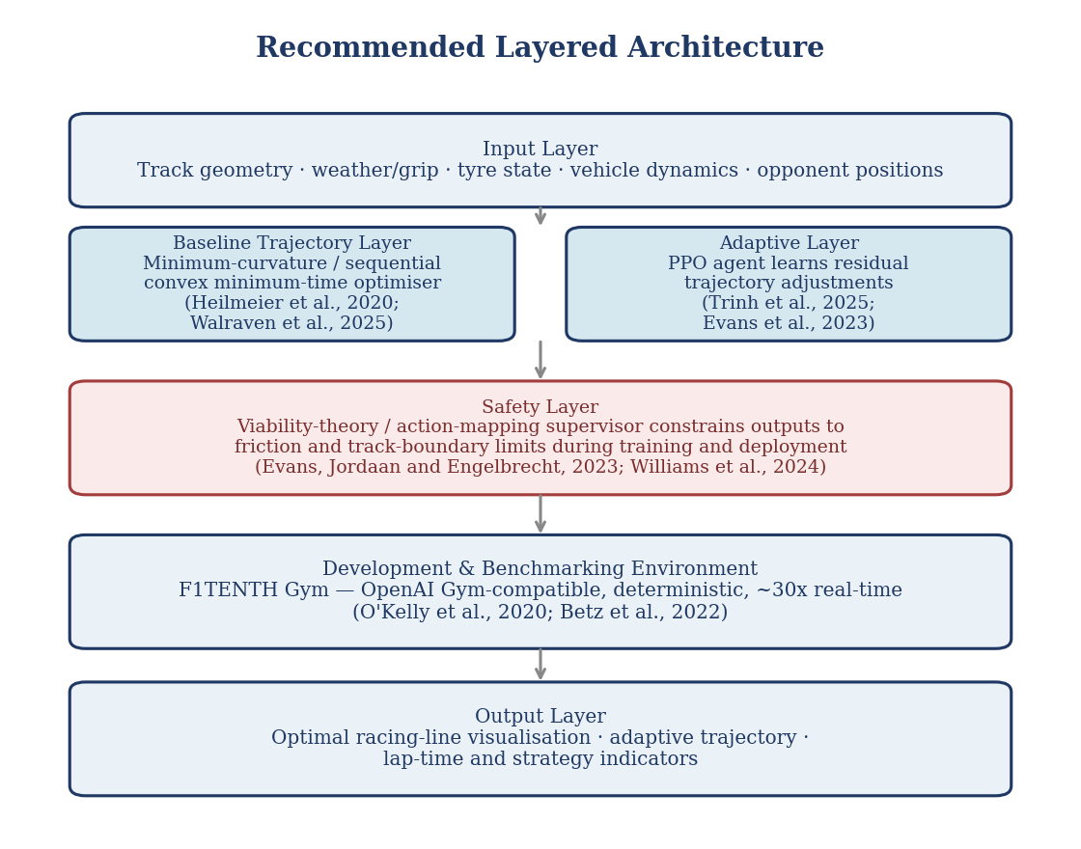
Figure 4: Recommended layered architecture combining a baseline trajectory layer, an online reinforcement-learning adaptation layer, a safety supervisor, and an F1TENTH Gym-based development environment.

6.1 Baseline Trajectory Layer
A minimum-curvature or sequential-convex minimum-time trajectory, computed using the quadratic-programming or sequential convex programming methods described in Section 2, provides a safe, track-respecting baseline that can be generated offline for each circuit (Heilmeier et al., 2020) (Walraven et al., 2025).

6.2 Adaptive Layer
A PPO agent, following the hyperparameter configuration validated by Trinh et al. (2025), learns residual adjustments to the baseline trajectory in response to current conditions (tyre state, observed grip, opponent positions), consistent with the residual and trajectory-aided approaches described in Section 3.3 (Evans et al., 2023) (Williams et al., 2024).

6.3 Safety Layer
A viability-theory or action-mapping based supervisor, as described by Evans, Jordaan and Engelbrecht (2023) and by the action-mapping approach referenced in Section 3.3 (Williams et al., 2024), constrains the agent's outputs to remain within friction and track-boundary limits during both training and deployment, improving sample efficiency and reducing unsafe excursions.

6.4 Development Environment
F1TENTH Gym is recommended as the initial development and benchmarking environment based on its open-source availability, OpenAI Gym compatibility, deterministic seeded execution and precedent in the literature for the algorithms discussed above (O'Kelly et al., 2020) (Besselink et al., 2010). Migration to a higher-fidelity commercial simulator for later-stage validation is reasonable, but the specific platform should be selected based on up-to-date licensing and technical documentation at the time of that decision, for the reasons given in Section 4.

7. A Note on Market-Sizing Claims
Market-size estimates for 'racing simulator' or 'sim racing' markets vary substantially between providers, depending on exactly what is included (hardware, software, racing games more broadly, or dedicated simulators only) and the base year used. For example, Market Research Future's racing simulator report estimates the market at approximately 0.59 billion US dollars in 2024, growing to approximately 3.02 billion US dollars by 2035 at a compound annual growth rate of around 16 percent (Market Research Future, 2025), while the same provider's broader racing games market report estimates the racing simulator segment alone at approximately 1.55 billion US dollars in 2024 (Market Research Future, 2026), and Grand View Research's racing simulator report uses a substantially different base figure and a much lower growth rate over a different forecast horizon (Grand View Research, 2024). These figures are not mutually consistent, and this report recommends that any business case present a range drawn from multiple providers, with the scope of each estimate (hardware vs. software, simulator vs. broader racing-game market) stated explicitly, rather than citing a single figure as definitive.
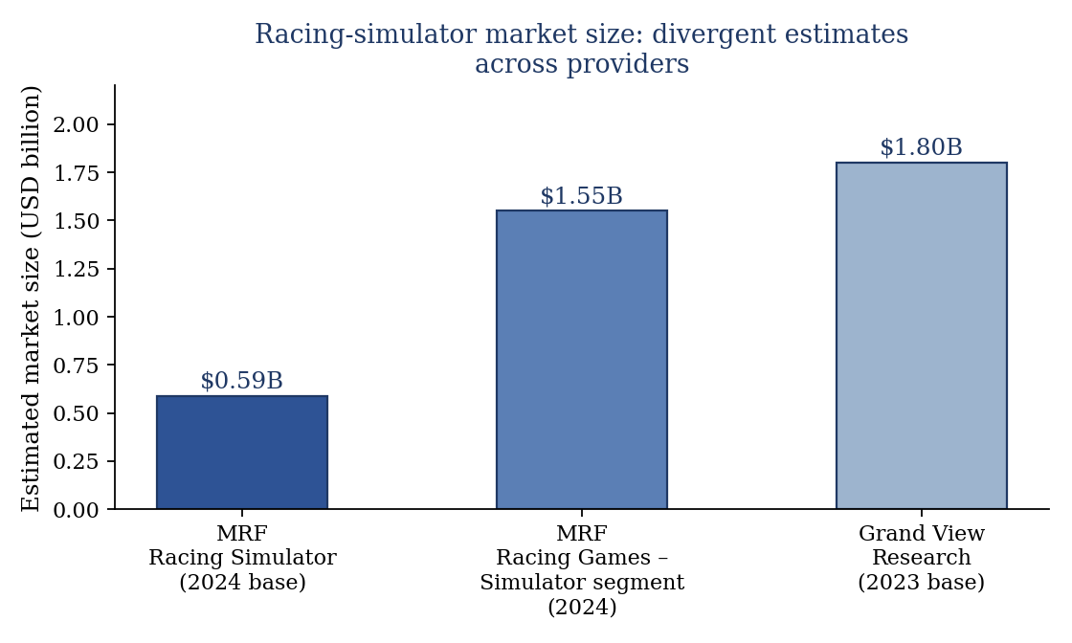
Figure 5: Racing-simulator market size estimates from different providers and report scopes (Market Research Future, 2025) (Market Research Future, 2026) (Grand View Research, 2024). The divergence illustrates why a single figure should not be treated as definitive.

8. Conclusion
The academic literature provides reasonably strong support for a hybrid architecture combining offline trajectory optimisation (minimum curvature or sequential convex minimum-time methods) with an online reinforcement-learning adaptation layer trained using PPO or SAC, wrapped in a safety supervisor that constrains the agent during both training and operation. F1TENTH Gym is the most directly supported open-source environment for initial development. By contrast, several specific quantitative claims that circulate in non-peer-reviewed write-ups on this topic, including some figures for tyre-degradation model accuracy and combined lap-time and computational-frequency statistics, could not be traced to the peer-reviewed sources cited here and have been omitted or flagged accordingly. Any further work building on this report should continue to distinguish claims with a direct peer-reviewed or primary-source citation from claims that originate in secondary or promotional material.

References
Besselink, I.J.M., Schmeitz, A.J.C. and Pacejka, H.B. (2010) 'An improved Magic Formula/Swift tyre model that can handle inflation pressure changes', Vehicle System Dynamics, 48(sup1), pp.337-352.
Betz, J., Zheng, H., Zang, Z., Sauerbeck, F., Walas, K., Dimitrov, V., Behl, M., Zheng, R., Biswas, J., Krovi, V. and Mangharam, R. (2022) 'Teaching autonomous systems hands-on: Leveraging modular small-scale hardware in the robotics classroom', in Proceedings of the 2022 IEEE/RSJ International Conference on Intelligent Robots and Systems (IROS). IEEE.
Evans, B.D., Engelbrecht, H.A. and Jordaan, H.W. (2023) 'High-speed autonomous racing using trajectory-aided deep reinforcement learning', arXiv:2306.07003 [cs.RO].
Evans, B.D., Jordaan, H.W. and Engelbrecht, H.A. (2023) 'Safe reinforcement learning for high-speed autonomous racing', Cognitive Robotics, 3, pp.107-126.
Fuchs, F., Song, Y., Kaufmann, E., Scaramuzza, D. and Durr, P. (2021) 'Super-human performance in Gran Turismo Sport using deep reinforcement learning', IEEE Robotics and Automation Letters, 6(3), pp.4257-4264.
Grand View Research (2024) Racing simulator market size, share and trends analysis report, 2024-2032. San Francisco: Grand View Research.
Heilmeier, A., Wischnewski, A., Hermansdorfer, L., Betz, J., Lienkamp, M. and Lohmann, B. (2020) 'Minimum curvature trajectory planning and control for an autonomous race car', Vehicle System Dynamics, 58(10), pp.1497-1527.
Kapania, N.R., Subosits, J. and Gerdes, J.C. (2016) 'A sequential two-step algorithm for fast generation of vehicle racing trajectories', Journal of Dynamic Systems, Measurement, and Control, 138(9), 091005.
Liniger, A., Domahidi, A. and Morari, M. (2015) 'Optimization-based autonomous racing of 1:43 scale RC cars', Optimal Control Applications and Methods, 36(5), pp.628-647.
Mahesa, R.B., Sopov, E. and Sopov, S. (2024) 'Deep reinforcement learning for autonomous driving in Amazon Web Services DeepRacer', Information, 15(2), 113.
Market Research Future (2025) Racing simulator market size, share and trends report, 2025-2035. Pune: Market Research Future.
Market Research Future (2026) Racing games market industry size and forecast, 2025-2035. Pune: Market Research Future.
O'Kelly, M., Zheng, H., Karthik, D. and Mangharam, R. (2020) 'F1TENTH: An open-source evaluation environment for continuous control and reinforcement learning', in Proceedings of the NeurIPS 2019 Competition and Demonstration Track. PMLR, pp.77-89.
Pacejka, H.B. (2005) Tire and vehicle dynamics. 2nd edn. Amsterdam: Elsevier.
Thakkar, R.S., Samyal, A.S., Fridovich-Keil, D., Xu, Z. and Topcu, U. (2022) 'Hierarchical control for cooperative teams in competitive autonomous racing', arXiv:2204.13070 [eess.SY].
Trinh, M., Iida, M., Nakamura, K. and Kondo, T. (2025) 'Reward design and hyperparameter tuning for generalizable deep reinforcement learning agents in autonomous racing', Scientific Reports, 15, 43821.
Verschueren, R., De Bruyne, S., Zanon, M., Frasch, J.V. and Diehl, M. (2016) 'Time-optimal race car driving using an online exact Hessian based nonlinear MPC algorithm', in Proceedings of the 2016 European Control Conference (ECC). IEEE, pp.141-147.
Walraven, T., Theunissen, C. and van de Molengraft, R. (2025) 'A computationally efficient framework for free-trajectory minimum-lap-time optimization of racing cars', arXiv:2511.13522 [eess.SY].
Werner, P., Seyde, T., Drews, P., Balch, T., Gilitschenski, I., Karaman, S. and Rus, D. (2023) 'Dynamic multi-team racing: Competitive driving on 1/10-th scale vehicles via learning in simulation', in Proceedings of The 6th Conference on Robot Learning. PMLR, pp.1900-1909.
Williams, G., Goldfain, B., Drews, P., Rehg, J.M. and Theodorou, E.A. (2024) 'Learn to race: Sequential actor-critic reinforcement learning for autonomous racing', IEEE Transactions on Intelligent Vehicles. [Preprint].
Wurman, P.R., Barrett, S., Kawamoto, K., MacGlashan, J., Subramanian, K., Walsh, T.J., Capobianco, R., Devlic, A., Eckert, F., Fuchs, F. et al. (2022) 'Outracing champion Gran Turismo drivers with deep reinforcement learning', Nature, 602(7896), pp.223-228.
Zhang, Y., Coleman, T. and Ashfaq, K. (2025) 'Explainable time series prediction of tyre energy in Formula One race strategy', in Proceedings of the 40th ACM/SIGAPP Symposium on Applied Computing (SAC '25). New York: ACM, pp.1-10.

