Roller Coaster Track Design Behavioral Experiment

# Motivation

Although it is well established that experts perform better than novices, there is a lack of formal methods to quantify the potential impact of expertise on the quality of design outcomes. The research question addressed through this behavioral experiment is*: How can the impact of expertise on the quality of design solutions be quantified?*

# Objective

The participants' task is to design a track consisting of a given initial height, followed by three segments: a loop, a hill and a circular valley with constant depth of $20$ units as shown in Figure 1. The track has four parameters, namely the initial height $H_{1},$ the radius of the loop $R$, the hill height $H_{2}$ and the valley width $w$. Given an initial height $H_{1}$, the participants are asked to choose appropriate values of the three segments to maximize the **enjoyment** experienced by the rider of the track.

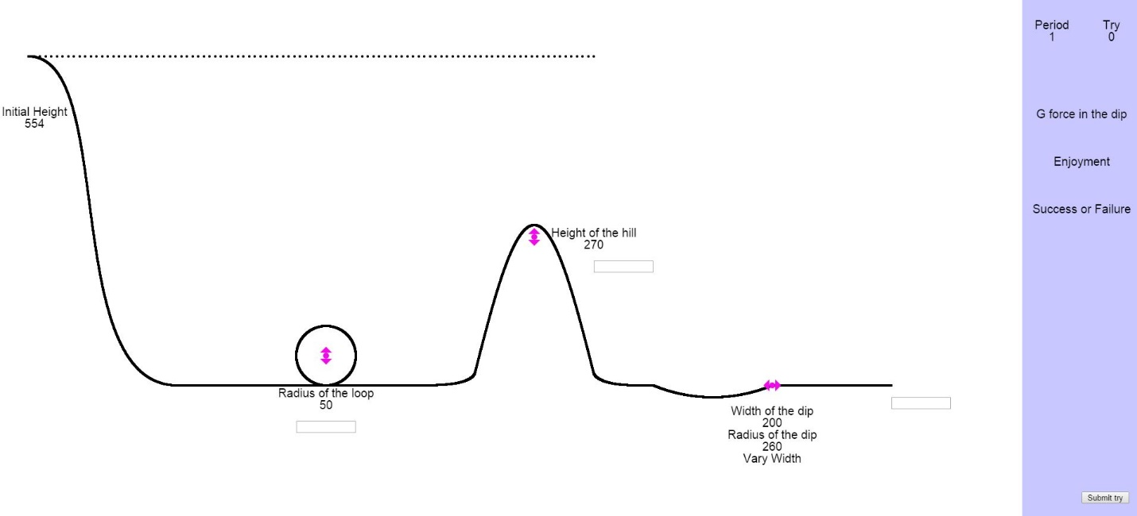

Figure 1 Game Interface

# Optimization of an unknown function with constraints

The problem statement of the game is such that the participants do not really know what the enjoyment function is. The participants are just qualitatively explained that the enjoyment of the ride depends on how big the loop and the hill is i.e. directly proportional to the radius and height. However if the width is too small the ride is “bumpy” and if the width is too large then the track is almost flat therefore there is some optimum value of width for which the enjoyment is maximized.

The participants are informed that the coaster is not attached to the track. So they have to design the track in a way that the coaster doesn’t “fly off” the track. Also, the centripetal acceleration should not be greater than $4g$ in the valley.

The game thus essentially boils down to participants optimizing an unknown function ( here: enjoyment) with some constraints. The ability of the participants to understand and formulate the constraints depends on their knowledge of kinematics. We hypothesize that an individual with a better understanding of kinematics will have a better understanding of the constraints.

# Expertise Quantification

We quantify individual’s knowledge of kinematics through Force Concept Inventory (FCI). The FCI is a multiple choice questionnaire with 30 questions on Newtonian concept of force. It has been verified using the Item Response Theory that it is a reliable metric to test an individual’s knowledge on Newtonian concept of force. We utilize this metric to test if these metrics can be used to quantify the impact of someone’s knowledge on their design solutions.