Design Lab

**Smart Lights**

Mateusz Kocoń, Łukasz Motyka Elektronika 3, 2016/2017

1. **Introduction.**

Smart Ligths is the device consisting of AdaFruit LED matrix (5x8 WS2812B), 4 sensors HC-SR04 and Kinetis board KL25Z. LED matrix is divided into four sectors (one sensor – one sector). Device measure distance and calculate brightness LEDs. If object is closer to device, LED matrix less lights to avoid dazzle. Each sensor measure a separate area.

1. **Hardware.**

Smart Lights contains:

- Kinetis board KL25Z with ARM Cortex M0+

- 4 sensors HC-SR04

- AdaFruit LED matrix 5x8 (WS2812)

- printed overlay to scatter light

- connection cables

**3. Schematic.**

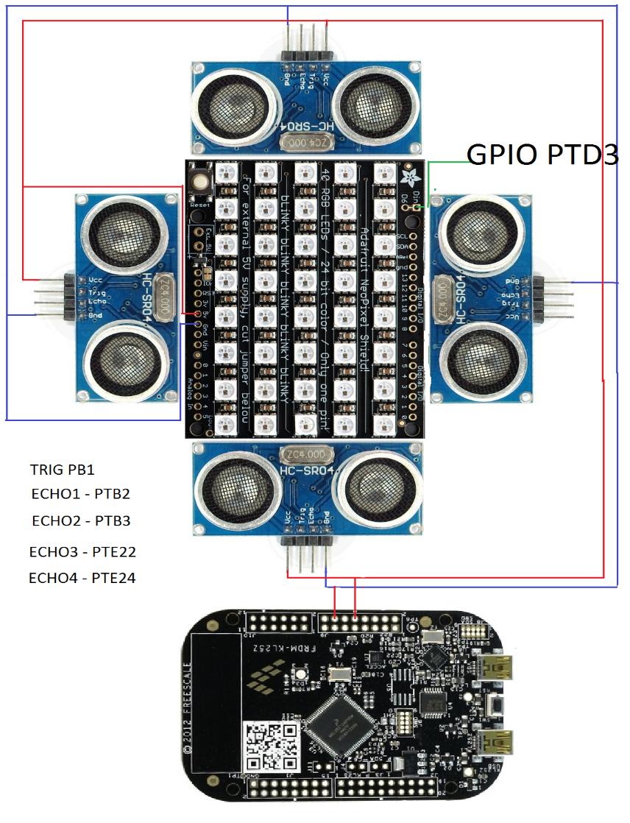

**5. WS2812B diode.**

To handle WS2812B diode we use FastGPIO in Kinetis KL25Z. This diodes need waveform as shown below.

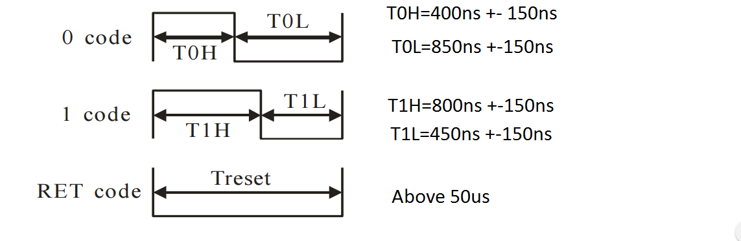

We used the simplest way to generate this waveforms, we just set and clear pin. We add assembler instruction „__nop()” to extend level and we were observing it on oscilloscope to compare. Below are function with handling:

void SendOne(void){

FPTD->PSOR|=0x8;

__nop();

__nop();

__nop();

__nop();

__nop();

__nop();

FPTD->PCOR|=0x8;

}

void SendZero(void){

FPTD->PSOR|=0x8;

FPTD->PCOR|=0x8;

__nop();

__nop();

__nop();

__nop();

__nop();

__nop();

}

We don’t use any mask to save time.

1. **Algorithm.**

In our project LED matrix is divide into four sector. On picture below how it looks like.

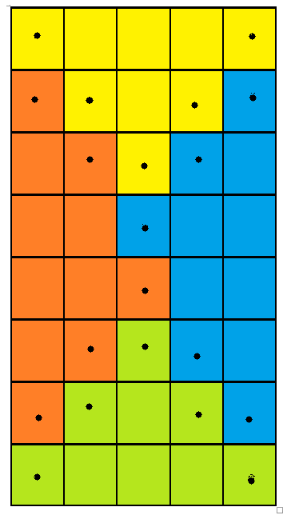

In different colors are different sectors.

We noticed if one sectors will light very bright and adjacent sector will will turn off, we will see low resolution of matrix. To eliminate this effect leds which neighbor with another sector have average value of brightness (dots on picture). Thereby we seemingly increase resolution.

The program is as follows:

- trigger sensors and measure time by TPM channels for everyone sensor

- four function calculate values for sectors

- function called „Antyaliasing” calculate values for diodes on the borders of sectors

- sending values to matrix