Have a drag-drop interface (jqueryUI) for creating layouts and elements that are then stored to mysql database

Left side is the collection of page elements available (Like visual studio)

When an element is dropped onto the stage, a new object is created in mysql database and then called onto the stage as a preview

Will be level based like (img -> a[0] -> p[0] -> div[0] -> body) == so the img will be a level 4 (zero based)

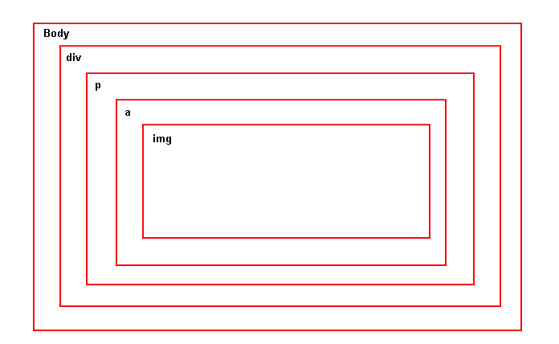

HTML page is rendered on page load from mysql database

Each element will have attributes like (width, height,color)