

**EXELON PATCH MEMORY CHALLENGE**

**http://memoryactivity.net**

This document is a step through guide for using online and setting up the web application for the iPad.

There is two challenge modes within the application: 1 USER, 4 USERS

**1 USER MODE + Leaderboard**

This is the single player challenge, where users can run the challenge, and competing against previous times. At the end of the challenge it is possible to submit the time taken to the leaderboard database.

**Leaderboard**

Displays the top 10 times of the single player mode.

If it is required that the database fields should be cleared, email the request to **info@designbuildplay.co.uk**

**4 USERS MODE : live challenge**

This mode allows 4 users to simultaneous compete against each other on the challenge. To activate the challenge each user must join and then wait for all 4 users to accept and begin. Once the server detects all 4 users are ready, the challenge will begin.

If at anytime one or more of the users exits the challenge, this mode will reset and wait for all four users to join and begin again.

If more than four users tries to join the challenge they will see a message that states the game is in progress and they must try again later or play the single user mode. It is only possible for one 4-user challenge to take place on the server at any one time.

**iPad Application**

The challenge can be played on the iPad through the safari browser or as a full screen application. To use the full screen mode save the application as an App to the iPad Home screen. Use the menu in the top left of the browser.

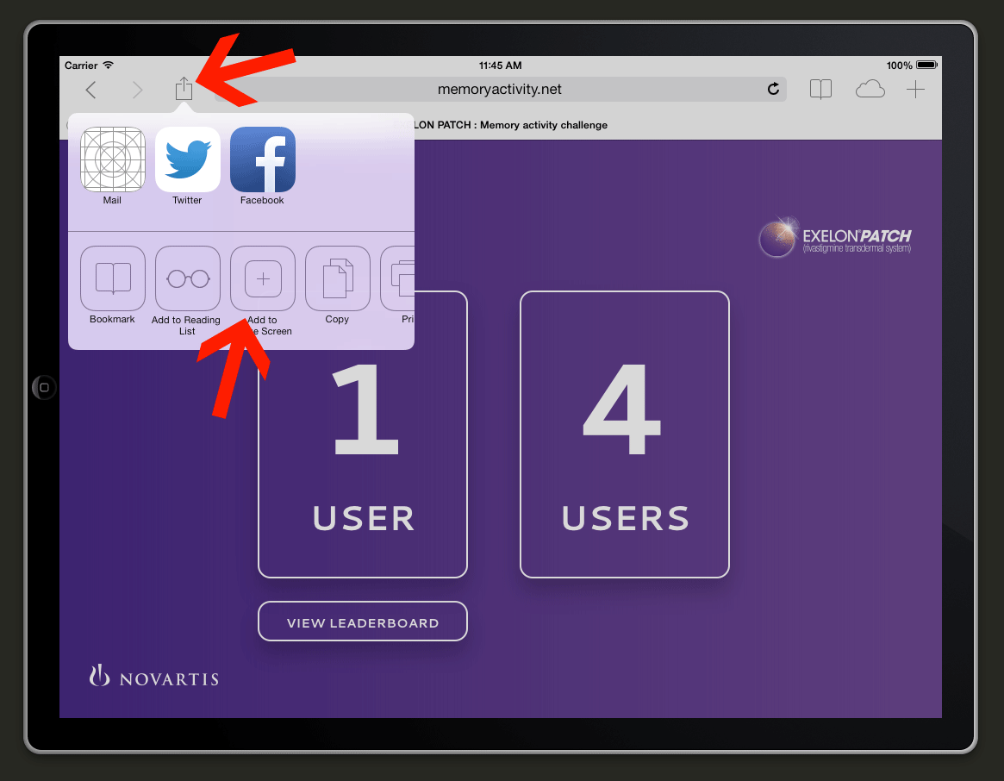

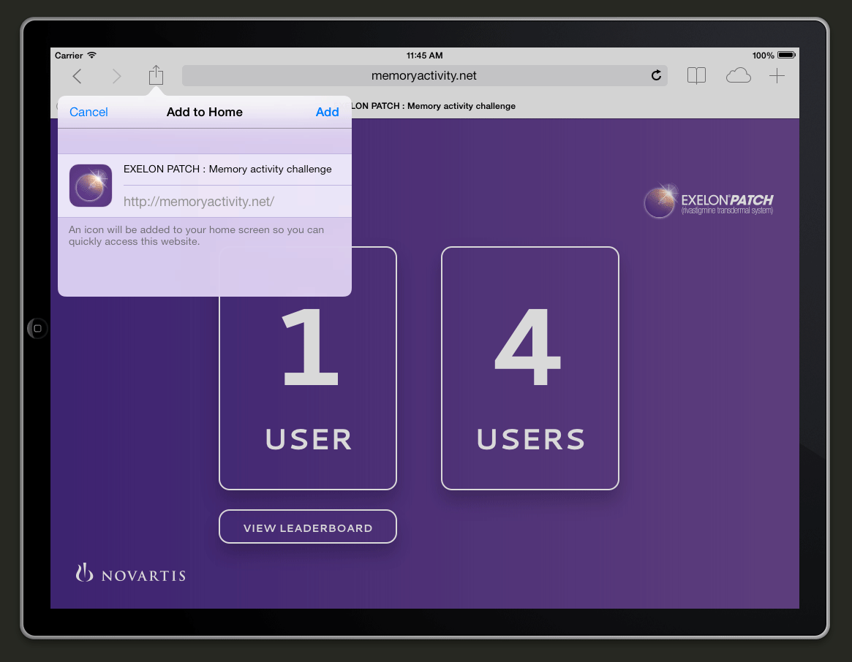

**Launching the application**

* Navigate and launch the saved app on the home screen named **EXELON PATCH**

**Guided Access mode**Guided access can be added to the ipad so the users are locked into the app if required.

* Open **Settings** on the iPad.
* Tap on **General** and scroll down to find **Accessibility**.
* Tap on **Guided Access**.
* On the Guided Access screen toggle the switch to **On**.
* **Set a Passcode** (something easy to remember e.g. “1234″)
* Now **Guided Access**, is ready to use, this is activated once in the app.

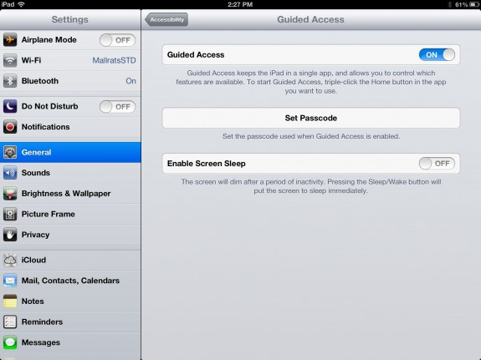

* Open up the EXELON PATCH application icon on the home screen
* Once the app is open **triple tap the home button**. This needs to be fairly fast. This will open up the Guided Access mode
* Switch off the **Motion** feature (bottom right). and then tap **Start** (top right). This feature stops users begin able to rotate the device.