Curriculum Vitae
_______________________________________________________
_______________________________________________________
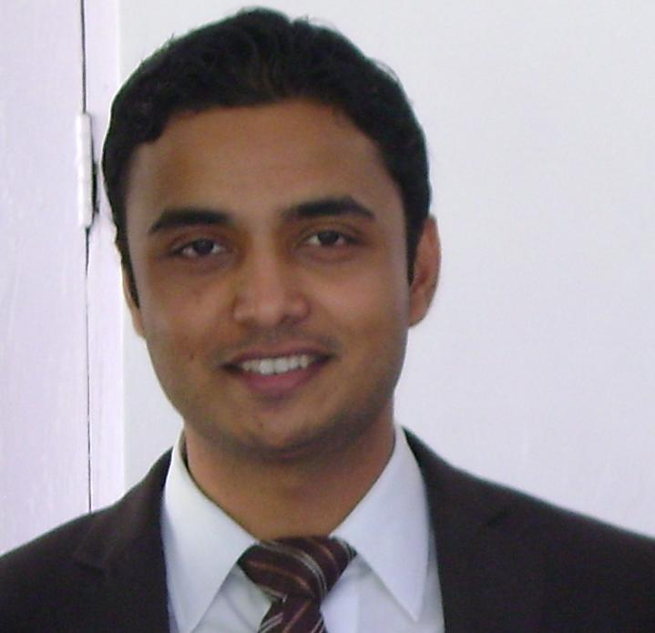
ARPIT CHANDLER

Flat No. 306,L-01 Greece Cluster
International City,
Dubai,UAE
Phone :00971-55-19 430 91
Email :-arpit_chandler@yahoo.com *Valid UAE LMV Driving License

Objective
_____________________________________________________________
To obtain a platform within a premier organization that fosters an environment of creativity and continual learning among its employees so that my analytical and inter personal skills are augmented for the betterment of the company.

Core Competencies
___________________________________________
- Strong ability to interpret and apply policy and procedures
- Ability to use a wide range of technology in the workplace
- A high level of English written and communication skills
- Very good organizational skills; a strong ability to monitor workflows, set priorities and use sound judgment in decision-making
- Ability to provide a quality professional service
- Apply ethical work practices and maintain integrity in all aspects of work
- Proven ability to work as part of a team, adapt to a changing work environment and apply a high level of initiative and flexibility

Employment Profile
_______________________________________________________

1.Ali AlHashemi Trading EST.
Dubai,UAE

Ali Alhashemi Trading Est. today is the largest graphic arts Equipment Trading & consumables supplies company in the Middle East Gulf, established in the year 1950.
It has the following product range:
Prepress Sheet fed Press, Newspaper Web, Commercial Web, Finishing & Binding Label, Printing System, Silkscreen Printing Sys., Wide range of Consumable Supply and industrial Adhesives, Service Support, Lamination Machine

Designation :Marketing Executive(Technical)

Since April 2010 till date

Job Responsibilities :

- New Business development for consumables for Printing and Packaging Industries in Dubai and all other emirates by Scheduling everyday’s work, Planning weekly visit reports, Evaluating calls to reach customers.
- The consumables include printing inks,printing plates,plates chemicals,lamination films,lamination Adhesive and Printing paper/boards.

- Also coordinating and visiting various branch offices in Riyadh, Oman, Bahrain, Qatar, Yemen and getting lead and generating business from these areas as well.
- Also looking after consumables Sales & Marketing simultaneously.

- Coordinating with the stores, purchase and other depts. For updating and sharing news.
- Providing various troubleshooting.

2.CHEMLINE INDIA LTD
New Delhi,India

Chemline India is a leading manufacturer and exporter of wide range of Industrial adhesives and coatings for packaging Industries. They have a wide range of industrial adhesives like labelling adhesives for distilleries, breweries etc, Hot melt book binding adhesives , lamination adhesives , soap wrapper coatings , PU (Polyurethane lamination adhesive for flexible packing) , Water base varnishes etc.

Designation : Marketing executive

Since Jan 2009 – March 2010

Job Responsibilities:

- New business development : exploring new parties
- New product development
- Existing clients retention.
- Coordinating with factory
- Coordinating with despatch department
- Provide client servicing

3.ICICI PRUDENTIAL LIFE INSURANCE
Pune,India

Designation: Financial Service Consultant.

June 2008 - December 2008

Responsibilities:
- Health Assurance consultant & Office Administration.
- Direct Selling of Health insurance to customers

Scholastics
_____________________________________________________________
- MBA ( spl . MARKETING ) from Pune University,India in 2008.
- B.Sc ( Computers ) from R.D.V.V Jabalpur,MP,India in 2006.
- Passed 12th from ICSE Board,New Delhi,India in 2001.
- Passed 10th from ICSE BoardNew Delhi,India in 1999.

IT Credentials
_____________________________________________________________
- Operating System Windows 95/98/XP/Vista
- Computer Hardware and Fundamentals
- C , C++ language, Internet
- MS-Office

PERSONAL VITAE
___________________________________________
Date of birth: 3rd July 1983

Languages known: English, Hindi

