ANDREW BLUM

12 Valley View Road, Trumbull, CT 06611

Phone: (203) 261-2586/Email: andrew.blum@sbcglobal.net

MARKETING RESEARCH CORE COMPETENCIES

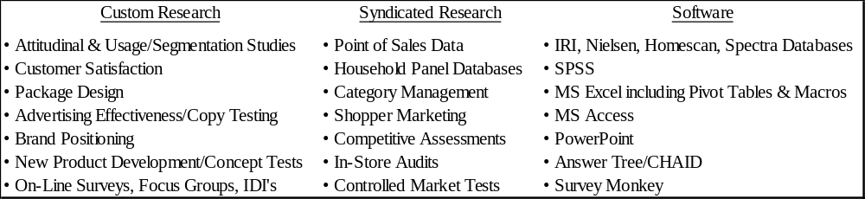

EXPERIENCE

Consultant/Manager, Strategy & Insights, Green Seed Group, Westport, CT, March 2009 to Present

• Green Seed Group is a boutique Consulting firm with clients in the Food and Beverage Industry.
• Lead the Strategy & Insights Team by providing clients with actionable recommendations by conducting strategic marketing research projects.
• Partner with Global Marketing Managers and directly with Clients to implement programs to drive brand growth including promotional lift analyses, creating fact-based sales stories, and forecasting.
• Conduct Opportunity Assessments (e.g. Competitive Landscape, Consumer Trends, Product Propositions) and U.S.-based Launch Strategies (e.g. Shopper Marketing Programs) for international brands and partner closely with C-Level clients in order to ensure business objectives are met by continuously monitoring and reporting on sales performance.
• Conducted market research studies and developed new product launch strategies for several new brands including “Grains of Truth” (healthy snacks), Nairns (crackers), and Wissotzky (tea).
• Created a series of report templates that automatically update periodic tracking reports.
• Create and present proposals to clients; manage 3rd party vendors and a $1 million dollar budget.

Pepsi: Consultant, Category Development for Lipton Iced Tea, May 2010 to March 2011
While consulting with Green Seed Group I also worked on several projects for Pepsi.

• Continuously supported Brisk; 2010 sales increased by 65% and share of category increased by 50%.
• Created a methodology to analyze sales lift for all promotional activities.
• Developed a sales story for Jug (1 gallon package) that drove an increase in ACV by 15 points.
• Presented a Go-To-Market strategy to Target and Stop & Shop for newly launched Diet PureLeaf.
• Identified new flavors for the Brisk portfolio that led to an increase in flavored sales by 4X in 2010.

Senior Manager, Client Service, Nielsen, Wilton, CT, February 2006 to March 2009

• Managed the PepsiCo/Frito Lay and Nestle business ($2 Million); prepared category, channel and brand analyses and presented findings and recommendations.
• Developed a C-Store strategy for Frito-Lay that helped increase annual channel sales by over 20%.
• Conducted an In-Store Audit for Nestle Waters that drove Shopper Marketing Strategies.
Market Research Consultant, The Hartford, Hartford, CT, February 2005 to December 2005

• Worked on a temporary-contractual basis as a consultant conducting several research projects including 1-on-1 In-Depth Interviews and On-Line Surveys for the Strategic Research department.

Director, Strategic Research, Holt, Rinehart, and Winston, Austin, TX, February 2004 to February 2005

• Conducted new product research studies and presented recommendations for product line.
• Designed a market research and strategic planning process to be utilized across the organization.

Manager, Consumer Research & Planning, Diageo, Stamford, CT, January 2002 to August 2003

• Responsible for proactively identifying and developing opportunities and identifying threats, by brand and by channel, in an effort to drive strategic and tactical initiatives.
• Prepared a Go-To-Market analysis for newly acquired Crown Royal brand.
• Developed an innovative methodology to track and determine ROI for On-Premise promotions.
• Conducted Line Extension research for Smirnoff that lead to incremental growth of 25%.

Market Research Manager, GE Financial, Stamford, CT, July 2000 to December 2001

• Responsible for all primary marketing research activities such as brand equity, “Voice of the Customer”, consumer trends, and new product development research studies.
• Wrote a position paper on division name; instituted a new-name study leading to a change in the division name (from GE Financial Assurance to GE Financial).
• Prepared a segmentation analysis that resulted in a 6-Segment Solution for U.S Households.
• Created company process for market research (“Assess the Market”) and was “Green Belt” certified.

Account Executive, Millward Brown, Fairfield, CT, March 1998 to June 2000

• Responsible for managing account teams (Warner Lambert, IBM, SAAB) designing research studies, designing samples, writing questionnaires, managing databases, analyzing data, writing reports, presenting findings to clients, and cross/up selling products to existing client base.

Marketing Associate, Oxford Health Plans, Norwalk, CT, December 1996 to March 1998

• Designed a Customer Relationship Management database and was responsible for customer analytics.

Senior Marketing Research Analyst, Swank, Inc., New York, NY, May 1991 to December 1996

• Created periodic and ad hoc reports to monitor category performance by retailer.

EDUCATION

Fairfield University, Fairfield, CT (Nationally Accredited by the AACSB)

Master of Business Administration with a Concentration in Marketing and a GPA of 3.74, May 2000

Bryant College, Smithfield, RI (Nationally Accredited by the AACSB)

Bachelor of Science in Business Administration with a Major in Management, May 1991

