Joseph B. Wright
560 Park Street
Hartford, CT 06106
PH: (860) 839-7072
wright.josephb@gmail.com

J.Morrissey
289 Broad Street
Windsor, CT
(860) 925-6000

November 4, 2011

To Whom It May Concern:

I am writing you today in regards to career development with your company and any position that I may be qualified for including the positions of Customer Service Representative & Data Entry Clerk. Although, currently, I only have buses and walking for transportation, a location in The Greater Hartford Area would not pose significant problems. I do have a valid CT Driver’s license.
Many opportunities come about from attrition hitherto, if you would read my resume, my work experience is extensive with my last position being an extended opportunity of nine years with Hendel’s Inc. An incomplete summary of employment and education follows:

- Hendel’s, a convenience store and gasoline station chain, is where I was a Store Manager. It was a multi task environment with customer service, data entry, vendor employee and corporate relations with accuracy and details as a vital function in daily operations. A customer and business friendly approach was essential in my own success in the position. Much of my work with Hendel’s was with military, corporate, bourgeoisie, and labor clientele.
- Two polarizing approaches to telephone sales and marketing were Reesebrothers and USI. Here I implemented my personal business study and developed acumen.
- In 1999, I was temporarily on bid lists with the National Forest Service and Pennsylvania Game Commission as a contracting associate with an environmental company in Erie, PA.
- I also have a BS Biology degree from Edinboro University of Pennsylvania. My Biology concentration was field wildlife and ecology courses (many graduate) with field studies on Presque Isle of Lake Erie, Pymatuming Reservoir, including University of Pittsburgh Ecology Lab, and semi-forested agricultural communities on the French Creek Watershed.
- My field work experience was an Alaskan Observer collecting data for the commercial fishing industry and NMFS, and as a Red Cockaded Woodpecker Research Team Member with the University of Florida on Eglin AFB in cooperation with DOD and USFWS.
- An Associates Degree in Photography from the Art Institute of Pittsburgh, and 3 years in the Pharmacy program at Duquesne University adds to my credentials.

At this time, I should note that I am an ex-offender. Although it was only on line with an undercover police detective, I was charged with attempted enticement of a minor and attempted risk of injury of a minor (10.01.08 / released 04.01.10). If you have any questions, my probation officer is Justin Quick and his phone number is (860) 241-2359.
When it comes to employees, where do they enhance your company’s future? I ask this question because I understand the importance of both the benefactor’s and the customer’s needs. I wish to explore this in detail with you in person and help you establish and maintain your marketplace strategy. With this stated, please reread my enclosed resume carefully and feel free to contact me.
Thank you for your time. I hope to hear from you.

Sincerely,

Joseph B. Wright

Attachments

Joseph B. Wright
560 Park Street
Hartford, CT 06106
Phone: (860) 839-7072
Employment Objective: To reestablish myself in the employment market. A position with promotion or career potential is highly preferred.

Education:
Edinboro University of Pennsylvania: B.S. Biology, Concentration Wildlife, QPA: 3.59
Including coursework at Univ. of Pittsburgh Ecology Lab, Pymatuming Reservior, Linesville, PA
Art Institute of Pittsburgh: Associate Degree in Photography / Multi-media
Duquesne University: Pittsburgh, PA; Pharmacy curriculum
Meadville Area Senior High: Meadville, PA; College Prep
Honors: Numerous Dean’s Lists; Perfect Attendance awards; Nominated to Biological
Honor Society; Several class, extra-cirricular offices/awards; Competitive scholarship
recipient, National Scholastic Honor Society; "best defensive street hockey player"...
Current Memberships / Colloquium:
Quixtar/Amwayglobal: IBO / Sole proprietor; currently dormant; 2007–Present
Leadership Team Development: Amway Global team mentoring; 2007–Present
CONN-OSHA: Control of Hazardous Energy (LO/TO) - October 4, 2011
Employment History:
Hendel’s, Inc. (Henny Penny): Waterford, CT; May 1999 – October 2008
Company Description: Medium sized convenience store chain
Job title: Store Manager
USI, Inc.: Madison, CT; May 1999 – September 1999
Company Description: Mail order laminating and office supply products
Job title: Telephone Sales Representative (inbound sales calls)
reesebrothers: Oil City, PA; September 1997 – May 1998
Company Description: Phone list publisher involved in telemarketing
Job title: Telecommunicator (outbound sales calls)
Sole Proprietor: Home based business; 1997 – 1999
Prior Experience (Sabbatical 1993-1996):
Alaskan Observers, Inc.: Seattle, Washington – Alaska; April 1991– June 1991
Certified Domestic Alaskan Groundfish Observer
University of Florida: Eglin AFB; June 1990 – September 1990
Red Cockaded Woodpecker Research Team
King’s Family Restaurant: Meadville, PA; August 1987 – April 1990
Head Grill Cook
Ric Evans Photography: Pittsburgh, PA; September 1986 – August 1987
Darkroom Printer
MT Lebanon Pharmacy: MT Lebanon, PA; October 1981 – September 1983
Delivery Driver, Pharmacy Technician / Intern
Meadville Tribune: Meadville, PA; 1975 – 1980
Carrier Personnel
Personal Data: I am a hardworking, dependable individual adaptable to the dynamic work environment, that includes systematic and personnel changes on all levels.

jbw All information is confidential rev. 10.08.11

Joseph B. Wright Skills & Interests Appendix Page 2

Skills & Abilities:
• Work history that includes a minimum of 50 hours and a maximum of 80 hours a week for a 9 year period without an absence in a high paced environment.
• Ability to enter data such as daily sales figures and adjust them when appropriate.
• Experience in cash handling and bank cash deposits.
• Understanding of what a health inspector means by “another day in paradise.”
• Experience with many levels of business including executives, owners, vendors, corporate representatives, maintenance personnel, dispatchers, help desks contractors, regulators, employees and customers.
• Ability to control all aspects of inventory including ordering, pricing, stocking, displaying, rotating, selling and returning.
• Ability to monitor, perform tests and read instrumentation as in large volume underground fuel storage tanks.
• Experience in scheduling, training, evaluating, rewarding and reprimanding, and entering and monitoring payroll data of employees.
• Understanding that customer service is a pleasant and amicable appearing service to meet the needs, concerns and problems of the customer.
• Ability to use the telephone to conduct sales and customer service.
• Understanding, developing and implementing rapport with customers.
• Adaptivity to a dynamic workplace.
• Ability to multi-task and bring about a low maintenance environment.
• Ability to impliment marketing techniques.
• Knowledge and understanding of financial decisions in the workplace.
• Numerous laboratory, field, computer (MS Office), and technical abilities.
• Use of scientific and technical knowledge and resources in problem solving.
• Trained in treatment of data for government paperwork reporting.
• Knowledge and ability to use techniques such as down inflection in public speaking.
• Ability to implement cold calling techniques when appropriate.
• Understanding the requirements of confidentiality and proprietary in business.
• Ability to produce.
• Knowledge of need and requirements of volume (sales).
• Understanding the usefulness of team effort.
• Ability to manage business expense accounts accurately and within budget.
• Understanding of accounting tools such as Profit & Loss statements.
• Knowledge of costs & benefits of promotional products and ideas.
• Understanding the need to be active in the free enterprise system.
• Understanding the needs of a business owner for I am a business owner.
• Understanding of thought processes and when and why to change it.
• Understanding and developing the concept of vision.
• Developing ability to mentor.
• Ability to utilize a proven system to recruit prospects and gain clients.
• Good driving record.

Hobbies & Personal Projects:
Catch & release fishing, open wheel & prototype auto racing, golfing, skiing, non-fiction reading, global & planetary observational analysis, research & development of altitudinal controls in car design, wild trout field classification, mountain lion field studies, playing stocks and commodities theoretically, business & economic current events, specification & design analysis of vehicle trends, monitoring oil & gas exploration and development, ice hockey, skiing, casual physical endurance training to pass tests such as fire jumpers, sky watching.

Joseph B. Wright
560 Park Street
Hartford, CT 06106
PH: (860) 839-7072

REFERENCES APPENDIX

The following are my references:

1. Mary Jo Hollern
Business Upline
Amway Business Owner
488 Sunset DR
Meadville, PA 16335
814.720.5981
mhollern@mmchs.org

2. Sal Galtieri
Religious Mentor
Work and Learn Trustee
29 Huntington ST
New London, CT 06320
860.823.9485
sjay777.comcast.com

I also have letters of recommendations and transcripts that are available upon request.

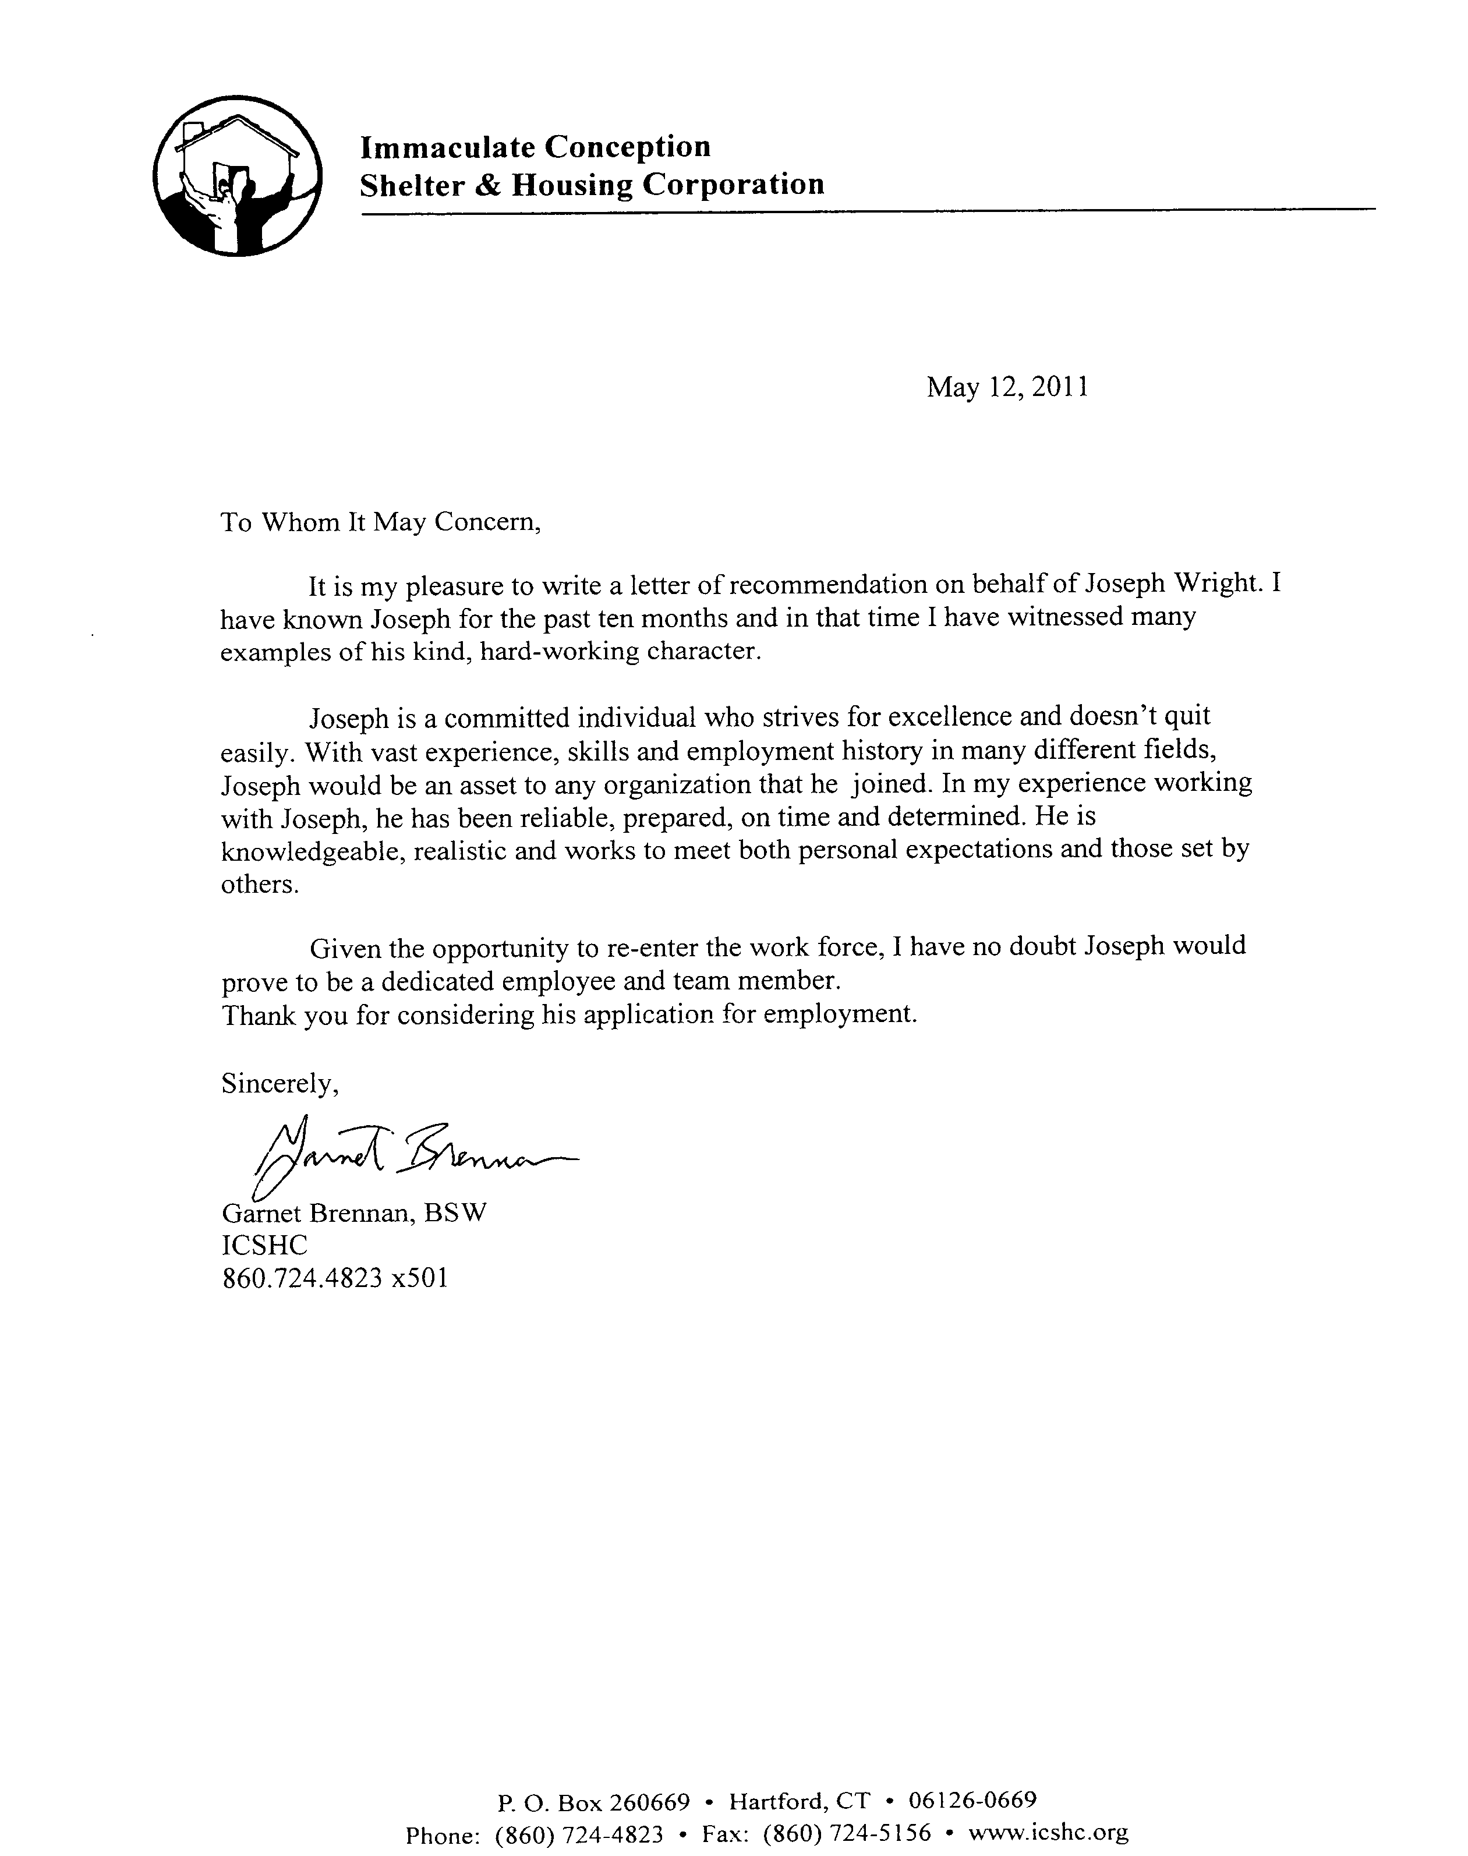

Joseph B. Wright Previous Employer / Salary History / Educational Institution Appendix

Employer / Salary History

Hendel's, Inc.
35 Great Neck RD
Waterford, CT 06385
(860) 437-4648
Starting salary: $6.00/hr.
Final salary: ~$35000/yr.
May 1999 – Oct. 2008

USI, Inc.
98 Fort Path RD
Madison, CT 06443-2284
(203) 245-8586
Salary: $7.50/hr.
May 1999 – Aug. 1999

Reese Brothers, Inc.
1504 11th AVE
Altoona, PA 16601-3306
Phone: (814) 941-8396
Salary: $7.00/hr. + Bonus
Sept. 1997 - May 1998

Alaskan Observers, Inc.
130 Nickerson, #206
Seattle, WA 98109
Dutch Harbor, AK
Salary: $1800/mo.
April 1991 - June 1991

University of Florida
in cooperation with DOD & USFWS
Eglin Air Force Base
State of Florida
Bureau of State Payrolls
Employee Records Becky Rosier
352-413-5431
Salary: $7.50/hr.
June 1990 – Sept. 1990

King's Family Restaurants
16494 Conneaut Lake Road
Meadville, PA 16335
Phone: (814) 333-8938
Starting salary: ~$4.00/hr.
Final salary: ~$5.00/hr.
Aug. 1987 - April 1990
Ric Evans Photography
100 Ross Street
Pittsburgh, PA 15219
Phone: 412 562 9888
Starting salary: $5.00/hr.
Final salary: $5.50/hr.
Sept. 1986 – Aug. 1987

Mt. Lebanon Pharmacy
300 Mount Lebanon Boulevard
Pittsburgh, PA 15234
412-344-6701
Salary: $3.50/hr.
Oct. 1981 – Sept. 1983

Meadville Tribune
947 Federal Court
Meadville, PA 16335
814-724-6370
Starting salary: ~$10.00/wk.
Final salary: ~$25.00/wk.
1975 – 1980

Salary Requirements

Negotiable and commensurate with experience.

Educational Institution Information

Edinboro University of Pennsylvania
200 Meadville Street
Edinboro, PA 16444
(814) 732-2761
BS Biology
September 1987 – May 1990

The Art Institute of Pittsburgh
420 Boulevard of the Allies
Pittsburgh, PA 15219-1301
1.412.263.6600
Associate Degree Photography / Multimedia
September 1983 – September 1985
Duquesne University
600 Forbes Ave.
Pittsburgh, PA 15282
412.396.6000
Pharmacy Curriculum
August 1980 – May 1983

Meadville Area Senior High School
930 North Street
Meadville, PA 16335-2199
(814) 336-1121
High School Diploma
September 1977 – June 1980

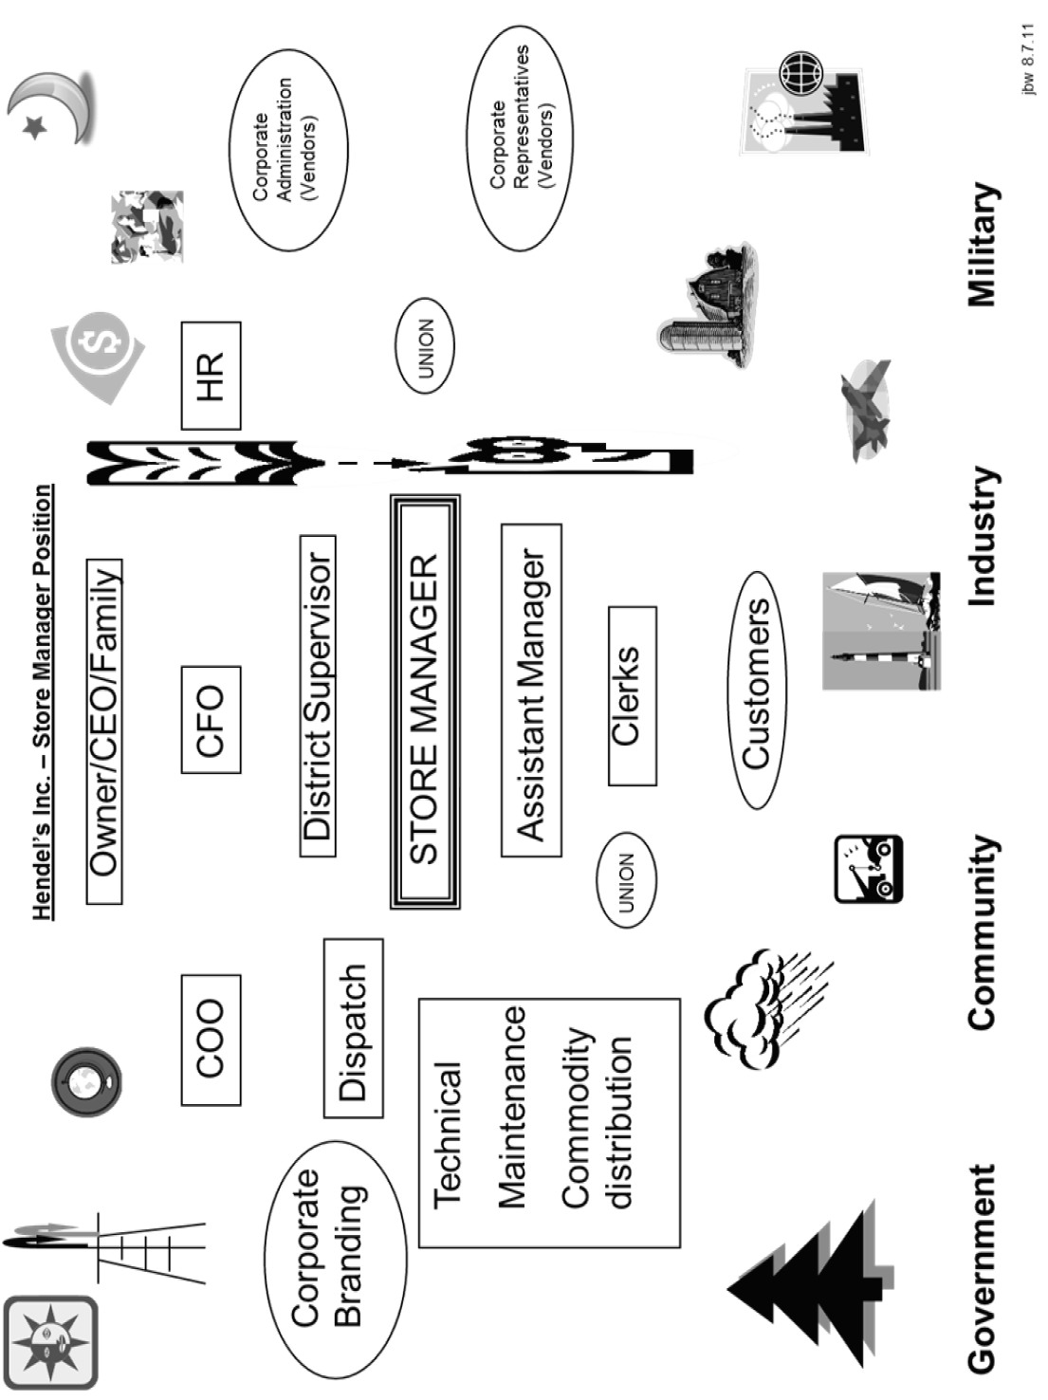

Joseph B. Wright College Coursework Appendix

Duquesne University (Transfer)
Bio 103 Prin of Biology
Bio 120 Botany
Bio 244 Human Phys/Anat 1
Bio 245 Human Phys/Anat 2
Chem 160 Prin Chemistry 1
Chem 16120 Prin Chemistry 2
Chem 20221 Gen Organic Chem
Chem 20420 Gen Biochemistry
Engl 101 Coll Writing Skills
Engl 102 Sp Writ/Research
Engl 388 Mythology
Hist 262 History of US 2
Math 112 Anal Geom Calc 1
OE 09380 (Entym of Sci Term)
(Pharm Math)
(Phys Pharm)
(Med Microbio)

Phil 09380 (Theology)
Phys 103 Physics I
Psyc 101 Gen Psychology
Soc 200 Princ of Sociol
Edinboro University of Pennsylvania
Phys 104 Physics 2
Biol 140 Zoology
Geog 101 World Geography
Math 260 Elem Statistics
Phil 20020 Intro to Philos
CSCI 100 Comp In Society
Biol 300 Genetics
Biol 500 Ecology
Art 100 Intro To Art
Biol 542 Ornithology
Comm 107 Fund Speech
Biol 682 Behavior Ecology
Biol 521 Plant Taxonomy
Biol 643 Mammalogy
Chem 250 Quant Analysis
HPE 07420 Fencing
HPE 105 Health

May 13, 1990 – B.S. Biology
QPA: 3.59

Official Transcripts are available upon request.

