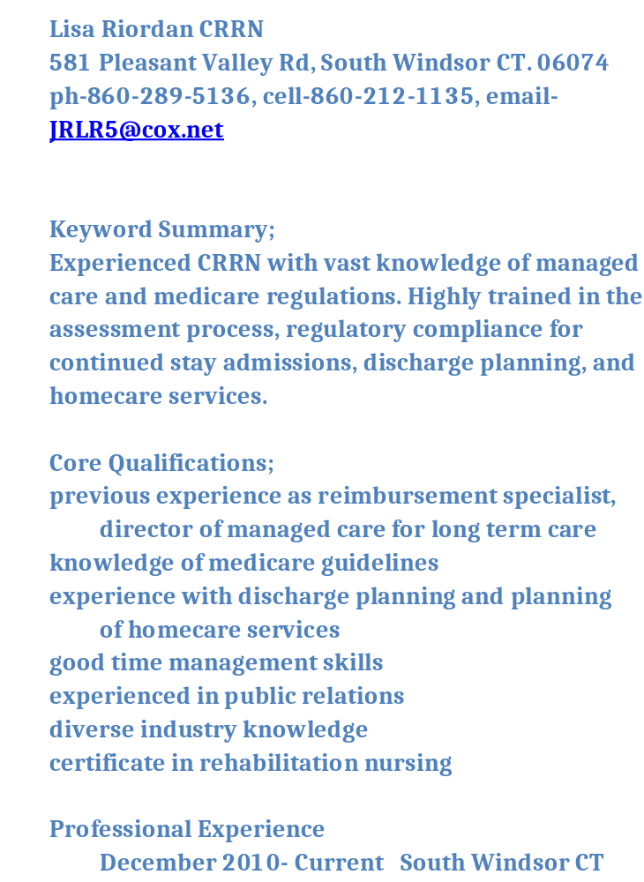Lisa Riordan CRRN 581 Pleasant Valley Rd, South Windsor CT. 06074 ph-860-289-5136, cell-860-212-1135, email- JRLR5@cox.net Keyword Summary; Experienced CRRN with vast knowledge of managed care and medicare regulations. Highly trained in the assessment process, regulatory compliance for continued stay admissions, discharge planning, and homecare services. Core Qualifications; previous experience as reimbursement specialist, director of managed care for long term care knowledge of medicare guidelines experience with discharge planning and planning of homecare services good time management skills experienced in public relations diverse industry knowledge certificate in rehabilitation nursing Professional Experience December 2010- Current South Windsor CT Benchmark Senior Living Resident Care Director/SALSA Responsible for the supervision of over 100 residents and over 50 staff members. Ensures all direct care complies with state and federal guidelines. Service program development and care package delivery. Assessments of residents to ensure the correct services. Other duties includes scheduling of staff, caregiver super- vision, QA compliance, labor management, incident documentation. Building and main- taining relationships with outside agencies, residents, and families. May 2010- December 2010 Suffield, CT Suffield By the River Assisted Living RN Supervisor of Assisted Living Oversaw the day to day operations of the service delivery, service planning, and care implementation of the community. Ensured all regulatory guidelines were met at all levels problem resolution, staff supervision, assess- ments of residents, family meetings, quality control. October 2008-May 2010 South Windsor CT Emeritus Senior Living Resident Care Director/Supervisor of ALSA Supervised over 50 staff and 95 residents to ensure all direct care delivered met with company,state, and federal expectations. Quarterly assessments and care planning of services for each resident. Scheduling, care- giver supervision, regulatory compliance with QA, family meetings and problem solving. Labor and budget control. Help grow occupancy. April 2002-October 2008 Hartford, CT Healthbridge Management Clinical Nurse Liaison/Field Case Manager Onsite evaluations of prospective patients Development of care plans to ensure proper service delivery in the SNF setting. Marketing and sales to homecare agencies, insurance, and hospital based case managers to increase census base for multiple long term care facilities. Customer relations, organizing and completing daily,weekly, and monthly con- version reports. Development and maintance of 30 day marketing plans. December 1996- April 2002 Glastonbury, CT Genesis Healthcare Reimbursement Specialist/ Director of Managed Care Duties included, utilization review of managed care and medicare patients, continues stay certification, completion of all needed paper- work for authorization of payment as well as discharge planning, arrangement of homecare services and equipment. Timely and accurate assessment of patients to ensure quality of care delivered. Building of managed care census through marketing to hospitals and insurance case managers. Timely medicare recertification. Education 2009 CALA-SALSA certification 1992 Certification of Rehabilitation Nursing ( CRRN ) 1988 St Francis School of Nursing 1984 Rockville High School Interests 4-H director with over 25 years of community service, arts and crafts, bowling, bingo, reading spending quality time with family and friends sports, avid Atlanta Braves fan References furnished upon request

