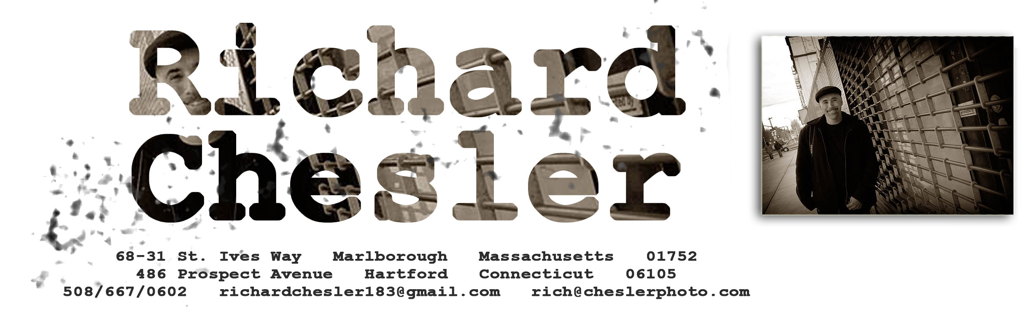

Graphic Design

Metrowest Printing - Marlborough, MA
Lead Graphic Designer/Sales Manager 2006-2011

Responsible for prospecting new clients while maintaining and expanding the scope of work for existing ones. Met with clients to pitch/create ground-up designs for a variety of print applications. My design expertise was in advertisements, signs, trade show booths, logo designs, marketing materials, brochures, stationary, direct mail pieces, catalogues, menus, and books.

Taught myself the entire print process end to end, learning all of the tools and techniques from design to color-separated offset printing to book bindery.

Expertise in the entire Adobe Creative Suite, including Photoshop, Illustrator, InDesign, and DreamWeaver plus extensive expertise in QuarkExpress and the MS Office Suite. I am very familiar with both Mac OS/X and PC Windows environments.

Photography

Chesler Photography - Marlborough, MA
Photographer 2007-Present

Have shot weddings and bar mitzvahs across New England and New York State, as well as one-off events in Mexico City, Naples and Key Largo, Sedona, Philadelphia, and the Jersey Shore. Have also done commercial shoots, sporting events, family portraits, school functions, and sessions with seniors and models.

Franchise Business Owner

do-re-ME.net - Marlborough, MA
Principal 2005-Present

Own a business that creates personalized children’s books and music. Ran a store at the Solomon Pond Mall but now sell strictly through the internet. The product line now includes personalized clocks and growth charts.

Sales

IntelliReach Corporation - Dedham, MA
Western US Territory Manager 2002-2005

Sold messaging solutions that included Archiving, Encryption, Filtering, and Administrative Management Tools. Grew sales in my territory to more than $560,000 in a single quarter, and reaching
$1 million in my first year. Sales ranged from $10k - $200k, and typically involved IT Directors, CIOs, Legal, and Compliance or Risk Officers. Sales cycles were usually one to six months, though larger projects took a year or more to close. Sales leads were generated through marketing activities and prospecting, cultivation of opportunities, and networking, involving decision makers at all levels of the organization. Made presentations and site visits when appropriate. Managed the IntelliReach team involved in each sale including Sales, Engineering and Executive resources.

Webhire, Inc. - Lexington, MA
Field Sales Representative 1999-2002

Sold web-based corporate recruiting tools and related services to mid-sized companies and Fortune 1000. Typically met with middle and upper management at the Director, VP and CFO/CEO level. Presented specific ROI analysis, negotiated contracts, and coordinated deliverables. Clients included Lego, Canon, Cadbury-Schweppes, and Snapple, which alone amounted to nearly $500,000 in sales.

Gradient Technologies, Inc. - Marlborough, MA
Regional Sales Manager 1994-1999

Assembled and managed team of Sales and Engineering resources specifically tailored to each sale of PC-DCE and NetCrusader middleware infrastructure and inter/intranet security products, and iFOR/LS licensing products on Windows, Macintosh, and various UNIX platforms to Global 2000 customers in manufacturing, telecom, higher education, research and government. Typical sales averaged $3,000 to $50,000, with some as large as $500,000. Sales cycles were 3 to 12 months.

References and Design Samples Available Upon Request

