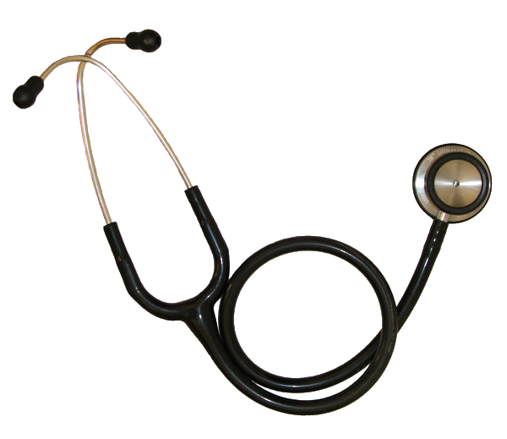
Katia DaSilva
35Evergreen Ave
Middletown, CT 06457
203-213-8606
katiamartins20@hotmail.com

Entry-level Certified Medical Assistant

PROFILE:
Graduating healthcare professional seeking a position as a Medical Assistant. Excellent clinical, assessment, and decision-making skills.

EDUCATION:
Certified Medical Assistant, AAMA December 2010

Lincoln Technical Institute, New Britain, CT
Medical Assisting Program High Honors March 2009 – December 2010

Stratford Career Institute, Home based school, Vermont
Administrative Assistant/Secretary High Honors Diploma 2008

High School Diploma, Portugal 2006

Courses Studied:
- Clinical Skills for Medical Assistants
- Anatomy and Physiology
- Coding and Reimbursement
- Medical Terminology

Clinical Skills:

- Vital Signs
- Urinalysis
- Patient instruction
- Sterilization
- ECG
- Charting
- Venipuncture
- Laboratory tests

Bilingual in English and Portuguese

WORK HISTORY:

Externship – West Hartford Medical Center
My extern was done at West Hartford Medical Center, a primary and urgent care facility. I performed both clinical and administrative aspects of the job. Some of the duties performed included, but not limited to:

Clinical

- Vital signs
- Laboratory tests:
- Urinalysis
- Rapid strep tests
- Glucose
- Hemoglobin
- Hpylori tests
- Venipuncture
- ECG
- Finger lance
- Aseptic technique
- Assist in minor office procedures:
- Ear irrigations
- Suturing
- Assist in Physical Exams

Administrative

- Excellent patient relations
- Telephone technique
- Appointment scheduling
- Charting
- Insurance verifications
- Prior authorizations
- Calling prescriptions
- Requesting lab results
- Bookkeeping skills
- Computer skills

Covidien, North Haven, CT (March 2008 – Present)
Manufacturing Technician – Responsible for operating and maintaining equipment. Preparing and working on the assembly line.

Taco Bell, Wallingford, CT (November 2007 – March 2008)
Cashier and food prep – Customers service, took customers orders, prepared food as ordered, and clean stations assigned.

