Arno Nadolny
Director Finance, Mergers & Acquisitions
arno.nadolny@hotmail.com | +1 214-415-7299 (mobile)
Plano, Texas, USA

Highlights
________________________________________________________________________________

MBA/Chartered Accountant with significant Corporate Development and Finance experience including mergers, acquisitions and divestitures, financial planning & analysis, and external reporting with a large public multi-national technology company supporting Corporate and Business Unit strategic initiatives.

- 10+ years Director level global Corporate Development experience with Nortel Networks
  - Significant experience partnering with Business Units to develop inorganic strategic initiatives
  - Successful track record of leading cross functional teams and external advisors on over a dozen buy and sell side, minority investments and IPO transactions ranging in size from $5M to $1B+ in North America, Europe, Israel, China, South Korea and Japan.
  - Extensive valuation, negotiation, business case, due diligence, integration experience
  - Demonstrated ability to successfully influence across a large matrix organization and work with all levels of management and JV Boards
- Multiple manager roles developing direct and deal constituent teams
- Experienced Finance professional with past roles including responsibility for Corporate Reporting and Consolidations for a $10B+ SEC filer, business unit FP&A support, internal audit
- US permanent resident, Canadian citizen

_______________________________________________________________________________________________________

Work Experience
_______________________________________________________________________________

Director Finance, Mergers & Acquisitions

Nortel Networks
1996-1999 Senior Manager, Mergers and Acquisitions (Toronto, Canada)
1999-2011 Corporate Director, Mergers and Acquisitions (Richardson, Texas)

- Corporate Business Development – Supported strategic initiatives including minority investments, joint ventures and acquisitions in the high tech Telecoms and Communications space including optical transport, 2/3G wireless, Video on Demand (VOD), Enterprise sales and distribution, IT Services, security software and manufacturing outsourcing.

- M&A Execution – Extensive acquisition, divestiture, joint venture, minority investment, spin out and IPO transaction experience in all areas of the M&A process including cross functional project management, target selection, auction process, business case development, negotiations, term sheets, definitive agreements, regulatory requirements, due diligence, human resources and business integration. Managed deal teams, including business unit and external advisors, on over a dozen buy and sell side transactions ranging in size from $5M to $1B (see Deal Sheet at end)

- Global Deal Experience - Significant deal experience in China, South Korea, Japan, England, Germany, Switzerland, France, Israel and Canada dealing with complex issues including China state owned enterprise auction process, anti-competition regulations, and joint venture boards (South Korea, China)

- CXO and Board Management and Presentation – Extensive Board (LG-Nortel, GDNT) and Management presentation experience

- Business Restructuring - Including the divestiture of Nortel’s Enterprise Networks business unit ($2.8B 2008 revenue) under a Chapter 11 “363” Auction process to Avaya, disposition of various non-strategic business units and manufacturing outsourcing

Senior Manager, Corporate Reporting
Nortel Networks - Toronto, Ontario
March 1992 – March 1996

- Managed the consolidation process and delivery of Nortel’s externally reported financial results for a $10B+ SEC filer in both Canadian and US dollars.
- Managed staff of 5 financial analysts

Meridian 1 Planning Manager

Belleville, Ontario

January 1990 – February 1992

- Managed the coordination and development of the financial plan for $300M Enterprise product line in Canada.
- Supported product investment decisions, product life cycle analysis and capital investment decisions
- Managed staff of 3 financial analysts

HQ Results Manager

Nortel Networks - Toronto, Ontario

April 1988 – December 1989

- Managed staff of 4 financial analysts

Internal Audit Analyst

Nortel Networks - Mississauga, Ontario

August 1986 – March 1988

- Performed a variety of compliance internal audits on Nortel business units primarily in the areas of Finance, Purchasing, and Research and Development.

Audit Senior

Price Waterhouse Chartered Accountants – Toronto, Ontario

September 1981 – August 1986

- Managed a variety of public and private company audits
_________________________________________________________________________________________________________

Professional Designation
_______________________________________________________________________________

Chartered Accountant

Institute of Chartered Accountants of Ontario

_________________________________________________________________________________________________________

Education
_______________________________________________________________________________

Master of Business Administration
Queens University, Kingston, Ontario

Bachelor of Arts, Honors
Queens University, Kingston, Ontario

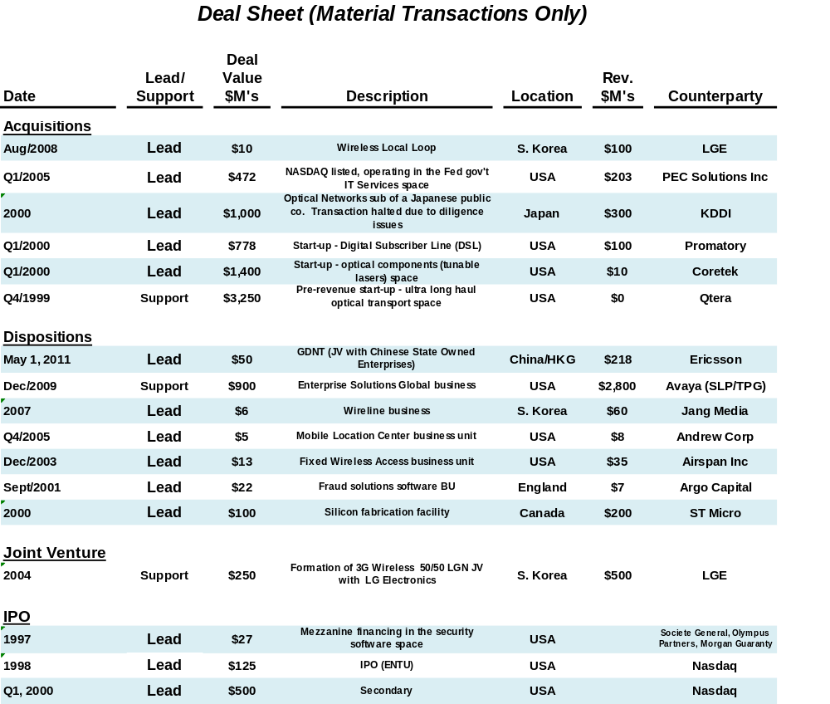

_________________________________________________________________________________________________________

Other
_______________________________________________________________________________

- List of all SEC Filings as a Signatory: http://www.secinfo.com/$/SEC/Name.asp?S=arno+nadolny

- Acquisition of PEC Solutions in 2005, a NASDAQ listed company

1. Tender Offer Statement - http://google.brand.edgar-online.com/EFX_dll/EDGARpro.dll?FetchFilingHTML1?ID=3699279&SessionID=UPPIHFsgRbCxKG7

2. Schedule 14D-9 Solicitation Statement - http://google.brand.edgar-online.com/EFX_dll/EDGARpro.dll?FetchFilingHTML1?ID=3646528&SessionID=Md2THSsb1g3rT77

