Villa Raag Landing Page - Luxury Resort
https://villaraag.vercel.app/
Villa Raag Images: https://drive.google.com/drive/folders/1WTBf-LIiA3YPnFYb5NWNeIm6l9WKf0_R

- Replace stock hero assets

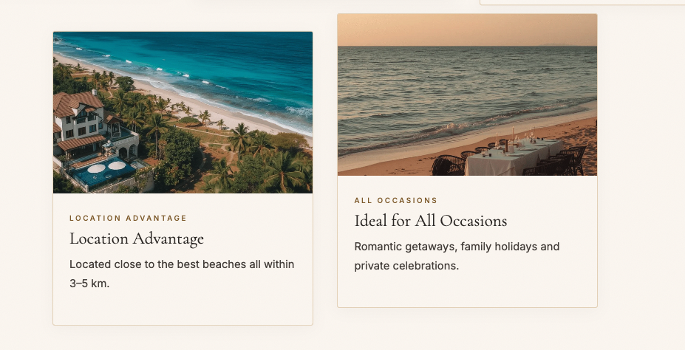
Alignment issue - please check

- Use original villa raag video as hero section.

- 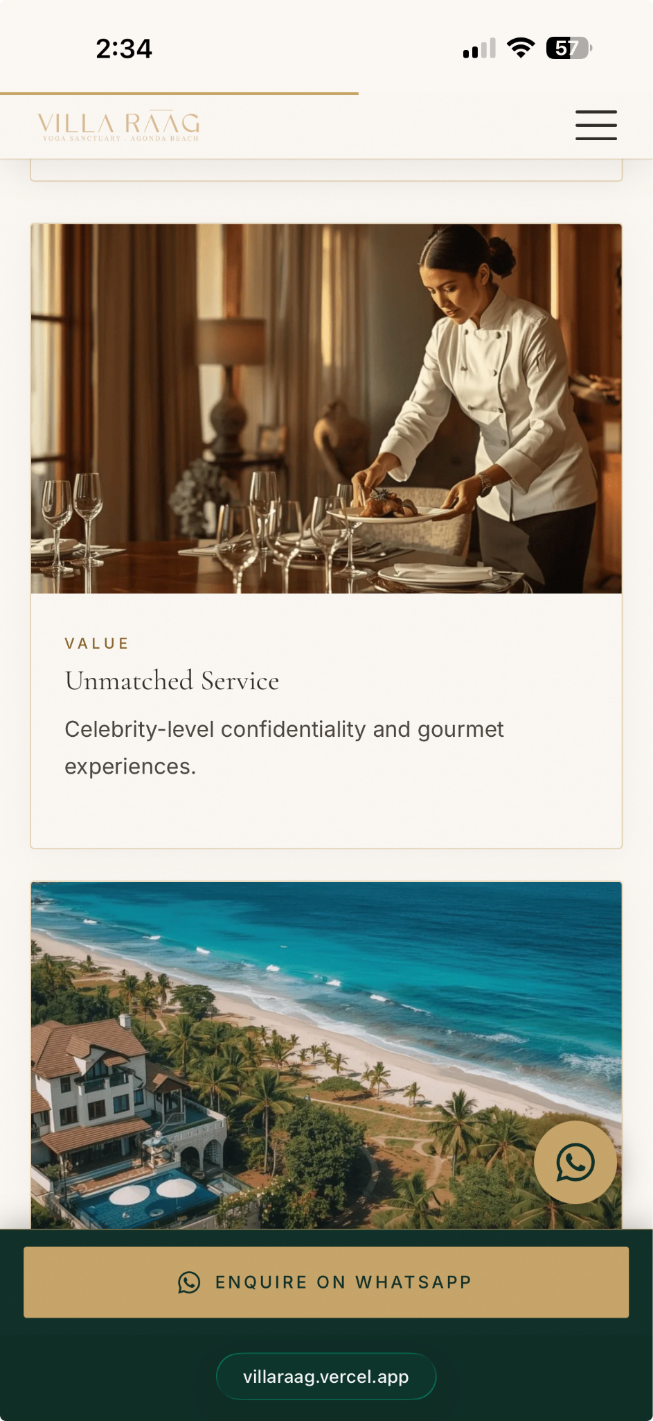

Make the logo a bit bigger, currently looks fade.

- Ultra-Private Beachfront Access - use real image from our Villa Raag Images drive
- Location Advantage - use real image from our Villa Raag Images drive
- Use Priya Sharma’s number for whatsApp placements: +91 92898 38797

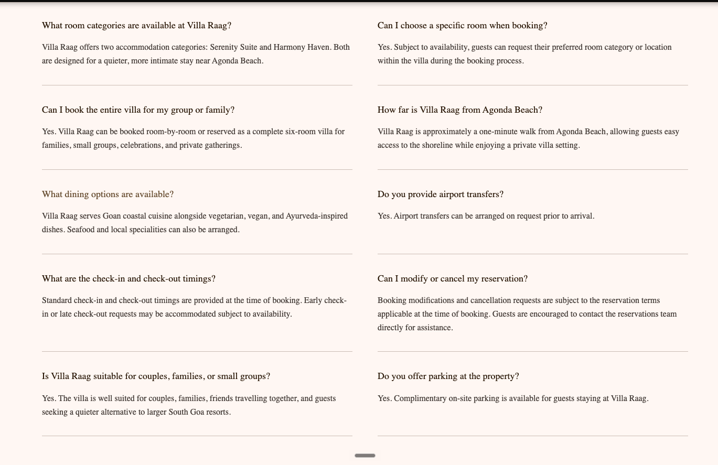

Use this FAQ structure, to make the section less scroll.

SEO Elements page correction.
<script async src="https://www.googletagmanager.com/gtag/js?id=G-RWRPVY637E"></script>
<script>
window.dataLayer = window.dataLayer || [];
function gtag() { dataLayer.push(arguments); }
gtag('js', new Date());
gtag('config', 'G-RWRPVY637E');
</script>
This is being fetched by older version: G-RWRPVY637E

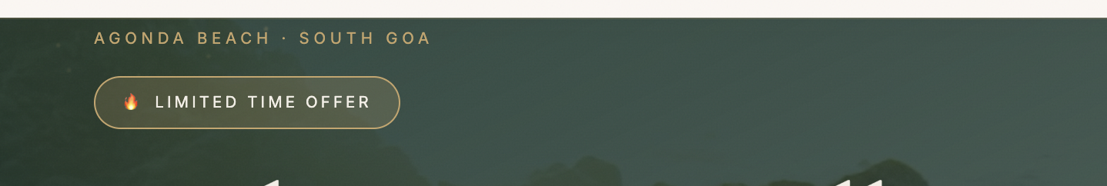

Remove the fire icon



Remove full stop

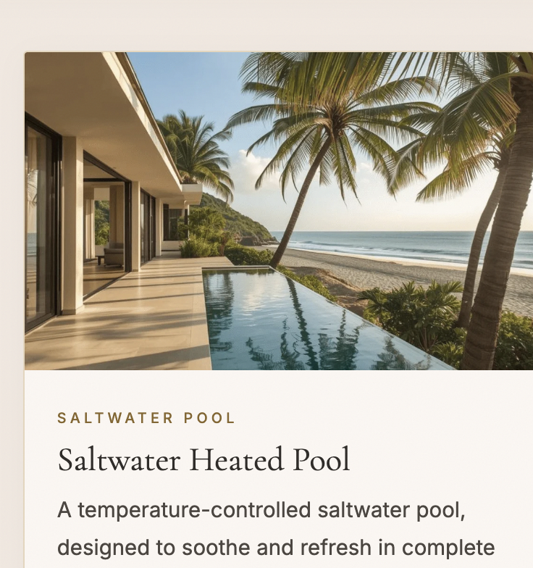

Use original image of the pool

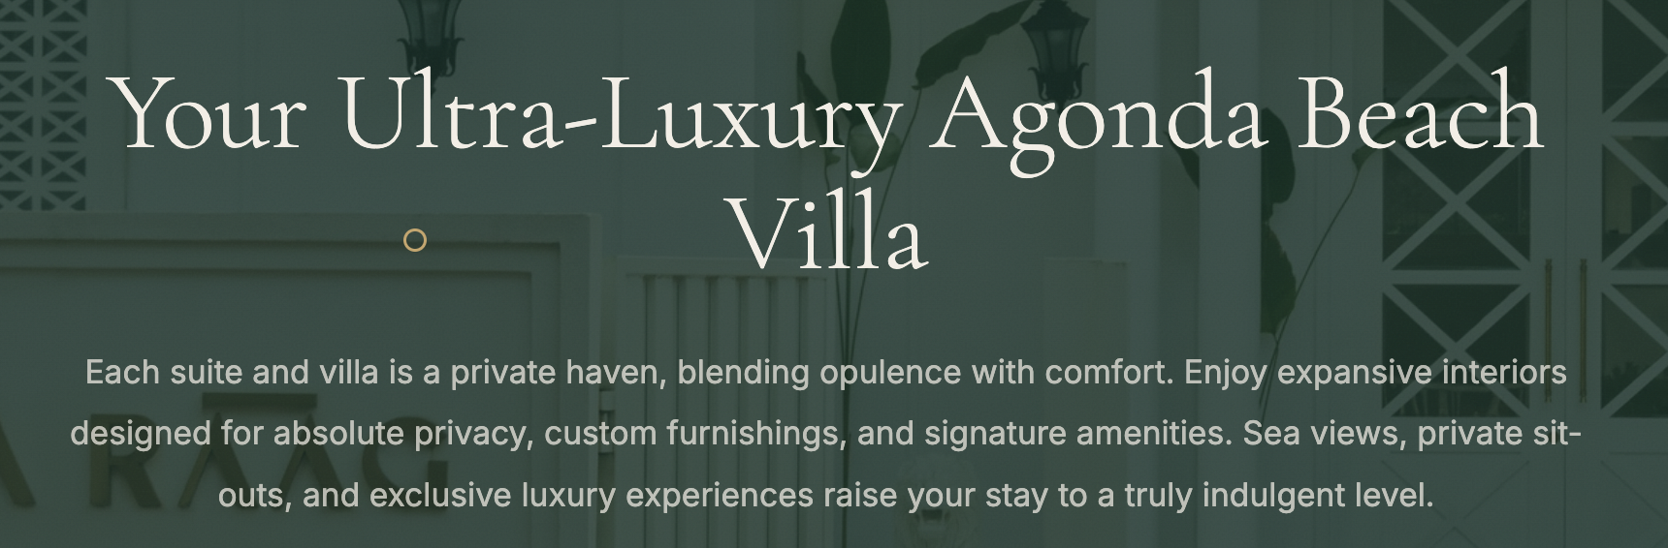

The heading can be in one line to avoid extra space

Alignment issue

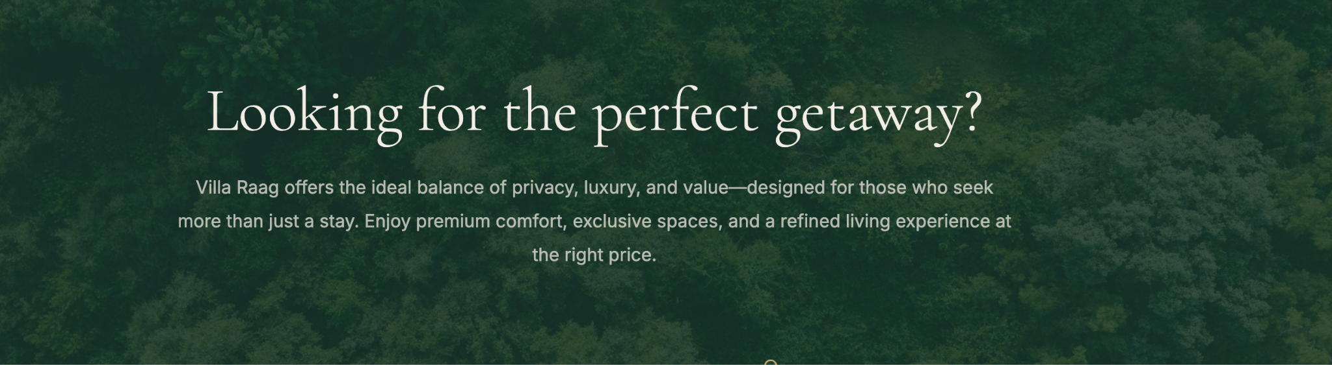

We can remove this part to avoid more scrolling

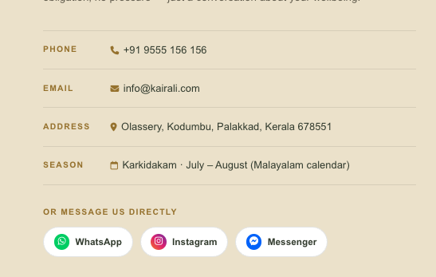
Please add whatsapp, instagram messenger like we have started doing for kathv also.
For whatsAPP use - priya sharma
Insta: https://ig.me/m/villaraag
messenger: https://m.me/villaraag



Remove fire icon

