**Student Guardian**

Aaran Manansala, Wenyan Hu, Grace Yaru

Login page

* Original planned functionalities for your product before development

Originally, we planned only 2 ways to login our app by using Facebook and Google API. However, Ramin gave us suggestion for what if people don’t have accounts for those two. Therefore, we made another way for newusers register and login page.

* Functionalities/ideas removed from the product and reasons for removing them

There is nothing remove from this page.

* Existing functionalities (working and broken) and how they are supposed to work. If broken, provide reasons to why they are broken

Currently, all the function is working right now. However, sometime if the computer has been used for a long time the register button will like frozen like we did it on presentation. It’s not a broken, but it just like something strange.

* Future functionalities that you wish to pursue for your product and a pseudo guess to how you would implement it

For future functionalities, we will just to make it looks nice or change some CSS animation.

Schedule page

* Original planned functionalities for your product before development

Originally, we planned that a weekly schedule to let people add schedule with time, class, instructor, location, class type. Like mybcit website course schedule, but we let users to add the content. We planned that users can add, change, delete the schedule. Also, they can go previous and next week to check their course schedule. When users open the schedule page, it will get the date of today, then show the related week of schedule.

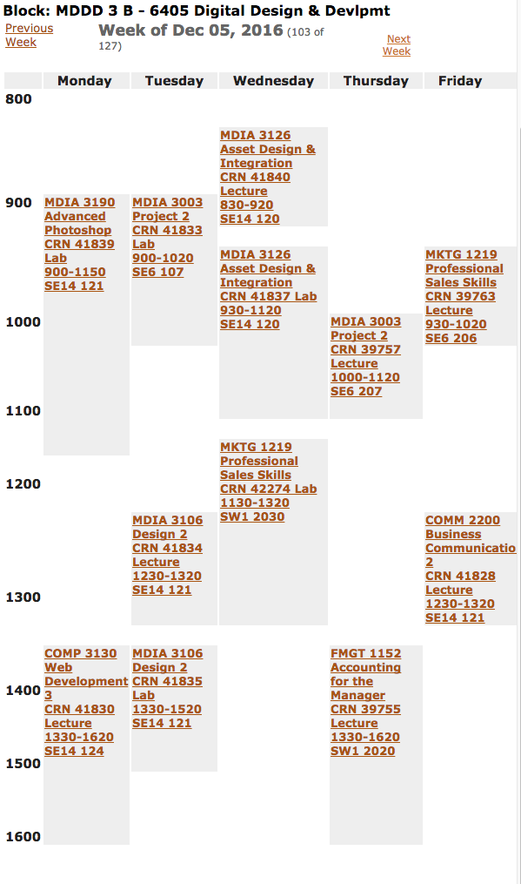

* Functionalities/ideas removed from the product and reasons for removing them

We removed the plus button on the right button to add new class schedule on the schedule page. Because users can click the empty spaces for add the new schedules, we think that the plus button for adding new schedule is useless. For example, if you want to add a new class schedule on specific day and hours (like Dec 9 10:15 am), you just need to click on the day Dec 9 and the second grid of the 10am, then the floating control panel will show the date and time that you click. If you aren’t click the right gird for the time, you still can change it.

* Existing functionalities (working and broken) and how they are supposed to work. If broken, provide reasons to why they are broken

Existing functionalities

-Users can add new schedule to the calendar;

-after input, press save, store input value into database;

-reclick the schedule that you have saved before, you can access the floating control panel again, the inpt show up the value that you have input before.

-users can make a change for those previous input value, press save the new schedule will render it again.

-users can delete the schedule that have added before, alert will remind users the schedule will be removed. Then the front end won’t show up the schedule any more.

Broken functionalities

-if users refresh the page to see the schedule, they still can see the schedule that they had deleted still there.

-if users make any changes for the existing schedule then press save again. It will store data into our database, then render this new calendar event again within the front end schedule page. Thus, we will have the old one and new one existing at the same time.

-grab user’s input value for location, then if users click the get direct to go to the google map page, the input value will exist in the end destination option selected.

reasons to why they are broken

It’s because whatever data in our database it will be render it out within the schedule page. We try to do figure out the id to match the id within database’s primary key id. Then successfully deleted the schedule within the database. We have select the table in the database, make ajax call to delete. For loop to loop through the array in the database to get the id number, but just just can’t get the correct id number. However, it is successfully to connect the database, because the remove function is go inside the ajax call success: function(){}.

For grab the user input location value, we made it localstorage the input value. Then getitem on the google map page. Change it to uppercase. Do the Regular expression to check the typing make the value that exist with the option or not. If match, the option within the end selection will be selected. However, it’s not working properly, and there is not path show up there until users click the option to make it select.

* Future functionalities that you wish to pursue for your product and a pseudo guess to how you would implement it

In the future, we can make it when users click the existing schedule to bring up the floating control panel. If they make any changes then press the save button, delete the data within the database and store the new data at the same time. Thus, the front end calendar just render one new schedule that was just changed.

Reminder page

* Original planned functionalities for your product before development

Originally, we planned to have another small calendar to show up a to do list to remind users that the things that they need to do.

* Functionalities/ideas removed from the product and reasons for removing them

There are nothing remove from this page. Conversely, we add some function for it for list week, list day, and month small calendar.

* Existing functionalities (working and broken) and how they are supposed to work. If broken, provide reasons to why they are broken

Existing functionalities

-press plus button to add due event, input value, the data and time can be switch to choose it if users use cellphone

-after press submit, the input value store into our database, then render it out within the list week, list day and month calendar.

-if user click the existing due event, the floating control panel will show up with the input value that they entered previously. They can change the input value then press save button again to store data, then show the render.

Broken functionalities

There is nothing broken in this page, however, just like the same problem that we had as schedule page. We haven’t figure out the id that match the database the primary key id. Thus, we can delete the old due event that users added before.

* Future functionalities that you wish to pursue for your product and a pseudo guess to how you would implement it

In the future, we can figure it out the delete from database and make a notification pops up or alert to really remind user the due time, due day. We do a research for it, the solution just use Settimeout(){}; but we found the due time should be hard code by hand instead of dynamic change follow the date and time. Thus, we didn’t make it.

Campus map page

* Original planned functionalities for your product before development

Originally, we planned to show up a campus map page to guide the student to the different buildings.

* Functionalities/ideas removed from the product and reasons for removing them

There is no function removed from this page. However, we add some functions for this page. For example, get users geolocation, we have start and end destination for users to choose, then show the walking path for the directions. The down part we have a clear written information that has been generated dynamically based the start and end value.

* Existing functionalities (working and broken) and how they are supposed to work. If broken, provide reasons to why they are broken

Existing functionalities

-get geolocation for to show “You are here now”. If users use cellphone because we use cellphone API, thus it can’t get you location when you use computer browser. It works on you phone properly. 

-select the start and end choose the location the bottom module will show up the directions for the walking path. (Even Ramin double it and said it looks like a driving path).

Broken functionalities

No broken functions for this page.

Future functionalities that you wish to pursue for your product and a pseudo guess to how you would implement it

In the future, we can make the google map page can be clickable to pick the start and end location. Also can be integrated with the schedule page the location input.

Settings page

* Original planned functionalities for your product before development

Originally, we planned to show our team and role, some basic settings. For example, users can upload the image for changing the default image.

* Functionalities/ideas removed from the product and reasons for removing them

There is no functions removed from this page. However, we don’t have enough time to continue develop it.

* Existing functionalities (working and broken) and how they are supposed to work. If broken, provide reasons to why they are broken

Existing functionalities

-about button show the child element of the our roles and brief description.

-general button show the file upload panel for users to upload image.

Broken functionalities

The change default image function hasn’t figure it out.

Future functionalities that you wish to pursue for your product and a pseudo guess to how you would implement it

In the future, we can make it change the font size, background color, or we can attach a brief tutorials for teaching our users.

Logout Button

Everything works fine for it.

Grade Calculator Page

* Original planned functionalities for your product before development

The grade average calculator page was suppose to be able to show what you had received on various assignments within a class, and then calculate what you need to get on the remaining assignments/tests to pass the course.

* Functionalities/ideas removed from the product and reasons for removing them

This was taken out because we wanted a more simple way to provide information to students. Also, we did not want to take away from the main function of the schedule page and the assignment reminder pages.

* Existing functionalities (working and broken) and how they are supposed to work. If broken, provide reasons to why they are broken

Existing functionalities

The grade calculator page allows the user to input classname and class grade to a table of values. Then the average would be dynamically changed based on the values inputted

Broken functionalities

The grade calculator page shows a NaN for the average if all items in the table are deleted, and also if the user saves some classes and leaves the page or refreshes the page, the average appears blank. I believe the average does not stay printed on the page because of the order of the call I made to the database. This then does not calculate the average based off the database so it outputs a blank average.

Future functionalities that you wish to pursue for your product and a pseudo guess to how you would implement it

In the future I would want to make the original idea of this page. Having a way to calculate what a student needs to get on the remaining things in the class would be more useful to the user. This would be made by further developing the present state and having each class being added to be clickable. Then you could then add assignments, tests, and other marks to calculate what you are getting in the class based on those marks.