1. Add the sysvars which are to be displayed in the device list section of the app. Refer to the red section in the below image

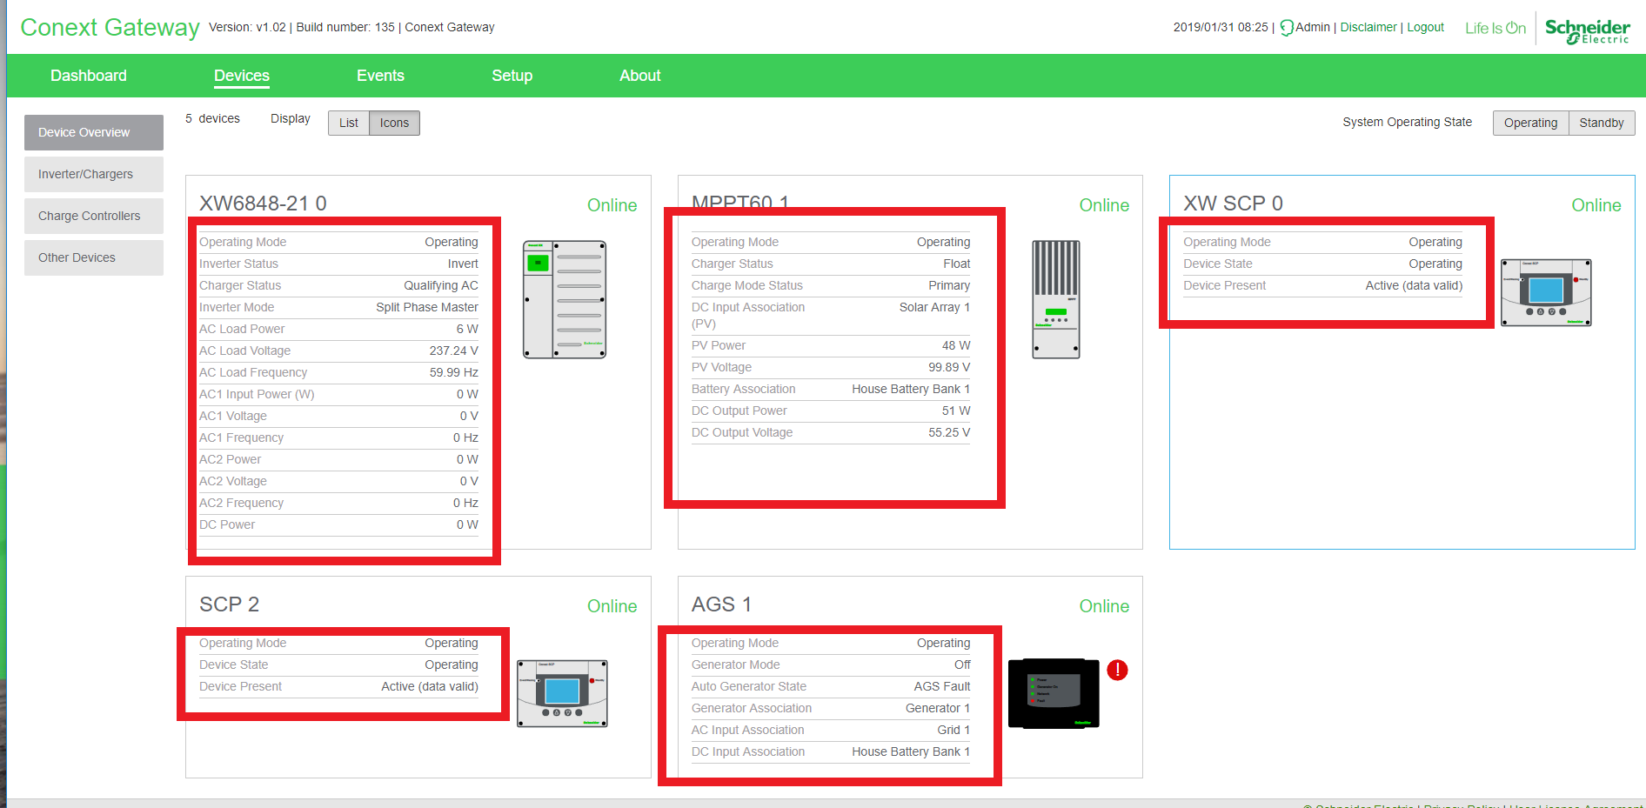

/src/app/xbgateway/DeviceList/devlistQuery.service.js

* Add new function to the service for the specific device and add the sysvars needed for that device

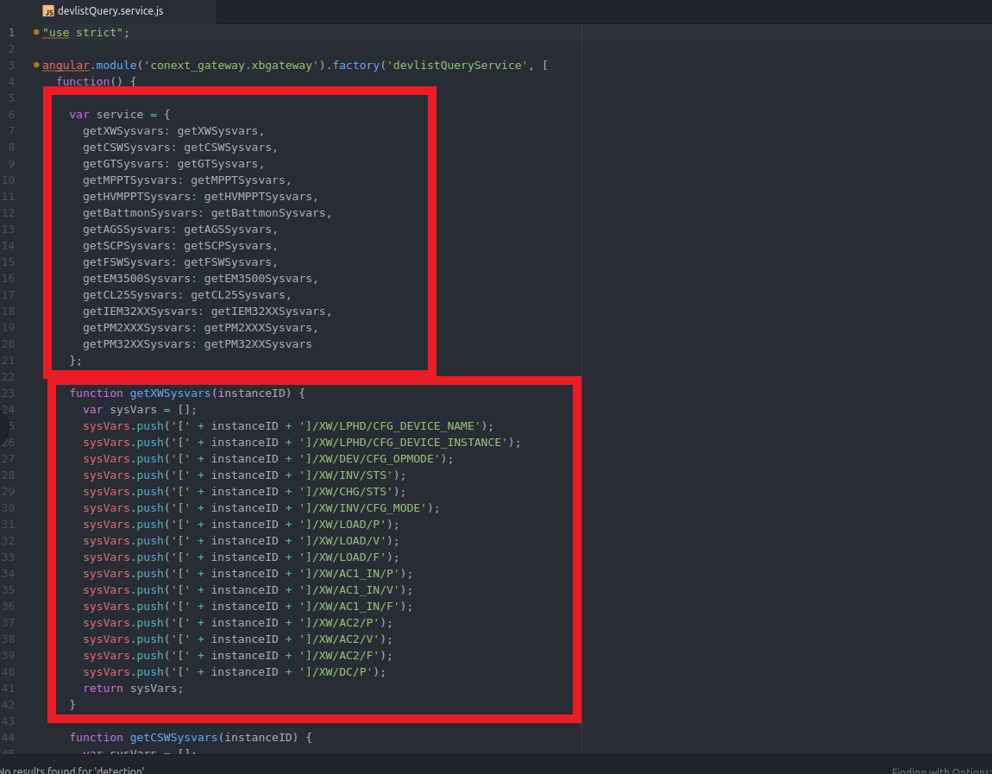

1. Call the devlistQueryService function from step one in:

/src/app/xbgateway/DevliceList/xbdevlist.controllert.js

* Make sure it is added to the correct group in the devices object
* Exp. devices.inverterChergers, devices.chargers, devices.inverters …

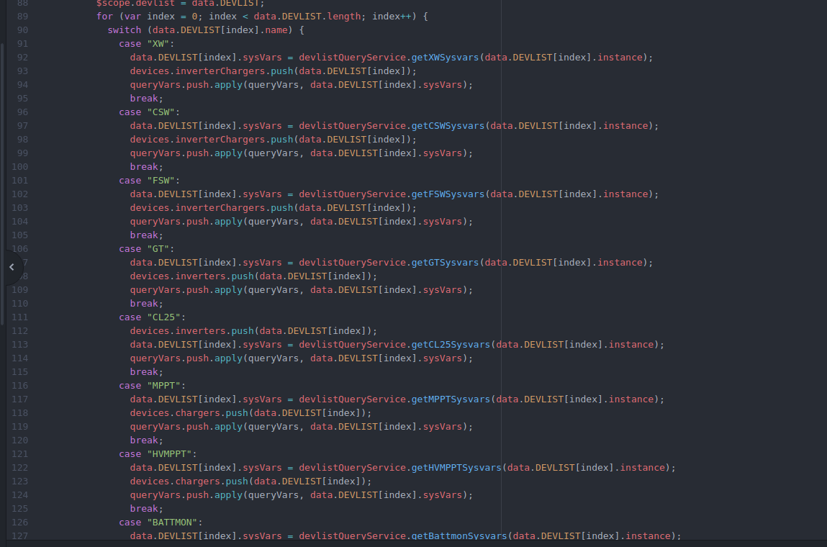

1. Implement imageClick handler to handle when the device is clicked in the device list section

/src/app/xbgateway/Directives/image_click.service.js

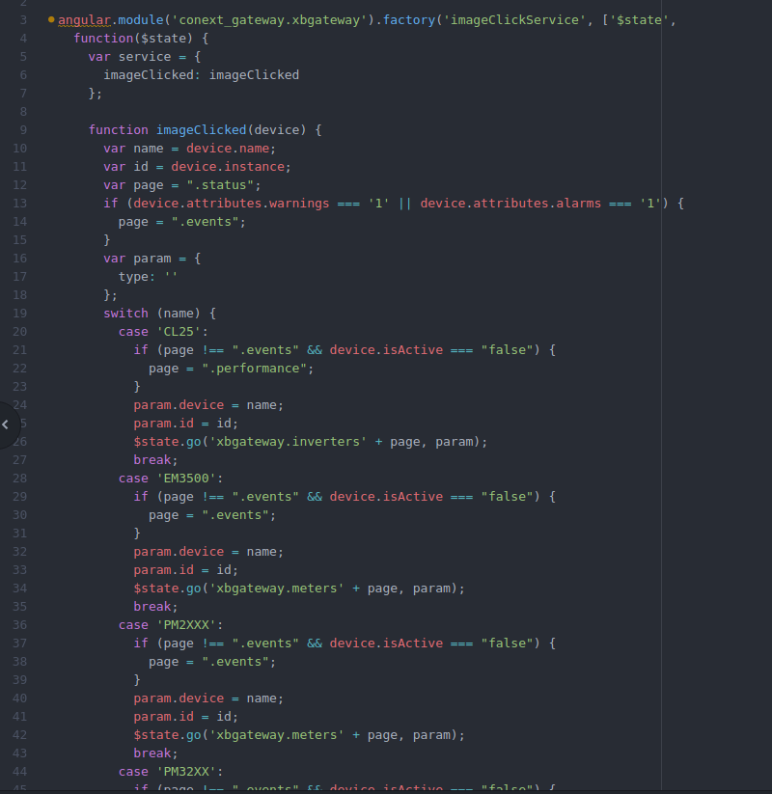

1. Add new device type in the sidemenu controller so that it will be shown in the appropriate sidemenu dropdown

/src/app/xbgateway/SideMenu/xbgateway.controller.js

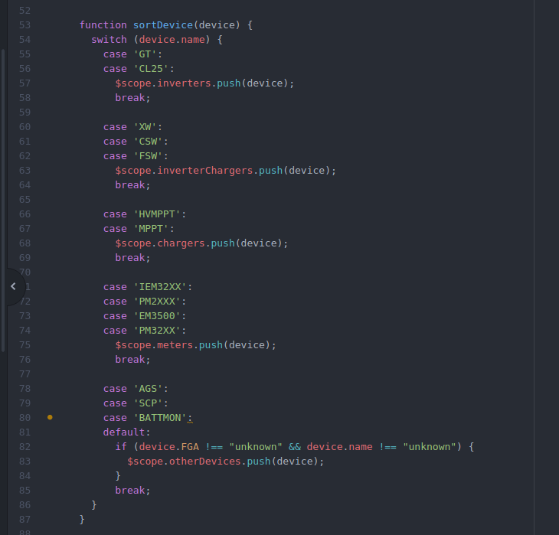

1. Create new image for device and wrap it in an angular directive. Follow the same format as the other directives which are in the folder.

/src/app/svg-directives/

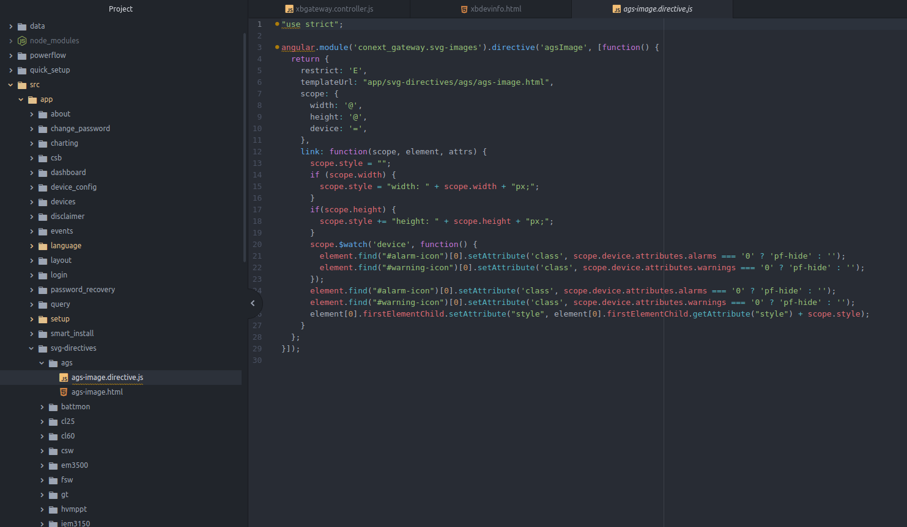

1. Add new device directive into the device info section.

/src/app/xbgateway/DevInfo/xbdevinfo.html

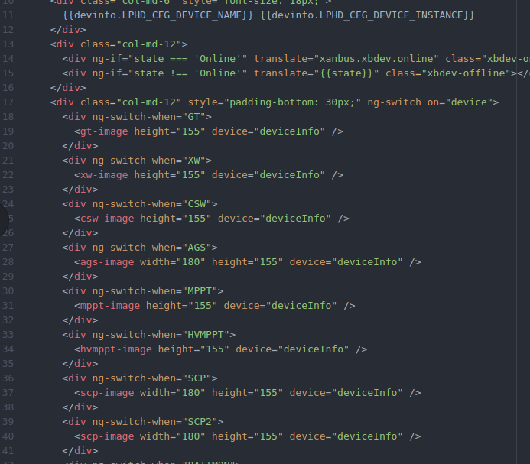

1. Add device sysvars for the status section

/src/app/xbgateway/Status/statusQuery.service.js

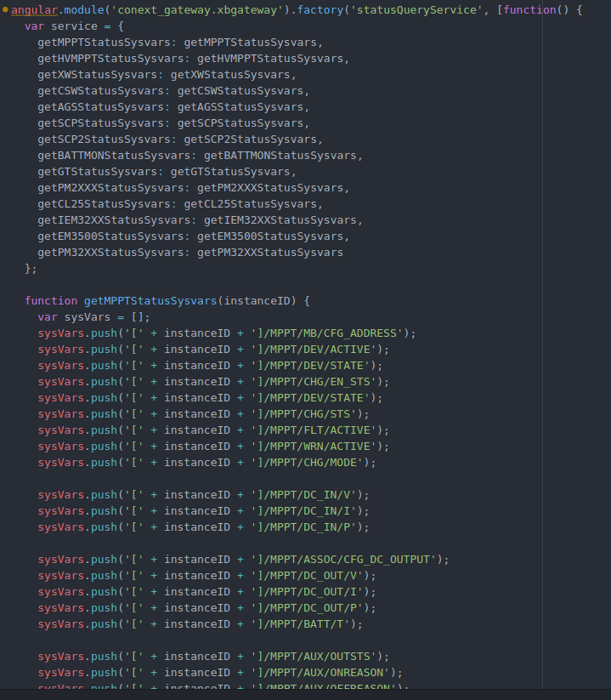

1. Call the function from the previous step in the status controller

/src/app/xbgateway/Status/xbdevstatus_detail.controller.js

