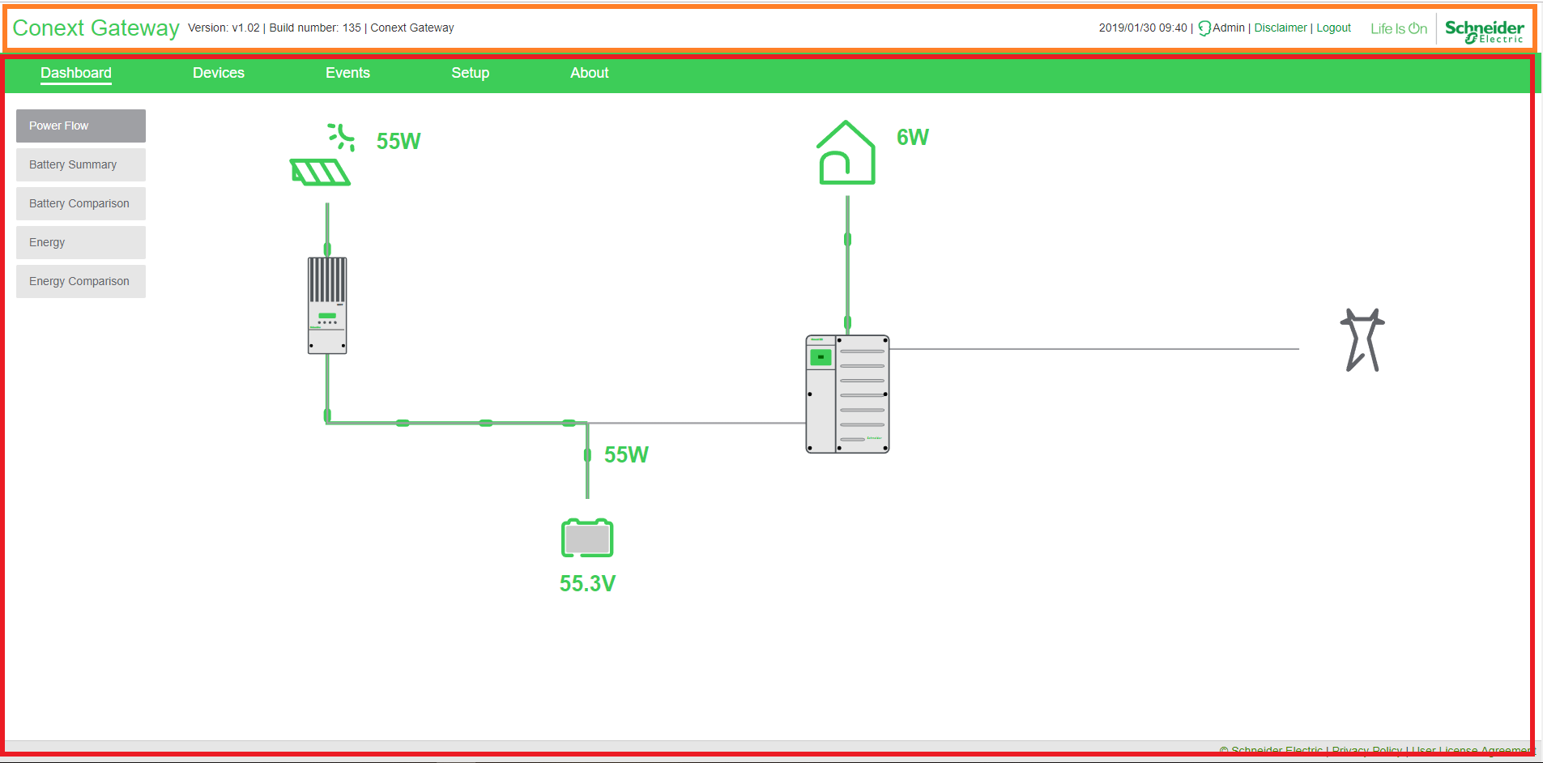

/src/app/layout/haeder.controller.js

/src/app/layout/header.directive.js

/src/app/layout/header.html

/src/app/layout/master_layout.controller.js

/src/app/layout/master_layout.html

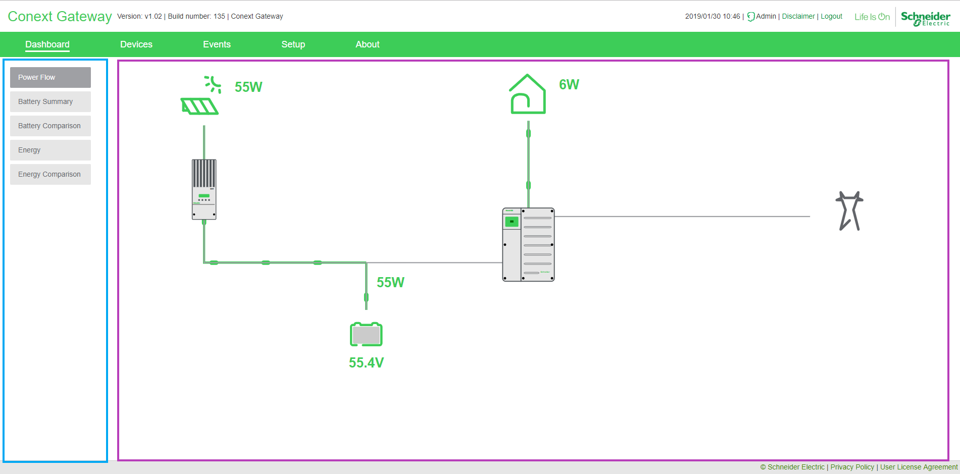

/src/app/dashboard/dashboard.html

/src/app/dashboard/powerflow/powerflow.controller.js

/src/app/dashboard/powerflow/powerflow.directive.js

/src/app/dashboard/powerflow/powerflow.html

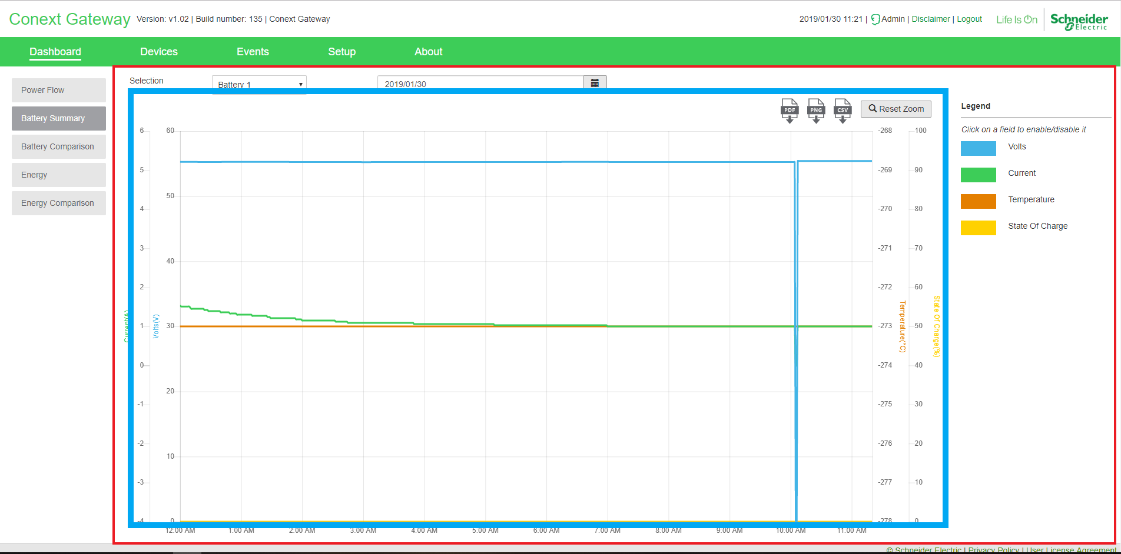

/src/app/dashboard/battery_summary/battery_summary.controller.js

/src/app/dashboard/battery_summary/battery_summary.html

/src/app/charting/chart.directive.js

/src/app/charting/chart.html

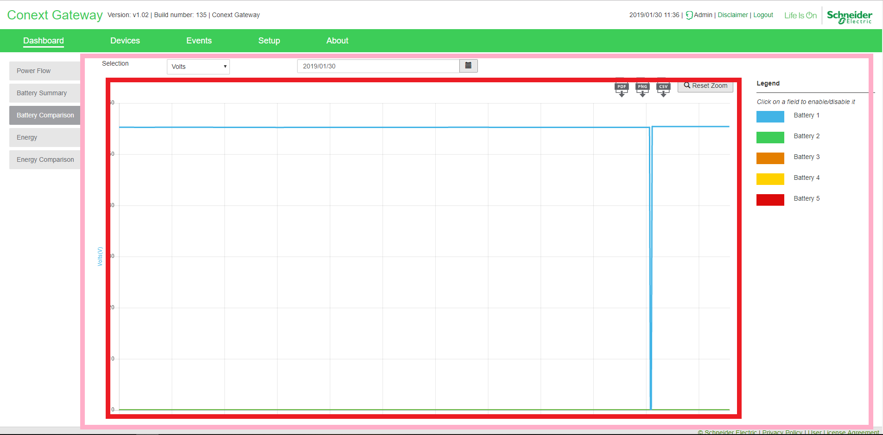

/src/app/dashboard/battery_comparison/battery_comparison.controllert.js

/src/app/dashboard/battery_comparison/battery_comparison.html

/src/app/charting/chart.directive.js

/src/app/charting/chart.html

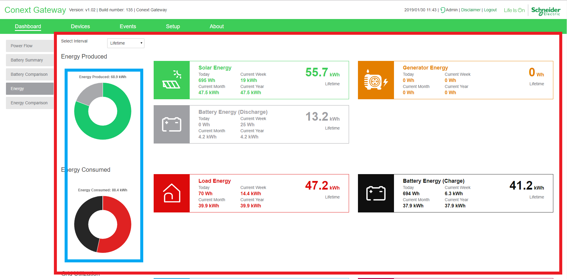

/src/app/dashboard/energy/energy.controller.js

/src/app/dashboard/energy/energy.html

/src/app/charting/chart.directive.js

/src/app/charting/chart.html

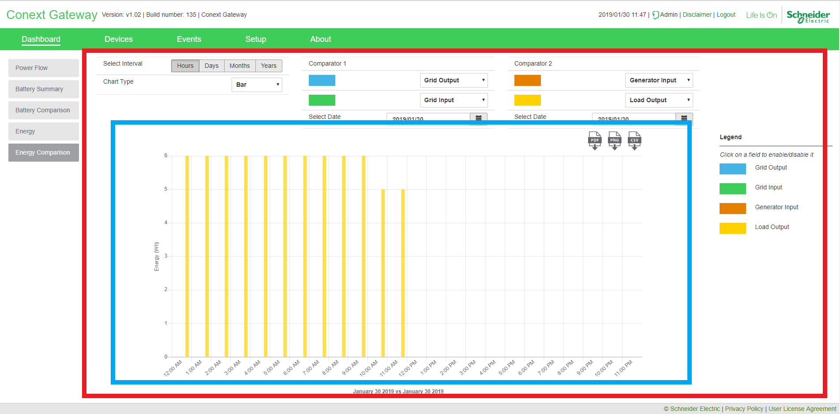

/src/app/dashboard/energy_comparison/energy_comparison.controller.js

/src/app/dashboard/energy_comparison/energy_comparison.html

/src/app/charting/chart.directive.js

/src/app/charting/chart.html

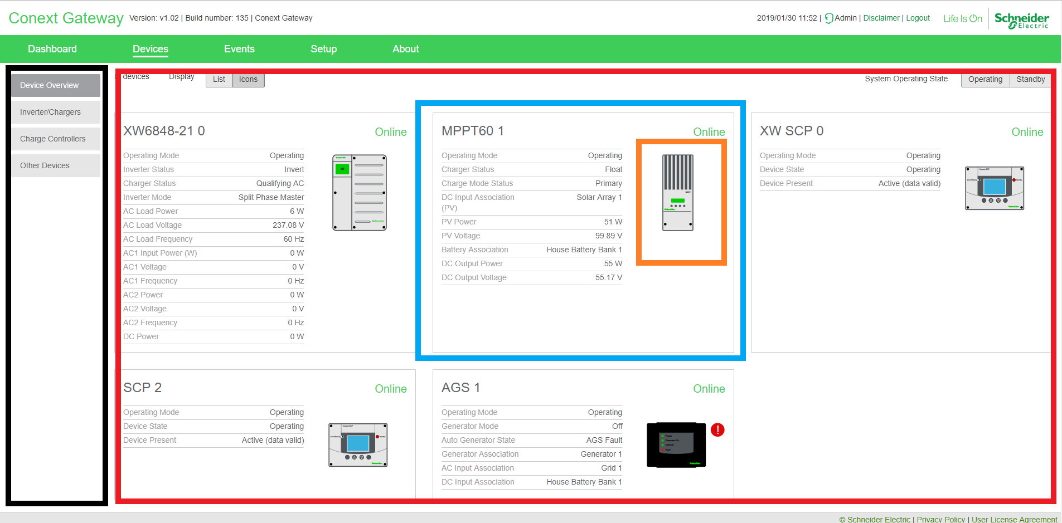

/src/app/xbgateway/SideMenu/sidemenu_xbgateway.html

/src/app/xbgateway/SideMenu/xbgatewat.controller.js

/src/app/xbgateway/DevliceList/xbdevlist.controller.js

/src/app/xbgateway/DevliceList/xbdevlist.html

/src/app/xbgateway/Directives/{{Device_type}}.directive.js

/src/app/xbgateway/Directives/{{Device_type}}.html

/src/app/svg-directives/{{Device_type}}/{{Device_type}-image.directive.js

/src/app/svg-directives/{{Device_type}}/{{Device_type}-image.html

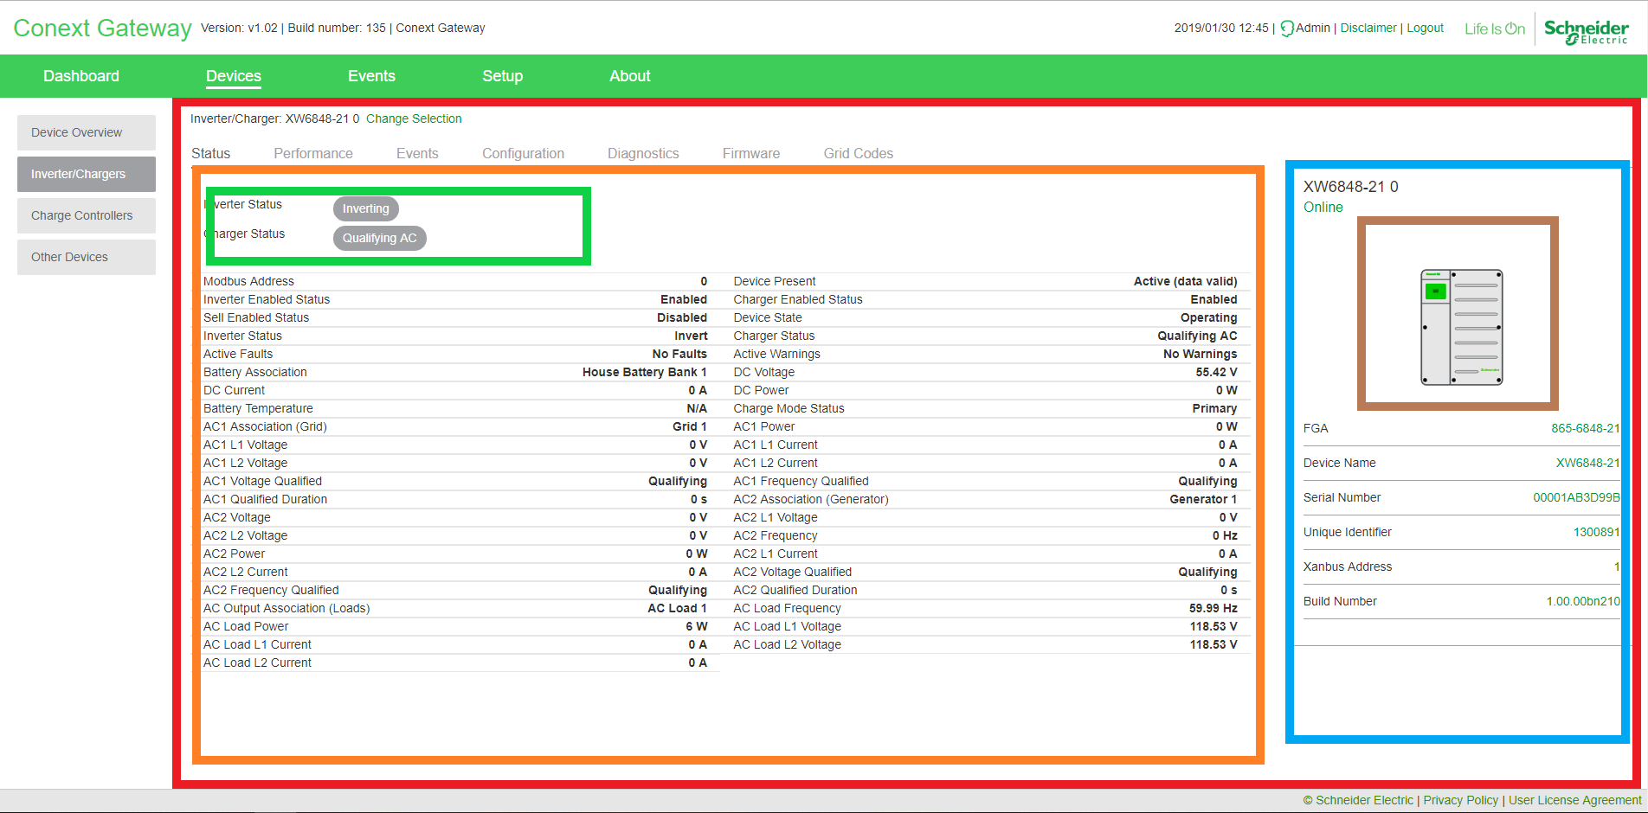

/src/app/xbgateway/DevDetails/xbdevdetail.html

/src/app/xbgateway/DevDetails/xbdevdetail.controller.js

/src/app/xbgateway/Status/xbdevstats_detail.html

/src/app/xbgateway/Status/xbdevstats_detail.controller.js

/src/app/xbgateway/{{Device_type}}/Status/{{Device_type}}_status_directive.js

/src/app/xbgateway/{{Device_type}}/Status/{{Device_type}}_status.controller.js

/src/app/xbgateway/{{Device_type}}/Status/{{Device_type}}_status.html

/src/app/xbgateway/Devinfo/xbdevinfo.directive.js

/src/app/xbgateway/Devinfo/xbdevinfo.html

/src/app/svg-directives/{{Device_type}}/{{Device_type}-image.directive.js

/src/app/svg-directives/{{Device_type}}/{{Device_type}-image.html

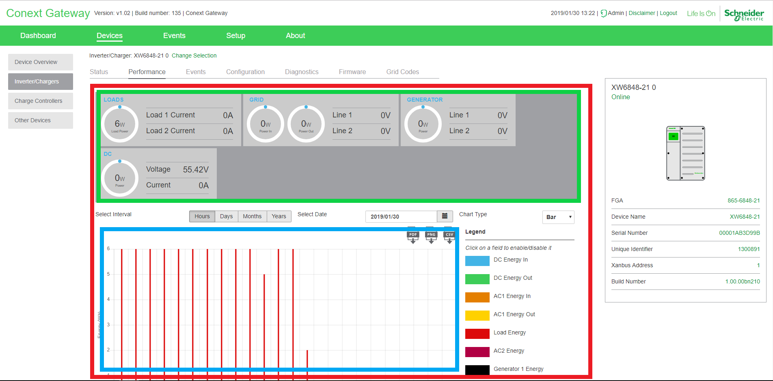

/src/app/xbgateway/performance/performance.controller.js

/src/app/xbgateway/performance/performance.html

/src/app/xbgateway/{{Device_type}}/Status/{{Device_type}}_performance_directive.js

/src/app/xbgateway/{{Device_type}}/Status/{{Device_type}}_performance.html

/src/app/charting/chart.directive.js

/src/app/charting/chart.html

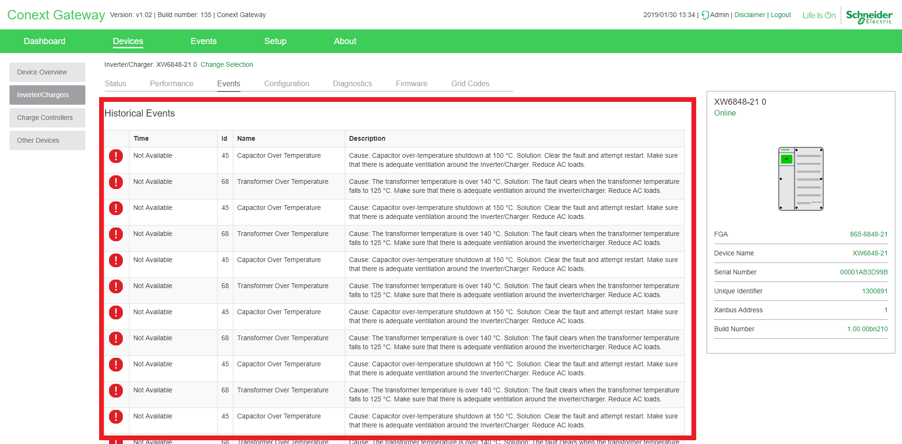

/src/app/xbgateway/DevDetails/xbevents.html

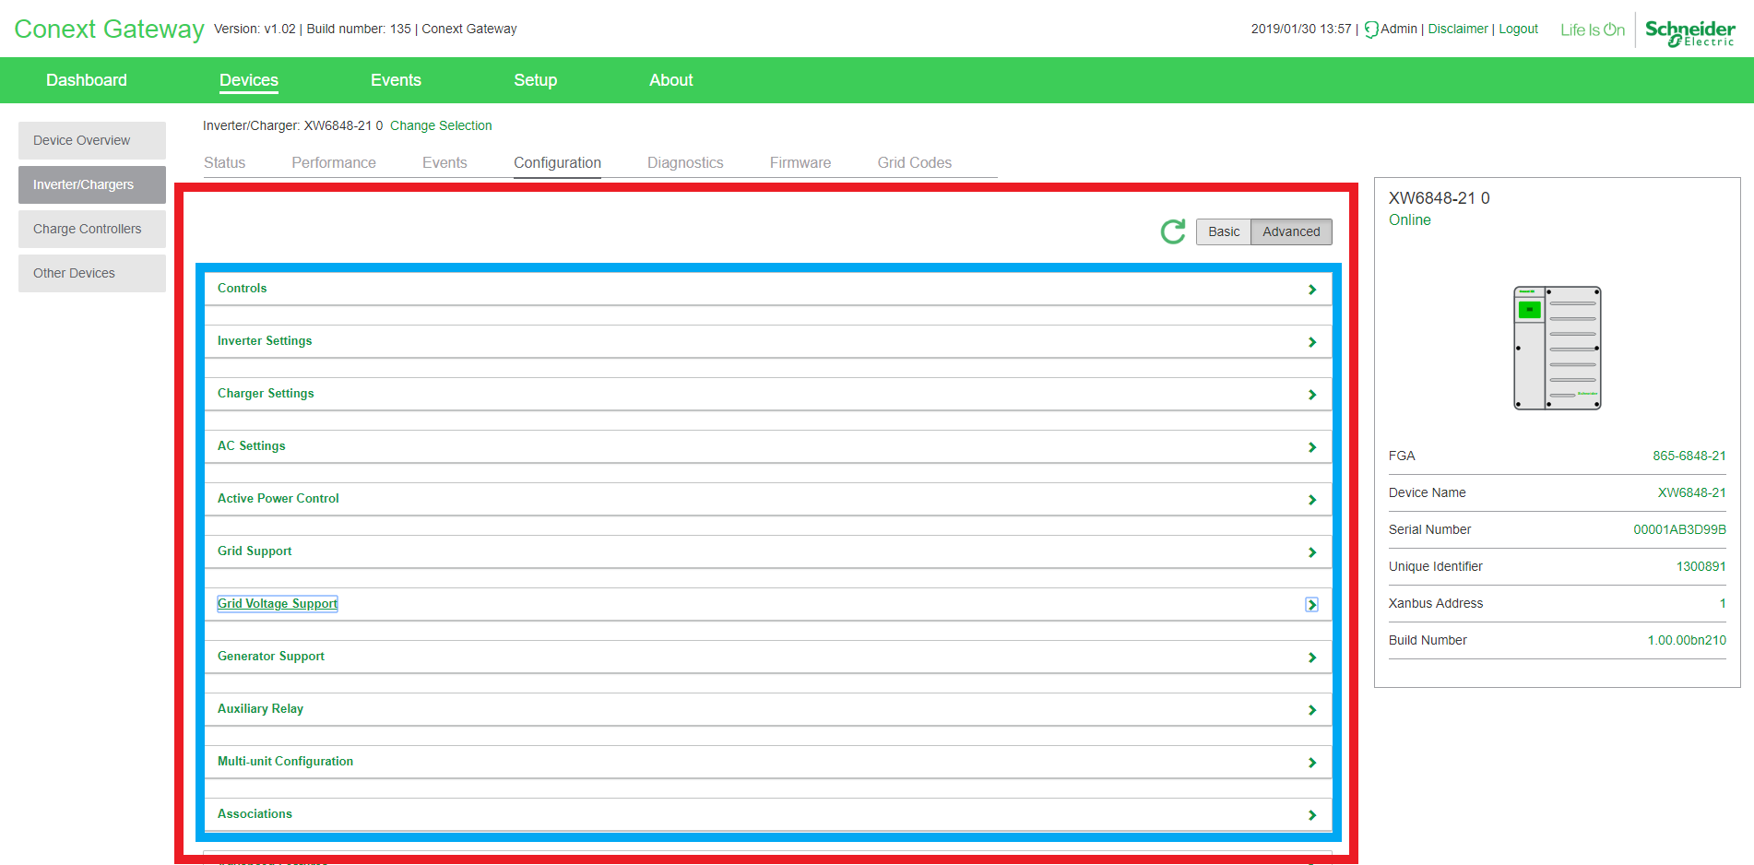

/src/app/xbgateway/Config/xb_config.controller.js

/src/app/xbgateway/Config/xb_config.html

/src/app/xbgateway/Config/xb_config.directive.js

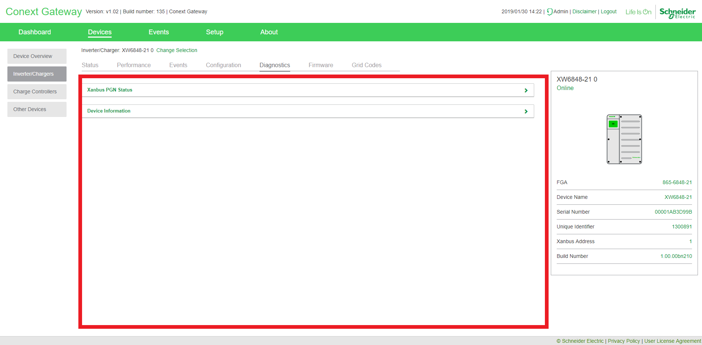

/src/app/xbgateway/xbdeviag.html

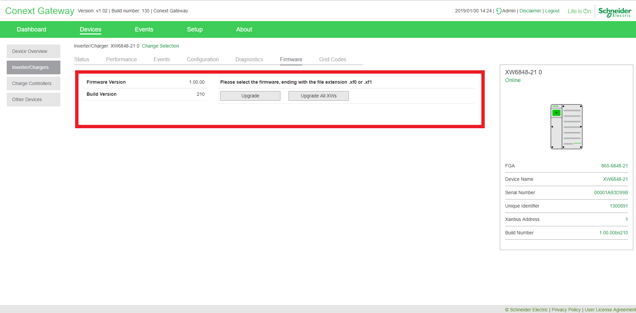

/src/app/xbgateway/FirmwareUpdate/firmware_update.controller.js

/src/app/xbgateway/FirmwareUpdate/firmware_update.html

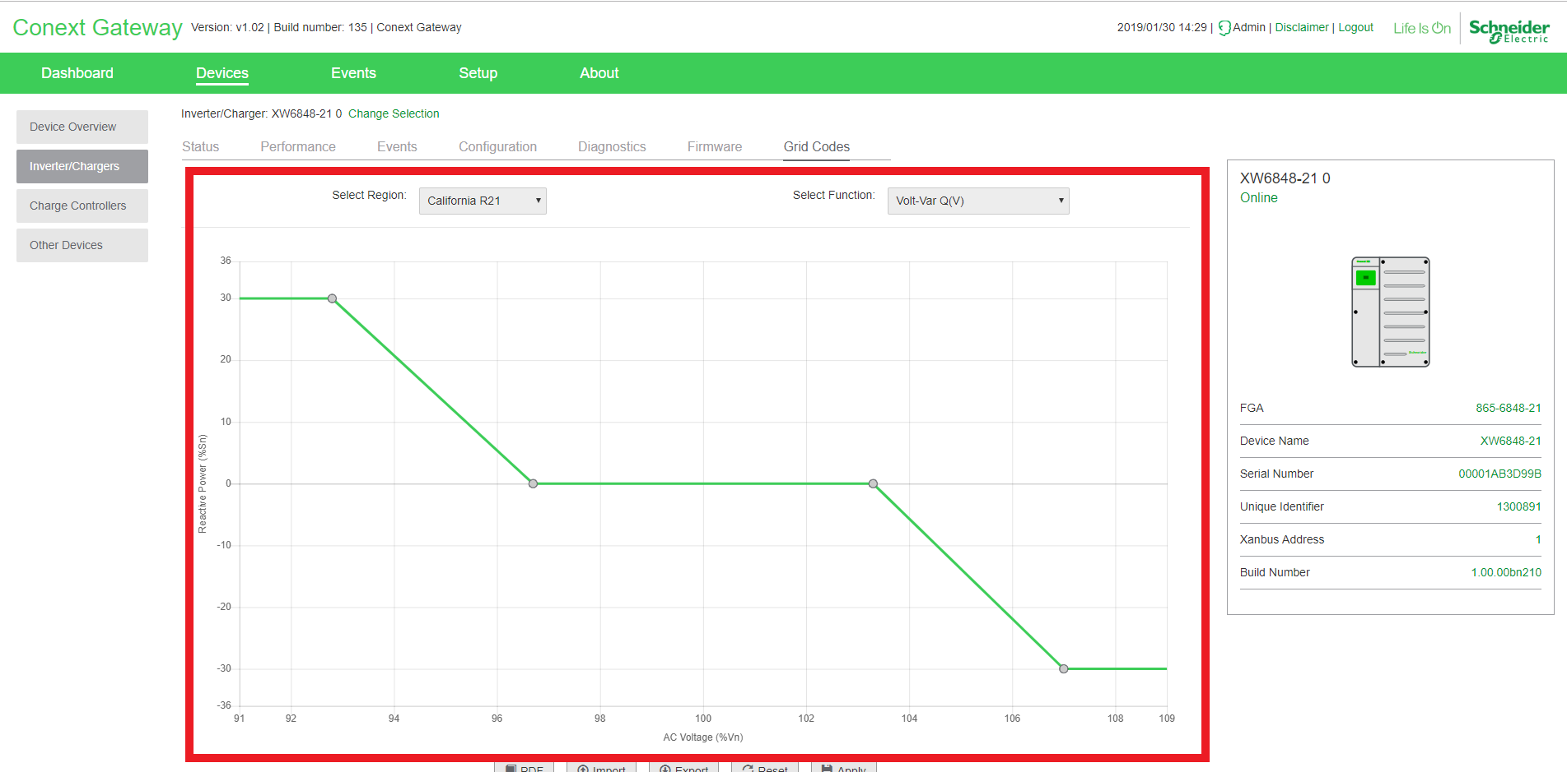

/src/app/xbgateway/GridCodes/gridCodes.controller.js

/src/app/xbgateway/GridCodes/grid_codes.html

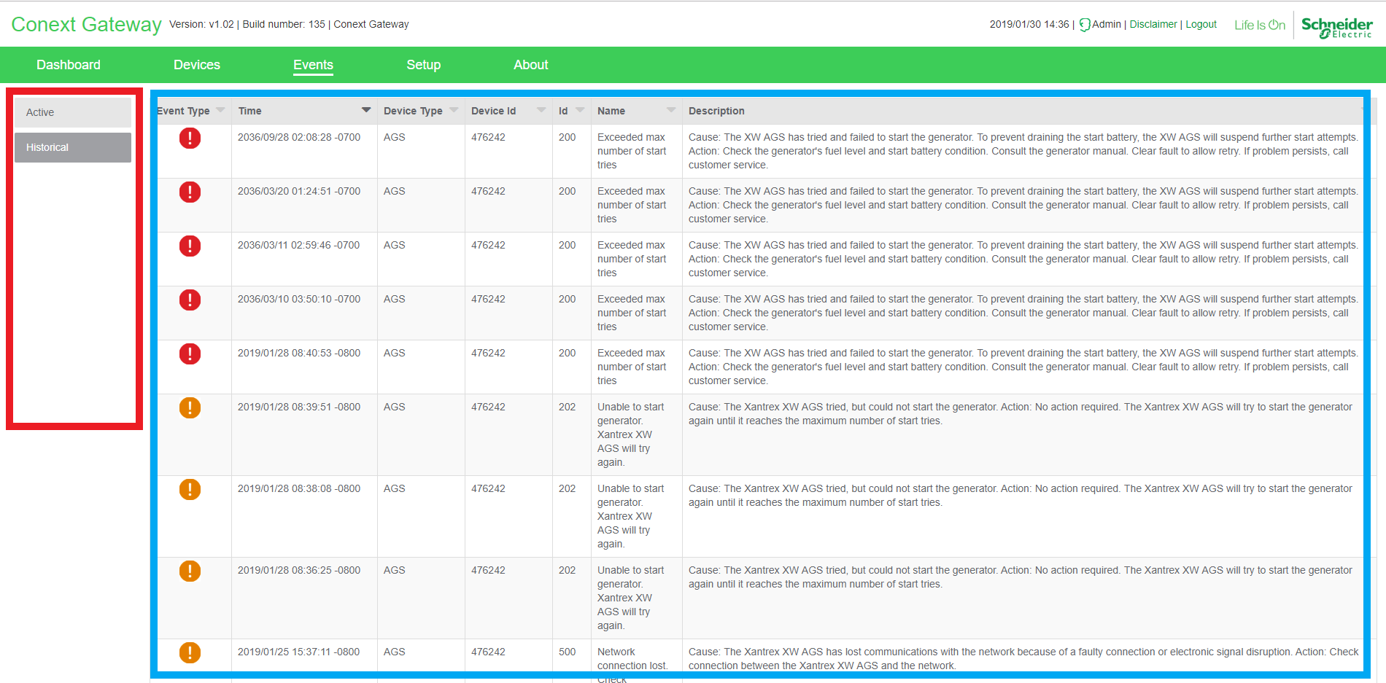

/src/app/events/sidemenu_events.html

/src/app/events/historical.controller.js

/src/app/events/active.controller.js

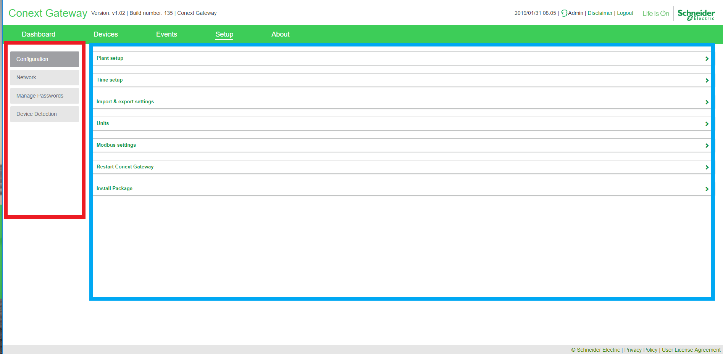

/src/app/setup/sidemenu_setup.html

/src/app/setup/configuration.controller.js

/src/app/setup/configuration.html

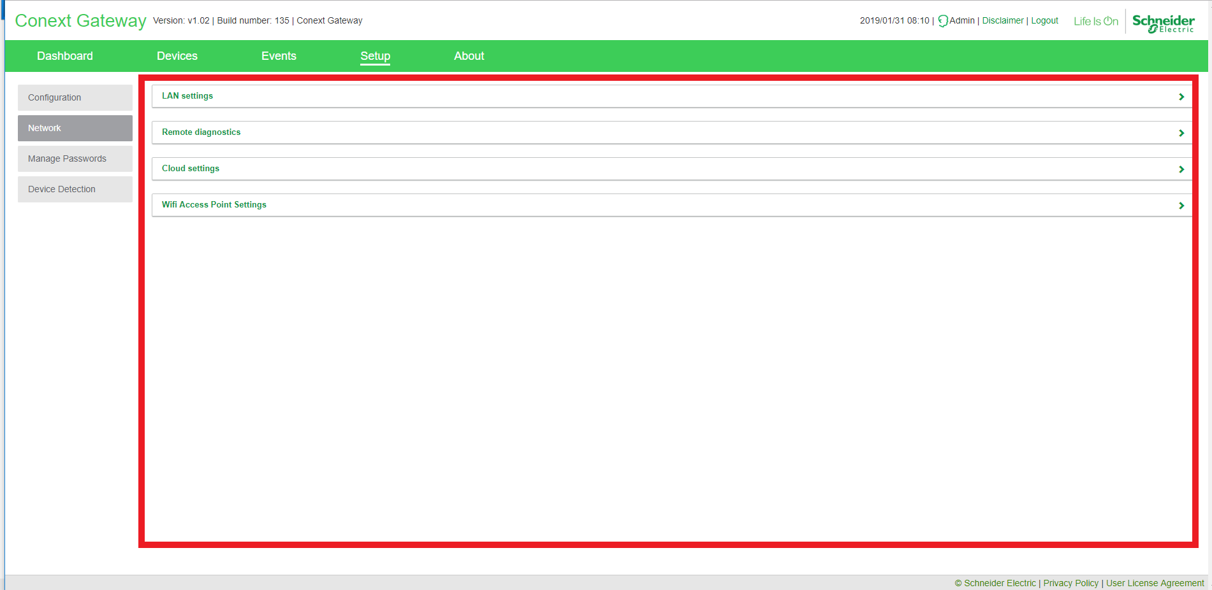

/src/app/setup/network.controller.js

/src/app/setup/network.html

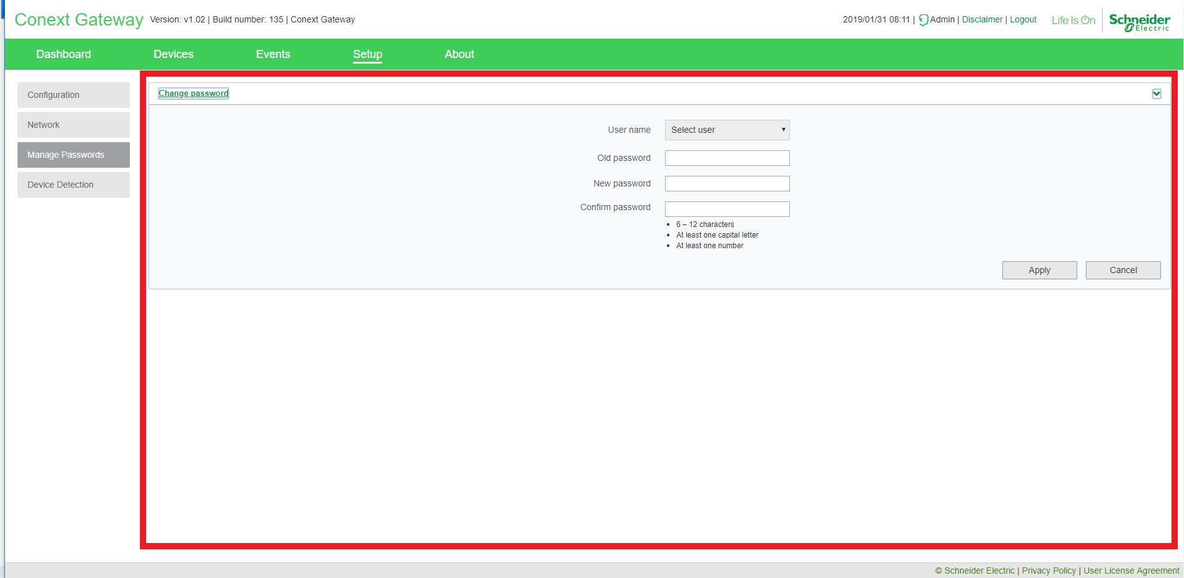

/src/app/setup/manage_passwords/manage_passwords.controller.js

/src/app/setup/manage_passwords/manage_passwords.html

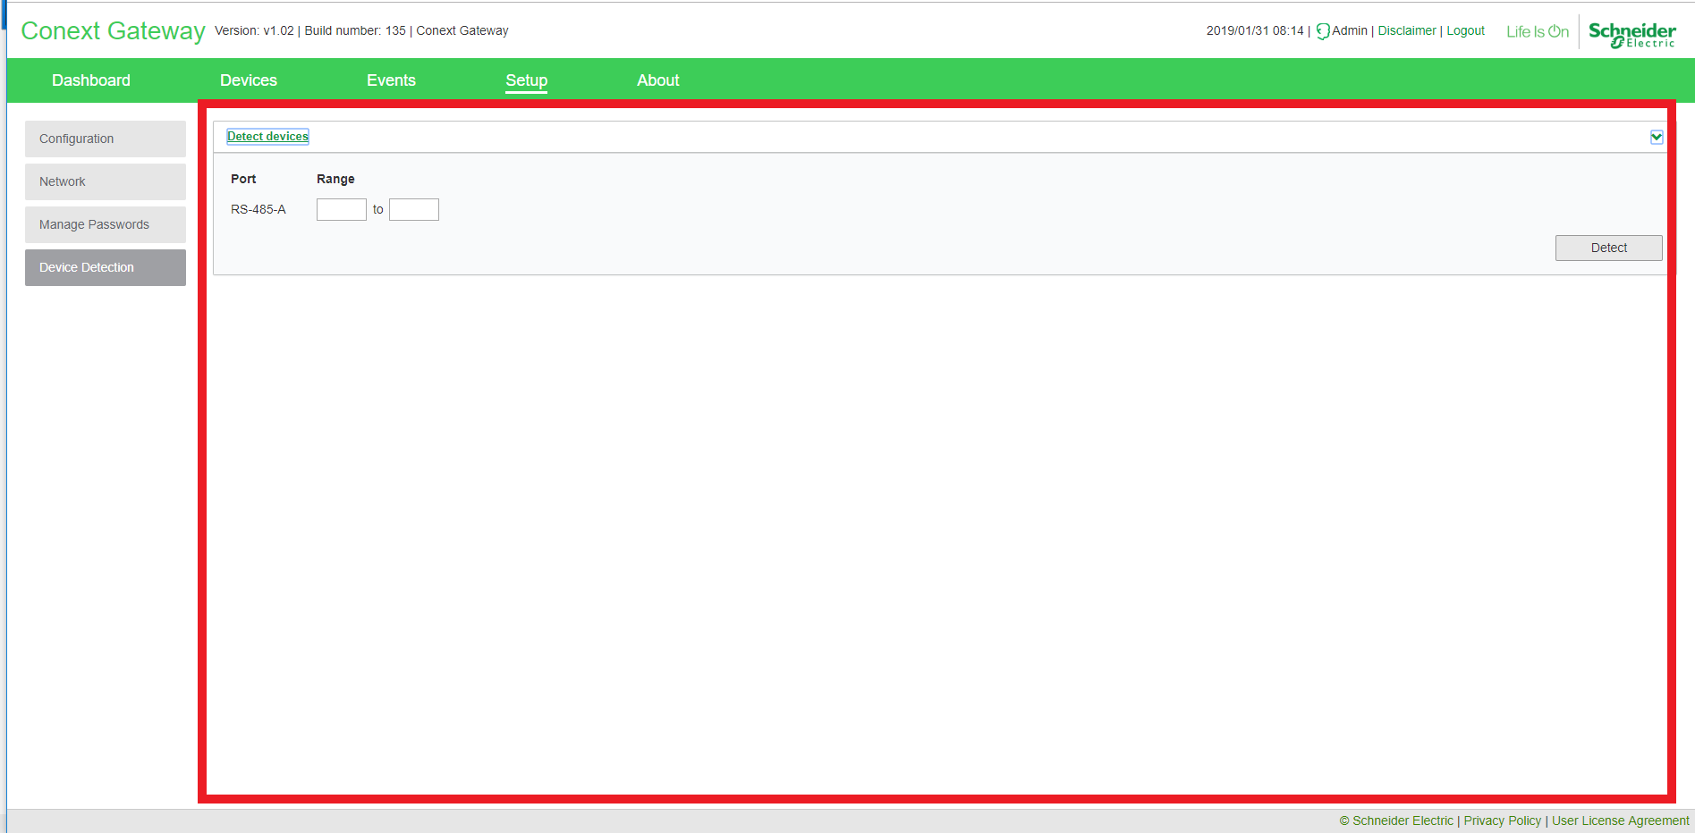

/src/app/devices/detection/detection.html

/src/app/devices/detecton/detection.controller.js

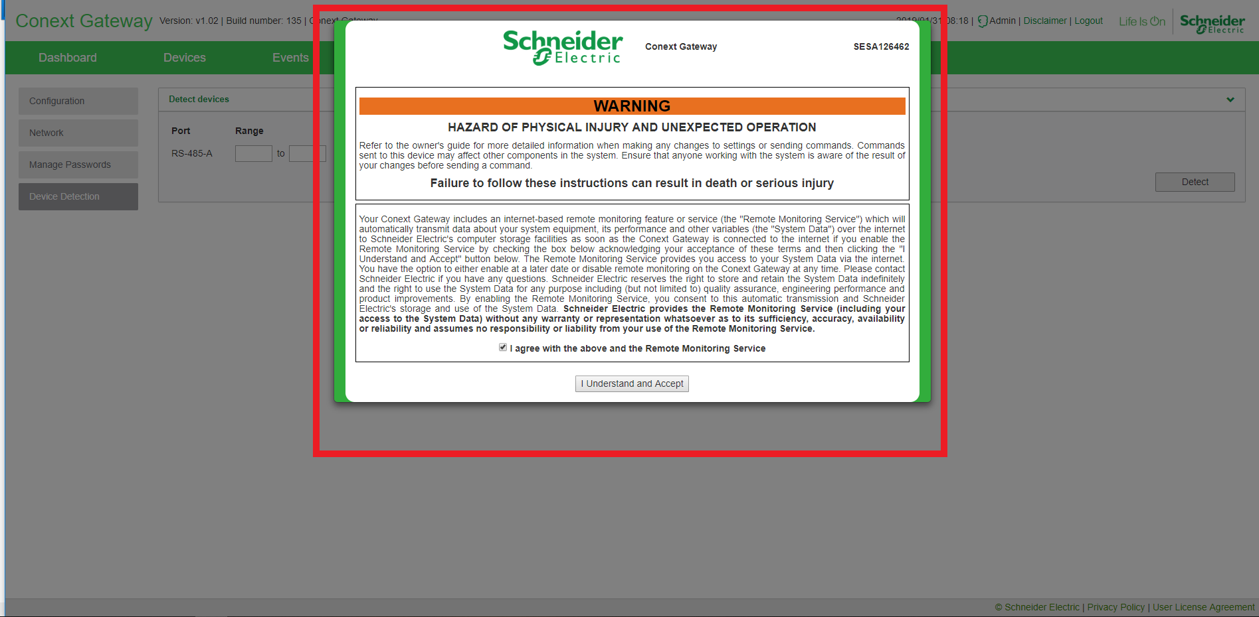

/src/app/disclaimer/disclaimer.controller.js

/src/app/disclaimer/disclaimer.html