
PBCST304 - OBJECT ORIENTED PROGRAMMING
Project Report
SMART GYM MANAGEMENT SYSTEM
[Student Name 1] - University Register Number: ____________________
[Student Name 2] - University Register Number: ____________________
[Student Name 3] - University Register Number: ____________________
[Student Name 4] - University Register Number: ____________________
DEPARTMENT OF ARTIFICIAL INTELLIGENCE AND MACHINE LEARNING
Marian Engineering College
Menamkulam, Thiruvananthapuram
OCTOBER 2026

MARIAN ENGINEERING COLLEGE
DEPARTMENT OF ARTIFICIAL INTELLIGENCE AND MACHINE LEARNING
CERTIFICATE
This is to certify that the project report entitled “SMART GYM MANAGEMENT SYSTEM” submitted by the students listed below, of Third Semester B.Tech in Artificial Intelligence and Machine Learning, has been prepared under the course PBCST304 - Object Oriented Programming. The report is based on the supplied Java source code and database files.
Student Name | University Register Number
[Student Name 1] | ____________________________
[Student Name 2] | ____________________________
[Student Name 3] | ____________________________
[Student Name 4] | ____________________________

The report is submitted for the academic requirements of Marian Engineering College.
Place: Thiruvananthapuram Date: ____________________
Project Guide | Head of Department
Name: __________________________  Designation: ____________________  Signature: ______________________ | Name: __________________________  Designation: ____________________  Signature: ______________________

DEPARTMENT OF ARTIFICIAL INTELLIGENCE AND MACHINE LEARNING
DECLARATION
We hereby declare that this project report entitled “Smart Gym Management System” is our work prepared for PBCST304 - Object Oriented Programming at Marian Engineering College. The report describes the supplied project implementation. It identifies the separate database setup file where its schema differs from the tables initialized by the application.
The screenshots in Chapter 6 were captured from the application’s trainer and member demonstration portals. Database-backed writes were not tested for this report.
Place: Thiruvananthapuram
Date: ____________________
Student Name | Signature
[Student Name 1] | ____________________________
[Student Name 2] | ____________________________
[Student Name 3] | ____________________________
[Student Name 4] | ____________________________

ABSTRACT
Smart Gym Management System is a Java desktop application for gym staff and members. It combines a Swing interface with role-aware accounts, JDBC data access, attendance records, individual diet and workout plans, and member weight and BMI progress. Staff can review the member directory, record attendance and weight, and prepare fitness plans. Members can view their progress, attendance history and assigned plans. The administrator interface provides account management, operational summaries and text exports.
The source demonstrates object-oriented design through abstract User and FitnessPlan classes, role- and plan-specific subclasses, interfaces for data operations, services, DAOs and Java collections. The application initializes users, attendance, diet_plans and workout_plans tables through DatabaseConnection. The separate database_setup.sql file describes a different membership, staff and payment schema; it does not match the schema initialized by the running application.
Keywords: Smart Gym, Java Swing, MySQL, JDBC, attendance, fitness planning, object-oriented programming

CONTENTS
Abstract i
List of Figures iii
List of Tables iv
List of Abbreviations v
Chapter 1 INTRODUCTION 1
Chapter 2 AIM AND OBJECTIVES 2
Chapter 3 REQUIREMENT SPECIFICATION 3
Chapter 4 DESIGN DOCUMENTATION 4
Chapter 5 SYSTEM IMPLEMENTATION 6
Chapter 6 SYSTEM OUTPUT AND SCREENSHOTS 7
Chapter 7 SOURCE CODE LISTING 17
Chapter 8 CONCLUSION 18
REFERENCES 19

LIST OF FIGURES
Figure 6.1 Login page and quick demo access. 7
Figure 6.2 Trainer attendance entry and check-in history. 8
Figure 6.3 Trainer diet-plan editor with nutrition targets. 9
Figure 6.4 Trainer weekly workout-routine editor. 10
Figure 6.5 Trainer member roster with weight, goal and BMI values. 11
Figure 6.6 Trainer and coach directory. 12
Figure 6.7 Member weight and goal-progress dashboard. 13
Figure 6.8 Member attendance chart and personal check-in history. 14
Figure 6.9 Member assigned diet plan and food and water journal. 15
Figure 6.10 Member weekly workout plan and personal log. 16

LIST OF TABLES
Table 2.1 User roles and system functions
Table 3.1 Software requirements
Table 4.1 Main application layers
Table 4.2 Main object-oriented relationships
Table 4.3 Database entities and key fields
Table 4.4 Runtime and separate SQL schemas
Table 5.1 Build and demonstration record

LIST OF ABBREVIATIONS
Abbreviation | Expansion
AWT | Abstract Window Toolkit
BMI | Body Mass Index
CRUD | Create, Read, Update and Delete
DAO | Data Access Object
GUI | Graphical User Interface
JDBC | Java Database Connectivity
JDK | Java Development Kit
OOP | Object-Oriented Programming
SQL | Structured Query Language
UI | User Interface

Chapter 1
INTRODUCTION

1.1 Background
A gym handles member registration, attendance, coaching and personal fitness plans. When these records are kept in separate files or handled manually, staff may have to repeat work to locate current information and members may have little visibility into their progress. A desktop system can keep related tasks together and present each user with the features appropriate to their role.
Smart Gym Management System is implemented in Java with AWT and Swing. Its source is organized into model, UI, service, DAO, database, exception and utility packages. The code covers account data, attendance, diet and workout planning, weight tracking, charts and text exports.

1.2 Problem Statement
The project addresses the need to manage gym accounts and fitness activity through one interface. Staff should be able to record attendance and issue plans while members review their progress. The system also needs a persistence layer and a usable demonstration path when MySQL is unavailable.

1.3 Relevance
The application is relevant to a gym seeking organized member and trainer workflows and to an academic project demonstrating OOP and database connectivity. Its models and interfaces provide examples of inheritance, abstraction, encapsulation, polymorphism, DAO contracts and JDBC.

1.4 Scope
The Java implementation covers account registration and sign-in, role-based panels, administrator account tools, staff attendance and fitness-plan editing, member weight and attendance views, and roster or attendance text exports. Fee invoicing, payment collection and membership expiry are described by database_setup.sql but are not evidenced as integrated Java workflows.

Chapter 2
AIM AND OBJECTIVES

2.1 Aim
The aim is to develop a role-based desktop application that supports gym administration and member fitness tracking through Java Swing, object-oriented models and MySQL connectivity.

2.2 Objectives
1. Provide sign-in and account creation for administrator, trainer and member roles.
2. Maintain user profiles, attendance, diet plans and workout routines.
3. Let staff record attendance and measured weight and edit individualized plans.
4. Give members goal progress, BMI, attendance history and assigned fitness guidance.
5. Give administrators account tools, dashboard indicators and text exports.
6. Use JDBC for MySQL persistence and temporary fallback behavior for selected DAO operations.
7. Demonstrate OOP through abstract classes, subclasses, interfaces, overriding, overloading and collections.

2.3 Users of the System
Table 2.1 User roles and system functions
User role | Primary functions
Administrator | Manage accounts; review operational indicators; export member and attendance records.
Trainer / staff | Mark attendance; update member weight; maintain diet and workout plans; review member and staff directories.
Member | Review goal progress, BMI, attendance, diet plan and workout routine; maintain personal logs.

Chapter 3
REQUIREMENT SPECIFICATION

3.1 Software Requirements
Table 3.1 Software requirements
Component | Requirement
Programming language | Java; compile source with JDK javac.
GUI framework | AWT and Swing desktop components.
Database connectivity | MySQL through JDBC and MySQL Connector/J 8.3.0 bundled in lib.
Persistence | MySQL when reachable; selected DAOs provide in-memory fallback collections.
Launch tools | compile_and_run.bat or compile_and_run.ps1; README.md also documents manual compilation.

3.2 Hardware and Display Requirements
The application requires a desktop or laptop capable of running the selected Java runtime and, for database-backed operation, a configured MySQL service. The main frame sets a minimum window size of 1020 x 680 pixels. The supplied project does not specify minimum processor, memory or disk values, so these depend on the installed Java runtime and local database environment.

3.3 Functional Requirements
1. The login portal provides sign-in, registration and quick demonstration access for trainer and member roles.
2. Staff can record member check-ins with date, time, status, workout focus and notes.
3. Staff can edit calorie and macro targets, meals, hydration guidance and weekly workout schedules.
4. Staff can review member profiles and weight, goal and BMI values, and the trainer directory.
5. Members can update weight metrics and view progress, BMI indicators and attendance history.
6. Members can view assigned diet and workout plans and keep food, water or workout logs.
7. Administrators can manage accounts, inspect dashboard indicators and export roster and attendance text files.

3.4 Non-functional Requirements
• Role-specific screens should make available actions clear.
• User-entered SQL parameters should be bound through PreparedStatement.
• Database-backed operations require valid MySQL settings and a reachable server.
• In-memory fallback data is temporary and is not durable offline synchronization.
• The UI, service, DAO and model separation should support maintenance.

Chapter 4
DESIGN DOCUMENTATION

4.1 System Architecture
The program is organized as a desktop client with presentation, service, DAO, model and infrastructure layers. GymManagementFrame hosts login and role panels. Services coordinate requests; DAOs use JDBC or fallback collections to read and write records.
Table 4.1 Main application layers
Layer | Project components | Responsibility
Presentation | GymManagementFrame, LoginPanel, StaffPanel, UserPanel, chart panels | Collect actions and present role screens and progress graphics.
Services | UserService, AttendanceService, FitnessService | Coordinate application and domain operations.
Data access | UserDAO, AttendanceDAO, FitnessDAO and interfaces | Run parameterized SQL and provide selected in-memory fallback.
Domain model | User, role subclasses, Attendance, FitnessPlan subclasses | Represent accounts, attendance and fitness-plan data.
Infrastructure | DatabaseConnection, exceptions, FileHandler | Initialize JDBC tables, report errors and export text files.

4.2 Class Design and OOP Concepts
User is an abstract base class for administrator, trainer and member accounts. FitnessPlan is an abstract base class for diet and workout plans. Subclasses override role and plan behavior; operation interfaces separate DAO contracts from implementations.
Table 4.2 Main object-oriented relationships
Type | Design role
User | Abstract class with shared account information and role-specific method contracts.
AdminUser, TrainerUser, MemberUser | Role subclasses implementing dashboards and feature-access behavior.
FitnessPlan | Abstract base class for fitness plan behavior.
DietPlan, WorkoutPlan | Plan subclasses for nutrition and weekly exercise guidance.
UserOperations, AttendanceOperations, FitnessOperations | Interfaces describing data operations implemented by DAO classes.

Encapsulation appears in private member metrics and plan fields with accessors. Method overloading is used for constructors and search operations. Runtime polymorphism lets services call behavior through a User or FitnessPlan reference. Lists and maps carry query results and fallback records.

4.3 Database Design
DatabaseConnection.initializeDatabase() creates four tables when the Java application connects to MySQL. This schema is application-specific and matches the DAOs used by the Java source.
Table 4.3 Database entities and key fields
Table | Primary and related fields | Purpose
users | user_id PK; unique username; role; contact; staff/member fields; weight and height metrics. | Shared sign-in identity, staff details and member profile.
attendance | attendance_id PK; member_id/name; date/time; status; workout_type; notes. | Member check-in history.
diet_plans | plan_id PK; member/name; trainer; calorie/macros; meals; water; notes; daily log. | Nutrition guidance and member journal.
workout_plans | plan_id PK; member/name; trainer; goal; weekly schedule; cardio and notes; workout log. | Exercise schedule and member log.

4.4 Separate SQL Setup and Schema Difference
The repository also includes database_setup.sql. It creates members, staff, attendance and member_payments tables, analytical views and sample data. This differs from the four tables created by DatabaseConnection. The Java source initializes users, attendance, diet_plans and workout_plans. Although both designs use an attendance table, their columns differ. The membership, staff-payroll and payment objects in database_setup.sql should be treated as a separate schema artifact until the project consolidates the designs.
Table 4.4 Runtime and separate SQL schemas
Schema source | Tables / views | Relationship to application
DatabaseConnection.java | users, attendance, diet_plans, workout_plans | Created during startup and used by Java DAOs.
database_setup.sql | members, staff, attendance, member_payments; three views | Separate membership and finance-oriented design; not initialized by application startup.

4.5 Transaction and Fitness Workflows
1. Authenticate the selected role and open its dashboard.
2. For attendance, select a member and enter date, time, status, workout focus and notes.
3. For a fitness plan, choose a member, load or enter plan values, then save the assignment.
4. For progress, update current weight and compare it with starting and target weights.
5. When MySQL is unavailable, selected DAO methods use process-local fallback collections; those records do not survive restart.

Chapter 5
SYSTEM IMPLEMENTATION

5.1 Technology Stack
Java implements the models, services, DAOs and interface. AWT and Swing provide the desktop UI; Java 2D paints the weight and attendance charts. JDBC connects to MySQL through Connector/J. FileHandler provides text exports.

5.2 Main Modules
Module | Implemented screens and operations
Login and account setup | Role-aware sign-in and account registration.
Trainer / staff | Attendance, diet and workout plans, member roster and staff directory.
Member | Weight progress, BMI, attendance chart, assigned plans and personal logs.
Administrator | Account management, dashboard and roster/attendance exports.
Charts and file output | Custom Java 2D charts and text exports through FileHandler.

5.3 Database and Offline Mode
DatabaseConnection loads its connection properties from db.properties and initializes the runtime tables after connecting. If connection setup fails, it marks the database unavailable. DAO classes may then use fallback data for selected operations. This supports a local demonstration but is not persistent offline storage.

5.4 Object-Oriented Implementation
Abstraction is used in User and FitnessPlan. Inheritance is used for role and plan subclasses. Private member fields support encapsulation. Overridden methods demonstrate polymorphism. UserOperations, AttendanceOperations and FitnessOperations define DAO contracts. The service layer keeps SQL out of the Swing panels.

5.5 Security and Scope Notes
DAO queries use PreparedStatement for parameter binding. The users table includes a password field, and password hashing is not evident in the reviewed implementation. Connection settings are externalized in db.properties, while source also contains connection defaults. The application should be treated as an academic demonstration until credentials, authorization, migrations and data protection are hardened.

5.6 Build and Demonstration Record
Table 5.1 Build and demonstration record
Activity | Observed result
Source compilation and launch | Java source compiled successfully and the temporary demonstration copy opened.
Screen capture | Trainer and member demo views captured; no records were saved.
Database writes | Not tested. The temporary copy used an unreachable loopback endpoint to avoid the configured project database.

Chapter 6
SYSTEM OUTPUT AND SCREENSHOTS
The following figures show screens captured from trainer and member demonstration portals. They document visible interfaces and sample records; they do not establish that MySQL-backed writes were verified.
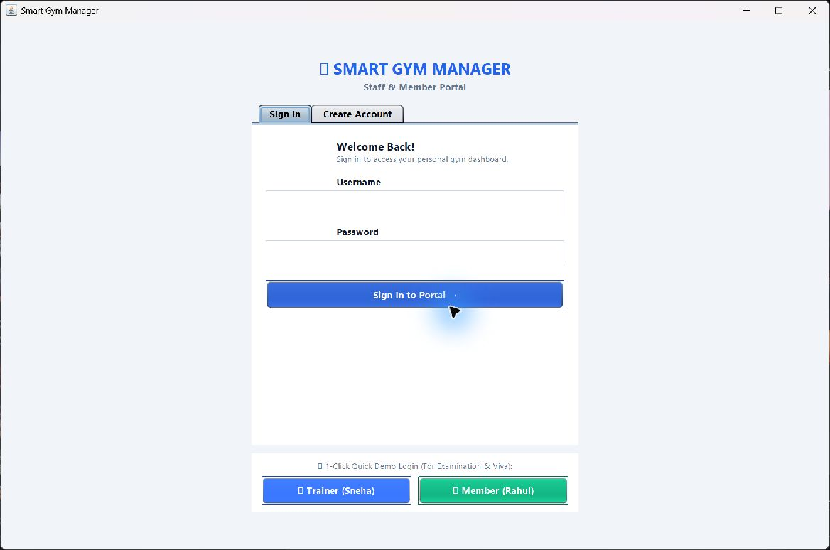
Figure 6.1 Login page and quick demo access.

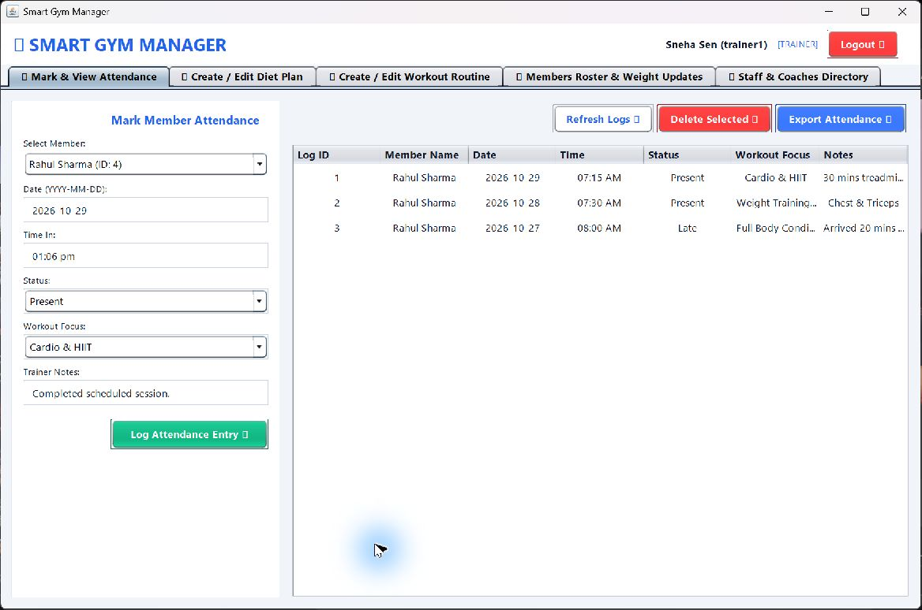
Figure 6.2 Trainer attendance entry and check-in history.

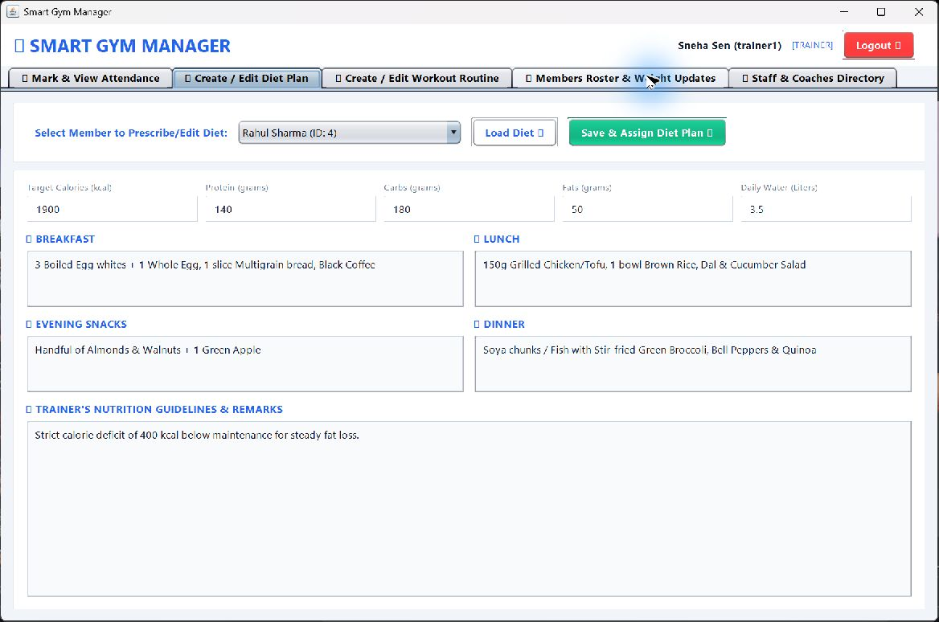
Figure 6.3 Trainer diet-plan editor with nutrition targets.

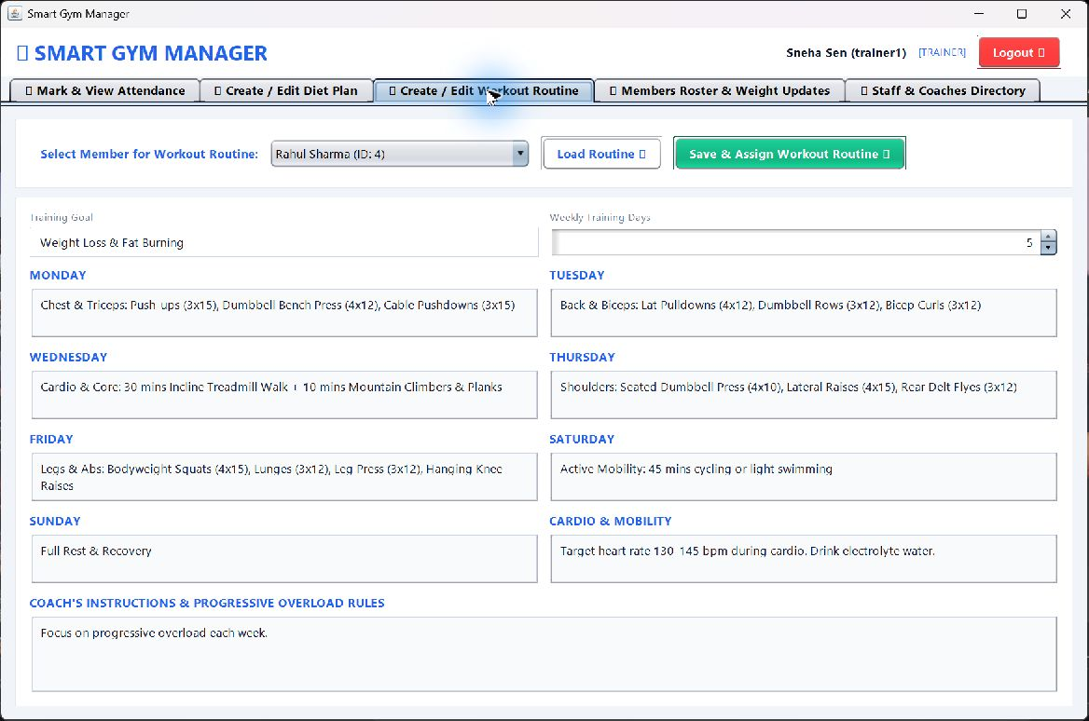
Figure 6.4 Trainer weekly workout-routine editor.

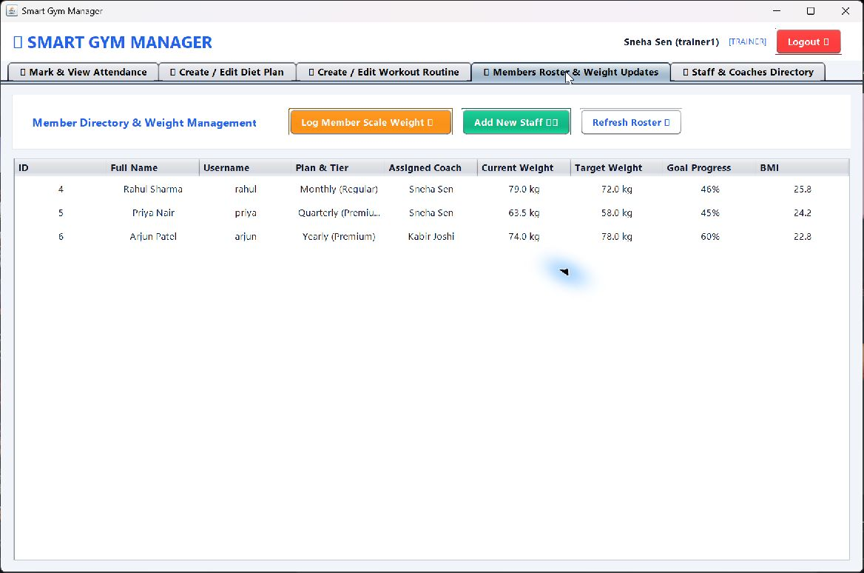
Figure 6.5 Trainer member roster with weight, goal and BMI values.

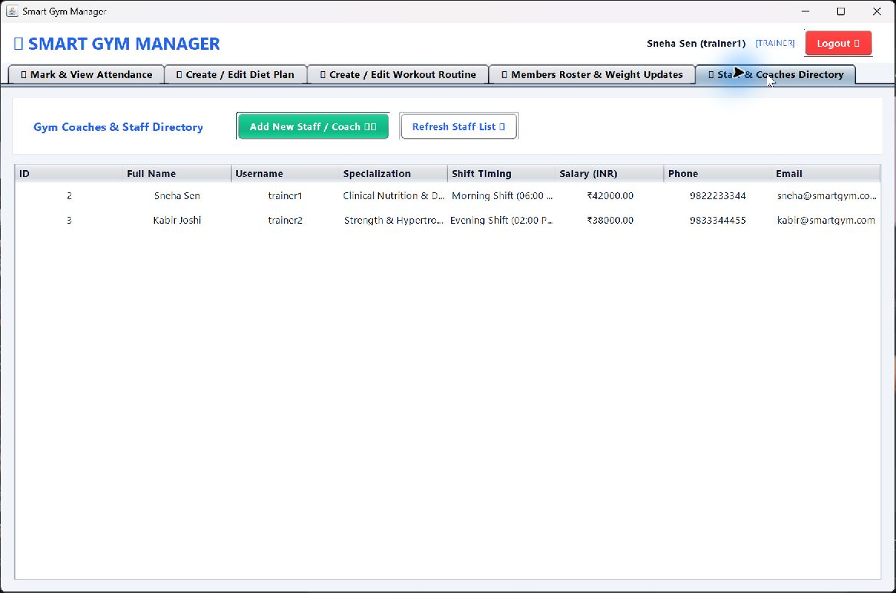
Figure 6.6 Trainer and coach directory.

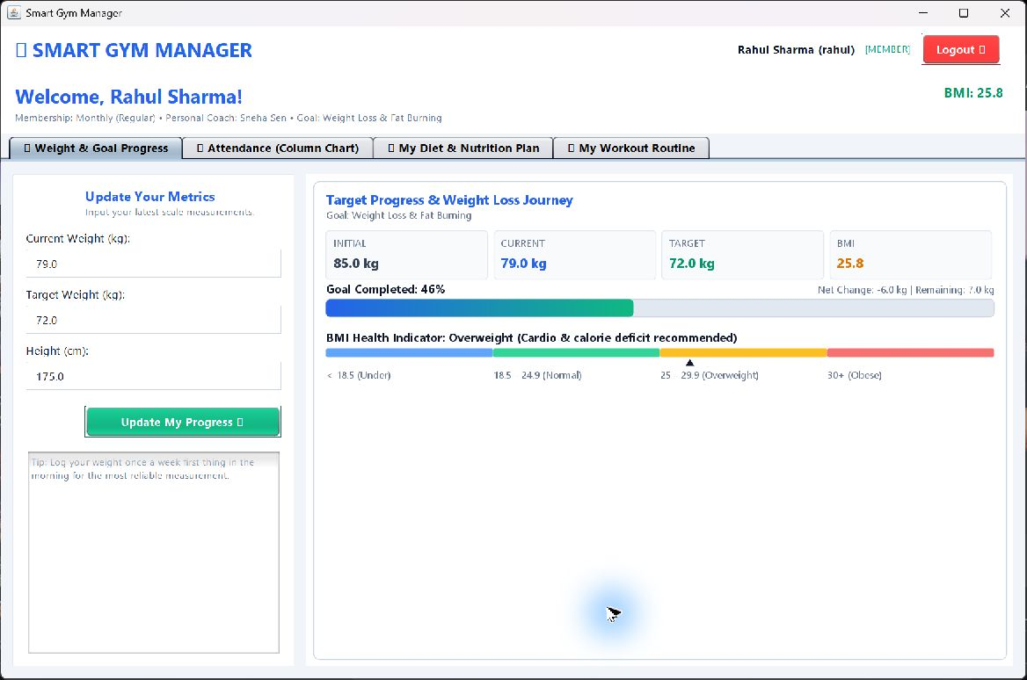
Figure 6.7 Member weight and goal-progress dashboard.

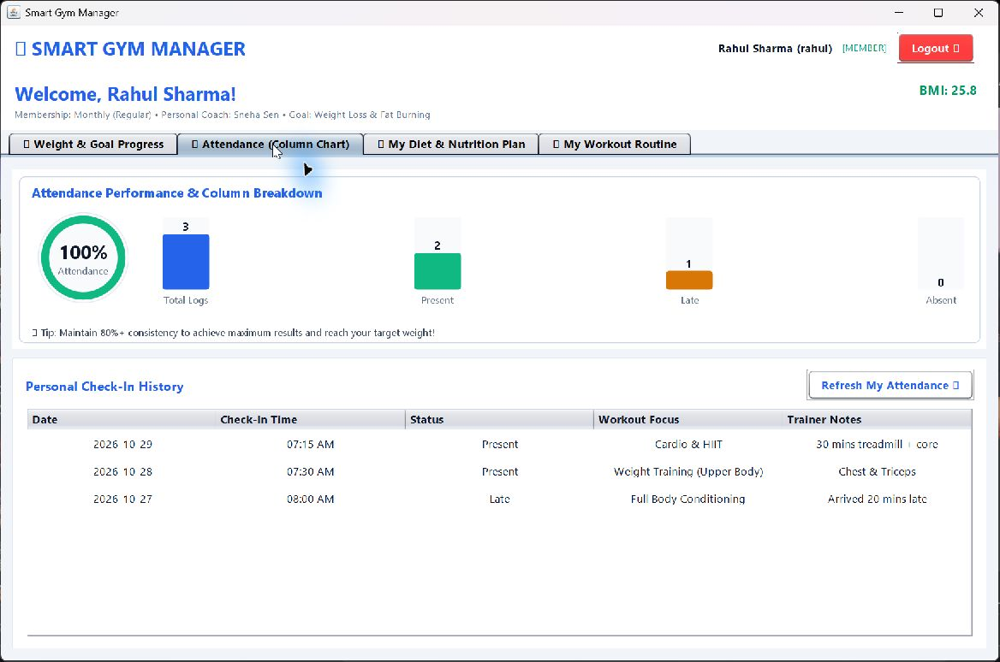
Figure 6.8 Member attendance chart and check-in history.

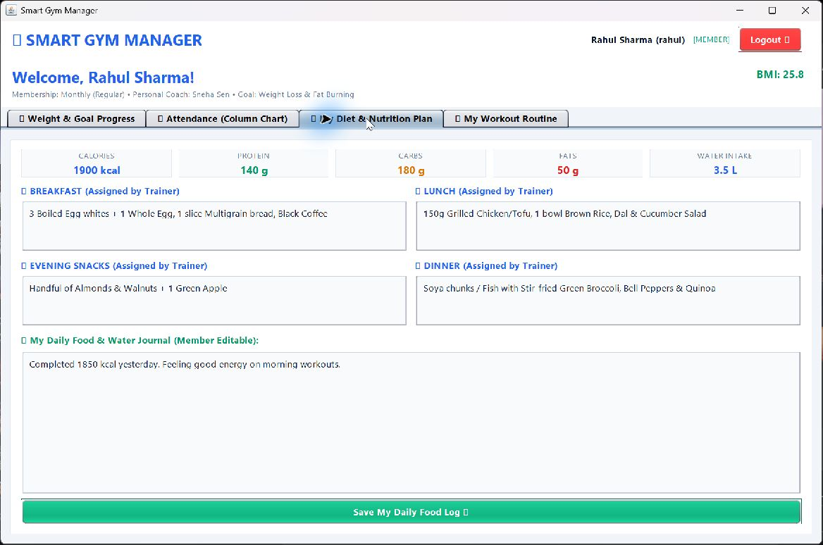
Figure 6.9 Member assigned diet plan and daily journal.

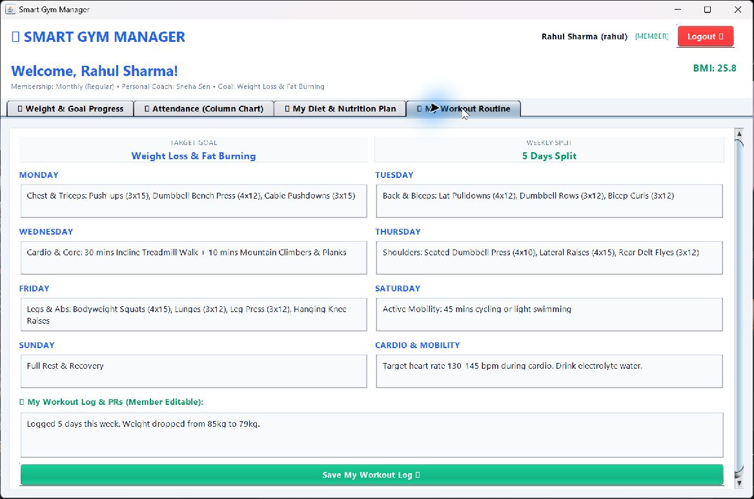
Figure 6.10 Member weekly workout plan and personal log.

Chapter 7
SOURCE CODE LISTING
The selected excerpts are taken from supplied source files. They illustrate abstract account behavior, member metric calculation, parameterized attendance persistence and runtime schema initialization.

7.1 Abstract account behavior from User.java
public abstract class User {
public abstract String getRoleDescription();
public abstract String getDashboardTitle();
public abstract boolean hasAccessTo(String feature);
}

7.2 BMI calculation from MemberUser.java
public double getBMI() {
if (heightCm <= 0) return 0.0;
double heightInMeters = heightCm / 100.0;
double bmi = currentWeight / (heightInMeters * heightInMeters);
return Math.round(bmi * 10.0) / 10.0;
}

7.3 Parameterized attendance insert from AttendanceDAO.java
String sql = "INSERT INTO attendance (member_id, member_name, date, time_in, status, workout_type, notes) VALUES (?, ?, ?, ?, ?, ?, ?)";
try (PreparedStatement ps = conn.prepareStatement(sql, Statement.RETURN_GENERATED_KEYS)) {
ps.setInt(1, attendance.getMemberId());
ps.setString(2, attendance.getMemberName());
ps.setString(3, attendance.getDate());
// Bind the remaining fields before executeUpdate().
}

7.4 Runtime table definition from DatabaseConnection.java
String createDietSQL = "CREATE TABLE IF NOT EXISTS diet_plans ("
+ "plan_id INT PRIMARY KEY AUTO_INCREMENT, "
+ "member_id INT NOT NULL, member_name VARCHAR(100) NOT NULL, "
+ "target_calories INT, protein_grams INT, carbs_grams INT, fats_grams INT, "
+ "breakfast TEXT, lunch TEXT, snacks TEXT, dinner TEXT, "
+ "water_liters DECIMAL(4,2), general_notes TEXT, user_daily_log TEXT"
+ ") ENGINE=InnoDB DEFAULT CHARSET=utf8mb4;";

Chapter 8
CONCLUSION

8.1 Conclusion
Smart Gym Management System combines gym account management and fitness tracking in a role-based Java desktop application. The code demonstrates layered design, object-oriented models, JDBC persistence, chart panels and text exports. Trainer workflows cover attendance and fitness plans; member workflows present progress, history and assigned guidance. Source review also identified a mismatch between the runtime schema and database_setup.sql, so consolidating the database designs is a practical next step.

8.2 Future Scope
• Align database_setup.sql with the runtime users, attendance and fitness-plan schema or implement membership/payment features in the application.
• Add foreign keys, indexes and versioned migrations for persistent data.
• Hash passwords and remove insecure development credentials from source defaults.
• Add automated tests for BMI and goal calculations, role access, DAO behavior and plan updates.
• Capture a verified administrator session and database workbench views if required for submission.

REFERENCES
[1] Smart Gym Management System source code, src/com/smartgym, supplied with the project.
[2] database_setup.sql, separate membership, staff, payment and analytics schema.
[3] README.md, compile_and_run.bat and compile_and_run.ps1 supplied with the project.
[4] PROJECT REPORT PBCST304_Projectreport FormatDemo, Marian Engineering College report format.
[5] Java Platform documentation, https://docs.oracle.com/en/java/.
[6] MySQL Connector/J Developer Guide, https://dev.mysql.com/doc/connector-j/en/.

