Here is my findings of the member survey.

* Link to survey <https://docs.google.com/forms/d/1SgXfOvBPVq967l1A3LZH2JNWEA5-076EWFgYAGcWv6w/edit?usp=sharing>).
* Link to the excel file that I worked on. (<https://docs.google.com/spreadsheets/d/1ol04wIs16Y3Faflj9k2hjQPD4dghVzC7tP5YTfFgK7A/edit?usp=sharing>)

I listed some of the findings that might be useful to us. I also listed some of the potential pitfalls that we should keep in mind when interpreting the results.

**Findings-**

* 28 people answered the questionnaire. Among the 28 people, 13 people had come between 1-4 nights (defined as ‘**new members**’), 15 had come > 7 nights (defined as ‘**old members**’)
* They immediately felt that Code for SF is a safe place, there is a sense community (3.8/5), members are part of the decision making process (3.2/ 5), and members are enthusiastic (3.9/ 5).  There is no difference between new members and old members.
* Among **all members** (n=28), their top skill sets are- **product and project management (11), frontend development (9), backend development (8), and data science (8).** Note: is it possible that these people are in front of their computers more often?  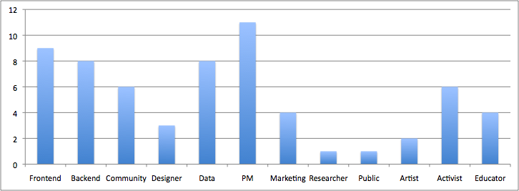
* If we look at just **new members** (blue bars), the most common skill sets are **frontend (6), backend (4), and data science (4)**. However, the most common skill set among old members is PM (8). 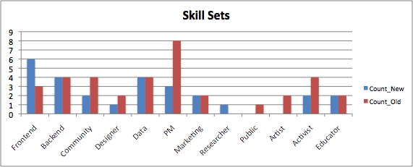
* Among 28 members, their **highlights** of the nights are broken down into the results below. The most common highlight is **‘meeting people**’. There is no significant difference between new members and old members.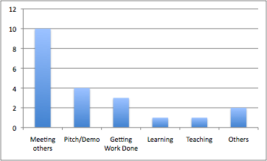
* For 1st time new members, 3 out of 5 felt that they were *fully aware of all the available activities*.
* For 1st time new members, 2 out of 5 felt that they knew *where to go to get started with projects.*
* For old members (>7 nights), 6 out of 15  were *fully aware of all the available activities* after 2 nights.

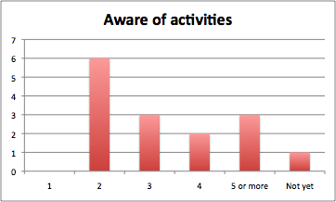

* For old members (>7 nights), 11 out of 15 old members needed **at least 3 nights** to know ***where to go get started with projects***. Also, it took them longer to know where to get started than knowing available activities.
* Old members are significantly more likely to recommend the Code for SF to others than new members (8.7/10 vs. 6.9/10).

**Personal thoughts on potential pitfalls of the questionnaire-**

* How was this questionnaire distributed?
* The questionnaire may need to better explain what *“all the available activities”* mean. If I didn’t know what ‘all the available activities’ are, how would I know the answer?
* The questionnaire asked about ‘*where to go to get started with a project*. Does this mean ‘who to talk to’,  ‘which team to join’, or ‘actually joining a project team’?   These are quite different choices. The questionnaire may need to make it clear.
* The question ‘*feedback for the survey*’ was a bit confusing. Some people interpreted it as ‘feedback for the event’, while some interpreted it as ‘feedback for the design of the questionnaire’. One did not understand the question. What was this question intended for?

**Other points that stood out to me-**

* One person mentioned feeling unwelcomed due to a lack of vegan food. Perhaps ‘Code for SF’ needs to set people’s expectation on food choices more clearly on the website. For example, is dinner provided? What are the options in general?
* One person mentioned breaking the projects down to smaller tasks + mentoring for less experienced contributors.
* More focused work time