New Member Engagement

Recommendations to improve new-member engagement as well as new-member retention at projects hosted at Code for San Francisco

**Summary**

New members arrive ready to contribute to projects or to learn skills, but current project members are mainly focused on their work. Key strategies to engage new members include clearly conveying project domain, better fitting new members’ skillsets with team needs, having one representative from each project assigned to engage with new members, and creating a process to kick-start new projects with the new members.

**Background**

Many new members show up at the Code for SF weekly meetup with lots of enthusiasm wanting to contribute to the community, and to work on a civic tech project. However, many of these new members do not return after a couple meetups, in spite of the initial passion. The core team at Code for SF was intrigued about this phenomenon. The group initiated this research project in order to understand more about new members’ needs, as well as what the organization can do to improve new-member engagement and retention.

**Methods**

* **Individual interview.** Individual interviews were conducted with four project leads and four newcomers between 01/2016-02/2016. The interview questions focused on their background, experiences, and expectations at Code for SF in order to identify their needs. The interview took about 30 minutes each either at the Code for SF Hack Night or on the phone.
* **Group interview.** One group interview was conducted with five first-time newcomers at Code for SF in 01/2016, with particular focuses on their positive and negative experiences, motivations to come, and desired outcomes in two months. The interview took 40 minutes at the Code for SF Hack Night.

**Findings**

At the Code for SF meetup, new members generally feel that they are welcomed and that there is a sense of community. They often spend the first night exploring existing projects, connecting with people, and evaluating projects that interested them.

**Top needs we identified from new members at Code for SF:**

* **Better understanding of project problem domain and goals.**While Code for SF hosts projects in the larger scope of civic tech, new members are often only passionate about a small subset of the civic tech issues. It is extremely important for the new members to see a list of problems currently being worked on by project teams, as well as mission statements, so that they can easily find projects that they feel most passionate about.  An interesting problem domain and a clear mission are what get new members excited.
* **Being acknowledged and engaged by project members.** Once a new member identifies a project they are interested in, they aim to initiate a conversation with the project team. However, if the entire project team happens to be deeply engrossed in their tasks and nobody acknowledges the new member, the new member can feel unwelcomed and ultimately discouraged to work on the project. A sense of connection incentivizes new members to return.
* **Knowing they can contribute effectively.** New members at Code for SF come from different backgrounds with different skill sets. The time that they have available to contribute as volunteers also varies greatly. When project teams communicate up front about their expectations in terms of skills, tasks, and time commitment, new members feel more comfortable to participate in the project knowing that they can contribute effectively within their ability and life constraints.
* **Achieving specific career or life goals.** Often new members come to the first Code for SF meetup with certain goals in mind, whether it is improving coding skills or doing good for the community. Knowing that they can achieve these goals with a project team at Code for SF is a strong motivator for new members to contribute.

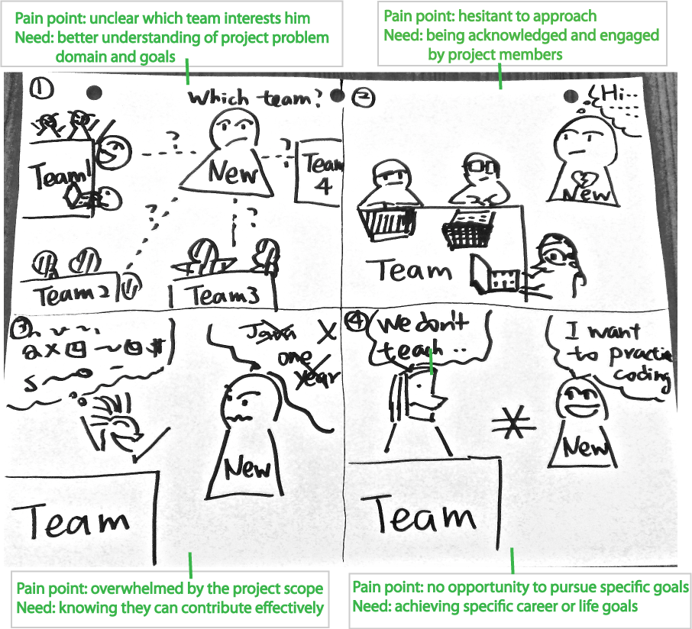

The existing project teams have their own expectations and needs about the meetup and the new members that want to join their project teams as well. Some top needs are listed below.

**Top needs from existing project teams:**

* **Balancing “working” with “talking”**. Existing project team members often want to spend focused time working on their projects without the disruption from others, including new members. But they also acknowledge that the nature of the meetup is for people to connect. They come up with different ways to balance “working” and “walking” at Code for SF, and isolating themselves from new members is often the sacrifice they choose to make.
* **Knowing new members’ skillsets, goals, and commitment levels.** Given the limited time members have at the Code for SF meetup, project teams sometimes feel overwhelmed engaging new members at the meetup, or onboarding them to the project. Knowing some basics of the new members, including their skillsets, goals, and commitment level would help project teams integrate new members more effectively.

**Recommendations**

It is natural that new members and project teams have different needs. The opportunities to improve new-member engagement/ retention are in the common ground in which both parties’ needs are met. Here are some high-level suggestions for achieving this:

* **Mechanisms to match the project teams’ needs with new members’ skillsets.** Project teams need help on specific tasks. New members want to contribute specific skillsets and time. One way to facilitate this matching process is the create a single-page platform where project teams list what they need help with, and the new members log their skills and expertise. This platform would serve the purpose of connecting teams with new members in a skill-focused format.
* **One representative from each project team assigned to engage with new members.** Project teams have limited human resource to engage with new members, while new members want to talk to project teams to find out more about the projects. There can be a mechanism wherein each team assigns one member to be the designated spokesman that connects with new members, while the rest of the project team focuses on their work. By doing this, both the project teams and the new members get their needs to connect met.
* **A process to kick-start new projects with new members.** If somehow new members do not find projects they feel passionate about, or they are unable to contribute to projects they are interested in due to the mismatch of skillsets, a process to help new members initiate new projects can keep them engaged productively.

**Acknowledgement**

Thanks to *Adopt-a-Drain*, O*pen Disclosure*, *SF in Progress*, *Data Science,* for sharing their experiences as project team leads or senior members.

Thanks toMatt, David, Jezmin, Brian, John, Phoebe, and Hailey for sharing their experiences as newcomers at Code for SF.