**Project Matching Hat Prototype Introduction** - by Jaoyi

**Idea of the prototype?**

* New members come to Code for SF hacknights to check out if there are projects and opportunities for them. New members usually are non-committal in the beginning and would not stay if they don’t find traction right away. They need a quick way to connect with project teams that fit their interests, skills, and goals in order to gain traction, and ultimately contribute to social good.
* The ‘matching service’ recommends project teams to new members based on their needs, with the goal of speeding up the process of finding opportunities and traction for new members.

**Who is this prototype for?**

* New members that want to find project opportunities to practice skills, contribute skills, or work on domain-specific civic projects at Code for SF hacknight.

**What are we trying to learn with the prototypes?**

* We want to learn if the design of the ‘matching service’ effectively help new members find project teams that match their skills and goals.
* We want to test out two different flows

**Journey map of the two prototypes**

* Prototype 1: check-in-> *profile* -> matching -> matched/ project list -> connect

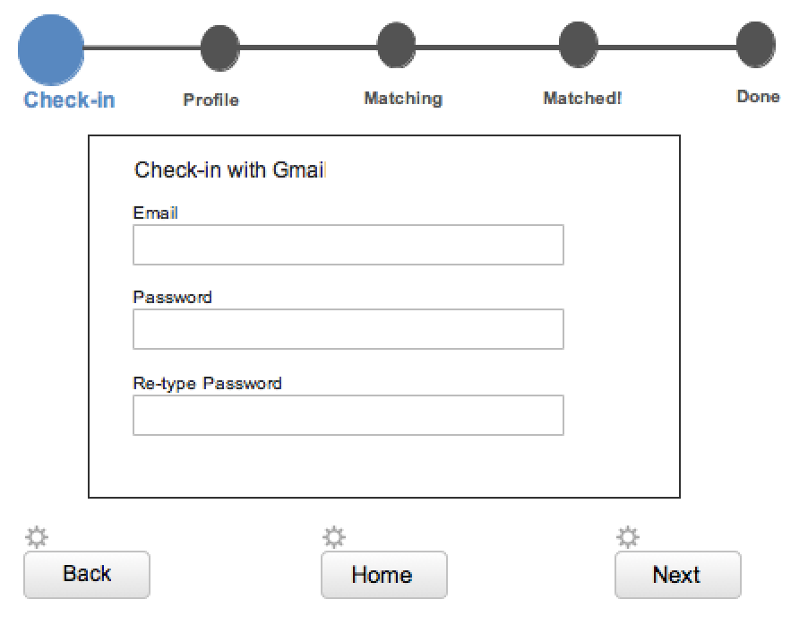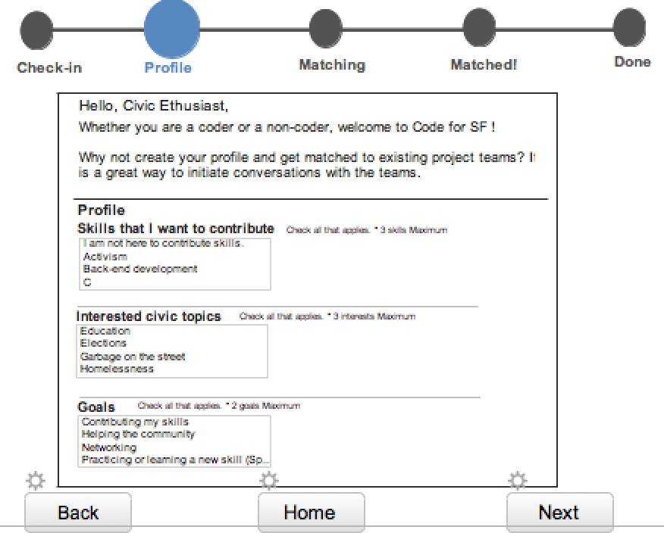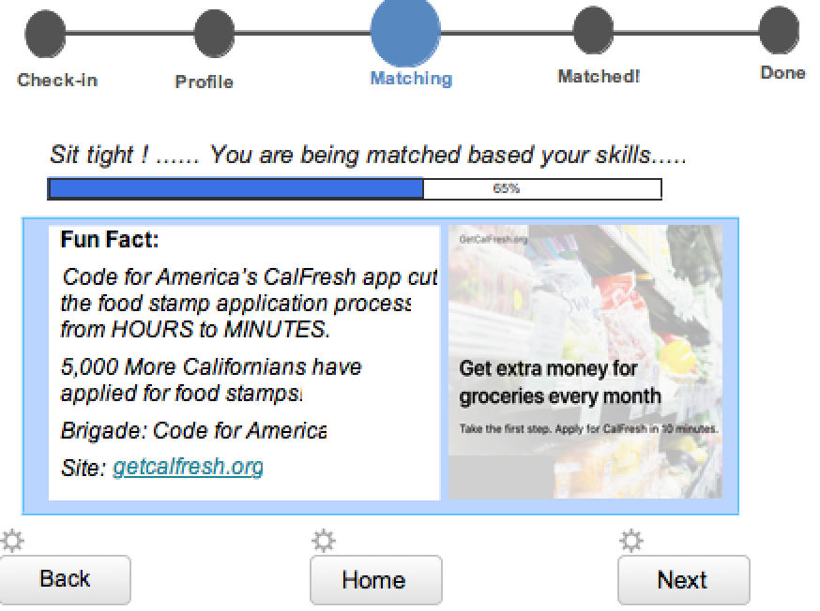

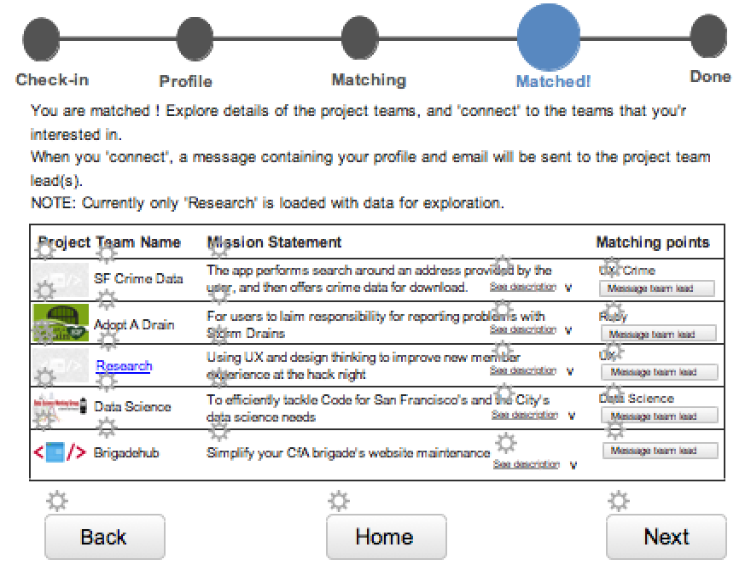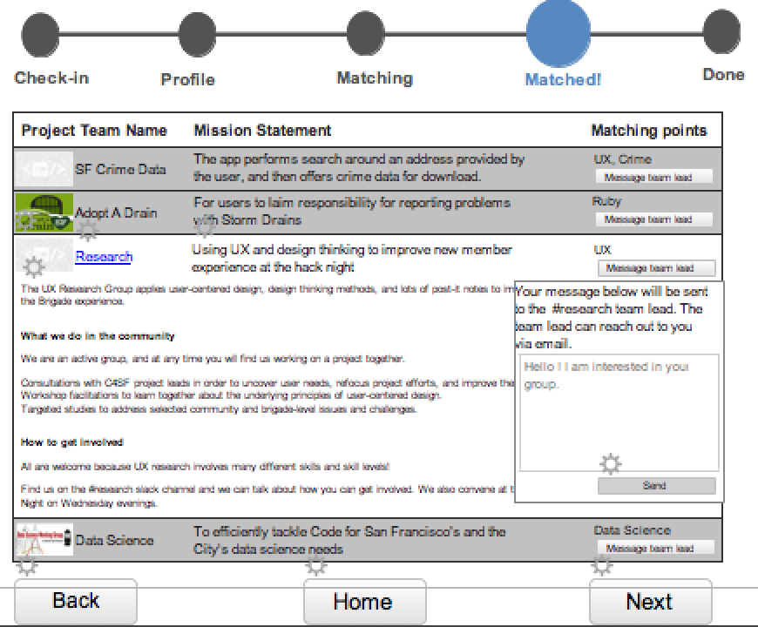

* Prototype 2: check-in -> *project list/ connect* ---> portfolio -> matching -> matched/project list -> connect

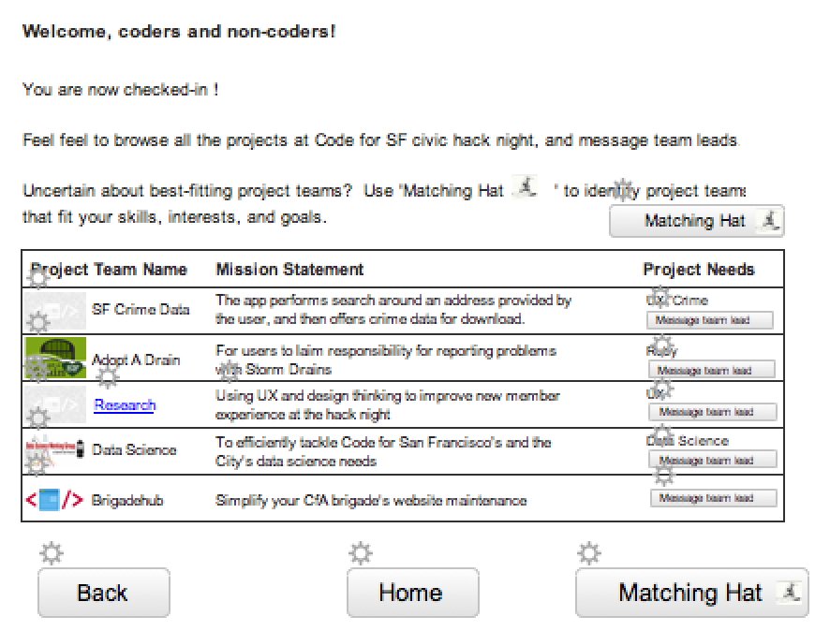

**What are our concerns?**

* Overall
  + Does the email check-in in the beginning make new members feel uncomfortable (though this is the standard process brigade uses now) ?
  + Would users sign up to github (as brigadehub hopes for) to check in ?
* Prototype 1
  + Would users find profile creation tedious ?
  + Does the process have too many steps?
  + Is the design of the project list easy to use?
  + Once matched, would users connect?
* Prototype 2
  + Would users use the matching service when given the option?
  + Is this two-stage flow more user friendly?
  + Is the design of the project list easy-to-use?
  + Once matched, would users connect?

**What interactions would be important to try?**

**Feedback**

* The good?
* The bad?
* Anything else?

**Current checkin**

