**Match Making User feedback_ Allie (2016/01/04)**

Allie was instructed to think-aloud as she went through the process. But we didn’t have a structured user testing plan at the point of feedback collection. So, there weren’t  specific tasks or structures for feedback collection.

**Key Notes:**

* Profile page
  + Let users select ‘no skills’
  + Allow upload for more information in the profile part
* Others
  + Slack is frustrating

**Raw Feedback from Allie**

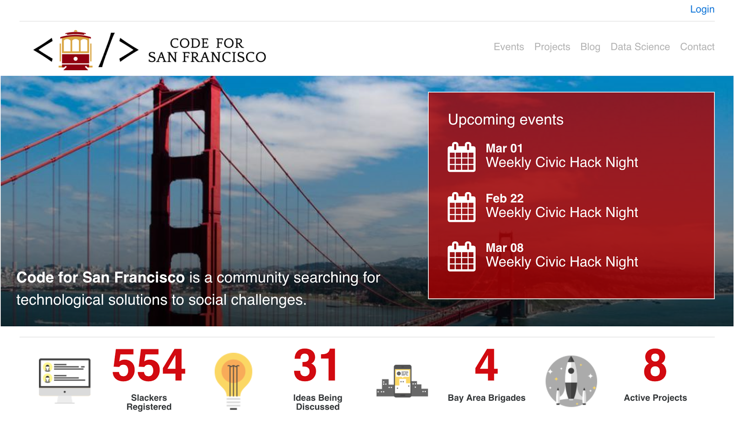

* **Log in**: confusing, don’t have an account yet

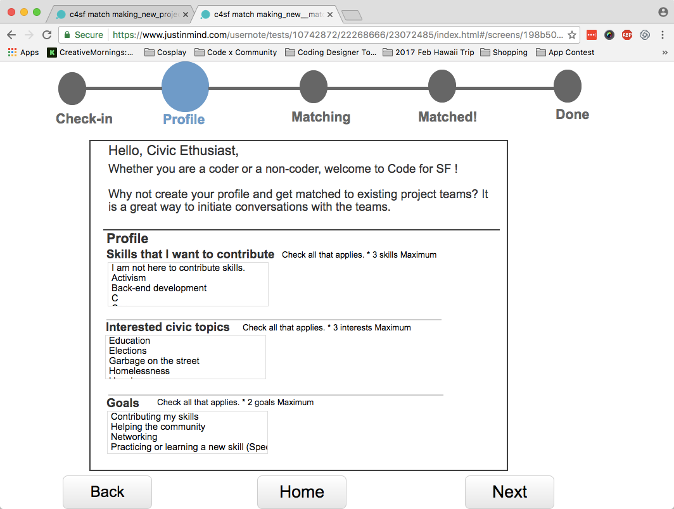

* portfolio: too intimidating
  + Jaoyi Note: already modified
* match-making: too much like dating site, reminds her of tinder
  + Jaoyi Note: already modified
* search bar, instead of ‘select’
  + Jaoyi Note:  constraints of Justinmind, the prototyping software
* **let people do ‘no skills’**, otherwise quite embarrassing for someone that feels like he/she doesn’t have skills
* Alphabetize
  + Jaoyi Note: already modified
* interests: more specific (e.g. what is ‘garbage’)
  + Jaoyi Note: Taxonomy project will hopefully address this
* she likes ‘goals’

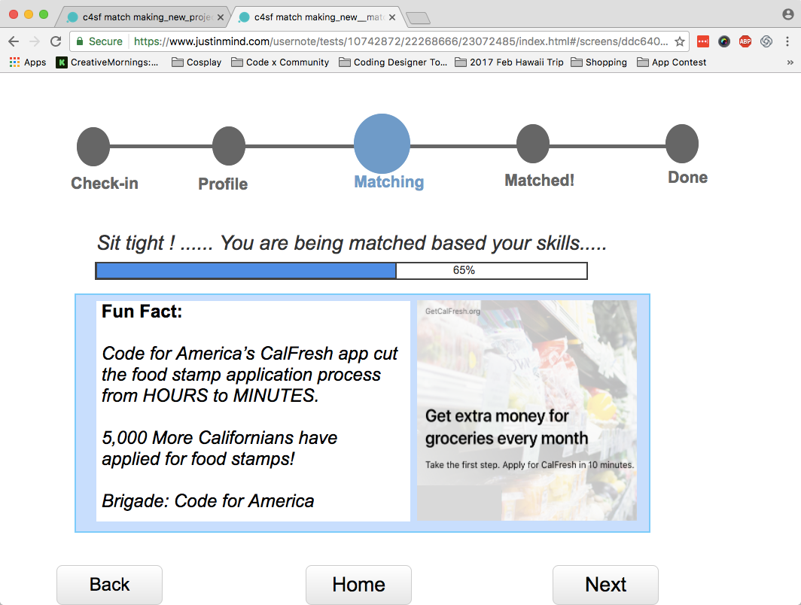

* bigger fun fact, hard to read. remove ‘apply now’…looks like add
  + Jaoyi Note: already modified.

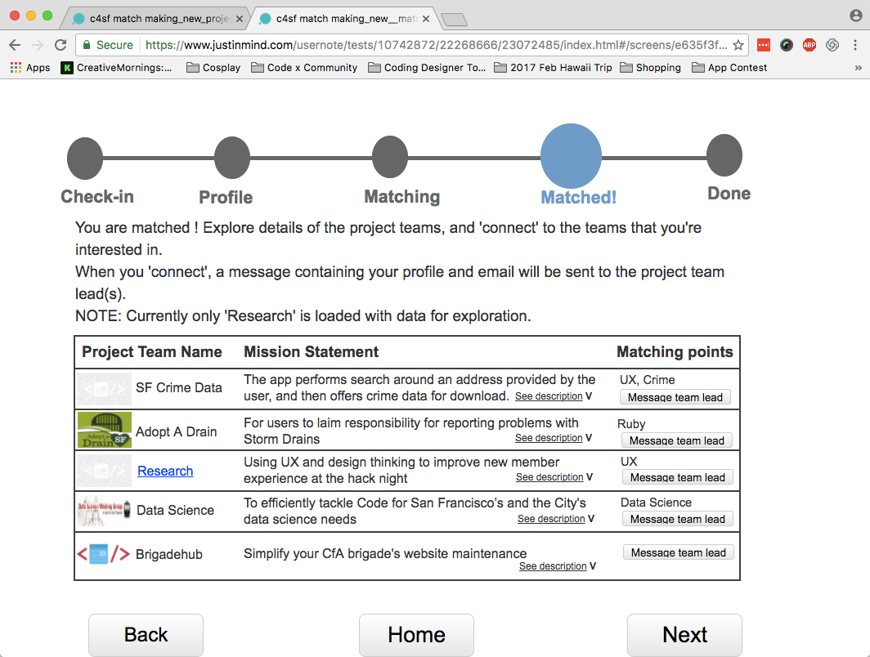

* make ‘matching points’ interactive… maybe next step
* **allow to upload more related info**
* icons for projects
  + Jaoyi Note: already modified

Side note: slack is frustrating. It’s a common frustration of new members.