**Project Matching Hat user feedback from Florence Tsai (2016/02/08)**

Florence is a UX designer. She provided expert feedback to us via google doc.

**Key notes:**

* Profile list
  + Better design of the list: longer boxes for easier selection, not cut off
* ‘Messaging team leads’
  + intimidating. It’d be nice to have team lead’s name, slack name, etc
  + The project list needs visual indications of the project teams that she has messaged.
* She likes fun facts
* She likes it that the app talks to non-coders as well
* She likes the summary page

**Raw Feedback from Florence**

Matching-first Flow

Thoughts:

* Felt intuitive; oftentimes when I sign up for a new service I have to set up the account, so this feels normal
* I felt like I was being guided and hand-held through the process, which was nice. I didn’t feel overwhelmed
* I liked this flow because it helped me get to projects or teams that I felt were relevant to me very quickly

Specific Screens

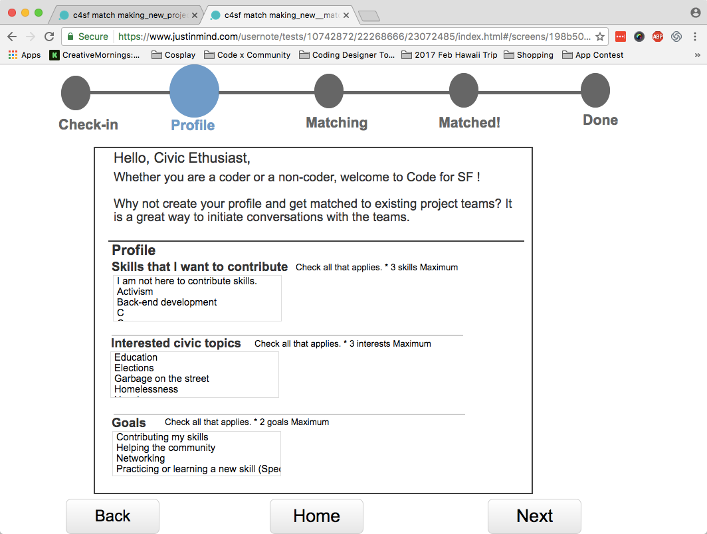

* This screen was nice. The text feels inclusive (**I like that it talks to coders and non-coders**, ensuring people will feel comfortable, regardless of coding ability)
* I wish the boxes for skills and topics and goals were longer so I wouldn’t have to scroll through them
* I also wish the list wasn’t cut off (for instance, in the Goals list “Practicing or learning a new skill…” is cut off because the box isn’t long enough

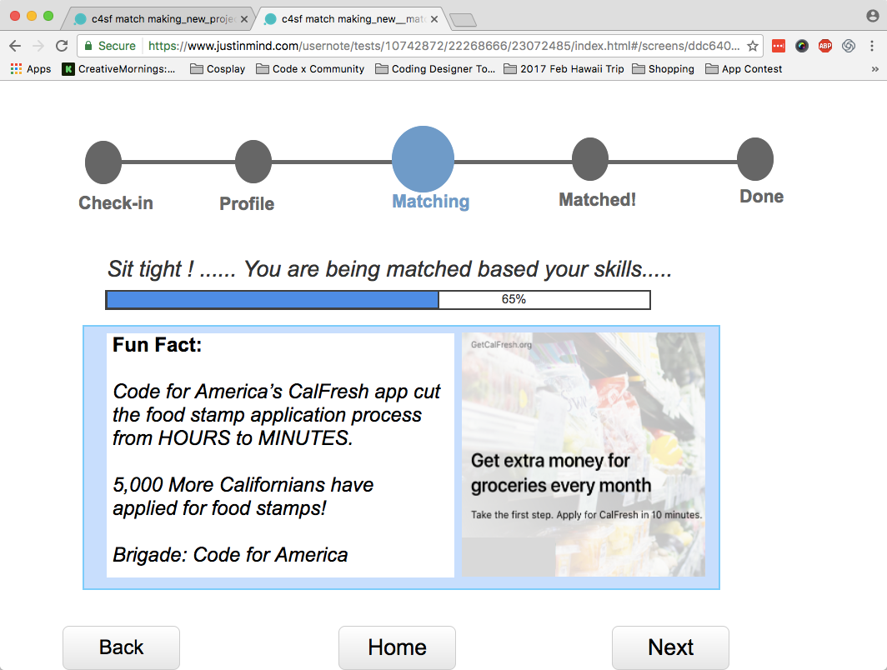

* This loading screen with fun facts was a really nice touch!

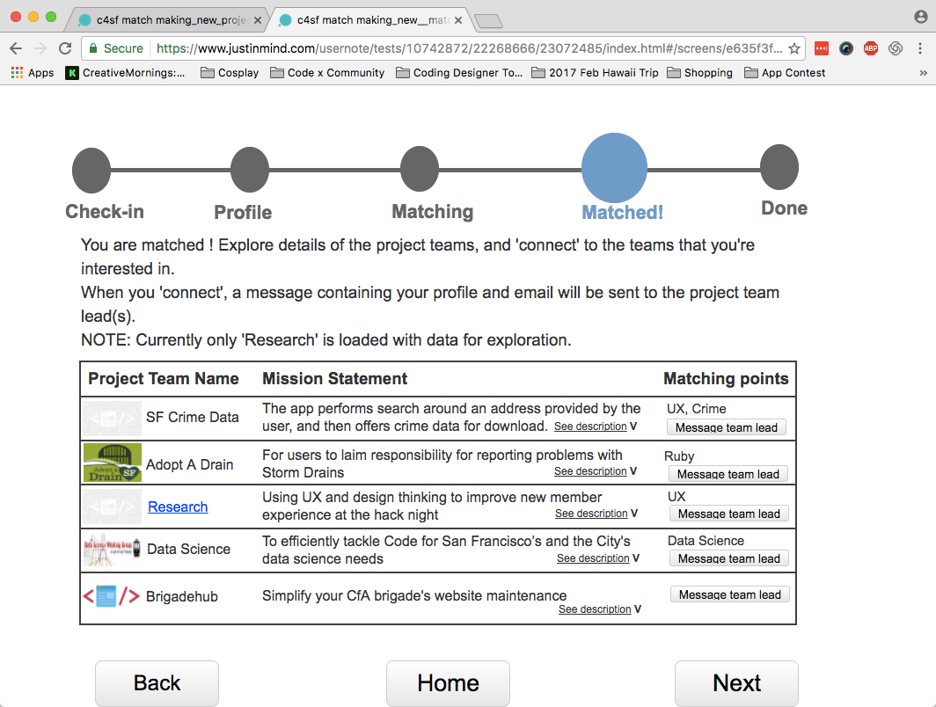

* **“Message team lead” on this screen sounded a little intimidating,** but I felt better once I read the ghost text that suggested what I could write to the team lead.
  + **It could be nice to even mention the team lead’s name and slack avatar, if possible**
* Might be nice if there were a **visual indicator to see what groups I’ve sent a message** to, since I can send a message to multiple groups

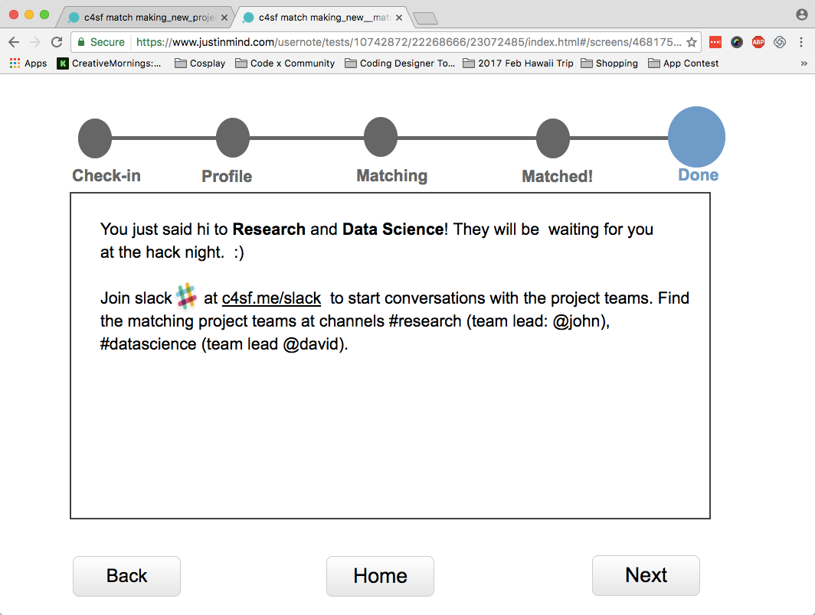

* This is a really nice summary and lets me know what to expect, which I like.
* It’s confusing that the “Next” button takes me back to the home page.

Project List First

Thoughts

* This flow is good if I wanted to just browse what projects there are first.
* I would really like this flow if there were a way to **filter** the list by Project Needs
* This flow feels very fast and easy

Screens

* Since the flow shares a lot of screens with the Matching-First flow, my thoughts are recorded there.