**User Testing and User Feedback Summary_V01_ 2017/02/16**

This document compiles the summary notes from Project Matching Hat V01 (Project List First) user testing and user feedback. The page-by-page summary notes are listed below.

* User Testing Members: Theg C (2017/01/25), Duong A (2017/02/01)
* User Feedback Members: Tsai F (2017/02/08), Allie (2017/01/06)

After this round of feedback collection, we decided to re-design the ‘connect/message team lead’ module, and the ‘project list’ module.

---------------------------------------------------------------------------------------------------------------------------------

**Check in**

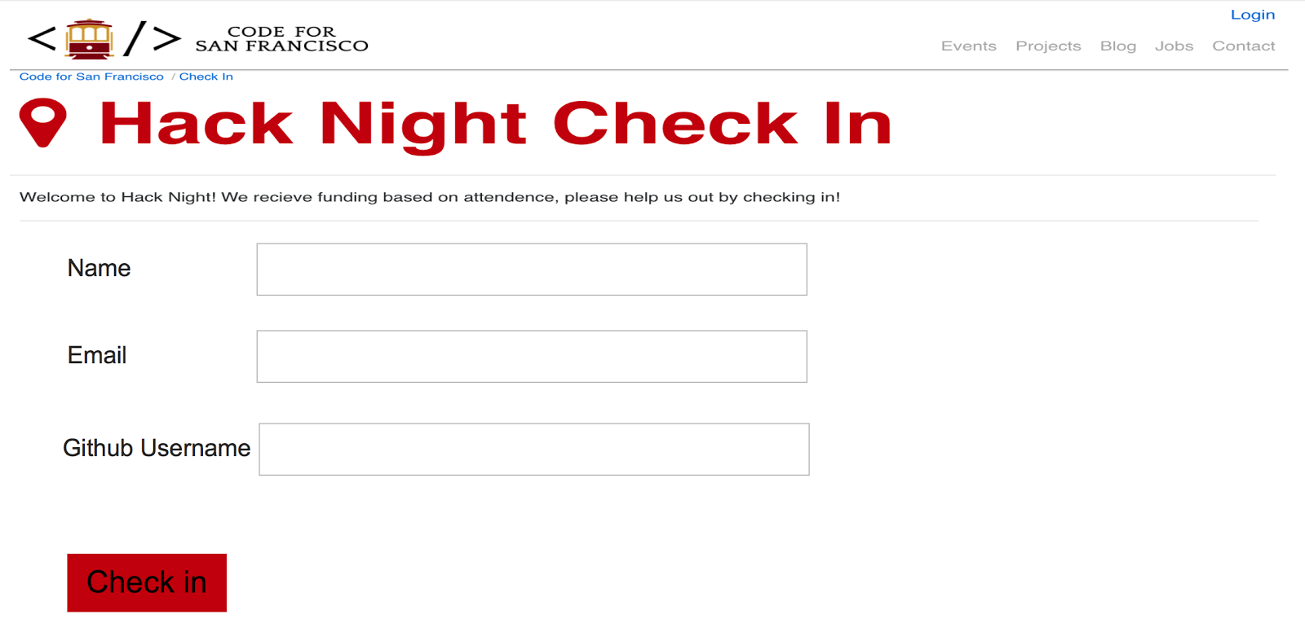

**Check in**

* Page display is distorted (Theg)
* Name:  better separated into ‘first name’ and ‘last name’ (Theg)
* Not able to use tab (note: prototyping software constraint)  (Theg)
* Github user name: he doesn’t have one..not sure if he can skip that (Theg, Duong)

**Project List Page**

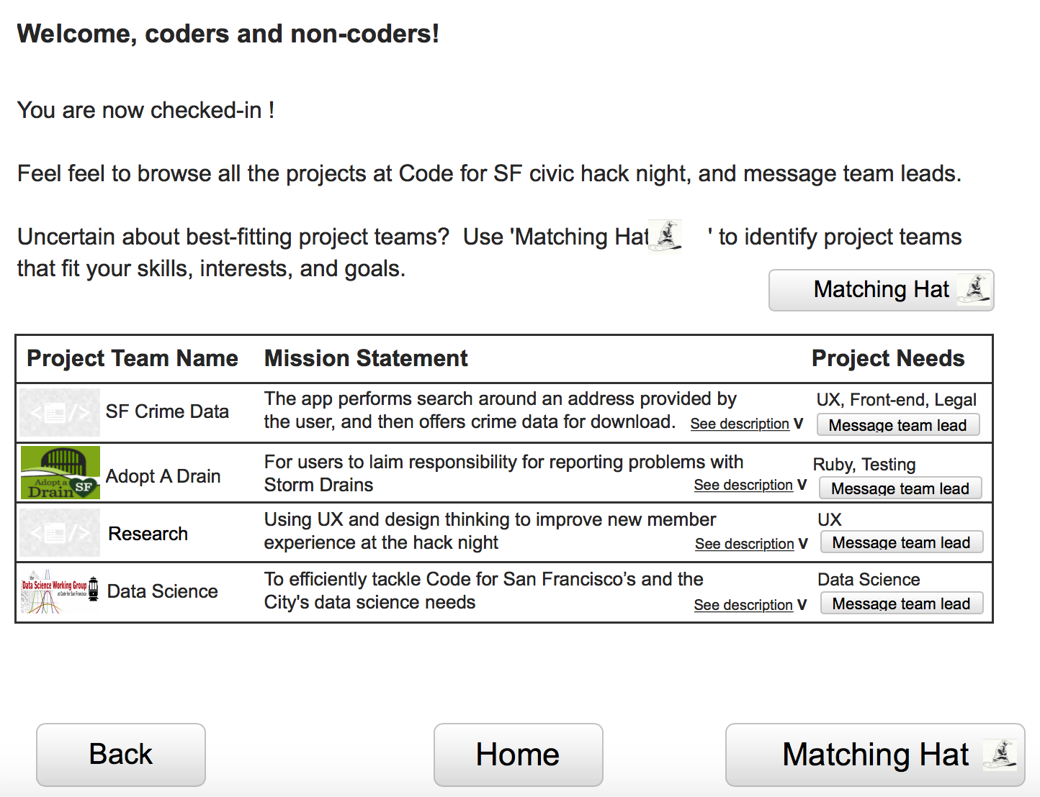

**Project list page**

* ‘You are checked-in’ not prominent enough (Duong)
* Matching hat is not prominent (Theg)
* Better explanations on Matching Hat. Users unfamiliar with Harry Potter may not know. ‘matching hat’ (Theg, Duong).
* List too text-heavy (Theg, Duong).
* Top intro too text-heavy (Duong)
* Nice welcome to non-coders (Tsai)

**Profile**

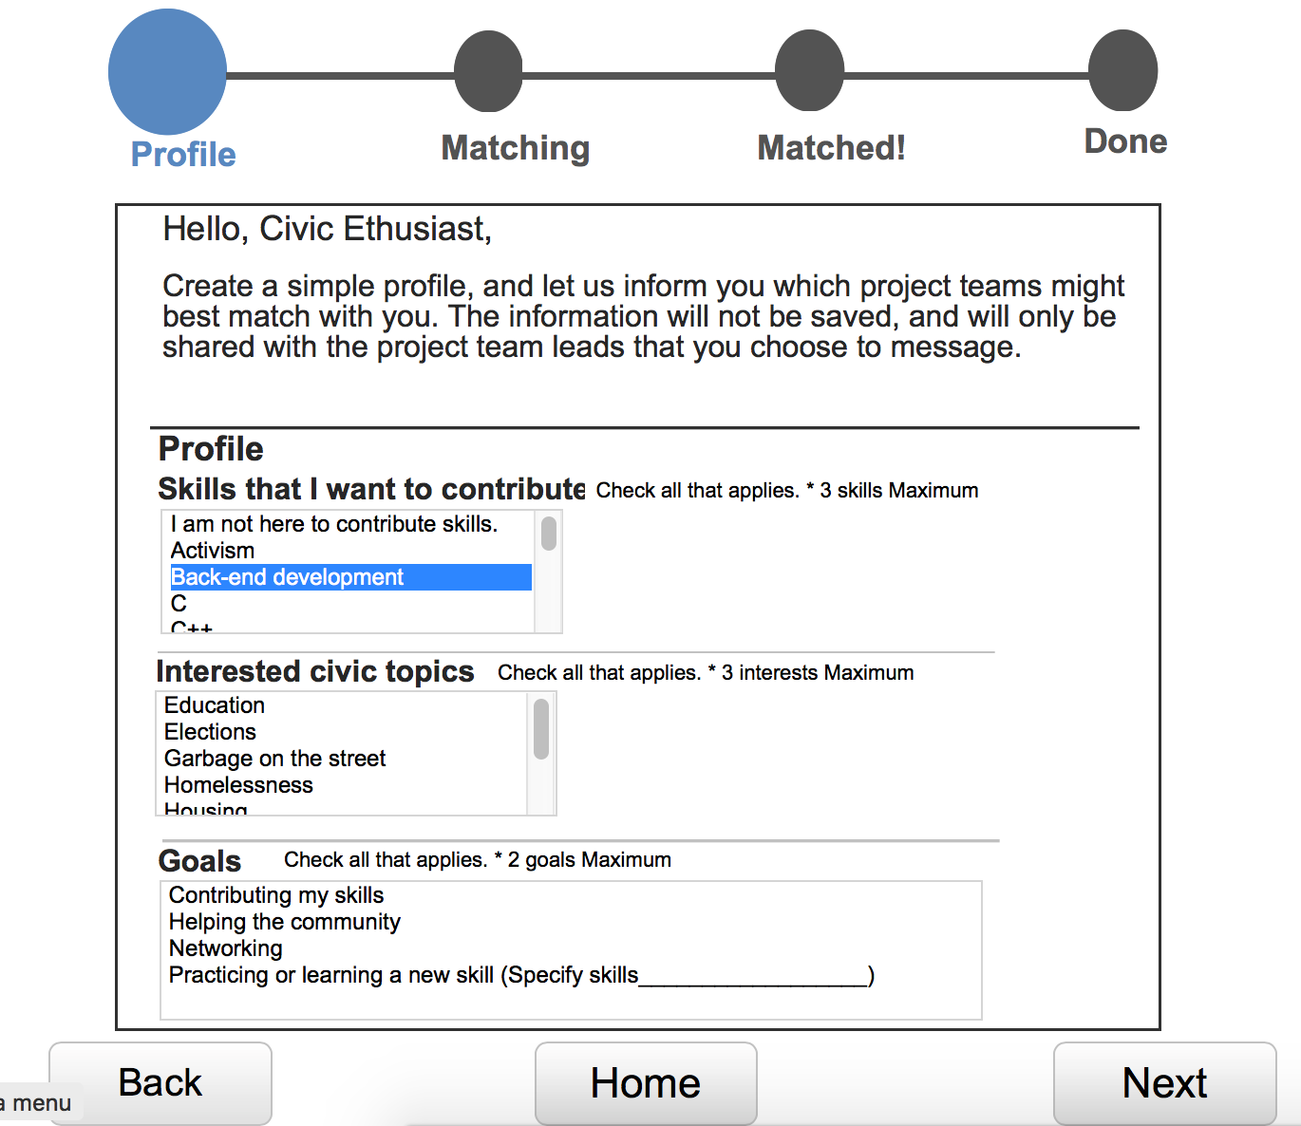

**Profile page**

* Top Intro is too text-heavy (Duong)
* Checkboxes instead of list (Note: prototyping software constraint) (Theg, Duong)
* Type and search (Note: prototyping software constraint) (Theg)
* longer boxes for easier selection, not cut off (Tsai)
* No selection of ‘experiences’- Chris has 7 years of government experience, but doesn’t quite count as skills (Theg)
* ‘3 Max’ is not prominent (Duong)
* ‘Others’ as a choice for skills (Duong)
* ‘ No Skills’ as a choice for skills (Allie)
* More than two goals (Duong)
* Allow for more information upload into the profile (Allie)
* Nice categories (Duong, Allie)
* Nice progress bar on the top (Theg, Tsai)

**Matching**

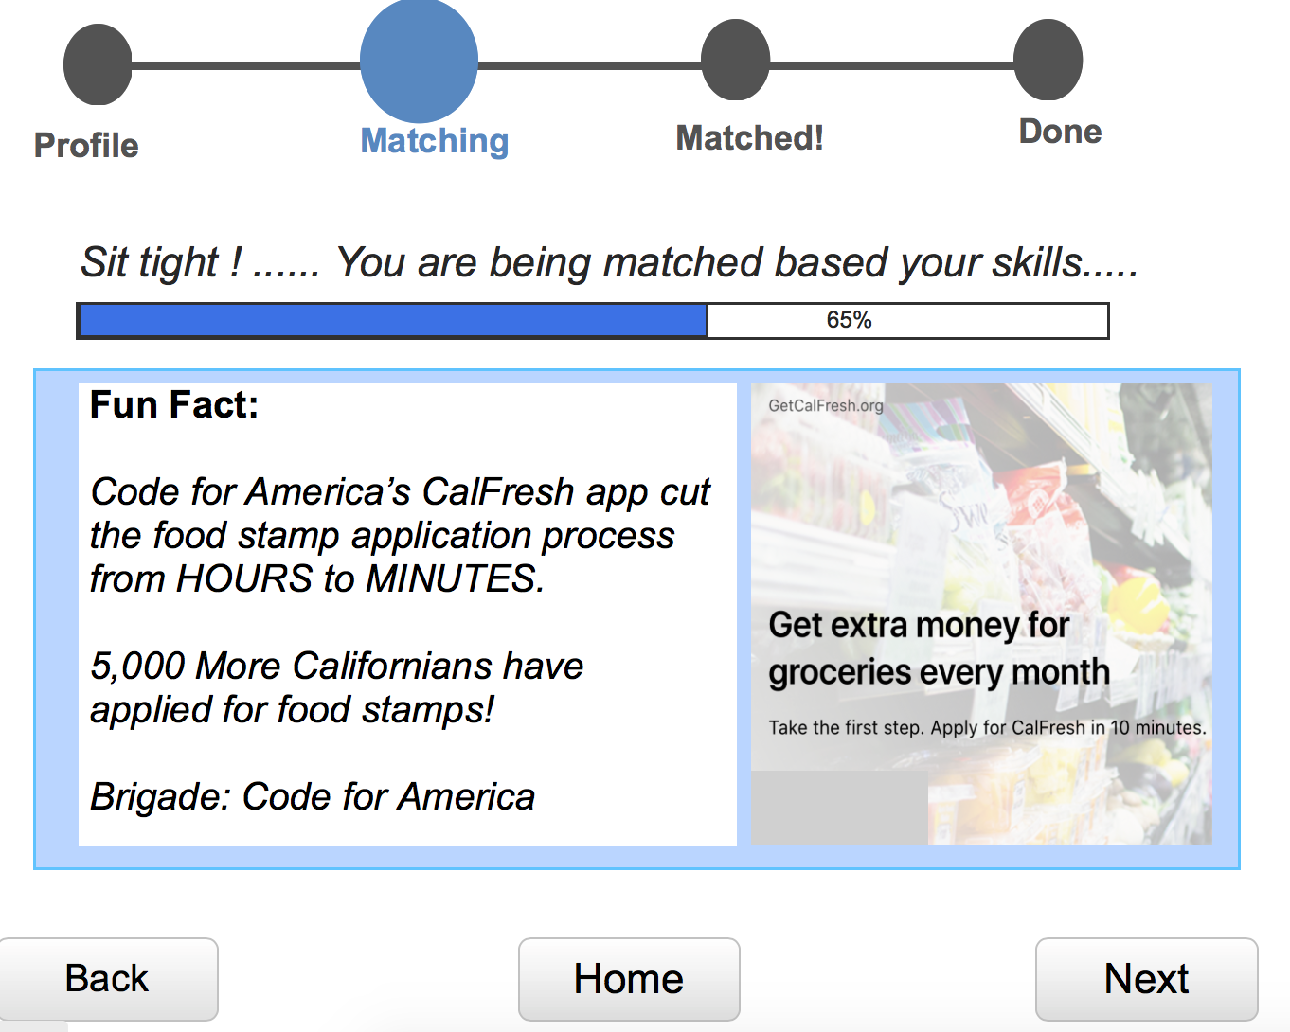

**Matching Page**

* Nice touch on fun facts (tsai, Allie,?)

**Matched- decisions on project teams**

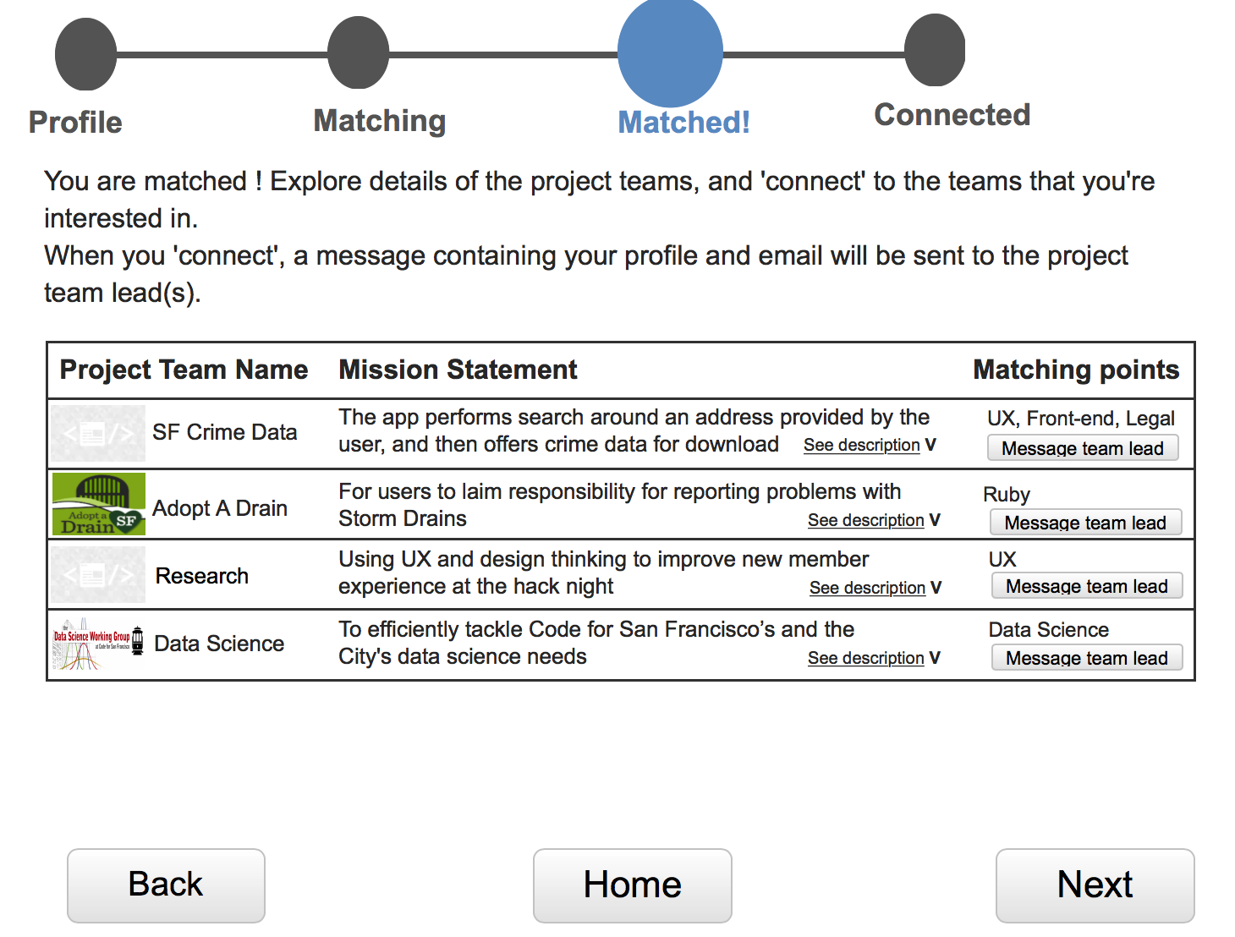

**Decision on project teams**

* Unable to keep more than one project details open (Note: prototyping software constraint) (Theg)
* Unable to save the matches(Theg)
* Matching Point: unclear what it is (Duong)
* Matching points: font can be bigger (Duong)
* Mission statement is critical for decision(Duong)

**Connect/ Message Team Leads**

|  |  |
| --- | --- |
| https://lh4.googleusercontent.com/vaB1_uaa0HOwRFSZ_0s60TTw3d8pG7G6kTd9rV1PWuXvyEiZ9sQefoDW7UO1Ur8uKVfnOhxM4E76KxyPattbKT-F3mXunBNFjs7QhO36jlCQyvMFu2cTHgIXgpgp-FCVLamvCYEM | https://lh5.googleusercontent.com/V8pJuMYFasPCH5qCWqcUJxy6q2Cqzd7l46iguZmArcf8qUCz_2M2M5GVBxsT5kEFdhqSUA2wWFCGWYxsB9buM7QEz0srZw3QLd_zkcL-duUNqwuga7h8Pu_J9o6oxgzY_mrRShdE |

**Connect**

* Message team lead seems intimidating (Duong, Tsai)
  + Jaoyi note: for new members that found this to be intimidating, some wouldn’t even click on it first to check it out. I changed it to ‘Connect’ for the next person, but it caused confusion.
* Unclear what ‘connect’ is (Theg)
* Unclear if the team leads will receive the messages and reply (Theg, Duong)
* He wants more direct connections (e.g. email exchange) (Theg, Duong)
* Be able to leave contact information to the team lead (Duong)
* Wants team leads to know they are matched  (Theg)
* A record of teams that he has messaged. For those that don’t reply, he may not want to join them. (Theg, Tsai)
* Wants team leads’ slack user names (Tsai)

**Other Notes:**

* Non-coders don’t feel welcomed. They are not sure how they can contribute even though they are highly-experienced
* Hard to navigate projects and the space
  + Jaoyi note: project list is in Alpha(?) under Brigadehub
* Slack is frustrating for new members