**Expert feedback_20160613**

Two parts of feedback are included- feedback from the storyboard brainstorming session & internal page-to-page feedback from the research group.

**Feedback from storyboard brainstorming**

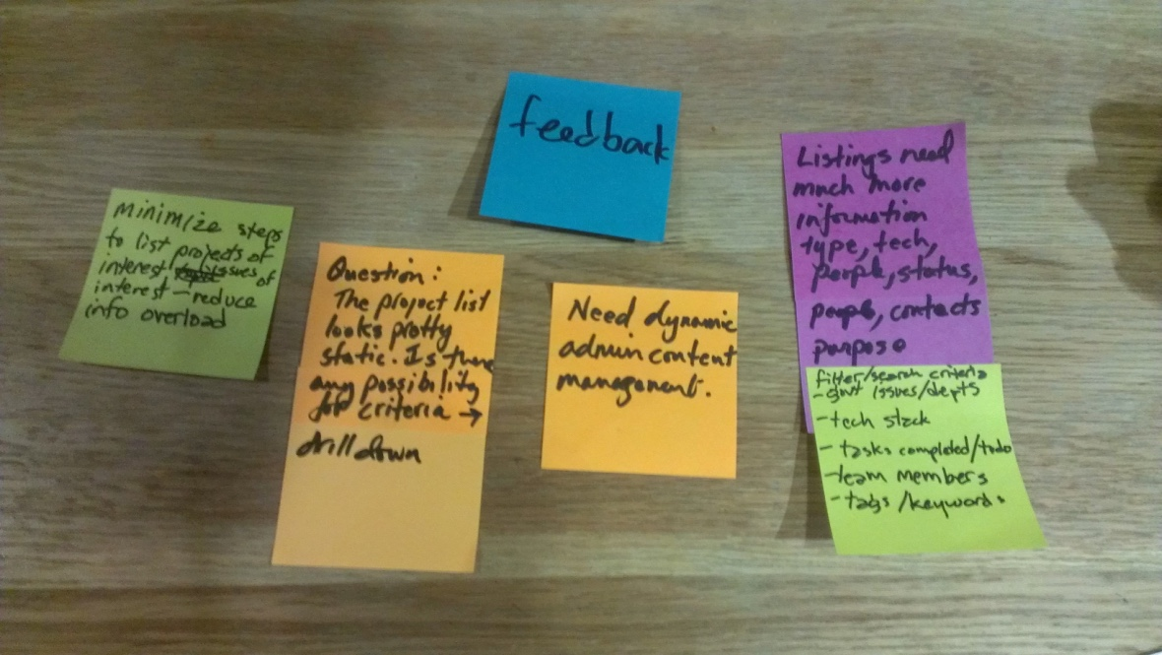

1. Be able to contact project leads
2. Categorization of project teams. Eg. active, inactive, show up more often
3. Better navigation.
   * E.g. better navigation (stacks, state of projects, etc)
   * Minimize steps, filters, tags
   * The website looks ‘static’, not ‘dynamic’, thus may not be able to set up filters
4. More info in the listing
   * Emails, status, mission,
   * tech stacks, gov issues/departments, tasks completed/to dos, team members, tags/keywords,
   * Good examples: amazon, best buy
5. Easy to update
6. What’s code 4 sf? This part needs more explanation. Some may think it’s a coding school
7. How to start a project (after reading the project page)

**Page-to-page feedback from the research group at Code for SF (Anna, Jaoyi, James)_20160613**

**Landing page**

Pros

* Join different social groups (e.g. slack, github, meetup)  (JY)
* Picture matching ‘call for action’ join (e.g. slack, meetup) (Anna)
* Anna likes the statistics and numbers (Anna)

Cons

* Clickability
  + All the big numbers are NOT clickable, not relative to users. They don’t serve much of a purpose. (Jamie)
  + Upcoming events are actually clickable (JY)
* Upcoming event:
  + Upcoming events on the top is problematic, repeat every week anyway (Anna & James), why not just go to meetup (Anna)
* Projects: There needs to be more information.  E.g. (James)
* Joins: Calls to actions, but not sure what one is joining, also new members may not want to join so many things. Projects are more important than joins. (James & Anna)

**Project page**

Pros

Cons

* Not sure what keywords are (James)- why not just create ‘topic’ ‘languages’ and ‘needs’ (James)
* Not sure which projects are active (James)
* Alignment of grids (Jaoyi) May need to limit how many keywords and needs each project can key in

**Project list page**

Cons

* No contact information
* Structure: mission, project, hard to scan