**UX recommendations based on user testing and expert feedback 2016-07-20**

**Aim**

New members need more information about current projects at c4sf in order to find a project to get involved in.  (Website <http://codeforsanfrancisco.org/>)

The aim of this usability testing is to identify potential design concerns to be addressed in order to improve the efficiency of the website and new member experience.

In particular, we want to learn-

* Whether users can find a link to the project list
* Whether users navigate the project list successfully
* Whether users are able to determine if the project fits their interest

**Testing Plan & Methodology**

* Detailed plan:  <https://docs.google.com/document/d/1juWVJxbpoyPQf-syQ_AiaRXZxm90rWgQROXvF74kFOg/edit?usp=sharing>
* Pain points: frustrations that users experience
* Severity rating:
  + 0- don't agree that is a usability problem
  + 1- cosmetic problem
  + 2- minor usability problem
  + 3- major usability problem; important to fix
  + 4- usability catastrophe; imperative to fix

**Participants**

* User testing: 4 participants (2 programmers, 1 designer, 1 data scientist )
* Expert feedback: 5 participants

**User Testing Results**

**Scenario 1_ finding project list from the ‘landing page’**

* Success rate of finding ‘project list’ with no trouble: ¾
  + 3 people clicked on ‘project’ on the top nav
  + 1 person clicked on ‘19 active projects’ and was stuck for 15 secs
* Pain Points

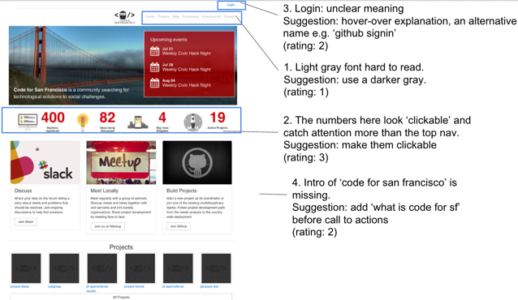

1. **Light gray fonts on the top nav bar:** hard to read

* Suggestion: use a darker gray
* Severity rating: 1

1. **The big stat numbers**: look clickable, but they are not

* Suggestion: make them clickable
* Severity rating: 3
* Other feedback
  + 3. **Login button**: “what is this for?”
    - Suggestions: hover-over explanation, and perhaps give it an alternative name (e.g. github login)
    - Severity rating: 2
  + 4. **Intro of ‘code for san francisco**’: important but nowhere to be found. Some may think it’s a coding school.
    - Suggestions: add ‘what is code for san francisco’ before other information. One option is to move  ‘call to actions’ to the bottom and put ‘what is c4sf’ first.
    - Severity rating: 2

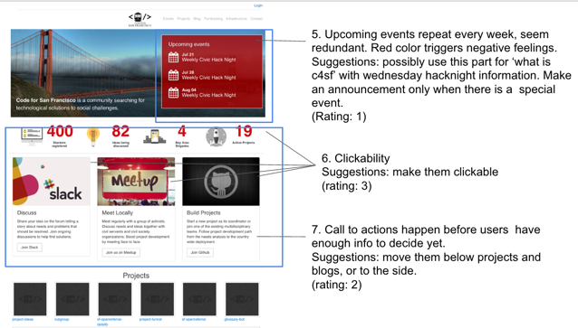

* + 5. **Upcoming events**: repeat every week, seem redundant (given that there is no special event most of the time). Why not just check at meetup site, or feature special events? Also, the red-color triggers negative feelings.
    - Suggestions: possibly use this part for ‘what is c4sf’ with wednesday hacknight information. Make an announcement only when there is a  special event.
    - Severity rating: 1
  + 6. **Clickability**:
    - stat numbers are not clickable though they appear clickable,
    - upcoming events are clickable but appear non-clickable.
    - Slack, meetup, github images seem clickable but they are not
    - Suggestions: clearly distinguish clickable vs. non-clickable items. See reference for details.  <https://www.nngroup.com/articles/clickable-elements/>
    - Severity rating: 3
  + 7.  **Call to actions occur too early**: before users can find out more about c4sf and its projects, they don’t find those call-to-actions relevant.
    - Suggestions: move them below projects and blogs, or to the side.
    - Severity rating: 2
  + 8. **Projects**: more explanations on what ‘projects’ mean.
    - Suggestions: add brief description
    - Severity rating: 1

**Scenario 2_ navigating project list on the ‘project page, or /projects’**

* Success rate of using ‘keywords’ to navigate the project list: 1/4
  + 3 people used ‘ctrl+find’ to search for keywords
  + 1 used ‘keyword’, but encountered several pain points
* Pain Points

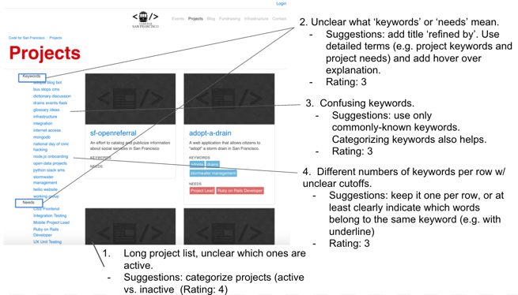

1. **Long project list**: The project list is long and a bit overwhelming to users. The list also doesn’t indicate ‘active projects’
   * Suggestions: categorize projects. The most important categorization would be ‘active vs. inactive’. Clearly indicate and move inactive projects to the bottom.
   * Severity rating: 4
2. **Unclear meanings of ‘keywords’ and ‘needs’.** Quote ‘I assume it is somehow being utilized in these projects?’. Quote ‘ i’m not sure what needs mean.’
   * Suggestions: Add title ‘refined by’ (see amazon for example) on top of ‘keywords and needs’. Also, use a more detailed term, such as ‘project keywords’, instead of ‘keywords’, and add explanations
   * Severity rating: 3
3. **Confusing keywords.** Quote ‘what is open data? Does that mean data science?’
   * Suggestions: use general and commonly-known keywords. Categorize keywords also helps.
   * Severity rating: 3
4. **Various numbers of keywords per row.** Different numbers of keyword links per row, with unclear cutoffs.
   * Suggestions: keep it one keyword per row. Or at least make it clear which words belong to one keyword (e.g. ‘open data’ is one keyword) with underline.
   * Severity rating: 3

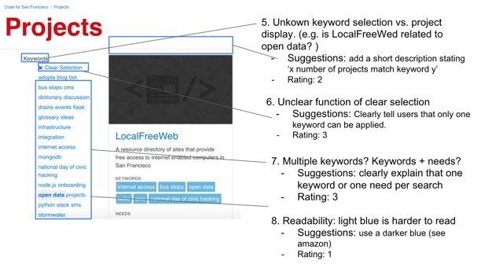

1. **Keyword selection vs. project display.** No indication of whether the projects show up match with the keyword used
   * Suggestions: add a short description stating ‘x number of projects match keyword y’
   * Severity rating: 2
2. **Keyword selection vs. deselection**. Once one keyword is selected, it is unclear if the keyword needs to be deselected first in order to use the second keyword, or if it is possible to combine two keywords.
   * For example, select ‘open data’, ‘LocalFreeWeb’ shows up. Select ‘bus stop’ without clearing selection first, the display is still ‘LocalFreeWeb’
   * Suggestions: Clearly tell users that only one keyword can be applied. Also, fix the bug mentioned above.
   * Severity rating: 3
3. **Multiple keywords and needs**. Not sure if ‘keyword’ and ‘need’ can be used at the same time to filter projects
   * Suggestions: Under ‘refined by’...add explanation/notification to let users know that they can only filter with one keyword each time
   * Severity rating: 3
4. **Readability.** Light blue texts a bit hard to read
   * Suggestions: Use a darker blue and bigger font size
   * Severity rating: 1

* Other feedback

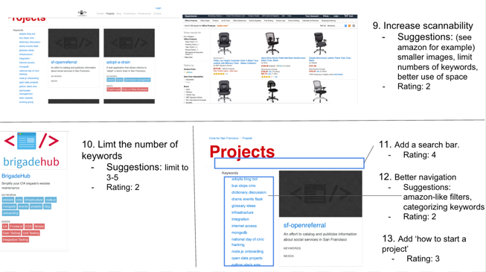

* + 9. **Increase scannability of projects list**. A couple people liked the scannability of the current website.
    - Suggestions: see amazon for example (smaller images, limit numbers of keywords, better use of space)
    - Severity rating: 2
  + 10. **Limit keywords and needs for each project** (e.g. 5) so one project doesn’t take up the entire page, and less overwhelming for users.
    - Suggestions: limit to 3-5 words
    - Severity rating: 2
  + 11. **Add a ‘search bar’**. Most think it’s more useful than keywords.
    - Severity rating: 4
  + 12. **Better navigation.** Possibilities (1) filters like amazon (2) group keywords, e.g.  states of projects, stacks, etc
    - Severity rating: 2
  + 13. Add ‘**how to start a project**’
    - Severity rating: 3

**Scenario 3_ determine if the project fits interests on the ‘individual project page, or /projects/~’**

* Success rate: ⅓
  + 2 people failed to find  ‘available projects/ tasks’, or team mission, under individual project pages. Unable to identify if the project team fits their interests.
  + 1 person was able to identify a project, and proceed to the github page
* Pain Points:

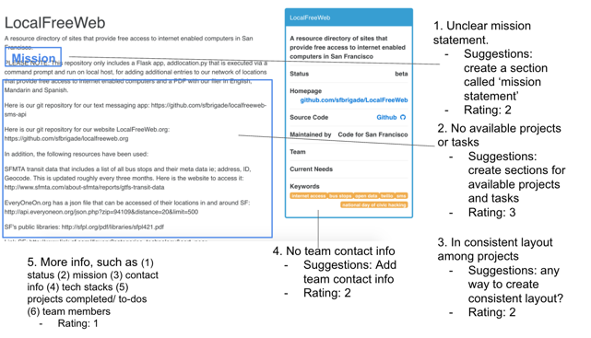

1. A lack of **team mission statement, or goals**.
   * Suggestions: create a section called’ mission’
   * Severity rating: 2
2. A lack of **available projects, or available tasks** 
   * Suggestions: create sections for available projects or available tasks
   * Severity rating: 3
3. **Inconsistent layout** among projects
   * Suggestions: any way to make it consistent?
   * Severity rating: 2

* Other feedback
  + The box on the right is useful
  + 4. Add ‘**contact information**’ to enable new members to reach out to project teams
    - Severity rating: 2
  + **5. More info in the project page** (1) status (2) mission (3) contact info (4) tech stacks (5) projects completed/ to-dos (6) team members, etc
    - Severity rating: 1
* Suggestions
  + Create a template for teams to fill out. The goal of the template is to make it easier for project teams to display information that new members are interested in. The template can include some of the suggestions above.

**Link to all figures**

https://docs.google.com/presentation/d/1wva0qpP2OSFsOal2kCudup-FQW3zTtQjW2uGmn1k74o/edit?usp=sharing