**Brigadehub Project List Storyboard_ 20160613**

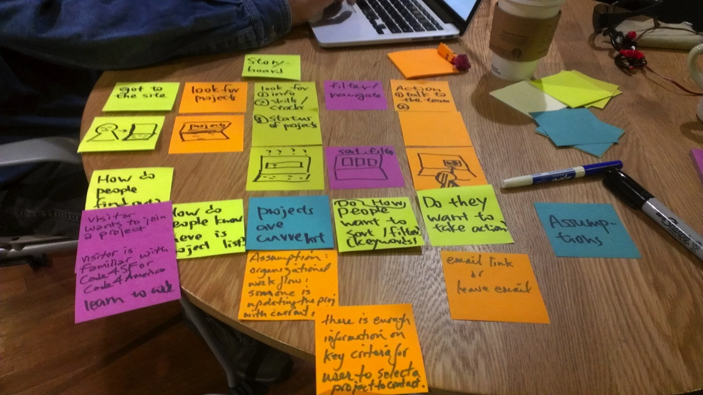

|  |  |  |  |  |  |
| --- | --- | --- | --- | --- | --- |
| **Steps** | Get to the site | Look for projects | Look for project info | Navigation (filter, keywords) | Action initiation  (contact, join) |
| **Questions/ concerns** | How do people find out ? | How do people know there is a project list? | How do people know which projects are current? | How do people want to navigate? (w/ key words) | How do people want to take action? |
|  | How do people know what c4sf is ? |  | How do people know the project lists are updated? |  | Do people want email links? |
|  | Do visitors want to join a project? |  |  |  |  |
| **Strategies** | From Surveyhttps://lh3.googleusercontent.com/bT4eWvhW6-zZus6MICqh2gXIjuv22hZ0TMk0yCQ178gblAduNwdxhOAaeIPYfBW7Cz9de6s25t84oLV32_IsKKnYGXksTFzPNLdPq-ZL9IyDqom-mZH37Ma5csAyl3uIN1kzZYtU | **Needs to be tested** | **Needs to be tested** | **Needs to be tested** | **Needs to be tested** |
|  | **Needs to be addressed** |  | **Needs to be tested** | **Needs to be tested** | **Needs to be tested** |
|  | / |  |  |  |  |

**To be addressed**

* What is Code for SF?

**To be tested**

* How do people know there is a project list?
* How do people know which projects are current?
* How do people know the project lists are updated?
* How do people want to navigate? (w/ key words)
* How do people want to take action?
* Do people want email links?