GD(i)

Georgetown Design (Initiative)

A Conceptual Framework for Building a

Design Initiative, Program(s), and Degree(s)

at Georgetown University

**DRAFT**

**A DEFINITION OF DESIGN**

Design thinking is a way of approaching complex problems:

* that begins with **understanding** the needs of those who are experiencing the problem and will implement the solution;
* integrates inputs from **across disciplines**, industries, and backgrounds to develop innovative solutions; and
* has **a bias toward action** through rapid prototyping, consistent feedback and iterative development.

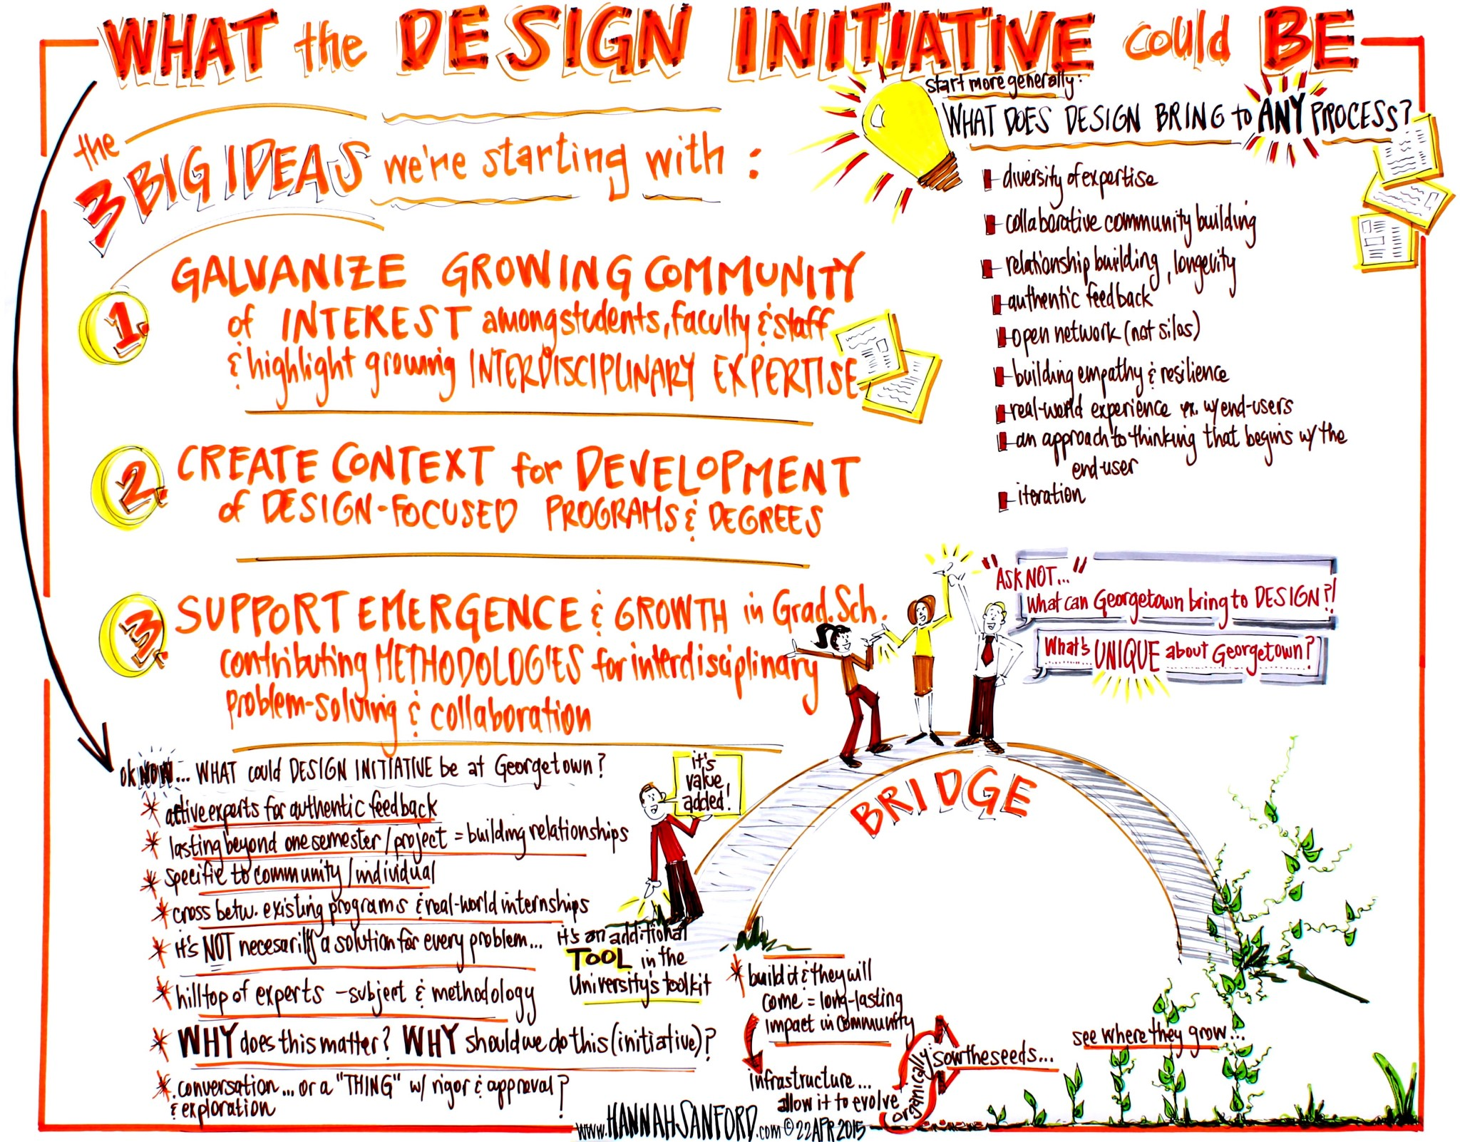

*“Design thinking is a human-centered approach to innovation that draws from the designer's toolkit to integrate the needs of people, the possibilities of technology, and the requirements for (...) success.” —Tim Brown, president and CEO of IDEO*

Design thinking is increasingly being employed by leading corporations and organizations, including a growing portion of the Georgetown community, because it offers a way to:

* 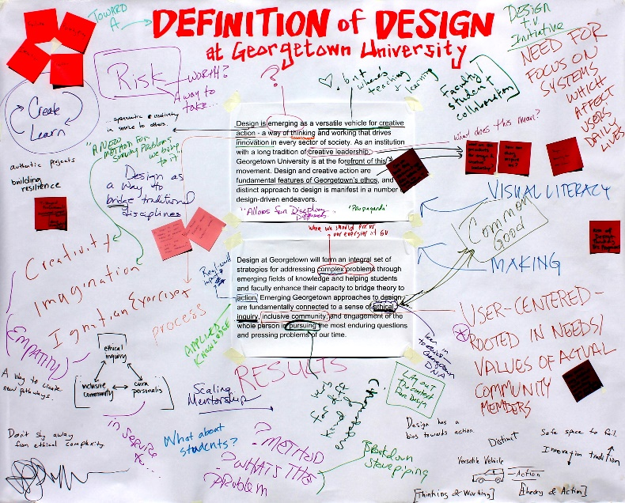**leverage a wide diversity of experience** from inside and outside the University;
* access and provide **authentic feedback on ideas, products, research, programs**; and
* **build a collaborative community with longevity** for ongoing iteration and problem solving.

A new design entity at Georgetown will apply scholarship to real-world problem solving through:

* Research

*Images in this document taken from a collaborative discussion including many members of the growing Georgetown design community*

* Education
* Service

**A VISION OF DESIGN AT GEORGETOWN**

Design is a versatile vehicle for creative action - a way of thinking and working that drives innovation in every sector of society. As an institution with a long history of developing global leaders, Georgetown University is increasingly using design-driven approaches across disciplines to teach students, conduct research, and create real world impact.

Design at Georgetown forms an essential set of methodologies for addressing complex problems by enhancing student and faculty capacity to bridge theory to action. Emerging Georgetown approaches to design are rooted in the needs of our community and are fundamentally connected to a sense of ethical inquiry, inclusivity, and engagement of the whole person in pursuing the most enduring questions and pressing problems of our time.

*“Students are challenged to engage in the world and become men and women in the service of others, especially the most vulnerable and disadvantaged members of the community.”* -- Georgetown University Mission Statement

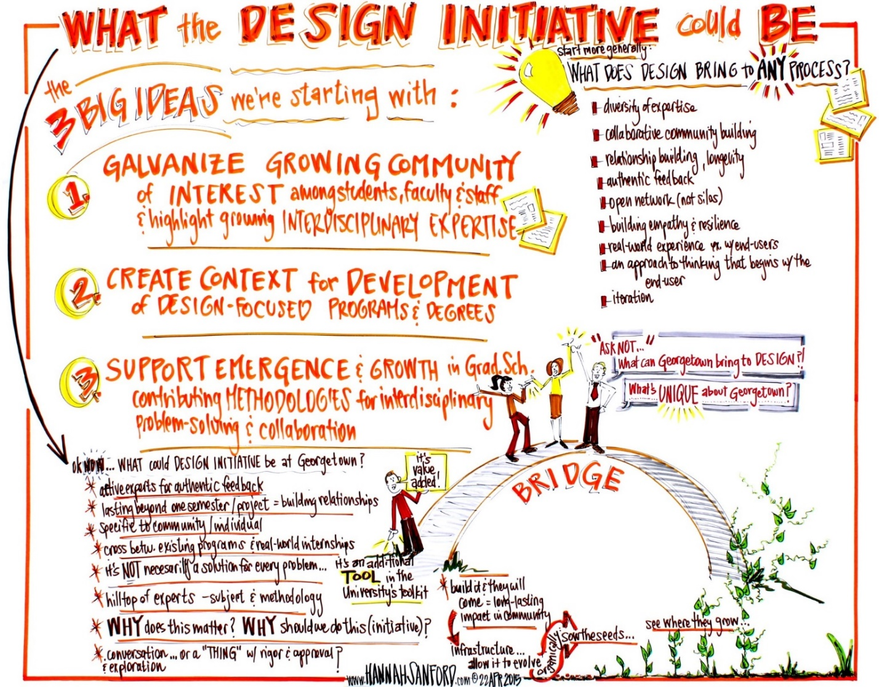

As an approach rooted in collaboration, the design methodology complements other methodological approaches across university disciplines, and even provides the opportunity to bridge them, through a community-centered process of ongoing inquiry, creation, feedback, and improvement.

Currently, design thinking is being used in one form or another in the following disciplines across the University:

* English and Writing
* Communications
* Philosophy and Ethics
* Science Programs
* Business School Programs
* Art Programs

|  |
| --- |
| **Existing Design Network at Georgetown**   * Designing the Future(s) of the University * Beeck Center for Social Innovation and Impact * Center for New Designs in Learning and Scholarship * Program on Science in the Public Interest * EthicsLab (Kennedy Institute of Ethics) * Communication, Culture and Technology * Department of Art and Art History, Master of Visual Communication * School of Continuing Studies, Master of Professional Studies in Urban and Regional Planning * Master of Science in Foreign Service |

Linking these existing programs and developing new expertise will allow Georgetown to develop a unique design initiative that provides value to students, faculty, and the global community.

**DEVELOPING A DESIGN INITIATIVE AND DESIGN-ORIENTED PROGRAMS AT GEORGETOWN**

Georgetown faculty and students are increasingly using design tools in their teaching, research, and engagement with other universities, public agencies, and corporations. However, this work is currently siloed in individual programs and lacks the visibility or support to further develop.

Developing a design entity at Georgetown may be comprised of at least the following three components

* **Organizing an “entity” to** galvanize and raise the visibility of a growing community of interest among faculty, students and staff and highlight growing interdisciplinary expertise and body of work;
* **Creating a context** for making faculty appointments and bringing in outside expertise; and
* **Developing one or more new degrees and programs** in the Graduate School, and supporting the growth of undergraduate and graduate work throughout the University that will contribute methodologies for interdisciplinary problem-solving and collaboration.

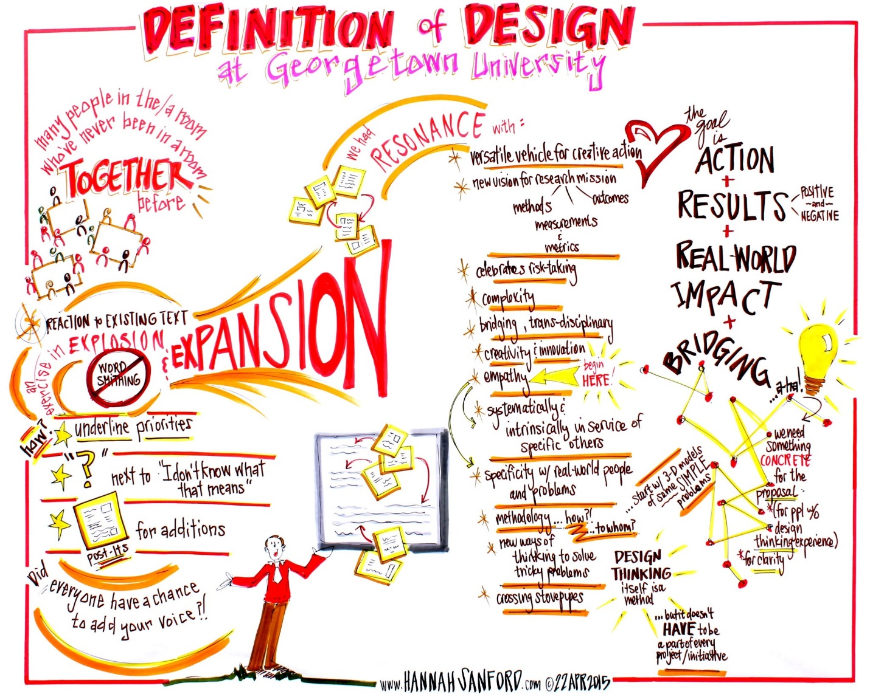**The Benefits and Features of a Design Initiative for Georgetown**

* build a culture of collaborative problem-solving approaches useful for many fields
* create a design-centric space for students at Georgetown, to be shared with students at other DC universities
* support signature student learning through design-based project work that bridges their academic studies with impact outside the university
* provide context for design-based collaboration with other leading universities, corporations, government agencies, and organizations
* create opportunities for students seeking careers in innovation and design
* support PhD training and development of the next generation of design-centered faculty
* create revenue at the graduate level and in executive education programs
* further support STEM and research offerings at the university
* build expertise in learning and curricular design
* provide skill and professional development opportunities to alumni

**NEXT STEPS**

Building Georgetown’s capacity and capabilities for design will require collaboration between programs, academic departments and administrative offices. Fortunately, there is currently an invested community of support who can propel this process forward.

This new “entity” will be able to foster greater collaboration among the existing design community, raise the visibility of design work already being done, and provide a context to bring in outside expertise, all while supporting the development of new programs and degrees.

To design, plan and build such a entity, we are proposing the following three next steps to be advanced by smaller independent working groups:

1. Name and organize official design “entity” to formally recognize and support the community at Georgetown working on design.
2. Develop one or more ideas for a graduate program in design that can be market-tested in the summer of 2015.
3. Deepen design in undergraduate and graduate curriculum, including new courses and minors that are currently in development throughout the University.

|  |
| --- |
| **How Georgetown is Currently Piloting a Design Initiative**   * New interdisciplinary courses are bringing students together across degrees and schools to learn from one another’s expertise * Students are utilizing expanding on-campus design studios to develop projects that bridge their academic studies into real-world impact * Studio faculty are being employed to support student learning and maximize outcomes * New design-centric undergraduate curricula are in development, including the proposed Writing, Design & Communications minor and the Science and Social Change minor * Georgetown faculty are engaging in dialogue with other institutions to understand the latest design tools and how to implement them |