Based on our observations of four studios, we believe that design pedagogy represents one productive future from the current postpedagogical moment. We believe so, in part, because design pedagogy speaks to the most recent and pressing concerns of rhet/comp, like collaboration, public engagement, and materiality, but also because it promises to re-connect us to valuable but neglected traditions, too.

In 2003, David Fleming argued that the time for the progymnasmata “has come (again)” (118). The “very idea” of the progymnasmata, if not their specific practices from ancient times, deserves serious re-consideration, Fleming believes, because it is “devoted to the development in students of a particular set of verbal habits and dispositions” (113). In his formulation, the progymnasmata result from, “the attempt to make of rhetoric not just a theory or art or an historical and cultural artifact or a sociocognitive process but rather a complete and developmentally attuned curriculum in written and spoken discourse, a multicourse program of language instruction whose end product is neither a text nor a skill nor some body of knowledge but a set of deep-seated verbal habits and dispositions oriented to public effectiveness and virtue” (114). For Fleming, the progymnasmata are still valuable as curricular models for five of their features in particular:

* The way students work on elements of larger tasks rather than tackling the full-scale of a project all at once (115).
* The focus on “pegs” on which to hang “verbal and ideational material” (116).
* The inclusion of a “wide variety of rhetorical elements to work on” (116).
* That thoughtful ordering of activities (116).
* The aim of integration across learning (117).

While instructional methods and curricular and pedagogical design in rhetoric and composition have moved away from the style of the progymnasmata, it may be that something like the original intentions and effects of the progymnasmata live on in the pedagogical methods of design studios. After all, the studios we observed enacted every one of these features, albeit in diverse frames-for-work: students move through scaffolded activities both within the timeframe of single semesters as well as on the scale of entire degree programs; the material and conceptual spatialization of knowledge; the sheer diversity of both tasks and possibilities for work; and, lastly, but perhaps most importantly, the integration of many forms of knowledge and modes of work -- scaffolding in this style of approach does not mean overt de-contextualization or an assertion of a rigid process, so much as focusing first on smaller scale, discrete (but only for the moment) tasks while maintaining mindfulness of larger contexts.

We think there’s value in connecting the dots between the historical intentions and methods of the progymnasmata with the questions asked by postpedagogy, and the methods and materials of design studio education. And so, with the cautious optimism appropriate to experimentation of this kind, which is high stakes to be sure, we offer our recommendations and warnings about experimenting with studio methods. In the spirit of such things, we ask that all of these be taken as starting points rather than conclusive in any way. Nudges...changes of trajectory

**\*\*\*\*\*\*\*\*\*\*\*\*\*\*\*\*\*\*\*\*\*\*\*\*\*\*\*\*\*\*\*\*\*\*\*\*\*\*\*\*\*\*\*\*\*\*\*\*\*\*\*\*\*\*\*\*\*\*\*\*\*\*\*\*\*\*\*\*\*\*\*\*\*\*\*\*\*\*\*\*\*\*\*\*\*\*\*\*\*\*\*\*\*\*\*\*\*\*\*\*\*\*\*\***

Assemble your own frame-for-work by surveying the landscape of affordances and constraints in your class and on your campus, but make sure it enacts interaction that is, in some ways, high impact, collaborative, DIY, and engaged materially. The F4W represent different ways to arrange what we’re calling the four features of design pedagogy. And it’s tempting to say that our classes will benefit if we simply pick and choose from these four features to infuse new practices, but we don’t think that’s quite true. We believe that together these four features coalesce to a productive degree of complexity that only a couple of which together do not. So, don’t just create a more collaborative classroom: create a frame-for-work that is collaborative, diy, high impact, and materially-engaged.

* Involve campus partners or community partners or commercial partners, systematically or through students’ own initiative.
* Craft student team projects or individual projects, but make sure that students that interact with each other in a variety of arrangements and modes.
* Allow for and expect that students will have to seek out knowledge in order to complete their project -- that it won’t all come from you or the assigned readings or research in the library -- and communicate these expectations.
* Make sure that students don’t only write in a writing or rhetoric class -- they should also be drawing, jotting and arranging ludicrous numbers of post-it notes, painting, building, coding, and so on.

**\*\*\*\*\*\*\*\*\*\*\*\*\*\*\*\*\*\*\*\*\*\*\*\*\*\*\*\*\*\*\*\*\*\*\*\*\*\*\*\*\*\*\*\*\*\*\*\*\*\*\*\*\*\*\*\*\*\*\*\*\*\*\*\*\*\*\*\*\*\*\*\*\*\*\*\*\*\*\*\*\*\*\*\*\*\*\*\*\*\*\*\*\*\*\*\*\*\*\*\*\*\*\*\***

Talk about process in a new way. In spite of the coming (and maybe passing) of the postprocess moment, most of us in the field probably never stopped invoking the importance of process in some fashion or another. We recommend understanding your course design as a kind of spatialized scaffolding -- “this kind of work will happen here; this other kind will happen over here” -- but with a diversity of processes across individuals and teams that we collectively understand to be the way of the world.

We’ve begun to see design process depictions appear in higher education contexts, but like the progymnasmata, or Fleming’s version of it anyway, we struggle to see process as staged and scaffolded and always looping unpredictably -- like the Squiggle -- but not rigid and therefore brittle.

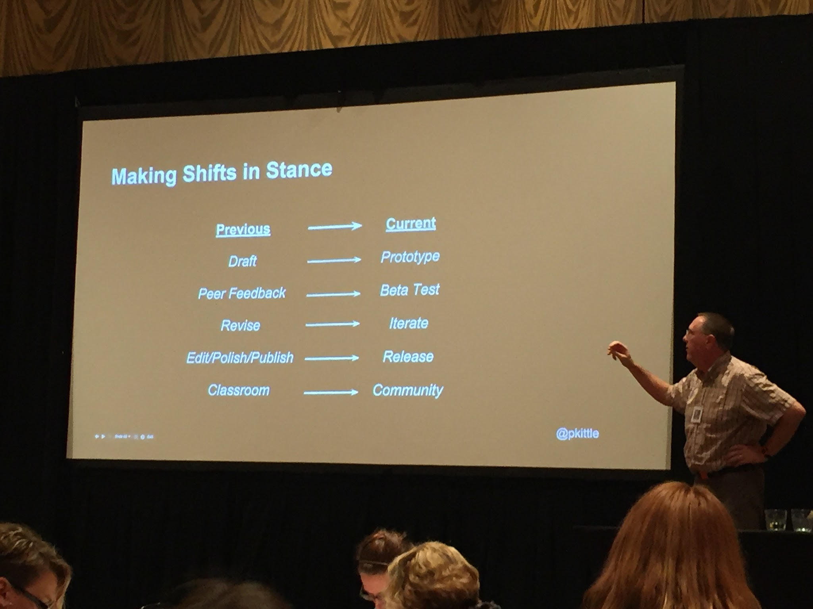

(P Kittle 4Cs 2016)

Some depictions of process emerging now mirror the design process to the writing process, such as [this dude’s talk at 4Cs in 2016). While we appreciate this effort to “design-ify” process, this set of steps still represents a more or less linear, chronological sequence. In other words, renaming the steps in a traditional process model does not transform that model, and therefore it still represents what postprocess theories critique about traditional process.

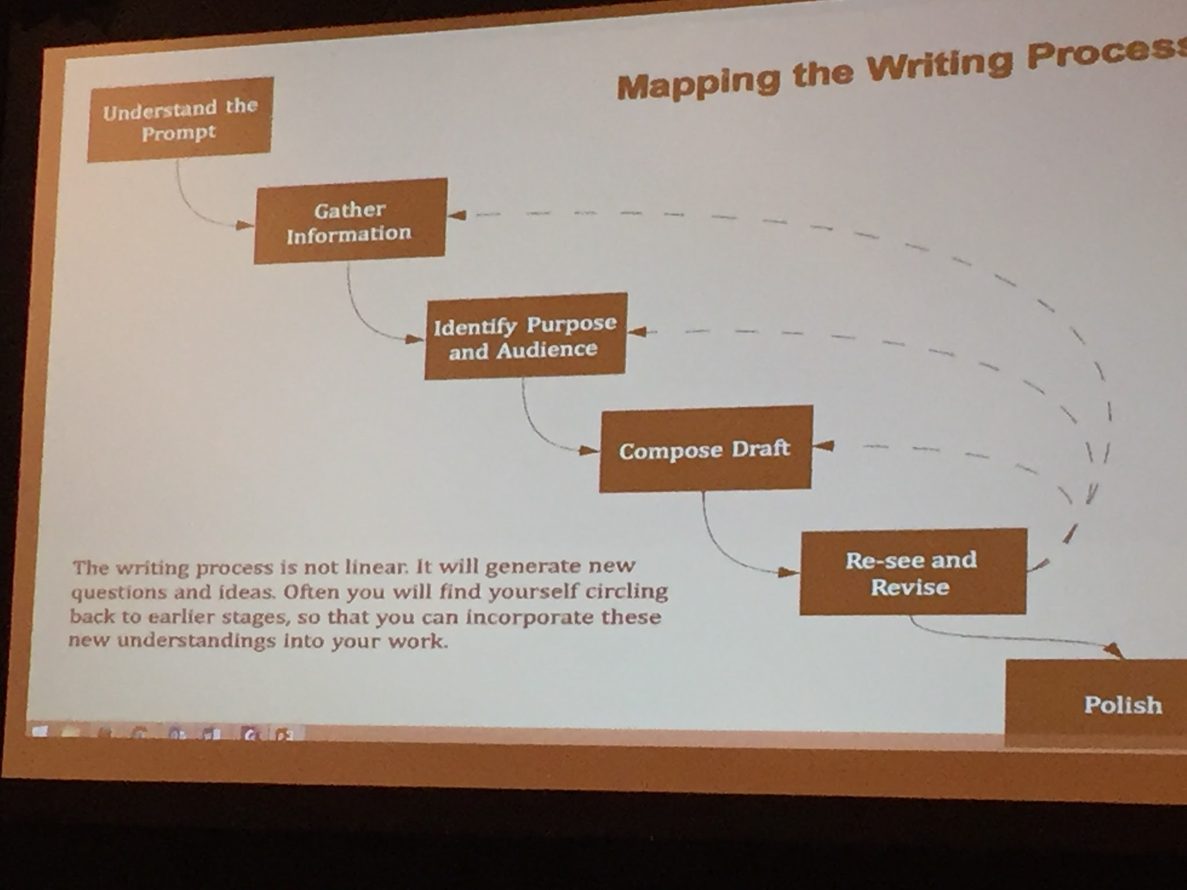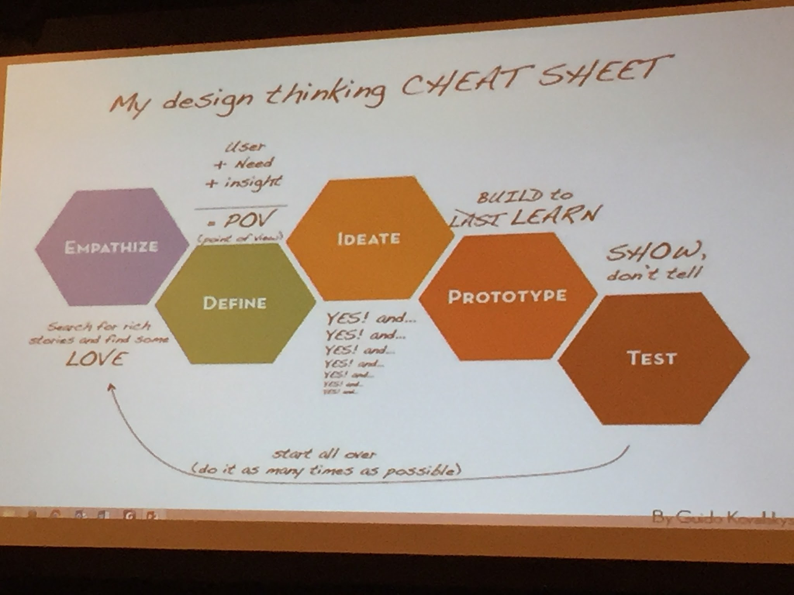

(Marlo Ransdell interior design at FSU from AACU 2016)

These examples, one depicting writing processes and one depicting design thinking processes, make important improvements on the prior depiction. In both cases, process is represented as ambiguous, plural, and -- maybe most importantly -- recursive. In each case, students will see these images (we hope) and realize quickly that their individual process (the “how *I*  work”) won’t emerge until they’re in up to their elbow.

And remember, the Squiggle from EthicsLab. For it’s faults -- the worst of which potentially is the blackboxing of XYZ -- its virtue remains similar to the above two examples. In each, process is something that we must talk about, but which we can never fully know ahead of time.

Engaging with students in process-talk but in a design-savvy, plural sense will help empower them. As APJ puts it:

I define design as the ‘constructive process’ by which the imagination takes on problems, frames them, models them, and creates response through the distribution of material -- real or virtual material -- in space. And design thinking is the same process, but where the product may be thought itself -- conceptual, strategic, structural, or systemic in nature. The beauty of the design process is its non-linearity. Instead, reason as nascent structure, dependent on feedback procedures creates a way of engaging complexity, richness, and the seemingly paradoxical or irresolvable, even, so as to build material stories or conceptual systems in which these are given meaning and form” (10).

**\*\*\*\*\*\*\*\*\*\*\*\*\*\*\*\*\*\*\*\*\*\*\*\*\*\*\*\*\*\*\*\*\*\*\*\*\*\*\*\*\*\*\*\*\*\*\*\*\*\*\*\*\*\*\*\*\*\*\*\*\*\*\*\*\*\*\*\*\*\*\*\*\*\*\*\*\*\*\*\*\*\*\*\*\*\*\*\*\*\*\*\*\*\*\*\*\*\*\*\*\*\*\*\***

Model the dispositions that we hope to cultivate in students. One possible set of such dispositions are the [8 Studio Habits of Mind](https://www.teachingchannel.org/blog/2015/03/03/8-habits-of-thinking/), published in *Studio Thinking* (2007, Lois Hetland, Ellen Winner, Shirley Veenema, Kimberly M. Sheridan), and part of Harvard’s Project Zero.

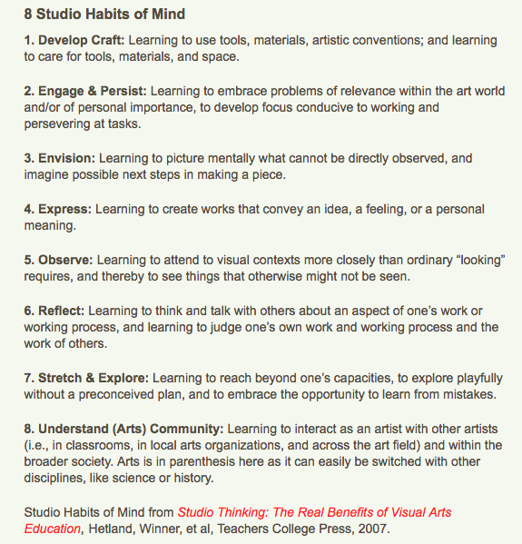

[Image from <https://www.teachingchannel.org/blog/2015/03/03/8-habits-of-thinking/>]

We might turn to sophistic pedagogy to clarify how these “Habits of Mind” might be cultivated. As Debra Hawhee notes, “sophistic pedagogy emphasized the materiality of learning, the corporeal acquisition of rhetorical movements through rhythm, repetition, and response. This manner of learning-doing entails ‘getting a feel for’ the work’” (160 Bodily Arts). That is, through repetition and practice, teachers and students can get “a feel for” these habits of mind until they become dispositionally incorporated. However, it is important to note that these habits of mind will look and feel different for each individual learning context. This is why response is key. As Hawhee states, “sophistic-style rhetorical training is always bound up with responsiveness within particular contexts” (160).

So, even as we invent scaffolded spaces for students to work, thus enacting their own repetition-and-response habits, we continually re-invent and co-occupy these spaces with students, thus involving ourselves in the same dispositional cultivation -- all of which, remember, are aimed at the progymnasmata’s goal of “a set of deep-seated verbal habits and dispositions oriented to public effectiveness and virtue” (114).

Desiging spaces for students to design, in other words, will help us to cultivate these dispositions in ourselves, even as we help to cultivate them in students. If they can do it, we can, too.

**\*\*\*\*\*\*\*\*\*\*\*\*\*\*\*\*\*\*\*\*\*\*\*\*\*\*\*\*\*\*\*\*\*\*\*\*\*\*\*\*\*\*\*\*\*\*\*\*\*\*\*\*\*\*\*\*\*\*\*\*\*\*\*\*\*\*\*\*\*\*\*\*\*\*\*\*\*\*\*\*\*\*\*\*\*\*\*\*\*\*\*\*\*\*\*\*\*\*\*\*\*\*\*\*\***

Keep ethics at the center of design approaches, Part 1. While terms like design, studio, design-thinking, hacking, making, craft, makerspaces are often used interchangeably, they are not the same things. These terms have very different histories, practices, purposes, and *ideologies*.

For example, design thinking, for many academics, evokes an association with the corporate, for-profit world of start-ups. Sometimes that’s enough to repel interest, but not always. In his keynote at the 2016 Watson conference, for instance, Scott Wible discussed how he uses design practices to connect his students to local community projects (e.g. non-profits) as opposed to using it for more business-minded, profit-making efforts. By doing so, Wible echoes our field’s longstanding commitment to “service learning” and engaged public work. In this case, then, design thinking could be a way to energizing existing pedagogical service models and opportunities.

***********************************************************************************************************

Keep ethics at the center of design approaches, Part 2. Makerspaces, as seen through research such as that done by Ann Shivers-McNair, often trumpet their progressive, bottom-up political orientations. They want to be free spaces for creativity, community centers for non-hierarchical productivity. But as Shivers-McNair notes, they are also predominantly white, male spaces.

<http://www.digitalrhetoriccollaborative.org/2016/03/17/what-can-we-learn-about-writing-and-rhetoric-from-a-makerspace/>

For example, in Neil Rothman’s mechanical engineering class at UMBC we encountered a large white male majority, seemingly a perpetuation of the patterns observed by Shivers-McNair (and [others](http://makermedia.com/press/fact-sheet/)). Even at a school that is known for its [diverse STEM program](http://www.cbsnews.com/news/hrabowski-an-educator-focused-on-math-and-science-13-11-2011/), problems with diversity in design persist. Diversity in design spaces, based on what we’ve read and observed, is perhaps getting better but there’s a long way to go for them to be truly inclusive.

One way our field might contribute to improving the inclusivity of design spaces is to bring design approaches to a general education student population. Pavesich’s class in the Studio Collaborative, for example, is an introduction to rhetoric course that satisfies a general education requirement. The students in this class, that is, are not yet segregated by historical patterns of major or specialization. Students -- of all backgrounds -- simply sign up and find themselves immersed in a design experience.

We believe that by infusing design approaches into general education classes, including First-Year Writing, our field can begin to break down the historical exclusivity of these modes of work and workspaces.

************************************************************************************************************

Re-purpose all of this. And then publish or present on it, okay?

**\*\*\*\*\*\*\*\*\*\*\*\*\*\*\*\*\*\*\*\*\*\*\*\*\*\*\*\*\*\*\*\*\*\*\*\*\*\*\*\*\*\*\*\*\*\*\*\*\*\*\*\*\*\*\*\*\*\*\*\*\*\*\*\*\*\*\*\*\*\*\*\*\*\*\*\*\*\*\*\*\*\*\*\*\*\*\*\*\*\*\*\*\*\*\*\*\*\*\*\*\*\*\*\***