**The Catholic University of America**

**School of Architecture and Planning**

**Eric Jenkins, AIA**

**Urban Practice Studio Methodology**

1. INFORMATION GATHERING
   1. Site Analysis / Context – Basic Information About the Site
      1. Photographs – contextual and elevations of surrounding streetscapes
      2. Location maps – relationship to neighborhood/city/state
      3. Topography
      4. Weather / Climate
      5. Other environmental factors
      6. Elevations
      7. Site Sections (multiple cuts in both directions)
   2. History/Culture
      1. Historical background of the neighborhood/site
      2. Timeline of events / important moments
      3. Historic maps
      4. Historic photographs
      5. Demographics
      6. Neighborhood organizations / political structure
   3. Modeling
      1. 3D model of the site (often SketchUp)
      2. Physical site model (often a large scale of the neighborhood/area to provide a deeper understanding of the dynamics of the site in three dimensions). Admittedly, this model is mostly instructive at the beginning of the analysis phase and for explaining the site to reviewers. It does not always get used much beyond that, but we have found it to be very helpful and often unavoidable.
2. INITIAL EXISTING CONDITION ANALYSIS
   1. Plan Diagrams – Dynamic Layered Understanding of the Site and Existing Conditions
      1. Urban fabric
      2. Transportation (major/minor routes, types, hubs/stops)
      3. Green space
      4. Nodes
      5. Neighborhoods
      6. Figure/Ground
      7. Zoning/Land Use
      8. Series of Development Diagrams (often based on historic maps)
   2. 3D Diagrams
3. DEFINING THE PROBLEM
   1. Ask Questions about the site:
      1. What is the site lacking?
      2. What are the missing:
         1. Programs?
         2. Connections?
         3. Networks?
         4. Fabrics?
         5. Nodes?
      3. What can we leverage to achieve a greater cohesion in the project?
   2. Perform a SWOT analysis of the study area.
      1. What are the Strengths, Weaknesses, Opportunities and Threats of the study area?
      2. How will these elements inform this particular design project?
   3. Diagrams
      1. Define and characterize the site through answers to the above.
         1. Example: Matt Hosko’s diagrams below regarding North Capitol Street for the Planning Studio project).

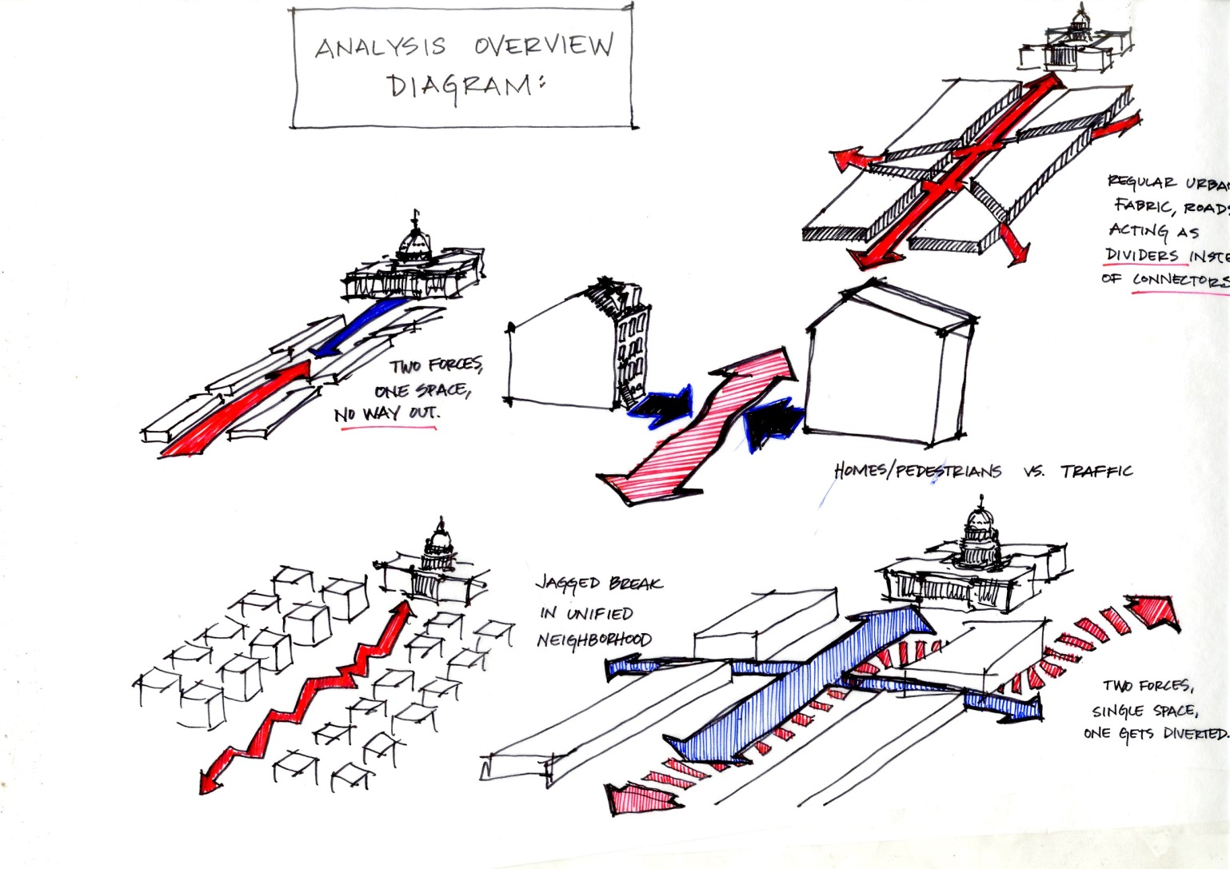

* + - 1. 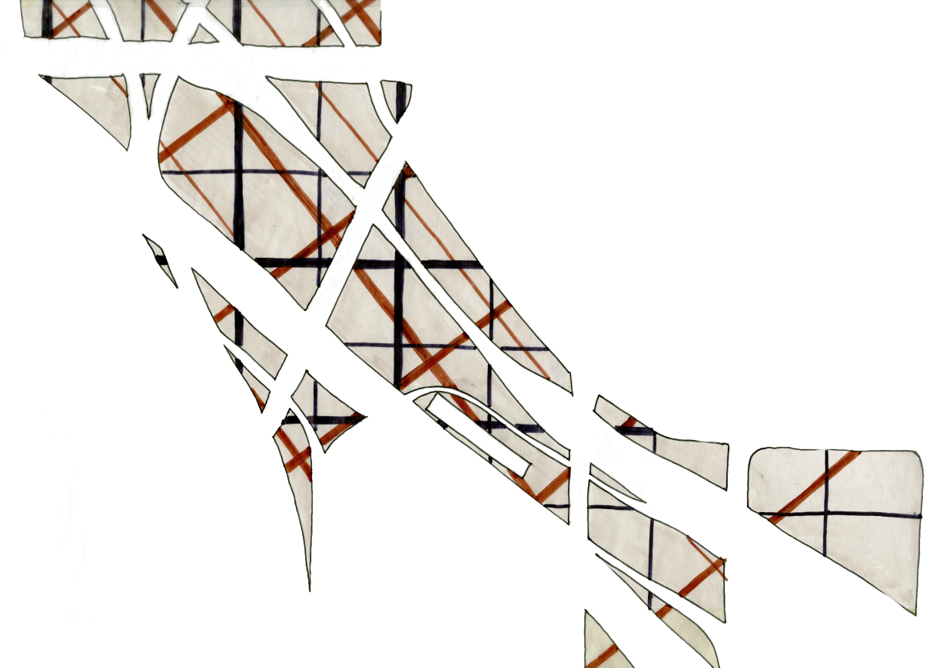Example: Layered plan diagram of the forces interacting and overlapping on the “Terrain Vague” site in Baltimore (UP Studio Fall 2014).

1. COMPARISON TO OTHER PROJECTS
   1. Precedent Analysis
      1. Select 15-20 projects at all scales that have relevance to this project.
      2. Choose 3 precedents that are interesting to you to explore in depth.
      3. Diagram the precedents.
      4. Diagram how the precedents could work on your site.
   2. Current Site Plans
      1. Are there other Urban Planning or design projects for this site?
      2. What can be learned from these projects?
2. EXPERIMENT – EXPLORING URBAN DESIGN
   1. Ask questions and begin to form answers:
      1. What are the big urban moves that will define and clarify the project?
   2. Test the answers through diagrams and sketches.
   3. Build study models (rough, quick, diagrammatic)
   4. Generate ideas through vocabulary. What is your approach to the project?
      1. Verbs are good since they are dynamic and active, but nouns can also provide clarity and direction.
      2. List of words used to generate ideas in UP Studio Fall 2014. We chose (3) words used in combination to form the major ideas about the project.
         1. Bridging
         2. Aligning
         3. Decking
         4. Stepping
         5. Weaving
         6. Ramping
         7. Digging
         8. Connecting
         9. Inserting
         10. Excavating
         11. Covering
         12. Sculpting
         13. Ribboning
         14. Branching
         15. Linking
         16. Crossing
         17. Joining
         18. Interlacing
         19. Relating
         20. Sewing
         21. Arcing
         22. Fastening
         23. Extending
         24. Filling
3. ORDER and CLARIFY
   1. How do all of the answers and ideas generated in Step 5 combine to form a series of decisions about the site that have a unifying vision?
   2. Develop a narrative about the site. What is the story you are trying to tell?
   3. Develop a “master plan” for the site. In the UP Studio this is done as a group and is often the most challenging part of the process.
      1. Where are the logical and necessary project sites located within this framework?
4. INDIVIDUAL DESIGN
   1. Choose a site.
      1. Based on the urban design, what is the appropriate program, scale, point(s) of access, relationship to street/grid/other nodes/edges/other project sites?
   2. Develop a parti.
   3. Diagrams.
   4. Sketches.
   5. Study models.
   6. Etc.
5. INFORMING ACROSS SCALES or “THE TROMBONE EFFECT”
   1. The urban design and individual project continue to develop through an iterative process through continually asking:
      1. How is your project informed by the urban design?
      2. How is the urban design informed by your project?