Note: This is a complete overview for the application and maintenance of the AirCoral® Calculator script on the Designplan website.

**Overview:**

The calculator calculates the amount of space a lighting fixture can purify. It should look as follows:

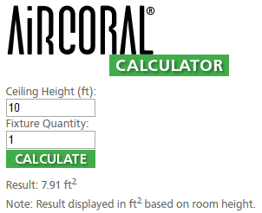

There are 5 important files needed for this calculator to work. They are located alongside this readme within Z:\WEBSITE DATABASE\Products\Buzzi & Buzzi\AirCoral Calculator Files.

They are as follows:

aircoral_calc.png, calculate_off.png, calculate_on.png, aircoral.js, ~~workingScript.txt~~ movedhostScript.html

If changes to the images need to be made, the GIMP .xcf files are located within:

\\INCSERVER01\Data\AARONWEISS\0_LOGOS AND LABELS\LOGOS\B&B Logo.

**Adding a calculator to a new page:**

To add a new product:

First, the absorbtion capacity has to be found.

**Method 1 (preferred if available):**

Visit Buzzi & Buzzi’s calculator: <http://www.buzzi-buzzi.it/en/aircoral-calculator.aspx>

Find the product on the drop down, and add the product.

Set the ‘H compartment’ to 1, and use this number in the code as described below:



**Method 2:**

Find the product on Buzzi & Buzzi’s web page (<http://www.buzzi-buzzi.it/en/index.aspx>).

Open the data sheet, as shown in the picture below:



Next, verify the fixture is AirCoral and take note of the absorbtion capacity.

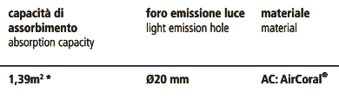

Once you have the absorbtion area, verify the height of the room located at the bottom of the document.



In this (and presumably all) case(s), the default room height is 2.7m. The absorbtion capacity will have to be changed before it is placed into the formula. To do so, we need to multiply the capacity by 100 times the roomheight, or: capacity*(100*roomheight). In this case, it will be: 1.39*100*2.7, or 375.3.

**Using the number:**

Now that you have this number, open the “workingScript.txt” file **in notepad** or another **basic** text viewer.

Find the **onclick="calculateArea(###)"** portion of code. Change the inside number to your new found number, in this case: **onclick="calculateArea(375.3)"**.

Next, copy the entire source code within “workingScript.txt”.

Navigate to edit the desired web page. Click the “HTML” button to go into HTML editing mode.

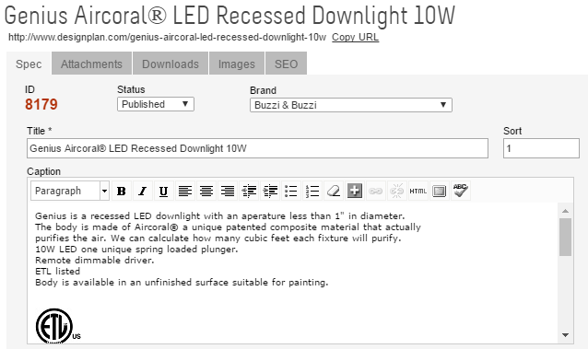

Paste the source code into the bottom of the text area underneath the pre-existing text and hit “Update”.

The calculator now should be on the page.

**Maintenance: Image sources.**

The image sources for this calculator (and other things on the website) are hosted on Photobucket.

To reupload the photos, visit <http://www.photobucket.com>.

Sign in using the following credentials:

|  |
| --- |
| User: [danw@designplan.com](mailto:danw@designplan.com) |
| Pw: lefty1 |

From here, deleting and reuploading images of the same name (aircoral_calc.png, calculate_off.png, calculate_on.png) will update all images at once on the Designplan website.

**Maintenance: Javascript hosting.**

____________________________________________________________________________

**Note:** **This is out of date.** I have moved the javascript file to my github page at <https://aaronjweiss.github.io/aircalc/>, or direct: <https://aaronjweiss.github.io/aircalc/aircoral.js>

If the host dies or changes need to be made:

Upload to your own host.

Change script links of all AirCoral Products.

____________________________________________________________________________

The javascript document is hosted on Google Drive under the danw account. The credentials are as follows:

|  |
| --- |
| User: [danw@designplan.com](mailto:danw@designplan.com) |
| Pw: leftbrainrightbrain |

To re-upload the js document:

Visit the google drive and go to the *designplan-public* folder.

To update the document, right click “aircoral.js” and click “Manage Versions..”.

Re-upload.

Verify this does not change the public host link. If it does, follow this tutorial to host the file:

<http://www.komku.org/2013/08/how-to-host-javascript-or-css-files-on-google-drive.html>